C950 Task-2 WGUPS Algorithm Overview

(Task-2: The Implementation phase of the WGUPS Routing Program)

Sam Merrill
ID #012638734
WGU Email: smerri25@wgu.edu
09/24/2026

C950 Data Structures and Algorithms II

A. Hash Table
Screenshot of Hash Table/Map below: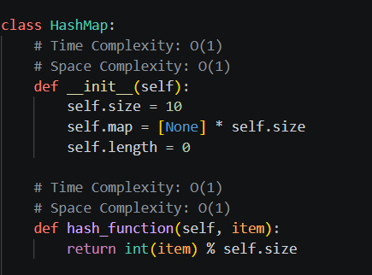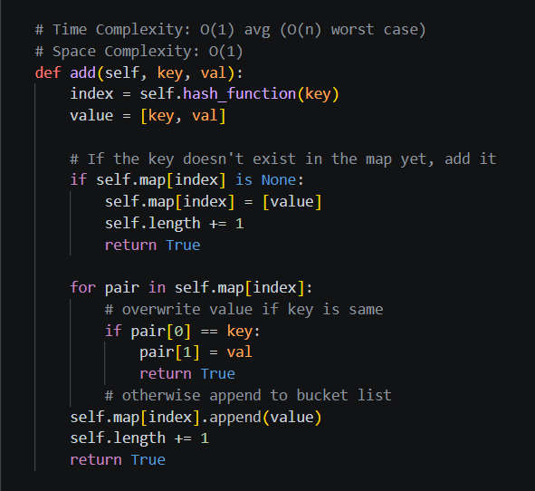

B. Look-Up Functions
Within Hash Table/Map Class:
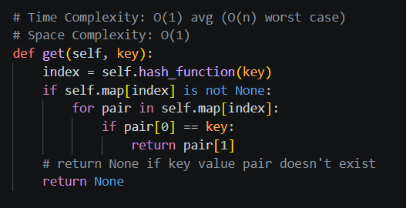
Within Package Reader Class:
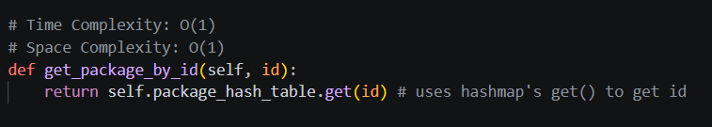
Within Package Class (the data returned by functions above):
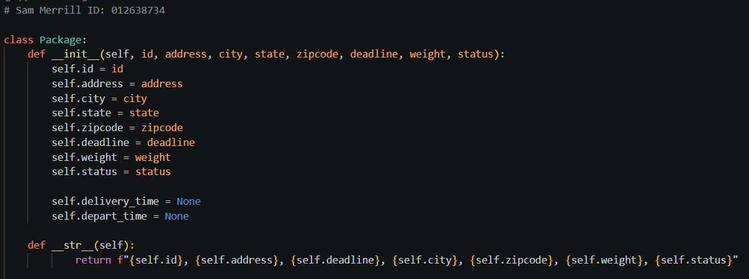

C. Original Code
Nearest Neighbor implementation to get distances for route:
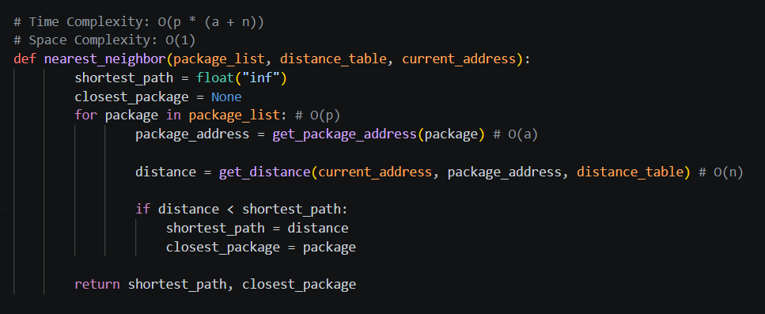
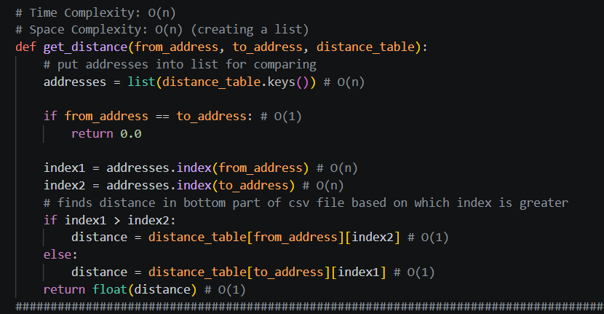
Using Nearest Neighbor to build routes/deliver packages:
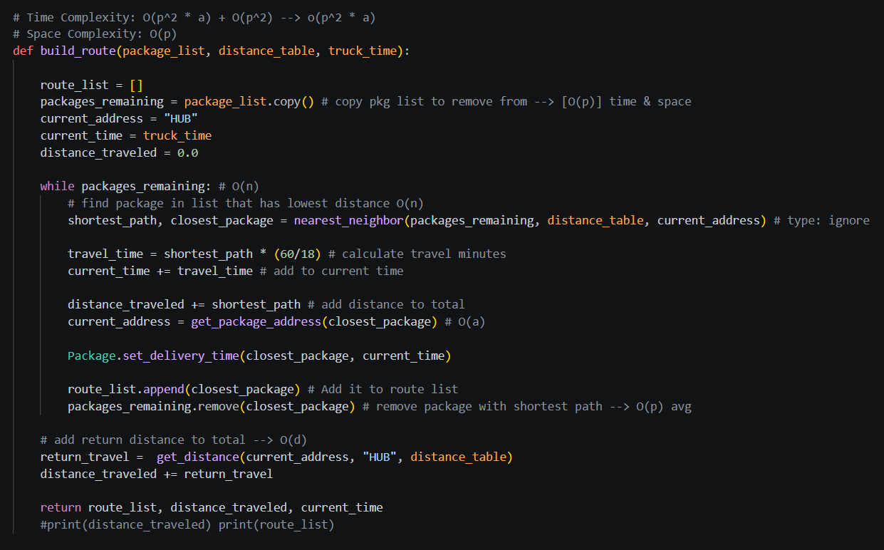

C1. Identification Information
Within main.py:
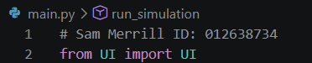

C2. Process and Flow Comments
See code for Comments, thank you.

D. Interface
See code for setup of user interface. Screenshots of simulation running:
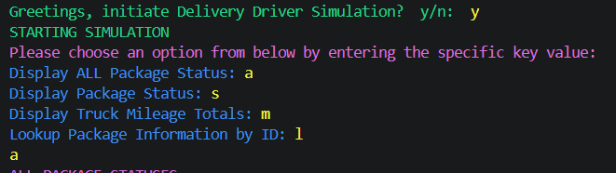

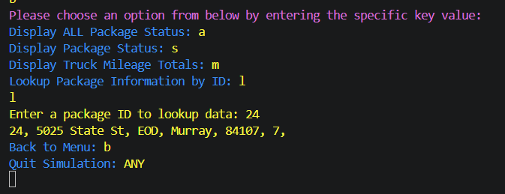
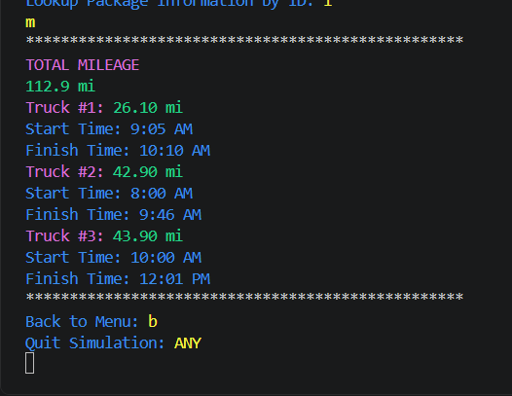

D1. First Status Check
Time between 8:35 a.m. and 9:25
Time Entered: 9:05am

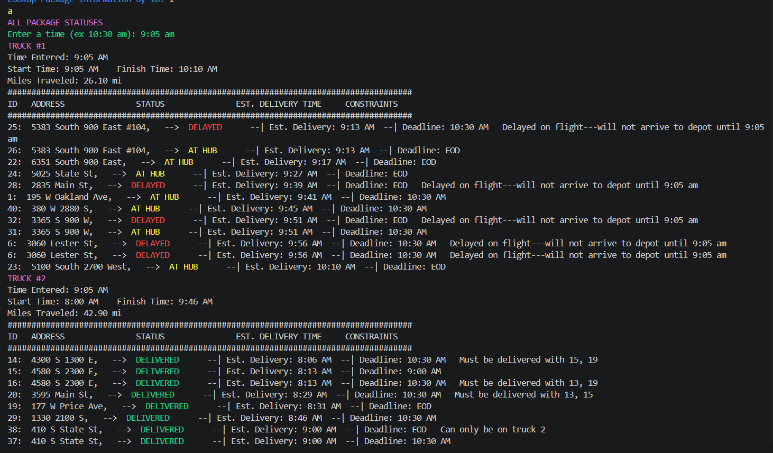
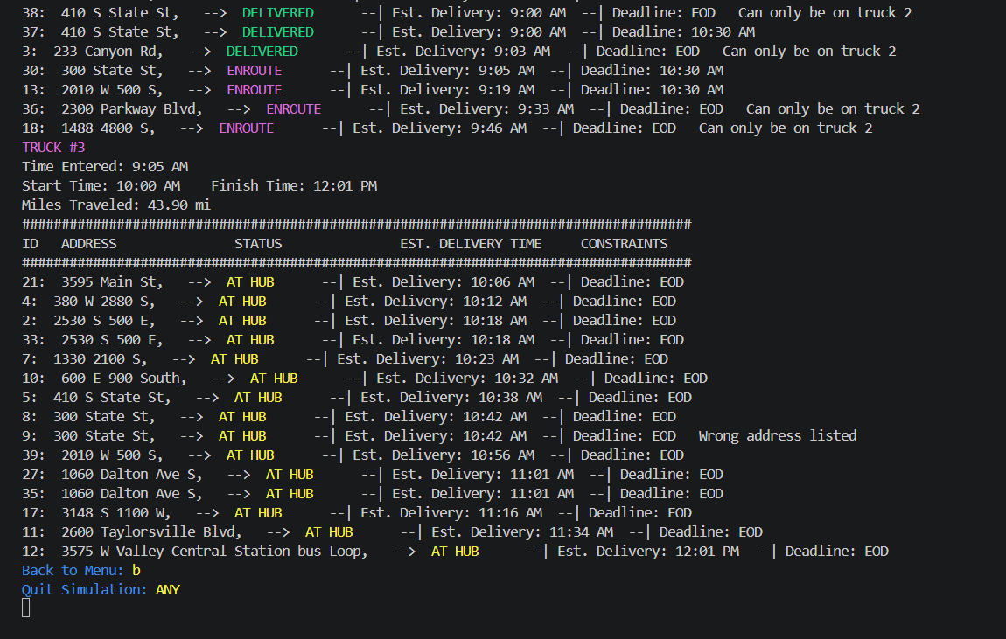

D2. Second Status Check
Time between 9:35 a.m. and 10:25 a.m.
Time Entered: 10:00am
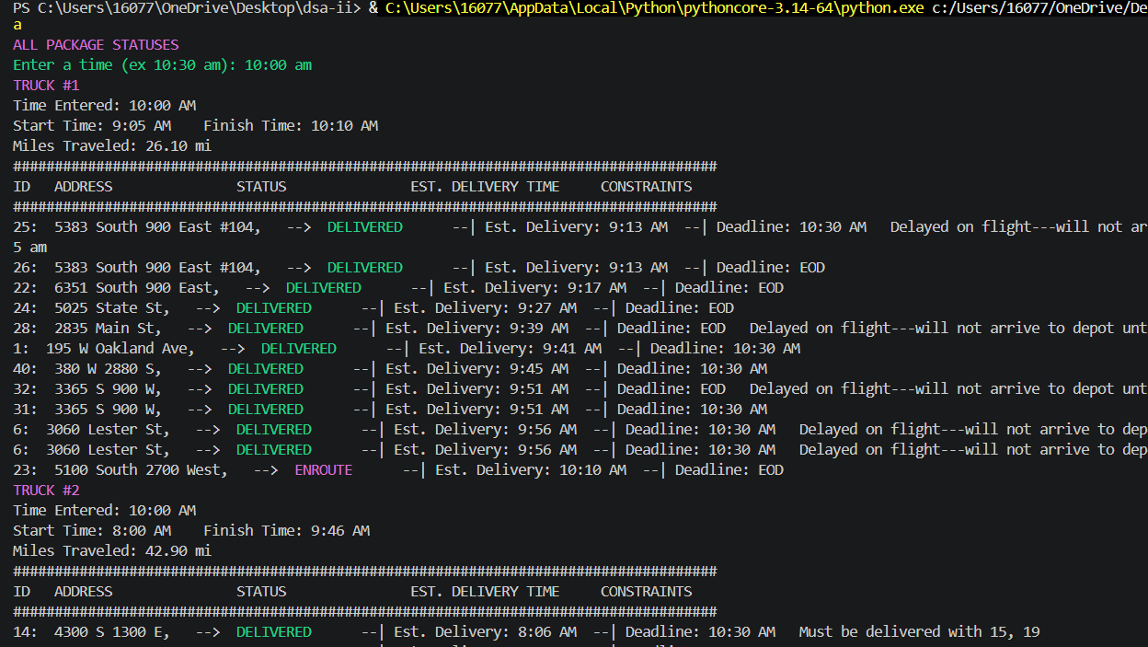
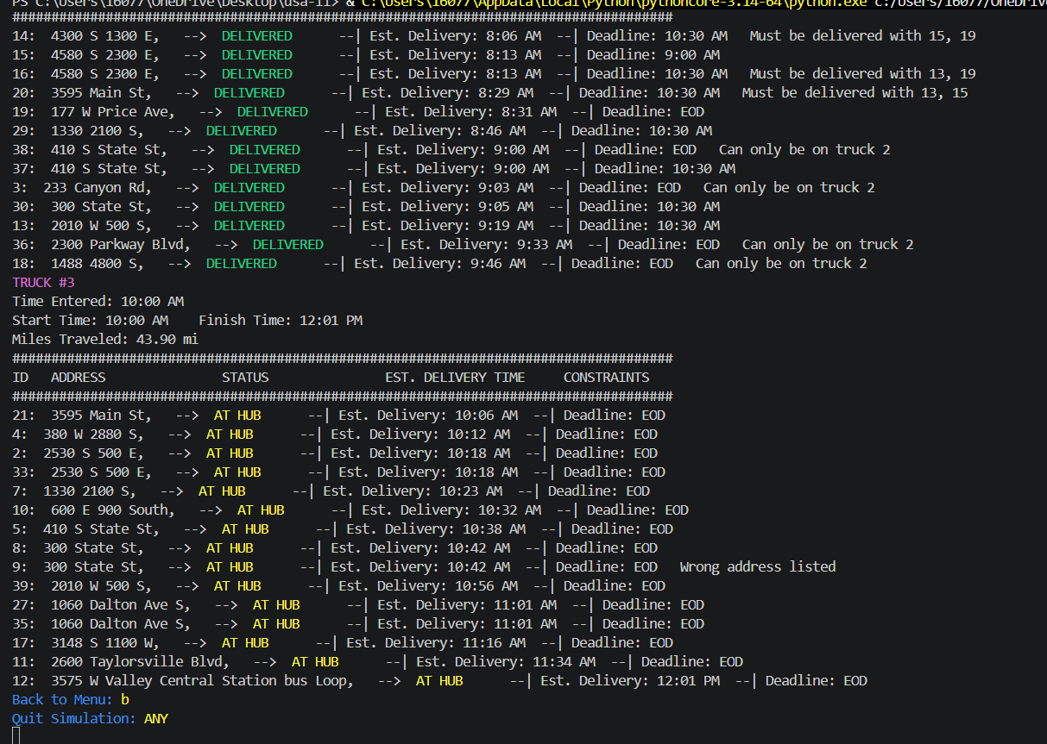

D3. Third Status Check
Time between 12:03 p.m. and 1:12 p.m.
Time Entered: 12:19pm
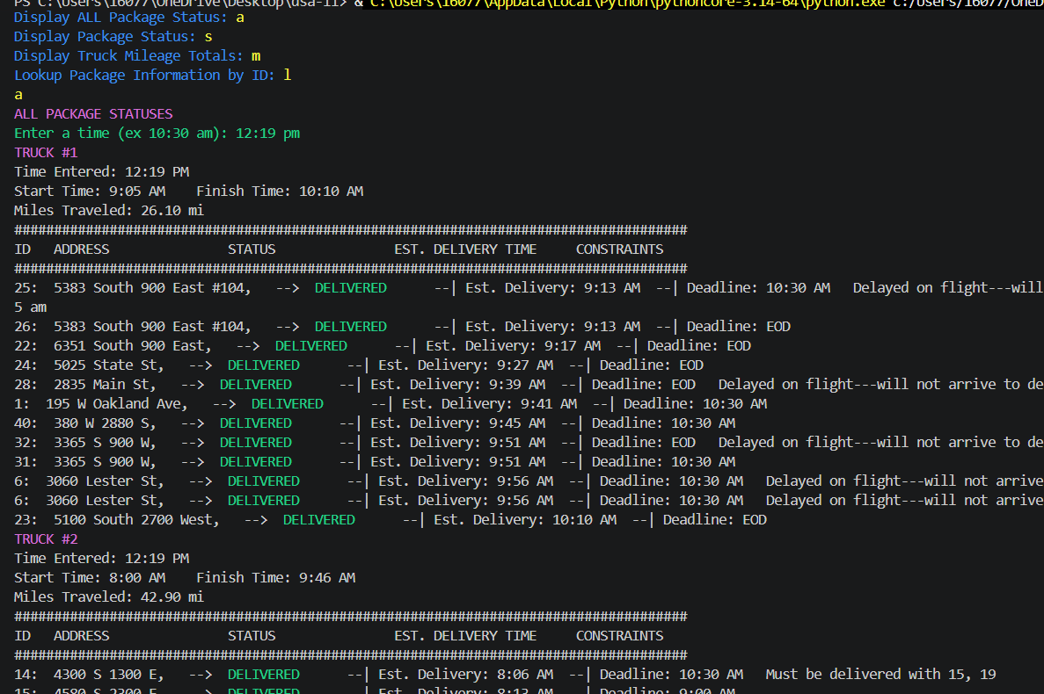
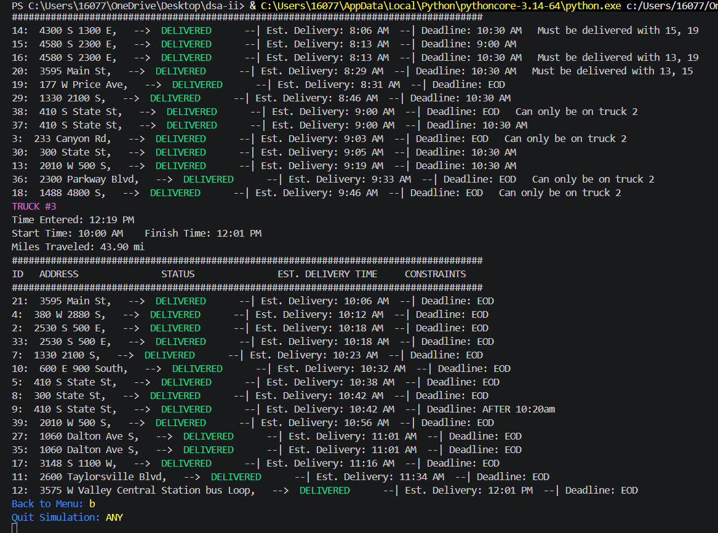

E. Screenshot of Code Execution
Assign start times and build routes to get distances: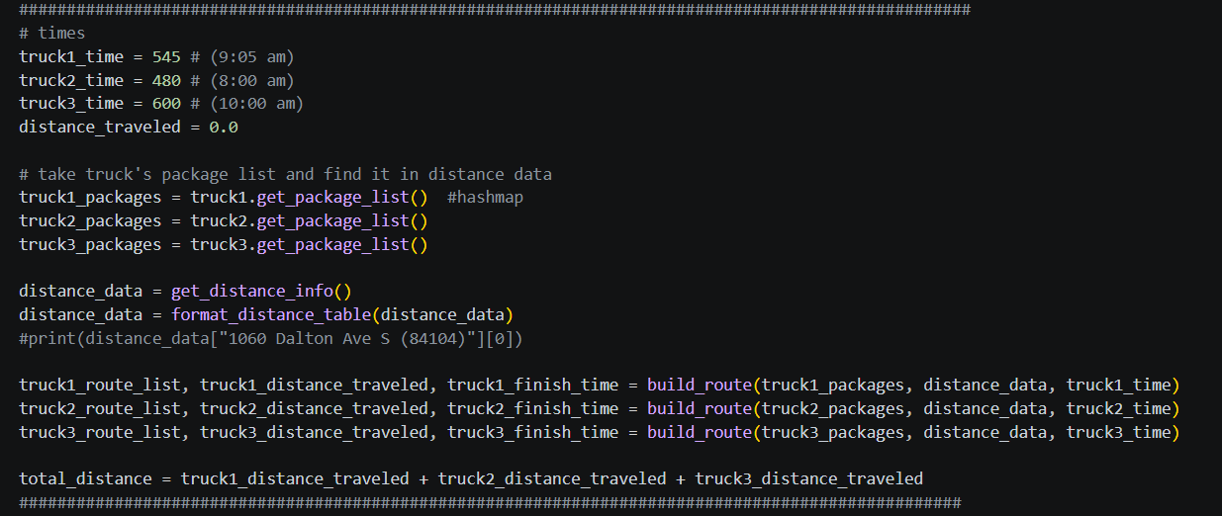

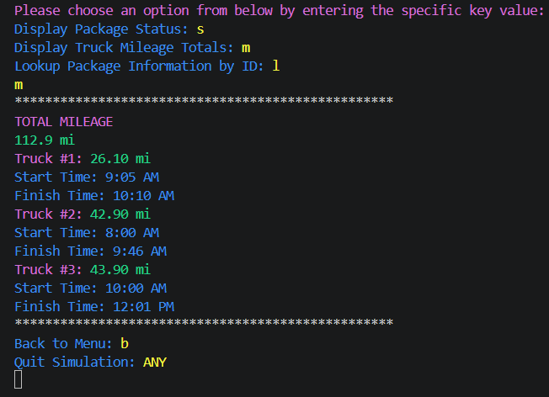

F1. Strengths of the Chosen Algorithm
A strength of the algorithm used in the solution is the runtime efficiency. It has a time complexity of polynomial time, rather than losing efficiency by searching through every possible route. Each package address in the route is searched through the distance table to find the closest location, and this is done until no additional addresses remain. This allows for the possibility of more packages in the future. Another strength of the nearest neighbor algorithm is the ease of implementation. Taking the current location, searching through the route package list for the closest package, and repeating is a fairly straightforward process, while still allowing for efficient route delivery (under 140 miles).

F2. Verification of Algorithm
All 40 packages will be delivered on time while meeting each package’s requirements, and keeping the combined total distance traveled under 140 miles for all trucks. Below are the total distance & times for all trucks. D3 above displays info at the user-entered 12:19 pm, with ALL package delivery times before their deadlines. A format_minutes(time_entered) function converts the user-entered time to the total minutes for time calculations.

F3. Other Possible Algorithms
Dijkstra’s Algorithm could be used to find an optimal delivery route for the WGUPS scenario. On an undirected graph, which our distance table could create, Dijkstra’s allows two-way traversals between nodes. Addresses would be treated as edges. This would find an optimal route, potentially a better route than the Nearest Neighbor. Another alternative path-finding algorithm is the A-Star algorithm, which utilizes a graph as well to find the shortest, most optimal route from a start node to an end node.

F3a. Algorithm Differences
Dijkstra’s algorithm uses a weighted graph to determine the best route, whereas nearest neighbor does not. It only makes one step at a time and does not reassess. The A-Star algorithm estimates the distance remaining to the destination, whereas NN only looks to the next closest destination. A-Star can make more informed decisions per se, as it has more information about the destination node.

G. Different Approach
A minor change to my simulation would be to update the UI functions. Currently, there’s a recursive function, run_simulation(), which keeps being called until the user ends the simulation. To avoid this in the future, I could implement a loop for better handling. Recursive functions aren’t always necessary, but I figured it would be optimal. If I did do this project again, though, I would change the UI and supporting functions.

H. Verification of Data Structure
The Hash Table/Map does the following:
- Stores all 40 packages.
- Package ID is the key; Package object is the value pair
- Add, update, and remove packages
- Return info of a package by ID
- Handles collisions in buckets
- Works within the program

H1. Other Data Structures
A binary search tree or a list could be used instead of a Hash Table to meet the requirements for WGUPS.

H1a. Data Structure Differences
A list and a binary search tree are quite different from a hash table. A hash table uses buckets to store packages and chooses which bucket based on the hashing function. A list only stores items sequentially. A BST organizes items according to their order, and searching is done by comparing values. A list would require a linear search of the package objects to search for a value, which is O(n), and a BST would require O(log n) if it were balanced. A hash table remains on top, with average O(1) lookup.

I. Sources
Wengrow, J. (2017). A common-sense guide to data structures and algorithms: Level up your core programming skills. Pragmatic Bookshelf.

GeeksforGeeks. (2026, July 21). A search algorithm*. https://www.geeksforgeeks.org/dsa/a-search-algorithm/

W3Schools. (n.d.). Dijkstra's algorithm. https://www.w3schools.com/dsa/dsa_algo_graphs_dijkstra.php

Lysecky, R., & Vahid, F. (2018, June). C950: Data Structures and Algorithms II. zyBooks.
Retrieved March 22, 2021, from https://learn.zybooks.com/zybook/WGUC950AY20182019/

J. Professional Communication
Nothing to write. Run your document through https://www.grammarly.com/

