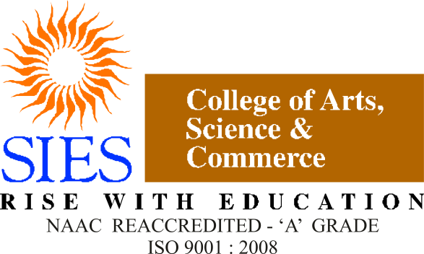

**S.I.E.S College of Arts, Science and Commerce**

**[Autonomous],**

**Sion(W), Mumbai – 400 022.**

**CERTIFICATE**

This is to certify that the project entitled “**Restaurant -Food Ordering and Reservations (WebApp)**” is a bonafide work of Miss. Sarah Stalin, Mr. Nimesh Thakur and Mr. Siddharth Worlikar submitted to college for partial fulfilment for the degree of Bachelor of Science **(Computer Science)[Semester V]** academic year **2018-19**

______________

Prof. In-Charge

(Prof. Manoj Singh)

Head of the Department Examiner

(Prof. Manoj Singh)

College Seal