Study Buddy

A Retrieval-Augmented Generation (RAG) Based PDF Question Answering System

1. Introduction
The increasing use of digital educational resources such as textbooks, lecture notes, research papers, and technical manuals has made information more accessible than ever. However, locating specific information within large PDF documents remains a time-consuming task. Traditional search methods rely heavily on exact keyword matching and often fail when users describe concepts differently from how they appear in the document.
Study Buddy was developed to address this challenge by transforming static PDF documents into an interactive knowledge source. Using Retrieval-Augmented Generation (RAG), the system allows users to upload PDF documents and ask questions in natural language. Instead of manually searching through pages of content, users can interact with their documents conversationally and receive accurate, context-aware responses.
The project combines modern Artificial Intelligence technologies, including Large Language Models (LLMs), vector databases, semantic embeddings, and conversational memory, to provide an efficient document-question-answering experience.

2. Problem Statement
Students and researchers frequently work with lengthy PDF documents containing large amounts of information. Finding specific concepts, explanations, or references within these documents can be difficult and inefficient.
Traditional search approaches suffer from several limitations:
- Dependence on exact keyword matching
- Inability to understand semantic meaning
- Poor handling of conversational follow-up questions
- Increased time spent searching instead of learning
As educational and research materials continue to grow, there is a need for a system that can understand natural language questions, retrieve relevant information, and provide accurate answers directly from uploaded documents.

3. Proposed Solution
Study Buddy addresses this problem using a Retrieval-Augmented Generation (RAG) architecture.
Users upload PDF documents through a web interface. The system processes and indexes these documents by converting their content into semantic vector representations. When a user asks a question, the system retrieves the most relevant information from the indexed documents and provides it as context to a Large Language Model.
Unlike traditional chatbots that rely solely on model knowledge, Study Buddy generates answers using retrieved document content. This approach improves accuracy, reduces hallucinations, and ensures that responses remain grounded in the uploaded documents.

4. System Architecture
Study Buddy follows a client-server architecture consisting of five major layers:
- User Interface Layer
- API Layer
- Processing Layer
- Retrieval Layer
- Storage Layer
The frontend provides the user interface for document management and question answering, while the backend handles document processing, indexing, retrieval, and communication with language models.
The workflow begins when a user uploads a PDF or submits a question through the frontend. Requests are sent to the backend through REST APIs. Uploaded documents are processed and indexed, while user queries trigger the retrieval pipeline. Relevant document content is retrieved, combined with conversational context, and passed to the language model for answer generation.
This layered architecture promotes scalability, maintainability, and separation of concerns.

5. Technology Stack

Frontend
The frontend was developed using React 18 and Vite.
React was selected because of its component-based architecture, allowing the application to be divided into reusable components such as the chat interface, document sidebar, upload module, and notification system.
Vite was used as the build tool due to its fast development environment and optimized production builds.
Axios was used for communication between the frontend and backend, handling document uploads, chat requests, document management operations, and status updates.

Backend
The backend was developed using Python and FastAPI.
Python was chosen because of its extensive ecosystem for Artificial Intelligence, Natural Language Processing, and machine learning development.
FastAPI provides high performance, asynchronous request handling, automatic API documentation, and request validation through Pydantic models. The backend manages PDF processing, indexing, retrieval, session management, and interaction with Large Language Models.

Storage Technologies
SQLite is used to store document metadata, upload status information, chat sessions, and conversation history.
ChromaDB serves as the vector database responsible for storing document embeddings and performing semantic similarity searches.

6. System Workflow
The operation of Study Buddy can be divided into two major phases: Document Ingestion and Query Processing.

Document Ingestion
When a user uploads a PDF document, the system first validates the file and performs duplicate detection using a SHA-256 content hash. This prevents identical documents from being indexed multiple times.
Text is then extracted from the document using the pypdf library. The extracted content is divided into hierarchical chunks consisting of larger parent chunks and smaller child chunks.
Parent chunks contain approximately 1500 characters and preserve contextual information, while child chunks contain approximately 500 characters and are optimized for semantic retrieval.
Each child chunk is converted into a vector embedding using the BAAI/bge-small-en embedding model running locally through ONNX Runtime. The generated embeddings are stored in ChromaDB together with metadata linking them to their original document sources.
Once indexing is complete, the document becomes searchable through semantic similarity search.

Query Processing
When a user submits a question, the system first examines recent conversation history stored in SQLite. Ambiguous follow-up questions are rewritten into complete standalone queries using a language model.
The rewritten query is then expanded into multiple variations through a process known as multi-query retrieval. These query variations improve retrieval coverage by accounting for differences in wording between the user’s question and the document content.
Each query variation is converted into an embedding and searched against ChromaDB. Retrieved results are merged, filtered, and ranked according to relevance.
The most relevant document chunks are then supplied to the language model as contextual information. Based on this context, the model generates an answer that is grounded in the uploaded documents and returned to the user.

7. Key Features
Study Buddy incorporates several advanced features that improve retrieval quality and user experience:
- Semantic document search
- Conversational question answering
- History-aware query rewriting
- Multi-query retrieval
- Hierarchical parent-child chunking
- Duplicate document detection
- Persistent document storage
- Source-grounded responses
- Multi-provider LLM support
These features collectively improve answer accuracy, retrieval performance, and usability.

8. LLM Integration
The system supports multiple Large Language Model providers through a provider abstraction layer.
Currently supported providers include:
- Google Gemini
- Groq (Llama 3.3 70B)
- OpenRouter
The abstraction layer allows language model providers to be changed through configuration without requiring modifications to the retrieval pipeline.
This design improves maintainability and allows future experimentation with newer models.

9. Deployment Architecture
The frontend is deployed on Vercel, while the backend is deployed on Railway.
Vercel provides automatic deployments, HTTPS support, and global content delivery for the frontend application.Railway provides container-based deployment, environment variable management, and persistent storage support for the backend services.
This deployment architecture ensures reliability, scalability, and ease of maintenance while keeping infrastructure management simple.

10. DFD diagram
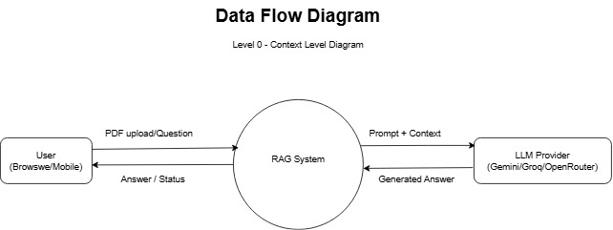

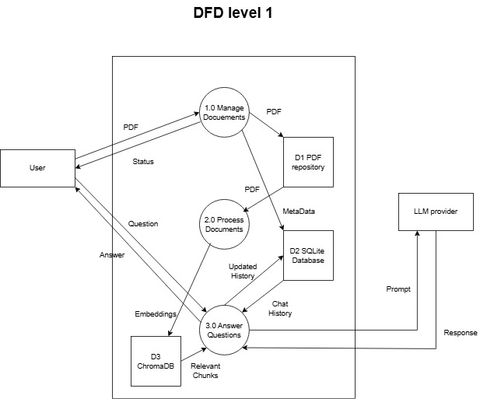

11. Challenges and Solutions
Several challenges were encountered during development.
Maintaining retrieval accuracy required balancing retrieval precision and contextual completeness. This challenge was addressed through the implementation of hierarchical parent-child chunking.
Handling conversational follow-up questions required preserving user context. This was solved through conversation memory and history-aware query rewriting.
Duplicate document uploads presented storage and indexing challenges. SHA-256 content hashing was introduced to accurately identify duplicate files regardless of filename changes.
Finally, maintaining persistent vector data across deployments required integrating Railway persistent volumes to prevent data loss.

12. Future Enhancements
Several improvements can be incorporated in future versions of Study Buddy:
- User authentication and personalized document libraries
- Streaming responses for real-time answer generation
- PDF highlighting and source navigation
- Batch document uploads
- Exportable study guides
- Advanced embedding models for specialized domains

13. Conclusion
Study Buddy demonstrates the successful implementation of a Retrieval-Augmented Generation system for document-based learning. By combining React, FastAPI, SQLite, ChromaDB, ONNX-based embeddings, and modern language models, the system transforms static PDF documents into an interactive question-answering platform.
Through semantic search, multi-query retrieval, conversational memory, and source-grounded answer generation, Study Buddy provides an efficient and accurate method for extracting information from large collections of documents. The project highlights the practical application of modern AI technologies in educational and research environments while providing a strong foundation for future enhancements.

