Installed Dependencies:

* Express
* Express-validator
* Config
* Bcrybt //update: bcryptjs is needed so I installed it using npm.
* Request
* Jsonwebtoken
* Gravatar
* Mongoose

Also Installed:

* Nodemon (I already have it installed globally but I think I need to install it with –save)
* Concurrently

After completing the back end, it’s time to jump to the front end and creating a react app:

npx create-react-app client

npx used to run commands like the one above without having to install them globally on our machine

In the client folder install the following:

* axios
* react-router-dom
* redux
* react-redux
* redux-thunk
* redux-devtools-extension
* Moment
* react-moment

Inside the client folder, remove the git repository and the git ignore folder (the readme file as well if you like)

Cd into the client and run the command rm-rf .git

Then inside the client, package.json file, add the following:

"proxy":"http://localhost:5000"

Before the end of the file

Get rid of the following files:

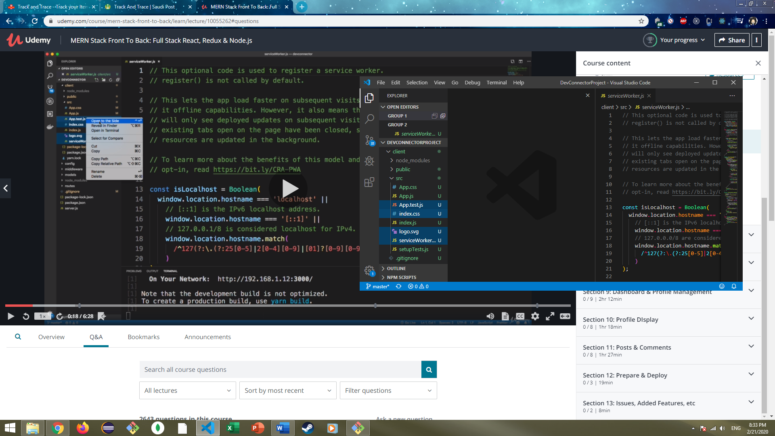

Then remove any references of those files from index.js,app.js

Edit app.js to an arrow function instead of the default one , and use fragment

const App=() =>(

<Fragment>

  <h1>App</h1>

</Fragment>

)

To add images to the project add them on the path Client>src>create a folder for ‘images’

Go to <https://fontawesome.com/> and grab the link provided after clicking on ‘Start for free’