# Week 4 Weekly report- team Up+

Things done this week:

* final version of team website, final version of flyer, poster, and logo
* submit the updated team description and logo onto ETC portal
* preparation for the 1/4 talk and presentation
* many deep brainstormings on the content of the experience, and later decided on making it with the journey look-like
* the potential platform will be on browser, however we could develop different versions for different platforms
* team pictures!!!
* 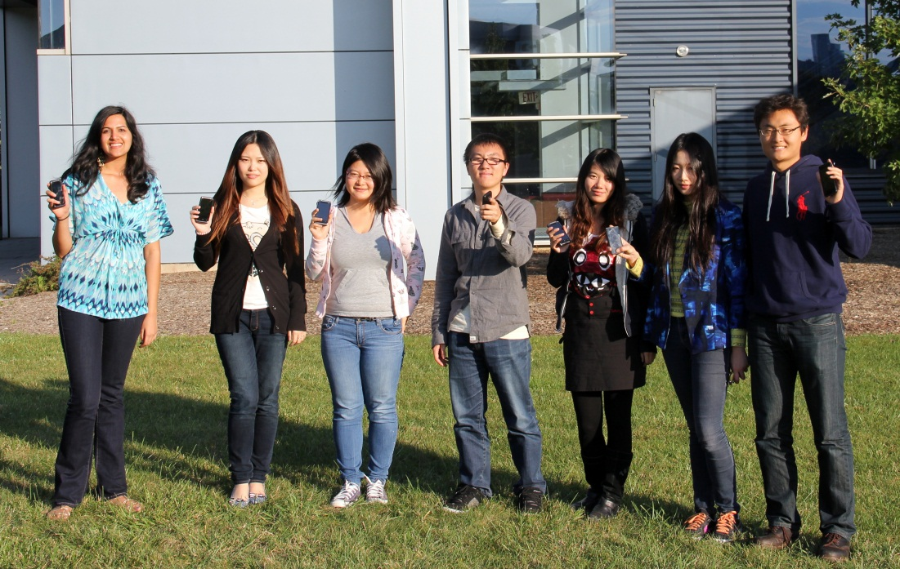

Plan for next week:

* got feedbacks from 1/4 and tweak the current idea
* discuss on what is good and bad parts about team work and communication so far
* separate the work into small teams
* make one or two fast prototypes

Challenge:

* how to make the experience more interactive, fun, informative and attractive