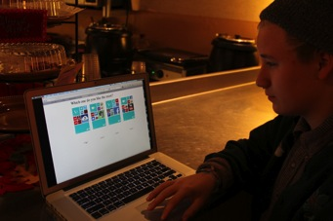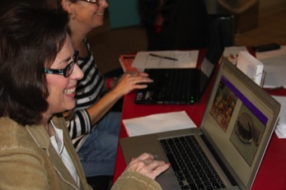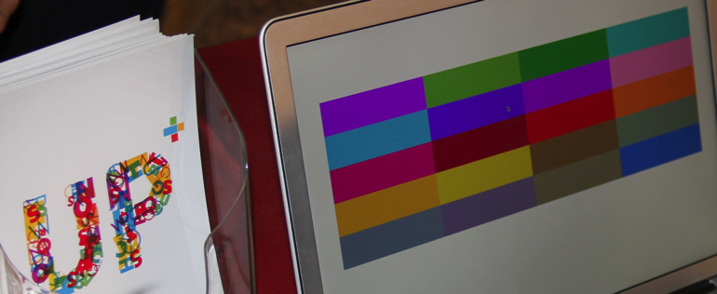

**Successful playtests and several updates on the pictures and the final start screen**

Week11 weekly-UP+

Things done this week:

New set of pictures, new avatar figure, lock screen,

Playtests in (Crazy Mocha, 61C café, te Café , ETC community group and Carnegie Science Center), totally more than 90+ people took our test and the result are stored in the data base,

The layout design of the final start and how to tweak the start screen,

When dealing with the game apps, we plan to display apps for people between the ages of 15 to 30, and based on the gender there will be different game apps

2012.11.05~2012.11.09

Tweak part code finished

A polished UI both journey and start screen part

Sound

Preparation for soft, 3-minute video intro, media archive, documentation

# **Future plan**

Our play test version link:

<http://www.upplusplaytest.azurewebsites.net>

It is being updated frequently.