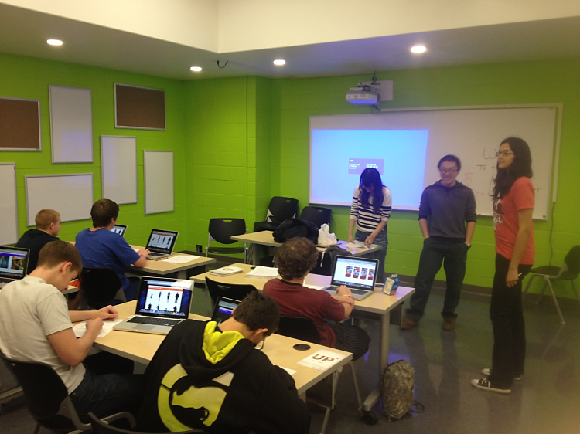

Week 12 newsletter

2012.11.12~16

Up+

UP+

Plan for next week

We have another playtest on Monday. Based on the data we have in the database, our current guessing rate is 40%(1 out 4).

From the playtest result, we found out that the people have a great favor on game apps. Now we have app for all use who is between the age range of 15~30.

Live tile animation function and lock screen

New front end with animation and compatible with all major browsers

The medium and large icons are extremely important for the users feeling of the start screen

<http://www.etc.cmu.edu/projects/up-plus/>

## Playtest and new strategy on the algorithm

Final push on the current version (add all parts together)

Playtest by sending out URL link

Documentation, archive, video

Team website

[Street Address]  
[City], [State][Postal Code]

[Web Address]

Lorem Ipsum