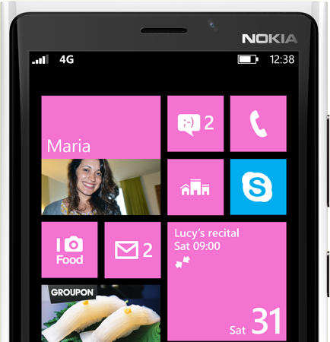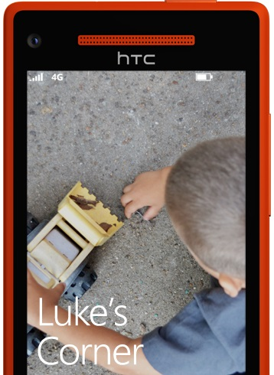

Up+ newsletter#13

11/19/2012~11/24/2012

<http://www.etc.cmu.edu/projects/up-plus/>

Things done

The text description of the app, Animation in IE, hover effect, lockscreen and kid’s corner, News pictures for lock screen, the kid’s corner(picture needed though), progress bar, combined the front end and back end together, changed the way to make dummy screens

Things to do

Video and soft opening preparation

Happy Thanksgiving ☺

2 weeks to go before finals. Let’s go!