Arabic Fake News Detection Using AraBERT Fine-Tuning
Yarmouk University , Faculty of IT , CIS Department
Course : CIS492 _ Rami Mohawesh
- Team member

Sarah Fuad AL_Hawamdeh (2022902058)
Heba Mohammad AL_Rashdan (2022903087)
Kholoud Mohammad AL_shorman (2022902039)
Abstract
This paper presents a deep Learning approach for detecting Arabic Fake News using fine-Tuning AraBERT model. We use Arabic Fake News Dataset (AFND) from Kaggle which contain 606,912 articles labeled as Credible – Not Credible – Undecided, since many article was labeled as ‘Undecided’, We decided to filter those out and focus on the 374,543 articles, in addition, we took a sample of 50,000 (40,000 for training / 10,000 for testing).
We also implemented statistical machine learning baseline model using TF-IDF and Logistic Regression for comparison. The results showed that the AraBERT model achieved an accuracy of 85.91% compared to 75.05% for the TF-IDF model with logistic regression (about 10% better than baseline), clearly indicating the superiority of deep learning over traditional statistical methods in the task of detecting fake news in Arabic.
Deep learning excels because it understands contextual meaning and the connections between words, unlike traditional methods that rely only on statistics and word frequency.

I. Introduction
Due to the massive spread of information on social media platform and Arabic news websites, it has become very difficult to distinguish between real (credible) and fake (Incredible) news, and this poses a great risk to the credibility of information and the guidance of public opinion. The Arabic language specifically faces special challenges in natural language processing (NLP) due to its linguistic complexity and the diversity of its dialects.
Traditional machine learning approach such as logistic regression with the TF-IDF technique have been used for classifying Arabic texts, but the fact is that these methods treat words as separate units and cannot understand the context of speech and the relationships between sentences. On the other hand, the emergence of large transformer-based models, such as AraBERT (Arabic Bidirectional Encoder Representation from transformers), has made a real difference; they have proven their ability to understand languages and handle complex natural language processing tasks much more intelligently than the old methods.

II. Dataset description
In this project, we used a dataset (AFND) available on Kaggle, which was collected from 134 different Arab news sources. The data was distributed into three categories:
- Credible 207,310
- Not Credible 167,233
- Undecided 232,369
For training purpose, we decided to exclude the 'unspecified' category, as the number of articles we dealt with became 374,543 articles. We converted the classifications to numerical values (0 for Credible and 1 for Not Credible) to facilitate the training process. We selected a random sample of 50,000 articles to train and test the model.

III. Code project explanation
- we use the colab for this project
  - Setting up access keys (Kaggle API and username).
  - Downloading the AFND Dataset
  - Unzipping the Dataset

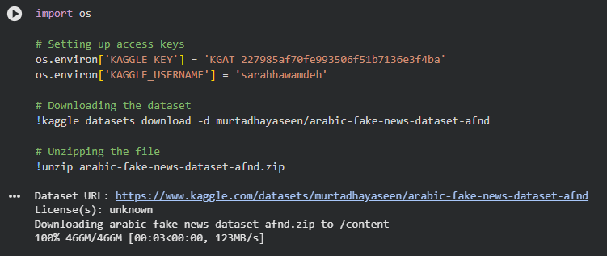

- Data loading and Integration
  - Loading and merging JSON files
- Read the individual scraped_articles.json files using glob library, and combine them into one DataFrame
  - Mapping news article to label
- Link each article to the appropriate credibility label (Credible – Not Credible – Undecided) by matching the source_id from the articles with the master sources.json file.
  - Data cleaning
- Create a final integrsted dataset (df_final)
- Ensuring the data is consistent and ready for the preprocessing stage

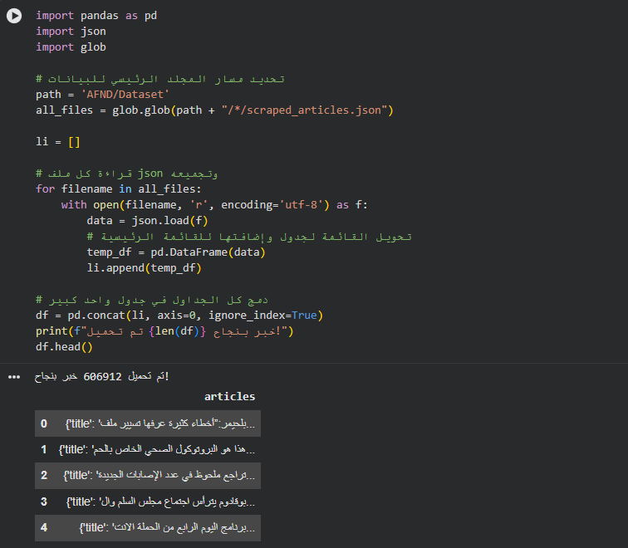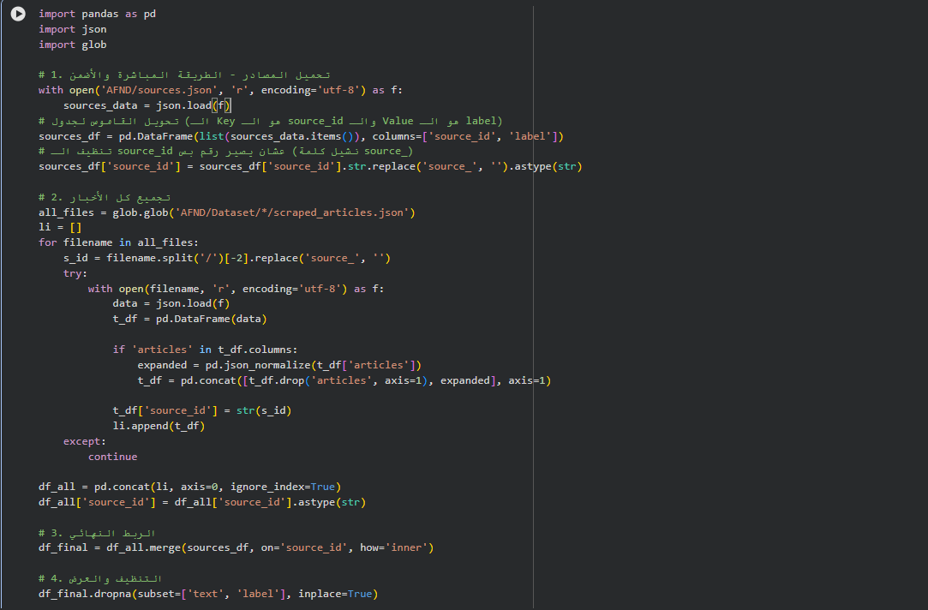

- Exploratory Data Analysis (EDA)
  - Class distribution visualization
- To analyze the balance of the dataset
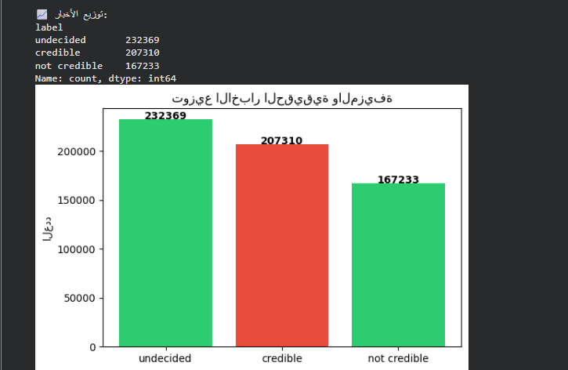
  - Text length analysis
- To calculate and visualize the word count for each article
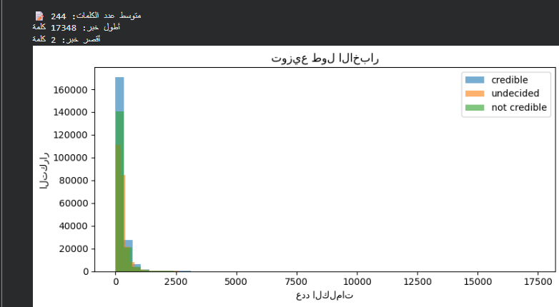
- Data preprocessing
  - Define Cleaning function called clean_arabic_text using the re library (Regular Expression)
  - Cleaning steps:
    - Removing URLs
    - Removing Punctuation and Symbols
    - Removing numbers
    - Normalizing whitespaces
  - Took a random sample of 50,000 articles using
(df_training.sample) .This ensure the training process is fast
  - Apply the function to the entire sample to create clean_text column
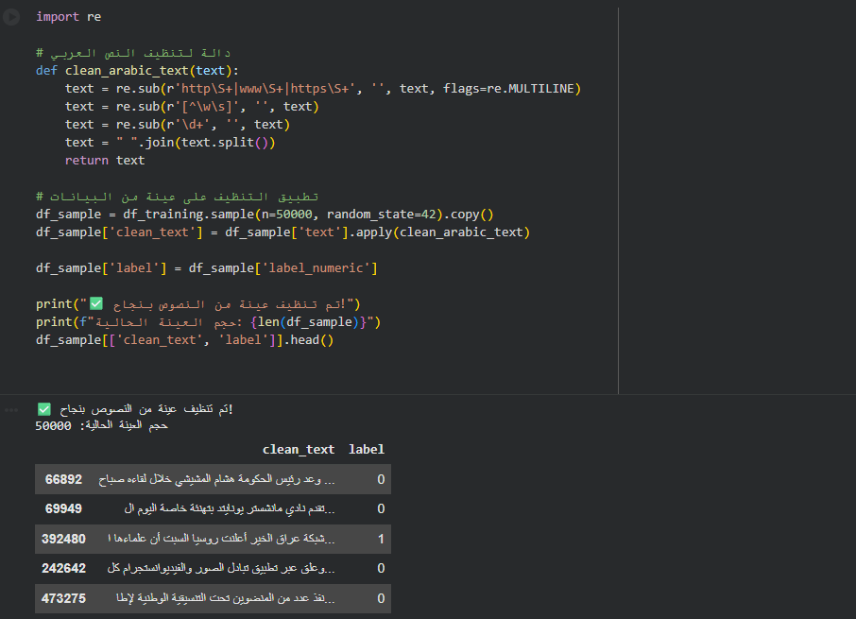
Not:
Now we will first implement a Statistical Machine learning model (Baseline) And then compare it with a Deep Learning model (AraBERT).
- Building the Baseline Model (statistical ml)
  - Divide the dataset into two part 80% for training the model and 20% for testing
  - Text vectorization using TF-IDF
- Purpose: To convert raw Arabic text into vectors based on word frequency
  - Train a Logistic Regression (statistical ML)
  - Evaluate Model and Model metrics
- Purpose: To measure how well the model identifies fake news by calculating Accuracy (75.05%) and F1_score(74.89%) and to see precisin and recall for both credible and not credible articles.
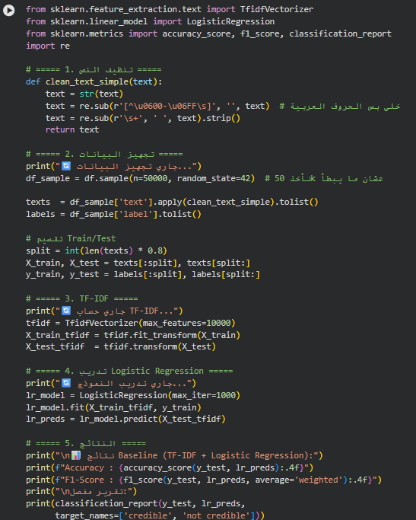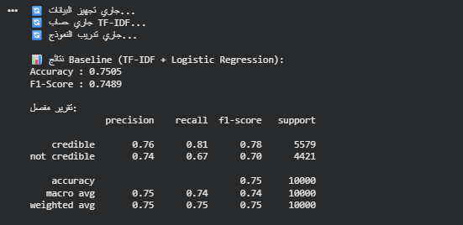
- AraBERT Initialization
  - import the Hugging Face transformers and datasets libraries
  - loading the pre-trained AraBERT Tookenizer
- The tokenizer disassembles Arabic words into sub word (tokens)
  - Create tokenize_function to handle the length of our text uniformly (We set a limit of 128 tokens)
- if an article is longer than that the function cuts it down (truncation)
- If it is shorter , it fills up the remsining space with empty tokens (padding)
The purpose: To makes sure all texts are exactly the same size
  - Text preprocessing
- 50,000 articles, clean them using clean_arabic_text function
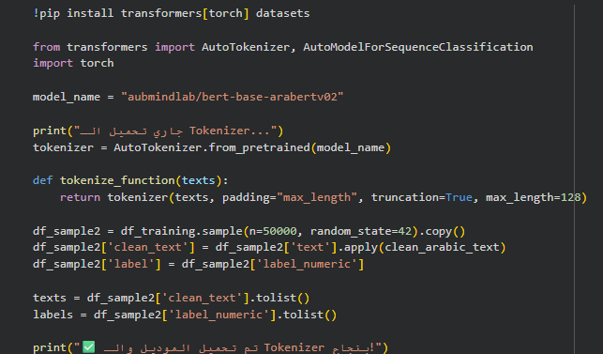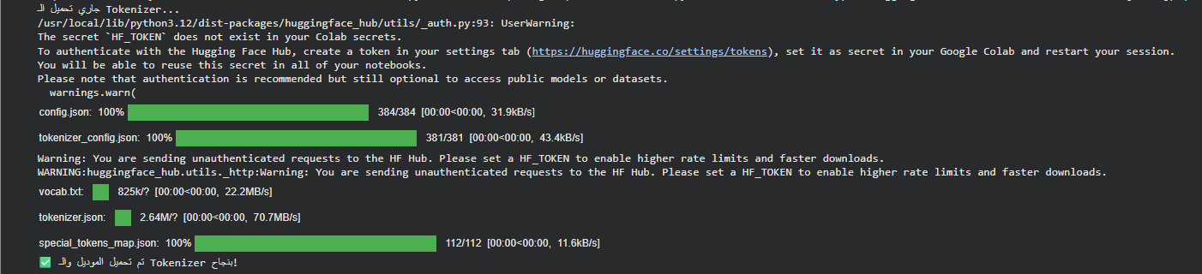

- Dataset preparation and Fine-Tuning setup
  - convert DataFrame to Hubbing Face Dataset
- To efficiently handle memory during training.
  - Executing Batched Tokenization dataset.map
- This process tranforms the raw Arabic words into numerical id, attention masks and sub-words (The GPU understands it immediately).
- The Tokenizer does not go through 50,000 news articles one by one because that takes too much time. Rather, it takes them in 'batches' and finishes them quickly.
  - Dataset splitting
- 80% for training (40,000)
- 20% for testing (10,000)
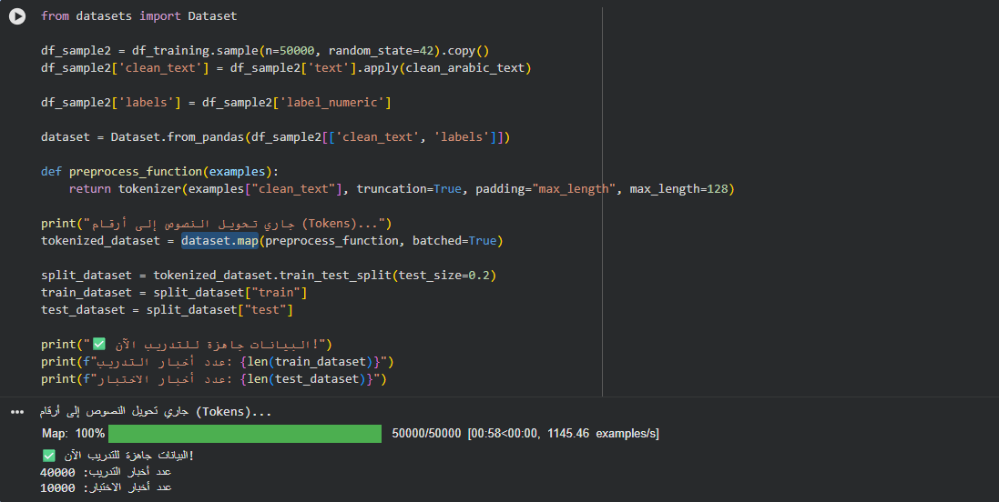

- AraBERT Model configuration and Fine_Tuning
  - Initializing the AraBERT Model
- We loaded the pre-trained AraBERT model and configured it for a binary classification
- (Num_lable=2) means the output exactly two categories: credible or not credible
  - Create the compute_metrics function to calculate the model performance
  - Define set of rules for training:
- Train for 2 epochs which means the model goes through the dataset twice.
- Grouped the data into batches of 16 to keep the memory steady
  - Set up the Hugging Face (Trainer) to combine the:
- Model
- Training configurations
- Tokenized datasets
- Evaluation metric
  - Running (trainer.train()) officially start the fin-tuning process on the GPU
Hyperparameter | Value
Number of epochs | 2
Train batch size | 16
eval batch size | 16
Warmup steps | 500
Weight Decay | 0.01
Max token length | 128
Train/Test split | 80% | 20%
Train sample | 40,000
Test sample | 10,000

Table I : AraBERT Training Configuration
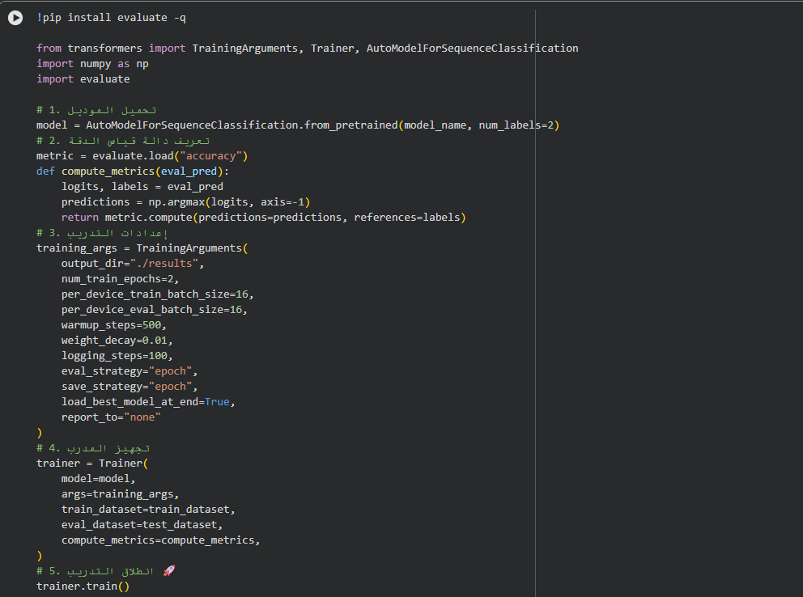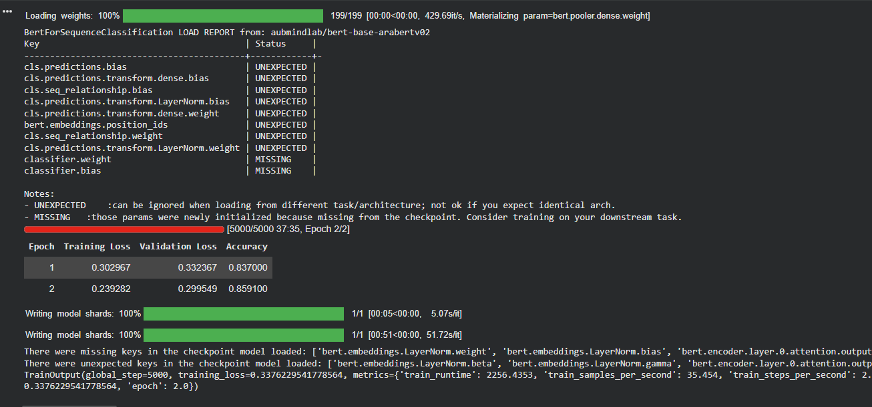

- Model evaluation and Comparative analysis

- We generated a Confusion Matrix using seaborn and matplotlib, to see where the model succeeded and where it made mistake
- And we made a comparison between statistical ML (TF-IDF and logistic regression ) and Deep learning (AraBERT).
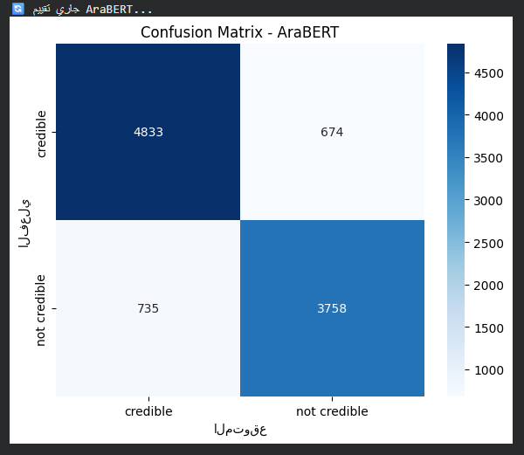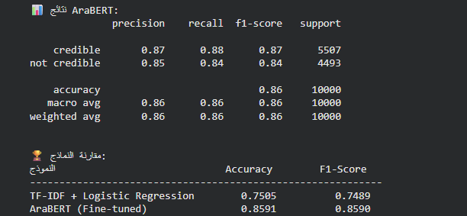

III. Comparison between statistical ML and Deep learning
Metric | TF-IDF + LR | AraBERT
Accuracy | 75.05% | 85.91%
Weighted F1-score | 74.89% | 85.90%
Precision(credible) | 76% | 87%
Recall(credible) | 81% | 88%
Precision(Not credible) | 74% | 85%
Recall(Not credible) | 67% | 84%

Table 2: Comparison between statistical ML and Deep learning

- Deep learning is better than statistical ML

