Statistical Inference Course Project Part 1

Sarah Fogel

Thursday, December 18, 2014

Instructions: The exponential distribution can be simulated in R with rexp(n, lambda) where lambda is the rate parameter. The mean of exponential distribution is 1/lambda and the standard deviation is also also 1/lambda. Set lambda = 0.2 for all of the simulations. In this simulation, you will investigate the distribution of averages of 40 exponential(0.2)s. Note that you will need to do a thousand or so simulated averages of 40 exponentials.

The following code was used to simulate the means of 1000 samples of 40 random exponential variates.

set.seed(59) #Make this reproducible by setting the starting point  
 N<-1000 #Set number of simulations  
 means<-c() #Initialize a vector to hold the means of the samples of 40 variates  
 for (i in 1:N) {  
 p<-rexp(40, rate=.2)  
 means[i]<-mean(p)  
 }

### Question 1: Show where the distribution is centered at and compare it to the theoretical center of the distribution.

The theoretical center of the distribution of sample means is the same as the center of the distribution that the sample comes from, so it's also 1/lambda. In this case that is 5.

The plot below shows a histogram of the means calculated above, together with the mean (center) of the sample distribution as well as the theoretical mean of the sample distribution. (The code for all plots is included at the end)

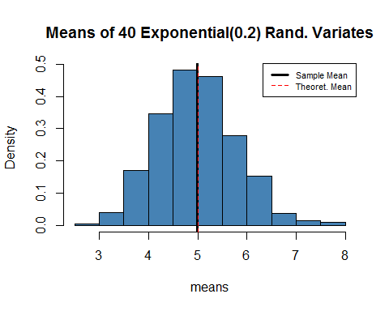

These values are, by visual inspection, quite similar

### Question 2: Show how variable it is and compare it to the theoretical variance of the distribution.

The theoretical variance of the distribution of sample means is sigma^2/n, where sigma^2is the variance of the distribution where the sample came from and n is the number of observations in each sample. In this case that is 1/(n*lambda^2). Therefore, the theoretical standard deviation of the distribution of sample means is 1/(sqrt(40)*.2)

The plot below shows a comparison between the actual and theoretical values of the mean +/- one standard deviation

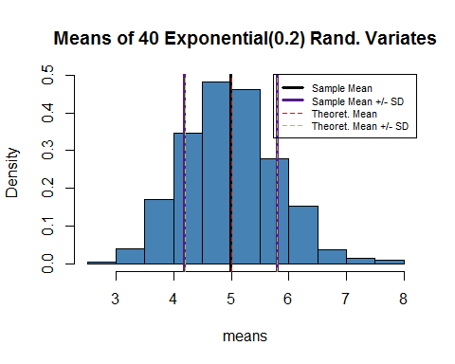

These values are, by visual inspection, quite similar

### Question 3: Show that the distribution is approximately normal.

I will use two comparisons to show that the distribution is approximately normal. First, a histogram of the mean values overlaid with both the Kernal Density Estimate and a Normal Density with mean and standard deviation equal to the mean and standard deviation of the distribution, shown below.

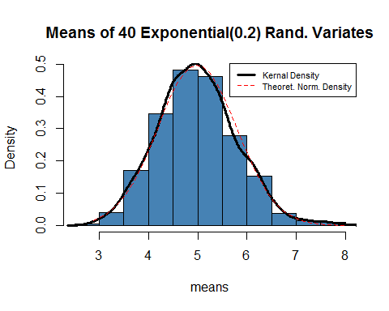

The second comparison is using a normal q-q plot. This graphs the quantiles of a normal distribution against the quantiles of the distribution of means.

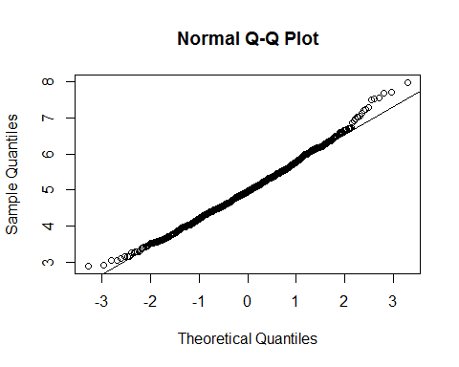

By visual inspection, both of these plots indicate a great deal of similarity between the normal distribution and the distribution of means

### Appendix

Code for Plot 1

theoretical.mean<-5  
  
 hist(means, col="steelblue", main="Sample Means of 40 Exponential(0.2) Random Variates", prob=T)  
 abline(v=mean(means), lty=1, lwd=3)  
 abline(v=theoretical.mean, lty=2, col="red")  
 legend(legend=c("Sample Mean", "Theoretical Mean"), x="topright", lty=c(1,2),  
 lwd=c(3,1), col=c("black", "red"))

Code for Plot 2

theoretical.sd<-1/(sqrt(40)*.2)  
  
 hist(means, col="steelblue", main="Sample Means of 40 Exponential(0.2) Random Variates", prob=T)  
 abline(v=mean(means), lty=1, lwd=3)  
 abline(v=theoretical.mean, lty=2, col="red")  
 abline(v=mean(means)+sd(means), lty=1, lwd=3, col="purple4")  
 abline(v=mean(means)-sd(means), lty=1, lwd=3, col="purple4")  
 abline(v=theoretical.mean+theoretical.sd, lty=2, col="yellowgreen")  
 abline(v=theoretical.mean-theoretical.sd, lty=2, col="yellowgreen")  
  
 legend(legend=c("Sample Mean", "Sample Mean +/- SD" ,"Theoretical Mean",   
 "Theoretical Mean +/- SD"),   
 x="topright", lty=c(1,1,2,2), lwd=c(3,3,1,1), col=c("black","purple4", "red", "yellowgreen"))

Code for Plot 3

#Create normal density  
 xfit<-seq(min(means), max(means), length = 40)  
 yfit<-dnorm(xfit, mean=mean(means), sd=sd(means))  
  
 hist(means, col="steelblue", main="Sample Means of 40 Exponential(0.2) Random Variates", prob=T)  
 lines(density(means), lwd=3)  
 lines(xfit, yfit, lty=2, col="red")  
 legend(legend=c("Kernal Density Estimate", "Theoretical Normal Density"),   
 x="topright", lty=c(1,2), lwd=c(3,1), col=c("black", "red"))

Code for Plot 4

qqnorm(means)  
 qqline(means)