T24 - Task 2

# Project: Holiday Cost Calculator

## Description

The project designed for budget planning for a holiday, which takes into consideration of the essential costs of accommodation, flights and car rental.

## Table of Contents

- Installation

- Usage

- Credits

## Installation

- Download the 'holiday.py' locally

- Run code accordingly.

- As prompted, input the required destination and number of nights staying.

- Final cost will be automatically calculated as output.

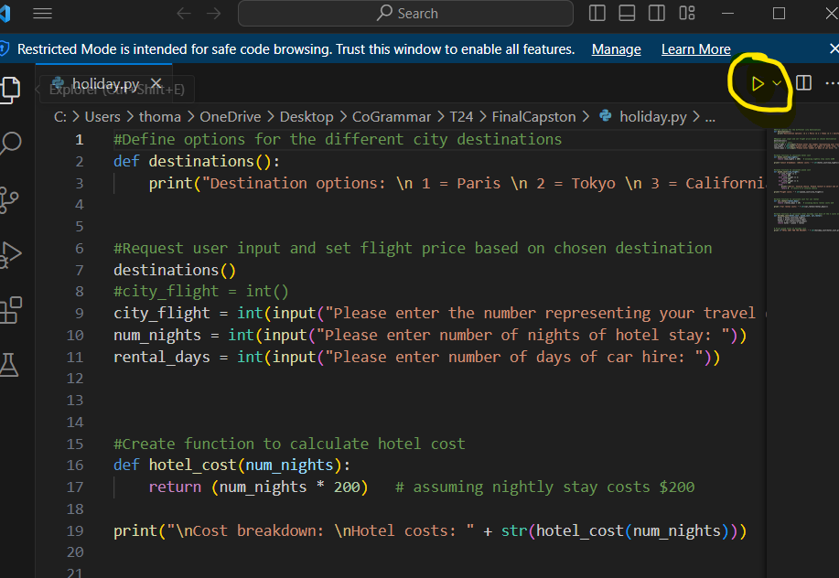

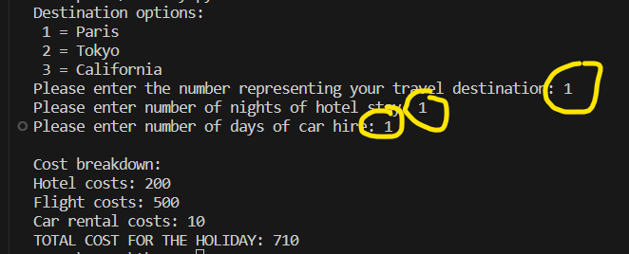

## Usage

Project covers key cities across the world with pre-set costs for each parameter. Coverage can be extended as per needed.

## Credit

Author - Sarah H.

Link - https://github.com/Sarahhyho/FinalCapston.git