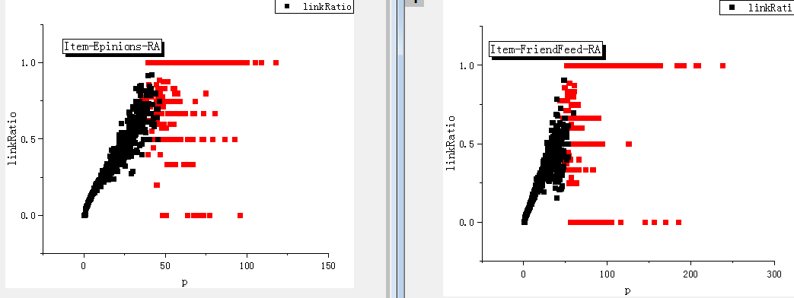

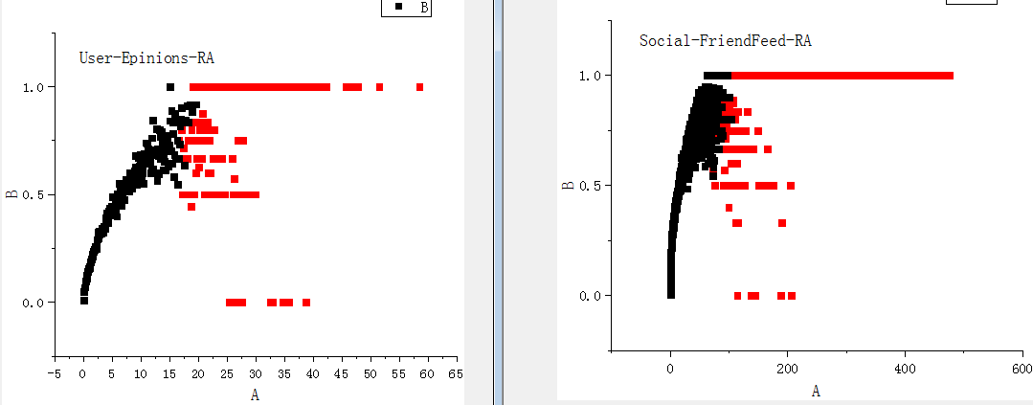

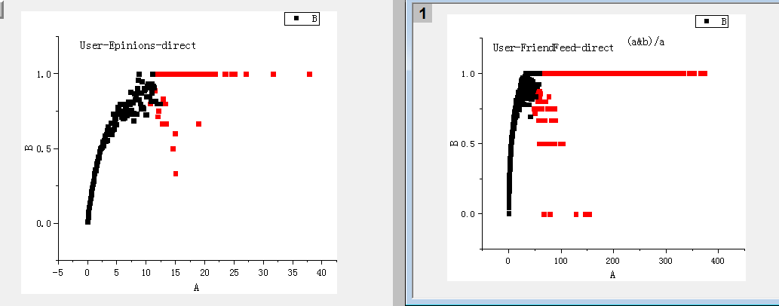

**User-item: 邻域增强相似性与连接概率link ratio的corrlation: similarity,小数点后保留1位**

|  |  |  |  |  |  |  |
| --- | --- | --- | --- | --- | --- | --- |
|  | Salton | Jaccard | (a&b)/a | RA |  |  |
| Epinions | 0.982 | 0.973 | 0.957 | 0.941 |  |  |
| FriendFeed | 0.931 | 0.914 | 0.891 | 0.888 |  |  |

**User-user: 邻域增强相似性与连接概率link ratio的corrlation: similarity,小数点后保留1位。**

|  |  |  |  |  |  |  |
| --- | --- | --- | --- | --- | --- | --- |
|  | Salton | Jaccard | (a&b)/a | RA |  |  |
| Epinions | 0.874 | 0.881 | 0.888 | 0.929 |  |  |
| FriendFeed | 0.856 | 0.86 | 0.832 | 0.869 |  |  |

