Module 1 – Project Review

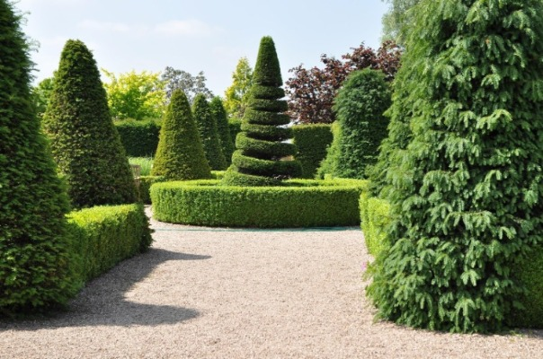

3D shapes are commonly used in computer graphics to create realistic images and simulations. Open Graphics Library (OpenGL) is a powerful tool used to create 3D shapes and images. This paper will explore how to re-create the selected 2D image of evergreen trees using 3D shapes in OpenGL.

The image of evergreen trees can be re-created using various 3D shapes. Three major objects that can be translated into simple shapes are trees, bushes, the ground, and the sky. We can use a cylinder shape to create the tree trunks and cones and cubes to create the foliage of the trees. A plane can be used to create the ground, a sphere can be used to create the sky and we can use Torus to create circular bushes. By using different shapes, we can create a more realistic 3D representation of the image.

One object that may require multiple shapes to re-create is the tree foliage. To accurately represent the branches and needles of the tree, we may need to use multiple cone shapes of different sizes and orientations. Adding a pyramid shape can help create a sharp texture and the cube as well.

When re-creating the image in 3D, there may be areas where simplification is necessary. For example, we may omit certain small details in the trees or combine some objects into a single shape to reduce complexity. Additionally, we may need to simplify the texture of the foliage to create a more efficient 3D model. The ground can be simplified by not using a plane to create less texture in the 3D model.

In conclusion, 3D shapes can be used to re-create 2D images in OpenGL. By using a combination of shapes, we can create a more realistic representation of the image. When simplifying the image, we should consider which objects can be combined or omitted to create a more efficient 3D model. We can create beautiful 3D models and images using OpenGL with practice and experimentation.