**Module Two Milestone**

In this paper, I will discuss the process of recreating a 2D image as a 3D scene. The objective is to select a suitable image, determine the objects be created in 3D, and choose the appropriate primitive shapes to represent these objects. By analyzing different perspectives and employing various primitive shapes, we aim to create an exciting and achievable 3D scene.

For this project, we will choose four objects to include in our scene. The selection will consider factors such as visual interest, diversity, and the potential to utilize different primitive shapes effectively.

Object 1: Coffee Mug

Reason: A coffee mug offers a simple yet recognizable object with interesting details such as handles and a curved body. Its inclusion provides an opportunity to explore the use of a curved primitive shape.

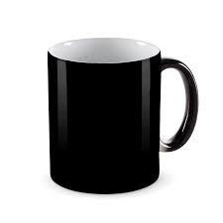

Object 2: Bookshelf

Reason: A bookshelf offers a complex structure with multiple shelves and varying shapes. It allows us to incorporate both cuboid and planar primitive shapes to represent the different components.

Object 3: Soccer Ball

Reason: A soccer ball provides a spherical object with a distinctive pattern. It can be represented using a sphere primitive shape, and its inclusion adds visual variety to the scene.

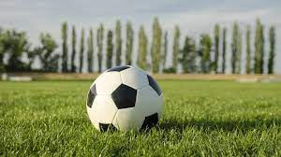

Object 4: Vase

Reason: A vase presents a unique object with a combination of primitive shapes. Its body can be represented using a cylinder primitive shape, while its upper portion can be created using a torus primitive shape. This combination adds complexity and visual appeal to the scene.

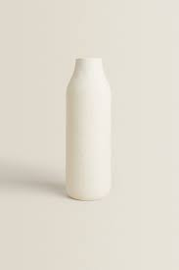

Primitive Shapes for Object Representation:

Now that the objects are selected, let’s discuss the primitive shapes that will be used to create their 3D representations. Aiming to choose shapes that closely resemble the objects' forms and ensure the achievability of the overall project.

Object 1: Coffee Mug

Primitive Shapes: Cylinder, Plane

Explanation: The body of the coffee mug will be created using a cylinder primitive shape due to its cylindrical form. The handle can be represented by combining a cylindrical shape with a smaller cylinder subtracted from it. The plane will be used as the base to ground the coffee mug.

Object 2: Bookshelf

Primitive Shapes: Cube, Plane

Explanation: The bookshelf will consist of multiple cuboid primitive shapes. Each shelf will be represented using a cuboid, and additional cuboids will create the sides and back of the bookshelf. The individual books can be represented by small cuboids or planes placed on the shelves. A plane will serve as the floor or base of the scene.

Object 3: Soccer Ball

Primitive Shape: Sphere

Explanation: The soccer ball will be represented using a sphere primitive shape, capturing its spherical form. The pattern on the soccer ball can be added using textures or decals in the 3D software.

Object 4: Vase

Primitive Shapes: Cylinder, Torus

Explanation: The body of the vase will be represented using a cylinder primitive shape due to its cylindrical form. The upper portion, which flares out, can be created using a torus primitive shape. This combination will accurately capture the overall shape of the vase.

Conclusion:

Recreating a 2D image as a 3D scene involves a careful selection of objects, consideration of different perspectives, and effective utilization of primitive shapes. In this paper, The four objects chosen, include a coffee mug, a bookshelf, a soccer ball, and a vase. We discussed the rationale behind their selection and identified the appropriate primitive shapes for their representation. By incorporating various shapes and exploring different perspectives, we aim to create an exciting and achievable 3D scene that accurately reflects the chosen 2D image.