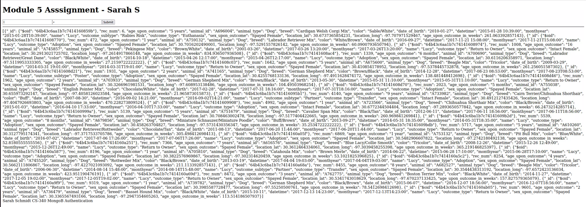Code execution with username and password

Judsaf

Jupyter Code

