1. Using the mongoimport tool, **create the database** “companies” by loading the documents found in the “companies.json” file into the “research” collection. This file is located in the “/usr/local/datasets/” directory in Apporto. Verify your load by issuing the following queries:
   1. db.research.find({"name" : "AdventNet"})
   2. db.research.find({"founded_year" : 1996},{"name" : 1}).limit(10)

Provide **screenshots** of your statements and the results as evidence.

Screenshot of importing companies db

* 1. A screenshot of a computer

     Description automatically generateddb.research.find({“name” : “AdventNet”})

b. db.research.find({"founded_year" : 1996},{"name" : 1}).limit(10)

1. Perform the following tasks **using MongoDB queries**:
   1. List only the first 20 names of companies founded after the year 2010, ordered alphabetically.

* 1. List only the first 20 names of companies with offices in either California or Texas, ordered by the number of employees and sorted largest to smallest.

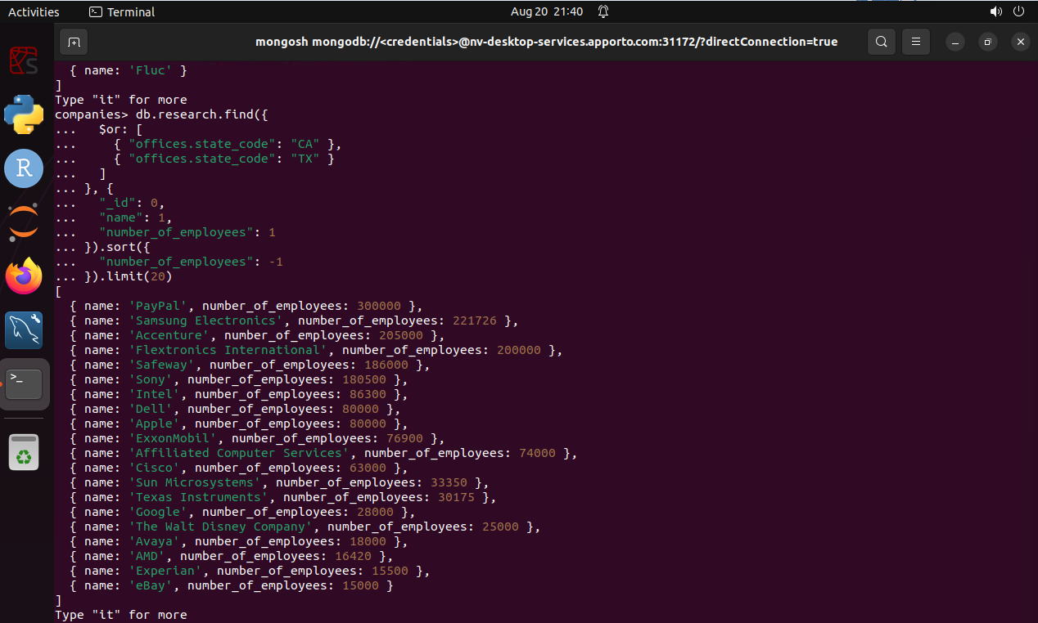

1. 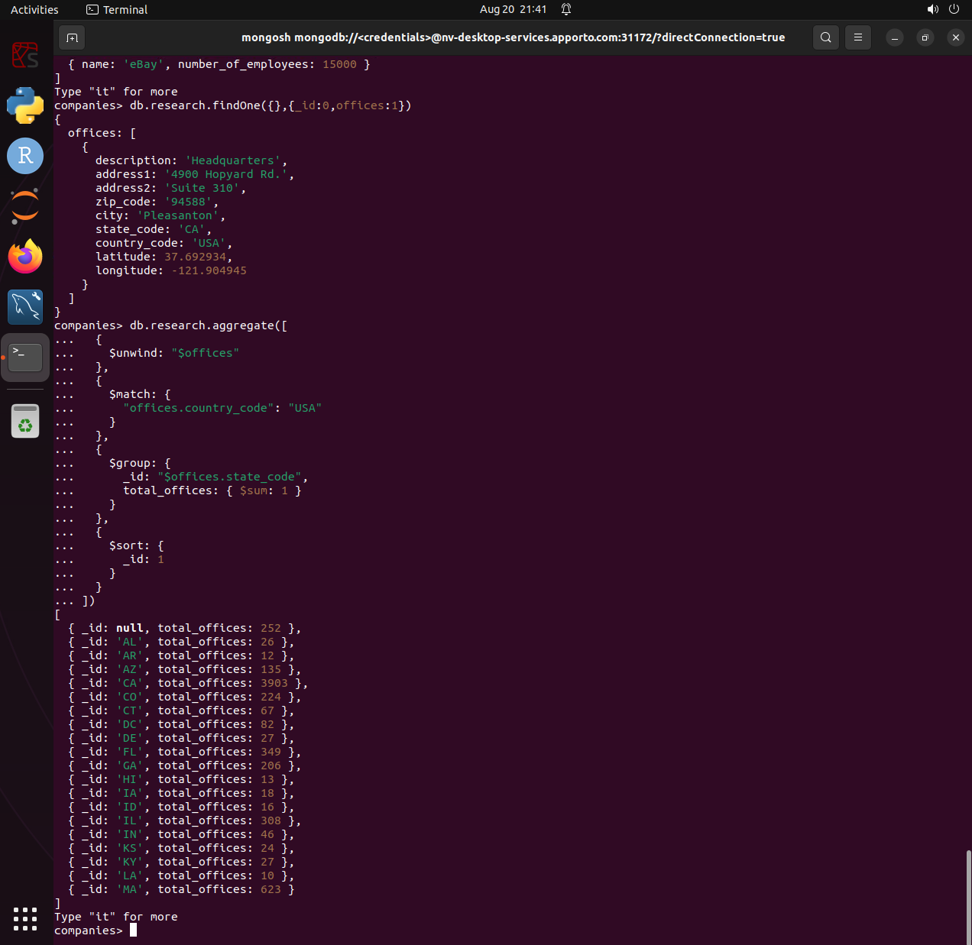**Design and implement a MongoDB aggregation pipeline** to show the total number of offices by state for all companies that have offices in the United States. Be sure that you account for the fact that some companies have offices in several states. Explain your aggregation pipeline.  
   Provide **screenshots** of your statements and the results as evidence.