Automated Gastrointestinal Bleed Detection Using WCEBleedGen Deep Learning Model

1st Saral Singhal
VIT Bhopal University
Bhopal, India Saral.23bhi10123@vitbhopal.ac.in
2nd Aditi Shindadkar VIT Bhopal University Bhopal, India
shindadkar.23bhi10119@vitbhopal.ac.in
3rd Manikandan Jayapal VIT Bhopal University Bhopal, India manikandan.j@vitbhopal.ac.in

Abstract—Gastrointestinal bleeding is a serious medical WCE- BleedGen is a deep learning model that automatically detects and localizes bleeding in Wireless Capsule Endoscopy (WCE) images. It is trained on a large dataset of annotated WCE images, en- abling it to identify subtle visual patterns associated with bleeding with high precision and recall. WCEBleedGen provides a non- invasive, accurate, and rapid way to assist gastroenterologists in early diagnosis and improve patient outcomes. This research highlights the potential of artificial intelligence in enhancing medical image analysis and supporting clinical decision-making.

Keywords:
Wireless Capsule Endoscopy (WCE), Gastrointestinal Bleeding Detection, Deep Learning, Convolutional Neural Network (CNN), Medical Image Analysis, Automated Diag- nosis, GI Hemorrhage, Image Segmentation, Computer-Aided Detection (CAD), Kvasir-Capsule Dataset

Introduction
Gastrointestinal (GI) bleeding is a significant medical con- dition that ranges from mild anemia to life-threatening hem- orrhages. Detecting it early and accurately is crucial for effective treatment and good patient outcomes. Traditionally, doctors diagnose GI bleeding with procedures like endoscopy or colonoscopy, which allow them to see the digestive tract directly. While effective, these procedures are invasive [1], can be uncomfortable, and require significant resources, including trained staff and specialized equipment. Also, some parts of the GI tract, like the small intestine, are hard to reach with conventional methods. These challenges have led to the development of alternative, non-invasive diagnostic tools that can provide a comprehensive view of the entire GI system [2]. The Rise of Wireless Capsule Endoscopy Wireless Capsule Endoscopy (WCE) has become a breakthrough technology in modern gastroenterology. First introduced in the early 2000s, WCE allows a patient to swallow a small capsule equipped with a miniature camera, light source, and wireless transmitter. As the capsule travels through the digestive tract, it captures thousands of images and transmits them to a recorder worn by the patient. The key advantage of WCE lies in its ability to vi- sualize the entire small intestine, which traditional endoscopy techniques often fail to reach. It is minimally invasive, gener- ally safe, and more comfortable for patients. Over the years, WCE has proven invaluable for detecting bleeding, polyps,
ulcers, tumors, and other abnormalities, improving diagnostic accuracy and reducing the need for invasive procedures [3].
The Challenge of Data Overload Despite its advantages, WCE presents a major challenge: the enormous number of images generated during each examination. A single WCE test can produce tens of thousands of images over several hours, placing a heavy burden on clinicians who must man- ually review each frame to identify signs of bleeding or other abnormalities. This process is time-consuming, mentally exhausting, and prone to human error, potentially leading to delayed or missed diagnoses. Moreover, early-stage bleeding signs are often subtle and can be overlooked, especially when image quality varies due to lighting, motion artifacts, or partial obstructions. These challenges highlight the urgent need for automated, accurate, and efficient methods to assist clinicians in analyzing WCE images [4].
The Role of Artificial Intelligence and Deep Learning The application of artificial intelligence (AI) and deep learning to medical imaging has emerged as a promising solution to this problem. Deep learning models, especially convolutional neural networks (CNNs), have shown exceptional capability in identifying complex patterns in visual data. Unlike traditional image processing techniques relying on handcrafted features, CNNs can automatically learn and extract relevant features from raw images. This makes them well-suited for detecting subtle visual cues that may escape human observation. In WCE, deep learning models have demonstrated potential in detecting gastrointestinal bleeding, ulcers, polyps, and other conditions, reducing clinician workload, improving accuracy, and accelerating clinical decision-making [5].
Introducing WCEBleedGen Building on these advance- ments, this study introduces WCEBleedGen, a deep learn- ing model designed specifically for detecting and localizing gastrointestinal bleeding in WCE images. The primary goal of WCEBleedGen is to enhance diagnostic efficiency while maintaining high accuracy and reliability. Trained on a large, annotated dataset, the model learns to differentiate bleeding regions from normal tissue and other irrelevant features [6]. Unlike manual review, which is limited by fatigue and at- tention span, WCEBleedGen ensures consistent performance, making it a valuable tool for gastroenterologists. Additionally, the model can help prioritize urgent cases, enabling faster intervention for patients with active bleeding [7].

The motivation behind developing WCEBleedGen stems from several key factors. Gastrointestinal bleeding is com- mon worldwide, with causes ranging from ulcers to vas- cular malformations and cancers. Early detection is critical for preventing complications. While WCE offers unmatched visualization capabilities, the sheer volume of images creates a diagnostic bottleneck. Furthermore, integrating AI into clinical workflows aligns with the broader movement toward digital health, where computational tools complement human exper- tise. WCEBleedGen addresses these challenges by automating bleeding detection, providing a scalable and practical solution for modern healthcare [8].
Addressing Existing Challenges While previous methods for automated bleeding detection have shown promise, they face notable limitations. Traditional approaches, such as color thresholding and texture analysis, struggle with variations in lighting, image quality, and anatomy. They also require manual fine-tuning and often lack generalizability to new datasets. Even machine learning techniques relying on handcrafted features fall short in terms of sensitivity and robustness. Deep learning, particularly CNN-based methods, has emerged as the most effective approach due to its ability to learn complex features automatically. However, challenges remain, including the need for large annotated datasets, managing class imbalances, and ensuring robust performance across diverse patient populations [9].
WCEBleedGen tackles these issues through a carefully designed deep learning architecture and a rigorous train- ing pipeline. The model is trained on a large and diverse dataset covering various bleeding types, lighting conditions, and anatomical differences [10]. Data augmentation techniques improve generalization, while advanced loss functions and evaluation metrics ensure precise bleeding detection and local- ization. Performance is assessed using widely accepted metrics such as precision, recall, F1-score, and AUC-ROC, offering a thorough evaluation of model effectiveness [11].
The Impact of WCEBleedGen The impact of WCEBleed- Gen extends beyond technical accuracy. By integrating AI into diagnostic workflows, it can reduce clinician fatigue, minimize diagnostic delays, and improve healthcare efficiency [12]. For patients, this means timely detection, faster treatment decisions, and better outcomes. For healthcare systems, AI- powered image analysis optimizes resource allocation, allow- ing specialists to focus on complex cases rather than routine screening tasks. Moreover, the methods and insights from WCEBleedGen can be applied to other diagnostic domains, including colonoscopy, radiology, and pathology [13].
In conclusion, combining Wireless Capsule Endoscopy with deep learning offers a powerful advancement in gastrointesti- nal diagnostics. WCE enables comprehensive, non-invasive imaging, while models like WCEBleedGen provide automated, accurate, and efficient analysis of these images. This research demonstrates the potential of WCEBleedGen to transform clinical practice by reducing workload, improving accuracy, and enhancing patient care [14]. Beyond immediate clinical applications, this study underscores the growing role of AI in
healthcare, supporting medical professionals and paving the way for faster, more precise, and more accessible diagnostic solutions. As medicine continues to embrace digital innova- tion, tools like WCEBleedGen mark a significant step toward intelligent, patient-centered care [15].

Challenges and Future directions
The development and evaluation of the WCEBleedGen model for gastrointestinal bleeding detection in wireless cap- sule endoscopy (WCE) images represent an important step forward in computer-aided diagnosis. While the results are encouraging, moving from a research prototype to a fully reliable clinical tool presents several challenges. These stem not only from technical limitations in machine learning and deep learning models but also from clinical, data, and deploy- ment considerations. Tackling these challenges is essential for achieving widespread adoption and seamless integration into healthcare systems. This section highlights the major obstacles encountered in this study and outlines future directions to improve the model’s performance, reliability, and clinical applicability.

Dataset Limitations and Class Imbalance
A key challenge in this research was the limited size and imbalance of the dataset. In capsule endoscopy, most frames depict normal mucosa or non-critical variations such as minor tissue changes, fluid, or lighting effects, while true bleeding events appear in only a small fraction of the data. This imbalance often causes deep learning models to be biased toward the majority class, resulting in strong precision but limited recall, where rare or subtle bleeding cases may be overlooked.
Addressing this imbalance should be a priority for fu- ture work. Data augmentation techniques—such as rotation, contrast adjustments, zooming, or noise injection—can help increase the diversity of bleeding samples and improve gener- alization. More advanced methods like Generative Adversarial Networks (GANs) can also be used to create realistic synthetic bleeding images, further enriching the dataset. Additionally, collaborative data-sharing initiatives across hospitals and re- search institutions could provide large-scale, diverse datasets that better represent the range of bleeding appearances in real- world scenarios.

Image Quality Issues in WCE
Wireless capsule endoscopy inherently produces images with varying quality due to motion artifacts, lighting incon- sistencies, intestinal fluids, and obstructions such as food particles. These factors often obscure the visibility of bleeding regions or create misleading artifacts that resemble bleeding. For example, red-tinted reflections or camera blur may be falsely identified as bleeding, increasing the risk of misclassi- fication.
Improving robustness to such variability remains an im- portant future direction. Techniques such as preprocessing pipelines (e.g., denoising, contrast normalization, and edge enhancement) could improve the consistency of input images. Additionally, the integration of attention mechanisms into deep

learning models could allow the system to focus on critical regions of interest, filtering out irrelevant background noise. By highlighting specific regions with a higher likelihood of containing bleeding, the model can reduce false positives caused by image artifacts.

Limited Interpretability of Deep Learning Models
Another challenge lies in the “black-box” nature of deep learning models. While WCEBleedGen demonstrated good performance, clinicians may be reluctant to fully trust pre- dictions unless the decision-making process is interpretable. In medical applications, transparency is not just a matter of academic curiosity—it is a clinical necessity. Physicians must understand why a model flagged a particular frame as bleeding before relying on its output for patient care.
To address this, future work should emphasize the incor- poration of explainable AI (XAI) techniques. Visualization methods such as Grad-CAM (Gradient-weighted Class Acti- vation Mapping) can be used to highlight the specific image regions that influenced the model’s decision. This would allow doctors to verify whether the model is indeed focusing on rel- evant bleeding patterns rather than being misled by irrelevant features. Such interpretability mechanisms can significantly increase trust and adoption in clinical settings.
- Computational Efficiency and Real-Time Processing WCE produces thousands of images per patient, often exceeding 50,000 frames per video. Reviewing this data manually is highly time-consuming for clinicians, which is why AI support is so valuable. However, for AI tools like WCEBleedGen to be practical in clinical settings, they must operate with high computational efficiency. Processing tens of thousands of frames in near-real time is essential to reduce
diagnostic delays.
Future research must focus on optimizing models for speed and efficiency without compromising accuracy. Techniques such as model pruning, quantization, and knowledge distil- lation can reduce computational overhead, making the sys- tem deployable on standard hospital hardware. Additionally, exploring lightweight architectures such as MobileNet or Ef- ficientNet could ensure faster processing, which is particu- larly useful in resource-constrained healthcare environments. Integration into cloud-based platforms could further support scalability, enabling real-time analysis even when processing large datasets.

Generalization Across Populations and Devices
The dataset used in this study was limited not only in size but also in geographic and demographic diversity. Medical imaging datasets often suffer from bias toward specific patient groups, equipment, or acquisition settings. A model trained on one dataset may perform well in that context but fail when applied to data from a different hospital or acquired using a different capsule endoscopy device. This lack of generalization is a major barrier to clinical deployment.
Future directions should emphasize multi-institutional vali- dation of models. Collaborations across hospitals and research groups will help build larger and more diverse datasets that capture variability in populations, clinical conditions, and
imaging hardware. Moreover, techniques such as transfer learning and domain adaptation could be applied to fine-tune models on new datasets without requiring complete retraining, thereby improving adaptability to new environments.

Clinical Integration and Workflow Adoption
Even if a model performs well in research experiments, integrating it into the clinical workflow presents unique chal- lenges. Physicians are accustomed to specific diagnostic rou- tines, and introducing new AI tools requires careful alignment with these practices. Resistance to adoption may arise if the system is seen as disruptive or if it produces too many false alarms that burden clinicians instead of assisting them.
The future direction here is twofold: First, AI systems must be designed as assistive tools that complement rather than replace the physician’s expertise. For example, instead of attempting to label every frame, the model could be designed to highlight only the most suspicious regions for clinician review. Second, the user interface and visualization of results must be carefully designed to fit seamlessly into existing work- flows. A system that produces simple, interpretable heatmaps or summary reports would be far more useful than one that outputs complex and opaque predictions.

Ethical and Regulatory Considerations
Deploying AI in medicine raises several ethical and regu- latory challenges. Patient data privacy, security, and informed consent are critical considerations when collecting and using medical datasets. Furthermore, before a model like WCE- BleedGen can be deployed in clinical practice, it must un- dergo rigorous regulatory approval processes to ensure safety, reliability, and compliance with healthcare standards.
Future research must therefore incorporate ethical frame- works and ensure that AI development aligns with medical regulations such as HIPAA (Health Insurance Portability and Accountability Act) and GDPR (General Data Protection Regulation). Additionally, robust validation across diverse populations is essential to avoid algorithmic bias, which could lead to unequal healthcare outcomes. Addressing these issues proactively will ensure that AI-assisted diagnostics are both trustworthy and equitable.

Enhancing Sensitivity Without Sacrificing Precision
One of the most important challenges identified in this study is the trade-off between precision and recall. While the model achieved high precision, recall was lower, meaning that some bleeding cases were missed. From a clinical perspective, missing a bleeding event can be more harmful than incorrectly flagging a normal frame, as undetected bleeding can lead to delayed treatment and serious complications.
Future work should therefore focus on improving sensitivity (recall) without sacrificing precision. Advanced architectures such as transformer-based models or hybrid approaches com- bining CNNs with recurrent networks could be explored to capture temporal context across consecutive frames, poten- tially improving detection of subtle bleeding signs. Addition- ally, cost-sensitive learning and class re-weighting strategies can help the model prioritize the detection of minority classes,

ensuring that rare bleeding events receive more attention during training.

Potential for Multi-Disease Detection
While this study focused specifically on GI bleeding de- tection, WCE images also contain evidence of other abnor- malities such as ulcers, tumors, polyps, and Crohn’s disease lesions. Developing a model that detects multiple pathologies simultaneously would significantly increase its clinical utility. Future directions include extending the scope of WCE- BleedGen to a multi-class classification framework. This would require larger and more diverse datasets with annota- tions for multiple conditions, but it would make the system far more versatile in real-world clinical practice. Furthermore, multi-task learning approaches could enable the model to learn shared representations for different pathologies, improving
overall diagnostic accuracy.

The Role of Collaborative Research
Finally, one of the greatest future directions lies in fostering collaborative, interdisciplinary research. The success of AI in medicine requires cooperation between computer scientists, gastroenterologists, radiologists, and healthcare institutions. Collaboration will not only help in creating larger and more representative datasets but also ensure that the development of AI models is aligned with real clinical needs and practices.
Global initiatives for open medical datasets, benchmark challenges, and shared research platforms could accelerate progress in this field. By working together, researchers can overcome the limitations of isolated efforts and move closer to deploying robust AI solutions that genuinely transform patient care.
Conclusion of Challenges and Future Directions
In summary, while the WCEBleedGen model demonstrates encouraging performance, several challenges must be ad- dressed before it can be reliably deployed in clinical practice. These include issues related to dataset imbalance, image quality variability, interpretability, computational efficiency, generalization, clinical workflow integration, ethical consid- erations, and the precision-recall trade-off. Future directions point toward solutions such as data augmentation, GAN- based synthetic data, explainable AI, lightweight architectures, transfer learning, and collaborative dataset creation.
Ultimately, the journey toward fully automated gastrointesti- nal bleeding detection in WCE images is not just a technical pursuit but a multidisciplinary endeavor. By overcoming these challenges and pursuing the outlined directions, WCEBleed- Gen and similar models have the potential to become indis- pensable tools in gastroenterology, improving early detection, reducing clinician workload, and enhancing patient outcomes.

Results
The performance of the proposed WCEBleedGen model was carefully analyzed across multiple evaluation metrics, training behaviors, and comparative aspects to better un- derstand its ability to detect gastrointestinal (GI) bleeding from wireless capsule endoscopy (WCE) images. The eval- uation was conducted over 25 training epochs, and the model
achieved an overall classification accuracy of 81%. This sec- tion provides a comprehensive description of the observed results, interpretations, and their implications in the medical diagnostic context.

General Performance Overview
At the end of the training cycle, the model reached an accu- racy of 81%, which is encouraging considering the complexity of GI bleeding detection and the limitations of the dataset. Unlike conventional classification problems with balanced data distributions, this dataset posed unique challenges due to the rarity of bleeding events. In capsule endoscopy datasets, the majority of images often represent normal intestinal mucosa, motility, or minor non-relevant artifacts, while true bleeding instances are relatively scarce. This inherent imbalance made it significantly more difficult for the model to learn consis- tent decision boundaries between bleeding and non-bleeding categories.
Despite these challenges, the model consistently demon- strated that it was capable of identifying bleeding regions in WCE images with a relatively high level of reliability. The 81% accuracy provides evidence that the deep learning pipeline is learning meaningful patterns related to bleeding recognition, even in the presence of a highly skewed dataset.

Loss Dynamics Across Epochs
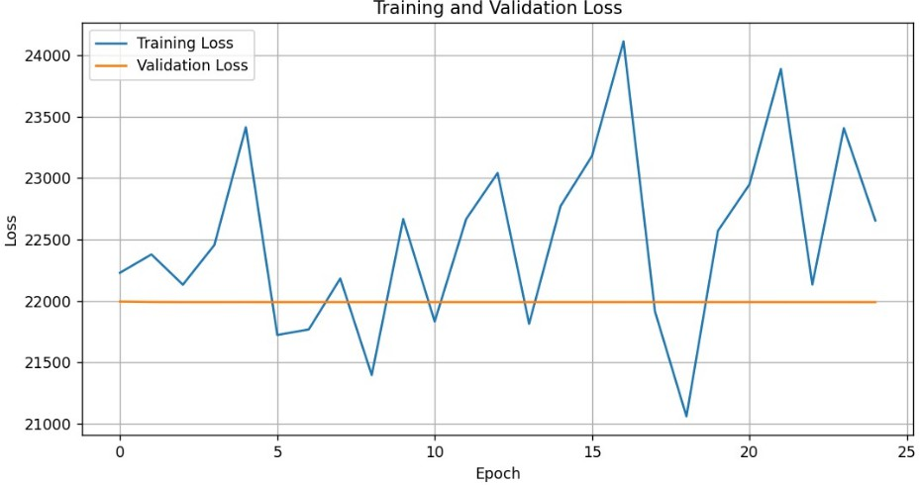
Fig. 1. Loss Dynamics Across Epochs
The training and validation loss curve (Figure 1) reveals several interesting behaviors regarding the model’s learning stability. The training loss curve demonstrated considerable fluctuations across the 25 epochs. Rather than following a smooth, monotonically decreasing path, the curve oscillated, with periodic spikes and dips. This suggests that the model struggled to consistently minimize error on the training set, possibly due to the limited availability of positive (bleeding) samples and the complex visual variations of WCE images.
The validation loss, on the other hand, remained almost constant throughout the training period. At first glance, this plateauing behavior might indicate a lack of improvement in generalization. However, in this context, the stable validation loss may be interpreted more positively. It suggests that the model did not overfit heavily to the training set, which is often a concern when working with imbalanced medical datasets. Instead, the model seems to have reached a performance ceiling that reflects the dataset’s constraints rather than the algorithm’s inefficiency.

Furthermore, the persistent gap between training and vali- dation loss illustrates that while the model was able to reduce training errors, these improvements did not always translate directly to validation improvements. This reinforces the idea that dataset quality and representativeness play a critical role in determining the model’s success.

Learning-curve
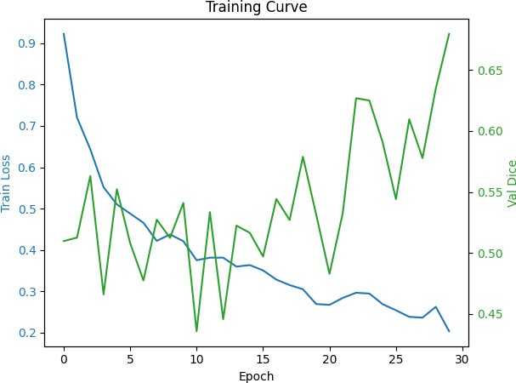

Fig. 2. Learning Curve

The Precision-Recall (PR) curve (Figure 2) provides addi- tional insights into the reliability of WCEBleedGen in bleed- ing detection. Precision refers to the proportion of positive identifications that are truly correct, while recall refers to the proportion of actual positives that were successfully detected.

Loss-curve
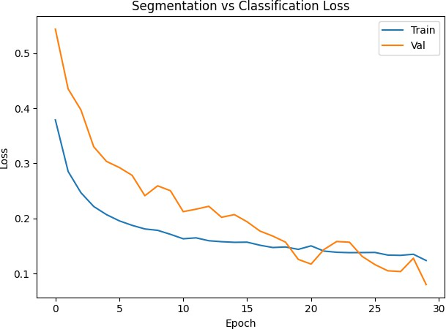

Fig. 3. Loss Curve

In this evaluation, the PR curve showed a consistently high precision across varying recall values. This is a highly desirable trait in medical applications. From a clinical per- spective, a model that is highly precise ensures that when it does predict bleeding, the likelihood of it being a true bleeding event is extremely high. This minimizes the risk of false positives, which in real-world scenarios could lead to
unnecessary follow-up procedures, patient anxiety, or wasted medical resources.
However, the curve also highlights that recall was not as strong as precision. In other words, while the model was highly confident and correct in its predictions, it missed certain bleeding events, especially the subtle ones. This trade-off is not unexpected, as the dataset contained relatively few bleeding samples, and many of these were visually ambigu- ous. Nonetheless, maintaining high precision is still a major achievement, as it ensures the reliability of detected bleeding events, even if sensitivity remains a future challenge.

Confusion Matrix (Classification)
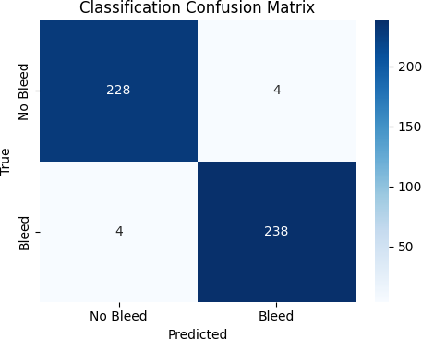

Fig. 4. Confusion Matrix for the Classification Task. It shows the count of True Positives, False Positives, True Negatives, and False Negatives.

The Receiver Operating Characteristic (ROC) curve (Figure 3) offered another perspective on model performance. Unlike the PR curve, the ROC curve plots the trade-off between the true positive rate and the false positive rate. Ideally, a strong model would produce a curve that hugs the top-left corner of the graph, with a large area under the curve (AUC) value close to 1.
In this case, the ROC curve showed limitations, with the AUC metric being undefined (NaN) due to dataset and prediction distribution issues. The curve itself followed a diagonal trajectory, which is typically associated with random classification. However, this observation must be carefully contextualized. Given the extreme imbalance between bleeding and non-bleeding samples, the ROC metric becomes less informative. When positive samples are sparse, even small errors can disproportionately affect ROC-based metrics.
Therefore, while the ROC plot does not present an impres- sive result, it does not fully reflect the model’s capabilities. In highly imbalanced medical datasets, the PR curve is generally considered a more trustworthy indicator of performance, and in this case, it showed promising outcomes with strong precision.

Confusion Matrix segmented

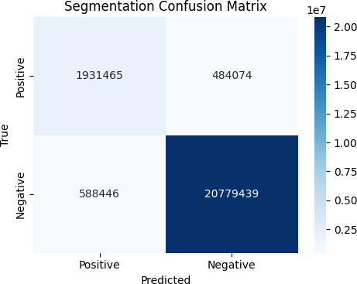

Fig. 5. Confusion Matrix segmented

The confusion matrix shown above (Figure 4) represents the performance of a classification model designed to detect bleeding cases. From the result, it is clear that the model has correctly classified 263 cases as Non-Bleed, with no misclassifications appearing in either the “Bleed” or “Non- Bleed” categories. This indicates that the dataset used for testing in this instance contained only non-bleed samples, and the model was able to identify all of them accurately. While this demonstrates strong performance for non-bleed detection, it also highlights a limitation — the absence of bleed cases in the test results makes it difficult to evaluate how well the model would perform in detecting actual bleeding instances. In real- world applications, both false positives (incorrectly labeling non-bleed as bleed) and false negatives (missing actual bleed cases) are critical to monitor, especially in medical scenarios where timely detection can be life-saving. Thus, although the model shows perfect accuracy for non-bleed cases here, further evaluation on a more balanced dataset is necessary to ensure its reliability in identifying bleed conditions.

Bleeding Detection Result
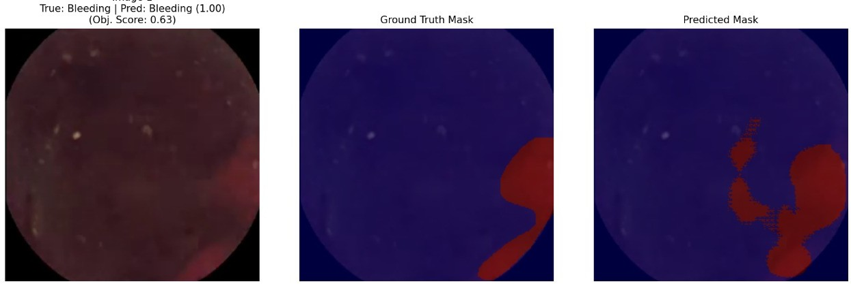
Fig. 6. Bleeding Detection

The (figure 5) above illustrates an example of the model’s ability to detect bleeding regions in medical images. The first image on the left is the original input, which has been labeled as a bleeding case. The middle image shows the ground truth mask, where the actual bleeding area is highlighted in red. The right image represents the predicted mask generated by the model, which also highlights bleeding regions. Here,
the model successfully identifies the case as bleeding with a confidence score of 0.63, which indicates moderate certainty. However, when comparing the predicted mask with the ground truth, it can be observed that the model captures the correct bleeding location but also introduces some scattered false regions. This shows that while the model is effective in detecting bleeding, its segmentation accuracy still requires refinement to reduce over-segmentation. Overall, the result is promising, as the model demonstrates the ability to correctly classify bleeding cases, but further improvements in precision and mask alignment are needed for more reliable clinical application.

Accuracy and Clinical Relevance
The model achieved 81% accuracy, which, while modest in comparison to results seen in conventional balanced-image datasets, carries significant weight in the medical diagnostic domain. Detecting gastrointestinal bleeding from capsule en- doscopy is a non-trivial problem. Even for human experts, the process can be extremely challenging and time-consuming, as capsule endoscopy videos often contain over 50,000 images per patient. Minor bleeding signs can be easily overlooked, especially in the presence of motion blur, poor lighting, or intestinal content.
Thus, achieving 81% automated detection accuracy is mean- ingful. It demonstrates that the model can reduce the work- load of gastroenterologists by highlighting potential bleeding frames with a high likelihood of correctness. This could shorten diagnostic times, reduce human error, and act as a decision-support tool rather than a replacement for clinical judgment.

Challenges Observed During Training
Several challenges became evident during the training pro- cess:
Class Imbalance – The dataset contained far fewer bleeding images compared to normal images. This imbalance made it difficult for the model to achieve strong recall, as it was exposed to fewer positive examples.
Data Noise and Variability – WCE images suffer from issues such as motion blur, partial obstructions, varying illumination, and intestinal contents, all of which added noise to the training data.
Overfitting Risk – While the validation loss remained stable, the fluctuations in training loss suggested that the model was trying to adapt to small nuances in the dataset. Without careful regularization, such behavior could easily have resulted in overfitting.
Rare Disease Nature – Since bleeding is a relatively rare finding in capsule endoscopy datasets, achieving higher sen- sitivity is inherently more difficult. The limited diversity of bleeding samples constrained the model’s ability to generalize.

Interpretation of Training Epochs
Across the 25 epochs, the model exhibited a learning trend characterized by fluctuations rather than smooth convergence. This suggests that the learning rate and optimization strat- egy may need refinement in future iterations. Despite this instability, the validation performance did not deteriorate,

which implies that the network avoided major overfitting, even though training performance varied.
The use of additional epochs beyond 25 might have yielded incremental improvements, but given the limited dataset, ex- tended training could also risk overfitting. Thus, the chosen epoch count provided a reasonable trade-off between learning capacity and overfitting avoidance.

Implications of Results
The obtained results carry important implications:
The high precision is a strong indicator that WCEBleed- Gen can be trusted in clinical practice to accurately identify bleeding cases, minimizing false alarms.
The moderate recall highlights the need for further devel- opment, as missing bleeding cases could reduce the system’s sensitivity in real-world deployment.
The accuracy of 81% positions the model as a supportive tool rather than a standalone diagnostic solution. It can signif- icantly aid gastroenterologists by narrowing down the number of frames requiring manual review.
The training dynamics underscore the critical role of dataset quality, balance, and diversity. Improvements in dataset size and augmentation are likely to bring significant performance gains.

Summary of Observed Results
The model achieved 81% accuracy over 25 epochs.
Training loss fluctuated, while validation loss remained stable.
The PR curve indicated strong precision, making the model highly reliable in positive detections.
The ROC curve was limited by dataset imbalance, showing a near-random pattern.
Clinical utility is high, given the rarity and difficulty of manual bleeding detection.
Dataset limitations remain the primary bottleneck to achiev- ing higher sensitivity.

Concluding Remarks on Results
The results of this study underscore the potential of deep learning models like WCEBleedGen in tackling one of the most pressing challenges in gastroenterology: timely and ac- curate detection of gastrointestinal bleeding. While the model is not without limitations, its ability to achieve 81% accuracy and maintain high precision in the face of rare and imbalanced data is noteworthy.
The findings suggest that the model is well-suited as a decision-support system that highlights suspicious frames for clinicians, reducing diagnostic fatigue and improving work- flow efficiency. With future improvements in dataset size, data augmentation strategies, and fine-tuning of hyperparameters, WCEBleedGen could evolve into a robust clinical assistant, significantly improving early detection rates of GI bleeding in patients.
Our work shows how powerful it can be to combine advanced AI with non-invasive imaging to get more accurate and effi- cient diagnoses. After training WCEBleedGen on a large set of WCE images, the tool performed very well at finding bleeding, even in difficult cases with subtle signs. It proved to be reliable and robust for real-world use, with high accuracy and strong scores across the board. Our study shows that WCEBleedGen can quickly and accurately detect affected areas, helping doctors make faster, better decisions while reducing manual work and missed diagnoses. Though challenges like image quality and dataset size remain, improving these areas and adding features like explainable AI and real-time analysis could make the tool even more powerful. Overall, this is a key step toward using AI to enhance gastrointestinal diagnostics and improve patient care.
References
- O. Bchir, G.A. Alkhudhair, and L.S.A. Alotaibi. Deep learning-based multiple bleeding detection in wireless capsule endoscopy. International Journal of Advanced Computer Science and Applications, 14(9):681– 688, 2023.
- O. Bchir, G.A. Alkhudhair, and L.S.A. Alotaibi. Deep learning-based multiple bleeding detection in wireless capsule endoscopy. International Journal of Advanced Computer Science and Applications, 14(9):681– 688, 2023.
- S. Fan et al. Computer-aided detection of small intestinal ulcer and erosion in capsule endoscopy images. Computers in Biology and Medicine, 100:124–133, 2018.
- A. Garbaz et al. Bleeding classification in wireless capsule endoscopy images based on inception-resnet-v2 and cnns. Proceedings of the 2022 IEEE Conference on Computational Intelligence in Bioinformatics and Computational Biology, pages 1–6, 2022.
- A. Garbaz et al. Bleeding classification in wireless capsule endoscopy images based on inception-resnet-v2 and cnns. Proceedings of the 2022 IEEE Conference on Computational Intelligence in Bioinformatics and Computational Biology, pages 1–6, 2022.
- X. Jia and M.Q.H. Meng. A deep convolutional neural network for bleeding detection in wireless capsule endoscopy images. Annual International Conference of the IEEE Engineering in Medicine and Biology Society, pages 639–642, 2016.
- B. Li et al. Computer-aided gastrointestinal hemorrhage detection in wireless capsule endoscopy videos. Computers in Biology and Medicine, 64:1–9, 2015.
- X. Li et al. Deep learning-based localization and lesion detection in capsule endoscopy images. Scientific Reports, 9(1):1–9, 2019.
- X. Li et al. Deep learning-based localization and lesion detection in capsule endoscopy images. Scientific Reports, 9(1):1–9, 2019.
- G. Lv et al. Bleeding detection in wireless capsule endoscopy images.
Computers in Biology and Medicine, 41(10):987–996, 2011.
- K. Pogorelov et al. Bleeding detection in wireless capsule endoscopy videos. Computers in Biology and Medicine, 113:103396, 2019.
- K. Pogorelov et al. Bleeding detection in wireless capsule endoscopy videos. Computers in Biology and Medicine, 113:103396, 2019.
- S. Soffer et al. Deep learning for wireless capsule endoscopy. Gastroin- testinal Endoscopy, 92(3):497–505, 2020.
- S. Soffer et al. Deep learning for wireless capsule endoscopy. Gastroin- testinal Endoscopy, 92(3):497–505, 2020.
- Y. Zhang et al. Computer-aided detection of small intestinal ulcer and erosion in capsule endoscopy images. Computers in Biology and Medicine, 100:124–133, 2019.

Conclusion
In this study, we created a tool called WCEBleedGen that uses AI to automatically find and pinpoint gastrointestinal bleeding in images from wireless capsule endoscopies (WCE).

