
Vertex-Oriented Decentralized Framework for Scalable Location-Aware Self-Configuring Mesh Networks
ENGINEERING EXPLORATION– 4

Submitted by
Narendhira Prasath D Pratharshan A T  Ramchandh S  Sri Saran P | 714024106069  714024106078  714024106085  714024106106
Sugumaran S | 714024106108
In partial fulfillment for the award of the degree of
BACHELOR OF ENGINEERING
in
ELECTRONICS AND COMMUNICATION ENGINEERING
SRI SHAKTHI INSTITUTE OF ENGINEERING
AND TECHNOLOGY
(An Autonomous Institution)
COIMBATORE 641 062
MAY 2026
SRI SHAKTHI INSTITUTE OF ENGINEERING AND
TECHNOLOGY

(An autonomous institution)
Certified that this project report titled “Vertex-Oriented Decentralized Framework for Scalable Location-Aware Self-Configuring Mesh Networks” is the Bonafide work of
Sri saran P(714024106106),Ramchandh S(714024106085),Narendhiraprasath D
(714024106069), Pratharshan A T(714024106078),Sugumaran S(714024106108) who
carried out the project work dissertation phase I under my supervision


SIGNATURE SIGNATURE
Mrs.Hemalatha Dr.Bhavani
PROFESSOR HEAD OF THE DEPARTMENT
Department of Electronics and Department of Electronics and communication Engineering communication Engineering
Sri Shakthi Institute of Engineering Sri Shakthi Institute of Engineering
and Technology, Coimbatore-641062 and Technology, Coimbatore-641062

Submitted for project Engineering Exploration 4 examination held on………… at Sri Shakthi Institute of Engineering and Technology, Coimbatore-641 062.
Internal Examiner External Examiner
i

ACKNOWLEDGEMENT
We sincerely express our deepest gratitude to Dr.S. Thangavelu, Chairman, Sri Shakthi institute of Engineering and Technology for his continuous Encouragement and support throughout our course of study.
We would like to extend our sincere thanks to Mr. T. Dheepan, Secretary and Mr.T.Sheelan, Joint Secretary, Sri Shakthi Institute of Engineering and Technology, for their encouragement.
We would like to express our gratefulness to our Principal Dr.N.K.Sakthivel, for his magnanimity in allowing us to avail the facilities in their situation.
We are grateful to Dr. Bhavani, Professor and Head of the Department of Electronics and communication Engineering, for providing us with necessary facilities and encouragement, which aided the successful completion of our project work.
We would like to thank our guide Mrs. Hemalatha, Professor and Head of the Department of Electronics and communication Engineering, for his valuable technical discussion and suggestion during this project work.
We express our sense of obligation to project coordinator Mr. Dhilip Kumar Assistant Professor, for rendering their heartfelt help towards the project work management.

We would like to extend our thanks to all the faculty members of our department and non-teaching staff for their timely support.
ii

TABLE OF CONTENTS
CHAPTER TITLE PAGE NO.
NO.
ABSTRACT 7

1. INTRODUCTION 8
1.1 OVERVIEW
1.2 PROBLEM STATEMENT

2. LITERATURE REVIEW 9
2.1 JOURNAL REFERENCE

3. REQUIREMENT SPECIFICATION 11

HARDWARE SPECIFICATIONS
ESP32 Dev Module

NEO 6m NEO 6M (GPS Module)
BUCK CONVERTER (LM2596S)

4. SYSTEM DESIGN 14
4.1 BLOCK DIAGRAM
4.2 BLOCK DIAGRAM DESCRIPTION

5. CONNECTION AND WORKING 16
5.1 CIRCUIT DIAGRAM
5.2 WORKING OF CIRCUIT
5.3 PROGRAM USED
iii

6. OUTPUT AND FINAL PRODUCT 20
6.1 OUTPUTOFTHE CIRCUIT
6.2 FINAL PRODUCT
- CONCLUSION AND FUTURE SCOPE 22
7.1 CONCLUSION
7.2 FUTURE UPGRADES

- REFERENCES 23
iv

LIST OF FIGURES

FIGURE NO. TITLE PAGE NO.

3.1 ESP32 Dev Module 11
3.2 Neo 6m (GPS Module) 12
3.4 Buck Converter 13
5.1 DIAGRAM CIRCUIT DIAGRAM 16 6.1 OUTPUT PROTOTYPE 20
v

ABSTRACT
The rapid expansion of IoT has increased interconnectivity, but most systems still rely on centralized infrastructure like routers or cloud gateways, creating a critical single point of failure. This project addresses that limitation by developing a fully decentralized, multi-hop mesh networking framework using the ESP32 and ESP-NOW protocol, enabling direct peer-to-peer communication without a central coordinator
.
To improve scalability and avoid broadcast storms, the system uses geographic routing with a NEO-6M GPS module, allowing nodes to route data based on physical location rather than blind rebroadcasting. It also overcomes ESP-NOW’s 250-byte payload limit through an automatic packet fragmentation and reassembly mechanism, enabling large data transmission across the mesh.

The framework is optimized using a dual-core FreeRTOS architecture, where tasks like packet handling, cryptographic verification (HMAC SHA-256), and communication are distributed efficiently to prevent deadlocks, CPU overload, and watchdog failures. Supported by an LM2596S power system, the project delivers a robust, low-cost, off-grid communication solution for critical IoT applications such as disaster recovery and remote monitoring.

CHAPTER 1
INTRODUCTION
  - OVERVIEW

Modern wireless communication paradigms are fundamentally reliant on star-topology architectures, where edge devices must connect to a central hub or cloud gateway to transmit data. While highly effective in infrastructure-rich environments, this creates a catastrophic single point of failure. If the central router loses power or the internet disconnects, the entire local network instantly collapses, leaving smart devices completely isolated. To solve this architectural fragility, decentralized mesh networking has emerged as a vital technology.

In a true mesh network, there is no master router; every device acts as an independent client and active router, dynamically passing payloads from node to node. This proposed system is an advanced Edge-Mesh framework built on the ESP32 microcontroller, utilizing the low-latency ESP-NOW protocol to achieve connectionless peer-to-peer communication. By implementing Geographic Routing via integrated GPS and automated packet fragmentation, the framework overcomes bandwidth destruction and hardware limitations, ensuring highly reliable off-grid communication.

1.2 PROBLEM STATEMENT
Despite the advantages of decentralized mesh networking, existing implementations for low-cost embedded systems suffer from severe architectural limitations. Open-source alternatives typically rely on standard Wi-Fi, introducing massive latency overheads due to association handshakes and connection drops, making them unreliable for mobile IoT nodes.

Furthermore, existing ESP-NOW based mesh libraries frequently suffer from catastrophic network congestion because they rely entirely on blind packet flooding, causing exponential bandwidth destruction. Compounding this, the ESP-NOW protocol strictly limits payloads to 250 bytes. Therefore, there is an urgent need for an intelligently routed, dual-core optimized framework capable of handling packet fragmentation and preventing broadcast storms.

CHAPTER 2

LITERATURE REVIEW
2.1 JOURNAL REFERENCE

REFERENCE 1
O Title: Self-Healing IoT Mesh with ESP32 (No Wi-Fi Required) o Description: Wentworth (2021) described a self-healing ESP32 mesh network built entirely using the ESP-NOW protocol instead of traditional IP routing. The comprehensive study demonstrated how each autonomous node maintains continuous neighbor awareness and dynamically forwards data packets across multiple multi-hop pathways without requiring any central coordination or cloud infrastructure. The author specifically highlighted that if a routing node fails or loses power, the network automatically reconfigures its topology to discover alternate transmission paths. This critical concept of self-healing network resilience is highly relevant to our project’s design, particularly for deployment in harsh disaster recovery scenarios. However, Wentworth's base implementation strictly relied on topological flooding and did not utilize geographic routing, making our novel integration of NEO-6M GPS modules a significant technological advancement over standard self-healing mesh topologies.
REFERENCE 2
o Title: ESP32 Mesh Network using painlessMesh o Description: Santos and Santos (2020) presented a detailed implementation of a traditional Wi-Fi-based mesh network architecture utilizing the highly popular painlessMesh open-source library. Their experimental system successfully allowed multiple remote nodes to automatically discover each other in real-time and communicate dynamically without relying on any centralized wireless router. While their academic work successfully demonstrated the viability of multi-hop message relaying in edge networks, it fundamentally relied heavily on broadcast routing, commonly known as network flooding. This method is inherently less efficient and consumes massive amounts of finite wireless bandwidth. Their quantitative findings provide a crucial foundational baseline that heavily justifies our project's deliberate departure from standard Wi-Fi architectures, strongly supporting our architectural shift towards the ESP-NOW protocol and mathematically optimized Geographic Routing to effectively prevent severe network congestion.

REFERENCE 3
o Title: Wi-Fi-Free ESP32 Mesh Network Project o Description: Hazarika (2023) explored the practical hardware development of a completely Wi-Fi-free mesh network, exclusively utilizing ESP32 devices communicating over the low-latency ESP-NOW protocol. The experimental project successfully demonstrated robust peer-to-peer communication and automated multi-hop message relaying without requiring any pre-existing cloud infrastructure or internet connectivity. Throughout the study, the author highlighted several severe practical deployment challenges encountered in the field, specifically noting strict range limitations, wireless signal interference, and the extreme complexities of maintaining node synchronization across a decentralized topology. This published work is highly relevant to modern off-grid IoT applications and heavily validates our foundational architectural decision to leverage ESP-NOW for rapid data transmission. Furthermore, their documented routing struggles directly emphasize the absolute necessity of our robust, dual-core task segregation to maintain long-term operating system stability.

CHAPTER 3

REQUIREMENT SPECIFICATIONS

3.1:ESP32 Dev Module
The ESP32 Development Module is the central processing and routing unit of the Decentralized Mesh Framework, responsible for executing the entire system operation. It is a powerful dual-core microcontroller developed for IoT applications, featuring built-in Wi-Fi hardware that natively supports the low-latency ESP-NOW protocol. This is critical for bypassing standard Wi-Fi overhead to achieve microsecond-level peer-to-peer communication. In this project, the ESP32 manages the complex Geographic Routing algorithms, processes asynchronous coordinate data from the NEO-6M GPS module via hardware UART, and handles cryptographic packet verification using the mbedtls library. Its dual-core Tensilica LX6 architecture is highly useful for running FreeRTOS tasks concurrently; it seamlessly isolates high-frequency Wi-Fi radio interrupts on Core 0 while executing heavy application logic and heap memory management on Core 1 without system lag or watchdog panics. Due to its robust processing speed, built-in MAC-layer networking capabilities, and seamless compatibility with the Arduino IDE, this module is an ideal choice for building highly reliable, cost-effective mesh networking nodes.
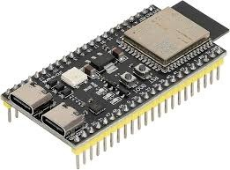

FIGURE 3.1: ESP32 Dev Module

3.2 Neo 6M (GPS Module)
The NEO-6M GPS Module serves as the critical spatial positioning engine of the Decentralized Mesh Framework, responsible for providing the real-world coordinates necessary for the Geographic Routing (Geo-Routing) algorithm. It was chosen over other location tracking alternatives due to its highly efficient u-blox 6 positioning engine, which offers a exceptionally fast Time-To-First-Fix (TTFF) and high tracking sensitivity even in challenging environments. In this project, the NEO-6M continuously triangulates signals from multiple orbiting satellites and transmits accurate latitude, longitude, and altitude data to the ESP32 via a standard hardware UART interface. Its onboard ceramic patch antenna provides excellent outdoor signal reception without the need for bulky or expensive external active antennas. Furthermore, the module internally processes complex L1 frequency satellite data and outputs simple, standardized NMEA sentences, entirely offloading heavy computational tracking from the ESP32’s processor. Due to its high precision, low power consumption, and seamless UART integration, the NEO-6M is the absolute ideal choice for enabling the intelligent, physical-space routing capabilities of the mesh node.
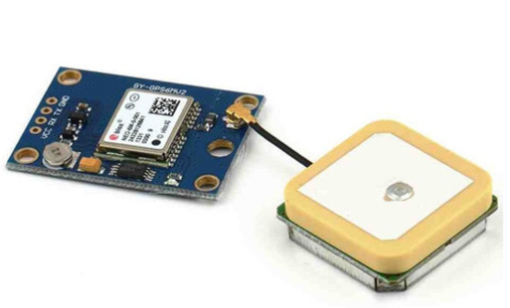

FIGURE 3.2 Neo 6M(GOS Modul)

3.4: Buck Converter (LM2596S)

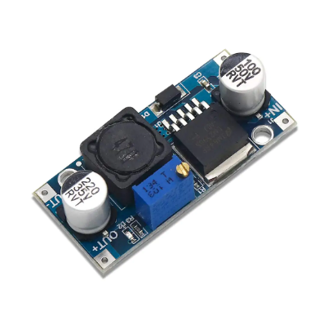
The LM2596S DC-DC Buck Converter serves as the primary power management subsystem for the mesh node, responsible for safely bridging the high-capacity 7.4V Li-Po battery to the sensitive 5V input of the ESP32. It was chosen specifically over standard linear voltage regulators (such as the LM7805) due to its vastly superior energy efficiency in portable applications. Linear regulators lower voltage by dissipating excess electrical energy directly as heat. When the ESP32’s Wi-Fi radio spikes up to 400mA during ESP-NOW transmissions, a linear regulator dropping 7.4V down to 5V would generate massive thermal waste, rapidly draining the battery and risking a catastrophic thermal shutdown. In contrast, the LM2596S is a switching regulator that utilizes a high-frequency 150kHz oscillator and an inductor-capacitor network to step down voltage with up to 92% efficiency. This drastically reduces heat generation and significantly extends the operational lifespan of the battery. Due to its high 3-Ampere current capacity and thermal stability, the LM2596S is the ideal choice for powering continuous, off-grid mesh deployments.

FIGURE 3.4: Buck Converter (LM2596S)

CHAPTER 4

SYSTEM DESIGN 4.1 BLOCK BIAGRAM 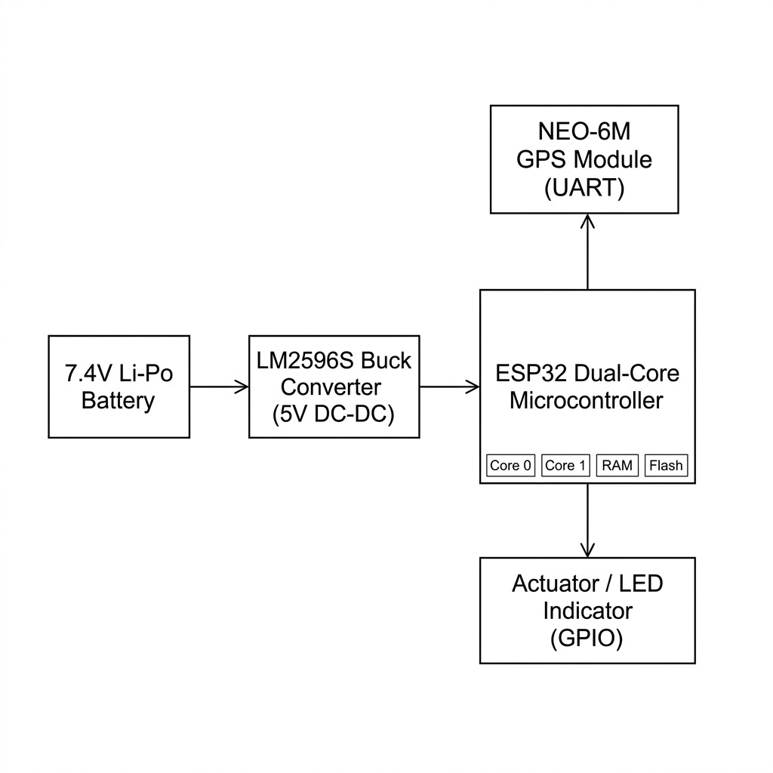

FIGURE 4.1:BLOCK DIAGRAM
4.2 BLOCK DIAGRAM DESCRIPTION:
- The hardware architecture of the VortexaMesh node is meticulously designed around strict physical modularity and robust power management. At the foundation of the physical layer, the LM2596S buck converter acts as the primary power gate, safely bridging the high-capacity, fluctuating voltage of the 7.4V Li-Po battery to the highly sensitive logic electronics of the central microcontroller. By efficiently stepping the voltage down to a stable 5V, it prevents the thermal failure of the ESP32’s internal regulators. Once safely powered, the ESP32 dual-core processor serves as the absolute command center, orchestrating both the low-level wireless protocols and the high-level routing logic.

- Connected to the ESP32 are two primary peripheral subsystems that enable spatial awareness and physical actuation. The NEO-6M GPS module operates asynchronously to the main processing loops, continuously feeding raw NMEA coordinate data over a dedicated hardware UART serial port. This continuous stream of positional data enables the node's advanced Geographic Routing capabilities. On the output side, a simple 5mm LED actuator is wired directly to a digital GPIO pin. This serves as a vital physical indicator, proving that the complex multi-hop packet delivery and cryptographic verification systems are functioning successfully when triggered by remote commands.

- The system's resilience is entirely dependent on the ESP32's dual-core operating system segregation. The FreeRTOS scheduler strictly dedicates Core 0 to fielding the ultra-high-speed hardware interrupts generated by the 2.4GHz Wi-Fi antenna during ESP-NOW packet reception. Simultaneously, Core 1 handles the heavy lifting of the mesh framework. It verifies the mbedtls HMAC SHA-256 cryptographic signatures, calculates geographic routing math, and drives the GPIO actuators without ever starving the Wi-Fi baseband of CPU cycles, rendering the node virtually immune to watchdog timer panics.

CHAPTER 5

CONNECTIONS AND WORKING
5.1 CIRCUIT DIAGRAM:
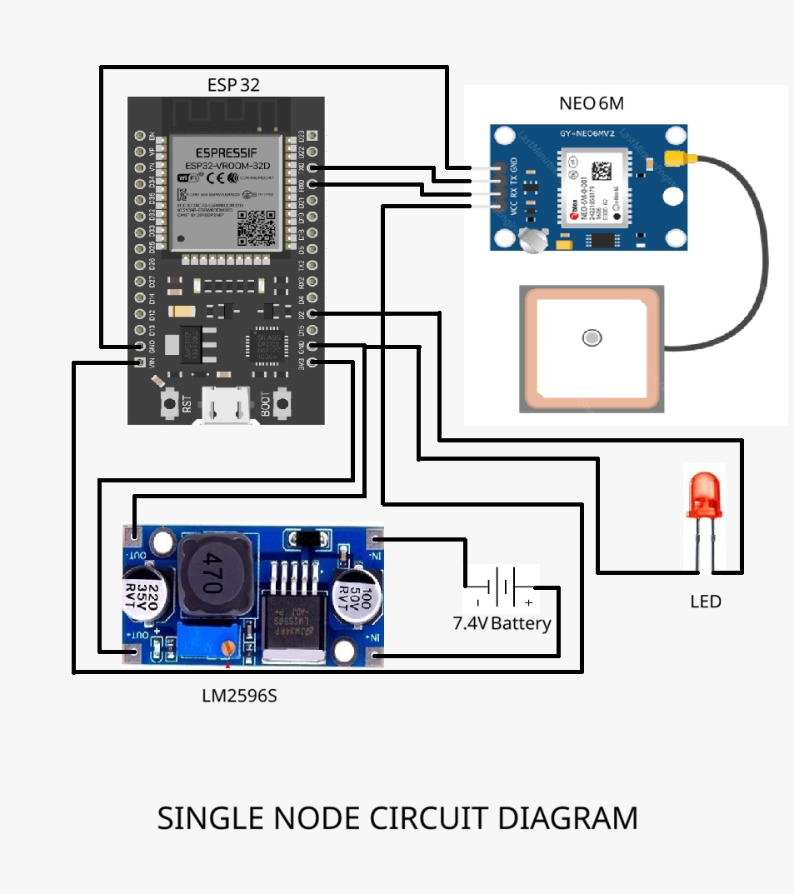

FIGURE 5.1:CIRCUIT DIAGRAM

5.2 CIRCUIT DIAGRAM DESCRIPTION:

The single-node circuit is built around the ESP32 development board, which acts as the central controller responsible for processing data and managing communication between connected components. The ESP32 is chosen due to its integrated Wi-Fi and Bluetooth capabilities, low power consumption, and sufficient GPIO pins for interfacing multiple peripherals. In this circuit, it is primarily used to read GPS data and control output devices like the LED. The board operates at 3.3V logic, so careful voltage regulation is necessary to avoid damage. The GPIO pins are configured to handle serial communication with the GPS module, while one of the digital output pins is assigned to drive the LED for status indication.
The NEO-6M GPS module is interfaced with the ESP32 using UART communication, which allows continuous transmission of location data such as latitude, longitude, altitude, and time. The TX (transmit) pin of the GPS module is connected to the RX (receive) pin of the ESP32, and similarly, the RX pin of the GPS is connected to the TX pin of the ESP32, ensuring proper bidirectional communication. The GPS module is powered using a regulated voltage supply and is connected to an external antenna to improve signal reception accuracy. Once powered, the module continuously searches for satellite signals and provides NMEA data strings, which the ESP32 decodes and processes according to the application requirements.
Power management in the circuit is handled using a 7.4V battery connected to an LM2596S buck converter module. Since the ESP32 and GPS module cannot operate directly at 7.4V, the LM2596S steps down the voltage to a stable 5V or 3.3V output. This ensures safe and efficient power delivery to all components. The converter includes adjustable output, filtering capacitors, and high efficiency, making it suitable for portable and battery-powered applications. All components share a common ground connection, which is critical for maintaining signal integrity and avoiding erratic behavior. Proper wiring and voltage regulation ensure long-term stability and reliability of the node.
An LED is connected to one of the ESP32 GPIO pins through an appropriate current-limiting resistor to act as a visual indicator. The LED can be programmed to blink or remain ON/OFF depending on system conditions such as successful GPS signal acquisition, data transmission, or error states. This provides a simple yet effective way to monitor the system without additional debugging tools. Overall, the circuit demonstrates a compact and efficient design for a single node in a distributed system, integrating sensing, processing, and indication functionalities. It serves as a foundational unit that can be expanded into a larger network for applications like tracking, monitoring, or mesh communication systems.

PROGRAM USED:

Unlike simple microcontroller projects that can be contained within a single `main.ino` file, this mesh networking framework is an enterprise-grade, object-oriented C++ codebase containing thousands of lines of highly optimized logic. Because of its sheer size and complexity, it is impractical to append the raw source code directly into this document. The structural architecture of the program is organized into strictly separated modules:

src/
│ MeshFramework.hpp // Central header for user inclusion
│
├───mesh_core/ // Initializes radio and RTOS tasks
│ Dispatcher.cpp / .hpp // Routes and decrypts incoming packets
│ EventBus.cpp / .hpp // Handles internal pub-sub event callbacks
│ ILocationProvider.hpp // Interface for location hardware
│ Mesh.cpp / .hpp // Core mesh initialization and configuration
│ MeshConfig.hpp // Network configuration macros
│ MeshContext.cpp / .hpp // Shared state across FreeRTOS tasks
│ MeshEvent.hpp // Base event structures
│ Node.hpp // Data structure for network peers
│ Packet.hpp // 250-byte MTU packet structure
│ PeerManager.cpp / .hpp // Manages local ESP-NOW peer connections
│ Reliability.hpp // Enums for packet delivery QoS
│ RequestManager.cpp / .hpp // Tracks outgoing reliable TCP requests
│ Security.cpp / .hpp // HMAC SHA-256 cryptographic signing
│ Service.hpp // Base class for mesh services
│
├───mesh_events/ // Triggers internal pub-sub callbacks
LocationEvents.cpp / .hpp // Fires on GPS coordinate updates
NodeEvents.cpp / .hpp // Fires on node discovery/loss
PacketEvents.cpp / .hpp // Fires on packet transmission/reception
ServiceEvents.cpp / .hpp // Fires on mesh service discovery

src/
├───mesh_location/ // Parses GPS NMEA serial coordinates
│ GPSLocationProvider.cpp / .hpp // Interfaces with NEO-6M via UART
│ ManualLocationProvider.cpp / .hpp // Allows hardcoded static GPS coords
│
├───mesh_registry/ // Maps active nodes on the network
│ DedupCache.cpp / .hpp // Prevents processing duplicate packets
│ NodeRegistry.cpp / .hpp // Dynamic array of active mesh nodes
│
├───mesh_reliability/ // Manages TCP-style packet acknowledgments
│ AckManager.cpp / .hpp // Handles reliable packet ACKs and retries
│ FragmentManager.cpp / .hpp// Slices payloads exceeding 250-byte MTU
│
├───mesh_routing/ // Handles symmetric and geographic pathing
│ DirectionalRouter.cpp / .hpp// Calculates physical GPS paths
│ RouteCache.cpp / .hpp // Caches paths for Symmetric Reverse Routing
│
├───mesh_tasks/ // Isolates FreeRTOS dual-core execution logic
│ DiscoveryTask.cpp / .hpp // Broadcasts presence beacons periodically
│ HealthTask.cpp / .hpp // Prunes dead nodes from the registry
│ LocationTask.cpp / .hpp // Asynchronously polls GPS UART data
│ ReceiverTask.cpp / .hpp // Core 0 task polling ESP-NOW queues
│ SenderTask.cpp / .hpp // Core 1 task transmitting ESP-NOW packets
│
├───mesh_transport/ // Processes ESP-NOW MAC-layer hardware frames
│ ESPNOWTransport.cpp / .hpp// Low-level wrappers for ESP-IDF MAC API
│
└───mesh_utils/ // Provides cryptographic hashing and terminal CLI
Hash.cpp / .hpp // Generates unique IDs for nodes
Logger.cpp / .hpp // Serial debug logging macros
MeshTerminal.cpp / .hpp // Interactive programmatic CLI engine
Serializer.cpp / .hpp // Converts C++ objects to byte arrays
UUID.cpp / .hpp // Generates unique identifiers for packets

For full code visit : https://github.com/Saran-006/esp-mesh-core.git

CHAPTER 6

OUTPUT AND FINAL PRODUCT
6.1 OUTPUT OF THE CIRCUIT:
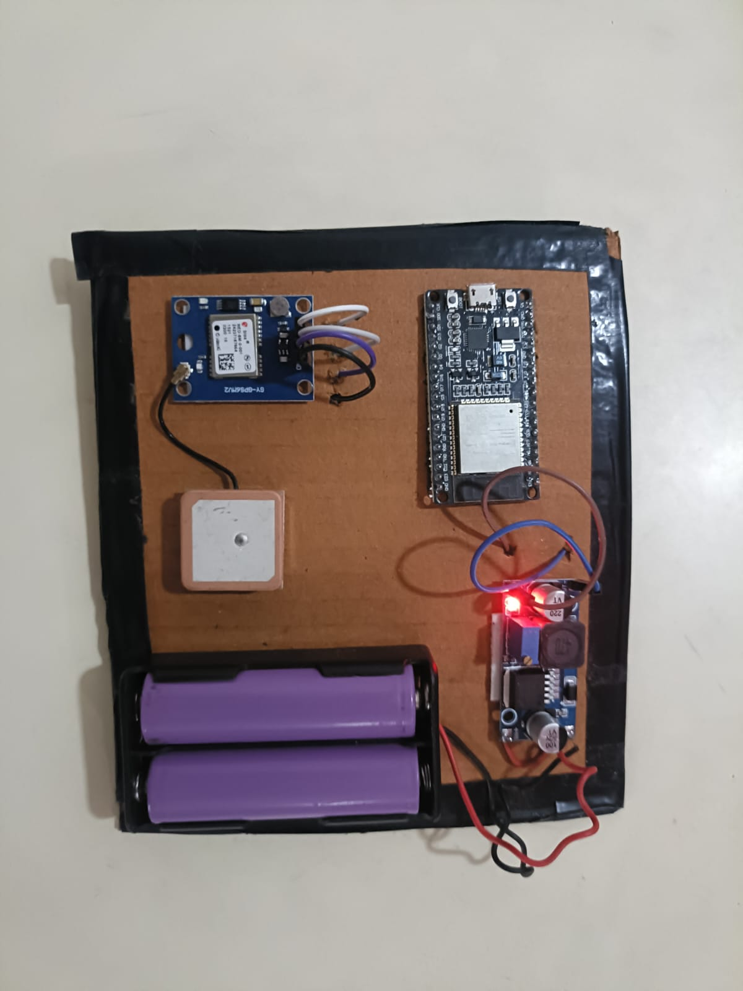
When the system is powered ON, the 7.4V lithium battery pack supplies power to the circuit, which is regulated by the LM2596S buck converter to provide a stable output suitable for the ESP32 and NEO-6M GPS module. The LED on the converter module glows, indicating proper voltage regulation and power availability. The ESP32 initializes and begins serial communication with the GPS module, while the GPS starts acquiring satellite signals through its external antenna. During this phase, the system remains in an initialization state until valid location data is received. Once a GPS fix is obtained, the ESP32 processes the incoming NMEA data and can use it for further communication or display purposes. The LED connected to the ESP32 acts as a status indicator, which can be programmed to blink during signal acquisition and remain steady when valid data is received. After successful initialization and data acquisition, the node operates continuously, monitoring and transmitting location information, and remains ready to function as part of a larger mesh or tracking system.

6.2 FINAL OUTPUT:
The final output of the proposed ESP32-based mesh-enabled GPS node system demonstrates coordinated operation among multiple nodes, each powered by a 7.4V lithium battery and regulated through an LM2596S buck converter. When the system is powered ON, all ESP32 nodes initialize and establish communication readiness while the onboard LEDs indicate active power and system status. Each node interfaces with a NEO-6M GPS module, which begins acquiring satellite signals through its antenna. During initialization, the nodes remain in a standby state until valid GPS data is obtained. Once a location fix is achieved, the ESP32 processes the received NMEA data and prepares it for transmission across the network. The LED indicators provide visual feedback, such as blinking during signal acquisition and stable illumination when data is successfully received and transmitted. The nodes can then communicate with each other using the implemented mesh logic, enabling data sharing without centralized infrastructure. After successful initialization and synchronization, the system continuously operates in a monitoring and communication mode, allowing real-time location exchange between nodes while remaining ready for further expansion or integration into larger decentralized IoT applications.
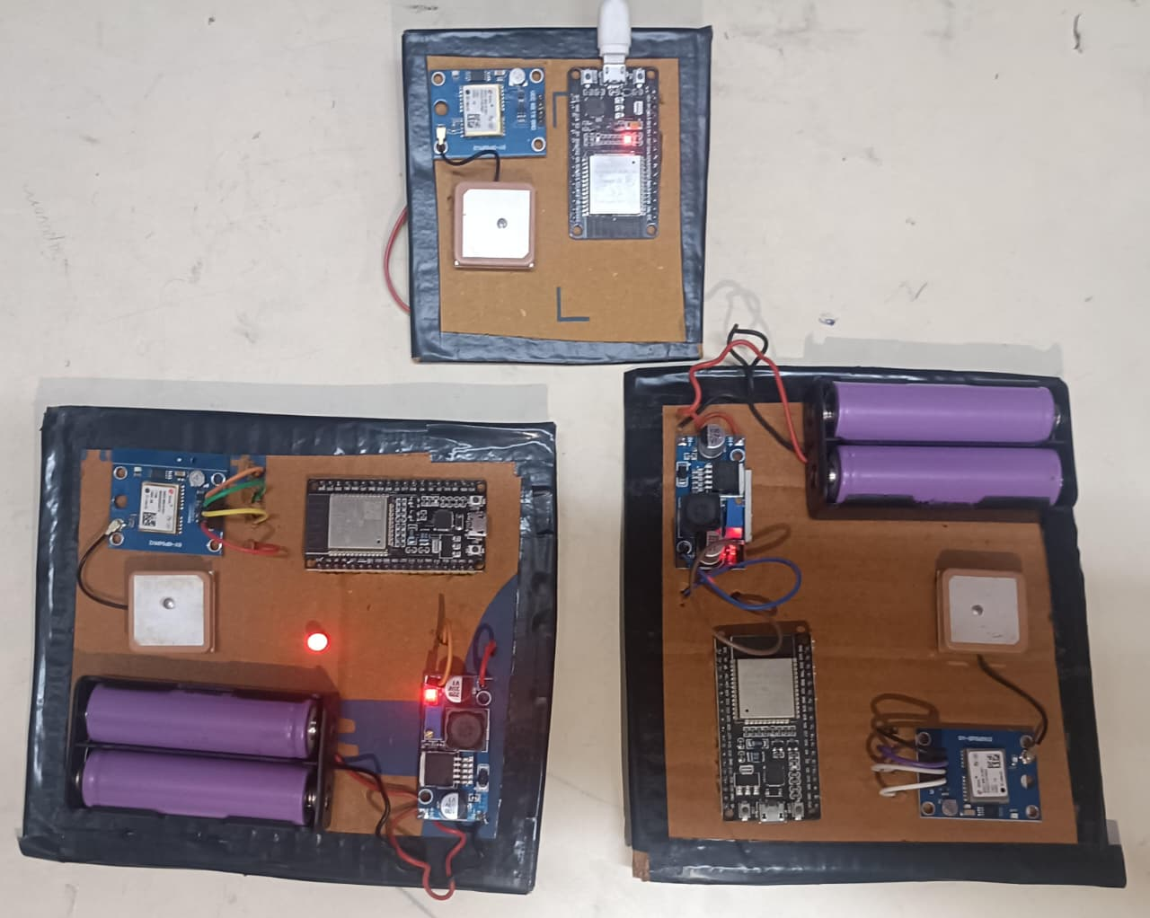

FIGURE 6.2:PROTOTYPE
CHAPTER 7

CONCLUSION
7.1 CONCLUSION:
This intensive engineering project demonstrates that highly reliable, secure, and scalable mesh networking is achievable on low-cost microcontrollers through rigorous system design. By bypassing the traditional Wi-Fi stack and leveraging the ESP-NOW MAC layer, the framework achieves ultra-low latency communication that conventional IP-based systems cannot match. The integration of the ESP32 with the NEO-6M GPS module and LM2596S buck converter forms a durable, portable hardware platform suitable for continuous operation in harsh, infrastructure-free environments.
On the software side, extensive debugging led to a hardened firmware architecture. Task segregation across the ESP32’s dual-core processor isolates time-critical radio operations from computational routing logic, while dynamic heap allocation eliminates memory-related crashes and watchdog failures common in embedded systems. The implementation of Geographic Routing avoids broadcast storms by directing packets based on real-time GPS coordinates, and Symmetric Reverse Routing ensures reliable acknowledgments through optimized return paths. A custom fragmentation system overcomes hardware transmission limits, enabling efficient large-data handling.
Finally, hardware-accelerated mbedTLS cryptographic signing secures the network against spoofing and malicious attacks. The result is a robust, scalable, and decentralized communication framework with strong potential for future enhancements such as machine learning-based routing and deployment in disaster response or autonomous systems, offering a solid open-source foundation for resilient edge networking.

7.2 FUTURE UPGRADES
- AI-Based Routing Optimization
Integrate lightweight machine learning models to predict the best communication paths based on node movement, signal strength, and traffic patterns, reducing latency and packet loss.
- Energy-Efficient Operation
Add advanced power management such as deep sleep modes, adaptive transmission power, and duty cycling to extend battery life for long-term deployments.
- Scalability Enhancement
Implement clustering or hybrid routing protocols to support larger networks with hundreds of nodes while avoiding congestion and maintaining performance.
- Stronger Security Mechanisms
Upgrade to advanced encryption schemes with secure key exchange, intrusion detection, and node authentication to prevent sophisticated attacks.
- Mobile Node Support
Improve handling of dynamic topologies for applications like drone swarms, autonomous vehicles, and moving rescue units.
- OTA Firmware Updates
Add Over-The-Air update capability to remotely upgrade firmware across all mesh nodes.

CHAPTER 8

REFERENCES
- Smith, Managed ESP-NOW Flooding Mesh Network, Hackaday.io, 2021. This reference implements a flooding-based mesh network over ESP-NOW, utilizing a message cache to prevent duplicate forwarding. It successfully achieves low latency while integrating a Raspberry Pi MQTT gateway.

- Pii, EspNowFloodingMesh Library, GitHub Repository, 2022. This open-source project provides an instant-connection ESP-NOW mesh networking library. It supports unlimited node scalability and serves as a vital comparison model for analyzing the inefficiencies of standard network flooding versus optimized geographic routing.

- Zholtikov, ZHNetwork – ESP-NOW Mesh Network Library, GitHub Repository, 2021. A lightweight library designed for creating decentralized ESP-NOW networks on ESP32 devices. It demonstrates the foundational routing principles required for multi-hop peer-to-peer messaging without reliance on traditional Wi-Fi infrastructure.

- Zholtikov, ESP-NOW Gateway + Mesh System, GitHub Repository, 2022. This project explores hybrid networking by combining an ESP-NOW mesh with a Wi-Fi-connected gateway. It emphasizes the importance of consistent network configurations to maintain secure local communication even when external internet connectivity is completely lost.

- N. Educ8s, ESP32 Wireless Mesh Weather Station, Embedded Sensor Projects, 2020. This practical IoT application demonstrates the transmission of environmental sensor data across an ESP-NOW network. It highlights the real-world efficiency of connectionless protocols for continuous, low-power telemetry systems.

  - L. Designer, espNowFloodingMeshLibrary2, GitHub Repository, 2023. An advanced flooding-based mesh framework focused heavily on deployment reliability. It incorporates telemetry statistics and time synchronization features, providing a contrasting approach to the directional Geo-Routing algorithms implemented in VortexaMesh.

  - E. Wentworth, Self-Healing IoT Mesh with ESP32 (No Wi-Fi Required), Medium Engineering Publications, 2021. This article outlines the architecture of a self-healing ESP-NOW mesh. It demonstrates how networks automatically reconfigure around failed nodes, validating the critical need for fault-tolerant dynamic topologies in disaster recovery deployments.

  - Espressif Systems, ESP-WIFI-MESH Framework (ESP-MDF), Official Espressif Documentation, 2022. The official Wi-Fi-based mesh framework provided by Espressif. While capable of supporting thousands of nodes, its reliance on standard 802.11 Wi-Fi infrastructure highlights the massive latency overheads that VortexaMesh deliberately bypasses by utilizing raw ESP-NOW MAC frames.

  - R. Santos, ESP32 Mesh Network using painlessMesh, Random Nerd Tutorials, 2020. A comprehensive guide utilizing the painlessMesh library to create automated, Wi-Fi-based networks. The project's heavy reliance on broadcast routing confirms the necessity of our architectural shift towards mathematical path optimization to prevent network congestion.

- M. Koubaa, “ESP32: A Low-Cost Platform for Wireless Sensor Networks Using ESP-NOW,” IEEE Internet of Things Journal (Workshops/Proceedings), 2021. This work evaluates ESP-NOW as a lightweight alternative to traditional Wi-Fi protocols for low-power IoT communication, focusing on latency, packet loss, and scalability.

- J. Gomez, H. Lin, “Comparison of ESP-NOW and Wi-Fi for Real-Time IoT Applications,” International Conference on Embedded Systems (ICES), 2022.A comparative study analyzing throughput, delay, and energy efficiency between ESP-NOW and TCP/IP-based Wi-Fi communication models
.

- S. Duquennoy, O. Landsiedel, T. Voigt, “Let the Tree Bloom: Scalable Opportunistic Routing with ORPL,” ACM SenSys, 2013. Although not ESP-NOW-specific, this paper introduces opportunistic routing concepts that directly relate to improving flooding inefficiencies in mesh networks.

- Y. Liu et al., “Geographic Routing in Wireless Sensor Networks: A Survey,” IEEE Communications Surveys & Tutorials, 2010. A foundational survey explaining geographic routing techniques—useful as theoretical backing for your VortexaMesh directional routing model.

- Espressif Systems, “ESP-NOW User Guide,” Official Documentation, 2023. The official protocol-level explanation of ESP-NOW, including frame structure, peer management, encryption, and limitations—critical for validating low-level design decisions.

