Car:

The number of car parts can vary, but modern vehicles can have over 30,000 individual parts, encompassing various systems and components, highlighting the intricate engineering and complexity involved in car design.

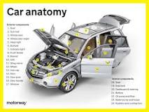

**Car body and main parts**

* Interior/cab/cabin.
* Engine compartment.
* Bonnet/hood. Bonnet/hood. Car cover. Support stick. Hinges and springs.
* Bumper. Unexposed bumper. Exposed bumper.
* Cowl screen.



How do roads function

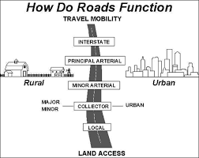

Road designations, also known as route numbers, are alphanumeric designations assigned by highway authorities to distinguish different roadways.

|  |  |
| --- | --- |
| Name | Picture |
| Car |  |
|  |  |