**Digestive System**

**The digestive system is a group of organs that work together to break down food into smaller molecules, allowing the body to absorb nutrients and eliminate waste. It includes the gastrointestinal tract (GI tract) and accessory organs.**

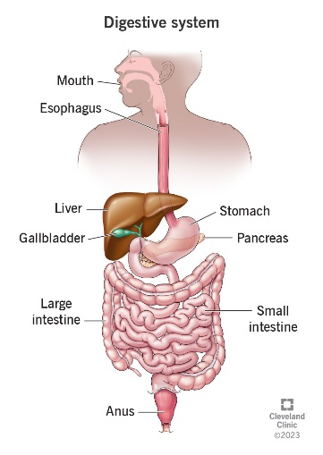

**Mouth**

**The mouth is the first part of the upper gastrointestinal tract and is equipped with several structures that begin the first processes of digestion**

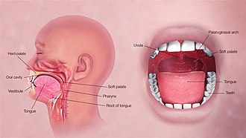

**Salivary glands**