Contents

1. Data 1

2. Calculate the emissions and population of different countries in WIOT database 1

2.1 Countries classification 1

2.2 Emission sectors 2

2.3 Pollutants of different emission sectors 3

3. Create satellite account 3

3.1 Match emission sectors with economic sectors 3

3.2 Calculation 5

4. Leontief Inverse 6

4.1 Technology matrix 6

4.2 Leontief Inverse 6

4.3 Check for correctness 6

5. Consumption-based emissions 7

5.1 Total emissions 7

Step 1: Calculate the total output from each economic sector to each country 7

Step 2: Calculate emission factors 8

Step 3: Calculate consumption-based emissions for each country 9

5.2 Emissions per capita 9

5.3 Emissions per million dollars of consumption/demand 9

6. Production-based emissions 9

6.1 Total emissions 9

6.2 Emissions per capita 9

7. Percentage of emissions due to consumption in that and other regions 9

# 1. Data

* Economic transactions (in millions of dollars) from WIOT (World Input-Output tables) database
* Anthropogenic emissions from CEDS (Community Emissions Data System)
* World population from [https://www.worldpop.org/](https://meet.google.com/linkredirect?authuser=0&dest=https%3A%2F%2Fwww.worldpop.org%2F)

# 2. Calculate the emissions and population of different countries in WIOT database

Since we only have the raster data of emissions and population for the whole world, we need to subset those data by different countries to get the specific regional data.

## 2.1 Countries classification

There are 43 countries in WIOT. I matched them according to their ISO, and the countries which are not in WIOT are classified as ROW (rest of the world).

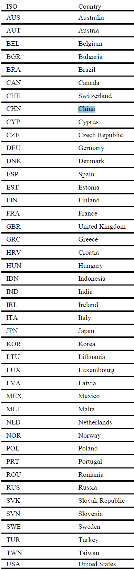

## 2.2 Emission sectors

|  |  |
| --- | --- |
| **Emission sectors** | |
| AGR | Non-combustion agricultural sector |
| ENE | Energy transformation and extraction |
| IND | Industrial combustion and processes |
| TRA | Surface Transportation (Road, Rail, Other) |
| RCO | Residential, commercial, and other |
| SLV | Solvents |
| WST | Waste disposal and handling |
| SHP | International shipping |

## 2.3 Pollutants of different emission sectors

|  |  |  |  |  |  |  |  |  |
| --- | --- | --- | --- | --- | --- | --- | --- | --- |
| Emission sector Pollutants | AGR | ENE | IND | TRA | RCO | SLV | WST | SHP |
| VOC |  | ✔ | ✔ | ✔ | ✔ | ✔ | ✔ | ✔ |
| PM2_5 |  | ✔ | ✔ | ✔ | ✔ | ✔ | ✔ | ✔ |
| CH4 | ✔ | ✔ | ✔ | ✔ | ✔ | ✔ | ✔ | ✔ |
| CO |  | ✔ | ✔ | ✔ | ✔ | ✔ | ✔ | ✔ |
| CO2 |  | ✔ | ✔ | ✔ | ✔ | ✔ | ✔ | ✔ |
| NH3 | ✔ | ✔ | ✔ | ✔ | ✔ | ✔ | ✔ | ✔ |
| NOx | ✔ | ✔ | ✔ | ✔ | ✔ | ✔ | ✔ | ✔ |
| SOx |  | ✔ | ✔ | ✔ | ✔ | ✔ | ✔ | ✔ |

|  |  |  |  |  |  |  |  |  |
| --- | --- | --- | --- | --- | --- | --- | --- | --- |
| Emission sector Pollutants | AGR | ENE | IND | TRA | RCO | SLV | WST | SHP |
| VOC |  | ✔ | ✔ | ✔ | ✔ | ✔ | ✔ | ✔ |
| PM2_5 |  | ✔ | ✔ | ✔ | ✔ | ✔ | ✔ | ✔ |
| CH4 | ✔ | ✔ | ✔ | ✔ | ✔ | ✔ | ✔ | ✔ |
| CO |  | ✔ | ✔ | ✔ | ✔ | ✔ | ✔ | ✔ |
| CO2 |  | ✔ | ✔ | ✔ | ✔ | ✔ | ✔ | ✔ |
| NH3 | ✔ | ✔ | ✔ | ✔ | ✔ | ✔ | ✔ | ✔ |
| NOx | ✔ | ✔ | ✔ | ✔ | ✔ | ✔ | ✔ | ✔ |
| SOx |  | ✔ | ✔ | ✔ | ✔ | ✔ | ✔ | ✔ |

# 3. Create satellite account

## 3.1 Match emission sectors with economic sectors

There are 56 economic sectors in WIOT database but just 8 emission sectors in CEDS. We have to match those emission sectors with economic sectors.

The following table shows the matching.

|  |  |
| --- | --- |
| **Sectors in WITO table (Economic sectors)** | **Classification** |
| 1 A01 Crop and animal production, hunting and related service activities | AGR |
| 2 A02 Forestry and logging | AGR |
| 3 A03 Fishing and aquaculture | AGR |
| 4 B Mining and quarrying | ENE |
| 5 C10-C12 Manufacture of food products, beverages and tobacco products | IND |
| 6 C13-C15 Manufacture of textiles, wearing apparel and leather products | IND |
| 7 C16 Manufacture of wood and of products of wood and cork, except furniture; etc. | IND |
| 8 C17 Manufacture of paper and paper products | IND |
| 9 C18 Printing and reproduction of recorded media | IND |
| 10 C19 Manufacture of coke and refined petroleum products | IND |
| 11 C20 Manufacture of chemicals and chemical products | IND |
| 12 C21 Manufacture of basic pharmaceutical products and pharmaceutical preparations | IND |
| 13 C22 Manufacture of rubber and plastic products | IND |
| 14 C23 Manufacture of other non-metallic mineral products | IND |
| 15 C24 Manufacture of basic metals | IND |
| 16 C25 Manufacture of fabricated metal products, except machinery and equipment | IND |
| 17 C26 Manufacture of computer, electronic and optical products | IND |
| 18 C27 Manufacture of electrical equipment | IND |
| 19 C28 Manufacture of machinery and equipment n.e.c. | IND |
| 20 C29 Manufacture of motor vehicles, trailers and semi-trailers | IND |
| 21 C30 Manufacture of other transport equipment | IND |
| 22 C31_C32 Manufacture of furniture; other manufacturing | IND |
| 23 C33 Repair and installation of machinery and equipment | IND |
| 24 D Electricity, gas, steam and air conditioning supply | ENE |
| 25 E36 Water collection, treatment and supply | ENE |
| 26 E37-E39 Sewerage; waste collection, treatment and disposal activities; materials recovery; etc. | WST |
| 27 F Construction | IND |
| 28 G45 Wholesale and retail trade and repair of motor vehicles and motorcycles | RCO |
| 29 G46 Wholesale trade, except of motor vehicles and motorcycles | RCO |
| 30 G47 Retail trade, except of motor vehicles and motorcycles | RCO |
| 31 H49 Land transport and transport via pipelines | ENE |
| 32 H50 Water transport | SHP |
| 33 H51 Air transport | SHP |
| 34 H52 Warehousing and support activities for transportation | TRA |
| 35 H53 Postal and courier activities | TRA |
| 36 I Accommodation and food service activities | RCO |
| 37 J58 Publishing activities | RCO |
| 38 J59_J60 Motion picture, video and television programme production, sound recording and music publishing activities; etc. | RCO |
| 39 J61 Telecommunications | RCO |
| 40 J62_J63 Computer programming, consultancy and related activities; information service activities | RCO |
| 41 K64 Financial service activities, except insurance and pension funding | RCO |
| 42 K65 Insurance, reinsurance and pension funding, except compulsory social security | RCO |
| 43 K66 Activities auxiliary to financial services and insurance activities | RCO |
| 44 L Real estate activities | RCO |
| 45 M69_M70 Legal and accounting activities; activities of head offices; management consultancy activities | RCO |
| 46 M71 Architectural and engineering activities; technical testing and analysis | RCO |
| 47 M72 Scientific research and development | RCO |
| 48 M73 Advertising and market research | RCO |
| 49 M74_M75 Other professional, scientific and technical activities; veterinary activities | RCO |
| 50 N Rental and leasing activities, Employment activities, Travel services, security and services to buildings | RCO |
| 51 O Public administration and defence; compulsory social security | RCO |
| 52 P Education | RCO |
| 53 Q Human health and social work activities | RCO |
| 54 R-S Creative, Arts, Sports, Recreation and entertainment activities and all other personal service activities | RCO |
| 55 T Activities of households as employers; undifferentiated goods- and services-producing activities of households for own use | RCO |
| 56 U Activities of extra-territorial organisations and bodies | RCO |

Specifically, we have the following classifications: Construction – IND; Land transport via pipelines – ENE; Water transport and Air transport – SHP; What belongs to IND or RCO also belongs to SLV. Those classifications are mainly based on the tables below.

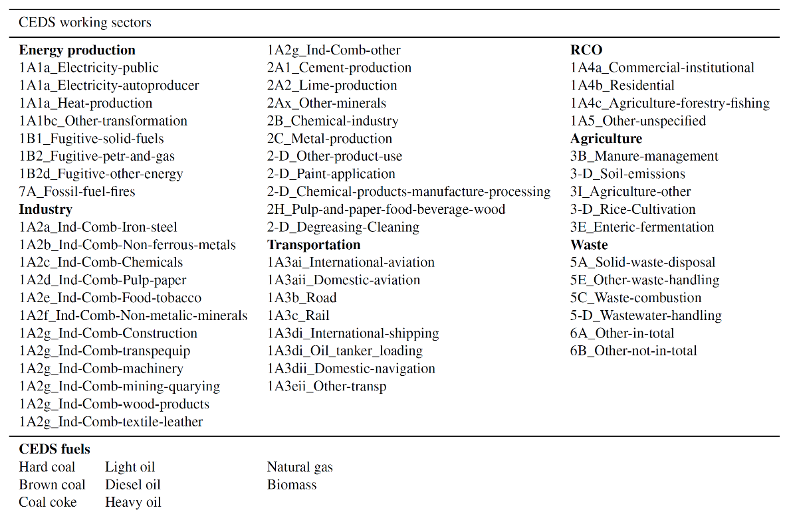

## 3.2 Calculation

First, we want to specify some notation.

I: set of 56 economic sectors in each region ($I_{1}$: AGR sectors (economic sectors that belong to AGR emission sector; $I_{2}$: ENE sector; $I_{3}$: IND sector; $I_{4}$: TRA sector; $I_{5}$: RCO sector; $I_{6}$: SLV sector; $I_{7}$: WST sector; $I_{8}$: SHP sector)

J: set of 44 regions

K: set of 8 kinds of air pollutants

(1) Emission fraction

Emission fraction is for each economic sector of each country.

$${Emission fraction}_{i,j}=\frac{ {Output}_{i,j}}{\sum_{I_{1}}{{Output}_{i,j}}}, i∈I_{1},j∈J$$

For example, AGR emission sector has three economic sectors: A01, A02 and A03. Then the emission fraction of A01 sector of Australia (AUS) should be：

$${Emission fraction}_{A01,AUS}=\frac{ {Output}_{A01,AUS}}{{Output}_{A01,AUS}+{Output}_{A02,AUS}+{Output}_{A03,AUS}}$$

(2) Emission amount

Emission amount of different pollutants is also for each economic sector of each country.

$${Emission amount}_{i,j,k}= {Emission fraction}_{i,j}×{Emission amount}_{j,I_{1},k} i∈I_{1},j∈J,k∈K$$

Note that ${Emission amount}_{j,I_{1},k}=\sum_{I_{1}}{{Emission amount}_{i,j,k}}$, which is the known value.

Still take the A01 sector of Australia (AUS) as example, the emission amount of this sector should be:

$${Emission amount}_{A01,AUS,CH4}= {Emission fraction}_{A01,AUS}×{Emission amount}_{AUS,AGR,CH4}$$

# 4. Leontief Inverse

$$Leontief Inverse={(I-A)}^{-1}$$

Where A is the technology matrix and I is the identity matrix with the same size as A.

## 4.1 Technology matrix

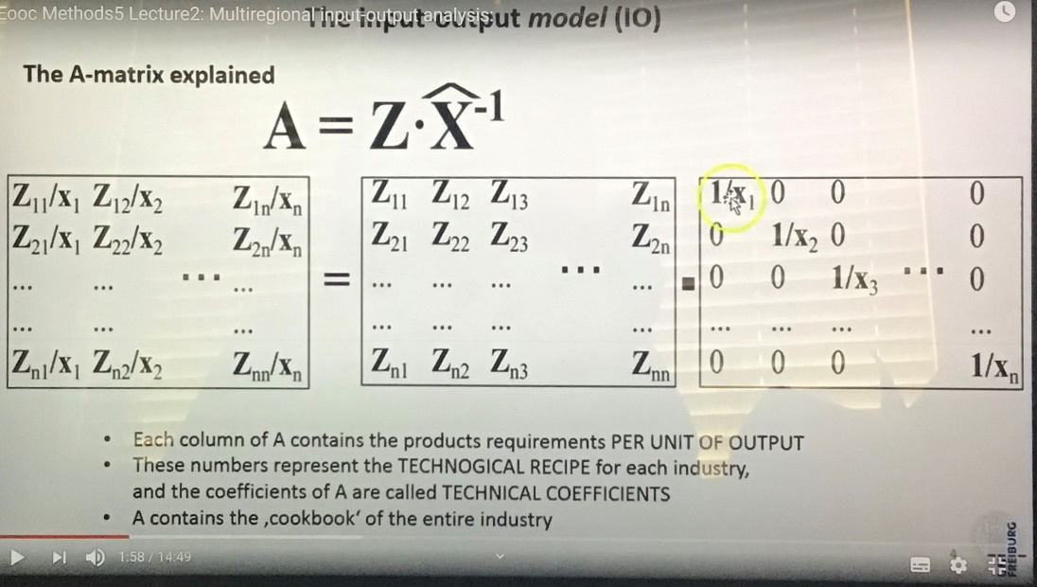

The Z matrix is the intermediate transaction among economic sectors. For example, element $Z_{ii'}$ is the intermediate output from sector i to sector i’.

The X matrix is the diagonal matrix composed of total output from each economic sector. For example, $X_{i}$ is the total output from sector i.

## 4.2 Leontief Inverse

$$Leontief Inverse={(I-A)}^{-1}$$

## 4.3 Check for correctness

After the calculation, we should check whether our calculation satisfy the function below:

$${(I-A)}^{-1}×D=X$$

Where ${(I-A)}^{-1}$ is the Leontief inverse; D is the total demand vector, and the element $D_{i}$ stands for the total demand of the whole world for the economic sector i; X is the total output vector, and the element $X_{i}$ stands for the total output from sector i.

# 5. Consumption-based emissions

## 5.1 Total emissions

### Step 1: Calculate the total output from each economic sector to each country

(1) Demand

First, we sum up each country’s final demand for each economic sector. As we can see below, each country mainly has five final demand: CONS_h, CONS_np, CONS_g, GFCF and INVEN. The summation of each five values gives us the total final demand of a country for an economic sector. For example, Australia’s final demand for sector A01 of AUS is 13021 million dollars. Therefore, for each country, we would have a column vector D’ that stands for this country’s demand for each economic sector. For example, $D_{1}^{AUS}$ stands for Australis’s demand for the first economic sector, which is the A01 sector of Australia.

As we can see below, Australia's final demand needs 13021 million dollars of goods from the first economic sector of AUS, 257 from the second sector of AUS; Austin's final demand needs 0.5766 million dollars of goods from the first economic sector of AUS.

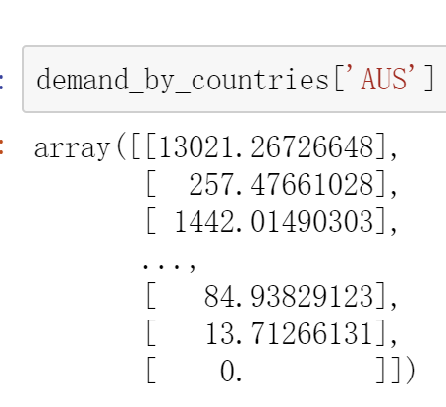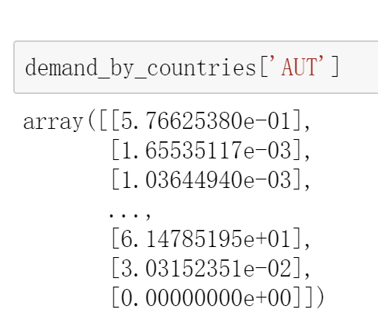

(2) Output

Then, we can calculate the total output from each sector using the function ${(I-A)}^{-1}×D'=X'$, where D’ is what we’ve derived just now. X’ is what we want to get, and it’s also a vector for each country.

$$X^{AUS}=\begin{matrix}Output from sector 1 \\ Output from sector 2 \\ ⋮\end{matrix}$$

For example, $X_{1}^{AUS}$ is the total output from the first sector (AUS A01) in order to satisfy the demand of Australia.

As we can see below, the first sector of AUS provides 44097 million dollars of products to Australia (the output from Australia's A01 sector to Australia is 44097 million dollars); The first sector of AUS provides 28.5 million dollars of products to Austin (the output from Australia's A01 sector to Austin is 28.5 million dollars).

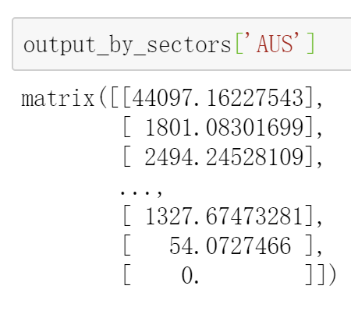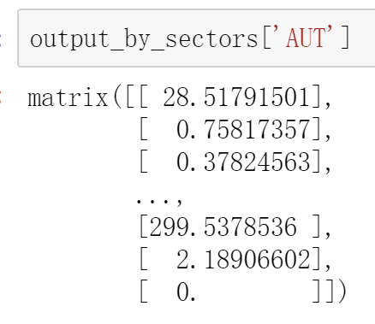

(3) Check for correctness

At the end of this step, we want to check whether our calculation is logical and valid. I add up the all output vectors for each country and see whether the outcome equals to the total output of each economic sector.

### Step 2: Calculate emission factors

$${Emission factor}_{k}^{i} = \frac{Emission amount of pollutant k from economic sector i}{Total output from economic sector i} (kg/million dollars)$$

Emission factor gives us a particular sector’s estimated emission of one kind of pollutant per million dollars of output.

### Step 3: Calculate consumption-based emissions for each country

First, we calculate the emission amount of each pollutants produced by each country’s each sector.

$${Consumption-based emission}_{i,j,k}={Emission factor}_{k}^{i}×X_{i}^{j},∀i∈I,∀j∈J,∀k∈K$$

Recall that I is the set of economic sectors, J is the set of regions and K is the set of pollutants.

Then, we calculate the emission amount of each pollutants produced by each country. In this step, we simply add up all sectors’ emissions of one country to get the total emissions.

$${Total consumption-based emission}_{j,k}=\sum_{I}{{Consumption-based emission}_{i,j,k}}, ∀j∈J,∀k∈K$$

## 5.2 Emissions per capita

$${Consumption-based emission per capita}_{j,k}=\frac{{Total consumption-based emission}_{j,k}}{{Population}_{j}}$$

## 5.3 Emissions per million dollars of consumption/demand

$${ Consumption-based emissions per million dollars of consumption}_{j,k}=\frac{{Total consumption-based emission}_{j,k}}{{Total final demand}_{j}}$$

# 6. Production-based emissions

## 6.1 Total emissions

Recall that when we create the satellite account, we’ve already derived the ${Emission amount}_{i,j,k}$, which is exactly the emission due to production, and here we denote it as ${Production-based emission}_{i,j,k}$ Therefore, to derive the total production-based emissions for one particular country, we just need to sum up all the sectors’ emissions for one kind of pollutants.

$${Total production-based emission}_{j,k}=\sum_{I}{{Production-based emission}_{i,j,k},∀j∈J,∀k∈K}$$

## 6.2 Emissions per capita

$${Production-based emission per capita}_{j,k}=\frac{{Total production-based emission}_{j,k}}{{Population}_{j}}$$

# 7. Percentage of emissions due to consumption in that and other regions

From previous calculation, we already have ${Consumption-based emission}_{i,j,k}$, which is the pollutant k’s emission from economic sector i due to region j’s consumption. And we also have ${Total consumption-based emission}_{j,k}$, which is the total pollutant k’s emission due to region j’s consumption.

$${Consumption-based emission percentage}_{j,j',k} = \frac{\sum_{sectors that are in j' region}{{Consumption-based emission}_{i,j,k}}}{\sum_{I}{{Consumption-based emission}_{i,j,k}}}$$