MARTIAL VOYAGE
A Main Project Report submitted by
SARAN S KRISHNAN
(MES24MCA2049)
to the APJ Abdul Kalam Technological University in partial fulfilment of the requirements for the award of the Degree
of
Master of Computer Applications



Department of Computer Applications
MES College of Engineering
Kuttippuram, Malappuram – 679582

April, 2026

Declaration

I undersigned hereby declare that the project report “MARTIAL VOYAGE” submitted for partial fulfilment of the requirements for the award of degree of Master of Computer Applications of the APJ Abdul Kalam Technological University, Kerala, is a bonafide work done by me under supervision of Mr.Balachandran KP, Associate Professor, Department of Computer Applications. This submission represents my ideas in my own words and where ideas or words of others have been included, I have adequately and accurately cited and referenced the original sources. I also declare that I have adhered to ethics of academic honesty and integrity and have not misrepresented or fabricated any data or idea or fact or source in my submission. I understand that any violation of the above will be a cause for disciplinary action by the institute and/or the University and can also evoke penal action from the sources which have thus not been properly cited or from whom proper permission has not been obtained. This report has not been previously formed the basis for the award of any degree, diploma or similar title of any other University.

Saran S Krishnan
(MES24MCA2049)

MES COLLEGE OF ENGINEERING, KUTTIPPURAM


DEPARTMENT OF COMPUTER APPLICATIONS
CERTIFICATE

This is to certify that the report entitled MARTIAL VOYAGE is a bonafide record of the Mini Project work during the year 2025-26 carried out by SARAN S KRISHNAN (MES24MCA2049) submitted to the APJ Abdul Kalam Technological University, in partial fulfilment of the requirements for the award of the Master of Computer Applications, under my guidance and supervision. This report in any form has not been submitted to any other University or Institution for any purpose.

Internal Supervisor Head of The Department
External Examiner

Acknowledgment

I express my sincere gratitude to our principal Dr.Rahumathuniza I for permitting and providing all facilities to carryout this project. I would like to express my sincere gratitude to my internal supervisor, Mr. Balachandhran KP, for his invaluable guidance, support, and encouragement throughout the development of this mini project. I also extend my thanks to the Head of the Department Prof. Balachandhran KP and all faculty members of the Department of Computer Applications, MES College of Engineering, for providing the necessary resources and a conducive environment for learning and innovation.
I am deeply grateful to my fellow martial artists and peers who inspired the vision behind Martial Voyage. Their insights and experiences shaped the direction of this project.
Finally I thank my family and friends for their unwavering support and motivation. Above all, I extend my heartfelt gratitude ot Almighty for giving me the strength and wisdom to complete this project.

Saran S Krishnan
(MES24MCA2049)

Abstract

The global martial arts community, despite its massive scale and shared dedication to personal growth, has long been hindered by digital fragmentation. Practitioners are frequently forced to navigate a disjointed array of generalized platforms for community engagement, specialized commerce, and performance tracking. Martial Voyage addresses this critical gap as a pioneering, purpose-built web application designed to unify the martial arts world within a single, cohesive digital ecosystem. By meticulously integrating e-commerce, social networking, and progress management, the platform eliminates the inefficiencies of the current landscape and provides a centralized, dedicated solution tailored specifically to the unique lifestyle and requirements of modern martial artists.
At its functional core, Martial Voyage is built on three interactive pillars. First, it features a curated, discipline-specific marketplace that provides practitioners safe and reliable access to high-quality training gear, apparel, and nutritional supplements. Second, it introduces a dedicated social and media-sharing network that filters out the noise of traditional social media, allowing users to connect with peers, share techniques, find sparring partners, and build meaningful relationships within their specific disciplines. Finally, the application offers an advanced suite of personal progression tools, enabling users to digitally log their daily training regimens, document belt promotions, and maintain a comprehensive archive of their competition history and personal achievements.
To support this multifaceted environment, Martial Voyage is built upon a highly responsive and scalable modern technology stack. The application utilizes JavaScript for dynamic, cross-platform frontend development, ensuring an intuitive and accessible user experience across various devices. The backend infrastructure is powered by Firebase, which handles secure authentication, real-time database management, and instantaneous updates crucial for the platform’s social and commerce features. Additionally, the system leverages Amazon Web Services (AWS) for secure, high-performance hosting, ensuring maximum uptime and data integrity as the community scales.
This report comprehensively outlines the development lifecycle of the Martial Voyage project. It details the initial motivations and strategic objectives, provides an in-depth analysis of the system architecture, and explores the implementation methodologies employed to bring the concept to life. Ultimately, this document illustrates how Martial Voyage culminates in a robust, innovative platform that fundamentally empowers martial artists to connect, grow, and thrive in their continuous pursuit of mastery.
Table of Contents
MARTIAL VOYAGE i
Chapter 1. Introduction 1
1.1 Motivation 1
1.2 Objectives 1
The primary objective of Martial Voyage is to develop a mobile application that: 1
1.3 Contributions 2
1.4 Report Organization 2
Chapter 2. System Study 3
2.1 Existing System 3
2.2 Proposed System 3
2.3 Functionalities of Proposed System 3
Chapter 3. Methodology 5
3.1 Introduction 5
3.2 Software Tools 5
3.3 Module Description 5
3.4 User Story 6
3.5 Product Backlog 6
3.6 Sprint Backlog 6
3.7 Project Plan 7
3.8 Database Design 7
Chapter 4. Results and Discussions 9
4.1 Results 9
Chapter 5. Conclusion and Future Scope 15
References 16
Appendix 17
Appendix A Data Flow Diagram 17
Appendix C Source Code 18
1. Sign Up Page. 18
2. Sign In Page 19
3. Dashboard 19
4. Martial Track Menu 20
5. Progress Tracker Bar 21
6. Timer 21
7. Choosing Level 22
8. Martial-Mart 23
9. Martial-Connect 25
Appendix D Screenshot 27
1. Sign Up Page 27
2. Sign In Page 27
3. Dashboard 28
4. Martial Track Menu 28
5. Progress Tracker Bar 29
7. Choosing Level 30
8. Martial-Mart home page 30
9. Martial-Connect homepage 31
10. Product Details 31
11. Product Kart 32
12. Messaging 32
13. Authentication 33
14. Database 33
15. Git History 34

Chapter 1. Introduction
Martial arts is not just a sport—it is a philosophy, a discipline, and a lifestyle embraced by millions worldwide. Despite its rich cultural heritage and widespread practice, the digital infrastructure supporting martial artists remains fragmented. Existing platforms often dilute martial arts content with unrelated material, making it difficult for practitioners to find authentic gear, track progress, or engage with like-minded individuals.
Martial Voyage aims to bridge this gap by offering a unified platform exclusively for martial artists. It combines e-commerce, social networking, and personal development tools into a single application. The platform is designed to support practitioners across disciplines like Karate, Taekwondo, Muay Thai, Jiu-Jitsu, and Kung Fu.
The project falls under the domain of full-stack web and mobile development, with a focus on user-centric design and scalable architecture. The UI/UX is crafted to be intuitive, visually engaging, and responsive across devices, ensuring accessibility for users of all skill levels.
The problem addressed is the lack of a dedicated digital space for martial artists. Existing solutions are either too generic or fail to integrate commerce, community, and progress tracking effectively. Martial Voyage offers a holistic solution that celebrates martial arts culture and supports practitioners' growth.

1.1 Motivation
It has been found that the martial artists have personally experienced the challenges of navigating multiple platforms to meet training, gear, and community needs. The absence of a unified digital space that understands and caters to the unique lifestyle of martial artists inspired the creation of Martial Voyage. This project is not just a technical endeavor—it is a personal mission to empower martial artists through technology.
The motivation stems from the desire to build a platform that reflects the values of discipline, growth, and community inherent in martial arts. By integrating commerce, content, and progress tracking, Martial Voyage aims to simplify and enrich the journey of every practitioner. -Introduction

1.2 Objectives

The primary objective of Martial Voyage is to develop a mobile application that:
- Empowers users to track and analyze their martial arts journey.
- Fosters a vibrant, discipline-specific social network.
- Centralizes martial arts-related commerce through a curated marketplace.

1.3 Contributions
Key contributions of Martial Voyage include:
- A dedicated e-commerce hub for martial arts gear and nutrition.
- A social media platform focused solely on martial arts content.
- A progress tracker for training, belt promotions, and competition history.
- Integration of Firebase for real-time updates and AWS for secure media storage.
These contributions address the limitations of existing systems and offer a comprehensive solution tailored to the martial arts community.

1.4 Report Organization
The report is organized in such a way that the chapter 2 gives the overview of the existing system and the proposed solution, chapter 3 describes the development approach tools used and the details of the modules that are designed, chapter 4 summerizes the outputs, various UI/UX designed and alterations on it, finally it summerizes the project archievements and the future scope in chapter 5.

Chapter 2. System Study
Martial Voyage is designed to address the fragmented digital experience faced by martial artists. The system aims to unify commerce, community, and personal progress tracking into a single, discipline-specific platform.

2.1 Existing System
Presently, martial artists rely on multiple platforms to fulfill their needs—e-commerce sites for gear, social media for community engagement, and spreadsheets or journals for tracking progress. These systems are generic and not tailored to martial arts, leading to inefficiencies, lack of personalization, and diluted content. For example, platforms like Instagram or Amazon do not offer martial arts-specific filters or features. This fragmentation hinders growth and community cohesion.
Improving upon these limitations, Martial Voyage proposes a unified solution that integrates all essential features into one seamless experience.

2.2 Proposed System
The proposed system, Martial Voyage, is a mobile-first application that centralizes martial arts commerce, social networking, and progress tracking. It offers:
- A curated marketplace for gear, nutrition, and event tickets.
- A media-sharing platform focused solely on martial arts content.
- A personal dashboard for tracking training, belt promotions, and competition history.
Technologically, the system uses React Native for cross-platform development, Django REST for backend services, and Firebase for real-time updates. It is designed to be scalable, secure, and user-friendly.
Target users include martial artists of all levels, instructors, academies, and vendors specializing in martial arts products.
-Methodology

2.3 Functionalities of Proposed System
- E-Commerce Hub:
  - Marketplace for gear, apparel, weapons, nutrition, and event tickets.
  - Vendor onboarding and discipline-specific product categorization.
  - Secure payment integration with Stripe and Razorpay.
- Entertainment & Social Network:
  - Media sharing: photos, videos, reels, and stories.
  - Follower system, hashtags, and content discovery.
  - Personal branding tools for fighters, instructors, and academies.
- Progress Tracker:
  - Training logs and belt promotion records.
  - Goal-setting and fitness analytics.
  - Journal entries and performance insights.

Chapter 3. Methodology

3.1 Introduction
To develop Martial Voyage, an Agile methodology was adopted. Agile promotes iterative development, continuous feedback, and adaptive planning—ideal for building user-centric applications like this one. The project was divided into sprints, each focusing on specific modules such as e-commerce, social networking, and progress tracking. This approach ensured flexibility, faster delivery, and better alignment with user needs.

3.2 Software Tools
Operating System | Windows 11
Front End | JavaScript, HTML, CSS etc..
Back End | Firebase
Database | Firebase
IDE | Visual Studio Code
Version Control | Git
Table 3.2: List of software tools or languages used for the project development

3.3 Module Description
The system is divided into modular components to ensure maintainability and scalability.

3.3.1 User Authentication Module
This model handles the signup and signin of the users. Ensures login for only registered users.

3.3.2 Progress Tracker Module
This module empowers users to log their martial arts journey. They can choose martial arts of their choice and can start their journey. Each can focus on their own martial arts and can train with the syllabus already provided in the page and also they can set timer for each section. They can also choose their level and start working according to their belt level.

3.4 User Story
Role | Goal | Benefit
Martial Artist | Buy gear and track progress | Saves time and improves focus
Instructor | Share content and manage students | Builds reputation and engagement
Vendor | Sell martial arts products | Reaches targeted audience
Table 3.4: User Story

3.5 Product Backlog
ID | Name | Priority | Estimate(hrs) | Status
1 | User Registration | High | 5 | Completed
2 | Login | High | 3 | Completed
3 | Progress Tracker | High | 20 | Completed
4 | Media Sharing | Medium | 20 | Completed
5 | Product Listing | Low | 20 | Completed
Table 3.5: Product Backlog

3.6 Sprint Backlog
Sprint | Task | Status
1 | Firebase Auth Setup | Completed
2 | UI Design for Login/Register | Completed
3 | Product API Integration | Completed
4 | Media Upload Feature | Completed
Table 3.6: Sprint Backlog
Chapter -Results and Discussions

3.7 Project Plan
User Story ID | Task Name | Start Date | End Date | Duration (Days) | Status
1 | Sprint 1 | 07/02/2026 | 09/02/2026 | 6 | Complete
2 |  | 12/02/2026 | 13/02/2026 |  | Complete
3 |  | 15/02/2026 | 16/02/2026 |  | Complete
4 | Sprint 2 | 19/02/2026 | 21/02/2026 | 5 | Complete
5 |  | 24/02/2026 | 25/02/2026 |  | Complete
6 | Sprint 3 | 28/02/2026 | 01/03/2026 | 4 | Complete
7 |  | 04/03/2026 | 05/03/2026 |  | Complete
8 | Sprint 4 | 10/03/2026 | 12/03/2026 | 6 | Complete
9 |  | 18/03/2026 | 20/03/2025 |  | Complete
Table 3.7: Project Plan

3.8 Database Design
The database schema includes collections of User details like Username, Email address.

Email | Provider | Created | Signed In | UID
sd@gmail.com | Email | Oct 5, 2023 | Oct 5, 2023 | g1f8s8a1u7m...
sd@gmail.com | Email | Oct 5, 2023 | Oct 5, 2023 | 1g1f8s8a1u7...
sd@gmail.com | Email | Oct 5, 2023 | Oct 5, 2023 | 2g1f8s8a1u7...
sd@gmail.com | Email | Oct 5, 2023 | Oct 5, 2023 | 3g1f8s8a1u7...
t1@gmail.com | Email | Oct 5, 2023 | Oct 5, 2023 | 4g1f8s8a1u7...
Table 3.8: Database Design
This table summarizes user authentication data for the MariaWorld-MVP Firebase project. It lists registered users along with their email addresses, authentication provider (Email), account creation and last sign-in dates, and unique Firebase-generated UIDs. All users were created and signed in on October 5, 2023, suggesting a coordinated onboarding event. The UID ensures each user is uniquely identifiable, even when email addresses repeat. This table supports backend integration, user management, and secure access control within the application.
Field Name | Value
Document ID | 1Hs5CNhEYPE...
createdAt | September 23, 2023 at 5:41:58 PM UTC-3
email | t@gmail.com
username | tm
Table 3.8: Database Design

Chapter 4. Results and Discussions

4.1 Results
The Martial Voyage application was successfully developed and tested across its core modules. Below are key screenshots and descriptions of the implemented features:
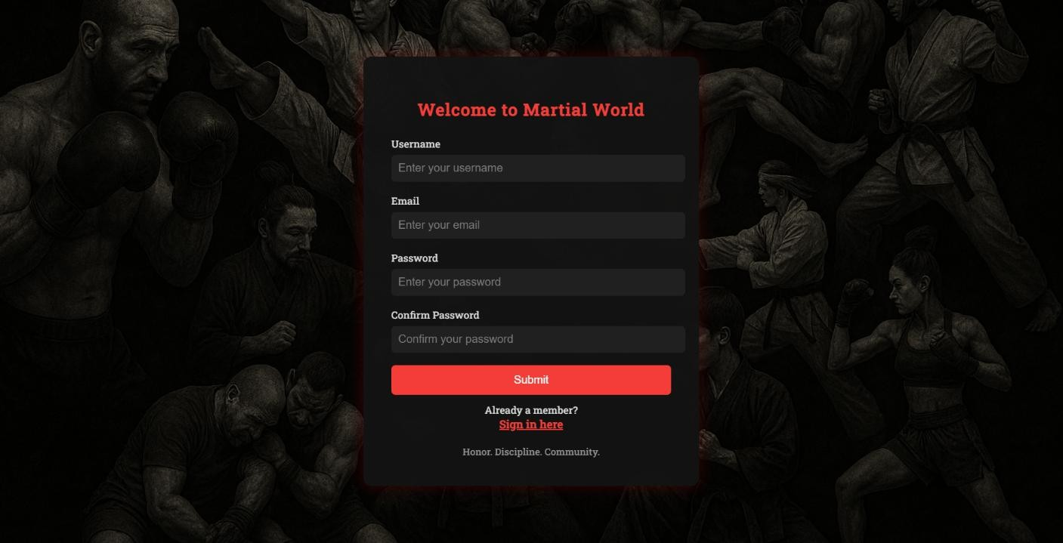
Figure 4.1: SignUp Page
This is the welcome screen of the app, featuring a clean UI with options to log in, register. It sets the tone for a martial arts-focused experience.
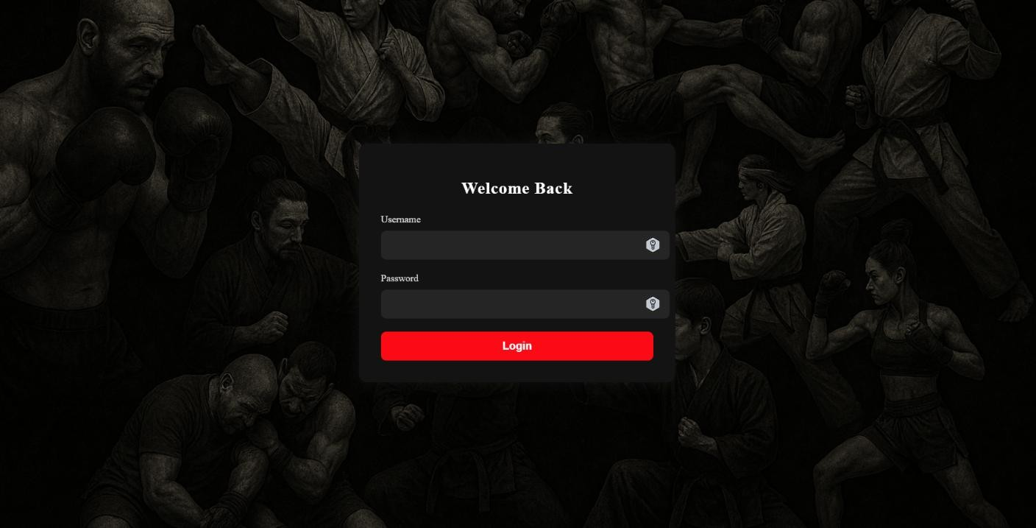
Figure 4.2: SignIn Page

Figure 4.3: Dashboard Page


Figure 4.4: Martial Track Page

Figure 4.5: Kungfu Page


Figure 4.6: Kungfu Tracking Page (Belt Levels)
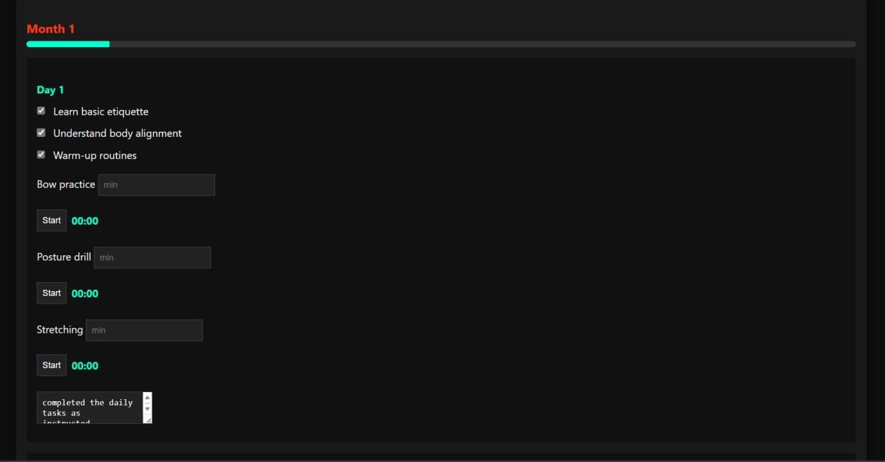
Figure 4.6.1: Kungfu Tracking Page (Timer and Checkbox)

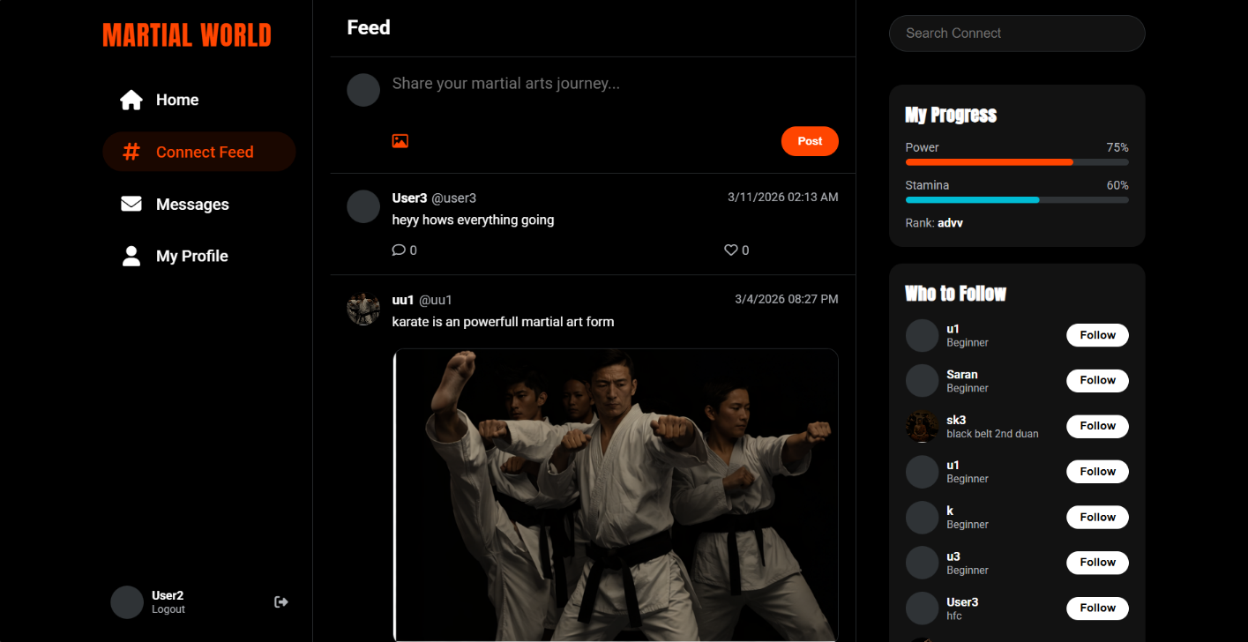
Figure 4.7: Martial Connect Page
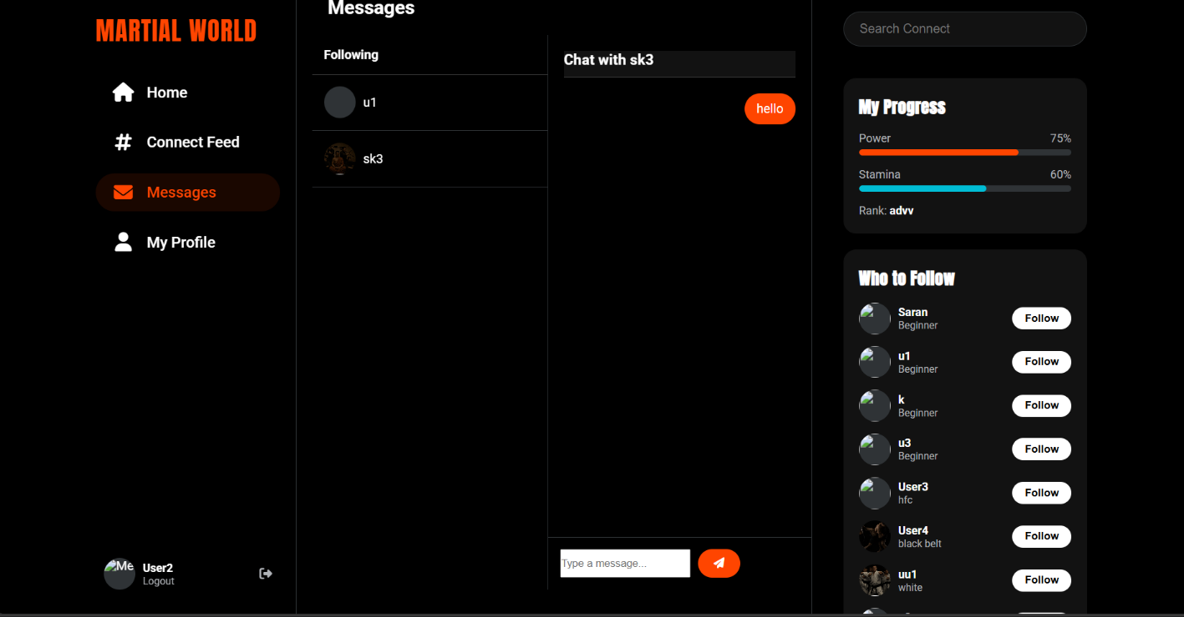
Figure 4.7.1: Martial Connect Page (Messaging system)
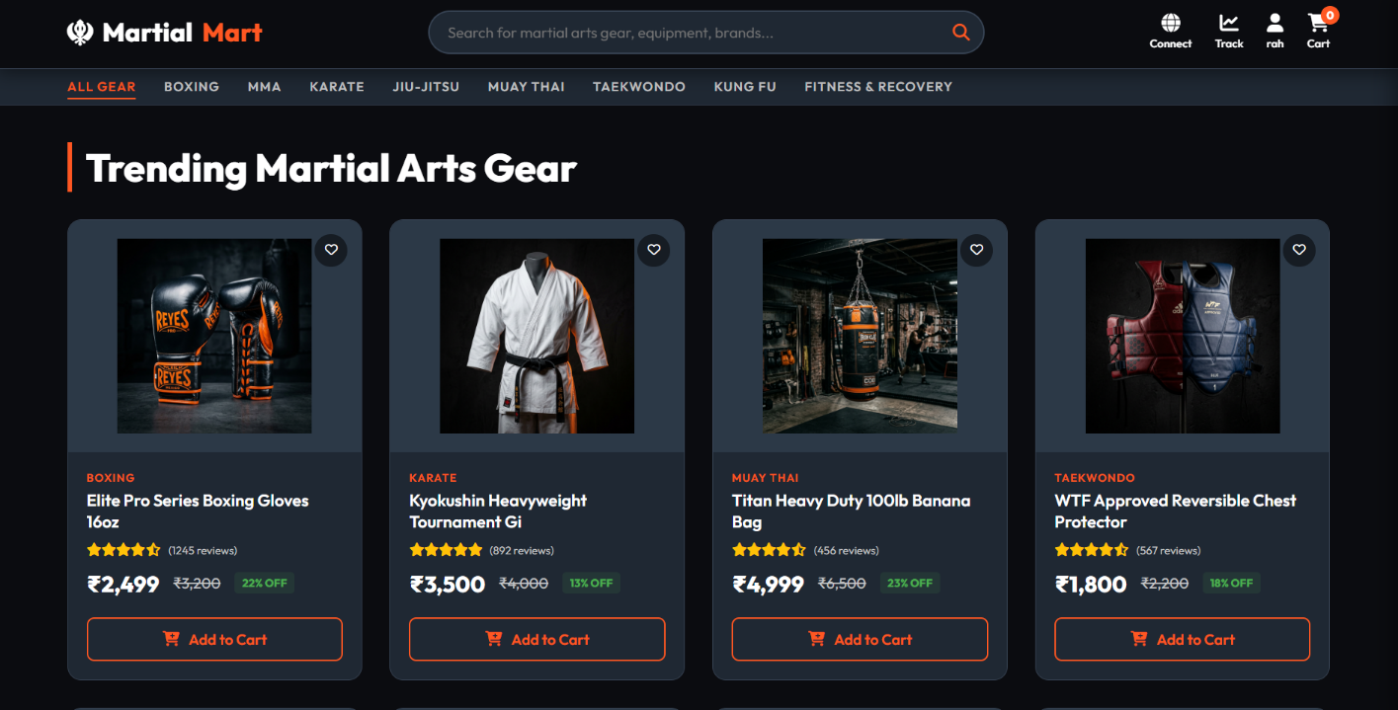
Figure 4.8: Martial Mart

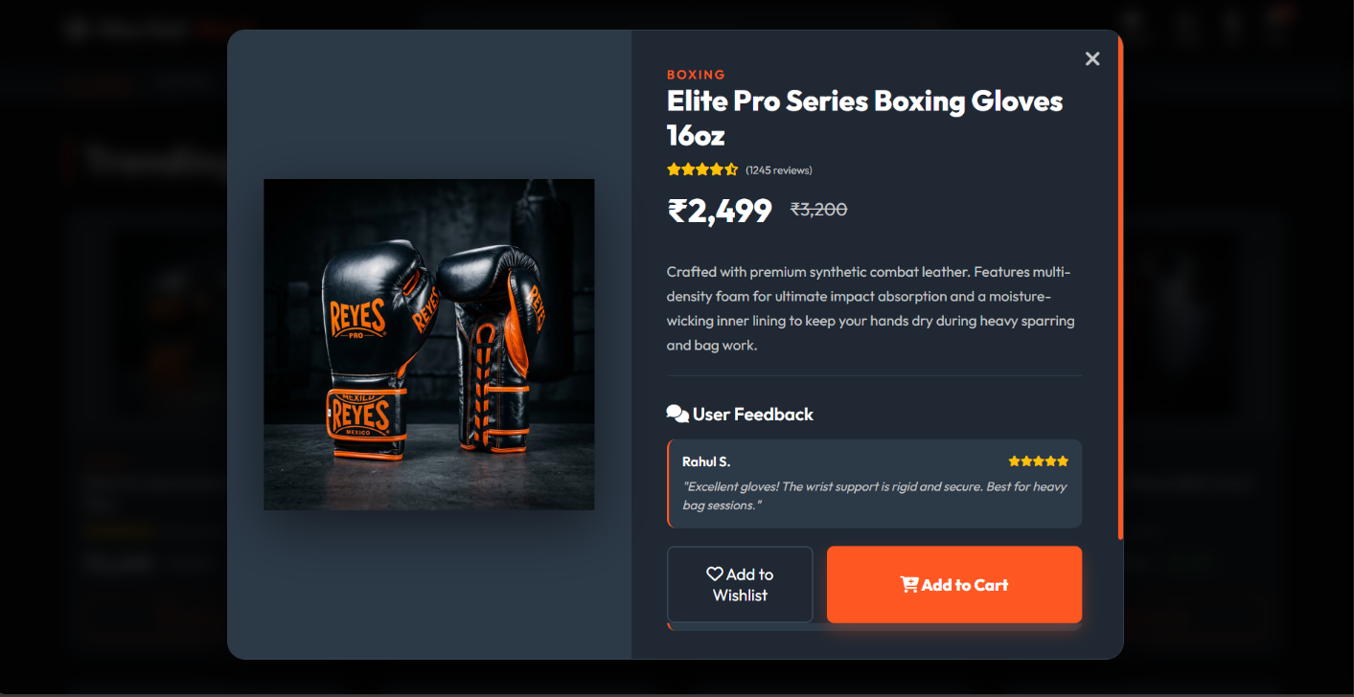

Figure 4.8.1: Martial Mart (Product Details)

Chapter 5. Conclusion and Future Scope
Martial Voyage is a comprehensive web application designed to unify the martial arts community through a dedicated digital ecosystem. It successfully integrates commerce, social networking, and personal development tools tailored to martial artists.
Key achievements include:
- A discipline-specific marketplace for gear and nutrition.
- A vibrant social platform for sharing martial arts content.
- A robust progress tracker for training, belt promotions.
The project demonstrates the power of full-stack development in solving real-world problems. While the MVP covers core functionalities, future enhancements could include creating own syllabus and academy management tools.
Limitations faced included time constraints for advanced features like live streaming and vendor analytics. These can be addressed in future iterations with extended development cycles and user feedback.

References

- Firebase, “Firebase Documentation,” Google LLC, [Online]. Available: https://firebase.google.com/docs. . [Accessed: 01 Oct 2025].
- WAKO India Kickboxing Federation, “National Kickboxing Guidelines,” [Online]. Available: https://wakoindia.org/. . [Accessed: 01 Oct 2025].
- "Getting started with Firebase on the Web" A concise walkthrough of setting up Firebase, including authentication, Firestore, and hosting. Ideal for web-based apps.
- HTML, CSS, and Javascript in 30 minutes A fast-paced crash course that introduces all three technologies in a single session—great for quick revision.
- Microsoft Copilot, AI Companion for Technical and Creative Assistance. [Online].
Available: https://copilot.microsoft.com. [Accessed: 06 Oct 2025].

Appendix

Appendix A Data Flow Diagram
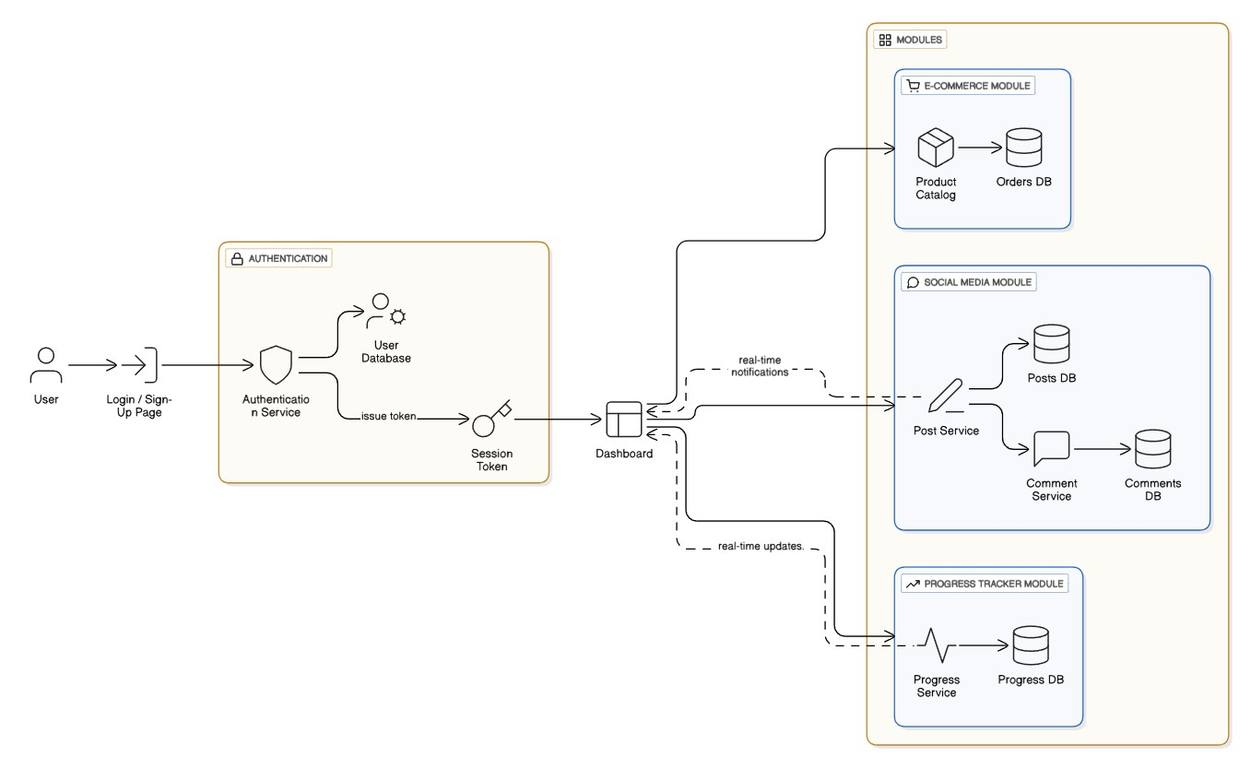

Appendix C Source Code

1. Sign Up Page.
<body>
<div class="login-container">
<h2>Welcome to Martial Voyage</h2>
<form id="loginForm">
<label for="username">Username</label>
<input type="text" id="username" placeholder="Enter your username" required />
<label for="email">Email</label>
<input type="email" id="email" placeholder="Enter your email" required />
<label for="password">Password</label>
<input type="password" id="password" placeholder="Enter your password" required />
<label for="confirmPassword">Confirm Password</label>
<input type="password" id="confirmPassword" placeholder="Confirm your password" required />
<button type="submit">Submit</button>
<div style="text-align: center; margin-top: 10px;">
<span style="color: #ccc; font-size: 0.9rem;">Already a member?</span>
<br />
<a href="signin.html" style="color: #e53935; text-decoration: underline; font-weight: bold;">Sign in here</a>
</div>
</form>
<div class="footer">Honor. Discipline. Community.</div>
</div>
</body>

2. Sign In Page
<body>
<div class="login-container">
<h2>Welcome Back</h2>
<form id="signinForm">
<label for="username">Username</label>
<input type="text" id="username" name="username" required />
<label for="password">Password</label>
<input type="password" id="password" name="password" required />
<button type="submit">Login</button>
</form>
</div>
</body>

3. Dashboard
<body>
<div class="section track">
<div class="section-content">
<h2>Martial Track</h2>
<p>Track your progress, training logs, and achievements here.</p>
<button onclick="location.href='martial-track.html'">Martial Track</button>
</div>
</div>
<div class="section connect">
<div class="section-content">
<h2>Martial Connect</h2>
<p>Connect with fellow martial artists, join forums, and share experiences.</p>
<button onclick="location.href='martial-connect.html'">Martial Connect</button>
</div>
</div>
<div class="section mart">
<div class="section-content">
<h2>Martial Mart</h2>
<p>Shop for gear, apparel, and training equipment tailored for martial arts.</p>
<button onclick="location.href='martial-mart.html'">Martial Mart</button>
</div>
</div>
<div id="mouse-light"></div>
<div class="logout-container">
<button onclick="logout()">Logout</button>
</div>
</body>

4. Martial Track Menu
<body>
<div class="overlay">
<h2>Martial Track</h2>
<form id="styleForm">
<label for="martialArt">Choose your martial art style:</label>
<select id="martialArt" required>
<option value="">-- Select Style --</option>
<option value="Kungfu">Kungfu</option>
<option value="Karate">Karate</option>
<option value="Taekwondo">Taekwondo</option>
<option value="Muay Thai">Muay Thai</option>
<option value="Boxing">Boxing</option>
<option value="Kickboxing">Kickboxing</option>
<option value="MMA">MMA</option>
</select>
</form>
<div id="descriptionBox">
<h3 id="styleTitle"></h3>
<p id="styleDescription"></p>
<button id="nextButton">Start Your Journey</buton>
</div>
</div>
</body>

5. Progress Tracker Bar
const progressPercent=totalGoals >0 ? Math.round((completedGoals / totalGoals) * 100) : 0; const progressFill = monthDiv.querySelector(`#progress-${belt}-${monthIndex}`); if (progressFill) { progressFill.style.width = `${progressPercent}%`;
}

6. Timer
function startTimer(button) { const exerciseDiv = button.closest(".exercise"); const input = exerciseDiv.querySelector(".timeInput"); const display = exerciseDiv.querySelector(".timer-display"); let minutes = parseInt(input.value); if (isNaN(minutes) || minutes <= 0) { alert("Enter a valid number of minutes."); return;
}
let seconds = minutes * 60; button.disabled = true; display.textContent = formatTime(seconds); const interval = setInterval(() => { seconds--; display.textContent = formatTime(seconds); if (seconds <= 0) { clearInterval(interval); button.disabled = false; display.textContent = "Time's up!"; playAlarm(); exerciseDiv.style.border = "2px solid #ff3c00";
}
}, 1000); } function formatTime(sec) { const m = Math.floor(sec / 60); const s = sec % 60; return `${m.toString().padStart(2, '0')}:${s.toString().padStart(2, '0')}`
}
function playAlarm() { const audio = new Audio("https://actions.google.com/sounds/v1/alarms/alarm_clock.ogg"); audio.play();
} updateSyllabus(); // Load default on page load

7. Choosing Level
function updateSyllabus() { const belt = document.getElementById("belt").value; const content = document.getElementById("beltContent"); const guide = document.getElementById("syllabusText"); const data = syllabusData[belt]; guide.innerHTML = `
<strong>Focus for ${belt.charAt(0).toUpperCase() + belt.slice(1)} Belt:</strong><br/> <ul>
<li><span style="color:#00ffcc;">Warm-up (5–10 min):</span> Stretching, breathing, light cardio</li>
<li><span style="color:#00ffcc;">Technique (15–20 min):</span> Practice key moves like <em>${data.exercises.join(', ')}</em></li>
<li><span style="color:#00ffcc;">Conditioning (10–15 min):</span> Strength drills, endurance work</li>
<li><span style="color:#00ffcc;">Reflection (5 min):</span> Write notes, review goals, track progress</li>
</ul>
<em>Tip:</em> Stay consistent. Mastery comes from repetition, discipline, and honest effort.
`;

8. Martial-Mart
<body>
<header class="navbar">
<a href="#" class="logo">
<i class="fa-solid fa-khanda"></i> Martial <span>Mart</span>
</a>

<div class="search-container">
<input type="text" id="searchInput" placeholder="Search for martial arts gear, equipment, brands...">
<button id="searchBtn"><i class="fa-solid fa-magnifying-glass"></i></button>
</div>

<div class="nav-icons">
<a href="martial-connect.html" class="nav-icon">
<i class="fa-solid fa-globe"></i> <span>Connect</span>
</a>
<a href="martial-track.html" class="nav-icon">
<i class="fa-solid fa-chart-line"></i> <span>Track</span>
</a>
<div class="nav-icon" id="user-profile-btn">
<i class="fa-solid fa-user"></i> <span id="nav-user-name">Login</span>
</div>
<div class="nav-icon" id="cart-icon">
<i class="fa-solid fa-cart-shopping"></i> <span>Cart</span>
<div class="cart-badge" id="cart-badge">0</div>
</div>
</div>
</header>
<nav class="categories-bar" id="category-bar">
<div class="category-item active" data-category="All">All Gear</div>
<div class="category-item" data-category="Boxing">Boxing</div>
<div class="category-item" data-category="MMA">MMA</div>
<div class="category-item" data-category="Karate">Karate</div>
<div class="category-item" data-category="Jiu-Jitsu">Jiu-Jitsu</div>
<div class="category-item" data-category="Muay Thai">Muay Thai</div>
<div class="category-item" data-category="Taekwondo">Taekwondo</div>
<div class="category-item" data-category="Kung Fu">Kung Fu</div>
<div class="category-item" data-category="Fitness">Fitness & Recovery</div>
</nav>
</body>

9. Martial-Connect
<body>
<div class="modal-overlay" id="onboardingModal">
<div class="modal">
<h2>Complete Your Dojo Profile</h2>
<p style="text-align: center; margin-bottom: 20px; color: #b0b3b8;">Enter the martial world fully.</p>
<form id="onboardingForm">
<div class="form-group" style="text-align:center;">
<img id="onboardingPreview" src="https://via.placeholder.com/100" class="user-avatar-large"
style="margin-bottom:10px;">
<br>
<label style="cursor:pointer; color:var(--accent-color); font-weight:bold;">
Upload Photo
<input type="file" id="profilePicFile" accept="image/*" style="display:none;">
</label>
</div>
<div class="form-group">
<label>Main Discipline (Interest)</label>
<select id="martialArtInterest" class="form-select">
<option value="Any">General Enthusiast</option>
<option value="Karate">Karate</option>
<option value="Boxing">Boxing</option>
<option value="MMA">MMA</option>
<option value="Muay Thai">Muay Thai</option>
<option value="Kung Fu">Kung Fu</option>
<option value="Taekwondo">Taekwondo</option>
<option value="Kickboxing">Kickboxing</option>
</select>
</div>
<div class="form-group">
<label>Current Rank / Level</label>
<input type="text" id="userRank" class="form-input" placeholder="e.g. White Belt, Amateur, Pro" required>
</div>
<div class="form-group">
<label>Bio & Philosophy</label>
<textarea id="userBio" class="form-textarea" placeholder="Tell us about your journey..." required></textarea>
</div>
<button type="submit" class="btn-submit">Enter the Dojo</button>
</form>
</div>
</div>

Appendix D Screenshot

1. Sign Up Page
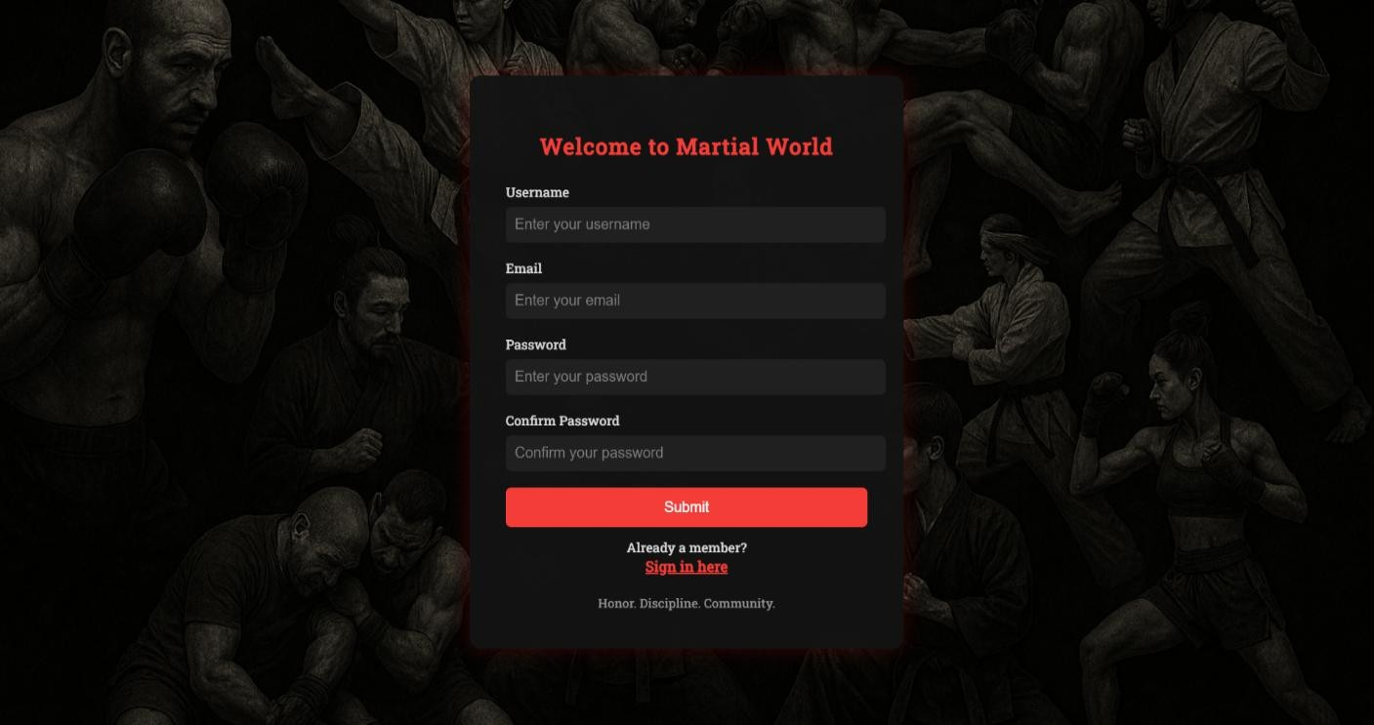

2. Sign In Page
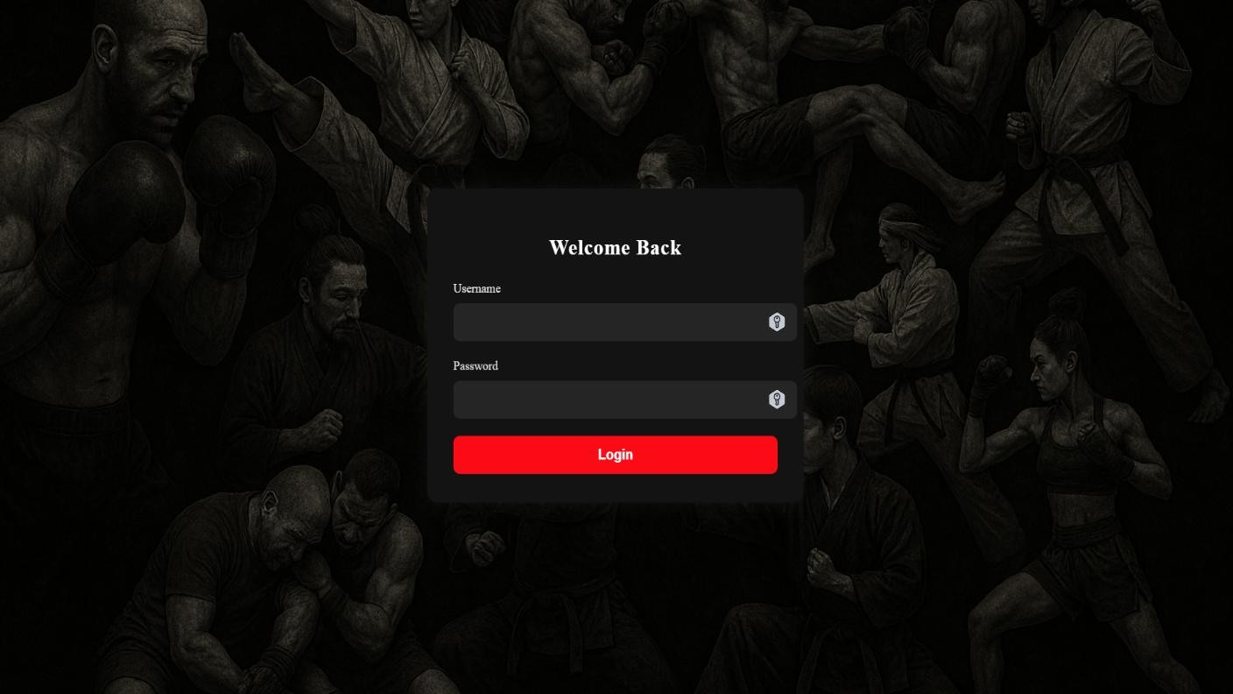

3. Dashboard
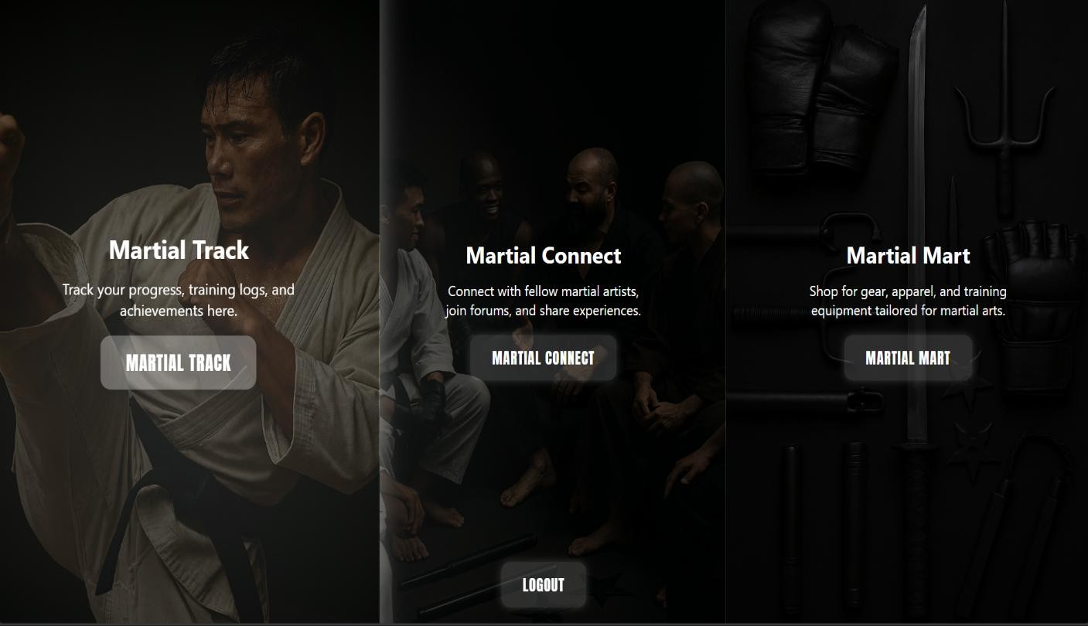

4. Martial Track Menu


5. Progress Tracker Bar
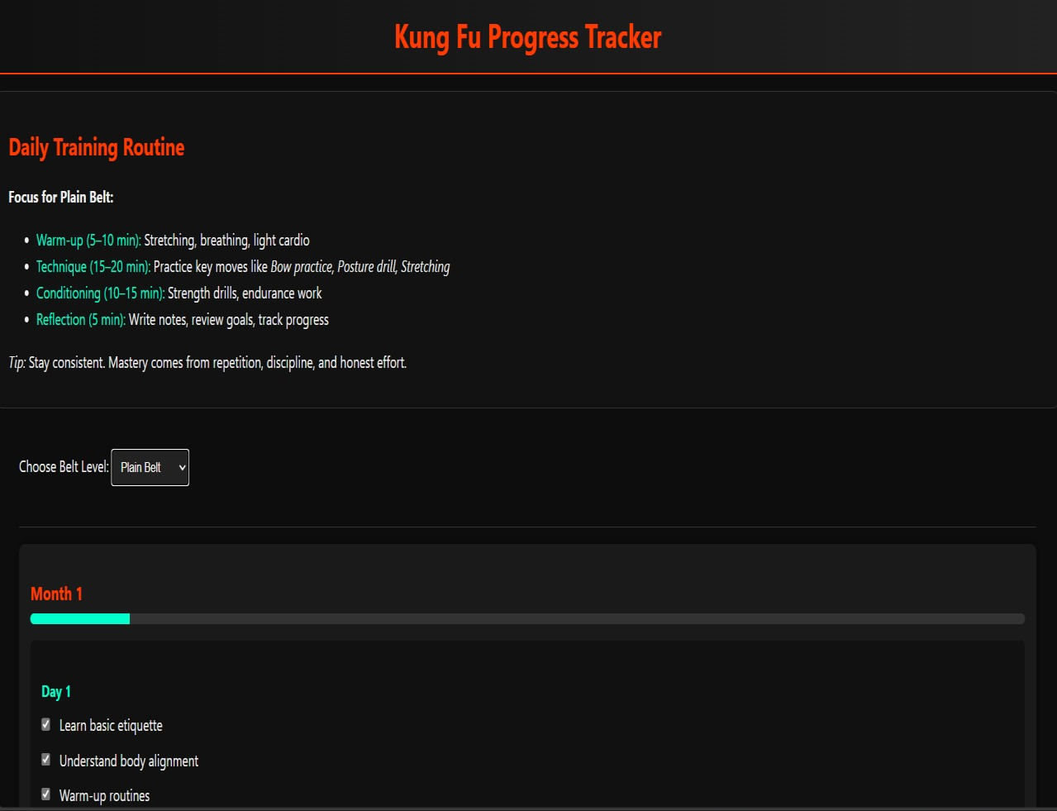

6.

Timer

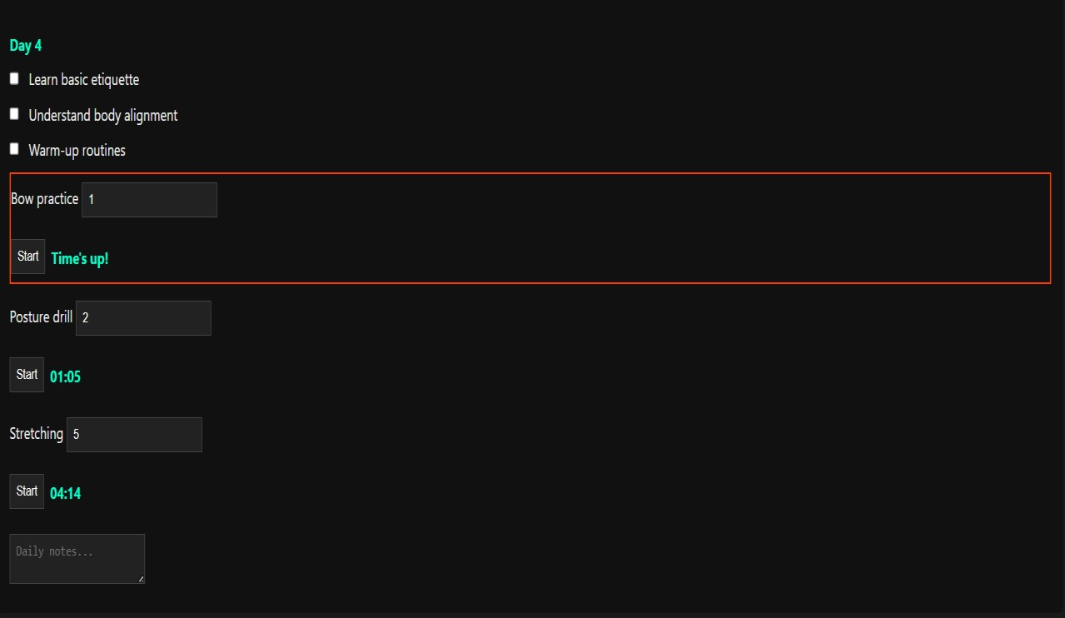

7. Choosing Level
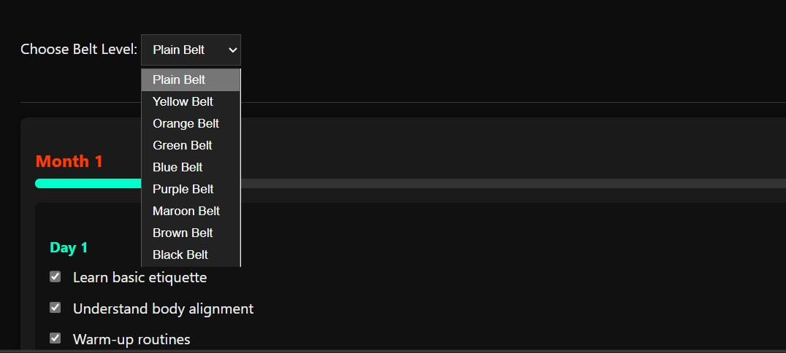

8. Martial-Mart home page
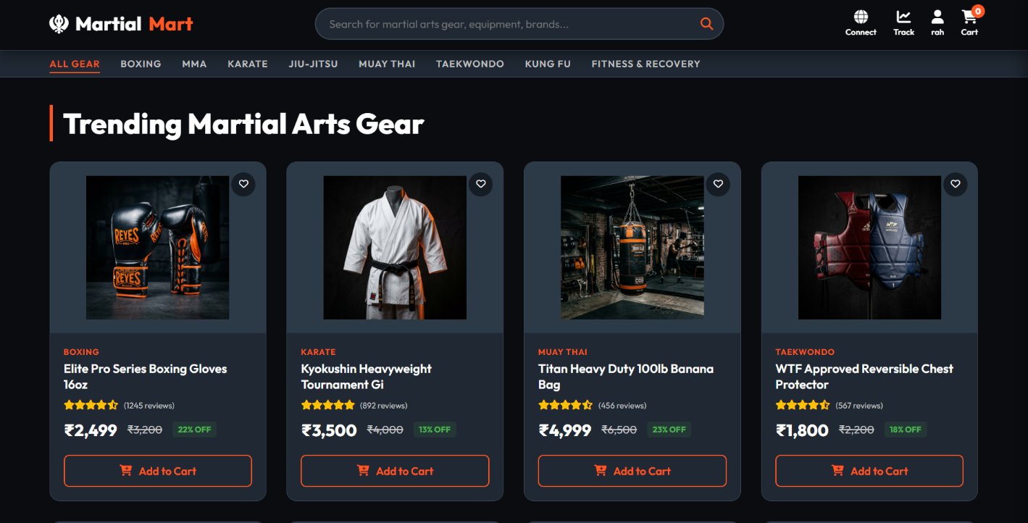

9. Martial-Connect homepage


10. Product Details
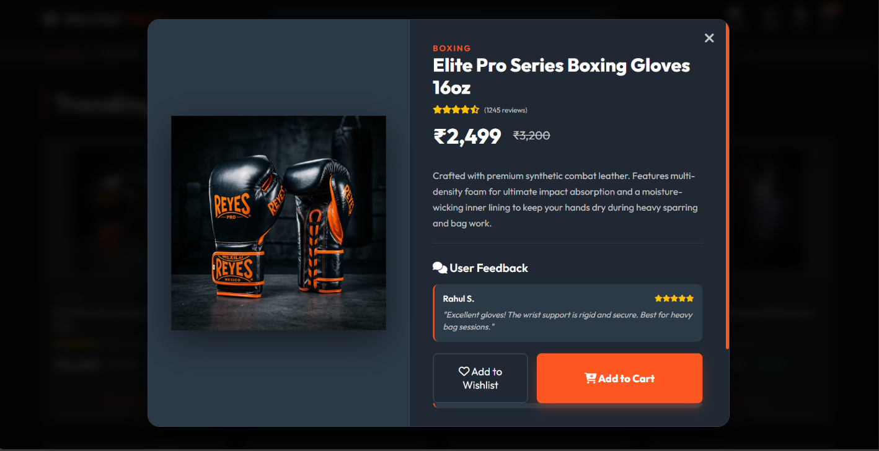

11. Product Kart
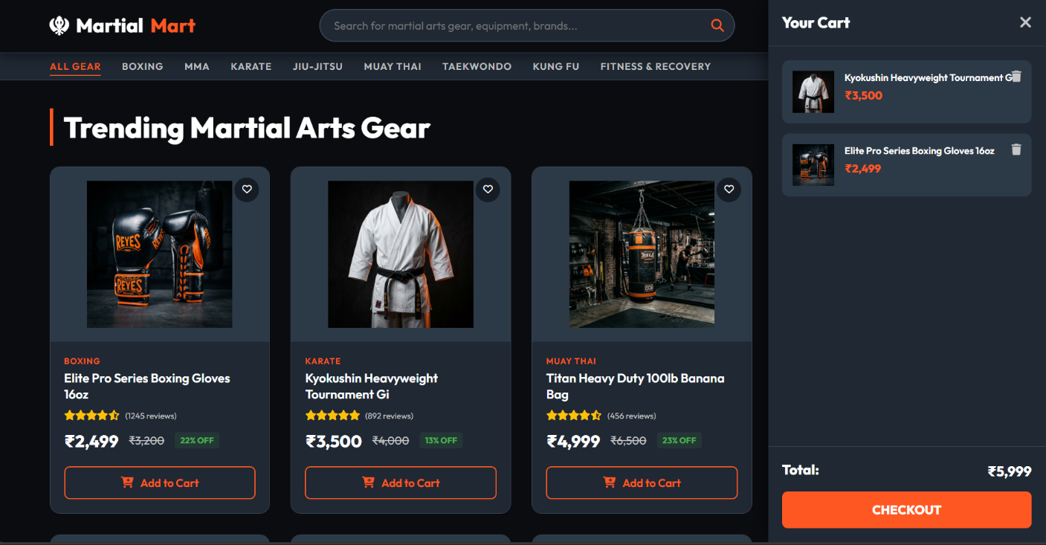

12. Messaging
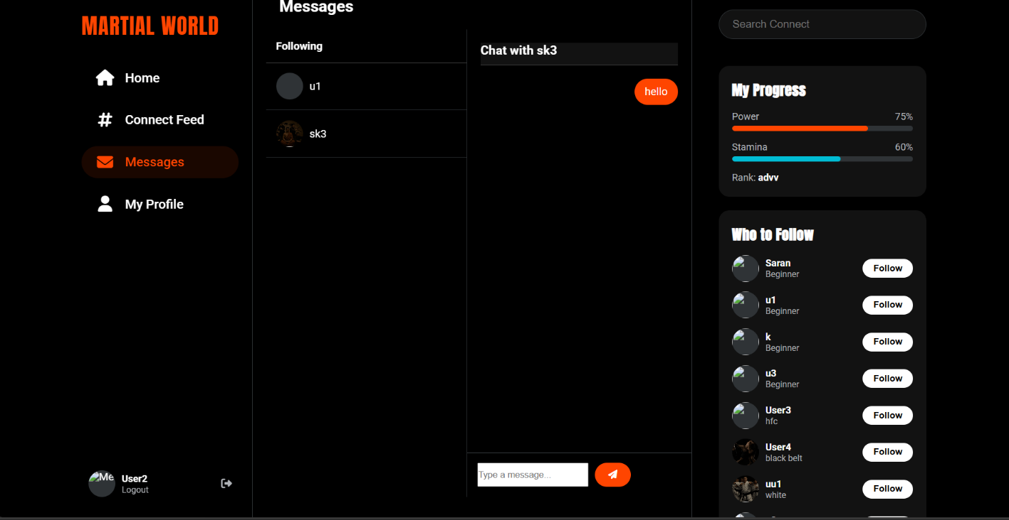

13. Authentication
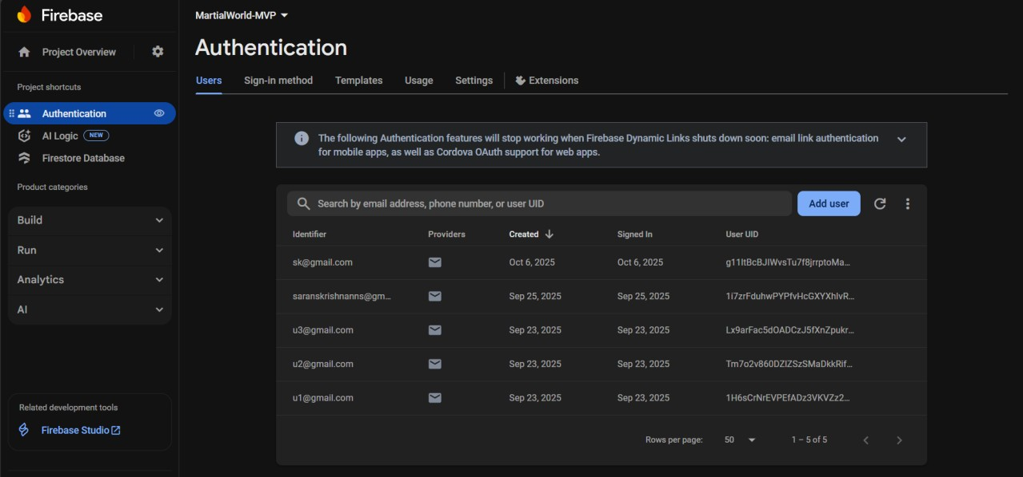

14. Database
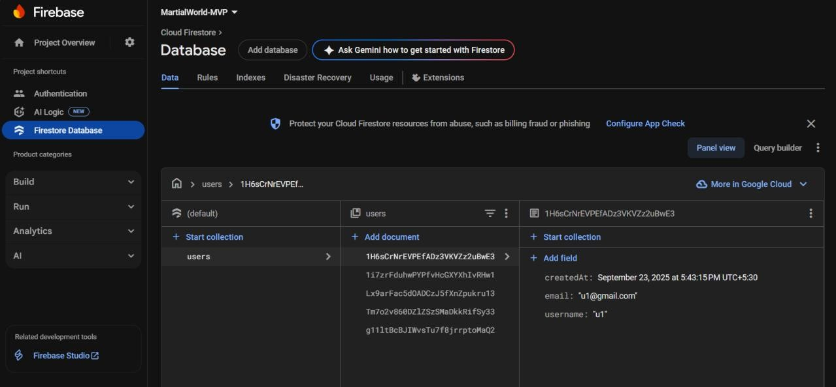

15. Git History

