**Currency Rate Update Configurations**

1. Set Base Currency From currency form

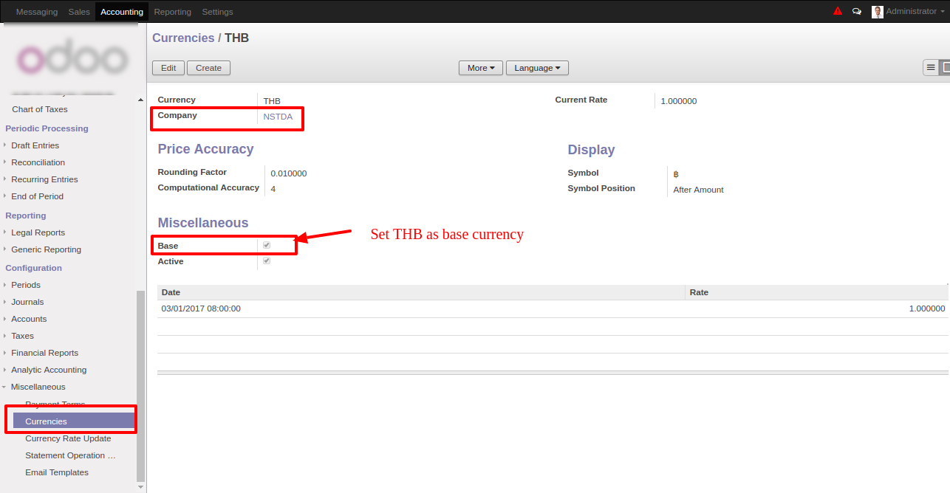

2. Set service on company form

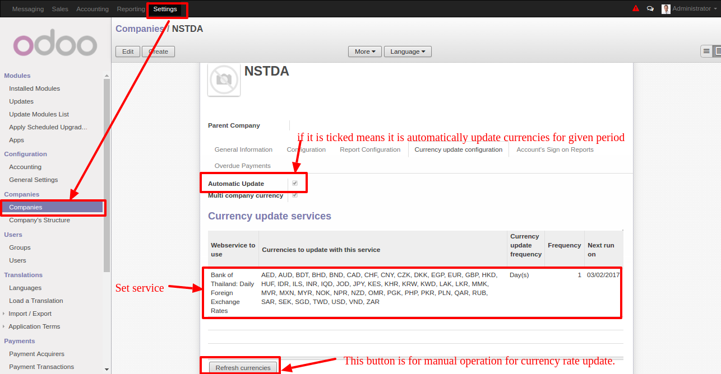

3. Schedule Actions

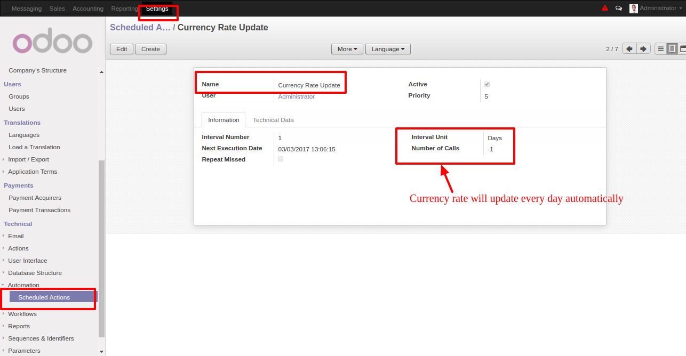

4. Results on Currency Update form

