

Name :- V. Vamsydhar

Email:- [vamsyvelisetti@gmail.com](mailto:vamsyvelisetti@gmail.com)

Batch :- 122

Lecture By :- K. Madhukar Sir

CROSS-REGION REPLICATION OF S3 BUCKETS

# S3 bucket :

* Amazon S3 is a simple storage service with limitless storage.
* It is a pay-as-you-go service.
* It is best known for its data performance, durability, flexible storage options, security, compliance, and auditing.
* In this documentation we will learn how to replicate files from one bucket in one region to another bucket located in another region.

# Cross-region replication :

* First, we have to create two buckets in two regions.
* Log into your Amazon console. Go to the S3 feature.

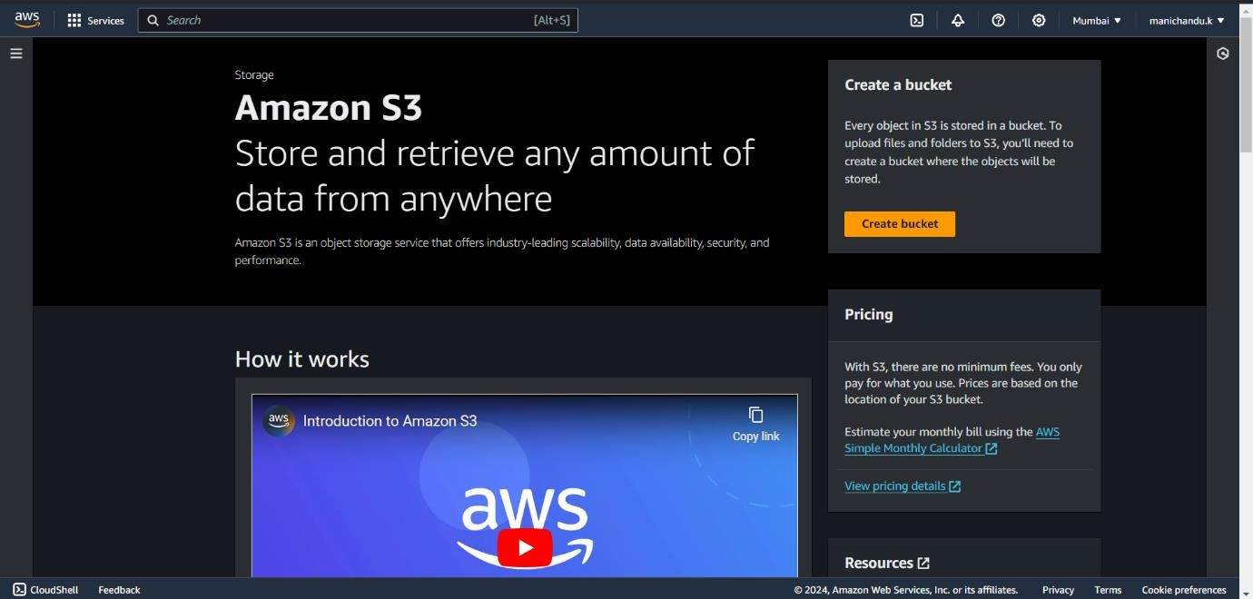

* Click on Create a bucket and give a name for the bucket. The name should be unique as no two buckets will not have the same name.
* Keep the other options default except versioning.
* Here we should enable versioning to ensure cross-region replication as replication will not be enabled without versioning.

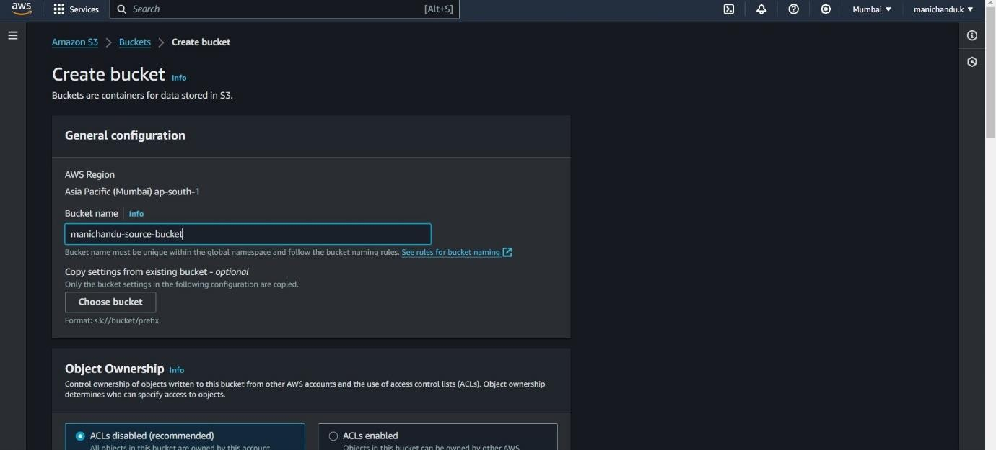

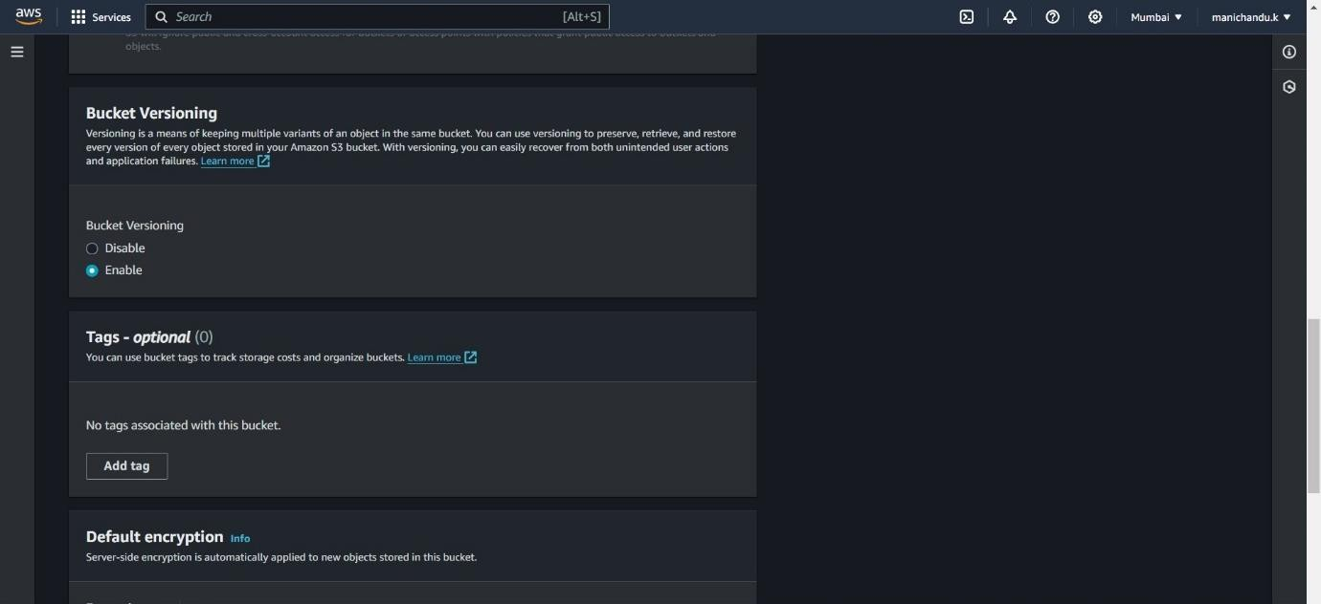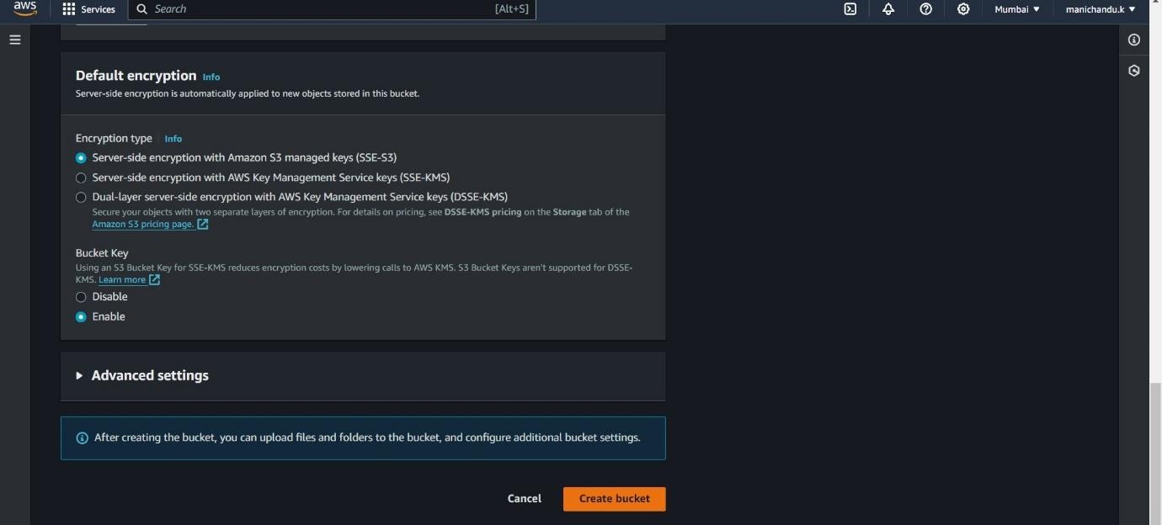

* + Click on create bucket and your bucket will be created.

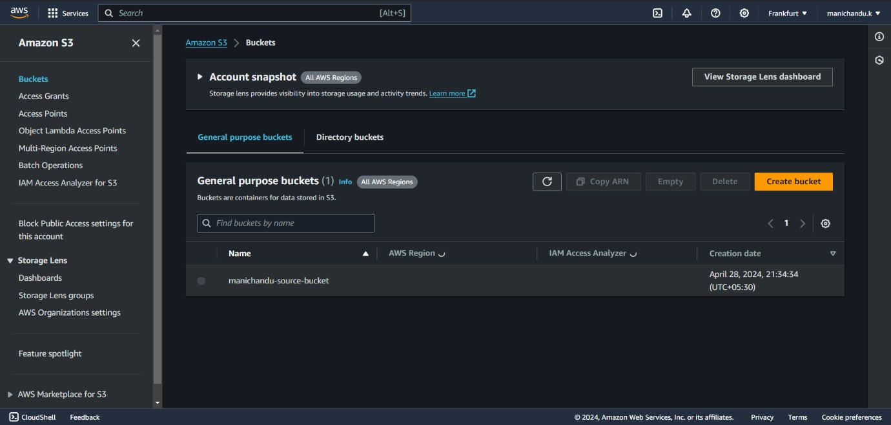

* + Now, move to another region, here I selected Frankfurt which will be in Europe.
  + Create an S3 bucket in the Frankfurt region enabling bucket versioning.

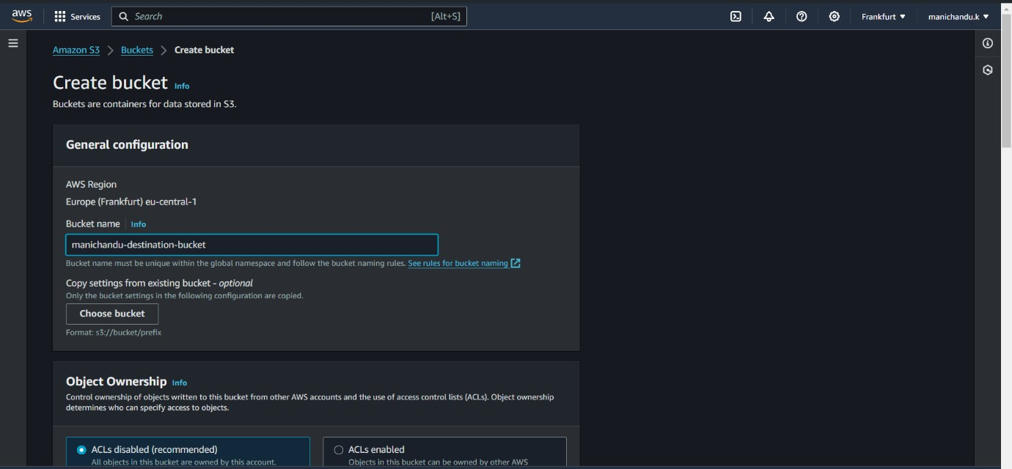

* We have created one bucket each in two regions.

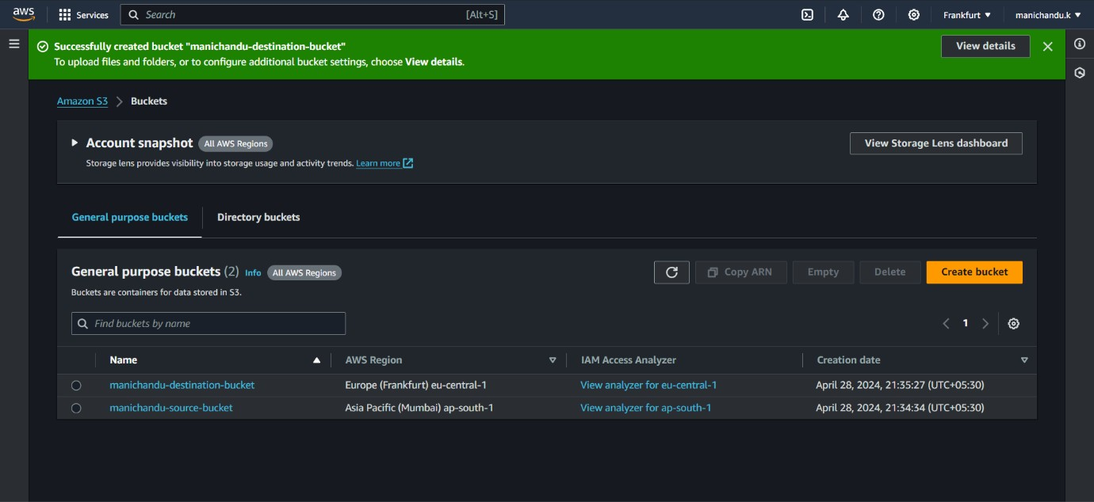

* Go to your source bucket and click on management.

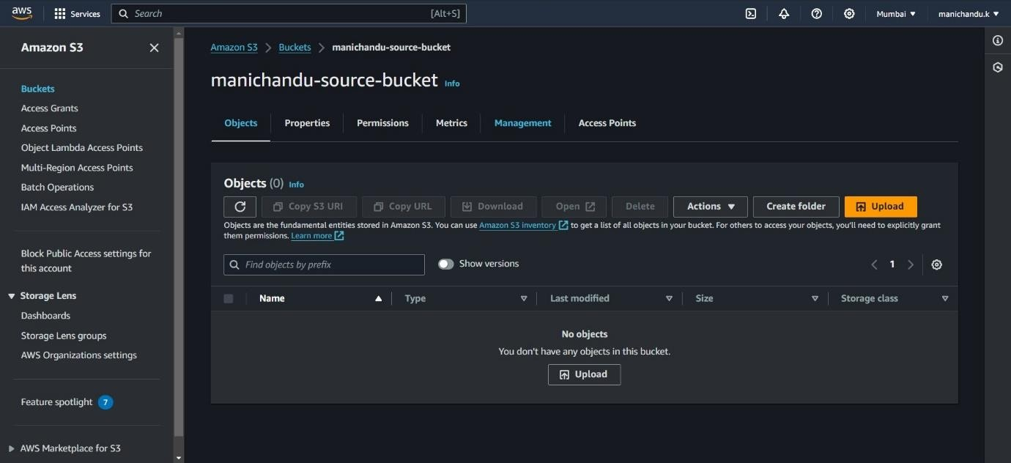

* Click on create replication rules.

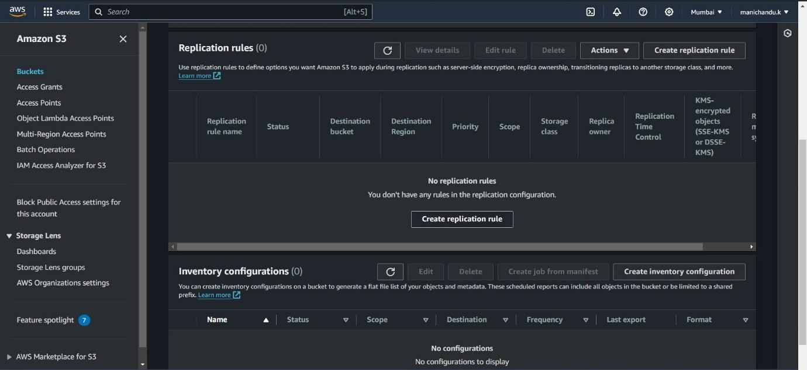

* Give a name for the replication rule

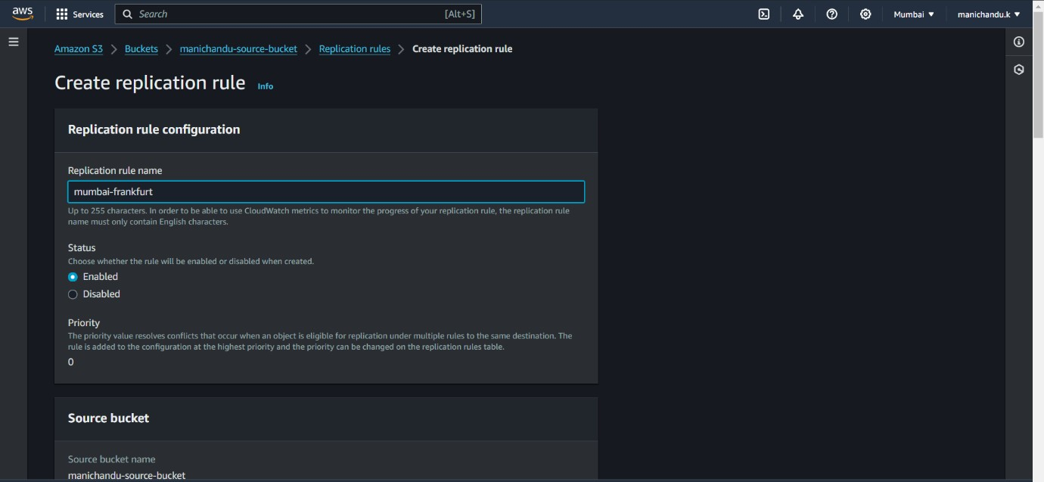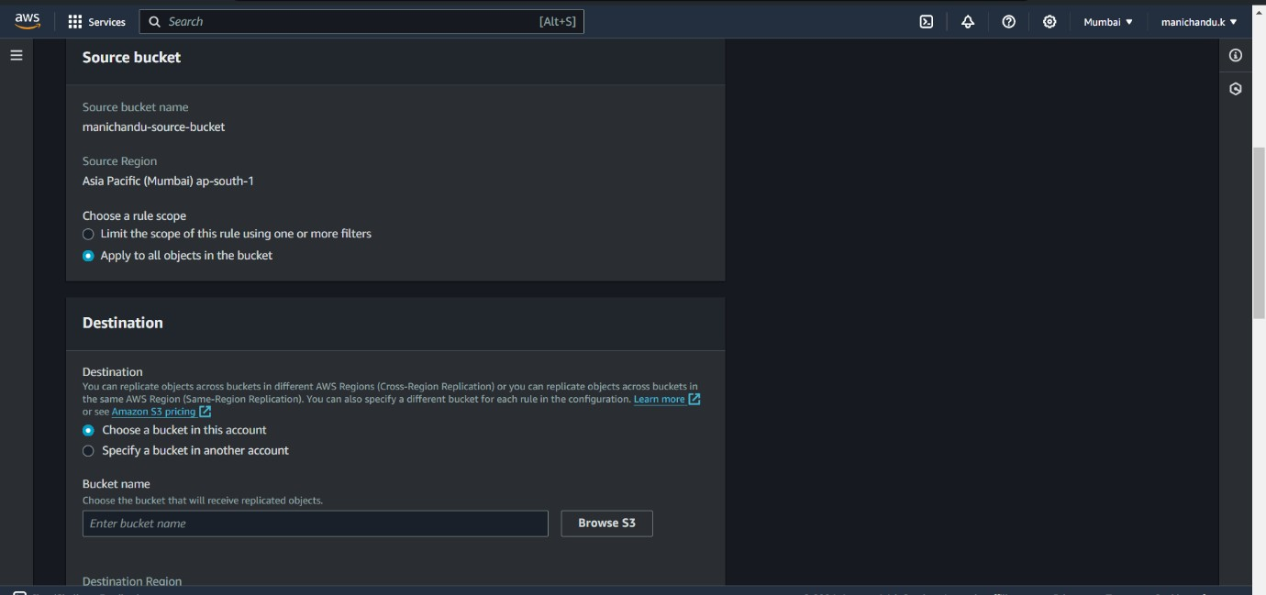

* When selecting an option for Choose a rule scope, select Apply to all objects or you can put a tag where a selected folder or files only will be replicated to the other bucket.
* Now choose the destination bucket.

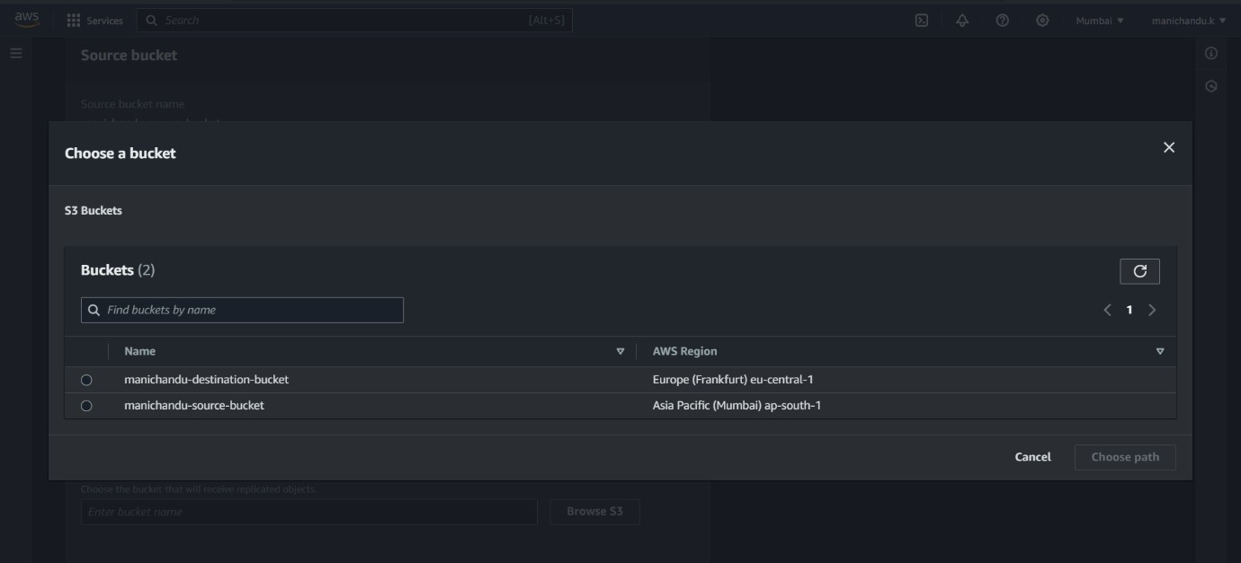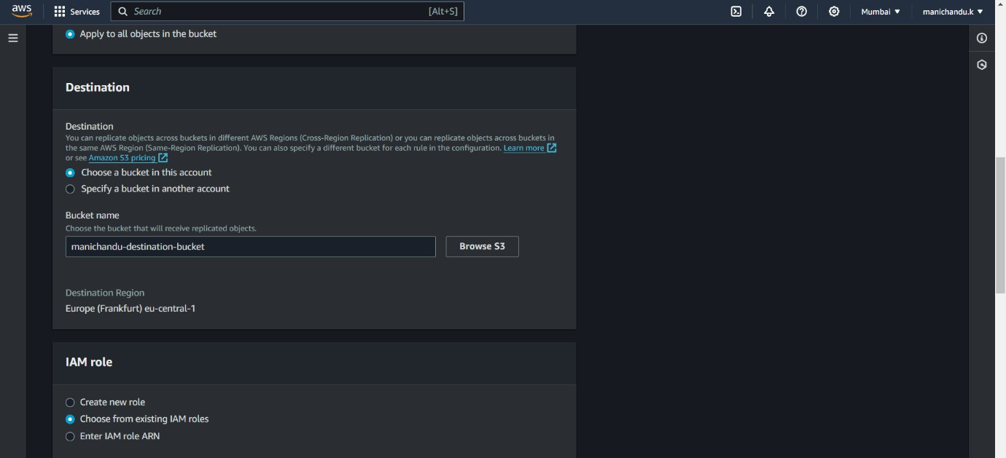

* When choosing an IAM role, click on create new role.
* Click on create and we will get a pop-up like this.

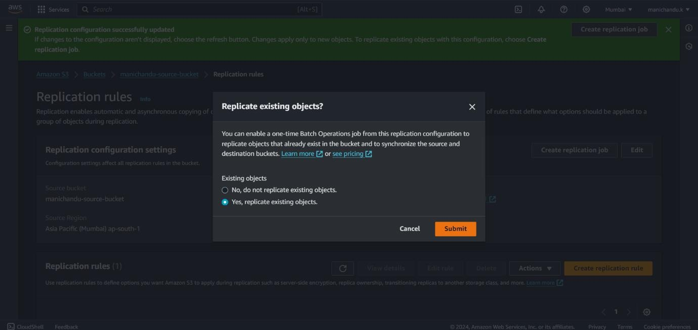

* If you have objects already in your bucket and want them to be replicated, select ‘yes, replicate existing objects.’
* Now go to the source bucket and upload a file in the bucket.

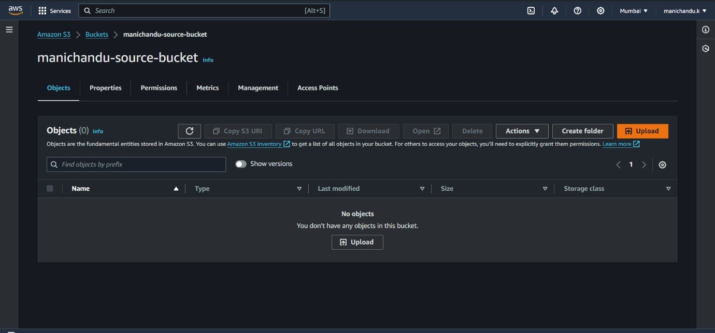

* Click on upload, and click on add files.

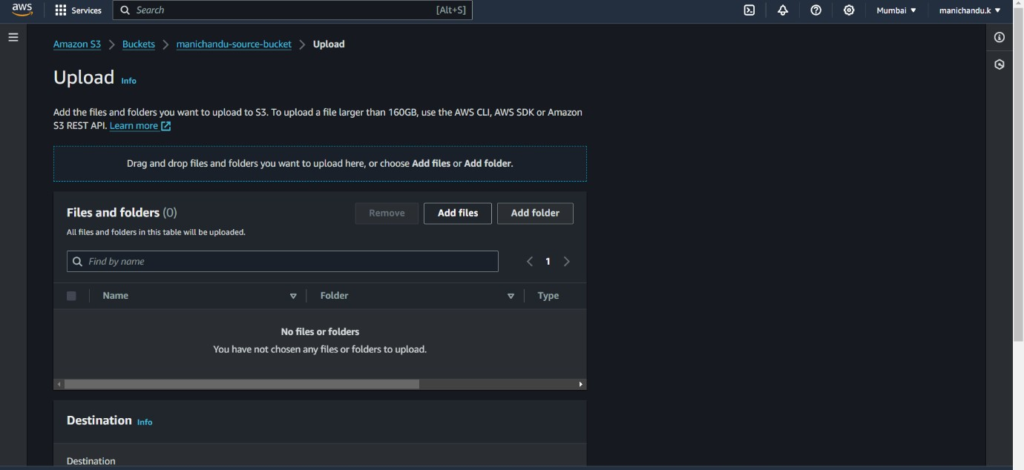

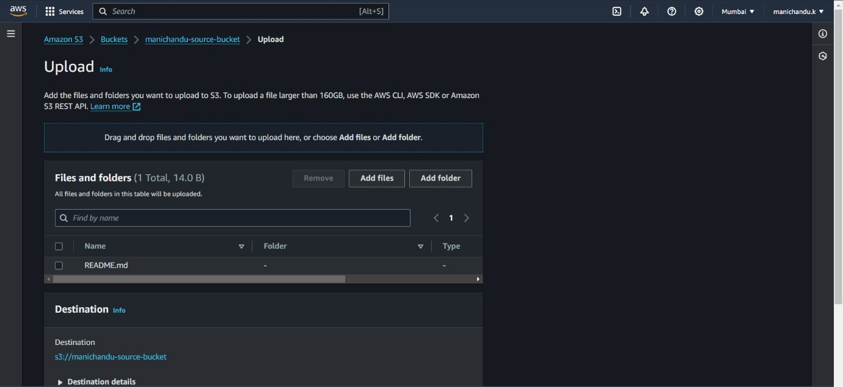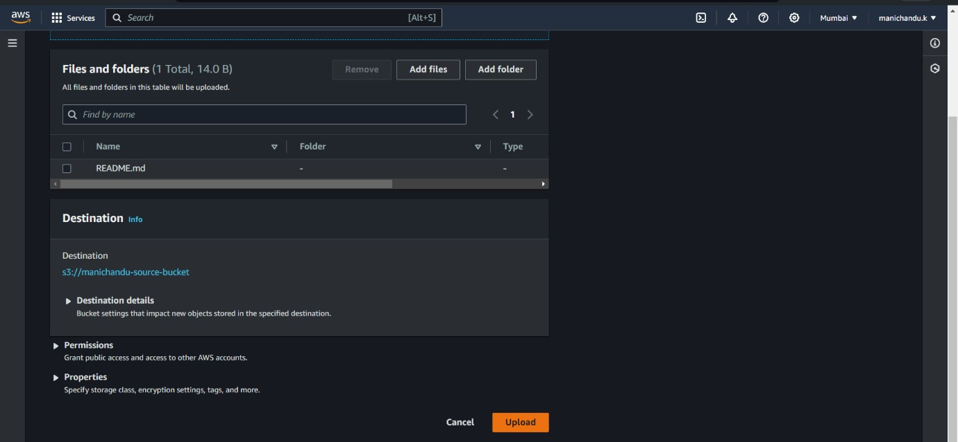

* Click on upload.

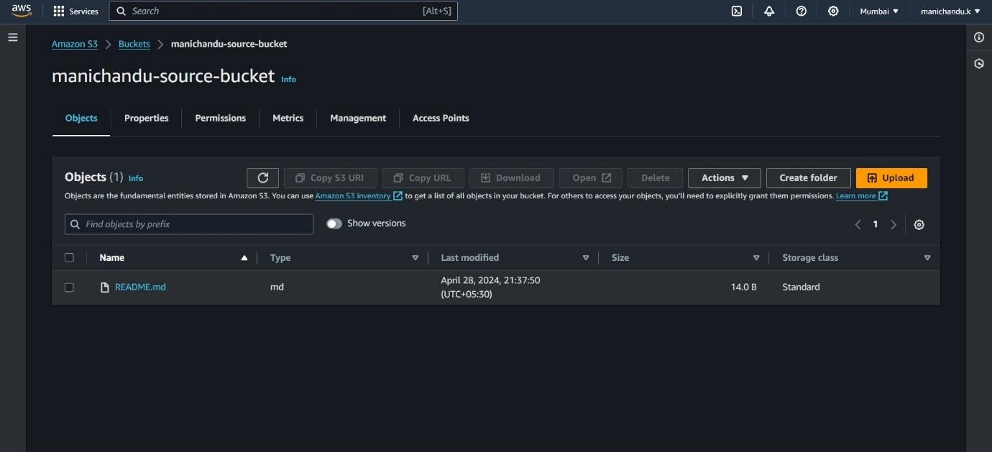

* After a while, we will see the replicated file in the destination bucket.

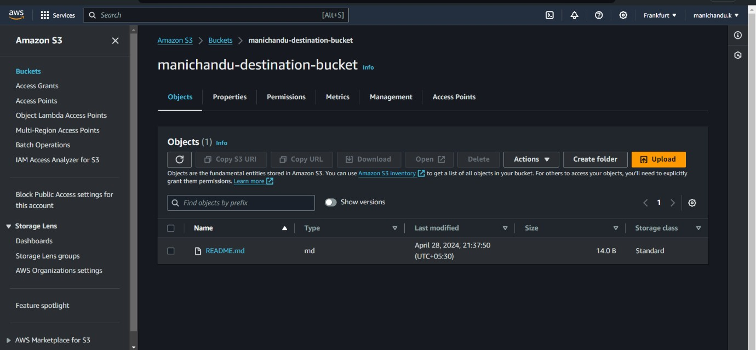

* Cross-region replication of S3 buckets is successfully done.

**THE END**