Insight Tested:
“Electronics product category is the most ordered product.”

1. Overview of Given Data

Parameter | Symbol | Order Value
Population size | N | 1000
Sample size (Air mode) | n | 204
Population Mean | μ | 25290
Sample Mean | $$\overline{x}$$ | 27090
Population SD | σ | 14380
Shapiro–Wilk statistic | W | 0.94774
p-value (normality test) | p | 6.666*10⁻⁷

2. Interpretation of Normality Test

Shapiro-Wilk – R:

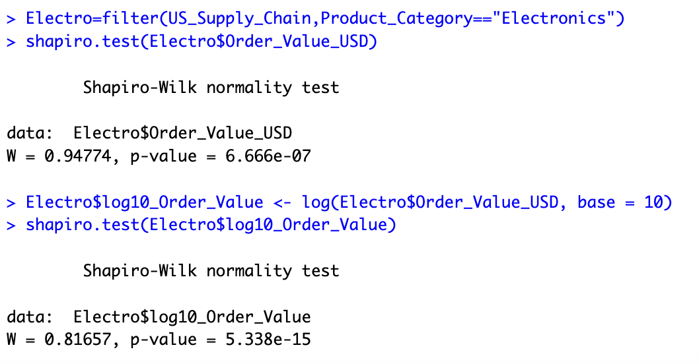

Logarithmic transformation - Excel:
formula : =LN(Column_name). Base = 10.

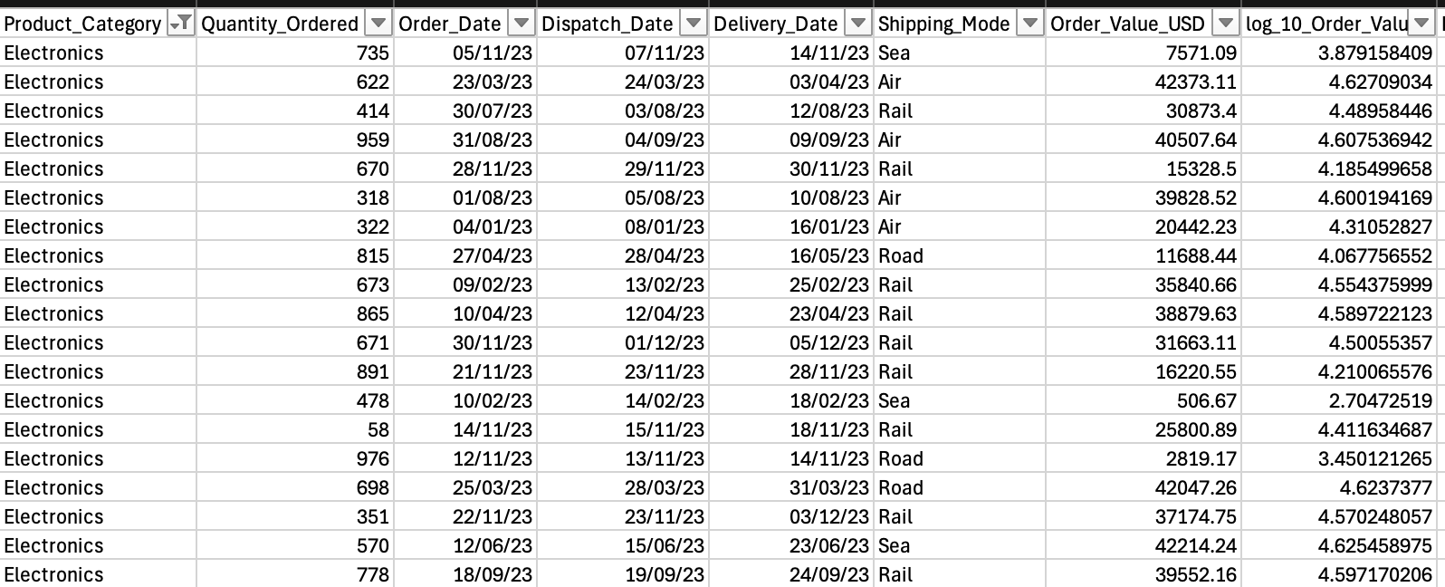

- However, since n = 204 (>30), the Central Limit Theorem allows approximate normal inference.
- Proceeding with parametric tests (z-test and t-test) is appropriate.

3. Hypotheses
Because the claim is that Electronics product category has the most Order Value.

H0 : μ = μ₀
H1 : μ > μ₀
This is a one-tailed, right-tailed test.

4. Formulas Used

Z-Test (if population SD known)
$$z=\frac{\overset{ˉ}{x}-μ_{0}}{σ/\sqrt{n}}$$

T-Test (if population SD unknown)
$$t=\frac{\overset{ˉ}{x}-μ_{0}}{\frac{s}{\sqrt{n}}}$$
(For large n, z ~ t.)

9. Interpretation of Results
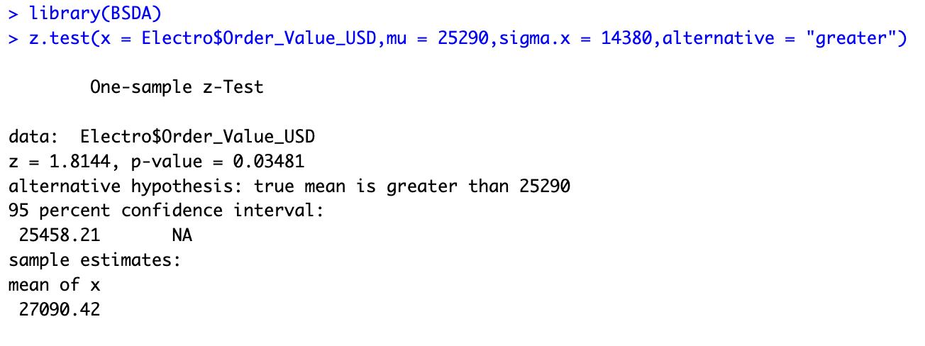
Summary of Findings:
- At the 1% level, results are not statistically significant. We do not have enough evidence to conclude the true mean is greater than 25290.
- At the 5% level and 10% level, results are statistically significant. We have sufficient evidence to reject the null hypothesis and conclude that the true population mean is likely greater than 25290.

