Table of Contents
Abstract 2
Chapter 1 Introduction to Problem 3
1.1 Objective 3
1.2 Introduction 3
1.3 Motivation 3
Chapter 2 Introduction to Design Thinking 4
2.1 Design Thinking 4
2.2 Brainstorming 5
2.3 Ideation 5
Chapter 3 Introduction to Ideation Tool 6
3.1 SCAMPER 6
3.2 Substitute 7
3.3 Combine 8
3.4 Adapt 8
3.5 Modify 9
3.6 Put To Another Use 10
3.7 Eliminate 10
3.8 Rearrange 11
Chapter 4 Define and Design 12
4.1 Empathy Interview 12
4.2 Questionnaire 12
4.3 Persona 13
4.4 User Needs 13
4.5 Ideation Method-Scamper: 14
4.6 Viability And Feasebility 15
Chapter 5 Prototype Model 16
5.1 Web-Application (Solution Prototype) 16
5.2 Mobile Version 17
Conclusion 18
References 19
Appendix A 20
Questionaire/Survey-Responses 20
Appendix B 22
Snippets of Source Code : 22
Table of Figures
Figure i: Design-Thinking-5 Stages 4
Figure ii: Scamper-Techinque 6
Figure iii: Scamper-PipeLining-Rendering 11
Figure iv: Feasibility-Viability & Desirability 15
Figure v: Web-Page First Sight 16
Figure vi: Downloads-section 16
Figure vii: Contact Section 17
Figure viii: Mobile-Version-1 17
Figure ix: Questionare - Answers 20

Abstract

Students are struggling to find previous question papers for➢reference. All the question papers are scattered and most of An easy way to navigate through all the question papers and➢them are totally absent. making students easy to search through all the papers The library of question papers should be confined to one➢without hassle. Mid or semester all the year question paper must be easy to access. Being the heart of the academic center, it is home for all the information services. It plays a proactive role in enabling access to information resources of all kind and providing innovative, responsive and effective services to meet the changing needs of the academic community. A re-searchable question is an uncertainty about a problem that can be challenged, examined, and analyzed to provide useful information. A successful research project depends upon how well an investigator formulates the research question based on the problems faced in day-to-day research activities and clinical practice. The underlying questions of a research project provide important information to decide whether the topic is relevant, re-searchable, and significant. A well-formulated question needs extreme specificity and preciseness which guides the implementation of the project keeping in mind the identification of variables and population of interest. This makes it easy for us to learn and grasp faster. It provides teachers the access to professional development, relevant information and reference material to plan and implement effective learning programs. Education and library are interrelated and fundamentally co-exist with each other. Education is the process of gaining knowledge, values, skills, habits, and beliefs. It is the social process in which children are subjected to the influence of the school environment to attain social competence personnel development.

Chapter 1 Introduction to Problem

1.1 Objective
The Main Objective of this Question bank is to implement an easy way to navigate through all the question papers .It plays a proactive role in enabling access to information resources of all kind and providing innovative, responsive and effective services to meet the changing needs of the academic community .

1.2 Introduction
Students are struggling to find previous question papers for➢reference. All the question papers are scattered and most of An easy way to navigate through all the question papers and➢them are totally absent. making students easy to search through all the papers The library of question papers should be confined to one➢without hassle. Mid or semester all the year question paper must be easy to access.
Access to education is specifically seen as access to opportunity. This clearly means that each individual must be given the opportunity to access the resources that will enable them to achieve their potential. Universal access is therefore at the point of time of entry to a course of study. It is not a right to a qualification or a degree – successful achievement is still dependent on merit and effort. All that equitable access gives is entry into the system that will support and direct achievement of the educational goal.

1.3 Motivation
A library plays an important role in meeting the growing needs of people in literacy. The library is essential for self-education, a means of information and knowledge. Education is the complex social process of gaining knowledge and experience formally.

Chapter 2 Introduction to Design Thinking

2.1 Design Thinking
Design thinking is a non-linear, iterative process that teams use to understand users, challenge assumptions, redefine problems and create innovative solutions to prototype and test. Involving five phases—Empathize, Define, Ideate, Prototype and Test—it is most useful to tackle problems that are ill-defined or unknown.
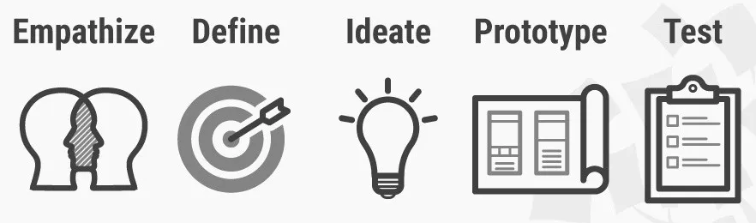Figure i: Design-Thinking-5 Stages

Design thinking’s value as a world-improving, driving force in business (global heavyweights such as Google, Apple and Airbnb have wielded it to notable effect) matches its status as a popular subject at leading international universities. With design thinking, teams have the freedom to generate ground-breaking solutions. Using it, your team can get behind hard-to-access insights and apply a collection of hands-on methods to help find innovative answers.
The Hasso Plattner Institute of Design at Stanford (aka the d.school) describes design thinking as a five-stage process. Note: These stages are not always sequential, and teams often run them in parallel, out of order and repeat them in an iterative fashion.

2.2 Brainstorming

Brainstorming is a method design teams use to generate ideas to solve clearly defined design problems. In controlled conditions and a free-thinking environment, teams approach a problem by such means as “How Might We” questions. They produce a vast array of ideas and draw links between them to find potential solutions.
Brainstorming is part of design thinking. You use it in the ideation phase. It’s extremely popular for design teams because they can expand in all directions. Although teams have rules and a facilitator to keep them on track, they are free to use out-of-the-box and lateral thinking to seek the most effective solutions to any design problem. By brainstorming, they can take a vast number of approaches—the more, the better—instead of just exploring conventional means and running into the associated obstacles. In brainstorming, we aim squarely at a design problem and produce an arsenal of potential solutions. By not only harvesting our own ideas but also considering and building on colleagues’, we cover the problem from every angle imaginable.

2.3 Ideation

Ideation is a creative process where designers generate ideas in sessions (e.g., brainstorming, worst possible idea). It is the third stage in the Design Thinking process. Participants gather with open minds to produce as many ideas as they can to address a problem statement in a facilitated, judgment-free environment.It's challenging to gain the perspective to find design solutions. To have productive ideation sessions, you'll need a dedicated environment for standing back to seek and see every angle. First, though, your team must define the right problem to address. Ideation, or "Ideate", is the third step in the Design Thinking process – after “Empathize” and “Define”

Chapter 3 Introduction to Ideation Tool

3.1 SCAMPER
SCAMPER refers to a series of thought sparkers or provocations which help you to innovate on an existing product, service or situation by looking through different lenses. There are seven provocation lenses in the SCAMPER method: Substitute, Combine, Adapt, Modify (Also Magnify and Minify), Put to another use, Eliminate, and Reverse.
The SCAMPER method helps you generate ideas for new products and services by encouraging you to ask seven different types of questions, which will help you understand how you can innovate and improve existing products, services, problems and ideas.
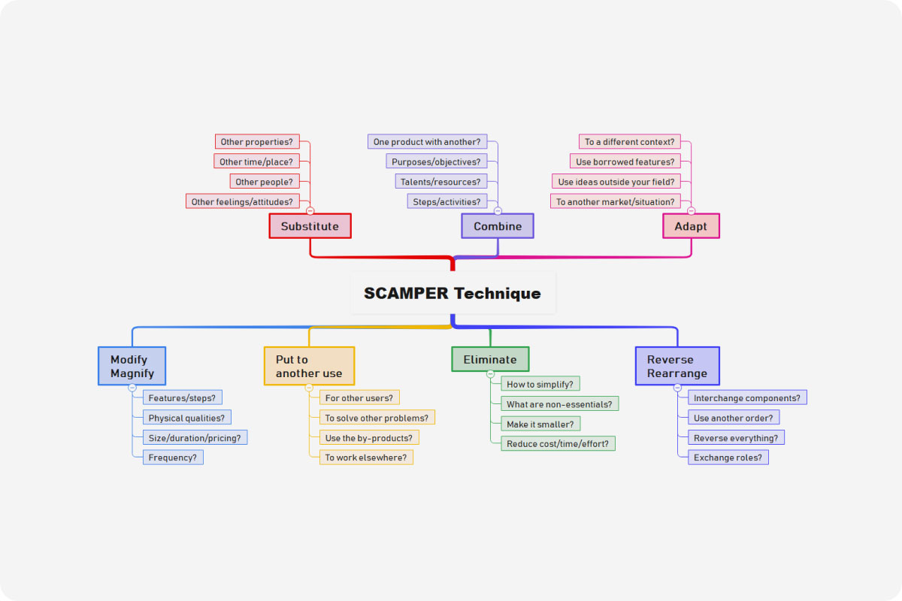Figure ii: Scamper-Techinque
SCAMPER is a quick, easy and direct form of creative brainstorming. You use the tool by asking questions about existing products, using each of the seven prompts above. These questions help you come up with creative ideas for developing new products, and for improving current ones.

SCAMPER is an acronym that is broken down into the following keywords.

- Substitute
- Combine
- Adapt
- Modify (or Magnify and Minify)
- Put to another use
- Eliminate
- Reverse

3.2 Substitute
Overall, the question to think about here is this: What can I substitute or change in my product, problem or process? You should think about substituting part(s) of your product or process for something else.

Guiding questions:
- What can I substitute so as to make an improvement?
- How can I substitute the place, time, materials or people?
- Can I substitute one part for another or change any parts?
- Can I replace someone involved?
- Can I change the rules?
- Should I change the name?
- Can I use this idea for other projects?
- Can I change my feelings or attitude towards it?

3.3 Combine
The overall question to think about here is: How can I combine two or more parts of my product, problem, or process so as to achieve a different product, problem, or process to enhance synergy? Creative thinking involves combining previously unrelated ideas, products, or services in order to create something new and innovative.
Guiding questions:
- Can I combine or merge this or that with other objects?
- What can I combine so as to maximize the number of uses?
- What can I combine in order to lower the time of production?
- Which materials could I combine?
- Where can I build synergy?
- Which are the best elements I can bring together so as to achieve a particular result?

3.4 Adapt
Overall, the question you need to think about is: What can I adapt in my product, problem, or process? Think about which parts of the product or process you could adapt so as to solve your
problem.
Guiding questions:
- Which part of the product could I change?
- Could I change the characteristics of a component?
- Can I seek inspiration in other products or processes, but in a different context?
- Does the history offer any solutions?
- Which ideas could I adapt, copy, or borrow from other people’s products? What processes should I adapt?
- Can I adapt the context or target group?
- What can I adapt in this or that way in order to make this result?

3.5 Modify
Overall, the question you need to focus on is this: What can I modify or put more or less emphasis on in my product, problem, or process? Can I change the item in some way? Can I change meaning, colour, motion, sound, smell, form, or shape? It’s time to magnify or exaggerate your idea, product, problem, or process—or to minify it. These questions will give you new insights about which components are the most important ones. Think about changing part or all of the current situation or product. Alternatively, distort the product in an unusual way.
Guiding questions:
- What can I magnify or make larger?
- What can I tone down or delete?
- Could I exaggerate or overstate buttons, colours, size…?
- Could I grow the target group?
- What can be made higher, bigger, or stronger?
- Can I increase its speed or frequency?
- Can I add extra features?
- How can I add extra value?
- What can you remove or make smaller, condensed, lower, shorter or lighter
or streamline, split up or understate?
- What can I change in this way or that way so as to achieve such and such a result?

3.6 Put To Another Use
The overall question to consider here is this: How can I put the thing to other uses? What are new ways to use the product or service? Can I reach out to other users if I modify the product? Is there another market for the product? It’s time to work out how you may be able to put your current product or idea to other uses and purposes.
Guiding questions:
- What else can it be used for?
- How would a child use it?—an older person?
- How would people with different disabilities use it?
- Which other target group could benefit from this product?
- What other kind of user would need or want my product?
- Who or what else may be able to use it?
- Can it be used by people other than those it was originally intended for?
- Are there new ways to use it in its current shape or form?
- Would there be other possible uses if I were to modify the product?
- How can I reuse something in a certain way by doing what to it?

3.7 Eliminate
Your overall question to consider here is: What can I eliminate or simplify in my product, design, or service? Think of what might happen if you were to eliminate, simplify, reduce, or minimise parts of your idea. If you continue to trim your idea, service, or process—you can gradually narrow your challenge down to that part or function that is most important.
Guiding questions:
- What can I remove without altering its function?
- Can I reduce time or components?
- What would happen if I removed a component or part of it?
- Can I reduce effort?
- Can I cut costs?
- How can I simplify it?
- What’s non-essential or unnecessary?
- Can I eliminate the rules?
- Can I make it smaller?
- Can I split my product into different parts?
- I can eliminate what by doing what?

3.8 Rearrange
Overall, you have to ask yourself this question: How can I change, reorder, or reverse the product or problem? What would I do if I had to do this process in reverse?
Guiding questions:
- What can I rearrange in some way – can I interchange components, the pattern, or the layout?
- Can I change the pace or schedule?
- What would I do if part of your problem, product or process worked in reverse?
- I can rearrange what in what way such that this happens?

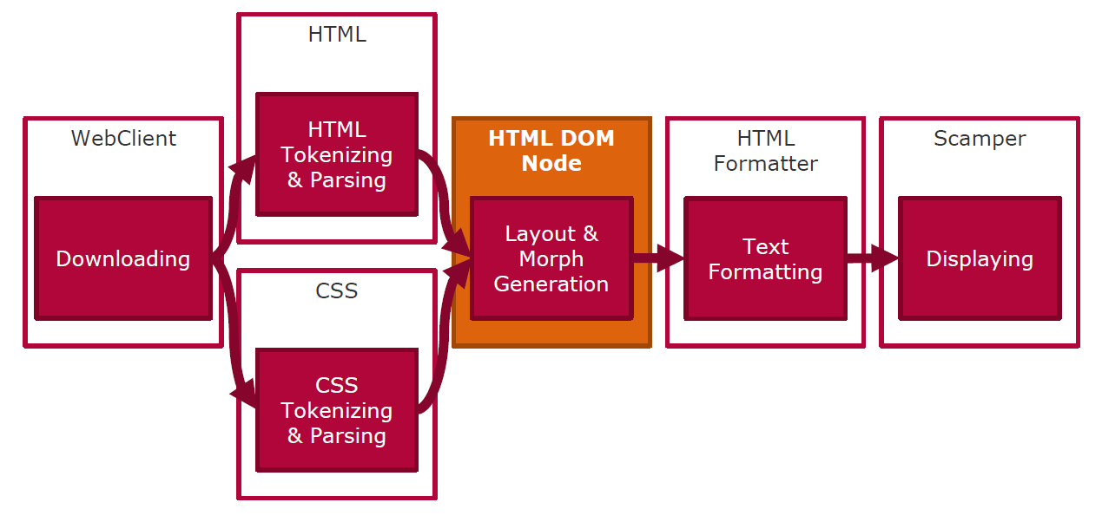Figure iii: Scamper-PipeLining-Rendering

Chapter 4 Define and Design

4.1 Empathy Interview
A survey has been conducted among students to know the problems they are facing in procuring Question Papers . After analyzing the survey record,many students feel that a platform where students and faculty would interact will be a better option to get good guidance and support from them in various phases of their college life.

4.2 Questionnaire
- Name
- Category (Learner / Tutor / Other )
- Do you feel Previous Quesion papers are useful and you can benift from them ?
- Do you frequently refer Previous Year Question Papers ? ▪
- Do you feel any difficulty in finding Prev.Question Papers ?
- What is/are your Soucre of finding this Material ? ▪
- What do feel about the Quality of Material you get ?(Rating : 1 to 5 ) ▪
- Will it be comfortable to find all the papers at one place ? ▪
- Feel Free to Share Your Experience regarding Previous Question Papers.
For Answers please refer Apendix A .

4.3 Persona
Student:
- Students are the users who are benifited from the website .
- It Increases the confidence of the candidates.
- It helps to understand the important parts of the syllabus.
- It helps the student to plan his examination.
- It Helps to chalk out the similar questions.
- It help to manage the time.
Tutors:
- Tutors can create a post to share any material which can reach to students of all branches.
- Makes Planning Easier.
- Helps with Version control and sampling.

4.4 User Needs
Primary Needs:
- Tutors can share knowledge over various platforms other than classroom
- Students can easily get all materupdates material needed at one place
- Easy for students to collect and use material .
Secondary Needs:
- Can show ways, share ideas and make students more active.
- Students get to engage in the community work.
Latent Needs:
- Latent needs can be defined as a desire or preference which cannot be satisfied due to a lack of information or availability of a product or service. Or, in plain English, a latent need is a problem that a user or consumer doesn't realise they have.
- Students need not waste their time in searching for the Reliable Material.
- When all the shared information by Tutor is grouped at one place can make it as a help which a faculty can use further.

4.5 Ideation Method-Scamper:

Substitute :

In traditional ways, when students need a necessary material , they try to approach their friends, known They invest some time in finding the right material for faculty. So, when both students and tutors are bought under help and it takes some time in finding. one platform we can eliminate all the difficulties which students are facing.

Combine :

Generally, knowledge shared by the faculties is limited to a class or group of students. Knowledge is to When these two users are both under one roof Students are in path of building their career. be shared without boundaries. creates benefits at great extent.

Adapt :

We would like to get a way where students are getting proper material in all cases and build an environment to develop a sense of ease.

Modify :

We are trying to change the way of providing useful and necessary data to both tutors and students .

Put To Other Use :

In mean time, It helps in developing a college community like culture.

Eliminate :

We would like to eliminate the problems in knowledge sharing process.
Reverse :

Knowledge sharing has no limits. Knowledge sharing can be like two-way handshaking. So, students can also share knowledge and contribute to the community.

4.6 Viability And Feasebility

- This Web app is built using front end technologies like HTML Bootstrap, JQuery , CSS .➢
- Google Drive makes it more easy and No-Cost
- Website light and creates a best user interface with magnificent UI.
- Technically it is feasible and simple to implement.
- This solution is economically feasible as well.
- Time taken to build the web app is considerate and not long.
- Our Website is user friendly.
- Our Website is Responsive (i.e. Compatabile with Mobile and Desktop )
- Students can get interest in accessing website to get connected.
- It is desirable as it servers the purpose without making things complex.

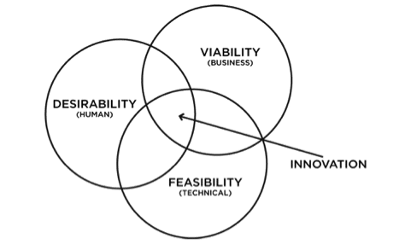Figure iv: Feasibility-Viability & Desirability

Chapter 5 Prototype Model

5.1 Web-Application (Solution Prototype)
We created a website using HTML & CSS and deployed it in w3 Spaces sub-domain.
Step 1 : Open any browser and type or paste this link https://vnr-qb.w3spaces.com/
This will open the Website.
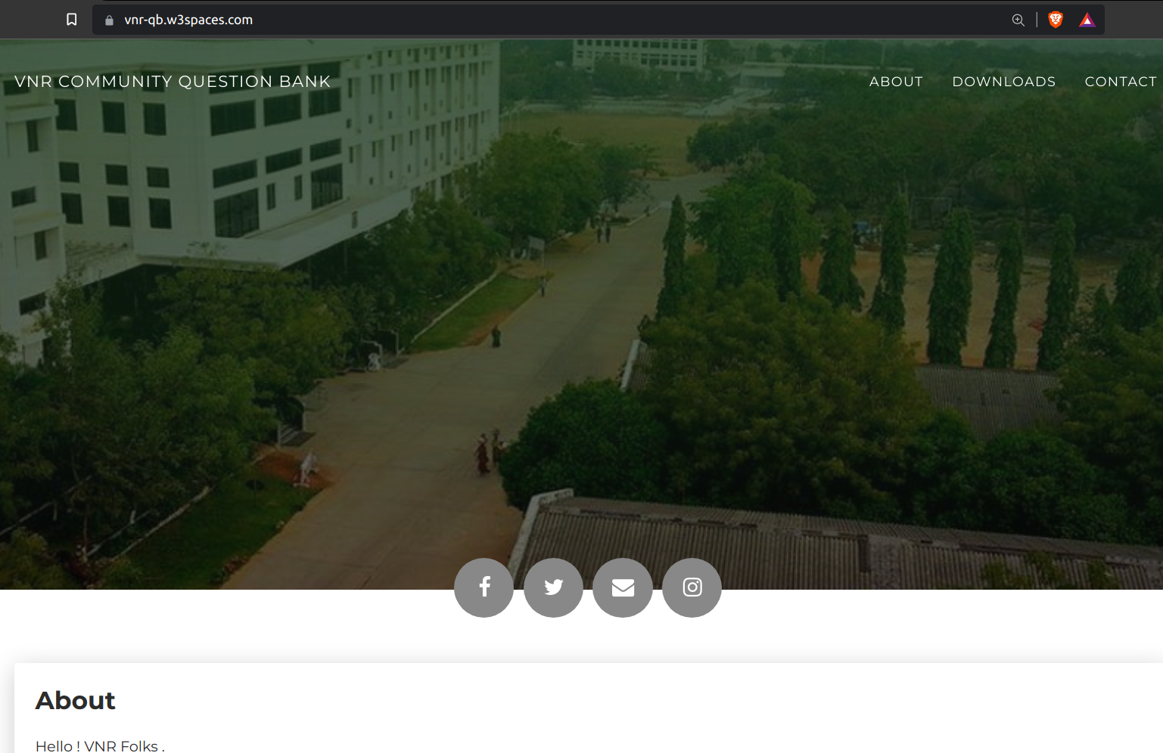Figure v: Web-Page First Sight
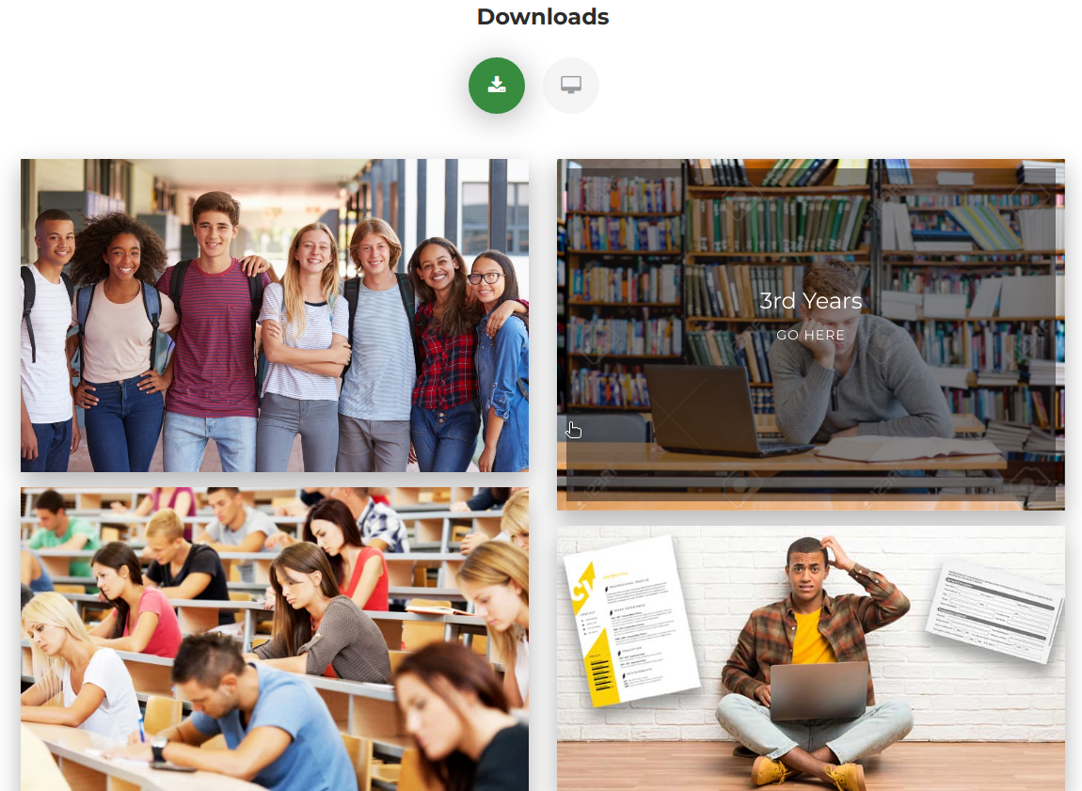Figure vi: Downloads-section

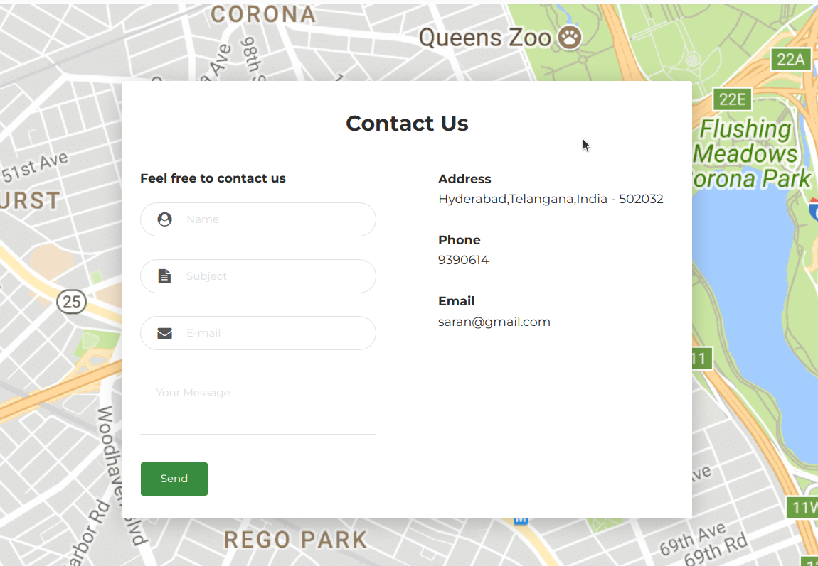Figure vii: Contact Section

5.2 Mobile Version
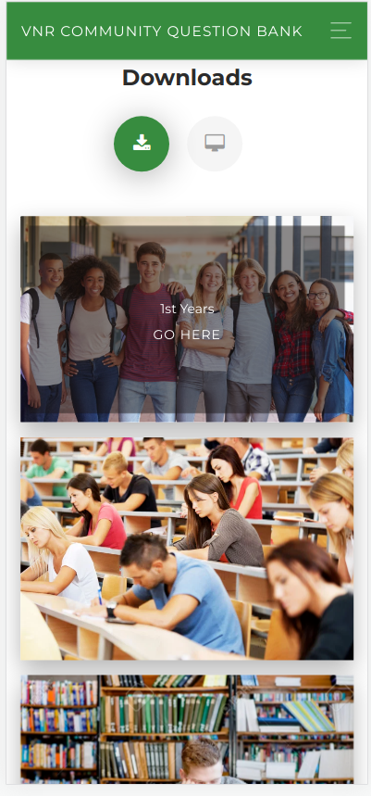
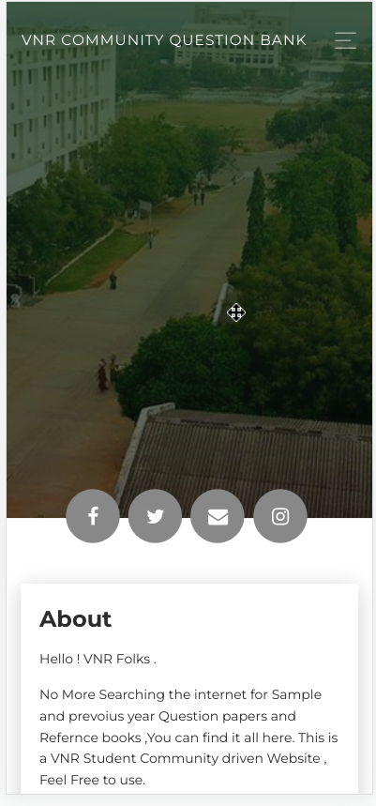Figure viii: Mobile-Version-1

Conclusion

The main aim of this project was to design and implement community question bank using Html, Css, Javascript. In this project many features are built using javascript. And uploading questions papers into every subject is the main task in this project. For styling our website we used basic css and html. In this project question are can be downloaded and readable papers in pdf format which easy to use.Any bugs identified in the process can be rectified and the software can be.It being a software will not wear out with time. Our solution is sustainable, it is easy to maintain in the long run.deployed again.
Since the digital transformation is updating regularly, there would be many updates in application development in future. Technologies would also change simultaneously and bring up major changes in every sector. The system can be further expanded on to IOS and Web platforms. Machine Learning can be integrated to do the same.

References

- https://spin.atomicobject.com/2015/01/06/human-centered-software-creating-value-balancing-feasibility-viability-desirability/
- https://www.interaction-design.org/literature/article/learn-how-to-use-the-best-ideation-methods-scamper
- https://www.interaction-design.org/literature
- https://www.tandfonline.com/doi/abs/10.1080/09718923.2017.1368220
- https://www.mindtools.com/pages/article/newCT_02.htm
- Design Thinking: A Creative Approach to Problem Solving - Mary K. Foster
- Belkin, D. (2015, January 17-18). Skills gap found in college students. The Wall Street Journal, p. A5. Google Scholar
- Dunne, D., Martin, R. (2006). Design thinking and how it will change management education: An interview and discussion. Academy of Management, 5, 512-523.

Appendix A

Questionaire/Survey-Responses
1. | 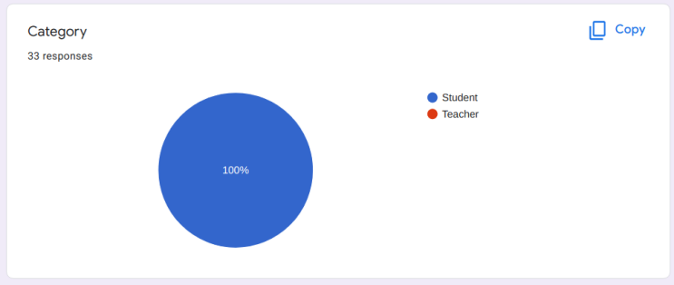Figure ix: Questionare - Answers
2 | 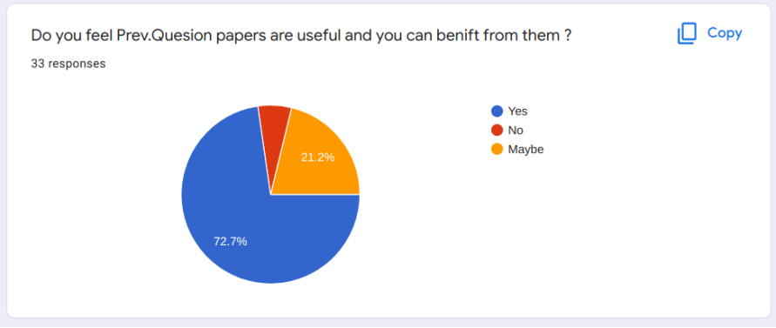
3. | 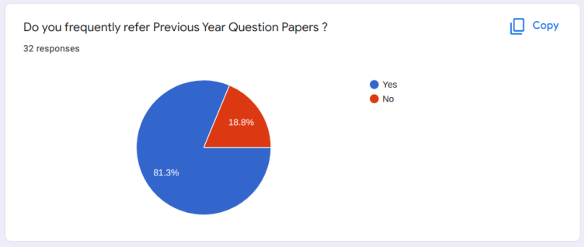
4. | 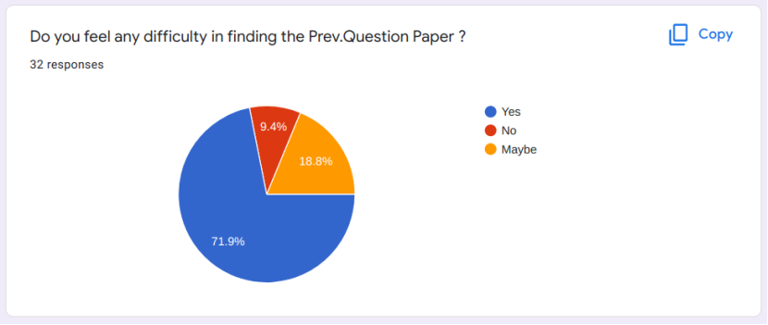
5. | 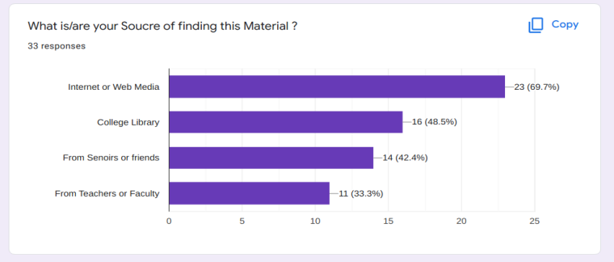
6. | 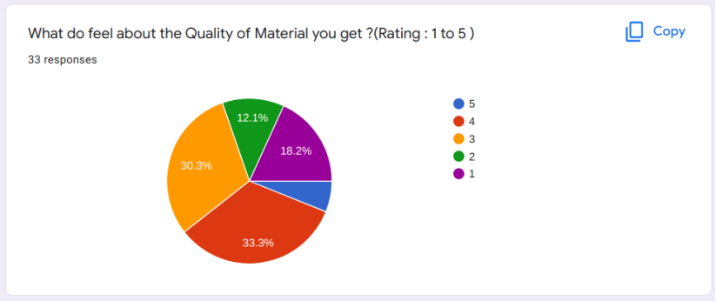
7. | 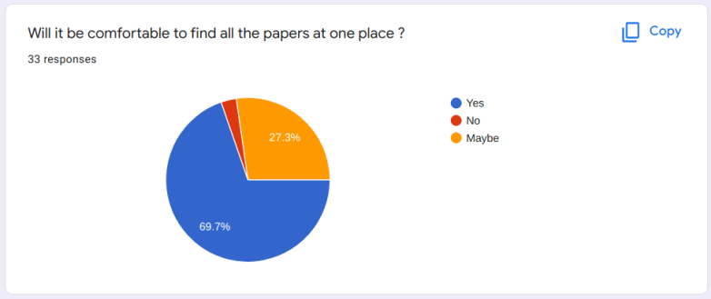
8. | 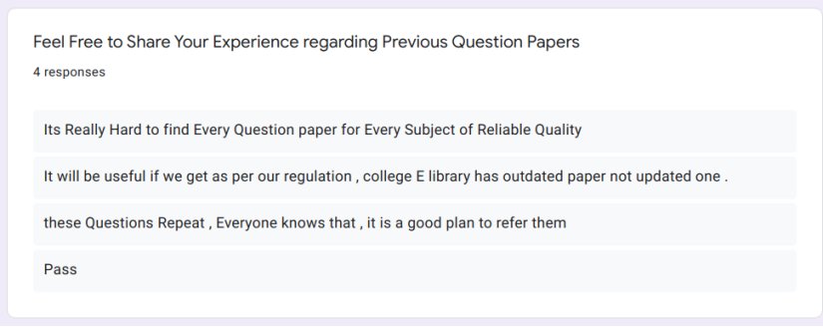

Appendix B

Snippets of Source Code :
<!DOCTYPE html>
<html lang="en-US">
<head>
<meta charset="UTF-8">
<meta http-equiv="X-UA-Compatible" content="IE=edge">
<meta name="viewport" content="width=device-width, initial-scale=1">
<title>Saran's Web CV</title>
<link href="https://fonts.googleapis.com/css?family=Montserrat:400,700,200" rel="stylesheet">
<link href="https://maxcdn.bootstrapcdn.com/font-awesome/latest/css/font-awesome.min.css" rel="stylesheet">
<link href="css/aos.css?ver=1.1.0" rel="stylesheet">
<link href="css/bootstrap.min.css?ver=1.1.0" rel="stylesheet">
<link href="css/main.css?ver=1.1.0" rel="stylesheet">
<noscript>
<style type="text/css">
[data-aos] {
opacity: 1 !important;
transform: translate(0) scale(1) !important;
}
</style>
</noscript>
</head>
<body id="top">
<header>
<div class="profile-page sidebar-collapse">
<nav class="navbar navbar-expand-lg fixed-top navbar-transparent bg-primary" color-on-scroll="400">
<div class="container">
<div class="navbar-translate"><a class="navbar-brand" href="http://www.vnrvjiet.ac.in/" rel="tooltip">VNR Community Question Bank </a>
<button class="navbar-toggler navbar-toggler" type="button" data-toggle="collapse" data-target="#navigation" aria-controls="navigation" aria-expanded="false" aria-label="Toggle navigation"><span class="navbar-toggler-bar bar1"></span><span class="navbar-toggler-bar bar2"></span><span class="navbar-toggler-bar bar3"></span></button>
</div>
<div class="collapse navbar-collapse justify-content-end" id="navigation">
<ul class="navbar-nav">
<li class="nav-item"><a class="nav-link smooth-scroll" href="#about">About</a></li>
<li class="nav-item"><a class="nav-link smooth-scroll" href="#portfolio">Downloads</a></li>
<li class="nav-item"><a class="nav-link smooth-scroll" href="#contact">Contact</a></li>
</ul>
</div>
</div>
</nav>
</div>
</header>
<div class="page-content">
<div>

