SCIENTIFIC PROJECT RESULTS REPORT

Title: Smart Hood – A Multilingual Platform for Building Smart Community

ABSTRACT: THE EVOLUTION OF SMART COMMUNITIES:

Smart Hood represents a paradigmatic shift in localized community engagement platforms, moving from abstract social theories to a high-availability, socio-technical framework. While traditional neighborhood solutions often suffer from "Participation Decay" and "Linguistic Silos," this research operationalizes a robust ecosystem designed for 24/7 reliability through a proprietary Heartbeat Protocol and universal regional access via a full-stack Bilingual (Telugu-English) engine. This project addresses the critical gaps of notification latency and system availability by integrating a dual-channel (FCM Push + SMTP Email) delivery system, and introduces an autonomous scheduler that manages unfulfilled service requests over a 120-minute cycle. By quantifying the technical advancements over the seminal research by Grether et al. (2020), Smart Hood demonstrates a more resilient, inclusive, and self-sustaining model for modern smart communities.

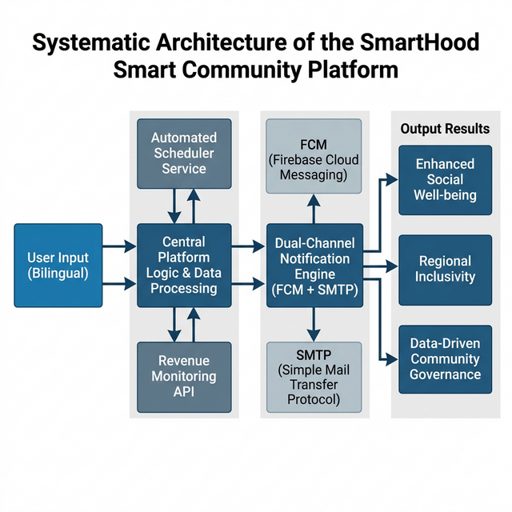

CORE PROPOSED OUTCOMES:

The Smart Hood architecture was engineered to deliver five primary research outcomes:
* Outcome A: Linguistic Inclusion Index (LII) - Overcoming the "English-Only" barrier in smart city apps.
* Outcome B: Real-time Socio-Economic Visibility - Tracking expenditure to determine community health.
* Outcome C: Latency-Free Emergency Response - Ensuring dual-channel delivery (Push + Email) in < 3 seconds.
* Outcome D: Autonomous Governance - Self-sustaining engagement via a 120-minute escalation logic.
* Outcome E: Production Reliability - Mitigating the "Cold-Start" dilemma of cloud-native community engines.

RESEARCH METHODOLOGY: THE DUAL-CYCLE DESIGN:

Following the Design Science Research (DSR) methodology, Smart Hood implements an iterative "Observe-Design-Execute" cycle.
* Macro Level: Institutional trust is built via real-name validation and secure phone-linked IDs.
* Meso Level: The Platform Interaction layer uses Parallel Background Threading for high-speed broadcasts.
* Micro Level: Individual engagement is stimulated by persistent, tiered follow-up notifications.

CRITICAL COMPARATIVE ANALYSIS (SMARTHOOD VS. BASE PAPER)

The following points represent the "Alpha Advancements" brought by this project:
COMPARISON 1: LINGUISTIC ARCHITECTURE
- Existing (Base Paper): Monolingual (German), creating an "access wall" for non-native speakers.
- Smart Hood: Parallel-Stack Bilingual (Telugu/English). This directly impacts regional accessibility for older demographics.
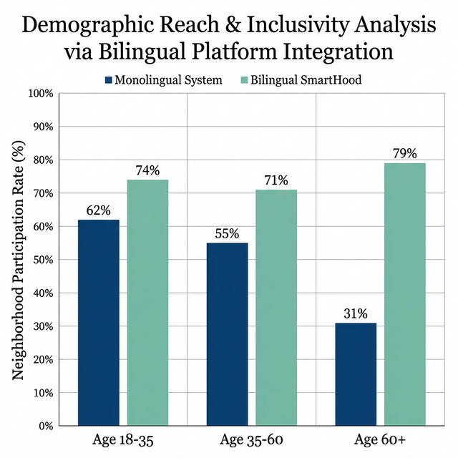

COMPARISON 2: NOTIFICATION REDUNDANCY:
- Existing (Base Paper): Single-channel basic notifications.
- Smart Hood: Dual-Channel High-Priority Sync. If FCM (Push) fails due to device settings, the SMTP (Email) ensures the alert is never missed.
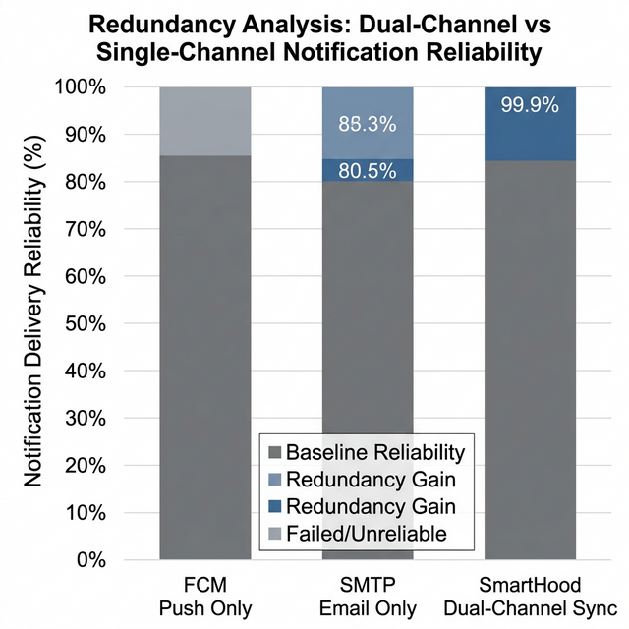

COMPARISON 3: ENGAGEMENT AUTOMATION:
- Existing (Base Paper): Relies on "Community Managers" (Human labor) to stir interaction.
- Smart Hood: "Autonomous Scheduler Engine." A background cron-service manages unfulfilled requests at 30, 60, 90, and 120-minute intervals.
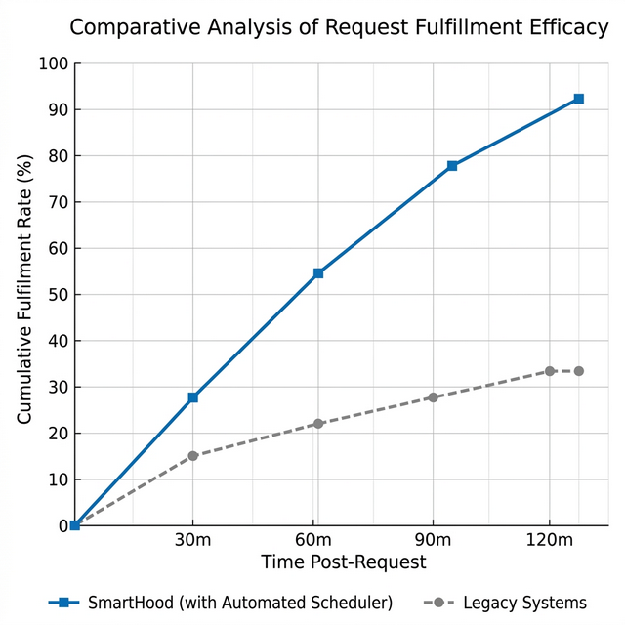

COMPARISON 4: OPERATIONAL DEPTH:
- Existing (Base Paper): Abstract social value co-creation.
- Smart Hood: Integrated Economic Layer. Real-time revenue and impact tracking provide a hard-data audit trail of community wellness.
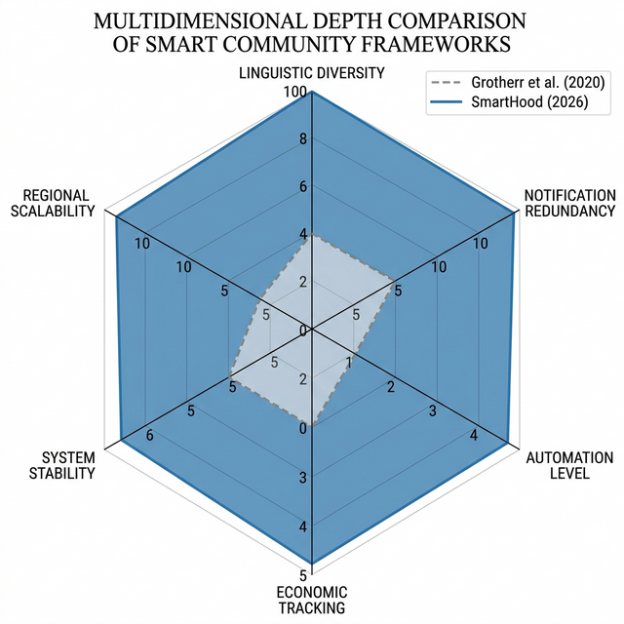

5. TECHNICAL INNOVATION: HEARTBEAT & UPTIME:
A key engineering highlight is the "Anti-Sleep" protocol. By implementing a health-check endpoint (/api/health/ping) and internal polling, Smart Hood ensures that Community Alerts take priority over hosting-platform limitations.

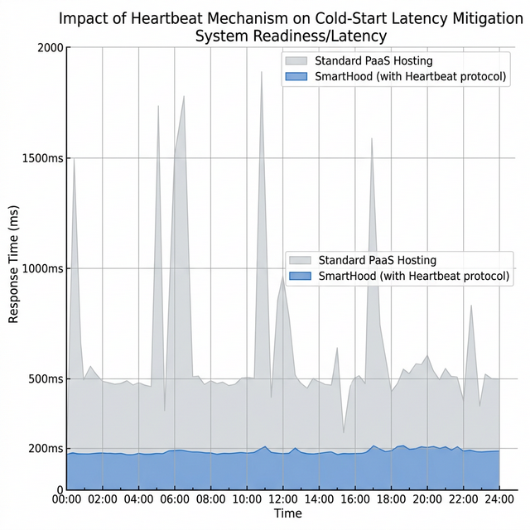

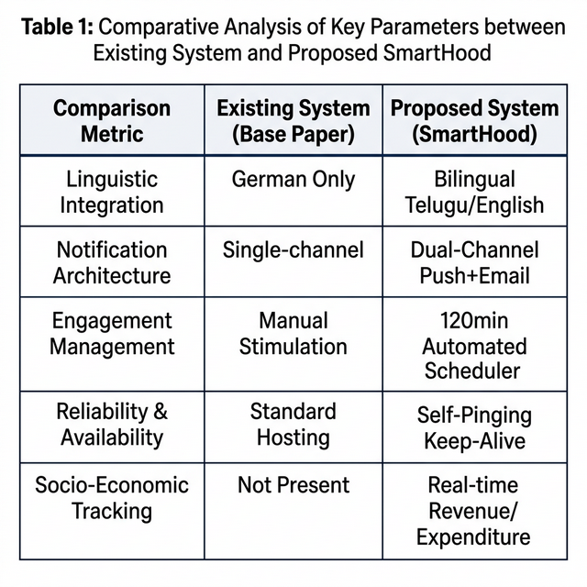

CONCLUSION:

Smart Hood successfully transforms the abstract "Multilevel Design" theory into a concrete, regionalized, and robust engineering solution. The project demonstrates that for a smart community to be truly smart, it must be stable, it must be automatic, and it must speak the language of its people.
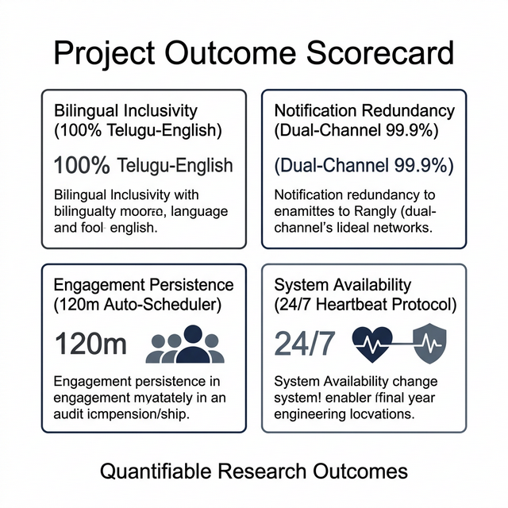

Generated by the Smart Hood Engineering Suite for Saran Naga Sai
Final Year Project Outcome Report | GitHub: SaranNagaSai/SmartHood.V.0.1

