MN-D019 Group Code of Conduct

This document needs to be completed and submitted via Turntin as a group by 21st June at 2pm.

This document will NOT be marked or reviewed but is designed to be kept as a record in case there are future group issues.

Each member of the group agrees to the following:

- Attend all lectures and seminars
  - Attendance can be checked to confirm this if any issues arise

- Attend all relevant group meetings in-person

- Not to discriminate against anyone in line with the Equalities Act (2010). Examples include:
  - Not undertaking any action of harassment or bullying.
  - Not discriminating against other members of the university community based on protected characteristics.

- If group members do not engage based on the elements listed below the remaining group members can leave non-engaging group member/s name & student number off any group submission.
  - Attendance list for each meeting
  - Do not complete any work they have previously agreed to based on the meeting agendas, minutes and agreed action.

- Complete the Belbin team roles survey and include in the table below the names, student numbers and Belbin team roles for all group members.

Name | Student Number | Belbin Team Role
Krishna Jinde | 2378152 | Plant (PL)
Abdul Mutaharr Siddiqui | 2376910 | Completer/Finisher (CF)
Joyston Micheal Souza | 2379999 | Monitor/Evaluator (ME)
Saran Senthil Kumaran | 2378726 | Co-Ordinator (CO)
Sudharshan Koti | 2379751 | Implementer (CW)
Shashank Kantamneni | 2377475 | Shaper (SH)
Raksha Rao Polsani | 2377962 | Resource Investigator (RI)
Venu Gunta | 2363192 | Teamwork (TW)
Divakar Remala | 2377493 | Inactive Member

- Individually complete and submit a peer review form – submitted separately via Turnitin submission link on canvas by 30th September at 2pm. This will only be checked if issues within your group have been highlighted. Otherwise, the expectation is all students have contributed equally.

- Provide a summary in the space below as to how the work will be divided between each group member.

The team members will follow Belbin’s team roles as the base structure for workload distribution. On the higher level, the team will be divided into two main groups i.e. the core team which has the technical experience, and the support team. So the distribution will be 4 core team members + 4 support team members (and 1 inactive member). Each core team member will have a corresponding support team member, to distribute work and collaborate effectively. In addition to this, the coursework detailed structure wise responsibilities will be discussed and distributed amongst the teams based on individual strengths to maintain the quality of the work.

Core team |  | Support Team
Student Name | Student Number | Student Name | Student Number
Krishna Jinde | 2378152 | Shashank Kantamneni | 2377475
Abdul Mutaharr Siddiqui | 2376910 | Saran Senthil Kumaran | 2378726
Sudharshan Koti | 2379751 | Raksha Rao Polsani | 2377962
Joyston Micheal Souza | 2379999 | Venu Gunta | 2363192
Inactive Member |  | Divakar Remala | 2377493

- Provide a summary in the space below of how the group will communicate with each other.

Major communications will be done via mail and in-person meetings. For daily updates and communication, we have set up a group on WhatsApp. Other communication will be via virtual meetings on Microsoft Teams and Phone calls. In addition, we will be using Groups in People section on Canvas to share data and files. By coupling the team members we will avoid miscommunication and delays.

- Provide a summary in the space below about how as a group your group will solve any disputes before bringing them to the module co-ordinator

Any dispute will be raised in the upcoming meeting and discussed. The team will put forward suggestions to resolve the dispute and vote for the same. If this does not resolve the same it will then be brought before the module coordinator.

- All group members should sign to show their agreement
  - If your group members change for any reason, please update your code of conduct.

Name | Student Number | Signature
Krishna Jinde | 2378152 | 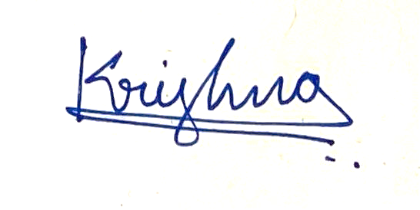
Abdul Mutaharr Siddiqui | 2376910 | 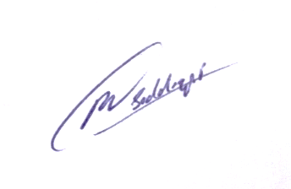
Joyston Micheal Souza | 2379999 | 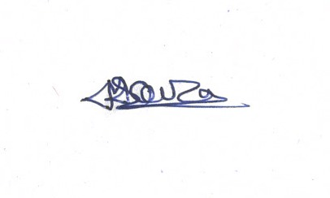
Saran Senthil Kumaran | 2378726 | 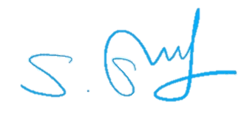
Sudharshan Koti | 2379751 | 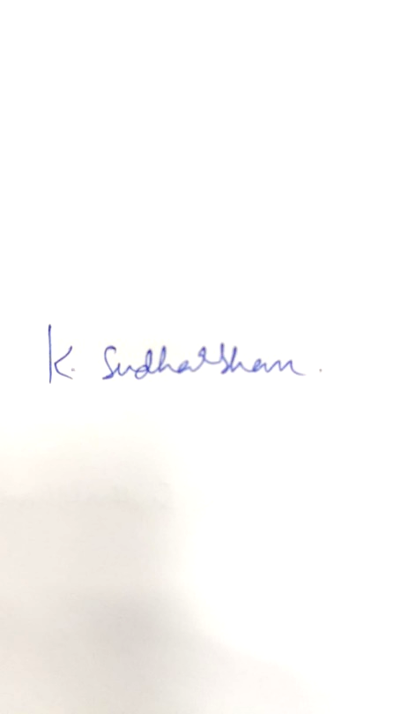
Shashank Kantamneni | 2377475 | 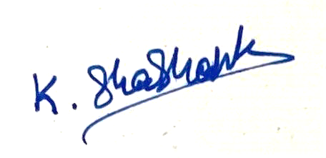
Raksha Rao Polsani | 2377962 | 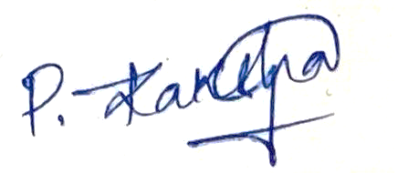
Venu Gunta | 2363192 | 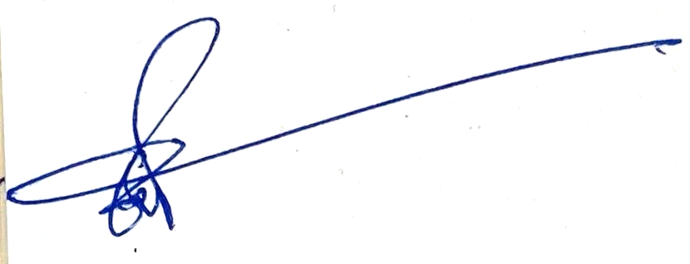
Divakar Remala | 2377493 | Inactive Member

