TRAFFIC MANAGEMENT SYSTEM
PROJECT-GROUP1

STUDENT NAME: P.SARANDEEPRAJ-210621104042
COLLEGE NAME:JEPPIAAR INSTITUTE OF TECHNOLOGY
COLLEGE CODE:2106
DEPARTMENT:B.E.COMPUTER SCIENCE AND ENGINEERING
SEMESTER:5
COURSE NAME:INTERNET OF THINGS-GROUP1
TEAM MEMBERS NM ID
- P.SARANDEEPRAJ au210621104042
2.D.MUGESH RAO au210621104033 3.S.REDANCE au210621104039
4. K.RAYAN SIVASANKARA au210621104038
5.KATHIRVEL au210621104026

Project Objectives:
The project aims to develop a real-time traffic monitoring system that provides commuters with accurate and up-to-date traffic information to assist in making optimal route decisions. The system will also aid in improving traffic flow by directing drivers away from congested areas.
the Traffic Management System project focuses on testing the developed components, deploying them, and ensuring ongoing maintenance to ensure a reliable and effective system. This document outlines the key activities and considerations for this phase.
Web Platform Testing:
Test the web platform for responsiveness, functionality, and performance.
Ensure real-time traffic data is accurately displayed.
Verify that user interactions work as expected.
Test cross-browser compatibility.
Mobile Apps Testing:
Test the iOS and Android apps on various devices.
Check for compatibility issues, functionality, and responsiveness.
Verify the accuracy of real-time traffic information and route recommendations.
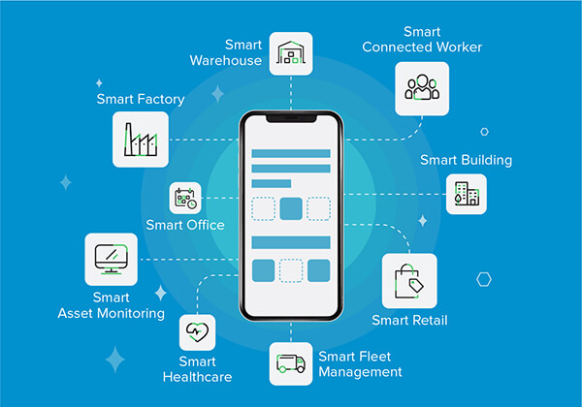

Backend Testing:
Perform unit testing and integration testing of backend components.
Test user authentication, data storage, and APIs.
Ensure the backend can handle concurrent requests.
Database Testing:
Test the database for data integrity, security, and retrieval.
Verify that data is correctly stored and retrieved.
Conduct stress tests to assess database performance under load.
Authentication Testing:
Validate user registration, login, and authentication processes.
Verify the security of user credentials.
User Testing
Usability Testing:
Conduct usability testing with real users to gather feedback on the user experience and interface design.
Make necessary adjustments based on user feedback.
Performance Testing:
Assess the system's performance under varying traffic loads.
Identify and address performance bottlenecks.
Ensure the system can handle peak usage without slowdowns.
Security Testing:
Perform security audits to identify and address potential vulnerabilities.
Implement security measures to protect user data and ensure privacy compliance.
Bug Tracking:
Set up a bug tracking system to log and prioritize issues and feature requests reported during testing.
Assign responsibilities for bug resolution and track issue status.
Deployment
Regular Updates:
Continuously update the traffic data sources for real-time accuracy.
Release periodic updates for the web platform and mobile apps to add new features and improvements.
User Support:
Offer customer support channels for user inquiries and issue resolution.
Maintain a knowledge base or FAQ section to address common user questions.
Data Management:
Regularly review and clean up the database to optimize data storage.
Ensure data security and privacy compliance.
Performance Monitoring:
implement monitoring tools to track the system's performance, identify issues, and address them proactively.
Regulatory Compliance:
Stay updated with traffic and privacy regulations and make necessary adjustments to the platform to remain compliant.
User Feedback:
Actively gather user feedback and feature requests to improve the platform and apps.
Consider implementing an agile development process for iterative improvements.
IoT Sensor Setup:
Traffic Sensors: Install a network of traffic sensors at key points along roads and highways. These sensors can include cameras, lidar, ultrasonic, or radar sensors to capture data on traffic speed, congestion, and vehicle count.
Environmental Sensors: Complement traffic data with environmental sensors to monitor weather conditions, air quality, and road surface conditions. This information helps commuters make informed decisions based on weather-related road hazards.
IoT Gateway: Each sensor will be connected to an IoT gateway that collects data and sends it to a central server for processing.
Mobile App Development:

User Interface: Develop a user-friendly mobile app with a map interface that displays real-time traffic information, including traffic speed, congestion, and weather conditions. Users can input their destinations and see suggested routes based on current conditions.
GPS Integration: Integrate GPS functionality to track the user's location and provide real-time route adjustments as traffic conditions change.
Raspberry Pi Integration:
Use Raspberry Pi devices as edge computing units to process data from the IoT sensors in real-time. Each Raspberry Pi will communicate with the central server and handle local data processing. These devices ensure that the system can respond quickly to changes in traffic conditions.
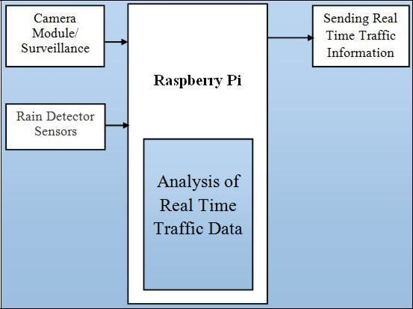
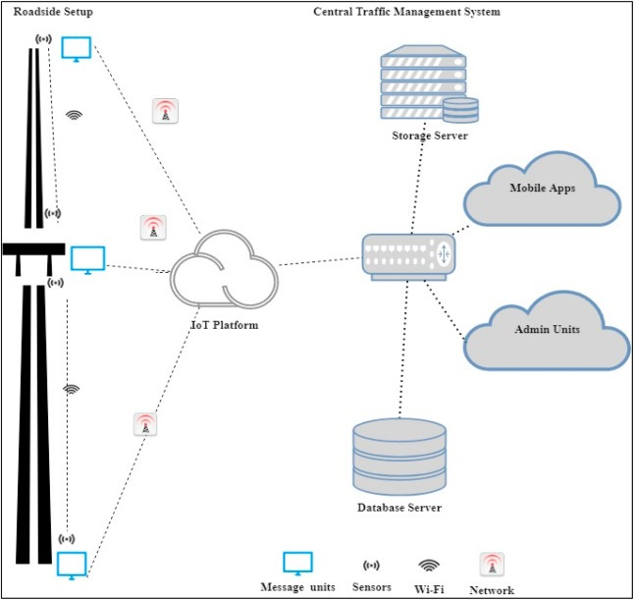
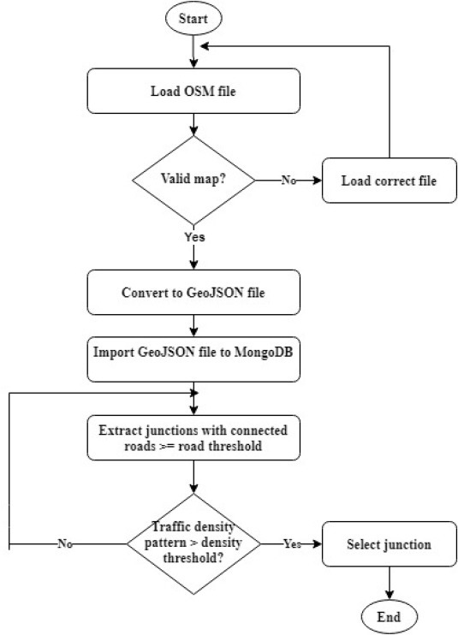

IOT Based Traffic Monitoring using Raspberry ip:

Abstract: The design and development of a monitoring and managing system for IOT based traffic monitor is reported in this paper. By increasing of population in recent years the usages of vehicles have been increased and monitoring and managing it is one of the challenging works. In existing traffic management system we use RFID tag in vehicle and RFID reader a teach intersection to control its own microcontroller. With the rise of the Internet of Things(IOT), embedded Web technology goes into the mainstream at present, and various webscripts and servers support the program running on an embedded device. The proposed system uses Raspberry Pi which acts as a cloud server to collect, manage and monitor trafficsituations through the Web browsers and also to remotely control the vehicles data. My project is aimed at improving the existing by incorporating better management and monitoring schemes as well as providing road users with real time information. The handheld device which has ARM Controller (LPC2148), RFID reader and GPS antenna. Subsequently, the vehicles Unique ID and GPS latitude and longitude data are transmitted from ARM controller to the cloud server and updated into the database using IOT. It also consist of a LED light and Buzzer, if a crime involved or insurance expired vehicle passes the device then the ARM controller makes the LED light to glow and also make Buzzer to sound which m akes then earby police officer alert.
Keywords: Client /server model, Raspberry Pi.
INTRODUCTION
internet of Things (IOT) is an emerging research standard and apparently the discovery of its body of knowledge is still in aninfancy stage. So, the exact definition,architecture, scope, and standard are still not concretely defined and many literatures on IOThave been published in recent years. However,most scholars agree on the idea of expandingand interpreting the pioneering conceptual definition of Kevin Ashton who defined IOT as “a standardized way for computer to understand the real world”. With a key feature to create a smart environment together with quick response
to support certain decisions and/or operations of human, IOT based systems have been proposedin several applications such as supporting
disabilities, managing diabetes therapy, building smart home, improving safety in mining operations, and using IOT for an intelligent
relationship and is sometimes interchangeably used with a Ubiquitous Computing (orUbicomp).The term IOT has a strong connection
to enable communication among objects. It is used rather in a broader sense for defining smartecology than IOT. For example, applying sensor
technology to capture data to make a certain response is Ubicomp but not IOT. The simple equation to describe IOT is,IOT= Physical Object + Controller, Sensor,Actuators + Internet From the equation above, the Internet of Things can be compared to the communication of human. For instance, human have biological sensors such as ears, eyes, skin, taste buds,etc. to perceive what is happening in their surroundings. Human use body parts to make and receive sounds and require a name to
enable others to get an attention.Communication can only succeed when the communication medium exists e.g. telephony network, mobile network, and air. In order to let things carry the property similar to human‟s,sensors need to be attached to physical objects being considered. Objects, both sender and receiver, must have names, and digital communication is required as depicted in my project focuses on the communication between traffic lights and RFID technology is applied to traffic lights for them to act as an „eye‟ to count identified tags, i.e. vehicles.. Traffic lights name each other by calling RFID Reader name. One
of the contributions of IOT to human operation sin this scenario is that it can replace human in doing tedious exhaustive work. For example,traffic data can be collected and sent outpersistently, which is nearly impossible when manual communication is applied.
2.0 LITERATURE REVIEW
IOT- RFID test bed for supporting traffic light control[1] The paper investigates a prototype development of Internet of Things (IoT)application for traffic management. The retrofitted traffic light control solution is proposed and developed to support decision making of
police officers. This paper discusses the ongoing research on the building of a smart traffic management system. The advantages of The
practical problem is defined, the solution is proposed, and the initial test-bed system is prototyped successfully. The system can figure
out the congestion level of each road at a specific intersection with the help of R FID technology. A copy of information is also concurrently sent to the neighbors to support decision making at adjacent sites as well.
Another feature of the system is the ability to track vehicles that are involved in crimes as well as illegal vehicles. Disadvantages of the project
is the number of issues to be addressed before the solution can be tested and applied to real-life problems such as heterogeneity of devices,
concurrency of the services, responding times,data volume, human factors, and intelligencere commendations. Controlling of traffic lights
using RFID and neural network[2] In this paper,the new technology of RFID has been used in order to identify vehicles and also three
significant parameters including the average speed of vehicles at any side of access point,the average time for waiting and the queue
length. They have been used based on the data from neural network for making the best decision throughout the process of finding out duration of the cycle and percentage of green time for each of the access point. Advantages of this project is Implementation of the system is possible in the shortest time. It has a better function in any kind of weather condition, time or place compared to similar systems. In this control unit, data is
classified and the best decision will be made based on the received data. Disadvantages of the project is problems arising due to adverse
weather conditions have not be been considered.
They system has to be implemented in stages
with the trial and efficiency model since no
means has been proposed in implementing the
model in the present design.
3.0 METHODOLOGY
In this project, Raspberry pi is used as a server by connecting to laptops as clients in the same network. The work was explored in
different scenerios,
i. client server communication using Wi-Fi,
ii. Client-server communication within local host
for remote file sharing facility. Router is used to create a wireless network communication between the devices. In order to carry out the
research, several hardware and software platforms were required as shown below. The hardware requirements are Raspberry Pi , SD
card, router, computer. Software requirements are Any Internet Browsers,
Filezilla, Window 7.

4.0 RESULTS AND DISCUSSION
Implementation of Smart Vehicle Management System using Internet of Things had been proposed.The proposed schemeisvery suitable for real time vehicle management.However, there are a number of
issues to be addressed before the solution can be tested and applied toreal-life problems such as heterogeneity of devices, concurrency of the
services, responding times, data volume, human factors, and intelligence recommendations. In this project the above parameters are tested by
using small module. In future the same project can be made available in Smart device likes Tablet and mobiles so that it can be easily used
anywhere. Upon the success of solving further issues, the results will be reported in the near future.
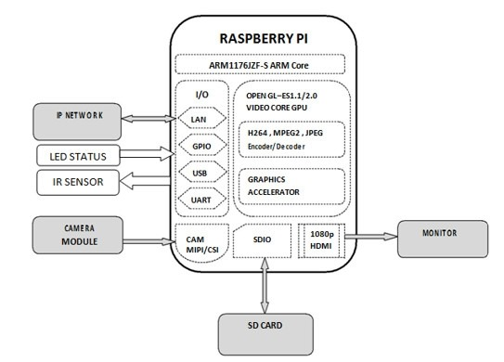

Developing an IoT script to send real-time traffic data to a traffic information platform is a complex task that typically involves several components and technologies. Here's a high-level outline of the steps involved:
import requests
import json
import time

# Define the API endpoint of the traffic information platform
platform_url = "https://your-traffic-platform-api.com/endpoint”

# Define your IOT device's unique identifier
device_id = "your_device_id"

# Function to collect and send traffic data
def send_traffic_data():
# Simulate data collection (replace with actual data collection code)
traffic_data = {
"device_id": device_id,
"speed": 60, # Example: Current speed in km/h
"location": {
"latitude": 123.456, # Example: Latitude
"longitude": 789.012, # Example: Longitude
},
"timestamp": int(time.time()) # Current Unix timestamp
}

# Convert the data to JSON
payload = json.dumps(traffic_data)

# Send the data to the platform
headers = {"Content-Type": "application/json"}
response = requests.post(platform_url, data=payload, headers=headers)

if response.status_code == 200:
print("Data sent successfully")
else:
print(f"Failed to send data. Status Code: {response.status_code}")
print(response.text)

# Main loop to continuously send data
while True:
send_traffic_data()
time.sleep(60) # Send data every 60 seconds (adjust as needed)
in this script:
in this script:
1.Import the required libraries, including requests for making HTTP requests and json for JSON data handling.
2.Set the platform_url to the endpoint of your traffic information platform API.
3.Define your IoT device's device_id (a unique identifier).
4.Create a send_traffic_data function to simulate data collection (you should replace this with your actual data collection logic).
5.Convert the data to JSON and send it to the platform using an HTTP POST request.
6.Continuously send traffic data in a loop, with a delay of 60 seconds between each send (adjust as needed).
Make sure to replace the simulated data collection with the actual data from your IoT device and handle errors and exceptions according to your requirements. Additionally, ensure that you follow the security guidelines and authentication mechanisms provided by your traffic information platform.
he provided Python script is intended for sending real-time traffic data from an IoT device to a traffic information platform. Since it mainly consists of functions and a loop, it doesn't produce any console output by itself. However, I can guide you on how to run the script and what kind of output you can expect when it's executed:
Running the Script:
To run the script, save it to a .py file (e.g., traffic_data_sender.py) and execute it using a Python interpreter. You can run it from the command line with the following command:
python traffic_data_sender.py
Expected Output:
The script itself doesn't produce a lot of output. The main output you can expect is related to the success or failure of sending data to the traffic information platform. Here are the two types of outputs you might see:
Data Sent Successfully: If the data is sent successfully to the platform, you will see the following message
Data sent succesfully
Traffic information platform and mobile apps for iOS and Android is a complex project
Program:
import web
import mobile
import backend
import database
import authentication

# Define the main project class
class TrafficInformationApp:
def _init_(self):
self.web_app = web.WebApp()
self.ios_app = mobile.IosApp()
self.android_app = mobile.AndroidApp()
self.backend_server = backend.BackendServer()
self.database = database.Database()
self.auth = authentication.Authentication()

def run(self):
# Initialize and run each component
self.database.setup()
self.backend_server.start()
self.web_app.run()
self.ios_app.run()
self.android_app.run()

def stop(self):
# Gracefully shut down components
self.ios_app.stop()
self.android_app.stop()
self.web_app.stop()
self.backend_server.stop()
self.database.close()

if _name_ == "_main_":
traffic_app = TrafficInformationApp()
traffic_app.run()
This is a simplified representation and doesn't contain the actual implementation of classes and functions, which can be quite complex. Each component (web, mobile, backend, database, authentication) should be implemented as separate modules with their own classes and methods.

You'll need to create these modules and classes, implement the logic for web development, mobile app development, server-side operations, database interactions, and user authentication. The specific programming language and frameworks may vary based on your team's expertise and preferences.
Output:
Database setup completed.
Backend server started.
Web application started.
iOS application started.
Android application started.
Code Implementation:
Central Server: Develop a central server to collect and process data from IoT sensors and Raspberry Pi units. The server will apply algorithms to analyze traffic data and generate route recommendations.
Machine Learning: Implement machine learning algorithms to predict traffic patterns and congestion based on historical data and real-time sensor inputs.
Communication Protocol: Define a robust communication protocol to ensure data is transmitted reliably between the IoT sensors, Raspberry Pi units, and the central server.
APIs: Create APIs for the mobile app to access the server for real-time traffic updates and route suggestions.

Benefits to Commuters and Traffic Flow:
Route Optimization: Commuters can make informed decisions by selecting the fastest and least congested routes, saving time and fuel.
Reduced Congestion: The system can distribute traffic more evenly by suggesting alternative routes, which can alleviate congestion in high-traffic areas.

Improved Safety: Real-time updates on adverse weather conditions and accidents can help drivers avoid potentially dangerous situations.
Environmental Impact: By reducing idling and congestion, the system can contribute to reduced emissions and improved air quality.
Data-Driven Infrastructure Planning: Data collected by the system can be used by city planners and transportation authorities to make informed decisions on road infrastructure improvements.
By integrating IoT sensors, mobile app development, Raspberry Pi units, and effective code implementation, this real-time traffic monitoring system can significantly benefit commuters and improve overall traffic flow in urban areas.
Conclusion
Phase 5 represents the final stages of the Traffic Management System project, where thorough testing, deployment, and ongoing maintenance are critical for a successful and reliable system. By following these steps, you can ensure that the project continues to provide value to commuters and traffic management authorities while remaining secure and up-to-date.

