/c/.cx v
Session notes
Stream | 2019 Semester 1 | Diploma Software Development
Teacher | Chaitali Samani
Units | ICASAD501A / Model data objects  ICASAD502A / Model data processes

BIT Field Support Services BFSS Data model

By Sarang Shin

Organization name & details | Business Information Technology
Functional area/s | IT
Document type | Data model blueprint
Project name | BIT Integrated System
Data model name | BIT Integrated System Data Model
Document version number | V1.0
Date | 05/04/2019
Disclosure | Confidential

Version change tracking sheet

Version | Date | Author | Requestor | Summary of changes | Formal Sign-off | Approver
V1.0 | 05/04/2019 | Sarang Shin |  | Added ERD and DFD – Context, Level 1
V1.1 | 03/05/0219 | Sarang Shin |  | Updated ERD
V1.2 | 25/05/2019 | Sarang Shin |  | Updated ERD – Roster, log tables

[CONTENT INDEX]

Content

A / Database glossary of terms, guidelines & naming conventions

B / Entities - Relationships diagram

C / Database dictionary (physical tables, stored procedures, triggers)

- Staff
- Contractor
- Coordinator
- Job
- Client
- Company
- Status
- Location
- JobCategory
- ContractorAvailability
- ContractorSkill
- ContracorRating
- ContractorLocation
- JobRejection
- Staff_log
- Job_log
- Client_log
- Company_log
- Stored Pocedures
- Triggers

D / Dataflow Diagrams

- BIT System Context Diagram
- BIT System Level 1 Diagram
- BIT System Level 2 Diagram – Account Handling

A / Database guidelines, glossary of terms & naming conventions

A.1) Glossary

PK = Primary Key
FK = Foreign Key (Related table in Description)

A.2) Guidelines and naming conventions

- All names contain Camel-casing.
- All names are written longhand
- PK are suffixed with ID

A.2.1) Physical tables naming

- Physical table names are camel-cased starting with a capital letter
- Multiple words are joined unless they are a log table in which they will be separated with an underscore.
A.2.2) Logical tables (views) naming
- They will be named the same as their physical counterparts.

A.2.3) Field naming

- All names contain Camel-casing starting with a Capital Letter.
- All names are written longhand.
- PK are suffixed with ID.

A.2.4) Function naming

- All names contain Camel-casing starting with a Capital Letter.
- Multiple words are joined.

A.2.5) Stored procedure naming

- All names contain Camel-casing starting with a Capital Letter.
- All names are as follows with “usp_[Platform]_[Entity][Action]”.
- [Platform] stands for which system module the stored procedure is being used by, e.g. Cloud, Client Server, Mobile.
- [Entity] stands for which domain entity the action is used for, e.g. Contractor, Client.
- [Action] stands for what the outcome of the stored procedure is, e.g. GetJobs, GetContractors.

A.2.6) Trigger naming

- All names are all lower-case.
- All names are as follows with “[Time]_[Affected Table]_[Action]”.
- [Time] can be either before or after, when the action was taken.
- [Affected_Table] stands for which domain entity the action is used against, e.g. Contractor, Client.
- [Action] stands for what action on was taken on the table, e.g. Update, Delete, Insert.

A.2.7) Variable naming

- All names are camel-cased starting with a lower-case letter.
- Multiple words are joined.

A.2.8) Other naming conventions

None

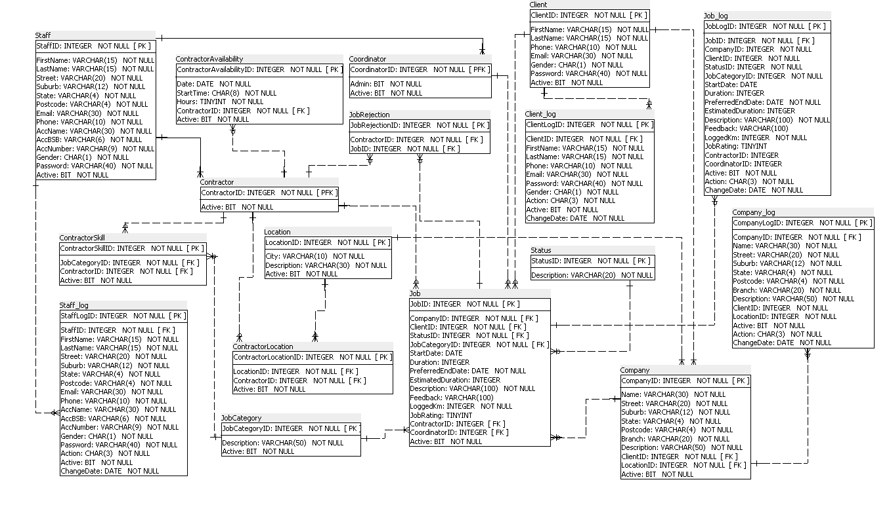
B / Entities - Relationships diagram

C / Database dictionary (physical tables)

Table Name: Staff
Table Description: Staff entity
Structure:
Columns | Type | Length | Domain | Key/Index | FK Relation | Comment/Description
StaffID | INT |  | Over 0 | PK |  | Unique ID – Auto Increment
FirstName | VARCHAR | 15 |  |  |  | Staff First Name
LastName | VARCHAR | 15 |  |  |  | Staff Surname
Street | VARCHAR | 20 |  |  |  | Street Address including number
Suburb | VARCHAR | 12 |  |  |  | Suburb
State | VARCHAR | 4 |  |  |  | State
Postcode | VARCHAR | 4 |  |  |  | Postcode
Email | VARCHAR | 30 |  |  |  | Email
Phone | VARCHAR | 10 |  |  |  | Mobile Phone Number or Landline Phone with Area Code
AccName | VARCHAR | 30 |  |  |  | Bank Account Name
AccBSB | VARCHAR | 6 |  |  |  | Bank Account BSB
AccNumber | VARCHAR | 9 |  |  |  | Bank Account Number
Gender | CHAR | 1 |  |  |  | M or F
Password | VARCHAR | 15 | SHA1 Encryption |  |  | Encrypted
Active | BIT |  |  |  |  | To be shown in system or not

Table Name: Contractor
Table Description: Contractor Entity
Structure:
Columns | Type | Length | Domain | Key/Index | FK Relation | Comment/Description
ContractorID | INT |  | Over 0 | PK | Staff | Unique ID
Active | BIT |  |  |  |  | To be shown in system or not

Table Name: Coordinator
Table Description: Coordinator Entity
Structure:
Columns | Type | Length | Domain | Key/Index | FK Relation | Comment/Description
CoordinatorID | INT |  | Over 0 | PK | Staff | Unique ID
Admin | BIT |  |  |  |  | Admin Status
Active | BIT |  |  |  |  | To be shown in system or not

Table Name: Job
Table Description: Job Entity
Structure:
Columns | Type | Length | Domain | Key/Index | FK Relation | Comment/Description
JobID | INT |  | Over 0 | PK |  | Unique ID – Auto Increment
CompanyID | INT |  | Over 0 |  | Company | Requesting Company
ClientID | INT |  | Over 0 |  | Client | Requesting Client
StatusID | INT |  | Over 0 |  | Status | Status of the job
JobCategoryID | INT |  | Over 0 |  | JobCategory | Type of job
StartDate | DATE |  |  |  |  | Start date of commencement
Duration | INT |  |  |  |  | How long the job took
PreferredEndDate | DATE |  |  |  |  | Client’s preferred due date
EstimatedDuration | INT |  |  |  |  | Estimated time taken from assessment
Description | VARCHAR | 100 |  |  |  | Job Description
Feedback | VARCHAR | 100 |  |  |  | Feedback after completion
LoggedKm | INT |  |  |  |  | Contractor’s logged mileage
JobRating | TINYINT |  |  |  |  | Between 1 to 5
ContractorID | INT |  | Over 0 |  | Contractor | Assigned Contractor
CoordinatorID | INT |  | Over 0 |  | Coordinator | Assessing Coordinator
Active | BIT |  |  |  |  | To be shown in system or not

Table Name: Client
Table Description: Client Entity
Structure:
Columns | Type | Length | Domain | Key/Index | FK Relation | Comment/Description
ClientID | INT |  | Over 0 | PK |  | Unique ID – Auto Increment
FirstName | VARCHAR | 15 |  |  |  | Client First Name
LastName | VARCHAR | 15 |  |  |  | Client Last Name
Phone | CHAR | 10 |  |  |  | Mobile Phone Number or Landline Phone with Area Code
Email | VARCHAR | 30 |  |  |  | Client Email Address
Gender | CHAR | 1 |  |  |  | M or F
Password | VARCHAR | 15 | SHA1 Encryption |  |  | Encrypted
Active | BIT |  |  |  |  | To be shown in system or not

Table Name: Company
Table Description: Company Entity
Structure:
Columns | Type | Length | Domain | Key/Index | FK Relation | Comment/Description
CompanyID | INT |  | Over 0 | PK |  | Unique ID - Auto Increment
Name | VARCHAR | 30 |  |  |  | Company Name
Street | VARCHAR | 20 |  |  |  | Street Address including number
Suburb | VARCHAR | 12 |  |  |  | Suburb
State | VARCHAR | 4 |  |  |  | State
Postcode | VARCHAR | 4 |  |  |  | Postcode
Branch | VARCHAR | 20 |  |  |  | Branch of the Company
Description | VARCHAR | 50 |  |  |  | Company Description
ClientID | INT |  | Over 0 |  | Client | Client Representative
LocationID | INT |  | Over 0 |  | Location | Location of Branch
Active | BIT |  |  |  |  | To be shown in system or not

Table Name: Status
Table Description: Status Lookup Table
Structure:
Columns | Type | Length | Domain | Key/Index | FK Relation | Comment/Description
StatusID | INT |  | Over 0 | PK |  | Unique ID – Auto Increment
Description | VARCHAR | 20 |  |  |  | Status Description/Name

Table Name: Location
Table Description: Location Lookup Table
Structure:
Columns | Type | Length | Domain | Key/Index | FK Relation | Comment/Description
LocationID | INT |  | Over 0 | PK |  | Unique ID – Auto Increment
City | VARCHAR | 10 |  |  |  | City of Location
Description | VARCHAR | 30 |  |  |  | Regional Identification of Location
Active | BIT |  |  |  |  | To be shown in system or not

Table Name: JobCategory
Table Description: Job Category Lookup Table
Structure:

Columns | Type | Length | Domain | Key/Index | FK Relation | Comment/Description
JobCategoryID | INT |  | Over 0 | PK |  | Unique ID – Auto Increment
Description | VARCHAR | 50 |  |  |  | Job Category Description/Name
Active | BIT |  |  |  |  | To be shown in system or not

Table Name: ContractorAvailability
Table Description: A Contractor’s Availability
Structure:

Columns | Type | Length | Domain | Key/Index | FK Relation | Comment/Description
ContractorAvailabiltiyID | INT |  | Over 0 | PK |  | Unique ID – Auto Increment
ContractorID | INT |  | Over 0 |  | Contractor | Contractor
Date | DATE
StartTime | TIME
Hours | INT
Active | BIT |  |  |  |  | To be shown in system or not

Table Name: ContractorSkill
Table Description: Skills/Job Category a Contractor can fulfil
Structure:

Columns | Type | Length | Domain | Key/Index | FK Relation | Comment/Description
ContractorSkillID | INT |  | Over 0 | PK |  | Unique ID – Auto Increment
ContractorID | INT |  | Over 0 |  | Contractor | Contractor
JobCategoryID | INT |  | Over 0 |  | JobCategory | Contractor skill
Active | BIT |  |  |  |  | To be shown in system or not

Table Name: ContractorLocation
Table Description: Locations where Contractor services
Structure:
Columns | Type | Length | Domain | Key/Index | FK Relation | Comment/Description
ContractorLocationID | INT |  | Over 0 | PK |  | Unique ID – Auto Increment
ContractorID | INT |  | Over 0 |  | Contractor | Contractor
LocationID | INT |  | Over 0 |  | Location | Location that Contractor serves
Active | BIT |  |  |  |  | To be shown in system or not

Table Name: JobRejection
Table Description: A table to contain which jobs a Contractor has rejected
Structure:
Columns | Type | Length | Domain | Key/Index | FK Relation | Comment/Description
JobRejectionID | INT |  | Over 0 | PK |  | Unique ID – Auto Increment
ContractorID | INT |  | Over 0 |  | Contractor | Contractor
JobID | INT |  | Over 0 |  | Job | Job that was rejected

Table Name: Staff_log
Table Description: A log table for when a record from the Staff table is inserted, deleted or updated
Structure:
Columns | Type | Length | Domain | Key/Index | FK Relation | Comment/Description
StaffLogID | INT |  | Over 0 | PK |  | Unique ID – Auto Increment
StaffID | INT |  | Over 0 |  | Staff | Affected Staff’s ID
FirstName | VARCHAR | 15 |  |  |  | Staff First Name
LastName | VARCHAR | 15 |  |  |  | Staff Surname
Street | VARCHAR | 20 |  |  |  | Street Address including number
Suburb | VARCHAR | 12 |  |  |  | Suburb
State | VARCHAR | 4 |  |  |  | State
Postcode | VARCHAR | 4 |  |  |  | Postcode
Email | VARCHAR | 30 |  |  |  | Email
Phone | VARCHAR | 10 |  |  |  | Mobile Phone Number or Landline Phone with Area Code
AccName | VARCHAR | 30 |  |  |  | Bank Account Name
AccBSB | VARCHAR | 6 |  |  |  | Bank Account BSB
AccNumber | VARCHAR | 9 |  |  |  | Bank Account Number
Gender | CHAR | 1 |  |  |  | M or F
Password | VARCHAR | 15 |  |  |  | Encrypted
Active | BIT |  |  |  |  | To be shown in system or not
Action | CHAR | 3 |  |  |  | UPD, DEL, INS
ChangeDate | DATE |  |  |  |  | Date of Action

Table Name: Job_log
Table Description: A log table for when a record from the Job table is inserted, deleted or updated
Structure:
Columns | Type | Length | Domain | Key/Index | FK Relation | Comment/Description
JobLogID | INT |  | Over 0 | PK |  | Unique ID – Auto Increment
JobID | INT |  | Over 0 | PK |  | Affected Job’s ID
CompanyID | INT |  | Over 0 |  | Company | Requesting Company
ClientID | INT |  | Over 0 |  | Client | Requesting Client
StatusID | INT |  | Over 0 |  | Status | Status of the job
JobCategoryID | INT |  | Over 0 |  | JobCategory | Type of job
StartDate | DATE |  |  |  |  | Start date of commencement
Duration | INT |  |  |  |  | How long the job took
PreferredEndDate | DATE |  |  |  |  | Client’s preferred due date
EstimatedDuration | INT |  |  |  |  | Estimated time taken from assessment
Description | VARCHAR | 100 |  |  |  | Job Description
Feedback | VARCHAR | 100 |  |  |  | Feedback after completion
LoggedKm | INT |  |  |  |  | Contractor’s logged mileage
JobRating | TINYINT |  |  |  |  | Between 1 to 5
ContractorID | INT |  | Over 0 |  | Contractor | Assigned Contractor
CoordinatorID | INT |  | Over 0 |  | Coordinator | Assessing Coordinator
Active | BIT |  |  |  |  | To be shown in system or not
Action | CHAR | 3 |  |  |  | UPD, DEL, INS
ChangeDate | DATE |  |  |  |  | Date of Action

Table Name: Client_log
Table Description: A log table for when a record from the Client table is inserted, deleted or updated
Structure:
Columns | Type | Length | Domain | Key/Index | FK Relation | Comment/Description
ClientLogID | INT |  | Over 0 | PK |  | Unique ID – Auto Increment
ClientID | INT |  | Over 0 | PK |  | Affected Client’s ID
FirstName | VARCHAR | 15 |  |  |  | Client First Name
LastName | VARCHAR | 15 |  |  |  | Client Last Name
Phone | CHAR | 10 |  |  |  | Mobile Phone Number or Landline Phone with Area Code
Email | VARCHAR | 30 |  |  |  | Client Email Address
Gender | CHAR | 1 |  |  |  | M or F
Password | VARCHAR | 15 |  |  |  | Encrypted
Active | BIT |  |  |  |  | To be shown in system or not
Action | CHAR | 3 |  |  |  | UPD, DEL, INS
ChangeDate | DATE |  |  |  |  | Date of Action

Table Name: Company_log
Table Description: A log table for when a record from the Company table is inserted, deleted or updated
Structure:
Columns | Type | Length | Domain | Key/Index | FK Relation | Comment/Description
CompanyLogID | INT |  | Over 0 | PK |  | Unique ID – Auto Increment
CompanyID | INT |  | Over 0 | PK |  | Affected Company’s ID
Name | VARCHAR | 30 |  |  |  | Company Name
Street | VARCHAR | 20 |  |  |  | Street Address including number
Suburb | VARCHAR | 12 |  |  |  | Suburb
State | VARCHAR | 4 |  |  |  | State
Postcode | VARCHAR | 4 |  |  |  | Postcode
Branch | VARCHAR | 20 |  |  |  | Branch of the Company
Description | VARCHAR | 50 |  |  |  | Company Description
ClientID | INT |  | Over 0 |  | Client | Client Representative
LocationID | INT |  | Over 0 |  | Location | Location of Branch
Active | BIT |  |  |  |  | To be shown in system or not
Action | CHAR | 3 |  |  |  | UPD, DEL, INS
ChangeDate | DATE |  |  |  |  | Date of Action

Stored Procedures

CREATE PROCEDURE usp_Cloud_ClientGetJobs(in clientID INT)
BEGIN
select job.StartDate,
job.JobID,
staff.FirstName,
staff.LastName,
job.description,
jobcategory.Description,
status.Description As Status
from job
left join staff on job.ContractorID = staff.StaffID
inner join jobcategory on job.JobCategoryID = jobcategory.JobCategoryID
inner join status on job.StatusID = status.StatusID

where job.ClientID = clientID
and job.Active = 1
order by job.StartDate;
END;;

CREATE PROCEDURE usp_Cloud_ContractorAssignRequest(in conID INT)
BEGIN
select job.JobID,
job.PreferredEndDate,
client.FirstName,
client.LastName,
client.Phone,
company.Name,
company.Branch,
company.Street,
company.Suburb,
company.State,
company.Postcode,
job.description,
jobcategory.Description
from job,
company,
jobcategory,
client

where job.CompanyID = company.CompanyID
and job.JobCategoryID = jobcategory.JobCategoryID
and job.ContractorID = conID
and job.StatusID = 3
and job.ClientID = client.ClientID;
END;;

CREATE PROCEDURE usp_Cloud_ContractorGetJobs(in conID INT)
BEGIN
select job.StartDate,
job.JobID,
client.FirstName,
client.LastName,
client.Phone,
company.Name,
company.Branch,
company.Street,
company.Suburb,
company.State,
company.Postcode,
job.description as jobdesc,
jobcategory.Description as jobcatdesc,
status.Description as statusdesc,
job.duration,
job.loggedkm,
job.StatusID,
job.PreferredEndDate
from job,
company,
client,
jobcategory,
status
where job.CompanyID = company.CompanyID
and job.ClientID = client.ClientID
and job.JobCategoryID = jobcategory.JobCategoryID
and job.ContractorID = conID
and job.StatusID in (4, 5, 6, 7, 8)
and status.StatusID = job.StatusID
and job.Active = 1;
END;;

CREATE PROCEDURE usp_Cloud_CoordinatorGetAssignments(in coorID INT)
BEGIN
Select Job.JobID,
job.ClientID,
job.CompanyID,
company.Branch,
company.Name,
job.Description,
job.PreferredEndDate,
job.EstimatedDuration,
job.JobCategoryID,
company.locationid
from job,
company
Where Job.CompanyID = company.CompanyID
and job.Statusid = 2
AND job.coordinatorID = coorID;
END;;

CREATE PROCEDURE usp_Cloud_CoordinatorJobStatus(in coorID INT)
BEGIN
Select job.JobID,
job.ClientID,
job.CompanyID,
company.Name,
company.Branch,
job.StartDate,
job.ContractorID,
staff.FirstName,
staff.LastName,
job.LoggedKm,
job.Duration,
status.Description
From job,
company,
staff,
status
where job.CompanyID = company.CompanyID
and job.ContractorID = staff.StaffID
and job.CoordinatorID = coorID
and job.StatusID = status.StatusID;
END;;

CREATE PROCEDURE usp_Cloud_ClientAddJob( in ClientID INT,
in CompanyID INT,
in JobCategoryID INT,
in `Desc` VARCHAR(50),
in DueDate DATE)
BEGIN
INSERT INTO Job ( JobID,
ClientID,
CompanyID,
StatusID,
JobCategoryID,
PreferredEndDate,
`Description`,
Active)
VALUES (NULL,
ClientID,
CompanyID,
1,
JobCategoryID,
DueDate,
`Desc`,
1);
END;;

CREATE PROCEDURE usp_Cloud_ContractorReject( in jobid int,
in conid int)
BEGIN

UPDATE job
SET job.ContractorID = null,
job.StatusID = 2
WHERE job.jobid = jobid
AND contractorid = conid;

INSERT INTO jobrejection(jobid, contractorid)
VALUES(jobid, conid);

END;;

CREATE PROCEDURE usp_Cloud_ContractorAccept(in jobid int)
BEGIN

UPDATE job
SET job.StatusID = 4
WHERE job.jobid = jobid;

END;;

-- For Contractor Assignment Cloud and Client/Server --

create procedure usp_GetContractors(in jobcatid int, in locid int)
begin
select c.contractorid,
s.firstname,
s.lastname,
cs.jobcategoryid,
jc.description as jobcat,
cl.locationid,
l.description as loc,
AVG(j.jobrating) as AverageRating
from contractor as c
inner join contractorskill as cs on c.ContractorID = cs.ContractorID
inner join contractorlocation as cl on c.ContractorID = cl.ContractorID
inner join job as j on c.ContractorID = j.ContractorID
inner join staff as s on s.StaffID = c.ContractorID
inner join location as l on l.LocationID = cl.LocationID
inner join jobcategory as jc on jc.JobCategoryID = cs.JobCategoryID
where c.active = 1
and cs.jobcategoryid = jobcatid
and cl.locationid = locid
Group by c.ContractorID
order by AverageRating;

end;;

-- Get Contractors Total Available Hours between today and DueDate --

create procedure usp_GetContractorsHours(in estimatedduration int,
in duedate date)
begin
select c.contractorid,
sum(ca.Hours) as TotalHours
from contractor as c
inner join contractoravailability as ca on c.ContractorID = ca.ContractorID
where ca.Date BETWEEN now() and duedate
group by ContractorID
HAVING TotalHours >= estimatedduration;

end;;

-- Get Contractors Total Active Jobs –

create procedure usp_GetContractorsTotalJobs()
begin

select distinct j.contractorid, count(*) as totalJobs
from job as j
where j.active = 1
and j.statusid between 3 and 5
and j.contractorid is not null
group by contractorid
having totalJobs < 2;

end;;

-- Get Job Rejection List for Job --

create procedure usp_GetRejections(in conid int, in jobid int)
begin

select j.contractorid,
j.jobid
from jobrejection as j
where j.contractorid = conid
and j.jobid = jobid;

end;;
Triggers

CREATE TRIGGER before_staff_update
BEFORE UPDATE ON staff
FOR EACH ROW
BEGIN
INSERT INTO staff_log
SET action = 'UPD',
ChangeDate = NOW(),
StaffID = OLD.StaffID,
FirstName = OLD.FirstName,
LastName = OLD.LastName,
Street = OLD.Street,
Suburb = OLD.Suburb,
State = OLD.State,
Postcode = OLD.Postcode,
Email = OLD.Email,
Phone = OLD.Phone,
AccName = OLD.AccName,
AccBSB = OLD.AccBSB,
AccNumber = OLD.AccNumber,
Gender = OLD.Gender,
Active = OLD.Active;
END;;

CREATE TRIGGER after_staff_add
AFTER INSERT ON staff
FOR EACH ROW
BEGIN
INSERT INTO staff_log
SET action = 'INS',
ChangeDate = NOW(),
StaffID = NEW.StaffID,
FirstName = NEW.FirstName,
LastName = NEW.LastName,
Street = NEW.Street,
Suburb = NEW.Suburb,
State = NEW.State,
Postcode = NEW.Postcode,
Email = NEW.Email,
Phone = NEW.Phone,
AccName = NEW.AccName,
AccBSB = NEW.AccBSB,
AccNumber = NEW.AccNumber,
Gender = NEW.Gender,
Active = NEW.Active;
END;;

CREATE TRIGGER before_job_update
BEFORE UPDATE ON job
FOR EACH ROW
BEGIN
INSERT INTO job_log
SET action = 'UPD',
ChangeDate = NOW(),
JobID = OLD.JobID,
CompanyID = OLD.CompanyID,
ClientID = OLD.ClientID,
StatusID = OLD.StatusID,
JobCategoryID = OLD.JobCategoryID,
StartDate = OLD.StartDate,
Duration = OLD.Duration,
PreferredEndDate = OLD.PreferredEndDate,
EstimatedDuration = OLD.EstimatedDuration,
Description = OLD.Description,
Feedback = OLD.Feedback,
LoggedKm = OLD.LoggedKm,
JobRating = OLD.JobRating,
ContractorID = OLD.ContractorID,
CoordinatorID = OLD.CoordinatorID,
Active = OLD.Active;
END;;

CREATE TRIGGER after_job_insert
AFTER INSERT ON job
FOR EACH ROW
BEGIN
INSERT INTO job_log
SET action = 'INS',
ChangeDate = NOW(),
JobID = NEW.JobID,
CompanyID = NEW.CompanyID,
ClientID = NEW.ClientID,
StatusID = NEW.StatusID,
JobCategoryID = NEW.JobCategoryID,
StartDate = NEW.StartDate,
Duration = NEW.Duration,
PreferredEndDate = NEW.PreferredEndDate,
EstimatedDuration = NEW.EstimatedDuration,
Description = NEW.Description,
Feedback = NEW.Feedback,
LoggedKm = NEW.LoggedKm,
JobRating = NEW.JobRating,
ContractorID = NEW.ContractorID,
CoordinatorID = NEW.CoordinatorID,
Active = NEW.Active;
END;;
CREATE TRIGGER before_client_update
BEFORE UPDATE ON client
FOR EACH ROW
BEGIN
INSERT INTO client_log
SET action = 'UPD',
ChangeDate = NOW(),
ClientID = OLD.ClientID,
FirstName = OLD.FirstName,
LastName = OLD.LastName,
Phone = OLD.Phone,
Email = OLD.Email,
Gender = OLD.Gender,
Active = OLD.Active;
END;;

CREATE TRIGGER after_client_insert
AFTER INSERT ON client
FOR EACH ROW
BEGIN
INSERT INTO client_log
SET action = 'INS',
ChangeDate = NOW(),
ClientID = NEW.ClientID,
FirstName = NEW.FirstName,
LastName = NEW.LastName,
Phone = NEW.Phone,
Email = NEW.Email,
Gender = NEW.Gender,
Active = NEW.Active;
END;;

CREATE TRIGGER before_company_update
BEFORE UPDATE ON company
FOR EACH ROW
BEGIN
INSERT INTO company_log
SET action = 'UPD',
ChangeDate = NOW(),
CompanyID = OLD.CompanyID,
Name = OLD.Name,
Street = OLD.Street,
Suburb = OLD.Suburb,
State = OLD.State,
Postcode = OLD.Postcode,
Branch = OLD.Branch,
Description = OLD.Description,
ClientID = OLD.ClientID,
LocationID = OLD.LocationID,
Active = OLD.Active;
END;;

CREATE TRIGGER after_company_insert
AFTER INSERT ON company
FOR EACH ROW
BEGIN
INSERT INTO company_log
SET action = 'INS',
ChangeDate = NOW(),
CompanyID = NEW.CompanyID,
Name = NEW.Name,
Street = NEW.Street,
Suburb = NEW.Suburb,
State = NEW.State,
Postcode = NEW.Postcode,
Branch = NEW.Branch,
Description = NEW.Description,
ClientID = NEW.ClientID,
LocationID = NEW.LocationID,
Active = NEW.Active;
END;;

D / Data flow Diagrams

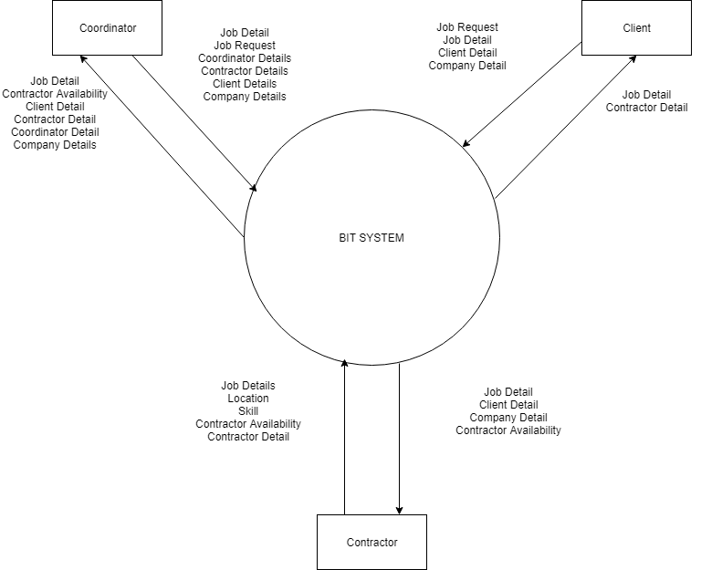
Context Diagram

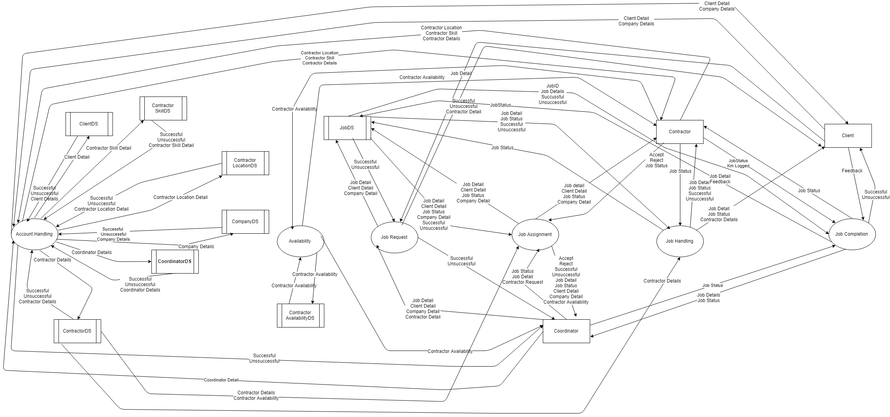
Level 1 Diagram

Level 2 Diagram – Account Handling
