1. File-> New-> Other

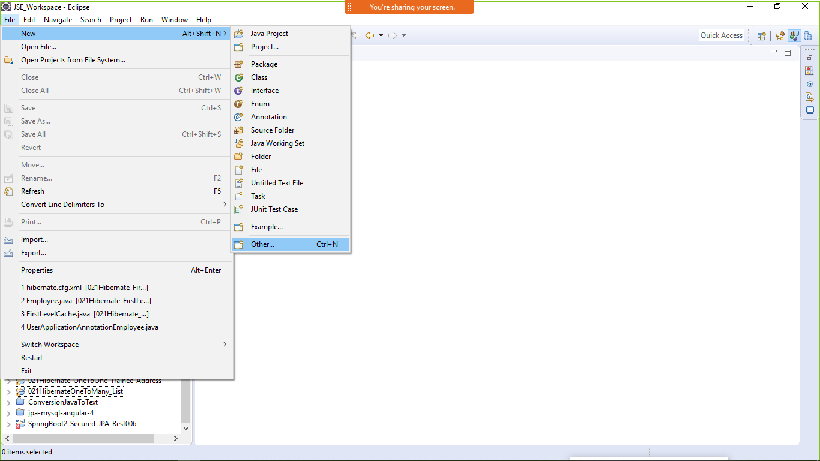

1. Type Maven -> Maven Project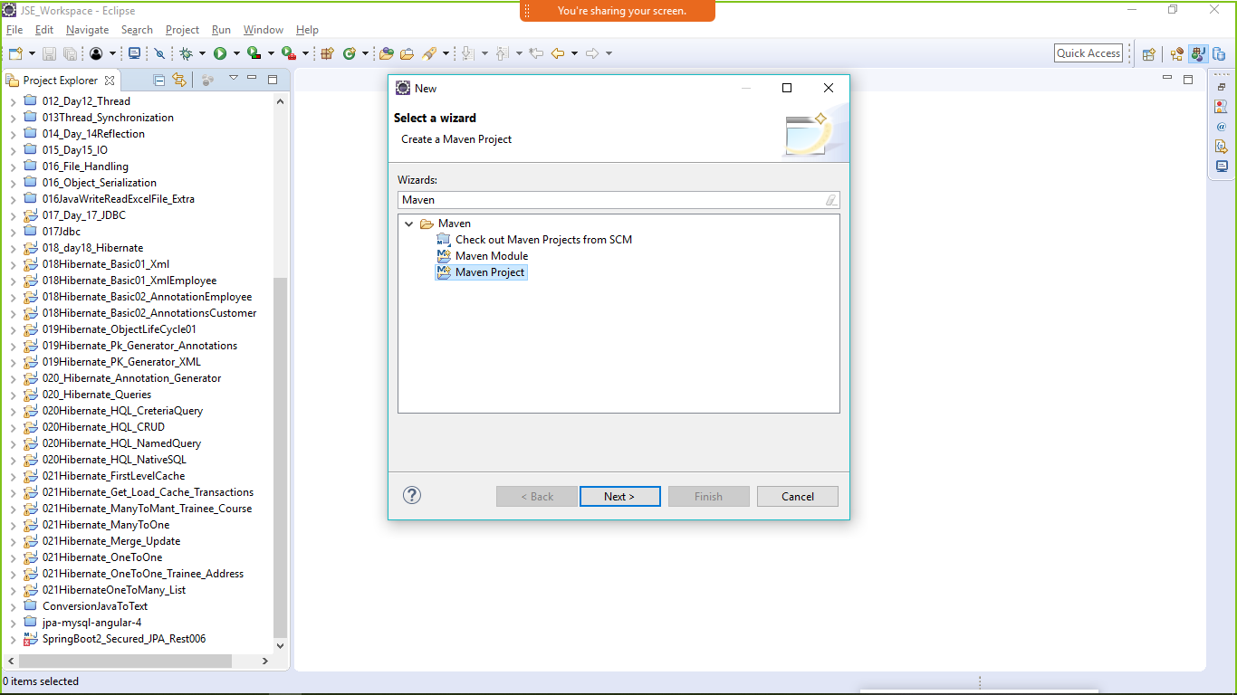
2. Create a simple maven project (skip archetype)-> next

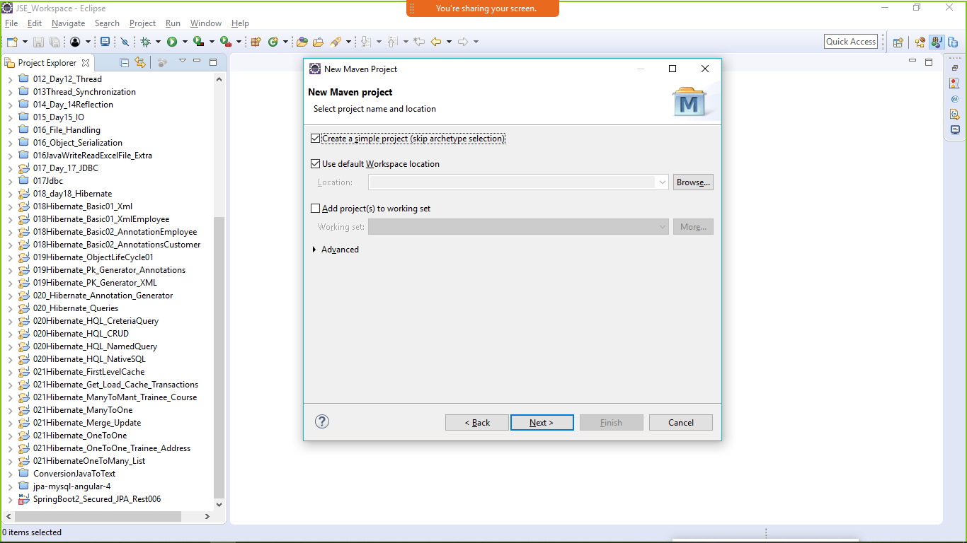

* 1. Group Id (package name) com.lnt.maven_project
  2. Artefact Id (Project name) 022_Maven_Project
  3. Version (your application version) 0.0.1-SNAPSHOT
  4. Packaging (your deployed application packaging) select -> jar(java archieve) ->Finish
     1. jar(java archieve)
     2. war(web archieve)
     3. ear(enterprise archieve)

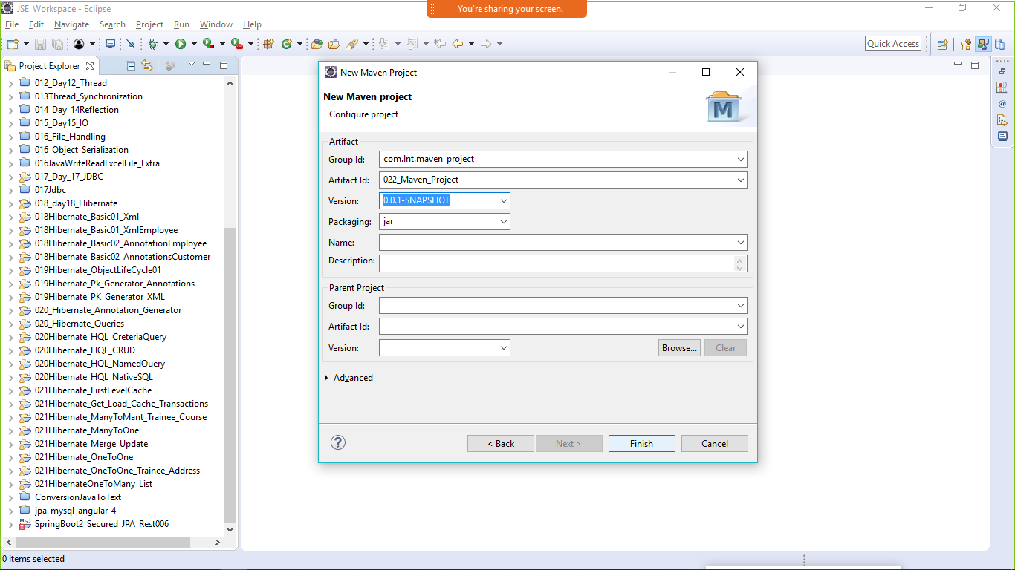

Maven follows convention over configuration

Maven Project structure

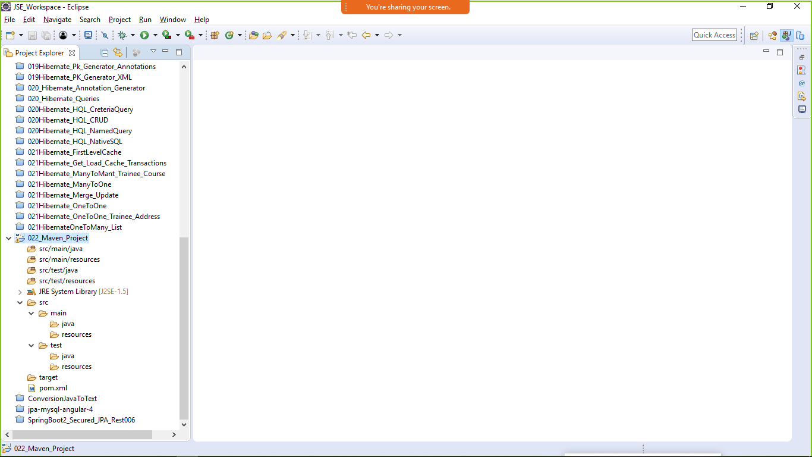

pom.xml (project Object Model) it is a xml file which describe each and every information about the dependency, repository, plugin, project_info (name, version, archetype, groupId, artifactId), build info.

1. Add the dependencies in the pom.xml file
   1. All the dependencies are available in <https://mvnrepository.com>

NOTE: For maven project , high speed internet is mandatory.

As we added the dependencies to the project maven will start creating the

***local repository. C:/User/currentUser/.m2/repository***

**<project xmlns=*"http://maven.apache.org/POM/4.0.0"***

**xmlns:xsi=*"http://www.w3.org/2001/XMLSchema-instance"***

**xsi:schemaLocation=*"http://maven.apache.org/POM/4.0.0 http://maven.apache.org/xsd/maven-4.0.0.xsd"*>**

**<modelVersion>4.0.0</modelVersion>**

**<groupId>com.lnt.maven_project</groupId>**

**<artifactId>022_Maven_Project</artifactId>**

**<!-- lets use hibernate in our project -->**

**<dependencies><!-- dependent jar files -->**

**<!-- https://mvnrepository.com/artifact/org.hibernate/hibernate-core -->**

**<dependency>**

**<groupId>org.hibernate</groupId>**

**<artifactId>hibernate-core</artifactId>**

**<version>4.2.3.Final</version>**

**</dependency>**

**</dependencies>** 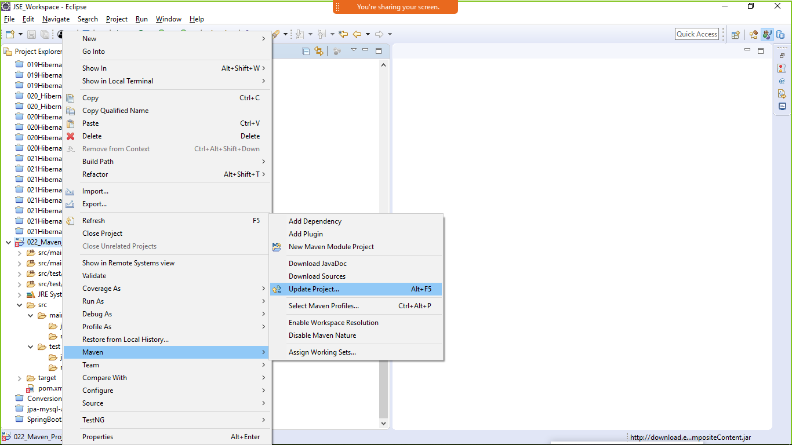

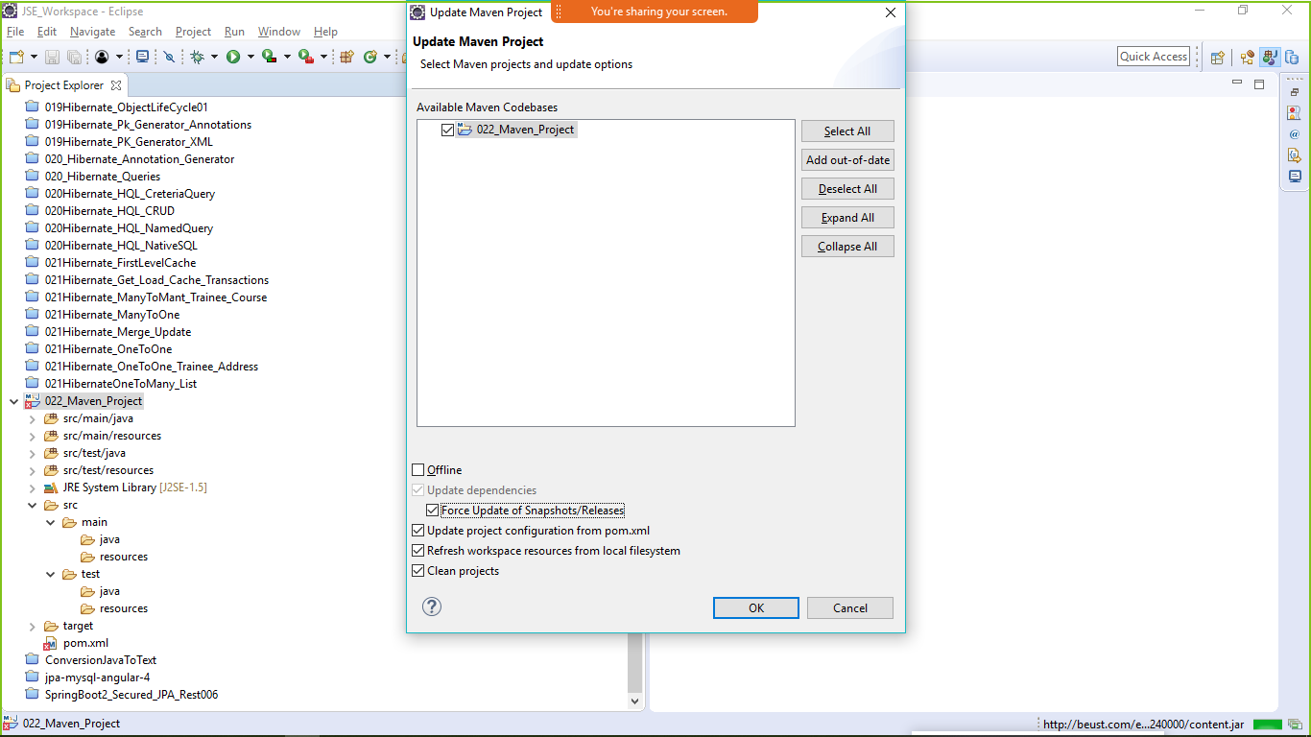

**</project>** 