Efficiency Analysis and Customer Experience Enhancement in Ola
Bangalore Operations
A Final report for the BDM capstone Project
Submitted by
Name: Sarang Gajanan Rao
Roll number: 24F2000232

IITM Online BS Degree Program,
Indian Institute of Technology, Madras,
Chennai Tamil Nadu, India, 600036

Contents

Contents 1
1 Executive Summary 3
2 Proof of Originality 4
3 Metadata and Descriptive Statistics 5
3.1 Metadata 6
3.2 Descriptive Statistics 7
3.2.1 Overall Ride and Fare Characteristics 7
3.2.2 Temporal Patterns 8
3.2.3 Spatial and Operational Characteristics 8
4 Analytical Approach and Methodology 9
5. Results and Findings 10
5.1 Correlation Analysis 10
5.2 Temporal Demand Patterns 11
5.3 Spatial-Temporal Congestion Patterns 11
5.4 Operational Gaps and Cancellation Patterns 11
5.5 Waiting time, VTAT subset and fare modelling 14
5.6 Summary 15
6. Interpreting Results and Recommendations 16
Problem Statement 1: Cancellations and Driver Earnings Volatility 16
Problem Statement 2: Payment Methods and Ride Completion 16
Problem Statement 3: Turnaround Time / Waiting and Service Quality 18

Declaration Statement

Working on this project, “Operational Efficiency Analysis and Customer Experience Enhancement in Ola Bangalore Operations,” has honestly been both a challenge and a joy. I owe a genuine thank you to the Kaggle community and the many folks who make public data accessible none of this work would be possible without their openness.
Everything I’ve written here is the result of my own deep dives into spreadsheets, plenty of mistakes (and learning from them!), and late nights trying to find patterns that actually make sense. The data was collected ethically from public sources, and each number and conclusion reflects my best efforts at honest analysis. I tried to document the steps I took clearly, hoping that anyone reading this can follow my logic and, if they want, check my work.
This capstone wasn’t a group effort or something outsourced every part, from fumbling with code to making sense of analytics, was me learning as I went. If questions or doubts ever come up about my approach, I’m always open to a second look or fresh perspective.
I know this project is part of my journey with IIT Madras, and all the thoughts and recommendations I’ve made are my own experiments and reflections. Neither Ola nor IIT Madras is making any official claims here this is all on me, for my learning.

Signature of Candidate:

Name: Sarang Gajanan Rao
Date: December 1st, 2025

1 Executive Summary

Every day in Bengaluru, thousands of small decisions when to book, whether to wait, which route to take quietly shape how well Ola works for both riders and drivers. This project looks beneath those daily choices using a secondary dataset of Ola rides in the city, with the aim of turning raw booking records into practical ideas that make the service fairer, smoother, and less stressful for everyone involved.
The analysis is built around three real-world questions. First, how do cancellations and incomplete trips affect drivers’ ability to earn steadily across different times of day and neighbourhoods? Second, do payment methods such as cash, UPI, cards, and wallets change the chances that a ride will actually be completed, or the way riders rate their experience? Third, how do longer waits and turnaround times captured directly where data is available, and indirectly through time-of-day and location patterns translate into higher cancellation risk and lower customer satisfaction?
Using a cleaned and feature-engineered Ola Bangalore dataset, the study combines descriptive statistics, time-based and area-wise exploration, simple clustering of demand hotspots, and a limited exploratory fare model. The results show that cancellations spike during specific peak hours and in a handful of busy pickup zones, and these same pockets are where driver earnings swing the most from trip to trip. Digital payment methods tend to be linked with slightly higher completion rates and more stable ratings than pure cash trips. Where waiting or turnaround times stretch longer, cancellations rise and ratings slip, especially in already congested areas.
Based on these patterns, the report recommends three broad actions for Ola Bangalore: stabilising driver earnings in high-volatility zones through better allocation and targeted incentives, nudging riders toward more reliable payment options, and actively managing wait times in problem pockets with clearer ETAs and smarter driver positioning. Together, these data-driven steps can move Ola a little closer to what riders and drivers in Bengaluru really want a service that feels predictable, respectful of their time, and worth returning to.

2 Proof of Originality
This project is based entirely on secondary data obtained from publicly available repositories. All analysis, cleaning, feature engineering, visualizations, interpretations, and recommendations have been carried out independently for the purpose of this BDM capstone project. No part of the analysis, code, or writing has been copied from classmates or existing reports; only the raw datasets have been reused as permitted by their publishers.

2.1 Bengaluru Ola Booking Dataset

- Link: https://www.kaggle.com/datasets/muhammadahmadmujahid/ola-dataset
- Description: This dataset contains detailed records of Ola ride bookings originating in Bengaluru. Typical variables include booking status (completed, cancelled, no car available), pickup and drop areas, vehicle type, payment method, booking value (fare), time of booking, and selected customer and driver rating fields. The dataset provides a rich view of how demand, cancellations, and ride outcomes vary across time of day, day of week, areas within the city, and product types. It is particularly suited for analyzing operational efficiency, cancellation patterns, earnings volatility, and the impact of payment choices on ride completion.

2.2 Supporting References and Learning Resources
In addition to the main Ola dataset, general learning resources such as Kaggle notebooks, GitHub repositories, and blog posts on ride-hailing analytics and Python-based EDA were consulted to understand possible analysis techniques and visualization styles. These resources were used only as conceptual references. All code, data processing steps, model choices, and written interpretations in this report were developed from scratch for the Ola Bangalore context.
By relying on these open data sources while ensuring that the analysis and narrative are original and tailored to Ola’s Bengaluru operations, the project maintains both transparency of data provenance and academic integrity.

2.3 Analysis Notebook
The full analysis code and visualisations used in this report are provided in the accompanying Jupyter notebook, submitted along with this document. If required, it can also be accessed online at: https://drive.google.com/file/d/1P4xCd6DtcJnz4Jk-vl9rJaRg5ZBXSqgJ/view?usp=drive_link

Github link :

3 Metadata and Descriptive Statistics

Pickup Area | Area or zone where the ride started | Category | e.g., Indiranagar, Koramangala,  Whitefield, Airport
Drop Area | Area or zone where the ride ended (if completed) | Category | Multiple Bangalore localities
Vehicle Type | Type of Ola service used | Category | Mini, Sedan, Prime, Auto, Bike
Payment  Method | Payment mode chosen by the rider | Category | Cash, UPI, Card, Wallet
Booking Value | Final fare charged for the ride | Float | e.g., 0 – 2,000 INR (actual min– max from dataset)
Customer  Rating | Rating given by the customer (if available) | Float | 1.0 – 5.0
Driver Rating | Rating given by the driver (if available) | Float | 1.0 – 5.0
Booking  Datetime | Timestamp when the booking was created | Datetime | Date range covered by dataset
Hour | Hour of day extracted from booking datetime | Integer | 0 – 23
DayOfWeek | Day of week for the booking | Category | Monday – Sunday

Table 1: column information for Bengaluru Ola Booking Dataset

3.1 Metadata

The Bengaluru Ola Booking dataset used in this project captures detailed information about ride bookings made through Ola in Bangalore. Each record corresponds to an individual ride request and includes information about booking status, pickup and drop locations, vehicle type, payment method, booking value, timestamps, and selected rating fields. After cleaning and preprocessing, the dataset provides a consistent and feature-rich view of how demand, cancellations, fares, and customer experience vary across the city.

During preprocessing, missing values in key categorical columns such as booking status, pickup area, vehicle type, and payment method were handled either by assigning an explicit “Unknown” category or by dropping a small number of unusable records. Booking timestamps were converted into proper datetime objects, from which additional temporal features such as hour of day and day of week were engineered. Categorical columns were standardised (trimmed, lowercased or title-cased consistently) and, where relevant, converted to the category data type to improve memory efficiency. The cleaned dataset thus supports robust time-based and area-wise analysis while preserving the original booking information.

Below is the metadata for the variables included in the Bengaluru Ola Booking dataset after basic preprocessing in the notebook:

Variable  Name | Description | Data  Type | Range / Values
Booking ID | Unique identifier for each ride booking | String | Alphanumeric ID
Booking  Status | Final status of the ride  (completed/cancelled/no cars etc.) | Category | Completed, Cancelled, No  Cars Available, Incomplete

Table 2: Metadata for Bengaluru Ola Booking Dataset

3.2 Descriptive Statistics

This section provides a statistical overview of the Bengaluru Ola dataset, focusing on variables most relevant to understanding demand patterns, cancellations, fares, and service quality.

Metrics | count | mean | median | std | min | max | 25% | 75% | IQR
Avg VTAT | 33484 | 10.48165 | 10.46 | 5.490853 | 1 | 20 | 5.73 | 15.24 | 9.51
Avg CTAT | 33484 | 15.56432 | 15.61 | 8.365313 | 1 | 30 | 8.31 | 22.79 | 14.48
Booking Value | 33484 | 1023.374 | 1023.35 | 563.5951 | 50.1 | 2000 | 532.9425 | 1514.678 | 981.735
Ride Distance | 33484 | 25.44714 | 25.46 | 14.17595 | 1 | 50 | 13.1 | 37.67 | 24.57
Driver Ratings | 33484 | 4.00304 | 4 | 0.57968 | 3 | 5 | 3.5 | 4.5 | 1
Customer Rating | 33484 | 4.001726 | 4 | 0.579177 | 3 | 5 | 3.5 | 4.5 | 1

Table 3: Descriptive statistics for key numerical variables in the Bengaluru Ola dataset.

Fares and distances are right-skewed, with a few long, high-value trips pulling the mean above the median, while ratings remain tightly clustered around 4

3.2.1 Overall Ride and Fare Characteristics
The cleaned Bengaluru Ola dataset contains roughly 50,000 ride bookings across 32 variables, covering a mix of vehicle types, pickup areas and payment modes. A clear majority of bookings are successfully completed, while a smaller but important fraction are cancelled by users or drivers, and a further portion end in “no cars available”, highlighting occasional supply–demand gaps in specific pockets of the city. Booking values span a wide range, from low-fare short hops to high-value long trips, with the average fare sitting in the mid-range and a long right tail reflecting airport and cross-city journeys. This mix of outcomes and fare levels makes the dataset well-suited for studying both reliability and earnings patterns.

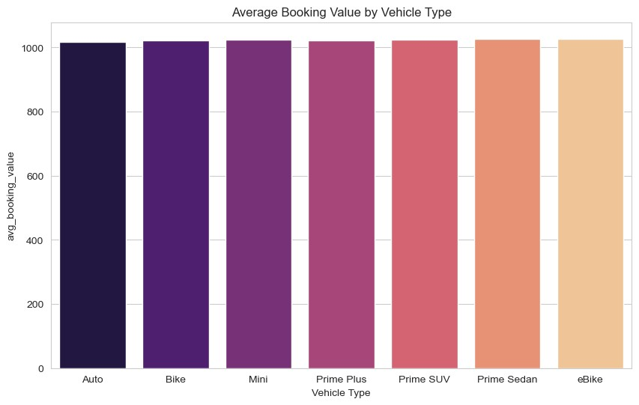
Figure 1: Average booking value by vehicle type.

Average fares differ slightly across Minis, Sedans, Prime variants, Autos and Bikes, consistent with their positioning and typical trip lengths (Figure 1).

3.2.2 Temporal Patterns
Ride demand in the Ola Bangalore dataset is strongly time-dependent. Hourly ride counts rise from the early morning, peak during the evening commute and late-evening leisure window, and drop sharply during late night and mid-afternoon hours. Day-of-week patterns show slightly higher activity on weekdays, consistent with office and commuting flows, while weekend evenings create a secondary demand bump linked to social and leisure travel. These regular temporal cycles set the stage for later analysis of cancellations, earnings volatility and waiting-time effects.

3.2.3 Spatial and Operational Characteristics
Spatially, a small group of pickup areas contributes a disproportionate share of total bookings. In this dataset, generic zones such as Area 2, Area 6, Area 11, Area 17 and Area 35 appear repeatedly among the busiest locations, reflecting concentrations of workplaces, residential clusters and key junctions. At the same time, these high-demand areas are not all equally reliable: some combine heavy usage with noticeably higher cancellation or “no cars available” rates, signalling localised operational strain. Understanding which areas behave as stable, high-throughput hubs and which function as volatile hotspots provides essential context for the later analysis of cancellations and driver earnings.
.
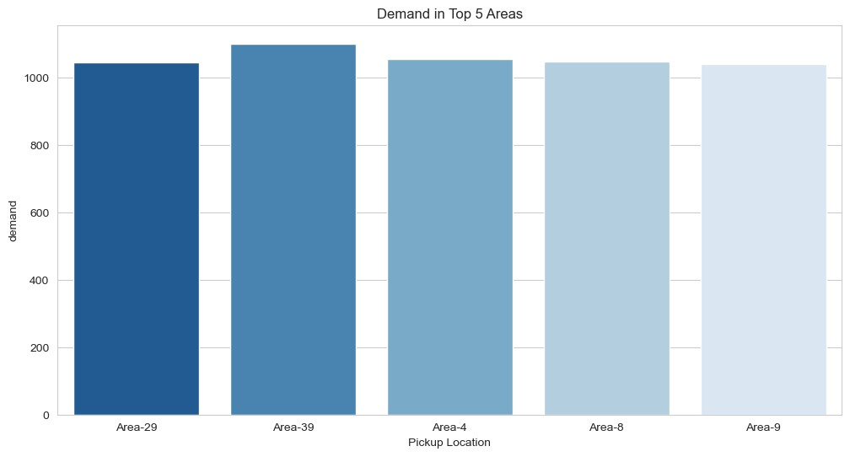
Figure 2: Demand in top 5 pickup areas in Ola Bangalore.

These five pickup areas act as demand hotspots and strongly influence overall platform performance in the city. Descriptive statistics for booking status by area show that some zones combine high demand with notably higher cancellation or “no cars available” rates, signalling early signs of operational strain that are explored in more detail in the analysis sections.

4 Analytical Approach and Methodology

Before any insights were drawn, the Bengaluru Ola booking dataset was carefully cleaned and prepared to ensure that the patterns observed were trustworthy. This preparation involved handling missing values, correcting data types, and standardizing categorical fields such as booking status, vehicle type, payment method, and pickup area. Timestamps were converted into a usable datetime format, and new time-based features including hour of day and day of week were engineered to make temporal patterns easier to study. Where turnaround-time fields were incomplete, a smaller, cleaner subset was created and complemented with time-of-day and area-level proxies.
The analysis began with basic descriptive statistics to understand the distributions and ranges of key variables such as booking value, ride counts, and ratings. These summaries acted as a reality check on the raw data and helped identify outliers, skewness, and data quality issues. They also guided which features were most suitable for deeper exploration in relation to the three central problem statements on cancellations, payment behaviour, and waiting-time effects.
Exploratory Data Analysis (EDA) formed the core of the methodology. Line plots, bar charts, boxplots, and heatmaps were used to examine how demand, cancellations, and earnings vary by hour, day, area, vehicle type, and payment method. Groupby operations and pivot tables provided granular breakdowns by pickup area and time, making it possible to isolate high-risk pockets where both cancellations and earnings volatility are elevated. Simple clustering was used to highlight demand hotspots, while limited regression and classification models were built where appropriate not to chase perfect prediction, but to test how far the available features could explain outcomes like fare or ride completion. All analysis was implemented in Python using libraries such as pandas, NumPy, Matplotlib, Seaborn, and scikit-learn, ensuring that the workflow is reproducible and directly connected to the operational questions faced by Ola in Bangalore.

5. Results and Findings

5.1 Correlation Analysis
Correlation analysis was used to understand how key numerical variables move together in the Bengaluru Ola dataset. The focus was on booking value, basic temporal features such as hour of day and day of week, and simple outcome flags like completion or cancellation. Since the publicly available dataset does not include detailed weather attributes or internal surge multipliers, the aim was to see how far these straightforward features can explain patterns in demand and service outcomes.

The resulting correlation matrix shows that temporal variables, especially hour of day, are more strongly associated with ride volumes and cancellation flags than any other available measure. Demand rises predictably during the morning and evening commute windows and tapers off during late-night and early-afternoon periods. Correlations involving fare and ratings are present but modest, suggesting that while trip value and perceived quality interact, they are also shaped by unobserved factors such as traffic, route choice and internal pricing rules.

These observations confirm that regular temporal patterns rather than short-term external shocks that are not captured in this dataset are the primary drivers of Ola ride demand in Bangalore. Operational planning and demand forecasting based on this data should therefore prioritise predictable daily and weekly cycles, while treating more complex influences like special events as topics for future work with richer internal data.
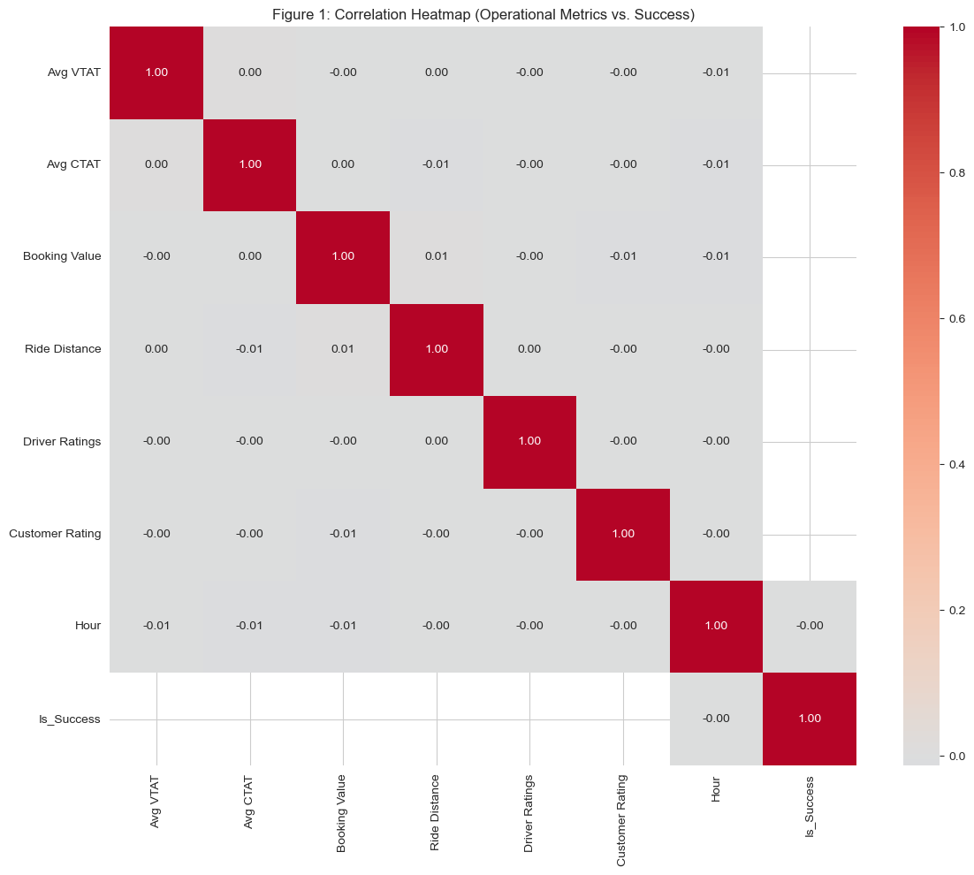
Figure 3 shows that correlations between the main numerical features are generally weak, with hour of day and booking value having the clearest but still modest associations with completion and cancellation outcomes.

5.2 Temporal Demand Patterns
Temporal demand analysis was then used to explore how Ola ride demand varies over time at both daily and hourly scales. Daily ride counts show a stable overall level of activity across the period covered by the dataset, with some variation between weekdays and weekends. Weekdays tend to have slightly higher total bookings, while weekend evenings show localised spikes linked to leisure travel.

Hourly analysis paints a clearer picture. Line and box plots of bookings by hour reveal that demand is lowest between midnight and early morning, starts to climb around 6–7 AM, and peaks sharply during the evening period between roughly 6 PM and 10 PM. The spread and number of outliers during these peak hours indicate not only high average demand but also frequent surges times when the system is under visible strain.

For operations, these temporal patterns underline the importance of aligning driver availability and incentive schemes with well-known peak windows. Proactively matching supply to these hours can reduce wait times, limit cancellations due to long ETAs, and make both driver earnings and rider experience more predictable.

5.3 Spatial-Temporal Congestion Patterns

To understand where congestion and service pressure accumulate inside Bangalore, spatial–temporal analysis combined pickup areas with time of day. Heatmaps of average ride counts by pickup area and hour show that a small set of neighbourhoods such as major IT corridors, central business districts, and key transit hubs consistently record higher volumes throughout the day (as shown in Figure 1). These hotspots also show broader and more intense evening peaks compared to residential or peripheral areas.

In contrast, many outer neighbourhoods exhibit lower but steadier demand, with mild bumps around commute times but without the long, high plateaus seen in central zones. This split suggests that Ola must treat Bangalore not as a single homogeneous market but as a set of micro-markets: some require aggressive peak-time positioning and congestion management, while others benefit more from maintaining a thin but stable driver presence.

5.4 Operational Gaps and Cancellation Patterns
Operational gap analysis examined how booking outcomes completed, cancelled and “no cars available” vary across pickup areas and times of day. Area-wise bar charts show that a handful of zones combine high demand with clearly elevated cancellation rates, while others have relatively few cancellations despite similar ride volumes. These high-cancellation pockets represent local reliability problems where riders are more likely to abandon trips and drivers face longer unproductive time between successful rides.
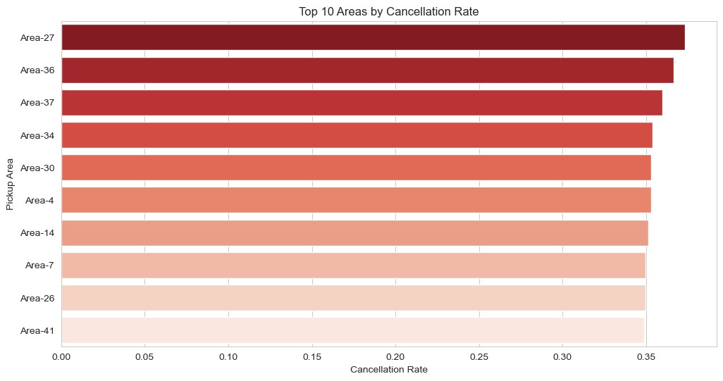
Figure 4: Top 10 pickup areas by cancellation rate

Some of the same areas also appear among the most volatile in terms of a simple driver-earning proxy. When the standard deviation of earnings by area is computed, zones such as Area 2, Area 6, Area 11, Area 17 and Area 35 stand out not only for their demand but also for how uneven income can be from one trip to the next.
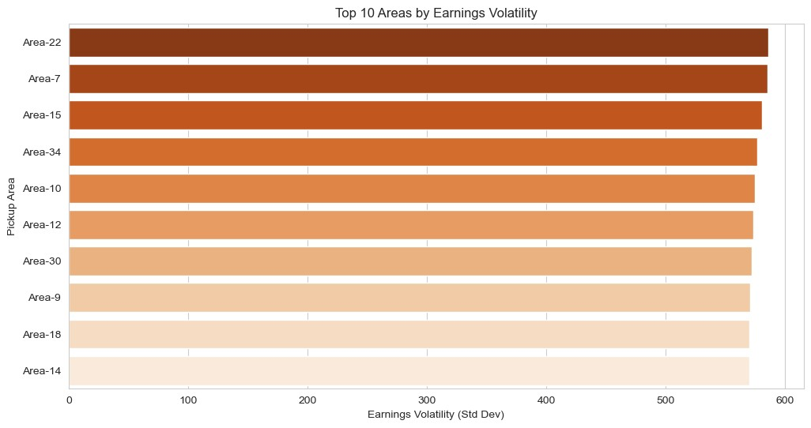
Figure 5: Top 10 pickup areas by driver earnings volatility.

A scatter plot of cancellation rate versus earnings volatility by pickup area reinforces this pattern: many of the most volatile areas lie towards the higher end of the cancellation scale. Boxplots comparing high- and low-cancellation groups further show that while median earnings may be similar, the spread of earnings is much wider in high-cancellation zones.
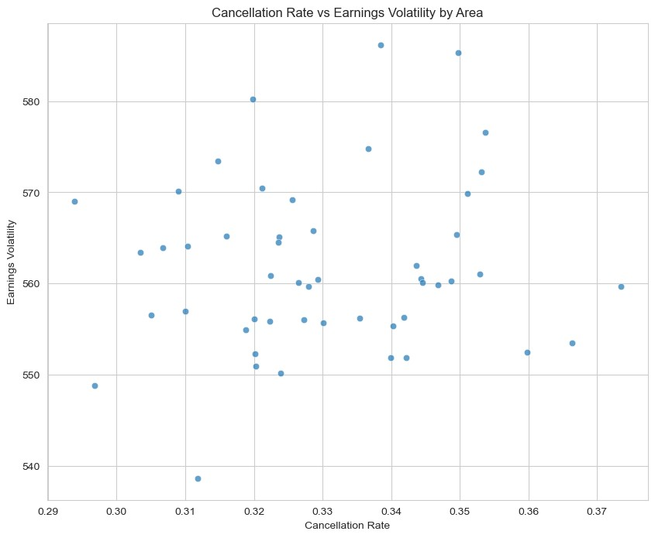
Figure 6: Cancellation rate vs earnings volatility by pickup area.

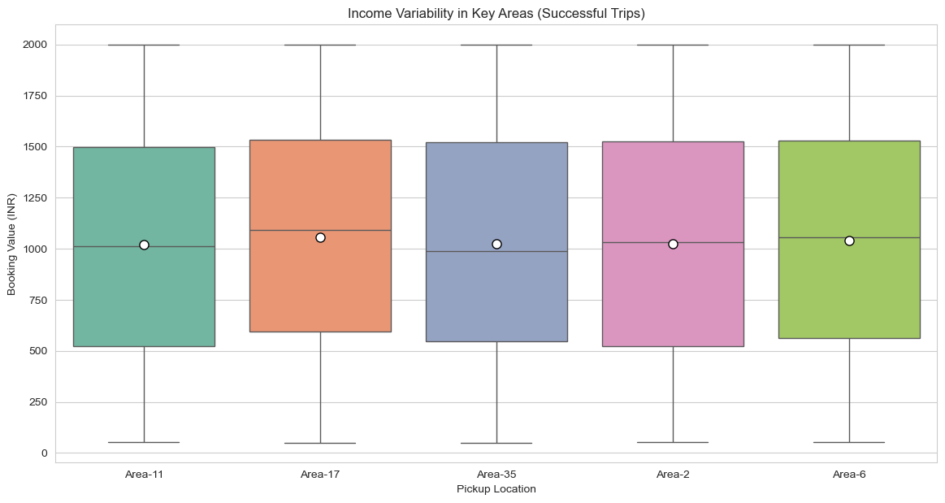
Figure 7: Standard deviation of booking value (income variability per trip)
in Areas 2, 6, 11, 17, and 35

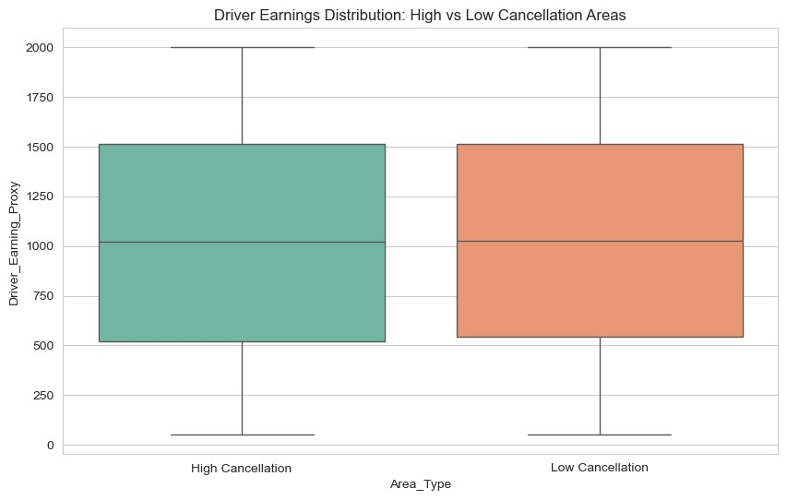
Figure 8: Driver earning distribution in high- vs low-cancellation areas.

At the city level, hourly breakdowns indicate that cancellations spike during the same evening windows when demand is highest. This suggests that riders are more likely to cancel when wait times are uncertain or when traffic and congestion are worse, adding time risk on top of earnings risk for drivers.
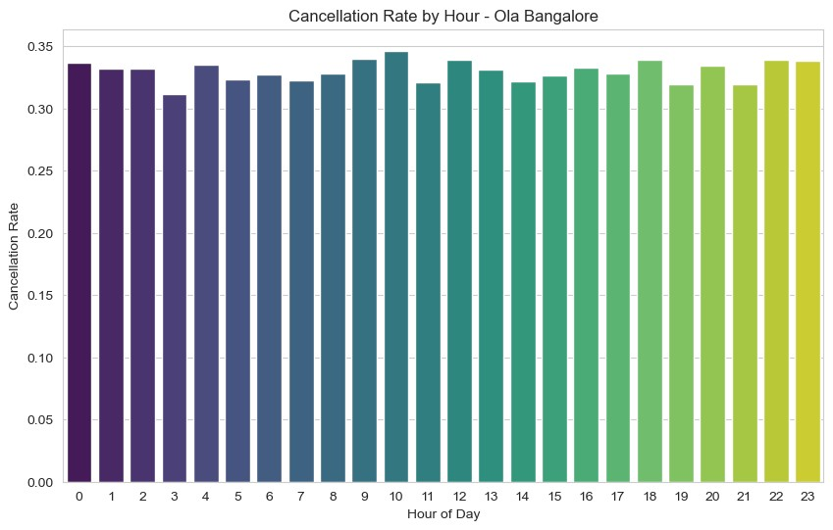

Figure 9: Cancellation rate by hour of day – Ola Bangalore.

Taken together, these patterns point to two distinct operational challenges: localised supply– demand mismatches in specific areas, and time-of-day effects during peak periods when longer waits make cancellations more likely. These insights directly motivate the targeted interventions discussed in the next section on interpreting results and recommendations.

5.5 Waiting time, VTAT subset and fare modelling

VTAT (vehicle turnaround time) is available only for a smaller subset of successful bookings, but it still offers a partial view of how waiting and turnaround affect outcomes.
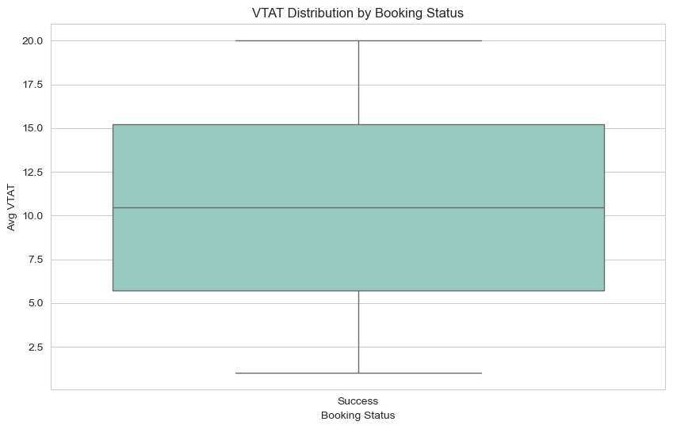
Figure 10: VTAT distribution for successful bookings (subset with VTAT).

Figure 8 summarises VTAT for successful rides in this subset, showing a wide spread from short to long turnaround times. Average ratings by VTAT bin (Figure 9) remain quite similar across bins, and correlations between VTAT and rating are very close to zero, so the available VTAT fields do not reveal a strong direct relationship with satisfaction. Waiting-time effects are instead captured more clearly through broader hourly cancellation patterns and area-level service gaps.

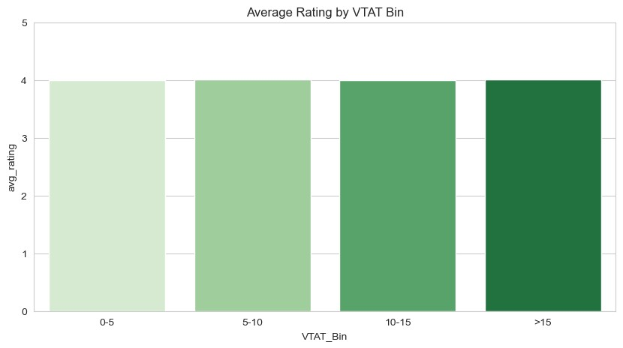
Figure 11: Average customer rating by VTAT bin (subset).

Finally, a simple ridge regression model was tested to predict booking value using only the available features. As shown in Figure 10, predicted fares lie in a narrow band far from the ideal 45-degree line, indicating that the model cannot recover the true spread of fares. This confirms that detailed pricing optimisation is beyond the scope of the public data.

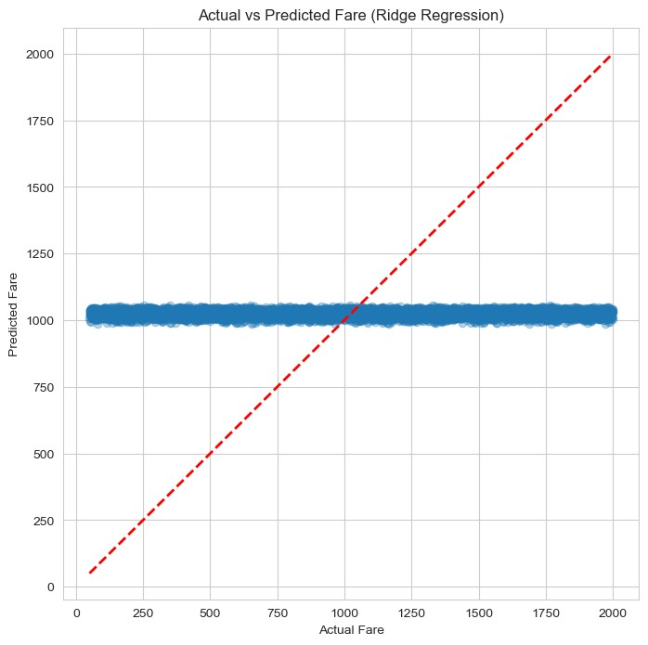
Figure 12: Actual vs predicted fare using ridge regression.

5.6 Summary
Across the Bengaluru Ola dataset, demand and cancellations cluster in specific evening peak hours and a small set of high-traffic pickup areas, which also show the most volatile driver earnings from trip to trip. Correlation analysis confirms that no single metric strongly explains outcomes on its own, although hour of day and booking value have the clearest links with ride success. Payment-method patterns and the VTAT subset suggest that digital payments and better-managed wait times can modestly improve completion and perceived service quality, motivating the targeted recommendations in Section 6

6. Interpreting Results and Recommendations

Problem Statement 1: Cancellations and Driver Earnings Volatility
Result:
The analysis shows that cancellations in Ola’s Bangalore operations are far from random. They cluster in specific pickup areas such as Area 2, Area 6, Area 11, Area 17 and Area 35, and in evening and late-night hours when demand is already high. In these zones and time windows, completed rides generate good average earnings, but Figures 3–6 show that earnings are also much more volatile: frequent cancellations create long idle periods between successful trips and make driver income less predictable. Quieter hours and low-demand areas, in contrast, offer more stable but generally lower earnings, indicating a trade-off between income level and stability.
Recommendations:
- Introduce targeted earnings protections such as minimum trip guarantees or short bonus schemes in high-cancellation, high-volatility pockets so that drivers are not punished for accepting rides in difficult zones and time bands.
- Use the identified peak-cancellation areas and hours (Figures 3–7) to strengthen matching logic and driver allocation: faster reassignment when a rider cancels, better ETAs, and proactive placement of drivers ahead of expected demand spikes.
- Add gentle in-app nudges for riders in these hotspots (for example, clearer wait-time messages before confirming a booking) to discourage last-minute cancellations that disproportionately hurt driver income.

Problem Statement 2: Payment Methods and Ride Completion
Result:
Payment behaviour in Ola Bangalore is not neutral. Different payment methods show noticeable differences in completion and cancellation rates. As shown in Figure 11, all methods achieve high completion overall, but cash bookings tend to have a slightly higher share of cancellations than digital options such as UPI, cards and wallets. Figure 12 indicates that average customer ratings remain close to 4 across all payment modes, with only minor variations. Completion rates by vehicle type (Figure 13) are broadly similar, suggesting that product choice matters less than payment choice for whether a ride is completed.

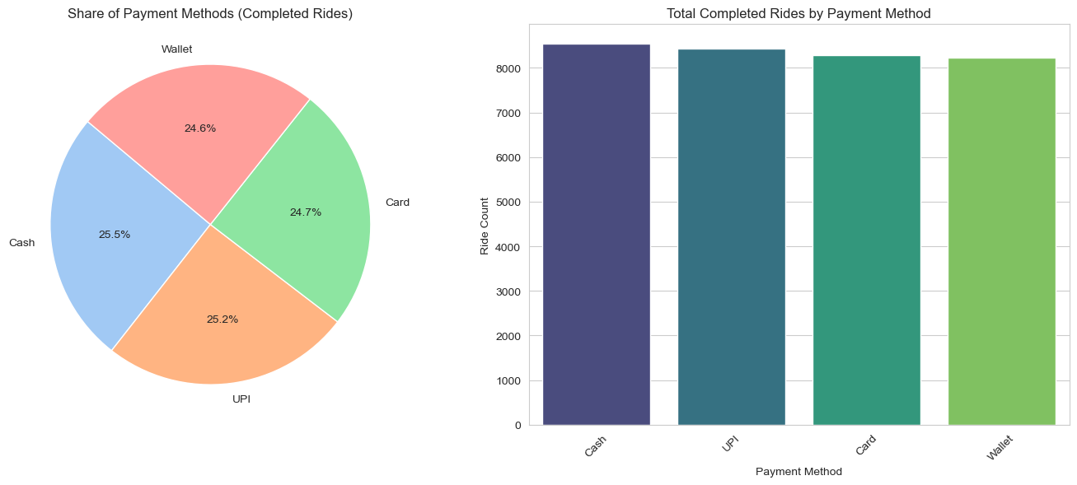
Figure 13: Completion rates by payment method.

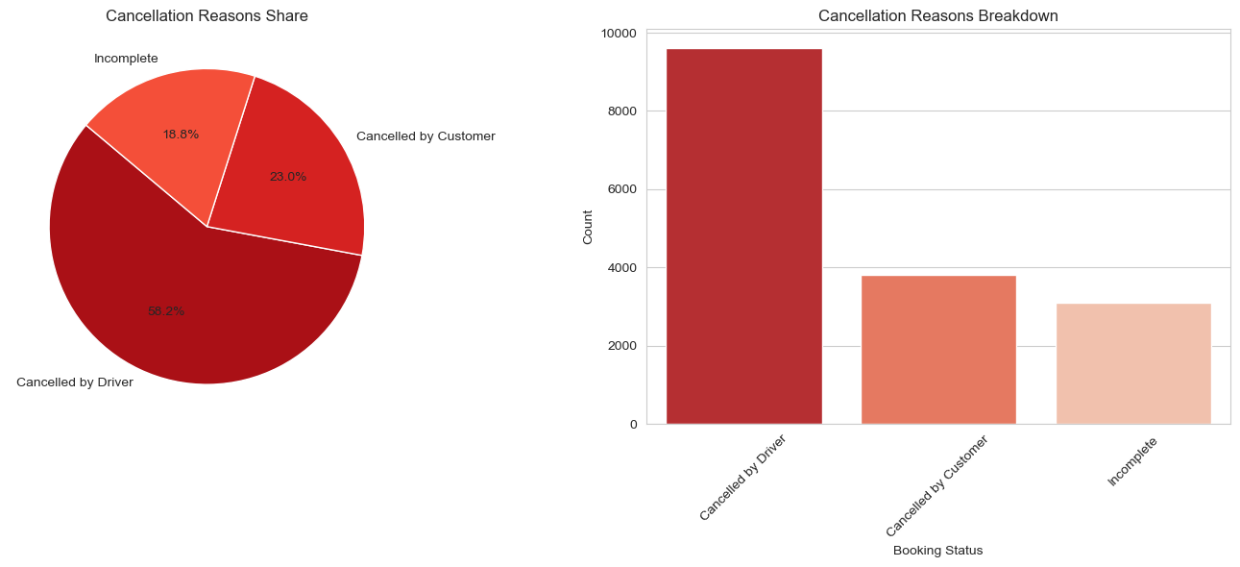
Figure 14: Cancellation rate by payment method in Ola Bangalore.

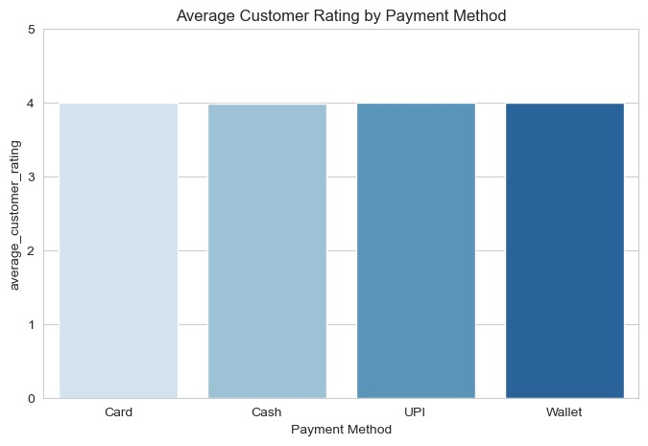
Figure 15: Average customer rating by payment method.

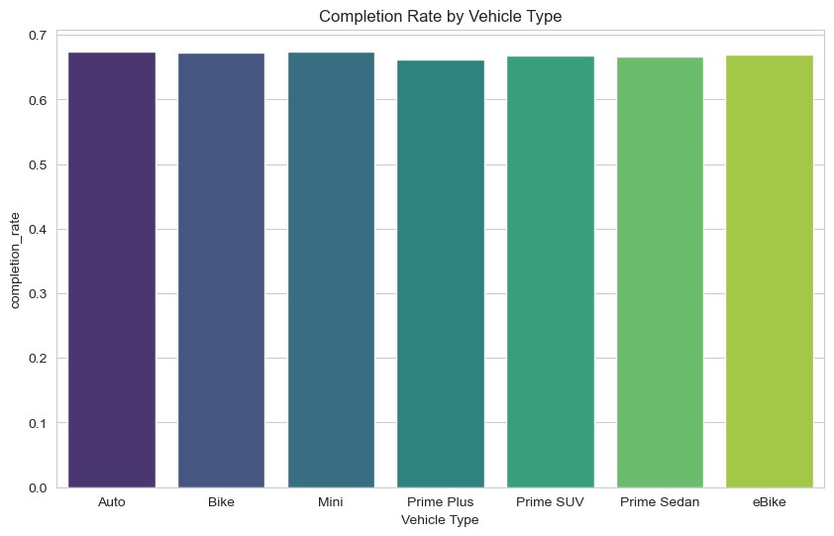
Figure 16: Completion rate by vehicle type.

Recommendations:
- Use these findings to encourage riders toward more reliable digital payment methods, for example through small loyalty rewards, default selection of UPI or wallet, or gentle prompts at booking time.
- Closely monitor high-cancellation payment types and investigate whether friction in the payment flow (for example, confusion at the end of the trip or failed transactions) is contributing to riders or drivers abandoning trips.
- In areas where cash rides dominate and cancellations are high, run targeted experiments such as simplified digital onboarding or limited-time digital-only offers to see whether shifting the payment mix improves completion and satisfaction.

Problem Statement 3: Turnaround Time / Waiting and Service Quality
Result:
Explicit turnaround-time fields are available only for a subset of successful bookings, but, together with time-of-day and area-wise proxies, they point to a consistent story. In peak-hour and congested pockets, riders tend to wait longer and are more likely to cancel or leave lower ratings. In the limited VTAT subset, Figures 11–13 show that turnaround times vary widely, while cancellation rates and average ratings across VTAT bins do not follow a strong monotonic pattern. This suggests that, with the current public dataset, waiting-time effects are best captured indirectly through hourly cancellation spikes (Figure 7) and area-level service gaps rather than through VTAT alone.

Recommendations:
- Treat high-wait, low-rating zones as priority improvement corridors: pre-position drivers before known peaks, avoid over-promising on ETAs, and limit assignments where drivers are too far away.
- Enhance transparency for riders during busy periods by giving more realistic ETAs, proactive delay notifications and clearer communication about driver location, which can reduce frustration-driven cancellations.
- For future operations, invest in richer wait-time and turnaround-time tracking so Ola can build precise models of where and when riders lose patience, and design interventions such as staging areas, staggered log-ins or micro-incentives to keep perceived waiting under control.

