**Mini Hackathon 2021**

**Preliminary Round**

**Report Submission**

Team Name – Tech Fusion

Team Leader’s Name - U. Gangezwer

Team Members

* + 1. K.A.D.S.T. Kumarapeli
    2. H.G.V. Halanayake
    3. K.G.A. Bandara

Kaggle User Name - Tech **Fusion**

Kaggle display Name - **Tech Fusion**

1. Introduction

This dataset represents collected information from nursery applications and the training dataset includes a column which says if the application got selected or not. Using this training dataset, a machine learning model has to be trained to accurately guess the outcome of a new application. Which is whether the new applicant get selected or not.

To overcome this Support Vector Machine (SVM) supervised learning model has been used.

1. Methodology

Firstly, what was done in the project was trying to clean the data. Yet when trying to carry out this task it seems that this was unnecessary as any of the rows didn’t had any null values and all of the values were already categorized. Hence the above-mentioned part was skipped. Then the given data was visualized to get a clear understanding on what variables has a significant effect on the final output.

Then based on data types and given variables few machine-learning models has been choose. From them the one with the highest accuracy has been chosen as the final machine learning model for this project. Through this procedure this project has been able to achieve an accuracy of 99.9%.

1. Results
   1. 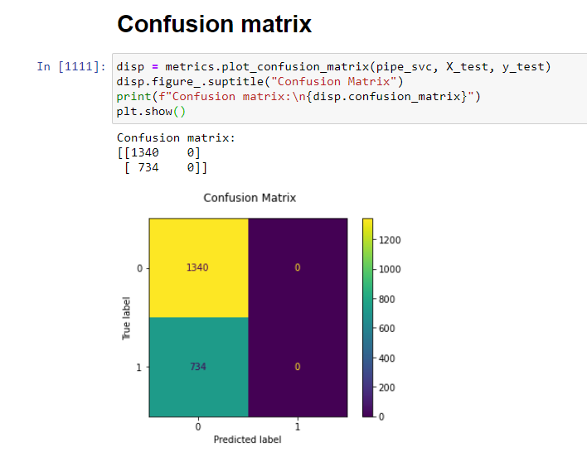
   2. 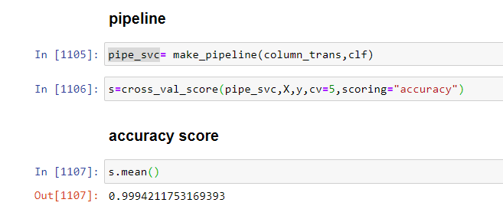
2. Conclusion

This chapter will discuss about the selection of dataset. for this project and social, legal, ethical, professional implications that got handled in this project. The dataset used for this is taken from kaggle with an adequate amount of data. The dataset has the needed columns to provide the necessary data to solve the given problem. The legalities that are associated with project were deeply researched and well analyzed with high regard given to the protection of the law. Additionally, the dataset which was collected from the kaggle was reviewed cautiously with adherence to the term and conditions. The dataset was very well checked to ensure that sensitive information about the users that could affect them socially was excluded. The providers of the dataset made the dataset for the competition usage without any restrictions. Apart from this professional standard were maintained throughout this project.