

**Software Development Group Project - 5COSCOO9**

**Module leader – Banuka Athuraliya.**

**Platform to Predict Crop Cultivation Timeliness by Utilizing Monsoonal Patterns and Data Science.**

**RAVENCLAW**

|  |  |  |  |
| --- | --- | --- | --- |
|  | **IIT Number** | **UoW Number** | **Name** |
| **Team Leader** | **2019446** | **w1761380** | **T.Shagar** |
| **Member 1** | **2019320** | **w1761135** | **Y.M.S.M.B.Jayathilake** |
| **Member 2** | **2019280** | **w1761378** | **N.R.Anuruddha** |
| **Member 3** | **2019922** | **w1790947** | **N.Sajivini** |
| **Member 4** | **2019236** | **w1761378** | **R.Anestan** |
| **Member 5** | **2019133** | **w1761376** | **M.Shafan** |

# 

# 

# **Abstract**

Farming in Sri Lanka is usually done physically. This research is trying to use a fundamental approach to inaugurate the prediction process in farming in our country. It is a prediction system designed in android application, which has been implemented to settle on the simplest crop before starting the cultivation process consistent with the world of cultivating the land. Here, the simplest crop signifies the crop which can be the foremost cost-effective for that land. During this case, the main crops of Sri Lanka, e.g., Mize, Potato, Carrot, and Sugar cane are going to be considered. This technique is additionally ready to prepare a schedule of the entire cultivation process e.g., the right time of fertilization and irrigation according to the sort of crop types. the entire system is concentrated on the climate and geographical conditions of various areas of Sri Lanka. It predicts the only cost-effective crop employing a prediction-based algorithm. The algorithms are aimed to use multiple linear regression with the association of some independent variables i.e., rainfall, average maximum temperature, and average minimum temperature of a particular location, and provides prediction supported yield rate per unit area. The KNNR algorithm was used to compare the accuracy and error rate of the predicted yield rate. The crop zone is split consistent with the division and districts.

# **Acknowledgment**

First of all, we would like to thank the Informatics Institute of Technology (IIT) for providing us this excellent opportunity to do this project and making us realize the value of research. Providing us with all the knowledge throughout our undergraduate life so that we could do this group project will be helpful to our final year project.

We would like to express our heartiest thanks and utmost gratitude to our lecturers who gave us this opportunity to expose our idea and to implement it. Special thanks to our lecturer Prathieshna Vekneswaran for providing his valuable insight, suggestion, and guidance on our SDGP group project progress. Continuous supervision and the spirit to push us more for getting a great project and an astonishing paper on this would never be possible without him. We are honored that he allowed us to work under his supervision.

We would like to acknowledge every member of Ravenclaw for holding this project and believing in them. Every member of this group has contributed their level best for this group project, and we are finally presenting good work. Special thanks to all the farmers who supported us by providing opportunities to help them.

# **List of Figures**

Figure 1 : Paddy: Paddy Production (Maha & Yala seasons) 2

Figure 2 : Crops are grown in different areas in Sri Lanka 3

Figure 3 : Vegetables grown in low countries. 4

Figure 4 : Vegetables grown in up country. 4

Figure 5 : Next to rice, there’re various types of plantations growing in Sri Lanka. 4

Figure 6 : Air Quality Index 7

Figure 7: Rich Picture Diagram 10

Figure 8 : Core Concept of the Application 12

Figure 9 : Integrated Drought Severity Index (IDSI) 2020– May-August 2020, (IWMI/WLE/MAFF) 16

Figure 10 : Total Rice Production Outlook, (Agri . Dept,2020) 18

Figure 11: Observed Rainfall in three zones, (WFP,2017/2019) 19

Figure 12 : Cost of cultivation of paddy, (Agri. Dept,2020) 19

Figure 13 : Major Components of Cost of cultivation, (Agri. Dept,2020) 20

Figure 14 : System Architecture of the Prediction of the suitable crop 22

Figure 15 : System Architecture of the prediction on crops yield 24

Figure 16 : System Architecture of the predictions on Crops Cost 25

Figure 17: 27

Figure 18 : Stakeholder diagram for prediction 29

Figure 19 : 32

# **List of Tables**

Table - 01 Weather patterns 05

Table 2 In scope & Out scope 09

Table 3 Stakeholder Analysis 28

Table 4 Use Case Analysis 34

Table 5 Functional requirement 35

Table 6 Risk and Mitigation 36

# 

# 

# **List of Abbreviation**

DoM - Department of Metrology

DoA - Department of Agriculture

DoAD - Department of Agrarian Development

AEZ - Agriculture Ecological Zone

ASC - Agriculture Service Center

NAICC - National Alliance of Independent Crop Consult

WFP - World Food Programme (United Nations)

**Table of Content**

**Abstract** I

**Acknowledgment** II

**List of Figures** III

**List of Tables** III

**List of Abbreviation** IV

**1.1 Chapter Overview** 1

**1.2 Project Background** 1

**1.2.1 Introduction to Problem Domain** 1

**1.2.1.1 Problem Boundary** 2

**1.2.1.2 Examples in the problem** 2

**1.2.2 Problem Definition** 2

**1.3 Research Areas** 3

**1.3.1 Rice Availability** 4

**1.3.2 Methods for finding weather patterns** 5

**1.3.3 Cost of Cultivation** 6

**1.3.4 Research Factors** 6

**1.3.4.2 The amount of rainfall** 7

**1.3.4.3 The humidity of the air** 7

**1.3.4.4 The amount of air pollution** 7

**1.3.4.5 The amount of water pollution** 7

**1.3.4.6 The amount of soil pollution -** 8

**1.3.4.7 Acid Rain** 8

**1.3.4.8 Temperature changes** 8

**1.3.4.9 The proliferation of insects** 8

**1.3.4.10 Livestock** 8

**1.3.4.11 Nomadism of wild animals -** 9

**1.4 Aim** 9

**1.5 In-Scope and Out of Scope** 9

**1.6 Proposed Solution** 9

**1.6.1 Rich Picture Diagram** 9

**1.6.2 Features of the Prototype** 10

**1.7 Objectives** 10

**1.7.1 Academic** 11

**1.7.2 Operational** 11

**1.8 Project Requirements** 11

**1.8.1 Hardware** 11

**1.8.2 Software** 11

**2. Comparison of similar research, products, and technology** 13

**2.1 The climate in Sri Lanka** 14

**2.2 The connection between Weather and Agriculture** 14

**2.3 Current Trends in Climate Change in Sri Lanka** 14

**2.4 Climate Change Impacts on Crop Productivity and Quality** 15

**2.5 Effect of temperature** 15

2.6 Effect of Rainfall 15

**3.1.2 Agricultural Conditions and Food Security** 16

**3.2 Calculating suitable crops for various district** 17

**3.2.1 Agriculture production, markets, and food security** 17

**3.3 Crops Lifespan during the previous year** 18

**3.4 Prediction of weather** 19

**3.5 Cost of cultivation and method of profit gaining.** 20

**3.5.1 Cost Structure** 20

**3.5.2 Labor usage and wage rate** 21

**3.6 Fertilizer Use** 21

**4.Research on Approach and Techniques** 22

**4.1 Prediction of Suitable Crop types based on the area.** 22

**4.2 Predicting Crop Yield - MLR Algorithm** 23

**4.3 Prediction on the Cost and Profits.** 25

**4.3.1 Calculating the Cost** 25

**4.3.2 Calculating Profit.** 26

**5. Summary** 27

**3.2 Methodologies** 28

**3.2.1 Research Approach** 28

**3.2.2 Process Model** 28

**3.2.3 Analyze and design Approach.** 29

**3.2.4 Programming Methodology** 29

**3.2.5 Testing Method** 29

**3.2.6 Project Management Method** 29

**3.2.7 Data Gathering Method.** 29

**3.3 Constraints** 29

**3.4 Communication Plan** 29

**3.5 Risk and Mitigation** 29

**3.6 Chapter Summary** 30

**4.2 Stakeholder analysis.** 31

**4.2.1 Onion Model** 31

**4.2.2 Stakeholder Analysis** 32

**4.3.1 Techniques for requirement gathering.** 33

**4.3.2 Questionnaire design** 33

**4.4 Analysis of gathered data.** 34

**4.4.1 Feedback questionnaire** 36

**4.5 Models** 36

**4.5.1 Use case diagram.** 36

**4.5.2 Use case descriptions** 37

**4.6 Functional requirement** 38

**4.7 Non-functional requirements** 39

**4.8 Chapter Summary** 39

**Reference** VIII

**Biography** IX

**Gantt chart** IX

**Appendix** IX

**Chapter 1 Introduction**

# **1.1 Chapter Overview**

This chapter will provide an overview of the project to get a better understanding. This will discuss the basic problem of the project, the solution which is yet to be developed, the aspects of the problem which is about to be covered from the research, and the specific requirements needed to execute the project. The features of the prototype and how those features can be implemented to solve the problem will be the highlight of this chapter. Most importantly this chapter will emphasize the large impact on the Sri Lankan economy which can be done by the solution suggested. The chapter consists of real-world statistics and also they have been represented graphically to increase the readability.

# **1.2 Project Background**

This project has been done by the team “Ravenclaw” which consists of six members as group work. This project can be called a collection of different personal experiences as the team members belong to different environments both geographically and socially. With the knowledge which has been gained from the environment, industries and researches by the members have come up with a productive solution for one of the largest problems which have a massive impact on the country’s economy. As the Sri Lankan economy is based on agriculture the main domain of this project is agriculture as the main industry which contributes largely every year to the country’s Gross Domestic Production

# **1.2.1 Introduction to Problem Domain**

Platform to Predict Crop Cultivation Timeliness by Utilizing Monsoonal Patterns and Data Science. This Project is all about prediction inclusion of data science and machine learning with the usage of valuable research papers and stats provided by reliable sources.

### **1.2.1.1 Problem Boundary**

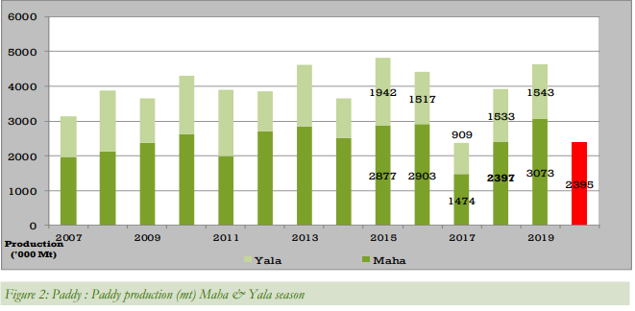

Figure 1 : Paddy: Paddy Production (Maha & Yala seasons)

The total paddy damages reported due to flood is 20,077 ha from Batticaloa and the total production loss due to damage is 27,750.

The Above stats from the Agricultural department shows there’s a huge loss of paddy reported in yala and maha traditional periods which are considered as safe periods for cultivation. Therefore It’s safer for farmers to have knowledge of upcoming monsoonal conditions and be prepared.

In this project, the solutions are mainly focused on Sri Lankan farmers. The project will be a mobile-based application designed and built mainly using Data Science and Machine Learning. By achieving this task the grou[p members hope to increase the productivity of the local agriculture industry, influence the organizations such as WFP, related NGOs, and other government organizations that are in the process of educating the farmers to adopt modern technology for the agriculture industry.

### **1.2.1.2 Examples in the problem**

Last few years the country has witnessed many heavy rainfall events in southwestern regions during the southwest monsoon season from May to September, while northcentral and northeast areas experienced drought when in varieties of crops growing season as an example of where maha season farmers start to cultivate paddy expecting northeast monsoon rains Since the uncertainty of these rains paddy and other cultivation crops got damaged and made millions of losses to farmers and the government.

## **1.2.2 Problem Definition**

The agriculture industry cannot increase productivity and also the industry experiences many losses and wastage of the harvest due to the harmful impact of the monsoons. This has caused a reduction in the Gross Domestic Product of the Sri Lankan economy.

# **1.3 Research Areas**

Since It’s dealing with Sri Lankan livelihoods The system must have good knowledge about currently what are the main rural livelihoods in Sri Lanka.

Livelihood patterns typically emerge based on the interaction of several factors related to the geography, topography of the land, the climate, demographic patterns, and infrastructural development.

Nearly 80 percent of the Sri Lankan population is considered rural.

While engaged in diverse activities, livelihoods are closely intertwined with agricultural industries, whether as producers, processors, traders, retailers, or elsewhere in the market chain. As such, livelihood zones in Sri Lanka are defined in large part by the agricultural activities that dominate the landscape.

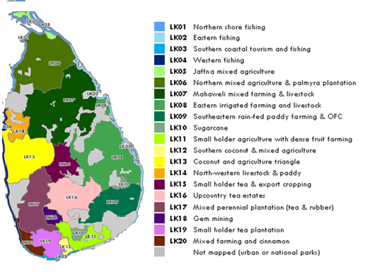

Figure 2 : Crops are grown in different areas in Sri Lanka.

Food Availability is also another key factor that has to figure out the most suitable places to plant the user’s desired crop as per the world food program Sri Lanka’s main production is rice, therefore the System should also have knowledge about rice availability.

## **1.3.1 Rice Availability**

**The areas of greatest surplus production fall largely into the major paddy producing livelihood zones,**

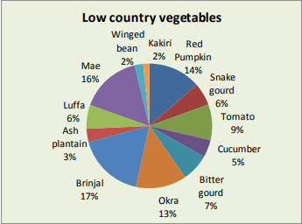

Figure 3 : Vegetables grown in low country.

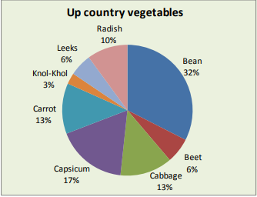

Figure 4 : Vegetables grown in up country.

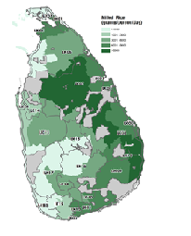

Figure 5 : Next to rice, there’re various types of plantations growing in Sri Lanka.

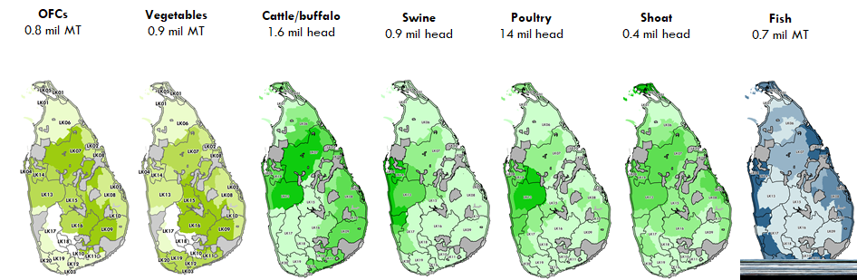

After predicting the information about the land of the user as a next step the weather conditions for the period of crops to grow is important. There are several methods to find weather patterns.

## **1.3.2 Methods for finding weather patterns**

|  |  |  |
| --- | --- | --- |
|  | **Field** | **Object** |
| **Primary** | Digital Remote Sensing | GPS Measurement |
|  | Digital Aerial Photographs | Survey Measurement |

|  |  |  |
| --- | --- | --- |
|  | **Field** | **Object** |
| **Secondary** | Scanned Maps | Topographical Surveys |
|  | DEMs from Maps | Toponymy Data sets from atlas |

Table - 01 Weather patterns

The system is going to use a primary method called Remote Sensing by an application called G.I.S

A geographic information system (GIS) is a framework for gathering, managing, and analyzing data. Rooted in the science of geography, GIS integrates many types of data. It analyzes spatial location and organizes layers of information into visualizations using maps and 3D scenes. ​With this unique capability, GIS reveals deeper insights into data, such as patterns, relationships, and situations—helping users make smarter decisions.

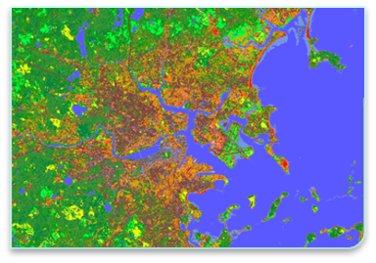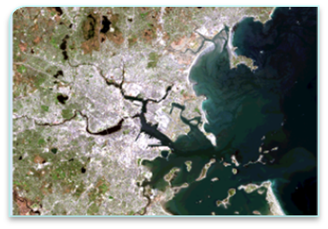

## **1.3.3 Cost of Cultivation**

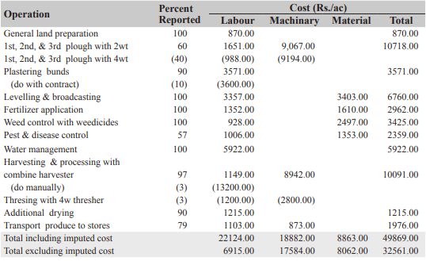

The user must have the knowledge and money to invest in cultivation, Also The system needs to give reliable information about costing and what is the expected profit a farmer can gain when it comes to selling, So It consists of all the information for a farmer or any organization that supports farmers.

## **1.3.4 Research Factors**

Climate change describes a change in weather patterns such as rainfall and temperature and soil quality due to global warming. Climate change occurs by two factors. Such as natural and anthropogenic factors. Deforestation, ozone layer depletion, CO2 concentration, greenhouse effect, aerosols, and agriculture are the factors for climate change.

Agricultural production is carried out through the selection of crops that will perform under suitable climatic conditions and farming practices. Agriculture is climatic dependent. Now a day’s farmers are facing important social, economic, and environmental challenges in their life that are needed to provide timely access to information. We are going to make a solution with technology to predict the chances of successful farming and find suitable cultivation for the situation. First of all, we want to find all impacting factors of agriculture

**1.3.4.1 Type of soil**

Soil plays a vital role in agriculture. It provides nutrients to the crop needed by the crop to complete its life cycle. The water holding capacity of soil also affects crop growth. The healthiest soil increases the productivity of agricultural land.

### **1.3.4.2 The amount of rainfall**

Rainfall is an important factor in the agriculture sector. It has a dramatic effect on agriculture. Regular patterns of rainfall are important to the growth and productivity of crops. If it is too wet or too dry, nutrients in the soil can run off and not make it to the plants’ roots, leading to poor growth and overall health. Additionally, as mentioned previously, overwatering or too much rain can also lead to bacteria, fungus, and mold growth in the soil.

### **1.3.4.3 The humidity of the air**

Humidity means the amount of water vapor contained within the air. It is expressed in percentage Climate control for plant growth is an essential consideration in regards to pest and disease management. When conditions are too humid, it may promote the growth of mold and bacteria that cause plants to die and crops to fail, as well as conditions like root or crown rot. Humid conditions also invite the presence of pests, such as fungus gnats, whose larvae feed on plant roots and thrive in moist soil.

### **1.3.4.4 The amount of air pollution**

There is now great concern that air pollutants (especially sulfur dioxide, ozone, and oxides of nitrogen) can alter the physiological processes of plants, thereby affecting patterns of growth. Air pollutants cause damage to leaf cuticles and affect stomatal conductance. They can also have direct effects on photosynthetic systems, leaf longevity, and patterns of carbon allocation within plants. Pollutants interact with other environmental factors and may alter plant-environment relationships on a regional scale 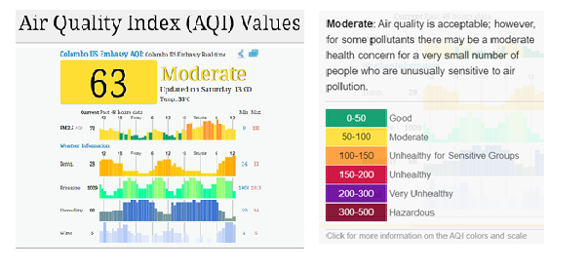

Figure 6 : Air Quality Index

### **1.3.4.5 The amount of water pollution**

Polluted water in the ground washes the essential nutrients plants need out of the soil. Water pollution makes the soil acidic and negatively affects the solubility of nutrient ions, such as iron, magnesium, potassium, and calcium ions. As a result, water removes these nutrients more quickly from the soil and sends them into streams and lakes, according to Cornell University in New York. Calcium and magnesium in particular are critical for proper plant growth. Iron helps plants to create the pigment chlorophyll -- which is necessary for food formation -- while potassium helps plants to use water. Without these nutrients, plants become more susceptible to drought, fungal infections, and insects. Water pollution also leaves large amounts of aluminum in the soil, which can be harmful to plants.

### **1.3.4.6 The amount of soil pollution -**

Soil pollution has many causes. Contaminants can be directly introduced. Soil can be contaminated by air pollution when precipitation deposits acidic compounds such as sulfur dioxide and nitrogen oxide. Human activities such as mining can release acidic drainage, which can have widespread effects. Whatever the cause, soil pollution has negative effects on plants and flora as well as the organisms that depend upon them.

### **1.3.4.7 Acid Rain**

Acid rain is an extremely destructive form of pollution. In acidic rain occurring area plant leaves turn brown and fall off. Also, plants show stunted growth and have damaged bark and leaves which makes them vulnerable to weather disease and pests. Dead or dying trees are a common sight in areas affected by acid rain. Acid rain leaches aluminum from the soil. That aluminum may be harmful to plants. Acid rain also removes minerals and nutrients from the soil that trees need to grow.

### **1.3.4.8 Temperature changes**

Temperature is also one of the main factors controlling plant growth, development, and yield. The optimum temperature is good for plant growth and productivity. Climate change affects several variables that determine how much plants can grow. Extreme temperatures, a decrease in water availability, and changes to soil conditions will make it more difficult for plants to thrive. Overall, climate change is expected to stunt plant growth.

### **1.3.4.9 The proliferation of insects**

Insects are the most diverse species on earth. Most of the insects are vital to humans and the environment. They have a direct impact on agricultural food production by chewing the leaves of crop plants, sucking out plant juices, boring within the roots, stems, or leaves, and spreading plant pathogens. They feed on natural fibers, destroy wooden building materials, ruin stored grain, and accelerate the process of decay.

### **1.3.4.10 Livestock**

Livestock products are important agricultural commodities for global security. Climate change is dangerous to livestock production due to the impact on the quality of feed, reproduction, milk production, and disease. These impacts mainly due to an increase in temperature, emission of CO2, and precipitation variation.Besides the obvious but complicated impact of being partially severed, livestock also impacts grass growth and regrowth by trampling, fouling, selecting or rejecting certain plants, and pugging the soil. All these interactions should be considered in determining forage yield and efficient management.

### **1.3.4.11 Nomadism of wild animals -**

Sri Lanka's biggest cultivation problem is elephant’s nomadism. We can get data on elephant counting’s, attacks count, and seasons then we can predict the percentage of elephant attacks in the or cultivation area.

## **1.4 Aim**

To Facilitate farmers and other organizations which support farmers, Simply educating the farmers along with ongoing trends, Also to draw interest among youngsters to gain knowledge about farming.

Through our application, we remove all the hindrance of monsoonal effect in the crops and bring your finger with customizable crop prediction features and implement modern technology in local agriculture.

## **1.5 In-Scope and Out of Scope**

This project is developed and implemented as a web application as a user-friendly mobile view to help farmers and the field of agriculture in Srilanka.

The web application developed and implemented to access, analyse and utilize data visualization methods (charts, graph , calendar, table) regarding crop cultivation ,weather prediction and harvesting period and also act as a supporting decision making system to generate reports and derive datagrams for future decisions.

|  |  |
| --- | --- |
| **In-Scope** | **Out of Scope** |
| Increase the productivity of local agriculture. | Introducing geographical knowledge to users. |
| Implementation of modern technology and methods in agriculture. | Creates innovative ideas to overcome the monsoonal challenges. |
| Maintain demand in the food supply. |  |
| Promote organic farming in Sri Lanka. |  |

Table - 2 In scope & Out scope

## **1.6 Proposed Solution**

The solution which as suggested by the team has illustrated as a rich picture diagram and the features of the prototypes as follows;

### **1.6.1 Rich Picture Diagram**

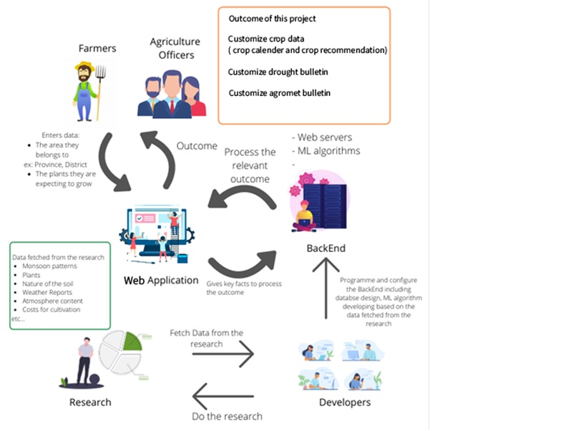

Figure 7 : Rich Picture Diagram

### **1.6.2 Features of the Prototype**

The features of the prototype are as follows,

* Users can get information about the monsoon patterns of Sri Lanka.
* Information about plants which can be grown in that particular area.
* Information about suitable timelines to grow and harvest crops.
* Cultivation tips to increase the harvest.
* Platform to get support from the support team.

# **1.7 Objectives**

* Provide information about weather conditions giving alerts in unexpected weather conditions.
* Provide information about different varieties of crops suitable with soil, weather conditions when to cultivate and harvest and yield period of crops.
* Giving new methods and technologies to cultivate crops giving ideas to farmers.

## **1.7.1 Academic**

**Data Science** - If we use data science, we can analyse all updated data and predict possibilities to perfect cultivation.

**Machine learning -** Machine learning will update new data to our application to calculate a perfect output.

## **1.7.2 Operational**

Our operational objective is to educate farmers and other related organizations. every area has an agriculture department if the agriculture department officer enters all data of that area farmers our application will automatically divide them into groups and make an event to study about our application. the officer will teach how to use this application and make them clear about this application.

# **1.8 Project Requirements**

## **1.8.1 Hardware**

Nowadays most people have at least a basic smartphone. So we have planned a mobile application to reach even poor people so that we need iOS devices and android devices.

## **1.8.2 Software**

This Application needs iOS software and android software as we are going to do a mobile application for iOS device and android device. As we have planned to do this application in react native language, we need React native application too.

**Chapter 2 - Literature Review**

**2.1. Chapter Overview**

“*Agriculture is the process of Harvesting the Solar Energy*” - G. Nammalvar

This paperwork is about weather and agricultural methods and processes play an important role. By researching the above factors through various reliable resources can help the system for prediction and advisory.

These are the most common frequently asked questions among discussed parties and these questions cannot be satisfied without proper research. They are: Is the farmer able to use the mobile app ?, Is it possible to predict the accurate period? What if the targeted crop count could not be achieved within the given period? and If cultivation cost is exceeded what is the solution?

The objectives should be achieved through this paperwork is to predict the weather and suitability of the given district, predict the suitable crops for suitable districts and weather conditions, and to predict the cost of crops that they cultivated.

If it is a large scale and open-air plantation (e.g.: paddy) the weather is the main factor which is unpredictable by a common man. The weather inputs should be given to the system (past, present, and previous) records to calculate the weather conditions during the lifetime of the paddy. At the final stage of the plantation, a farmer should be able to sell his/her goods to the end market to gain money. The system should suggest the relevant good market where they sell his/her goods and what is the current buying price of the goods.

In this current world, where everyone is lacking knowledge and interest in agriculture, this step is to give them an idea about how anyone can make their plants not only as a hobby but also as a profit gaining idea.

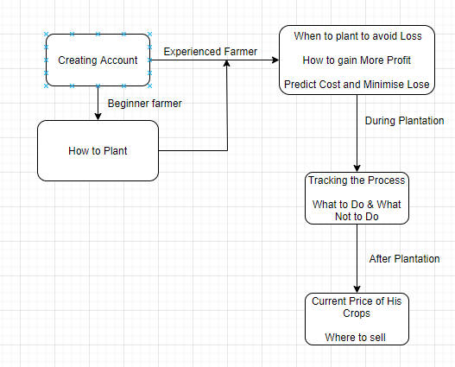

Figure 8 : Core Concept of the Application

# **2. 2 Comparison of similar research, products, and technology**

Agriculture is important in people's lives. This is influenced by water, ecosystem, biodiversity, economy, energy use, and supply. Variation taking place among the distribution of productivity land and crop production. International trade, national agriculture policies, and decisions of producers are shaped by information about crop production and demand. Well organized forecasting of the production level within season helps many purposes such as storage, distribution, pricing, and marketing.

For improving the production quality precision agriculture is Important. The application of technologies and principles to manage spatial and temporal variability is associated with aspects of agriculture production known as precision agriculture. Computers, Global positioning system (GPS), Geographic Information System (GIS), Remote Sensing, and Application Control are technologies of precision agriculture.

The potential of precision agriculture can be visualized through decreased use of water, fertilizer, herbicides, and pesticides besides the farm equipment. Farmers are usually aware that their fields have variable yields. These variations due to management practices, soil properties, and environmental characteristics.

These factors lead to the use of precision agriculture for sustainability. Certain objectives are satisfied by using precision agriculture. They follow easy management of inputs farmers usually facing problems about the use of inputs, availability, lack of irrigation it can be solved by good agricultural practice.

## **2.2.1 The climate in Sri Lanka**

Sri Lanka is a small tropical island. Due to latitude, there is no significant annual variation in temperature but there is significant regional variation in temperature Due to altitude. Sri Lankan annual rainfall is about 1850mm. There are three major sources of rainfall such as monsoonal, convectional, and depressional. Sri Lankan climate is divided into four seasons based on rainfall patterns.

I. First inter monsoon season: March – April

II. Southwest monsoon season: May – September

III. Second inter monsoon season: October – November

IV. Northeast monsoon season: December - February

Sri Lanka is divided into three climatic zones such as wet zone, dry zone, and intermediate zone. Annual rainfall, soil type, vegetation, and contribution of southwest monsoon rains are used to classify the climatic zone. It has further divided into 46 Agro-ecological regions (Punyawardena, 2007).

## **2.2.2 The connection between Weather and Agriculture**

Weather plays a vital role in crop growth and yield. Ambient temperature, solar radiation, and rainfall are the important ones among the weather variables (Hoogenboom, 2000). Hodges (1991) stated in his study Temperature is the main weather variable contributing to the vegetative and reproductive stage. Ambient temperature is important to the crop life cycle. An increase or reduction in temperature shows a severe impact on crop development. Optimum temperature was suitable for crop growth and yield.

Solar radiation gives energy for the process such as photosynthesis, carbohydrate partitioning, biomass accumulation of individual plants (Bootie and Loomis, 1991). Puckridge and Ruthowsky (1971) concluded their study was the conversion energy of intercepted radiation into biomass accumulation high during low radiation than high.

Rainfall does not directly affect any of the crop development stages of the crop but indirectly affects crop growth and development. During the high amount of rainfall water-logging occurs, during the lack of rainfall period drought occurs (Hoogenboom, 2000). High temperature, humidity, and rainfall provide a suitable environment for funga**l** growth (Fraisse *et al*, 2006). Most of the crop failures in the US with excess or lack of rainfall (Ibarra And Hewitt, 1999). Hoogenboom (2000) indicated soil temperature, wind, relative humidity also affect crop productivity.

## **2.2.3 Current Trends in Climate Change in Sri Lanka**

Sri Lanka has a long sequence of climatic data particularly rainfall and temperature since 1860. Current analysis of data shows that the country's mean temperature is significantly increasing at a rate of 0.01 to 0.03 0C per year (Punyawardena, 2013).

Nissanka et al. (2012) stated during the last 50 years seasonal rainfall of climatic zones has not undergone significant change. There is a noticeable increase in temperature anomalies in most regions during recent times (Premalal and Punyawardana, 2013).

## **2.2.4 Climate Change Impacts on Crop Productivity and Quality**

Climate change is a statistically important variation of mean or its variability, it is lasting for an extended period caused by human activities (Wickramasinghe, 2013). The potential effect of climate change on soil fertility and the ability of crops to acquire and utilize soil nutrients is poorly understood but essential for understanding future agriculture (Samuel *et al*., 2010). Climate conditions, especially drought, show impacts on reduction in yield and food insecurity in Africa over the last 50 years (Barrios *et al*., 2008). During the 20th century Asia, Africa, and South America experienced a 0.7–1.0°C increase in temperature (IPCC 2007). Increase in environmental temperatures, irregular pattern of rainfall, reduction in soil fertility, and various pest and disease dynamics are the main factors in climate change which influence crop production (Eswaran *et al*., 2016).

Changes in environmental factors such as rainfall and temperature expect to have negative effects on agriculture and particularly in developing areas (IPCC, 2007). The extreme effect of drought on crop failure led to starvation during the 20th century and the increase in the 21st century (Broad and Agrawala, 2000). Depending on location, increases in the frequency and magnitude of droughts and floods are expected to influence agricultural production (IPCC, 2007). Current climate models express that future patterns of drought in Asia are expected most difficult during the summer and spring in monsoon regions and West Asia (Kim and Byun, 2009).

Recent researchers indicate a lack of knowledge in understanding the crop responses to climate variation is greater for temperature and rainfall (Lobell and Burke, 2008). Effect of climate on growth and yield of the crop, extremes of temperature, and water scarcity have different effects on the nutritional quality of the product. Increasing temperature and drought tend to decrease yield and starch content while protein content increases (Erekul and Kohn, 2006).

## **2.2.5 Effect of temperature**

Increasing environmental temperature shows the influence on crop growth. It may have a direct or indirect negative impact on crop development. Due to higher temperature crop, evaporative demand increases that mean irrigation requirement is increased. In other ways, higher temperature causes increased usage of water by people for their activities and it leads to scarcity of water in the agriculture sector.

Tuber formation and yield of potato express notable effects due to the higher temperature at Nuwara Eliya. Raising environmental temperature causes increased respiration rates, lower rice yields specifically in the dry zone which is the main rice-growing area. In paddy, grain sterility is induced due to a combination of increased temperature and high relative humidity and a sudden decrease in temperature also causes grain sterility. Increasing ambient temperature increases the soil temperature also causes rapid decomposition of organic matter due to increased soil microbe activity (Wickramasinghe, 2013).

## **2.2.6 Effect of Rainfall**

High intense rain within a short period causes accelerating soil erosion. Some studies indicated 33% of land area affected by soil erosion. The rainfall pattern affects agriculture in various ways. Irregular patterns of rainfall affect the cropping calendar and affect fruit setting on fruit crops. Rainfall directly influences cropping intensity and new technologies (Fernando and Chandrapala, 1995).

**2.3. Limitation of Existing Work**

**2.3.1 Suitability for agriculture and districts**

According to the World Food Programme (2019), Sri Lanka is a small (65,610 km2) but diverse island nation located in the Indian Ocean off the south-eastern coast of India. Administratively, it has nine provinces, 25 districts, 325 divisional secretariats (DS), and over 14,000 Grama Niladhari (GN) divisions, or village clusters, with the capital city of Colombo located in the Western Province.

Distinct topographic, geographic, and climatic characteristics around the country overlap to create a mosaic of agro-ecological areas that then inform livelihood patterns. At the broadest level, three agro-ecological zones (wet, intermediate, and dry) are defined by the prevailing climate and rainfall patterns (Fig. 01). Altitudinal differences (highland, upland, and lowland) serve to further delineate within these major zones, while soil type narrows the areas even further to a total of 46 sub-agro-ecological zones.

Approximately 64 percent of the country's landmass can be found in the dry zone, which extends over the northern, north-central, and eastern regions. This zone receives less than 1,250 mm of rainfall per year that falls mostly during the North-East Monsoon, between December and February.

The mountainous wet zone in the south-central region accounts for 24 percent of landmass while the intermediate zone spanning between the wet and dry zones accounts for the remaining 12 percent. In a typical year, the wet zone receives more than 2,500 mm of rainfall spanning through two monsoonal periods, the South West Monsoon (SWM) occurring between May and September, and the North East Monsoon (NEM). (WFP,2020)

### **2.3.1.2 Agricultural Conditions and Food Security**

Integrated Drought Severity Index (IDSI) analyses the agricultural drought conditions. Figure 04 shows that due to the heavy rains received through Sept to Dec 2019, in many areas of the country, the overall health of agricultural land has moved to normal.

In some areas it shows dry now as the paddy harvesting has started around the country, indicating negative health in fields. According to the Department of Agriculture, given the high rice production in both the Maha and Yala seasons, it is predicted that rice stocks will be sufficient for the next nine months. Total rice production for this season is 2.97 million Mt (Figure 05).

Paddy production in Batticaloa, Mannar, and Ampara districts sustained the most damage in this period. While this was a substantial loss for several local communities, it should not harm overall rice production and the surplus prediction.

Dry conditions in January and February have prevailed across most of the major rice-producing areas. This has meant favorable conditions for paddy harvesting and drying activities.

Food inflation increased substantially to a 25-month high of 11.7 percent in January 2020 from 6.3 percent in December 2019, while Non-food inflation stood at 2.9 percent.

## **2.3.2 Calculating suitable crops for various district**

### **2.3.2.1 Agriculture production, markets, and food security**

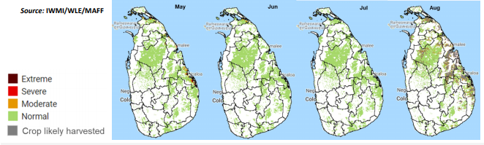

Figure 9 : Integrated Drought Severity Index (IDSI) 2020– May-August 2020, (IWMI/WLE/MAFF*)*

Integrated Drought Severity Index (IDSI) which is a composite of rainfall, vegetation, soil moisture, and temperature to monitoring the scale of Agricultural drought (Figure 07) indicates that this “Yala” season is a normal year, providing a bumper harvest for significant crops such as rice and maize, which is an increase in production compared to 2019 (IWMI).

Based on the Crop Forecast by the Department of Agriculture, the sown extent of Paddy in the “Yala” season at the end of August 2020, reached 96 percent of the target, despite damages occurring to nurseries due to the impact of Cyclone Amphan. This was the best during the last 5-years mainly due to good water capacity. The expected paddy production would be sufficient for more than five months. When considering the expected paddy production of 1.84 million metric tons for the “Yala” season (Figure-07), the country will gain good paddy production during this year.

The cultivation progress of major OFCs up to the end of August 2020 was 114 percent of the target. The progress of cultivating major up-country vegetables is at 84 percent from the target, but in the low country, it was 118 percent of the target. However, the cultivation of crops such as Maize, Soya bean, and Red Onion reported slightly lower progress (75 percent, 62 percent, and 72 percent respectively). Perennial crops including tea and rubber coconut are not largely affected by the water stress, however, heat conditions have influenced tea production during some months.

Prices of several fruit varieties have increased due to limited supply and high demand. In terms of coconut prices, the Hector Kobbekaduwa Agrarian Research & Training Institute (HARTI) indicates a significant increase in wholesale and retail prices of large and small coconuts compared to last year, due to the limited supply, which may continue during the next three months.

The local big onion production was impacted by heavy rains during the past two months, prompting the average wholesale and retail prices to increase to Rs. 145.25/kg and Rs.178.33/kg respectively in September. Nevertheless, compared to the same period last year, average wholesale and retail prices decreased by 3.4 percent and 21.2 percent respectively.

The outbreak of COVID-19 created difficulties in farming from March to May. This was partially offset by introducing home gardening around the country through a government program that issued two million seed packs to farming families. The home gardens helped to reduce household food insecurity to some extent. (WFP,2020)

## **2.3.3 Crops Lifespan during the previous year**

The Maha season 2018/19 concluded reporting paddy cultivation extent of 759,571 ha. This is a 91% achievement from the target (832,785 ha). Rice production in the Maha 2018/19 season alone will be sufficient for 9.36 months – until mid-September 2019. The Yala 2019 harvest will be available from August 2019, therefore ensuring domestic demand for rice is met by local production.

With the start of the first inter-monsoonal rains, the seasonal agricultural practices, including paddy cultivation, for Yala 2019 commenced in May. The total rice production in Yala 2019 is estimated to be 970,000 MT, ensuring the total availability of rice meeting the national demand for 2019. Comparatively, the Yala production of 2018 was 850,000 MT.

Yala paddy production in certain pockets of North Western, North Central, Uva, and Eastern Provinces will be impacted as paddy cultivation was not undertaken due to lack of water storage in small-scale irrigation tanks.

Other field crops, vegetables, and fruits will face the challenge of current dry weather and may result in reduced yields (Socio-Economic Planning Centre of Department of Agriculture,2018/2019).

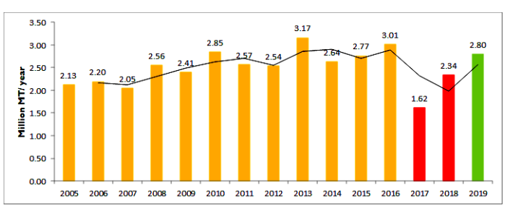

Figure 10 : Total Rice Production Outlook, (Agri. Dept,2020)

A successful Maha Season 2019-2020 means paddy production is estimated to be sufficient to meet domestic demand until September 2020. Floods, mainly along the East and North coast, caused an estimated production loss of 57,065 Mt. This, however, should not have an impact on short- to medium-term food security. Limitation of vegetables and onions was observed in early 2020.

Substantial rainfall, particularly in the Central, North, and East saw dramatic rises in major/minor water reservoirs. Currently, water levels are above 80% of total capacity, substantially higher than this time last year (66%). Nevertheless, drier conditions have shown a slight decline in the water level the past month affecting some sectors, especially drinking water in a few areas & hydropower.

## **2.3.4 Prediction of weather**

According to the WFP (March 2019) for April to June, most parts of the country received below normal rainfall during April and May. Temperatures were above normal as predicted, and frequent heat weather advisories and precautions were issued.

Overall, the rainfall during Maha season 2019/20 has been above average through Sept-Dec 2019. The majority of the rain occurred from October to December with an average of 304 mm each month. As seen in Figure 07 there are distinct spikes in rainfall during this time, specifically in the third decade of both October and November.

Below-average rainfall conditions in January have been experienced in Trincomalee, Anuradhapura, Polonnaruwa Matale, Kandy, Badulla, Monaragala, Batticaloa and Ampara districts; and other parts of the island. In February, above-average rainfall conditions were experienced in some parts of the Mannar district; however, below-average rainfall was experienced in the rest of the island.

The dry weather condition has led to wildfires spreading through the country, especially through the Central and Uva Provinces. These are being managed by airborne water bombers and are under constant monitoring, by DMC.

Some rainfall has been received in the 3 rd week of March especially in southern/south-western parts of the country, however, the country is yet to receive the 1 st Inter-monsoon, which might commence in early April. These rains have supported the reduction of high salinity in drinking water in the Kalutara area.

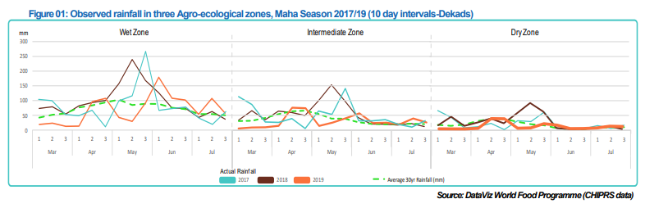

Figure 11: Observed Rainfall in three zones, (WFP,2017/2019)

The above chart (Figure 01) shows the rainfall observations/pattern over the past three years from March to July, which is most important for the Yala cropping season. The same pattern might continue in the three agro-ecological zones with some variabilities, but no major shift is expected in 2020. The chart depicts the inter-monsoon rains starting in early April and enhancing during the onset of the South-west monsoon in late May. However, extremes may occur due to the climatological phenomenon, creating adverse impacts.

## **2.3.5 Cost of cultivation and method of profit gaining.**

The cost of cultivation of paddy was surveyed in eleven irrigated regions and five rain-fed districts in Sri Lanka. Total cost (cost of cultivation including farmer-owned input) per acre and percent share of cash cost (cost of cultivation excluding farmer-owned inputs) are given in Figure 2.1 and Table 2.5 respectively. Total cost per acre under irrigated conditions ranged from Rs. 44,894 in Trincomalee to Rs.58,793 in Hambantota. Under the rain-fed condition, the total cost per acre ranged from Rs. 33,995 in Batticaloa district to Rs.54, 506 in Kandy district. The percentage share of cash cost in total cost was more than 58% in all the districts except in Kandy. (Met. Dept,2020)

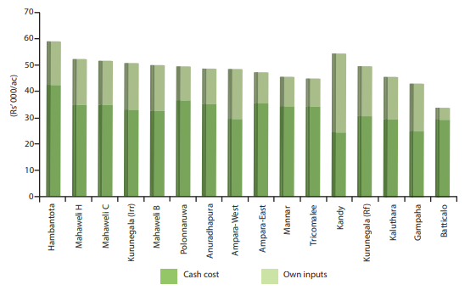

Figure 12 : Cost of cultivation of paddy, (Agri. Dept,2020)

### **2.3.5.1 Cost Structure**

The total cost is divided into three main components namely Labor, Material, and Power (Table 2.6 and Fig: 12). The percent share of labor cost in total cost ranged from 40% (Rs. 18,111) in Mannar to 50% (Rs. 25,279) in the Kurunegala district under the irrigated water regime. In the rain-fed water regime, it varied from 31% (Rs. 10,560) in Batticaloa district to 73% (Rs.39, 964) in Kandy district. A lower percentage of labor cost (40% - 50% of the total cost) in all the districts in the irrigated condition is due to the use of combine harvesters for harvesting. However, a reduction in labor cost in these districts has been put back by power cost keeping the overall cost at a comparable level with all other districts.

When considering irrigated water regime, the percent share of power cost in total cost ranged from 32% (Rs.14, 929) in Ampara East to 41% (Rs.20, 279) in Polonnaruwa. In rain-fed areas, it varied from 20% (Rs.10, 755) in Kandy district to 40% (Rs. 17,027) in Gampaha District. The share of material cost varied from 14% (Rs. 7,177) in Kurunegala to 23% (Rs. 10,884) in Ampara East at the irrigated conditions. In the rainfed condition, it varied from 7 %( Rs. 3,787) in Kandy district to 32% (Rs. 10,877) in Batticaloa district.

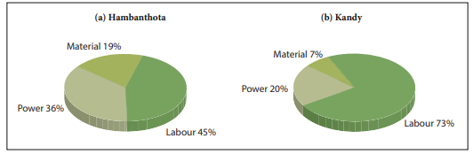

Figure 13 : Major Components of Cost of cultivation, (Agri. Dept,2020)

Land preparation (plowing and leveling), harvesting and drawing, threshing, and winnowing are the main operations that can be mechanized. Most of the farmers interviewed in all the districts do land preparation with 4 wheel tractors except at Mahaweli B, Kalutara, and Kandy districts (Table 2.1). The cost of land preparation (for three ploughings) by 4 wheel tractors ranged from Rs. 5,224 in Ampara East to Rs. 10,298 in Hambantota district. The usage of 4 wheel tractors for land preparation was 100% in Ampara East, Hambantota, Mannar, Trincomalee, Mahaweli C, and Batticaloa.

Fig 12 further depicts that many of the majority of farmers in all the irrigated districts used combine harvesters for harvesting (100% in Ampara, Hambantota, Mannar, Polonnaruwa, Trincomalee, Mahaweli C). Furthermore, many of the farmers under rain-fed conditions also used to combine harvesters for harvesting. (Batticaloa, Gampaha, Kurunegala, and Kalutara district 100%, 90%, 84%, and 70% respectively.).The average cost of harvesting, threshing, and winnowing by combine harvesters ranged from Rs. 5,863 in Batticaloa to Rs.10,079 in Mahaweli System H. The cost of manual harvesting and drawing ranged from Rs. 14,648 in Kalutara district to Rs.18,965 in Kandy district. In rain-fed conditions, 90% of farmers used manual harvesting methods in the Kandy district.

### **2.3.5.2 Labor usage and wage rate**

According to Fig 14, the total man-days per acre ranged from 7 MD in Batticaloa to 33 MD for Kandy. As a result of mechanized harvesting in all the irrigated areas, labor usage was between 13-20 MD. At irrigated conditions, Mannar (13 MD) reported the lowest labor requirement. Kandy district reported the highest labor use (33 MD) due to labor-intensive practices such as transplanting, manual harvesting, and drawing. The wage rate varied from Rs. 1,211 in Kandy district to Rs.1,642 in Hambantota district. Family labor accounted for over 50% of total labor usage in all the districts except in Batticaloa (43 MD).

## **2.3.6 Fertilizer Use**

Almost all farmers have tended to use straight fertilizer. The ratio of TSP, Urea, and MOP used as basal dressing varied for districts (Fig 15). The total quantity of these fertilizers used as basal dressing under irrigation conditions varied from 20 kg/ac in the Hambantota district to 70 kg/ac in Ampara West. In rain-fed conditions, it ranged from 21 kg/ac in Gampaha district to 35 kg/ac in Kandy district.

# **2. 4. Research on Approach and Techniques**

The research which was conducted by the team is mainly focused on multiple purposes in order to create the app. They are as follows;

1. Research on creating backend services and Api endpoints in order to perform operations such as User Registration, Login, Forgotten Password, Update Personal details etc..
2. Machine Learning Algorithms to perform operations such as Predicting the crops yield, crop cost, identify monsoon patterns etc..
3. Calling external API and filter them according to the requirement of the application.

## 2.4.1 Research on creating backend services and Api endpoints in order to perform operations such as User Registration, Login, Forgotten Password, Update Personal details etc..

### 2.4.1.1 Server or Serverless

One of the main goals of this project is to create a Reliable, Secured Backend service which can keep the app up and running without any interruptions. The team had extra weight on this aspect. This Literature Review will provide a good understanding of the technologies, programming patterns and algorithms which will be used for developing.

Initially the team had a research on how the Backend services are going to be hosted. The options which are available are, host in a Physical Server or go for Serveless. The main factors which were considered are Service cost, maintenance, security. As this app can be downloaded by any person through the play store, and also free for all, definitely this will be used by many people and will definitely use Back end services so many times. Physical servers do not handle such an amount of requests(approximately 300 requests per day) with a good speed while serveless will handle very well with a good response time. - (Single Mind Consulting - Sam Kilada). And also physical servers will not have a stable security protocol as it should be handled by the team/organization who have less experience and also will have to spend extra time on security and getting backups. The serverless platforms definitely run by professionals as it will be more reliable and secured. The cost on serverless will be paid as you go which they allow us to pay based on the consumptions of the servers while the physical servers will be costly plus the maintenance cost. (Stonegroup - Abbie Rodger). This application consists with large amount of media files such as images of plants, graphs, grids. if the purpose of a server is simply to hand out static pages and process basic API requests, then perhaps an Azure Web App (or AWS Elastic Beanstalk app) is a good option as it is a great, scalable solution. However, if your server processes images or long-running requests, consider a serverless option like Azure Functions or AWS Lambda. - (Single Mind Consulting - Sam Kilada).

### 2.4.1.2 Database Solution

In order to store data which are related to the project, it needs the best solution for database management. There are plenty of options when it comes to databases. Team had to go through a research to choose whether SQL or No SQL according to the requirement. The main factors which were focused on are the growth of the application, configuration, speed and complexity of the application.

If the application constantly adds new features, functions, data types, and it’s difficult to predict how the application will grow over time. Changing a data model is SQL is clunky and requires code changes. A lot of time is invested designing the data model because changes will impact all or most of the layers in the application. In NoSQL, we are working with a highly flexible schema design or no predefined schema. The data modeling process is iterative and adaptive. Changing the structure or schema will not impact development cycles or create any downtime for the application. (Integrant- 2018) As it says if the application keeps growing with new functionalities or features it will be a good solution to go for NO SQL due to its adaptability while SQL well structured nature will not respond well for new features.

You have a lot of data, many different data types, and your data needs will only grow over time. NoSQL makes it easy to store all different types of data together and without having to invest time into defining what type of data you’re storing in advance.(Integrant - 2018) As it says no need of complex configurations and spend lots of time even though there is a change in the data types of the database. SQL highly structured nature will restrict sometimes those types of changes.

You’re working with complex queries and reports. With SQL you can build one script that retrieves and presents your data. NoSQL doesn’t support relations between data types. Running queries in NoSQL is doable, but much slower. You have a high transaction application. SQL databases are a better fit for heavy duty or complex transactions because it’s more stable and ensure data integrity. (Integrant - 2018) If the application is consists with complex transactions it will be the best solution for the team to use SQL. And also if the application needs an environment which is all connected with well structure relations and architectures, SQL will be the option. But the due to this complex structure SQL is slower than NO SQL. My SQL will be one of the best options for SQL databases while MongoDB and DynamoDB will be best suited for NO SQL.

### 2.4.1.3 Back-End Framework

The next challenge which needs to be faced by the team is to create the server side application which communicates with the database with REST API Endpoints. In order to achieve this requires a better Backend framework. The options which are mainly focused on the project are Spring Boot and Node.js which are really popular among developers nowadays.

Node.js, developed primarily in JavaScript, uses an event-driven, single-threaded, non-blocking I/O model. This makes it incredibly efficient and lightweight. Perfect for very data-intensive applications that need to operate in real-time across distributed devices.(Medium - Ryan Gleason). As it says node js is really lightweight when it comes to the memory and also it will increase the performance of the application. Non-blocking I/O:This is a very important concept to understand when learning about Node.js. This system allows a thread to work on another task while it is waiting for a different task to be completed. In other words, new tasks are not blockedwhile waiting for other tasks to finish. How is this accomplished? Node.js relies on asynchronous functions. -(Documentaion - node.js) As this is single threaded it has a low memory utilization and also does not require to worry about problems which occurs when handling multiple threads.

Implemented in Java, Spring Boot allows for quick startup of a production-grade, stand-alone application. This is a bootstrapped version of the Spring platform. The idea for Spring Boot is that it’s very easy to just run, so it minimizes the amount of fuss that comes with getting an application up and running. - (Medium - Ryan Gleason). Spring Boot is multi-threaded and it will be the best option for huge repetitive operations. In this while the main operation functions the other operations will run concurrently. But there will be concurrency issues when it comes to decide what to run and what to not run. For that a proper task management architecture needs to be implemented. That makes the application more complex.

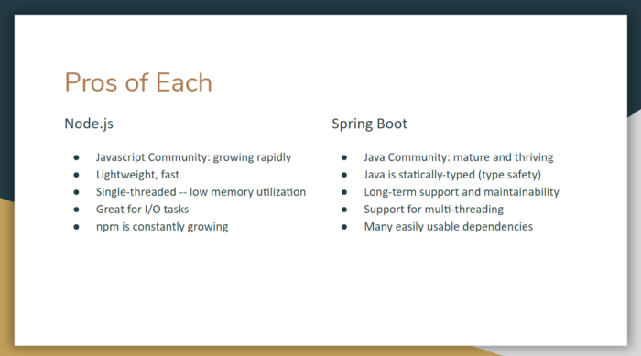

Figure ## - Pros of Node.js and Spring boot Frameworks

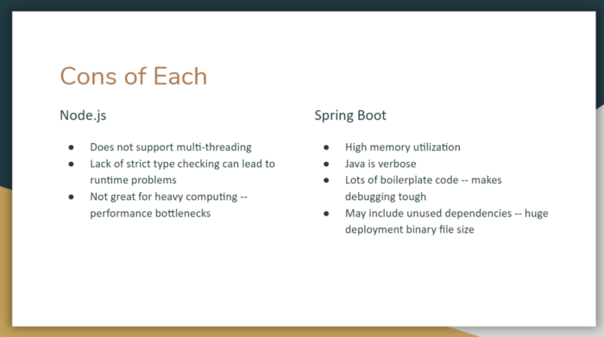

Figure ## - Cons of Node.js and Spring boot Frameworks

### 2.4.1.4 React Native or Angular? Which One to choose

When it comes to the front end of the application, there are many options to go with. But the team choosed React and Angular as the main options considering the factors such as future trendings, community support, surveys(Stack-Overflow Survey).

React js is a lightweight component UI library which is the “View” of the MVC Architecture. It gives more freedom to choose what are the suitable libraries for the application. Angular is a well structured framework when it comes to app developing. Angular has its own routing facility while react js needs an external library to handle routine. (X-Team -Thomas DE Moore)

Even Though these are really powerful and popular way of making apps there were some factors which the team focused on choosing one. They are Learning curve, app structure, state management, performance.

React is minimalistic: no dependency injection, no classic templates, no overly complicated features. The framework will be quite simple to understand if you already know JavaScript well. Angular itself is a huge library, and learning all the concepts associated with it will take much more time than in the case of React. Angular is more complex to understand, there is a lot of unnecessary syntax, and component management is intricate. Some complicated features are embedded into the framework core, which means that the developer cannot avoid learning and using them. Moreover, there are a lot of ways of solving a single issue.- (freecodecamp - Oleg Romanyuk)

When it comes to performance react is a lightweight UI library so its performance are higher than Angular as it is a heavy and well structured framework consists with MVC(Model View Controller).

React has a simple app structure which has multiple ways of developing the code. It means developers can use either class component or functional components. Angular is well structured it is sticked to MVC which is in-built(in order to achieve MVC in react native it needs implement some other libraries). It is mainly based on best practices and also suitable for experienced developers. Angular code is more statndarized than the React native code.

The application code consists of different Angular components, each being written in four separate files: a TypeScript to implement the component, an HTML file to define the view, a CSS file to define the stylistic features, and a special file for testing purposes. Links to these files are written in the app directive, which displays the structural logic of the app. Respectively, Angular components are also reusable.- (freecodecamp - Oleg Romanyuk)

When it comes to the language React Native is based on Javascript ES6+ and JSX. While Angular is based on Typescript which is easier to identify typos and refactoring process.

One of the main factors of this aspect is the state management. This is so important when it comes to interacting with endpoints and session handling etc.. Its so important to maintain global states across the application. In react native requires external libraries such as Redux for state management. These states can be altered using reducers and actions and maintain global states. Redux is kinda a heavy and costly library and needs to implement it carefully otherwise it will affect performances(Redux- Documentation)

In Angular, component data is stored in component properties. Parent components pass data through to children ones. State changes in some parts can be identified and recalculated, but in a large app, it can cause a multi-directional tree series of updates, which will be difficult to track. - (freecodecamp - Oleg Romanyuk)

|  |  |  |  |
| --- | --- | --- | --- |
| Activity | Time | Sender | Activity |
| Data Observation and Analysis | Daily update | Climate DoM | Observational data |
| Every month on 03rd | Climate DoM | Seasonal Weather Prediction through web-portal |
| Every Day | NMC (DoM) | 10 Day Forecast through web-portal |
| Daily | NMC (DoM) | Short Range Weather Forecast through web-portal |
| Every month on 08th | NAICC | Seasonal Agro-met Advisory |
| Immediately | NMC / DoM | Extreme weather events |
| Immediately | DMC | Extreme weather for agriculture after discuss with NRMC |
| Every day (by noon) | NMC (DoM) | Daily rainfall chart based on nearly 200 rain gauges. Gridded data |
| Every month (by 15th) | CCCS / DoM | Drought map based on monthly rainfall. Gridded data compatible to GIS |
| Data Observation | Every Day | DAD | Daily Rainfall |
|  | 09th Every month | NAICC | Agromet advisory |
| Data Analysis(Local Level) | 20th Each month | DoA (Province) | Customize drought information for farmers |
| Data Analysis(Local Level) | Beginning of the season | DoA (Province) | Customize crop recommendation for farmers |
| Data Analysis(Local Level) | Beginning of the season | DoA (Province) | Customize cropping calendar for farmers |
| Data Observation | End of the month | ASC | Tank water availability (Qualitative statement) |

## 

**2.4.1.Daily Update on Observational Data**

Data Source Would be DOM to compare the predicted weather and the actual weather, Inorder to predict how accurate our prediction is. To make our application more reliable.

***//Predicted Results***

**let predefined = {**

**humidity : '22.9', *//Cel***

**temp : '37.4'**

**}**

***//actual result***

**$.ajax({**

**get: 'Weather API'**

**method : 'GET'**

**}).then(obj => {**

**console.log(predefined.humidity === obj.humidity)**

**}**

Figure 14 : weather observable list

# 2.4.2 Machine Learning Algorithms to perform operations such as Predicting the crops yield, crop cost, identify monsoon patterns.

## 2.4.2.1 Prediction of the Crops type

To perform the predictions on which crop will be suitable for a given area, the system has used the K-NN (K-Nearest Neighbor) algorithm as the machine learning approach (DOISE Karnataka - 2020). K-NN is a simple algorithm that stores all the available cases and classifies the new data or the case based on similarity measures. (eureka) KNN is mainly used for least distance measures to identify its nearest neighbors. This algorithm has increased the accuracy of the prediction as it examines a wide range of data to process relevant information. The best approach is to do predictions based on Euclidean Distance. It is measured as follows,

**Euclidean Distance = (** (edureka - KNN Algorithms)

Based on the Decline Distance the system can identify its nearest neighbors and indicate which class these data belong to.

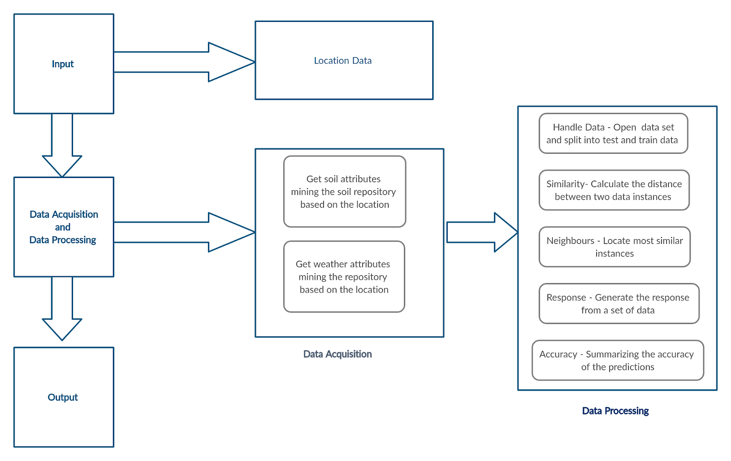

Figure 14 : System Architecture of the Prediction of the suitable crop

According to fig 16 as the first step, the user needs to enter the location, or it can be fetched by the system itself. After that system mines the soil repository and the weather repository and fetches relevant data. After that, the system loads the CSV file which contains the existing dataset, and splits them to test and train data sets. It uses the Euclidean Distance to calculate the distance between two instances and identify the nearest neighbors. It will process and output suitable crops to grow in a specific area.

## **2.4.2.2 Predicting Crop Yield - MLR Algorithm**

Multiple factors affect the success of a crop yield such as weather components which include rainfall, temperature, and when it comes to the soil nutrients such as Potassium, Nitrogen, Phosphorus, and pH. The proposed system suggests a mobile-based application that can predict accurately the most profitable crops to the farmers. According to the location, the proposed application will identify the weather conditions and type of soil, and other factors from the database. These data will be processed at the server-side and results will be sent to the user.

Regression Analysis will be used in the proposed system as an algorithm to predict various components.

Regression Analysis

Regression analysis is one of the most used predictive models for analysis. It is a method to elucidate the relationship between one or more dependent variables and the independent variables. There are three types of Regression,

* Simple Linear Regression - Relationship between two variables ,

one dependent variable, one independent

variable

y = α + βx + ε

α = y intercept, β = Gradient, y = dependent variable, x = independent variable, ε = random error

* Multiple Linear Regression - One dependent variable, more than one independent variables.

y = β0 + β1x1 …. +βpxp + ε

y = dependent variable , β0 , β1 ,...,βp = regression coefficient , x1, …, xp = independent variable , ε = random error

* Non - Linear Regression - The relationship between dependent and independent variables is non-linear in regression parameters.

(Yan X and Su X G-2009)

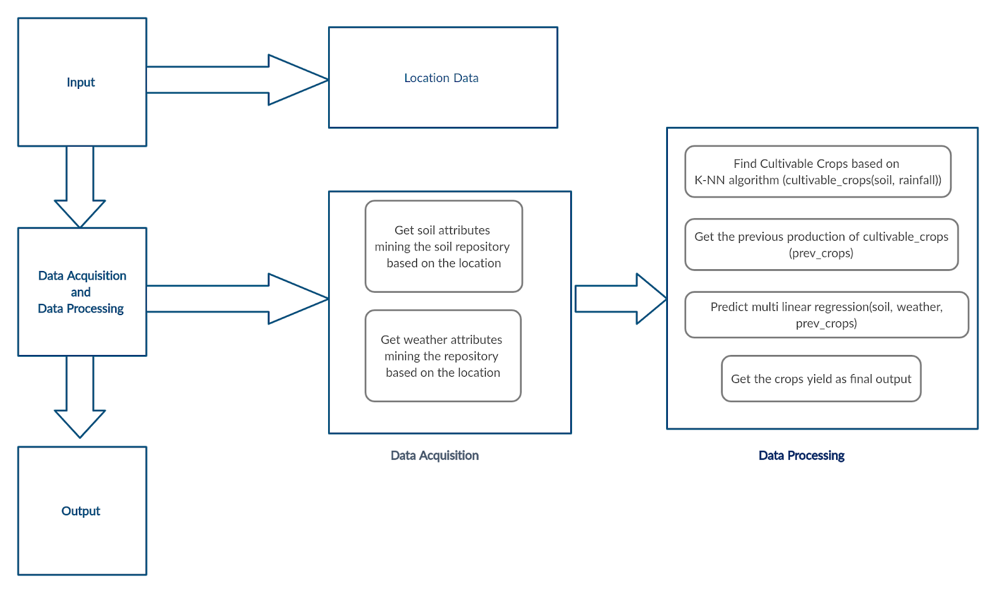

Figure 15 : System Architecture of the prediction on crops yield

## **2.4.2.3 Prediction on the Cost and Profits.**

This prediction has been a highlight prediction which is going to be performed in the system because people who are novices in the agriculture industry, can get a rough idea regarding the costing and profit margins before even entering the industry. This will increase productivity and it will cut off the wastage which can occur due to lack of knowledge. This prediction may help to make long term decisions productively. To calculate the Cost, it implements the Multiple Linear Regression Algorithm to perform prediction, as it requires multiple variables such as different types of expenditures, taxes, and compensations.

### **Calculating the Cost**

To calculate the cost, the algorithm requires to set up multiple independent variables such as expenditures types, taxes, compensations, royalty, etc… All the variables and other data related expenditures can be taken from the official website of the agriculture department of Sri Lanka. (DOA Crop Forecasting 2020) After setting up independent variables, one needs to create a model using these variables and get the coefficients and also intercept by training the model. Once all the variables are set, the system can make predictions on costing for the crops. This can be calculated by using the below formula.

= coefficients = Independent Variables b = interception Y = Dependent Variable

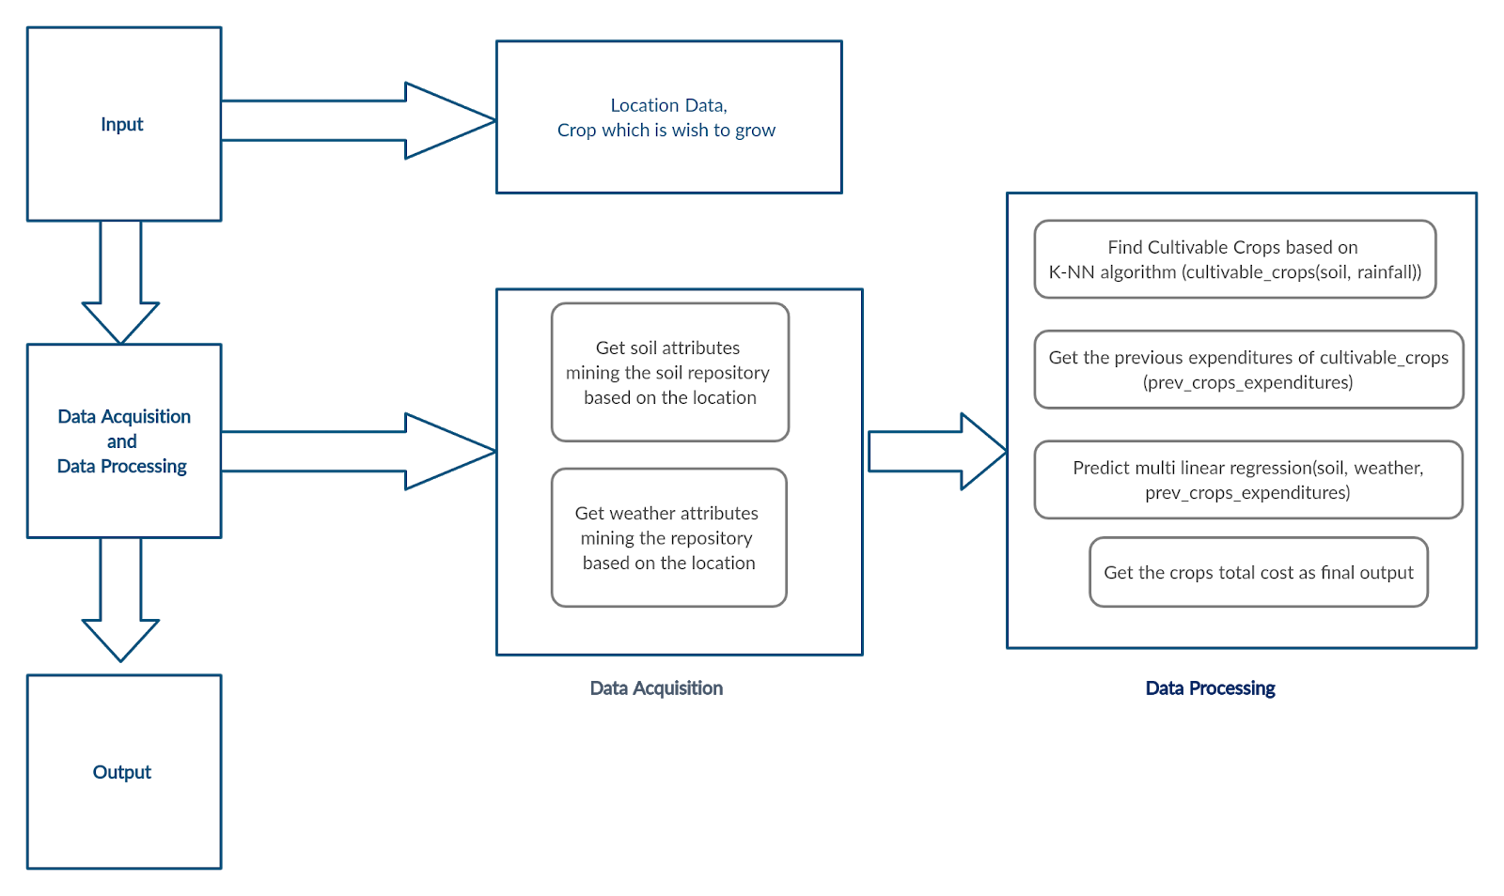

Figure 16 : System Architecture of the predictions on Crops Cost

### **Calculating Profit.**

This system can predict the crop yield and the cost of crops based on the K-NN algorithm and the Multiple Linear Regression Algorithms. To get the profit of a given crop, it is necessary to have the income which can be generated by a specific crop. To generate the income system can use information such as Crop yield and multiply it by its market price. After that calculation, the cost of the crop can be deducted from the income and get the net profit.

**Total Profit = Total Revenue - Explicit Cost**

# **2.5. Summary**

This paperwork indicated that farmers-based prediction methods on climatic changes in their farming experience were able to perceive the ongoing climate change-taking place in their farming environments. The majority of the farmers have experienced an increasing trend in rainfall variability and consequential dry spells in recent years. The paperwork revealed that the majority of farmers have attempted to overcome some of the impacts of climate change by adjusting their farming practices and some traditional methods. For the modern upcoming farmers we precise to make this platform to predict crop cultivation for the climatic changes. Thus, this prediction package could be recommended for adoption by the farmers to improve the yield plants germination and to overcome abrupt climate change. while using this methodology resilience to climate change resulting in improved environmental sustainability to improve income diversion to the farmers.

It is clear that in the study area adaptation is taking place on farmers’ to cultivate suitable crops. Climate change is likely to exacerbate the severity of impacts in the future, requiring farmers to contemplate beyond autonomous adaptation measures practiced at present. Hence, agricultural systems must adjust to new environments that are likely to evolve in the future.

**Chapter 3 - Project Management**

**3.1. Chapter Overview**

This chapter elaborates project management methodologies of our system. Risk involved in the project and mitigation plan for the system. The process model, research approach and evolution of project gathering data to upgrade the system.The activity schedule and data gathering methods are discussed in this chapter.

# **3.2 Methodologies**

### **3.2.1 Research Approach**

There are two categories of research approaches which are inductive and deductive approaches. The main difference between inductive and deductive reasoning is that inductive reasoning aims at developing a theory while deductive reasoning aims at testing an existing theory. So in this project the team will follow the deductive approach.

### **3.2.2 Process Model**

There are several project management methodologies existing and using in the industry by startups as well as big name companies. In this Project we will be using Agile methodology based Scrumban Methodology which is one of the best solutions for managing group projects. It is easier to keep track of everything and also boost the work which does not show any progress.

**Why Choose Scrumban?**

Scrumban is the combination of Kanban and Scrum Frameworks which are based on Agile. As the team decided to develop this application according to versions there will be continuous improvements and changes. So the app will be launched as version by versions adding more features to the functionality. And also the development process consists of many components which need to be developed separately and integrate them. As an example team needs to develop Back end services and also needs to develop UI for the app. These services need to be developed separately by the team mates. So for that there will be allocated developers for each task during the development process. So due to that everything needs to be kept tracked in an organized manner.

Considering those factors the team decided to go with Scrumban Methodology. Because scrum provides the suitable environment for our versions of application with the use of having developing sprints for each launch. This will help the team to plan and design while maintaining the developing process. Kanban will provide the best way to manage team work with use of Kanban boards which provides a graphical view for the project. So these two frameworks will be used as Scrumban as the team’s project management methodology. And also daily scrum meetings will be more effective to discuss the ongoing problems of developers and resolve them and maintain productivity. If there are any blockers the developers can let others know about those. At the end of each sprint there will be a Sprint retrospective to review the progress of the process. Points will be allocated for each task when doing the sprint planning. The amount of completed points will be reviewed during the retrospective.

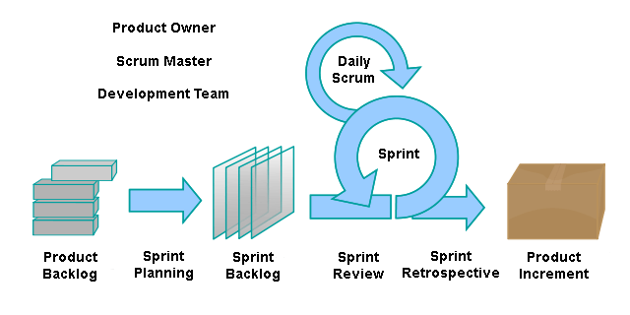

Figure ## - Agile Methodology

*Figure 17*

### **3.2.3 Analyze and design Approach.**

Object Oriented Design approach is followed because it’s easy to understand and reusability of code. OOD avoids complication of the system .And also it reduces the development time.OOD increases the quality of the application naturally it has modular design. Therefore we use OOD techniques to code reuse.

### **3.2.4 Programming Methodology**

Object Oriented Programming approach will be used during the development process as it allows reuse components. As an example react native is a UI library which consists of tons of components. So these components can be reused literally anywhere in the code. In order to do that these components need to be exported. It will increase the quality of the code as well as the readability.

### **3.2.5 Testing Method**

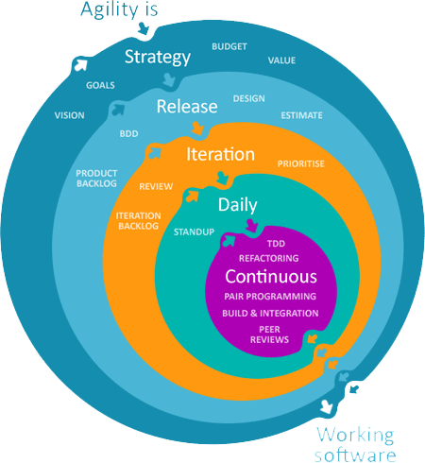

### **3.2.6 Project Management Method**

### **3.2.7 Data Gathering Method.**

Following data collective Methods declared to be appropriate for the project.

Questionnaire : Sending questions to target people who are currently starting their farming process and if this application is helpful to them. And collecting necessary information from them.

Interview - The experience of every farmer plays a vital role in this project. Every experienced farmer would’ve come across several types of barriers and would have gained a lot of experience. Contacting them in person can help to feed this project with relevant information.

Document analysis - Similar research has been done in different countries and is also being taken into consideration.

Surveys - conducting surveys among farmers, modern farmers, and those who are willing to farm.

# **3.3 Constraints**

Project constraints are needed to be identified and considered,if not it might cause difficulties completing the project. because of that, those should be properly addressed to ensure the success of the project. The following constraints are identified in the project.

* Since the research area is quite heavy, time limitation is a constraint due to deadlines.
* Lack of knowledge of how to use machine learning methods on collected data.
* Due to the pandemic getting data from a resourceful person like a farmer is more limited.

# **3.4 Communication Plan**

Due to Current (2020.2021) Pandemic situation Team members asked to Communicate via Online Platform Microsoft Teams .

# **3.5 Risk and Mitigation**

|  |  |  |  |  |
| --- | --- | --- | --- | --- |
| **No** | **Description** | **Impact** | **Probability** | **Mitigation action** |
| R1 | Lack of knowledge in technologies | High | High | Getting advice from tutors and self-studying. |
| R2 | Getting Sick / Affected by Coronavirus | High | High | Taking safety precautions and maintaining good hygiene practice. |
| R3 | Technical issues while holding meetings | Medium | High | Informing earlier, postponing the meetings |

Table 6 Risk and Mitigation

# **3.6 Chapter Summary**

This Chapter gives a good view on data gathered requirements and methodologies we used in this application. Briefly explain about the Risk and mitigation circumstance of our project. Communication plan and constraints of the project we thoroughly discussed about these all factors in this chapter.

**Chapter 4 – System Requirements Specification (SRS)**

**4.1 – Chapter Overview**

This chapter describes the algorithm that was observed to be suited to our project and what role it plays in this project. This chapter is about the Software Requirement System which discusses the use-case diagram, programming view through the class diagram, and onion model of the system. And also this chapter goes through stakeholders, requirements that are functional and non-functional along with the project. The functionalities this system offers.

# **4.2 Stakeholder analysis.**

# **4.2.1 Onion Model**

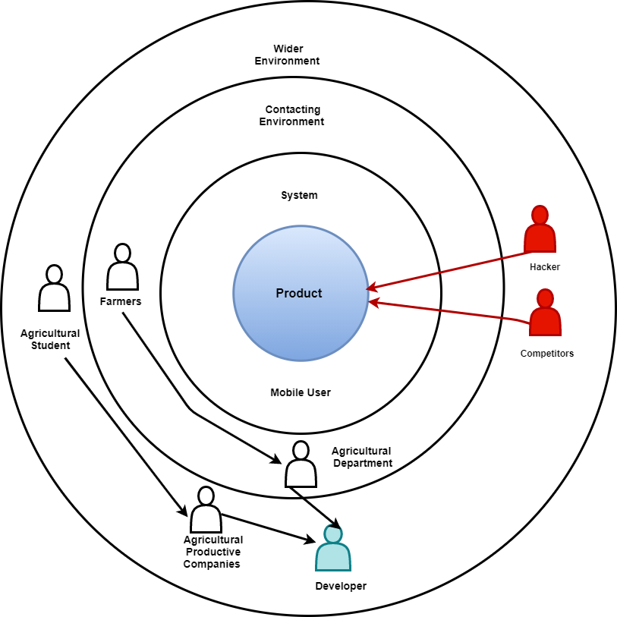

*Figure 18:*Stakeholder diagram for prediction

The above diagram is illustrating the onion model of the Crop prediction system. All the stakeholders are discussed in stakeholder analysis.

**4.2.2 Stakeholder Analysis**

|  |  |
| --- | --- |
| **Stakeholder** | **Viewpoint** |
| Farmers and DoA | Use the system easily and navigate to the page easily.  Can select the language which they are fluent in. |
| DoA | The latest data regarding crop cultivation will be available for relevant authorities. |
| Agricultural Student | Gain new knowledge from the application advice to farmers to use the app teaching the process of the application. |
| Agricultural productive companies | Get advantage from the application and helps to farmers in the crucial time and |
|  |  |
|  |  |
|  |  |
|  |  |

Table 3 Stakeholder Analysis

**4.3 Requirements Gathering**

Requested Help From DoM , DoA and WFP and successfully gained great support from them,

As this project is dealing with weather which is updating day to day , It is Mandatory to gain relevant data and update to the database. To create a crop calendar for each season (YALA / MAHA) Regular Crop Calendar Format from DoA is needed but our project deals with both DoA and DoM. The help from both ends is most needed.

**4.3.1 Techniques for requirements gathering**

Literature Review Technique - Using this technique trying to understand the Similar systems and what are the lacking parts of those and what should be added to be more convenient.

Questionnaires - Using a questionnaire to get the ideas of farmers and stakeholders what they expect and get the ideas to develop the system for more effective use

Interviews - By conducting interviews with farmers and interested parties try to get accurate details and information on the technical side as well as expectations.

## **4.3.2 Questionnaire design**

The first survey consisted of 5 Multiple Choice Questions. The aim was to survey with at least 50 farmers inside and outside the country. It requires at least 5 minutes of their time. Farmers who are unable to fill google sheets are asked to give an interview with the same 5 questions.

For the farmers who are outside the countries, there are few more questions asked to see the difference in patterns between them and us.

# **4.4 Analysis of gathered data.**

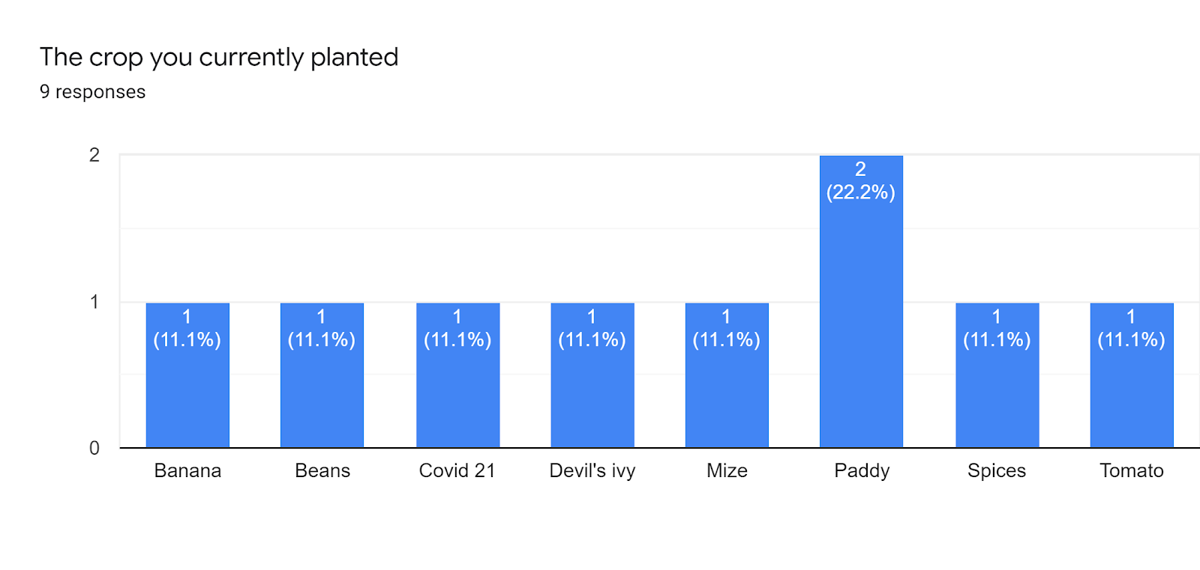

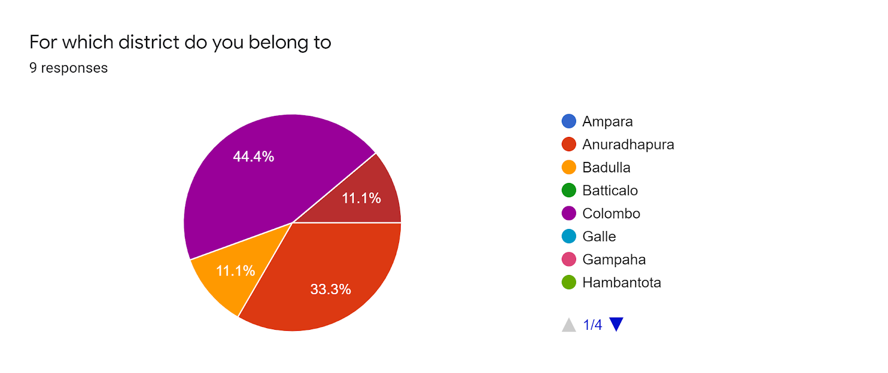

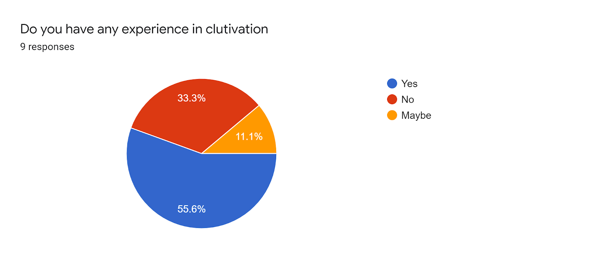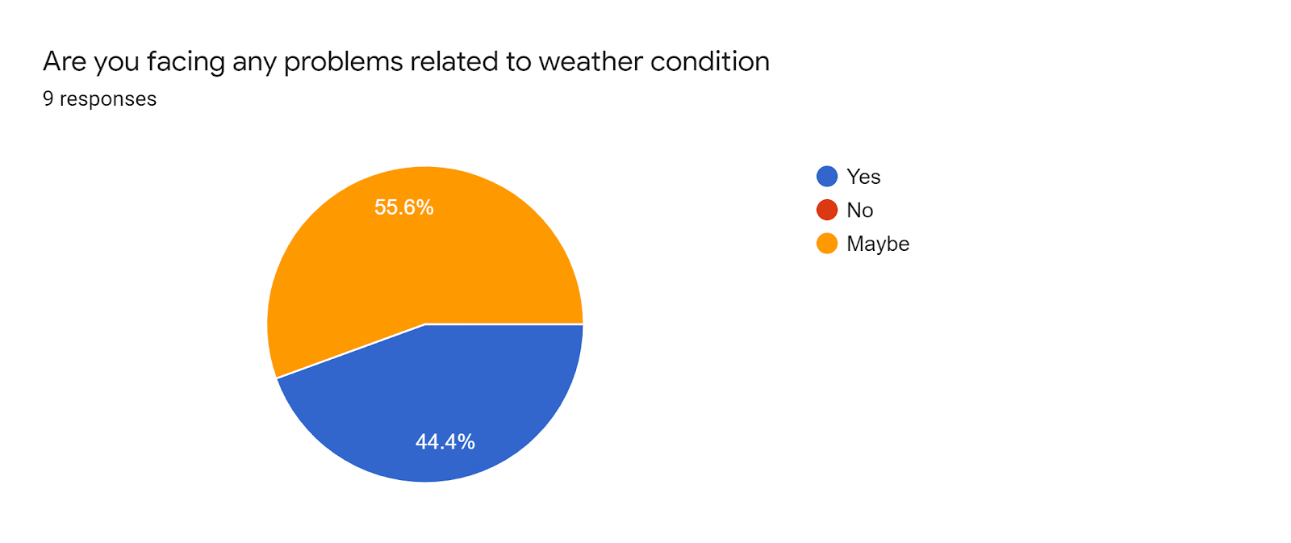

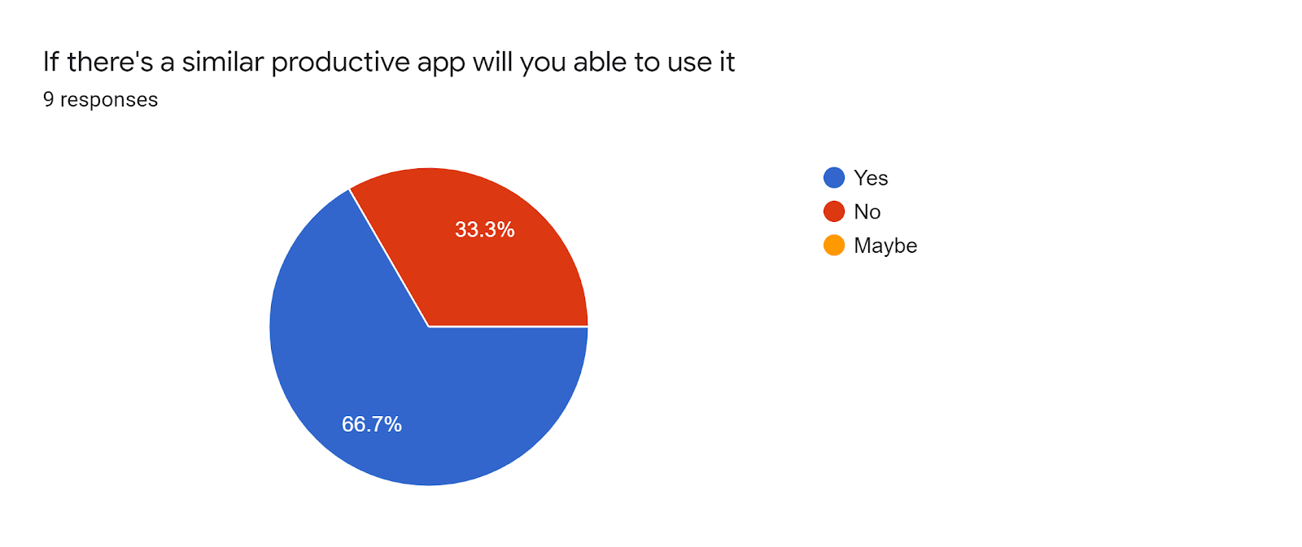

## **4.4.1 Feedback questionnaire**

From the feedbacks the threats which affect cultivation is not only flood but also insects, not uniformly raining, sudden climatic changes also been considered as a major barrier. Farmers are eagerly expecting some ways to gain more profit from fewer investments. In the future, if there is a suitable crop prediction to gain more profit because if they know a crop is going to be in demand in the future, in a way it can be very much appreciated by them.

# **4.5 Models**

## **4.5.1 Use case diagram.**

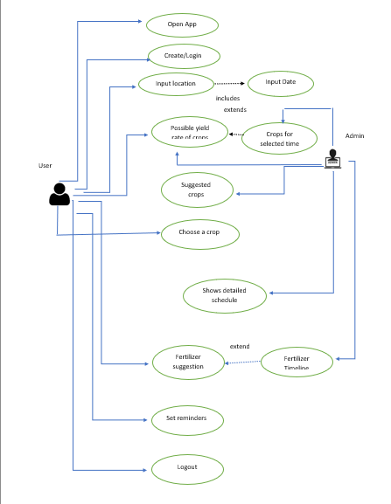

Figure 19 : Use Case Diagram

The user is the primary actor who operates the system functionality. User login to the app and he/she input the data according to their requirements. Admin is a secondary actor who gives crop suggestions, yield rate for crop according to the selected time, and showing the detailed schedule of the crop.

## **4.5.2 Use case descriptions**

|  |  |
| --- | --- |
| Use Case Name | Crop Prediction System |
| Description | The use case diagram describes how a user operates the app, gives input to it and how the admin gives output for the condition, which is required by the user, with the help of a backend algorithm. |
| Primary Actor | User |
| Secondary Actor | Admin |
| Entry Condition | The user should have a valid phone number or mail address and he/she should create a new valid password for this app to log in. |
| Main Flow | **Actor**  1. User opens the web-app.  2. He/she created an account in this app.  3.User input the date and location for cropping.  **System**  1.App then finds out which crops are available for the chosen region and the date input by the user is a proper time to start the cultivation.  2.Backend algorithm gives the approximate yield rate for the crops.  3.App shows the resulting crops with their predicted yield rates, in descending order to choose the crop by the user.  4.App shows the procedure of cropping throughout the cropping season. |
| Sub Flow | **Fertilizer Suggestion**  1. User clicks “Fertilizer Suggestion” button,  2. App shows a detailed fertilizer suggestion as to when, how much fertilizer should be applied according to the crop.  3. Setting Reminders  1. When the user logs out of the system.  2. App shows the remainder when the seed sowing day, when should apply fertilizer, and final cultivation of the specific crop. |
| External Flow | The app will give these reminders from time to time to the user. |
| Exceptional Cases | Internet connections are lost while the user is using the app, hackers can hack. |

Table 4 Use Case Analysis

# **4.6 Functional requirement**

We analyzed the requirements for our crop prediction app. Requirements are functional and non-functional requirements.

The priority level ‘C’ is replicating that it is critical without this requirement it shows bugs, ‘I’ replicate to it is an important factor that adds value to the application and ‘D’ replicates to desirable.

|  |  |  |  |
| --- | --- | --- | --- |
| **Functional Requirements** | | **Level of Requirement** | **Description** |
| FR1 | PC / Laptop/Smartphone | C | This is a web-app. So, users should need devices. To get our service accurately. |
| FR2 | User Authentication | C | Authenticated access can operate the app.  To avoid risk from hackers and outside users. |
| FR3 | Security | D | Security for this web-app is a must. Someone being able to hack this  The web-app can create a problem. Our goal is to build the application and store data in such a way that even anyone can't hack it. |
| FR4 | Decision | D | Decision making can be regulated by user preference. |
| FR5 | User Issues | I | It can be in vary |
| FR6 | Translator | D | Information is translated to both languages Sinhala and Tamil. |

Table 5 Functional requirement

# **4.7 Non-functional requirements**

**NR1 - Performance -** Data processing speed should be fast.

**NR2 - Usability -** The system user design and user experience have to be good and user friendly.

**NR3 - Reliability** - When the web-app is crashed should be able to recover quickly and crashed details given to the user can create a positive impact on the application.

**NR4- Accuracy** - Multiple users can log in to our application in different milliseconds. The application should be ready to handle this high traffic efficiently.

**NR5 - Availability -** The application available all the time.

**NR6 - Security -** The application is secured and authentication is provided by proper login credentials.

# **4.8 Chapter Summary**

The chapter gave a good knowledge of the project methodologies and the model that are related to this system. This chapter shows the feedback of the questionnaire and interview, Weather our project is suitable and demand full to users and we have got some ideas to implement our project. This Chapter is about Software Requirements of System.

**Chapter 5 – Design**

## **5.1 – Chapter Overview**

This chapter describes the design of the solution requirements which we identified in previous chapters.It provides detailed procedural flow of information.This chapter also elaborate on the high level architecture of the system and UI mockups. Chapter shows that solutions are achieved practically.

## **5.2 – High level Architecture Diagram**

## 

## **5.3 – Class Diagram**

## 

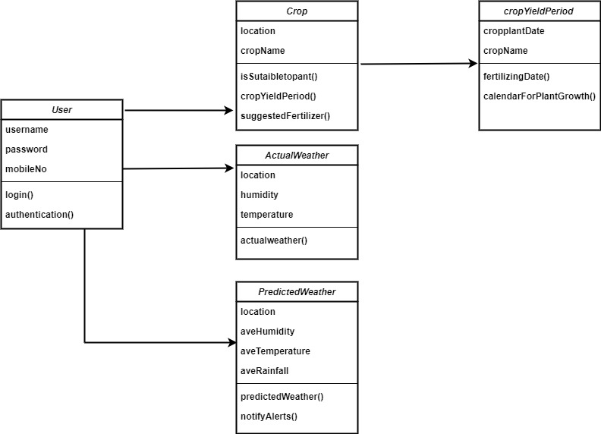

## **5.4 – Sequence Diagram**

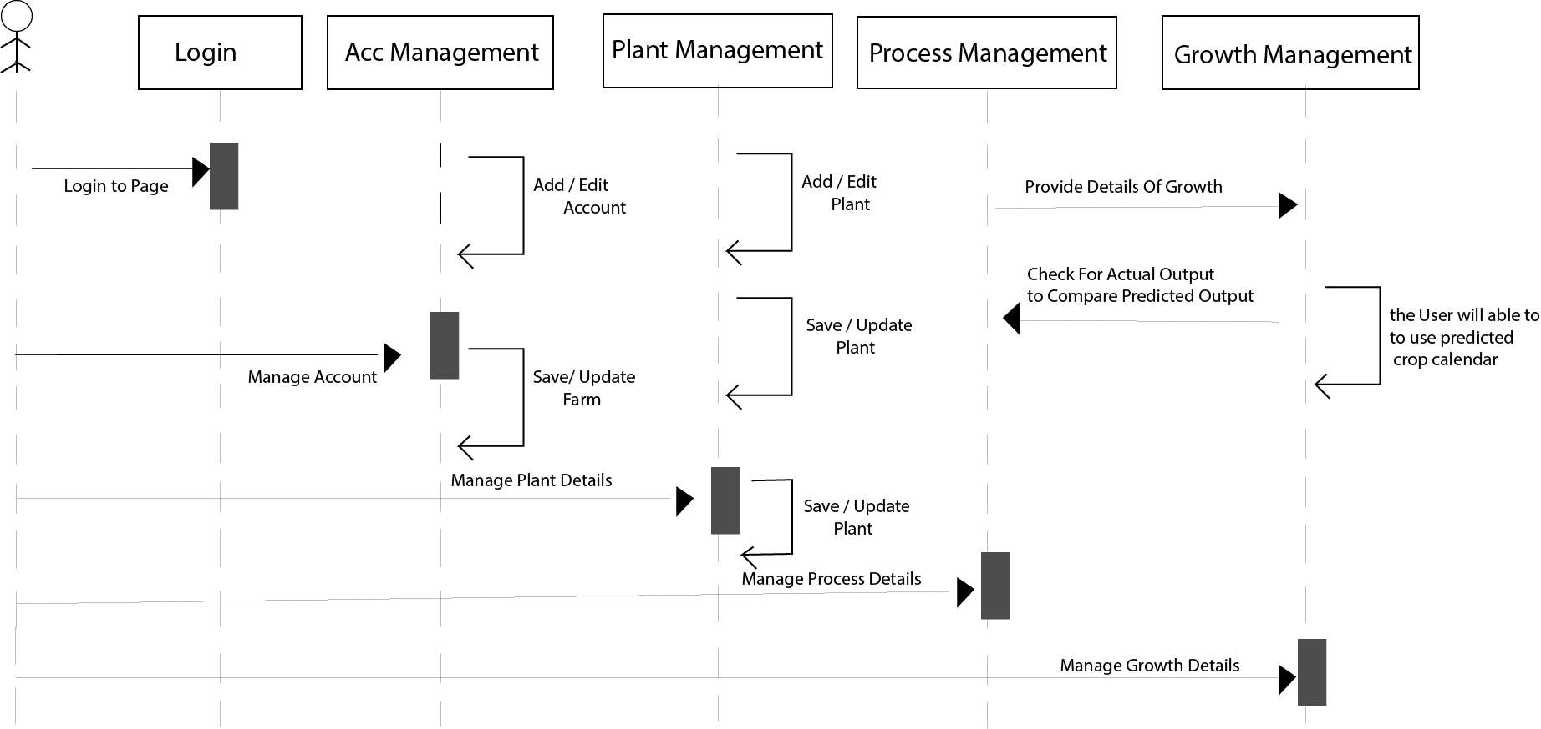

## **5.5 – Activity Diagram**

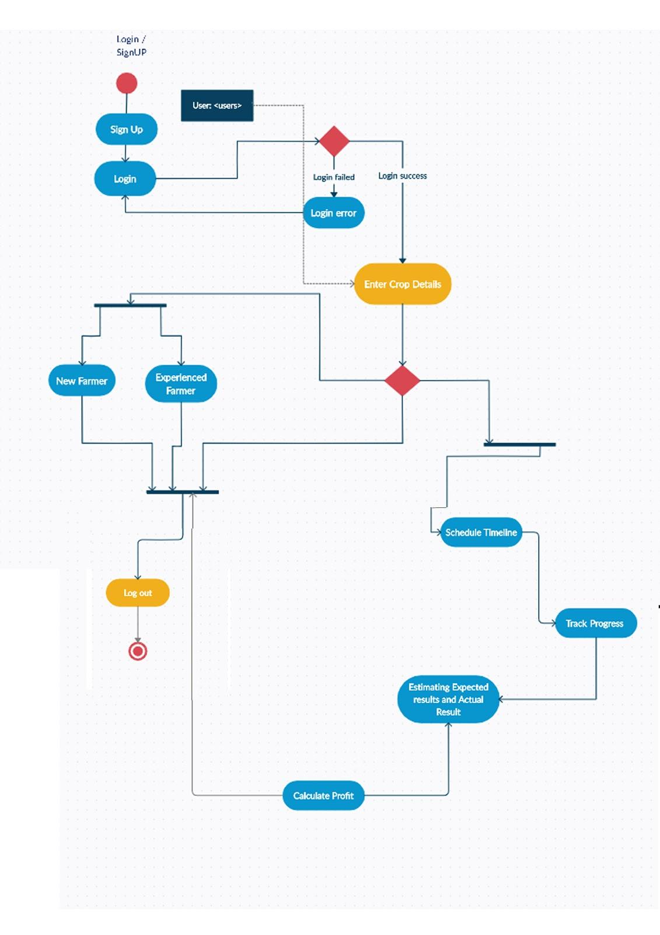

## **5.6– Wireframes**

Home Page -

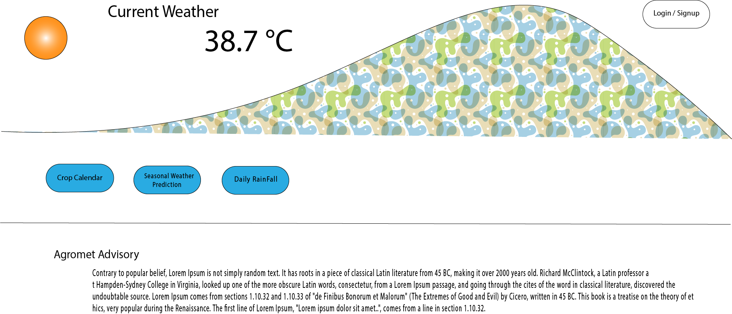

User’s Region

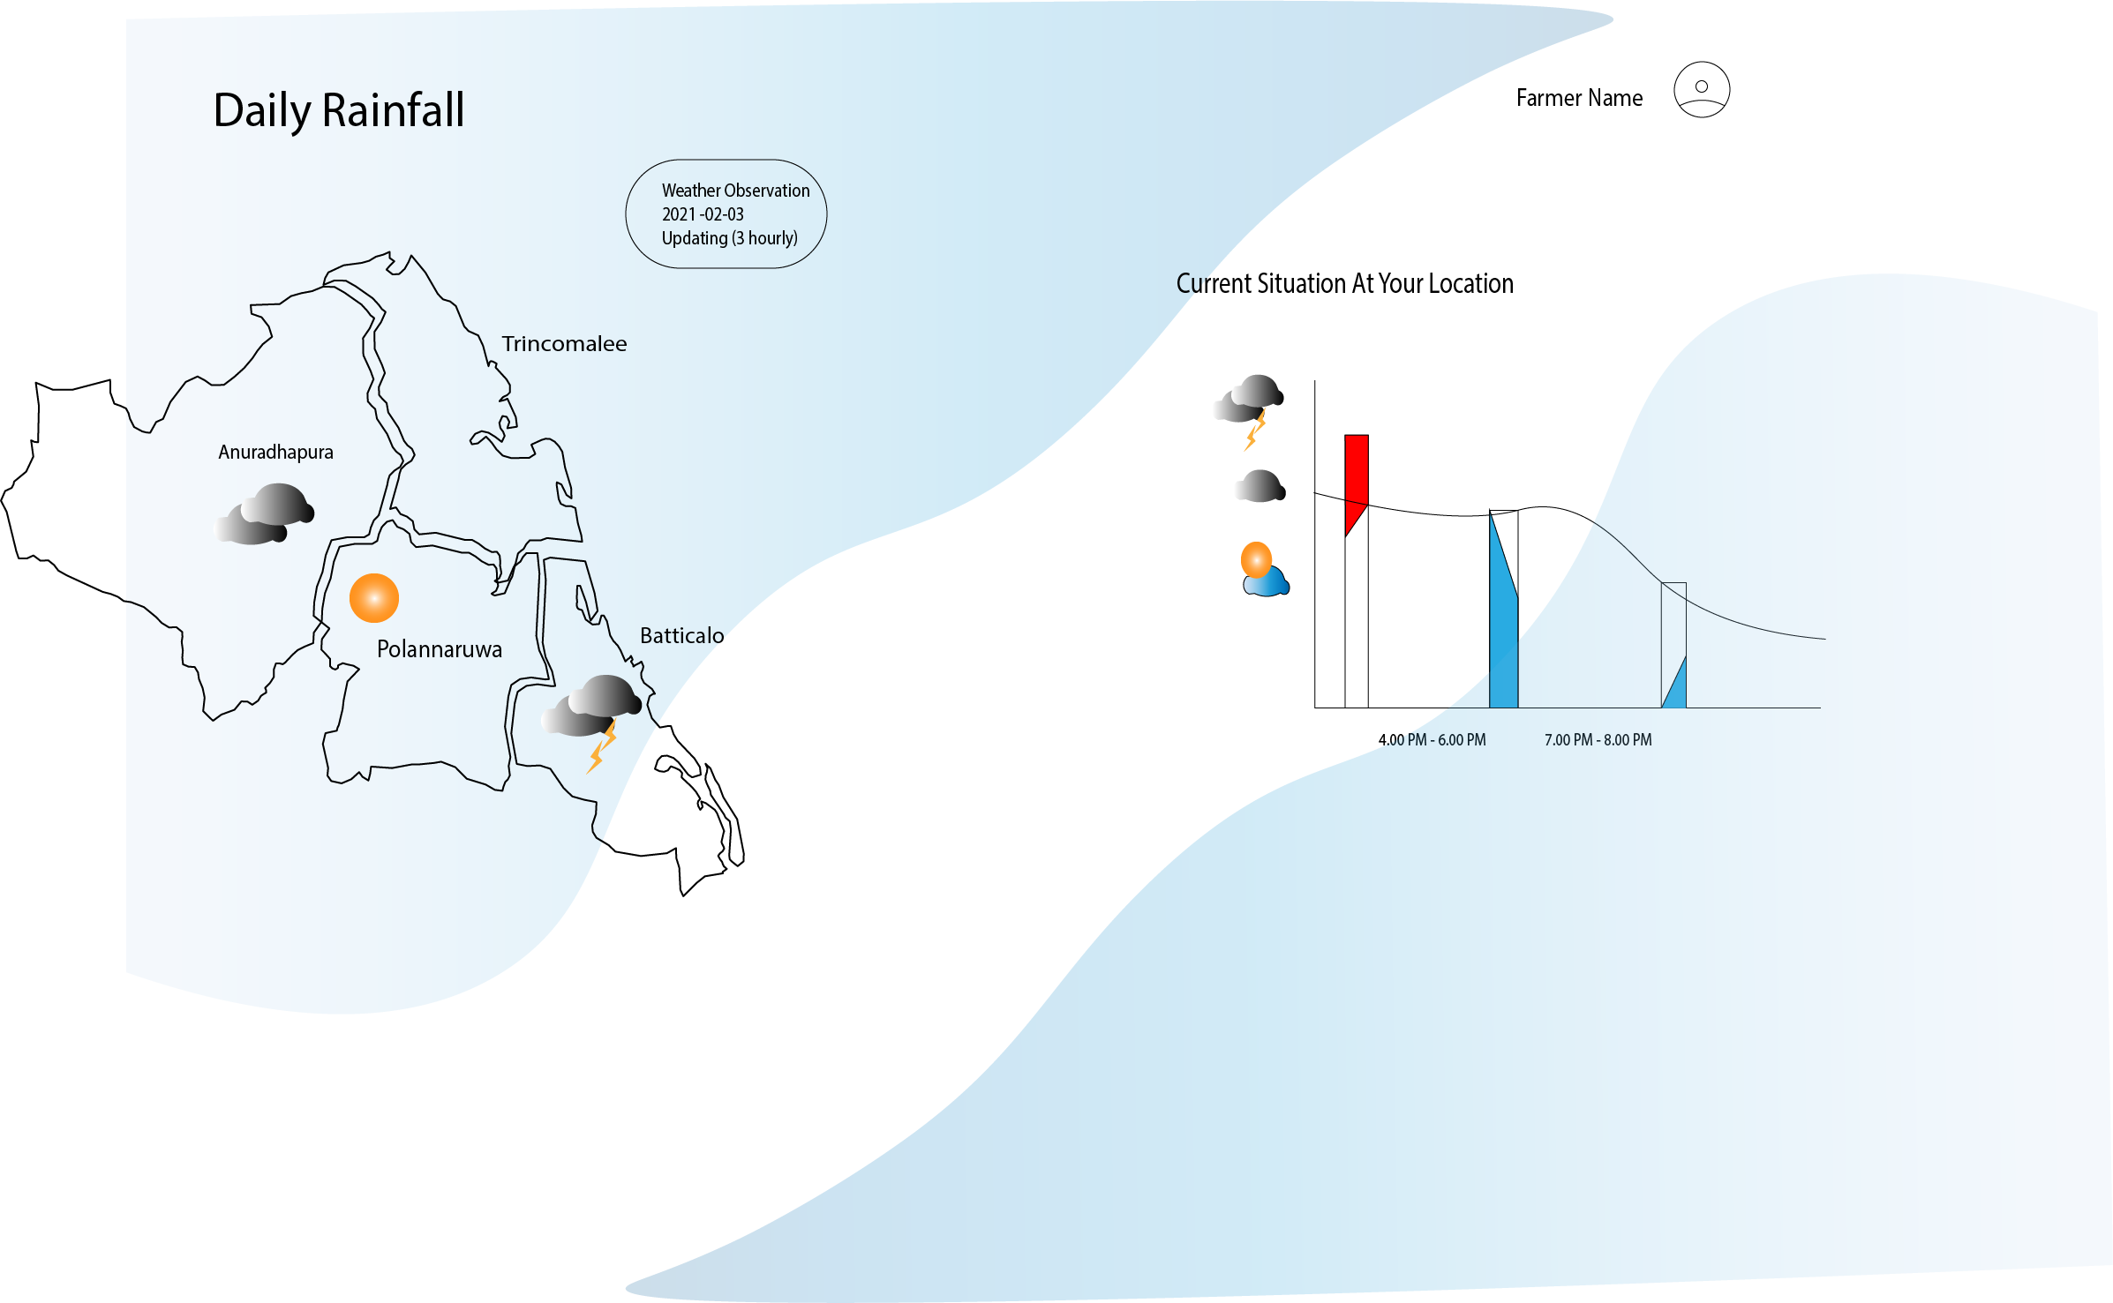

Page 3 -Generated Crop Calendar

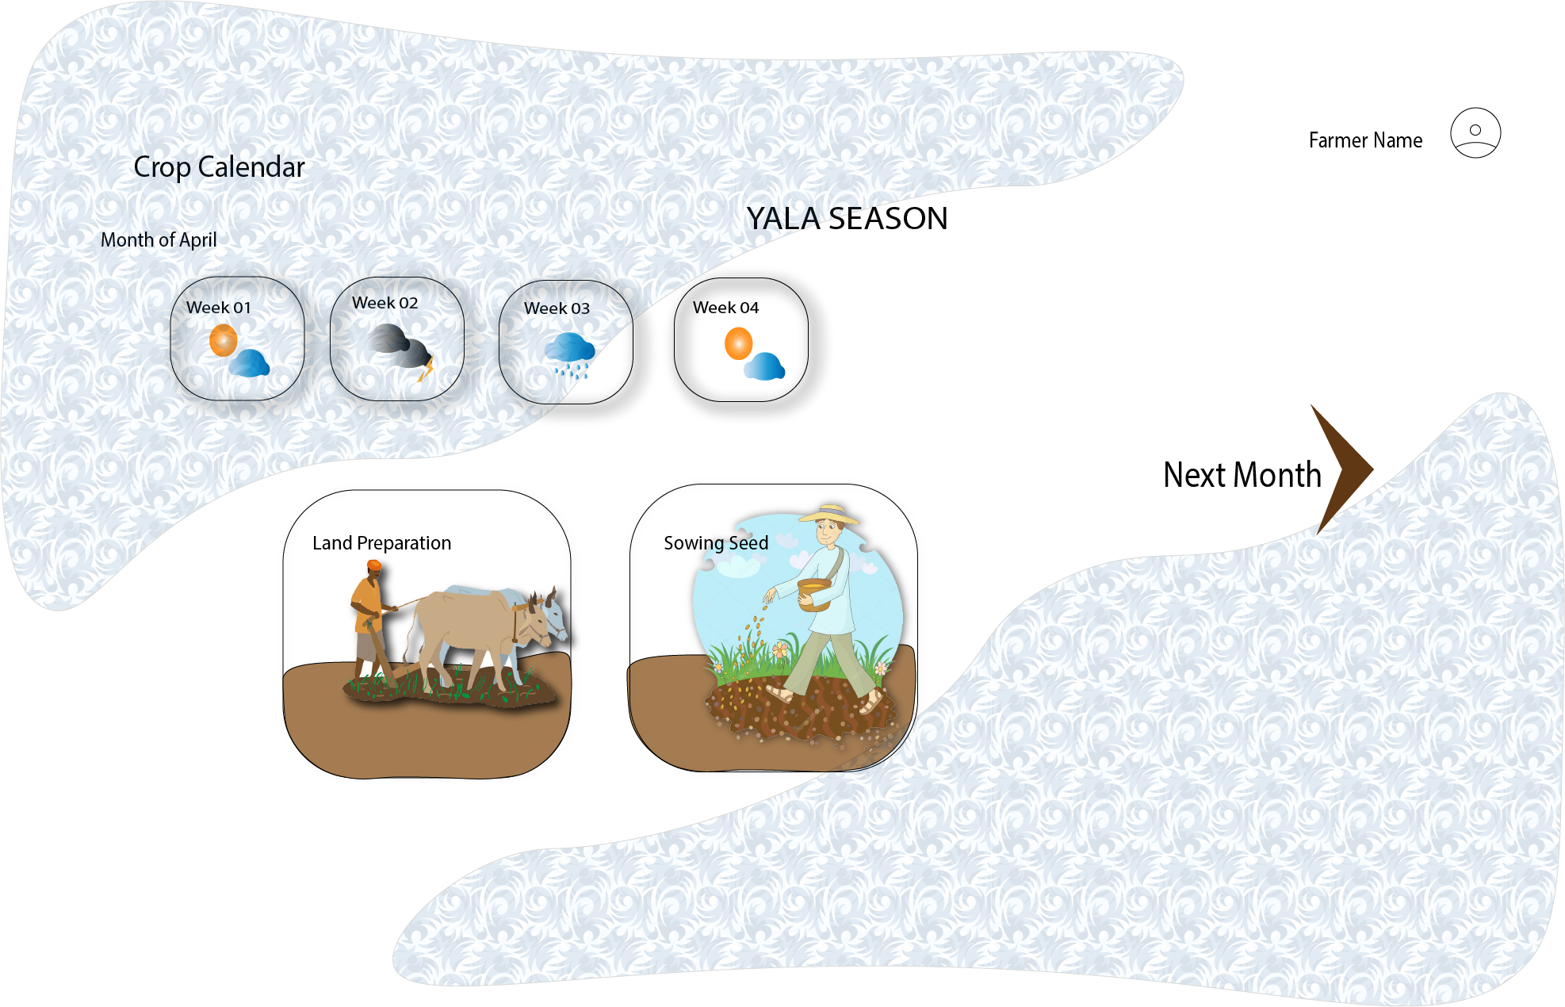

**5.7 – Chapter Summary**

This chapter elaborated the high and low level architecture of the project and also briefly explained about high level architecture , class diagram, activity diagram and sequence diagram.

Next chapter mainly focuses on implementation. We initiated the implementation through wireframes and UI design in this chapter. How each component was built we encountered the challenge and we made a solution do our project.

# **Reference**

World Food Program, U. N. (2019). Climate and Food Security Monitoring Bulletin. *Climate and Food Security Monitoring Bulletin*, 1–20.www.wfp.org/publications/sri-lanka-climate-and-food-security-monitoring-bulletin

Cost of Cultivation, Agricultural Department of Sri Lanka,

WFP Sri Lanka - Food Security Atlas: Livelihoods, Food Security, and Resilience

Sri Lanka – Climate and Food Security Monitoring Bulletin for the Maha (primary) Harvest Season (2019-2020)

DOA Crop Forecasting 2020, 2020, Crop Forecasts of Sri Lanka

DOISE Karnataka - 2020, Analysing of Crop Yield Prediction Using Data Mining Techniques, Ms.Fathima, Ms. Sowmya, Ms. Sunita Barker, Dr.Sanjeev

Edureka - KNN Algorithms, 2020, KNN Algorithm: A Practical Implementation Of KNN Algorithm In R, Zulaikha Latif.

(Yan X and Su X G(2009). *Linear Regression Analysis: Theory and Computing* [Online], Singapore;

World Scientific Publishing, Available from; Google Books [accessed 21 November 2020])

Antwi-Agyei, P., Dougill, A. J. and Stringer, L. C. (2015) ‘Barriers to climate change adaptation: evidence from northeast Ghana in the context of a systematic literature review’, *Climate and Development*, 7(4), pp. 297–309. doi: 10.1080/17565529.2014.951013.

Gbetibouo, G. A. and Hassan, R. M. (2005) ‘Measuring the economic impact of climate change on major South African field crops: A Ricardian approach’, *Global and Planetary Change*, 47(2-4 SPEC. ISS.), pp. 143–152. doi: 10.1016/j.gloplacha.2004.10.009.

Gregory, P. J. *et al.* (2009) ‘Integrating pests and pathogens into the climate change/food security debate’, *Journal of Experimental Botany*, 60(10), pp. 2827–2838. doi: 10.1093/jxb/erp080.

Lanka, S. (2013) *ISAE 2013 Agriculture and Environment 2013*, *Proceedings of the International Symposium on Agriculture and Environment 2013*.

Lee, S. *et al.* (2012) *E-Agriculture in Action: Big Data for Agriculture*, *Journal of Chemical Information and Modeling*. Available at: http://dx.doi.org/10.1016/j.tws.2012.02.007.

Olatinwo, R. and Hoogenboom, G. (2014) ‘Weather-based Pest Forecasting for Efficient Crop Protection’, *Integrated Pest Management: Current Concepts and Ecological Perspective*, (October 2017), pp. 59–78. doi: 10.1016/B978-0-12-398529-3.00005-1.

Panabokke, C. R. (1996) *Soils and Agro-Ecological Environments of Sri Lanka*, *Natural Resources, Energy and Science Authority of Sri Lanka*.

St.Clair, S. B. and Lynch, J. P. (2010) ‘The opening of Pandora’s Box: Climate change impacts on soil fertility and crop nutrition in developing countries’, *Plant and Soil*, 335(1), pp. 101–115. doi: 10.1007/s11104-010-0328-z.