**Web Application Development: Project 1**

**Project 1: Document**

Student names: Luis Humberto Rubio Valenzuela (ID 0222339)

Saranienke Calderon Hohmann (ID 0226427)

Teacher: Gabriel Castillo

Due date: September 13, 2021

Word count: 669 words

**Development log:**

**Friday 10:**

* **Navigation Bar:**
  + For the navigation bar we used a header that had the following classes:
    - d-flex
    - flex-wrap
    - justify-content-center
    - border-bottom
    - (for the rest of the document we are not going to mention things like the padding py or px classes)
  + The navigation bar contained two things:
    - An img tag (our logo) and one h2 tag (Our website’s name)
    - A list with the class “nav-pills”



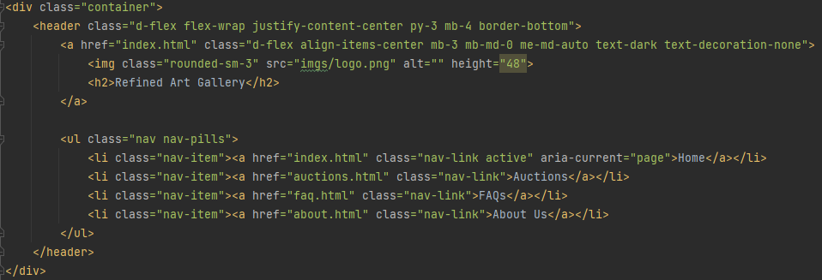

* **“Welcome Message”**
  + For the welcome message we used the following:
    - An h1 tag for the big bold message.
    - A div with a col-6 for the text and buttons
    - Another div for the image that is below the buttons
  + The two buttons were created using the classes btn-primary and btn-outline-info respectively

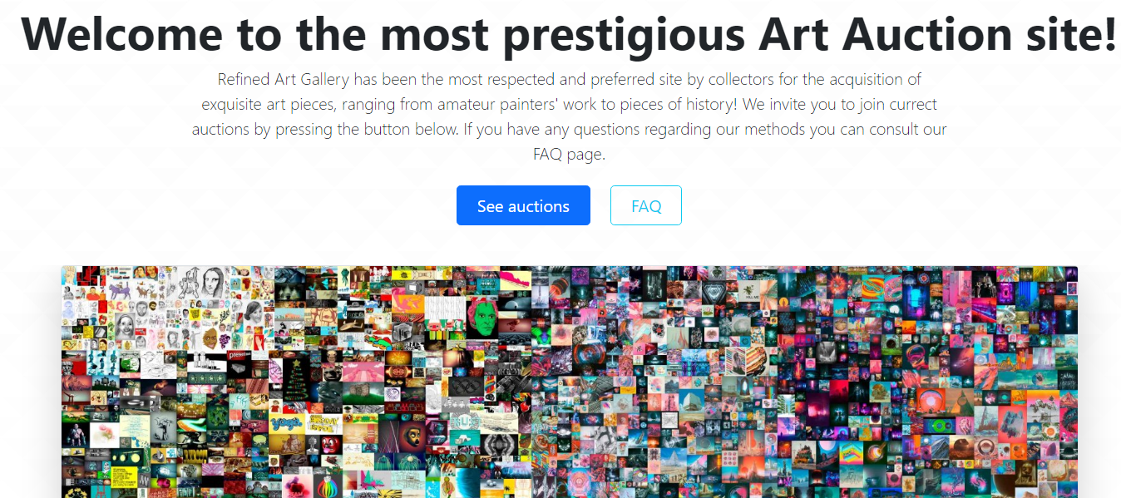

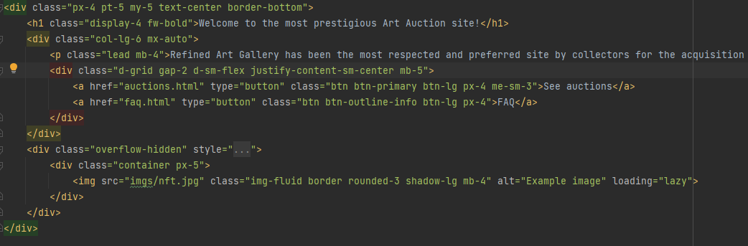

* **Question Submitter**
  + For the question submitter we used a row with two cols of lengths 7 and 5 respectively.
  + For the submitter we used two divs with the form-floating class and they contained each one input tag with the form-control class
  + The text part really explains itself
  + The button is simply a button with the btn-primary class.
  + For the small text we used a small tag with an hr tag to separate.

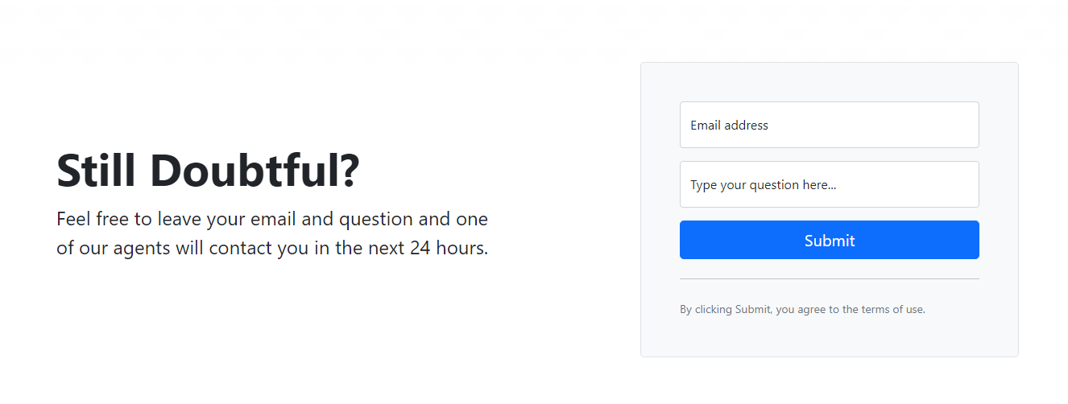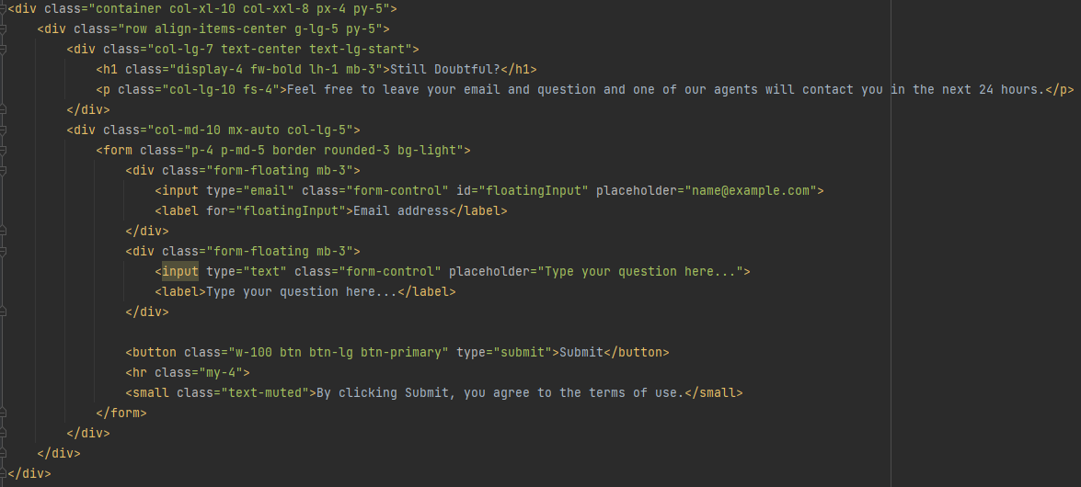

* **Footer**
  + For the footer we used 6 rows with two columns each
  + Nothing fancy

**Saturday 11:**

* **About Us**
  + For the about us we simply used the “featurette” class combined with two columns of length 7 and 5 respectively, one for the text and one for the image.

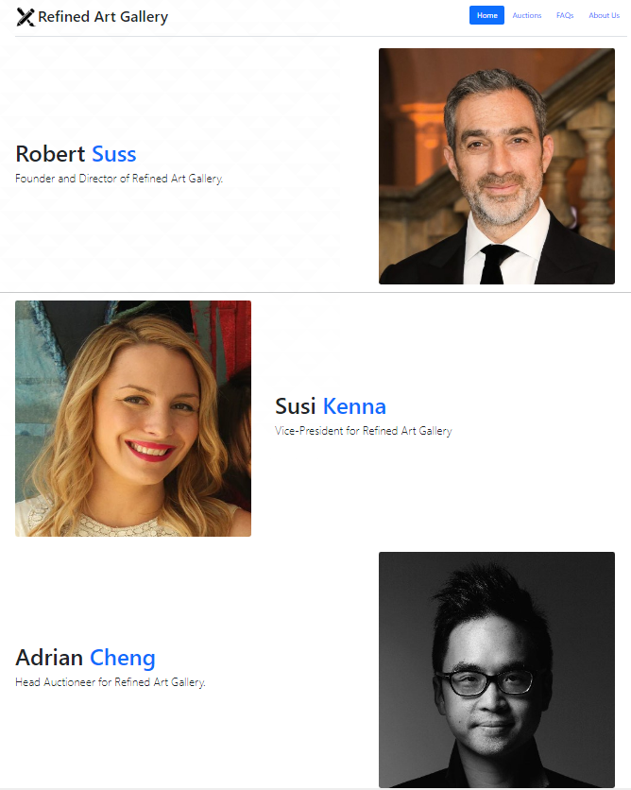

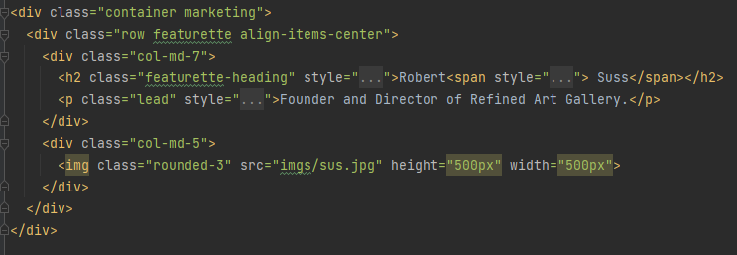

* On Saturday we did the auctions page, where you can see a picture of each artwork, the number of people interested, and you can click in each artwork and get more information about it and the painter
  + Each “card” consists of a row with two cols with length of 7 and 4 respectively.
  + The image was “cut” on purpose using the overflow-hidden class.
  + For the icon of the “people interested” we used a svg provided by bootstrap.

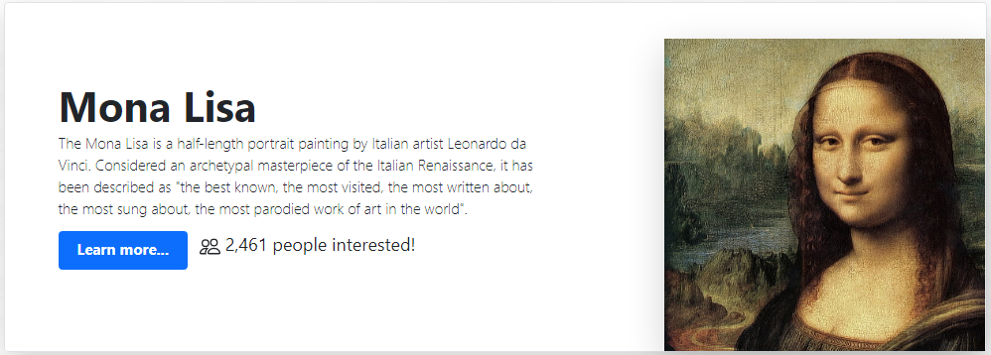

* **Painting info and bidding pages**
  + Each painting had its own page that had both info about the painting and the author. The page also included the last bid price and a button to bid.
  + How we made this is really similar to how we made the auctions page before.
  + The SVG we used this time is a coin.

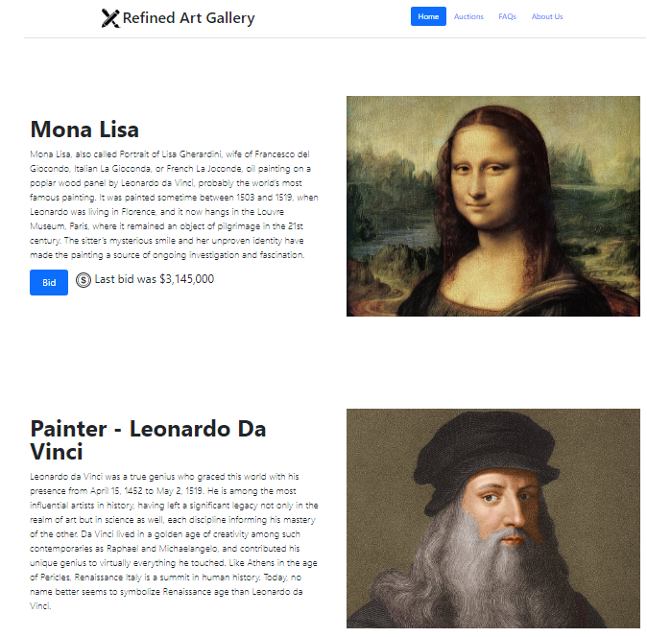

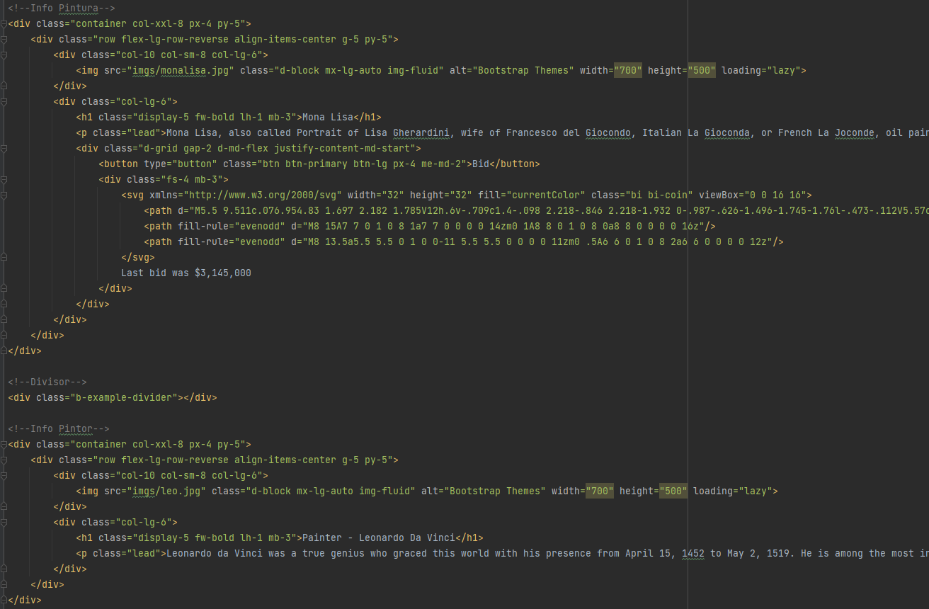

**Sunday 12:**

* **FAQ**
  + For the FAQ we used a 2 rows x 4 cols grid and filled it with questions that could be the most asked.
  + Nothing too fancy.

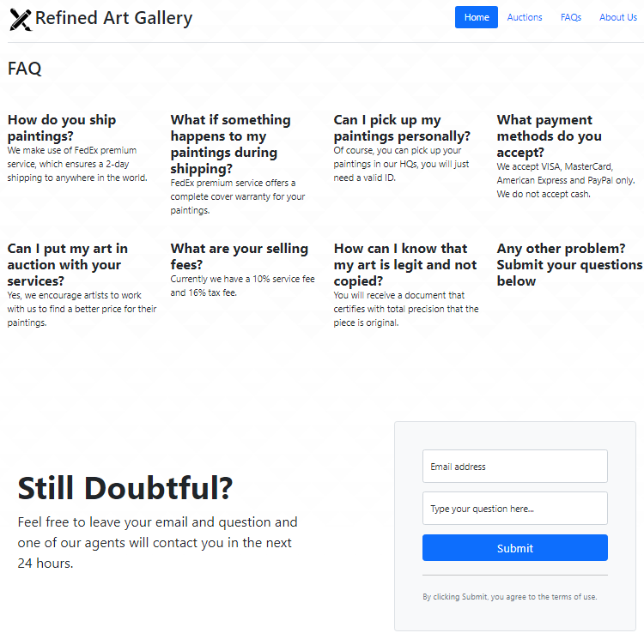

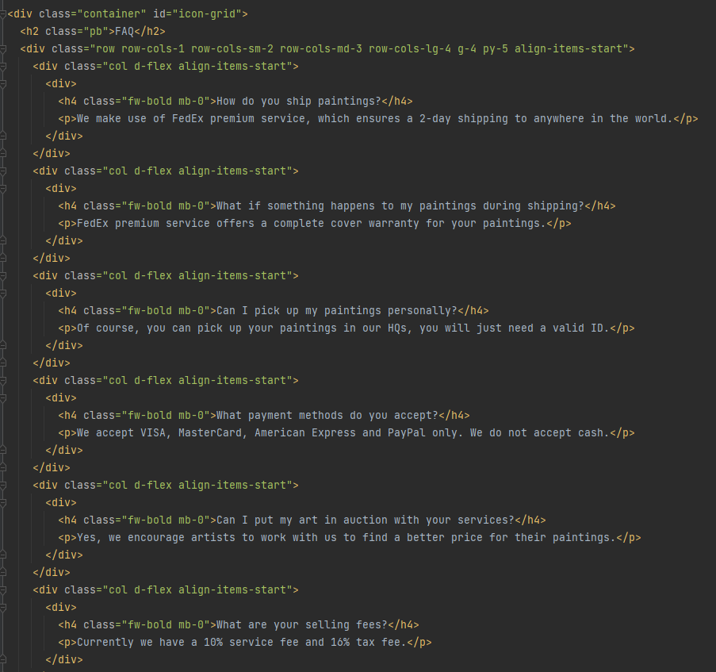

We finished the FAQs page where you can see the most asked questions, and you can also submit your question entering your Email address. This was the easier part because we used the code, we did the day we started the project.

The same day we checked that all we did was okay, and we add some details as the icon and the titles, that was the easiest part.

**Personal project log:**

**Saranienke Calderon**: I made the FAQs page, and to add the submit I used the code my teammate did in the first part of the code. I also made the about us page. I added all the information of the painter and artworks. I put the icon and titles in all the pages. I liked the auctions page; I think it looks professional.

**Luis Humberto Rubio Valenzuela**: I made all the general design of the website (navigation bar, footer and general design) and I populated the *Home* and *Auctions* pages. I personally liked the design I did but when I think about it, maybe it is not the best fit for an art website. From Saranienke’s work, I liked the grid style FAQ she did, I think the About us page could’ve been a bit better.