

# SCHOOL OF INFORMATION TECNOLOGY AND ENGINEERING

**FOOD HUNT**

# Done by 18BCA0005- A. GIRIDHARAN

**18BCA0033- VANDEMATARAM.J**

**18BCA0032 – SARANKUMAR.B**

**For the course**

**Course Code: Object Oriented Programming Course Name: ITA3001**

**Semester: Fall 2019**

**Content**

|  |  |  |
| --- | --- | --- |
| **Sno.** | **Topic** | **Page Number** |
| **1** | **Abstract** | **3** |
| **2** | **Introduction** | **4** |
| **3** | **Architecture Diagram** | **5** |
| **4** | **Sample code** | **6** |
| **5** | **Screen shot** | **27** |
| **6** | **Conclusion** | **30** |

**ABSTRACT**

The Food Hunt system provides service to choose different food menus from various restaurant that are available in our service. Each individual user has an own account in order to sync the previous history of his/her own usage. The users have lot of category in the menu such as Chinese, tandoori, regional cuisine etc. According to the food chosen, the restaurant is displayed. System provides payment with different options such as COD (Cash on delivery), Net banking, Mobile wallet and cards. The service feedback is also received from the user after the purchase and payment. All the account details are stored in database (Mysql), those details are fetched every time when the user logins. All the account details are stored in database (Mysql), those details are fetched every time when the user logins.

# INTRODUCTION

Food Hunt is integration of modules, different modules possess different process and each have different way of working method. Modules such has order intake, choose restaurant, order info, payment, receipt, and feedback.

Order intake is the process of taking down the order from the users. We leave dropdown menu with different types cuisines like Italian. Indian, Chinese, western, beverages, dessert. When a user chooses one particular food style, we list of food dishes under that food style. Each restaurant has a certain special style deliver a particular food style. So, when user selects one type of food style the results will be shown according to the rating on that style from the previous users. Choose restaurant module can help the user to choose the right restaurant for the right food style. For example, when it comes to western, we will list KFC, McDonalds etc and when it comes to Indian, we will recommend various Indian restaurant. Order info is the list that users have order and selected food for checkout, this module will consist of quantity of food, total amount and various tax that will applied by the system that is said to be service tax.

Payment module is the terminal we list the various payment option such as card, net banking, mobile banking etc. once the payment is done the user will be directed to the receipt. In this module the user can view the receipt for the bill that they have payed, it also provides information about the order summary and total amount that have been payed. After the order and payment, the user have to leave feedback to know our service performance to improve or change the process that the users need to get.

# ARCHITECTURE DIAGRAM

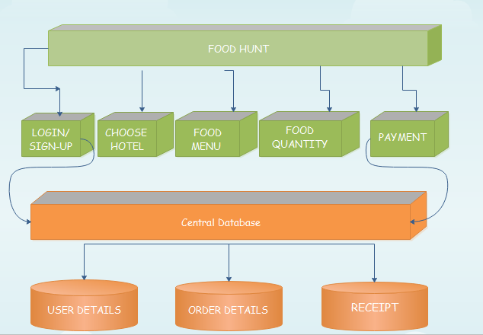

**SAMPLE CODE**

#include <iostream> #include<conio.h> #include<windows.h> #include<mysql.h> #include<sstream> #include <time.h> #include<string.h> using namespace std;

stringstream ss,table;

MYSQL* conn; MYSQL_ROW row; MYSQL_RES* res;

int flag=0; char

foo1[50][20]={"Idly","Dosa","Pongal","Vadai","Poori","Tea","Coffee","Milk","Jam mun"};

char foo2[50][20]={"Sambar Rice","Rasam Rice", "Curd Rice", "Meals", "Mini Meals", "Veg Briyani" , "Thum Briyani" , "Tomato Rice", "Lemon Rice"};

char foo3[50][20]={"Fried Rice","Paneer Rice","Gobi Rice","Mushroom Rice"," Parota"," Dosa"," Noodles" ,"Chappathi" ,"Curd Rice" };

char foo4[50][20]={" Parota","Chappathi","Tea","Coffee","Boost","Moltova","Complain"," Black Tea","Jammun" };

char foo5[50][20]={"Idly"," Dosa "," Pongal", "

Vadai","Poori","Tea","Coffee","Milk","Jammun"};

char foo6[50][20]={"Chicken Briyani","Mutton Briyani","Fish Briyani","Veg Briyani","Veg Meals","Veg-Mini Meals","Non-Veg Meals","Non-Veg Mini Meals","Fish Fry","Chicken 65" ," Mutton 65"," Sweet corn Soup"};

char foo7[100][50]={"Fish Fry","Chicken 65","Mutton 65","Dragon Chicken","Chilly Chicken","Chilly MUtton","Mushroom Fry","Gobi Manchurian"," Panneer Finger","Sweet corn Soup"," Mushroom Soup","Baby Corn Soup "," Ginger

Garlic Soup ","Pepper Garlic soup "," Aatu Kall Soup ","Chicken Soup"," Fried Rice ","Paneer Rice","Gobi Rice "," Mushroom Rice"," Egg Fried Rice ","Schwan Chicken Rice "," Mutton Rice "};

char foo8[50][20]={" Parota","Chappathi","Tea","Coffee","Boost","Moltova","Complain"," Black Tea","Jammun" };

char f[50][25],h[10][25],food[50][20];

int cost1[30]={30,45,35,5,40,10,12,10,15};

int cost2[30]={40,40,35,80,50,55,75,40,40};

int cost3[30]={80,95,95,95,25,45,85,25,35};

int cost4[30]={25,25,10,12,10,10,10,15,15};

int cost5[30]={30,45,35,5,40,10,12,10,15};

int cost6[30]={100,110,100,80,80,50,120,60,150,90,90,50,50,50};

int cost7[30]={120,90,90,150,130,130,90,90,90,50,50,50,50,80,80,80,95,95,95,95,95,95, 85,100,95};

int cost8[30]={25,25,10,12,10,10,10,15,15};

int setset[50],costtt[50];

int hour,i=0,sets[50],cost[100],c[100],cow=0,kn[50],total=0;

class login

{

private :

string name,phno,email,password,lname,lpassword;//lname login name public :

usersignup()

{

cout<<"\n Sign up ..."; cout<<"\n\n Name : "; cin>>name; cout<<"\n phno : "; cin>>phno;

cout<<"\n email : "; cin>>email;

cout<<"\n password : "; cin>>password;

ss << "INSERT INTO `signup`(`Name`, `Email`, `Phno`, `Password`) VALUES ('"+name+"','"+email+"','"+phno+"','"+password+"')";

string query = ss.str(); int qstate = 0;

const char* q = query.c_str(); qstate=mysql_query(conn, q); if(qstate == 0)

{

cout<<"\n Sign up complete ";

}

else

cout<<"\n Failed to sign up";

}

void userlogin()

{

cout<<"\n User login ";

cout<<"\n\n User name : "; cin>>lname;

cout<<"\n Password : "; cin>>lpassword;

if(conn)

{

int qstate = mysql_query(conn , "select Name,Password from signup");

if(!qstate)

{

res = mysql_store_result(conn);

while(row = mysql_fetch_row(res))

{

if(row[0]==lname && row[1]==lpassword)

{

flag=1; break;

}

else

{

flag=0;

}

}

}

if(flag==1)

{

cout<<"\n Login Successful";

}

else

cout<<"\n User name or Password is incorrect";

}

}

}u;

class restaurants

{

private:

int opt,ch,se,ch1,setta; public:

void hotel()

{

cout<<"\n\t\t\t\t\t Hotel ";

cout<<"\n\t\t\t 1. Saravana Bhavan \n\t\t\t 2. Namma Veedu \n\t\t\t 3. Royal vega

\n\t\t\t 4. The Reef ";

cout<<"\n\t\t\t 5. Chick Inn \n\t\t\t 6. vegie Nation \n\t\t\t 7. Sangam Restaurant

\n\t\t\t 8. Oasis Restaurant";

cout<<"\n\t\t\t 9. Hilltop Towers \n\t\t\t 10. cloud hall ";

cout<<"\n\n\n\t\t\t Enter the hotel : "; cin>>opt;

/*switch(opt)

{

case 1:

h[12][25] = "Saravana Bhavan"; break;

case 2:

h[12][25]=" Namma Veedu"; break;

case 3:

h[12][25]="Royal vega"; break;

case 4:

h[12][25]="The Reef"; break;

case 5:

h[12][25]="Chick Inn "; break;

case 6:

h[12][25]="vegie Nation ";="Fried Rice","Paneer Rice","Gobi Rice","Mushroom Rice"," Parota"," Dosa"," Noodles" ,"Chappathi" ,"Curd Rice" ;

break; case 7:

h[12][25]="Sangam Restaurant"; break;

case 8:

h[12][25]=" Oasis Restaurant"; break;

case 9:

h[12][25]="Hilltop Towers"; break;

case 10:

h[12][25]="Cloud Hall";

}*/

if((opt == 1)|| (opt == 6) || (opt == 7))

{

vegfood();

}

else

{

}

}

nonveg();

void vegfood()

{

if((hour >= 1) && (hour <= 11))

{

cout<<"\n Menu : ";

cout<<"\n 1. Idly \t\t\t\t\t\t RS:30 \n 2. Dosa \t\t\t\t\t\t RS:45\n 3. Pongal

\t\t\t\t\t\t RS:35\n 4. Vadai \t\t\t\t\t\t RS:5\n 5. Poori \t\t\t\t\t\t RS:40\n 6. Tea \t\t\t\t\t\t RS:10\n 7. Coffee \t\t\t\t\t\t RS:12\n 8.Milk \t\t\t\t\t\t RS:10\n 9. Jammun \t\t\t\t\t\t RS:15\n 10.exit";

quantity(10,1);

}

else if((hour>=12)&&(hour<=16))

{

cout<<"\n Menu : ";

cout<<"\n 1. Sambar Rice \t\t\t\t\t\t RS: 40\n 2. Rasam Rice \t\t\t\t\t\t RS: 40\n 3. Curd Rice \t\t\t\t\t\t RS: 35\n 4. Meals \t\t\t\t\t\t RS :80\n 5. Mini Meals

\t\t\t\t\t\t RS: 50";

cout<<"\n 6. Veg Briyani \t\t\t\t\t\t RS:55\n 7. Thum Briyani \t\t\t\t\t\t RS:75\n 8. Tomato Rice \t\t\t\t\t\t RS:40\n 9. Lemon Rice \t\t\t\t\t\t RS:30\n 10.Exit";

quantity(10,2);

}

else if((hour>=17)&&(hour<=22))

{

cout<<"\n Menu : ";

cout<<"\n 1. Fried Rice \t\t\t\t\t\t RS :80\n 2. Paneer Rice \t\t\t\t\t\t RS:95\n

3. Gobi Rice \t\t\t\t\t\t RS:95\n 4. Mushroom Rice \t\t\t\t\t\t RS:95\n 5. Parota \t\t\t\t\t\t RS: 25";

cout<<"\n 6. Dosa \t\t\t\t\t\t RS:45\n 7. Noodles \t\t\t\t\t\t RS :85\n 8.

Chappathi \t\t\t\t\t\t RS: 25\n 9. Curd Rice \t\t\t\t\t\t RS:35\n 10.Exit"; quantity(10,3);

}

else if((hour>=23)&&(hour<=24))

{

cout<<"\n Memu : ";

cout<<"\n 1. Parota \t\t\t\t\t\t RS:25\n 2. Chappathi \t\t\t\t\t\t RS:25\n 3. Tea

\t\t\t\t\t\t RS:10\n 4. Coffee \t\t\t\t\t\t RS:12\n 5. Boost \t\t\t\t\t\t RS:10\n 6. Moltova

\t\t\t\t\t\t RS:10\n 7. Complain \t\t\t\t\t\t RS:10\n 8.Black Tea \t\t\t\t\t\t RS:15\n 9. Jammun \t\t\t\t\t\t RS:15\n 10.exit";

quantity(10,4);

}

}

void quantity(int x,int y)

{

do

{

cout<<"\n Choose option : "; cin>>ch1;

if(ch != x)

{

cout<<"\n sets : "; cin>>se;

ch=ch1; if(y==1)

{

strcpy(food[i],foo1[ch]); setset[i]=se; costtt[i]=cost1[ch]; setta=se*cost1[ch-1]; total=total+setta;

}

if(y==2)

{

strcpy(food[i],foo2[ch]); setset[i]=se; costtt[i]=cost2[ch]; setta=se*cost2[ch-1];

total=total+setta;

}

if(y==3)

{

strcpy(food[i],foo3[ch]); setset[i]=se; costtt[i]=cost3[ch]; setta=se*cost3[ch-1]; total=total+setta;

}

if(y==4)

{

strcpy(food[i],foo4[ch]); setset[i]=se; costtt[i]=cost4[ch]; setta=se*cost4[ch-1]; total=total+setta;

}

if(y==5)

{

strcpy(food[i],foo5[ch]); setset[i]=se; costtt[i]=cost5[ch]; setta=se*cost5[ch-1]; total=total+setta;

}

if(y==6)

{

strcpy(food[i],foo6[ch]); setset[i]=se; costtt[i]=cost6[ch]; setta=se*cost6[ch-1]; total=total+setta;

}

if(y==7)

{

strcpy(food[i],foo7[ch]); setset[i]=se;

costtt[i]=cost7[ch]; setta=se*cost7[ch-1]; total=total+setta;

}

if(y==8)

{

strcpy(food[i],foo8[ch]); setset[i]=se; costtt[i]=cost8[ch]; setta=se*cost8[ch-1]; total=total+setta;

}

i=i+1; cow=i;

}

}while(ch != x);

/*/ switch(y)

{

case 1:

{

cost[100]=30,45,35,5,40,10,12,10,15;

}

break ; case 2 :

{

cost[100]=40,40,35,80,50,55,75,40,40;

}

break; case 3 :

{

cost[100]=30,45,35,5,40,10,12,10,15; cost[100]=80,95,95,95,25,45,85,25,35;

cost[100]=25,25,10,12,10,10,10,15,15; cost[100]=30,45,35,5,40,10,12,10,15;

cost[100]=100,110,100,80,80,50,120,60,150,90,90,50;

cost[100]=120,90,90,150,130,130,90,90,90,75,75,75,75,80,80,80,95,95,95,95,95,95,8 5,100,95;

cost[100]=25,25,10,12,10,10,10,15,15;

}

break; case 4 :

{

}

break; case 5:

{

}

break ; case 6:

{

}

break ;

case 7 :

{

cost[100]=120,90,90,150,130,130,90,90,90,75,75,75,75,80,80,80,95,95,95,95,95,95,8 5,100,95;

}cout<<total; break;

case 8:

{

cost[100]=25,25,10,12,10,10,10,15,15;

}

}*/

}

void nonveg()

{

if((hour >=1 ) && (hour <=11 ))

{

cout<<"\n Menu : ";

cout<<"\n 1. Idly \t\t\t\t\t\t RS:30 \n 2. Dosa \t\t\t\t\t\t RS:45\n 3. Pongal

\t\t\t\t\t\t RS:35\n 4. Vadai \t\t\t\t\t\t RS:5\n 5. Poori \t\t\t\t\t\t RS:40\n 6. Tea \t\t\t\t\t\t RS:10\n 7. Coffee \t\t\t\t\t\t RS:12\n 8.Milk \t\t\t\t\t\t RS:10\n 9. Jammun \t\t\t\t\t\t RS:15\n 10.exit";

quantity(10,5);

}

else if((hour>=12)&&(hour<=18))

{

cout<<"\n Menu : ";

cout<<"\n BRIYANI \n\tNON-VEG \n 1. Chicken Briyani \t\t\t\t\t\t RS:100\n 2. Mutton Briyani \t\t\t\t\t\t RS:110\n 3. Fish Briyani \t\t\t\t\t\t RS:100\n\t VEG \n 4. Veg Briyani \t\t\t\t\t\t RS:80\n\n Meals \n\t VEG \n 5. Veg Meals \t\t\t\t\t\t RS:80\n 6. Veg-Mini Meals \t\t\t\t\t\t RS:50";

cout<<" \n\t NON-VEG \n 7. Non-Veg Meals \t\t\t\t\t\t RS:120\n 8. Non- Veg Mini Meals \t\t\t\t\t\t RS:60\n\n STARTERS \n\t NON-VEG \n 10. Fish Fry

\t\t\t\t\t\t RS:150\n 11. Chicken 65 \t\t\t\t\t\t RS:90\n 12. Mutton 65 \t\t\t\t\t\t RS:90\n\n SOUP \n\t VEG \n 13. Sweet corn Soup \t\t\t\t\t\t RS:50\n 14. Mushroom Soup \t\t\t\t\t\t RS:50\n\t NON-VEG \n 15. Aatu Kall Soup \t\t\t\t\t\t RS:50\n 16.Exit";

quantity(16,6);

}

else if((hour>=19)&&(hour<=22))

{

cout<<"\n Menu : ";

cout<<"\n \n STARTERS \n\t NON-VEG \n 1. Fish Fry \t\t\t\t\t\t RS:120\n

2. Chicken 65 \t\t\t\t\t\t RS:90\n 3. Mutton 65 \t\t\t\t\t\t RS:90\n 4. Dragon Chicken

\t\t\t\t\t\t RS:150\n 5. Chilly Chicken \t\t\t\t\t\t RS:130\n 6. Chilly MUtton \t\t\t\t\t\t RS:130\n\t VEG \n 7. Panneer Fry \t\t\t\t\t\t RS:130\n 8. Mushroom Fry \t\t\t\t\t\t

RS:90\n 9. Gobi Manchurian \t\t\t\t\t\t RS:90\n 10. Panneer Finger \t\t\t\t\t\t RS:90\n\n SOUP \n\t VEG \n 11. Sweet corn Soup \t\t\t\t\t\t RS:50\n 12. Mushroom Soup

\t\t\t\t\t\t RS:50";

cout<<"\n 13. Baby Corn Soup \t\t\t\t\t\t RS:50\n 14. Ginger Garlic Soup

\t\t\t\t\t\t RS:50\n 15. Pepper Garlic soup \t\t\t\t\t\t RS:50\n\t NON-VEG \n 16. Aatu Kall Soup \t\t\t\t\t\t RS:80\n 17. Chicken Soup \t\t\t\t\t\t RS:80\n \n\n FRIED RICE

\n\t VEG \n 18. Fried Rice \t\t\t\t\t\t RS:80\n 19. Paneer Rice \t\t\t\t\t\t RS:95\n 20. Gobi Rice \t\t\t\t\t\t RS:95\n 21. Mushroom Rice \t\t\t\t\t\t RS:95\n\t NON-VEG \n

22. Chicken Fried Rice \t\t\t\t\t\t RS:95\n 23. Egg Fried Rice \t\t\t\t\t\t RS:85"; cout<<"\n 24.Schwan Chicken Rice \t\t\t\t\t\t RS:100\n 25. Mutton Rice

\t\t\t\t\t\t RS:95\n 26.Exit";

quantity(26,7);

}

else if((hour>=23)&&(hour<=24))

{

cout<<"\n Memu : ";

cout<<"\n 1. Parota \n 2. Chappathi \n 3. Tea \n 4. Coffee \n 5. Boost \n 6.

Moltova \n 7. Complain \n 8.Black Tea \n 9. Jammun \n 10.exit"; quantity(10,8);

}

}

}r;

class orderinfo

{

public :

string add; void getadd()

{

cout<<"\n Enter the address : "; cin>>add;

display();

}

void display()

{

cout<<"\n Your Orders .."; for(i=0;i<cow;i++)

{

cout<<endl; cout<<"\n\t\t";

cout<<food[i] <<"\t" <<setset[i] <<"\t" <<costtt[i]; cout<<endl<<endl;

}

}

}o;

cout<<"\n\t\t TOTAL : "<<total; cout<<endl<<endl; cout<<endl<<endl;

class payment

{

public:

int card1,walet;

void pay_method()

{

int option; cout<<"\t\t\t\t*******************PAYMENT

METHODS**********************";

cout<<endl;

cout<<"\t\t\t\tChoose the payment methods"; cout<<endl;

cout<<"\t\t1.NET BANKING \t 2.DEBIT/CREDIT CARD \t 3.CASH ON DELIVERY \t 4.WALLET";

cout<<endl;

cout<<"Choose the payment methods : "; cin>>option;

switch (option)

{

case 1:

default:

{

{

}

case 2:

{

}

case 3:

{

}

case 4:

{

}

cout<<endl;

cout<<"You have chosen Net banking"; Netbanking();

break;

cout<<endl;

cout<<"You have chosen Card payment"; card();

break;

cout<<endl;

cout<<"You have chosen Cash on Delivery"; cod();

break;

cout<<endl;

cout<<"You have chosen Wallet Payment"; wallet();

break;

cout<<endl;

cout<<"Enter the correct choice"; system("cls");

pay_method();

}

}

}

void Netbanking()

{

Bank\n";

Bank\n";

Bank\n";

int bank;

char banks[15]; cout<<endl;

cout<<"\t\t1.Andhra Bank \t\t 2.City Union Bank \t\t3.Allahabad

cout<<endl;

cout<<"\t\t4.HDFC Bank \t\t 5.Bank of Baroda \t\t6.IndusInd

cout<<endl;

cout<<"\t\t7.Canara Bank \t\t 8.Syndicate Bank \t\t9.IDBI

cout<<endl;

cout<<"\t\t10.Icici Bank \t\t 11.Corporation Bank \t\t12.Indian

Overseas Bank\n";

cout<<endl;

cout<<"\t\t13.State Bank Of India \t 14.Punjab National Bank \t15.Indian Bank\n\n";

cout<<"\t\t\t\t\tChoose Your Bank : "; cin>>bank;

switch (bank)

{

case 1:

{

user(); break;

}

case 2:

{

user(); break;

}

case 3:

{

user(); break;

}

case 4:

{

user(); break;

}

case 5:

{

user(); break;

}

case 6:

{

user(); break;

}

case 7:

{

user(); break;

}

case 8:

{

user(); break;

}

case 9:

{

user(); break;

}

case 10:

{

user(); break;

}

case 11:

{

user();

break;

{

}

case 12:

user(); break;

}

case 13:

{

user(); break;

}

case 14:

{

user(); break;

}

case 15:

{

user(); break;

system("cls");

}

default:

{

cout<<endl;

cout<<"Choose the correct Bank:"; Netbanking();

}

}

}

void card()

{

cout<<"\n\t\t1.Debit Card \t\t2.Credit Card"; cout<<"\n\tChoose Your Card:";

cin>>card1; switch (card1)

{

case 1:

{

}

case 2:

{

}

default:

{

debit(); break;

debit(); break;

cout<<endl;

system("cls");

cout<<"Choose the valid Card Option:"; card();

}

}

}

void debit()

{

int cnum,cvv,select;

char date[11], cname[30]; if(card1==1)

{

}

else

{

}

cout<<"\n\t\t\t\tEnter Your Debit Card Information\n\n";

cout<<"\n\t\t\t\tEnter Your Credit Card Information\n\n";

cout<<"\t\tNAME ON CARD:"; cin>>cname;

cout<<"\n\n\t\tCARD NUMBER:"; cin>>cnum;

cout<<"\n\t\tEXPIRATION DATE:"; cin>>date;

cout<<"\n\t\tCVV NUMBER:"; cin>>cvv;

cout<<"\nPress one for CONFIRM or two for CANCEL\n"; cout<<"\t\t\t1.CONFIRM \t\t\t 2.CANCEL";

cin>>select; if(select==1)

{

}

else

{

}

}

void cod()

{

cout<<"\n\tYou have done successful payment";

cout<<"\n\tYou have cancelled your payment request";

cout<<"You are Eligible for Cash on Delivery";

}

void wallet()

{

cout<<"\n\t\t1.PAYPAL \t\t2.PAYTM \t\t3.AMAZON PAY"; cout<<"\n\tChoose Your Wallet:";

cin>>walet; switch (walet)

{

case 1:

{

}

case 2:

wallet_info(); break;

{

}

case 3:

{

}

default:

{

wallet_info(); break;

wallet_info(); break;

cout<<endl;

system("cls");

cout<<"Choose the valid Wallet Option:"; card();

}

}

}

void wallet_info()

{

int selection;

char email[35],password[20]; if(walet==1)

{

cout<<"\n\t\t\tLogin into your PAYPAL account\n";

}

else if(walet==2)

{

cout<<"\n\t\t\tLogin into your PAYTM account\n";

}

else

{

cout<<"\n\t\t\tLogin into your AMAZON PAY account\n";

}

cout<<"\t\tEMAIL OR PHONE NUMBER:";

cin>>email;

cout<<"\n\n\t\tPASSWORD:"; cin>>password;

cout<<"\t\t\t1.CONFIRM \t\t\t 2.CANCEL"; cout<<"\nPress one for CONFIRM or two for CANCEL:"; cin>>selection;

if(selection==1)

{

}

else

{

}

}

cout<<"\n\tYou have done successful payment";

cout<<"\n\tYou have cancelled your payment request";

void user()

{

int select;

char login[20],pass[20]; system("cls");

cout<<"\n\t\t\t\tWelcome to your Bank\n"; cout<<"\t\t\tEnter Your Login Id:"; cin>>login;

cout<<"\n\t\t\tEnter Your Password:"; cin>>pass;

cout<<"\t\tFoodhunt is requested to pay some Amount\n"; cout<<"Press one for CONFIRM or two for CANCEL\n"; cout<<"\t\t\t1.CONFIRM \t\t\t 2.CANCEL";

cin>>select; if(select==1)

{

}

else

{

}

cout<<"\nYou have done successful payment";

cout<<"\nYou have cancelled your payment request";

}

}pay;

class feedback

{

public:

void feedback1()

{

char fback[500]; int select;

cout<<"\n\t\t\t\t\t\tGET IN TOUCH WITH US\n"; cout<<"\n\tGive Your Valuable Feedback Here:\t"; cin>>fback;

cout<<"\nPress one for CONFIRM or two for CANCEL\n"; cout<<"\t\t\t1.CONFIRM \t\t\t 2.CANCEL"; cout<<"\n\t\tEnter here:";

cin>>select; if(select==1)

{

}

else

{

cout<<"\n\tThanks for your Valuable Feedback";

cout<<"Please Enter Your Feedback";

system("cls"); feedback1();

}

}

};

int main()

{

int option;

conn = mysql_init(0);

conn = mysql_real_connect(conn,"localhost","admin","admin","foodhunt",0,NULL,0);

if(conn)

{

cout<<"\n \n\tFOODHUNT"; do

{

cout<<"\n\n 1. New User signup " <<"\n 2. Login " << "\n 3. Exit"; cout<<"\n Enter the option : ";

cin>>option; switch(option)

{

case 1 : u.usersignup(); break;

case 2 : u.userlogin(); break;

case 3 : cout<<"\n Thank you "; break;

default : cout<<"\n Please 1 2 or 3 ";

}

}while((option!=3) && (flag==0)); if(flag==1)

{

system("CLS"); cout<<"\n FOOD HUNT ";

time_t now = time(0);

tm *ltm = localtime(&now); hour= 1 + ltm->tm_hour; cout<<hour;

r.hotel();

o.getadd(); pay.pay_method(); feedback data;

data.feedback1();

}

}

else

cout<<"\n Server error...";

return 0;

}

# SCREEN SHOTS

**Registration**

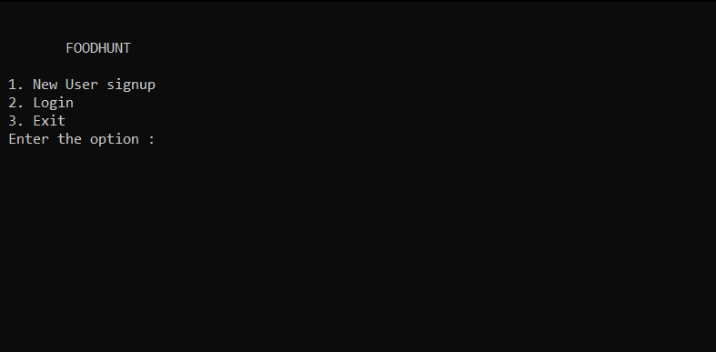

**Hotels**

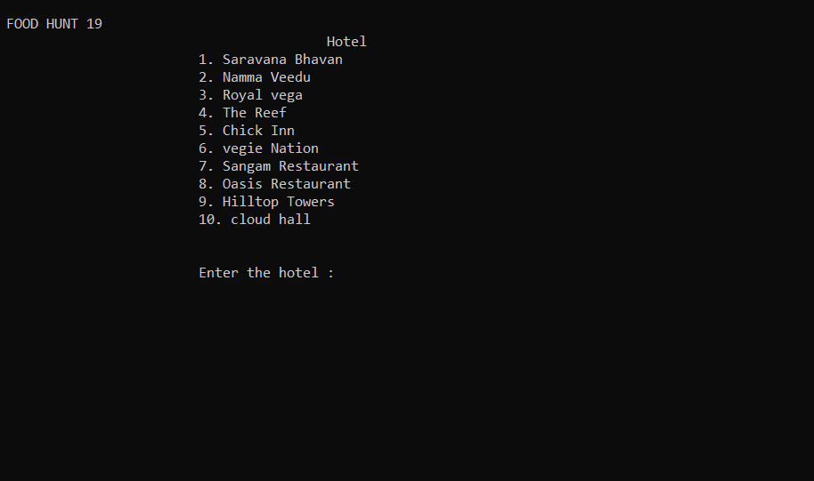

**Foods In Hotels**

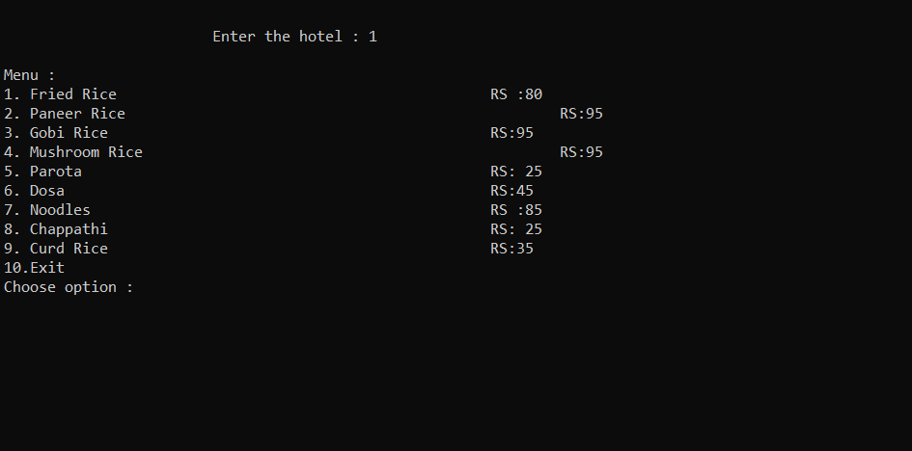

**Ordering food**

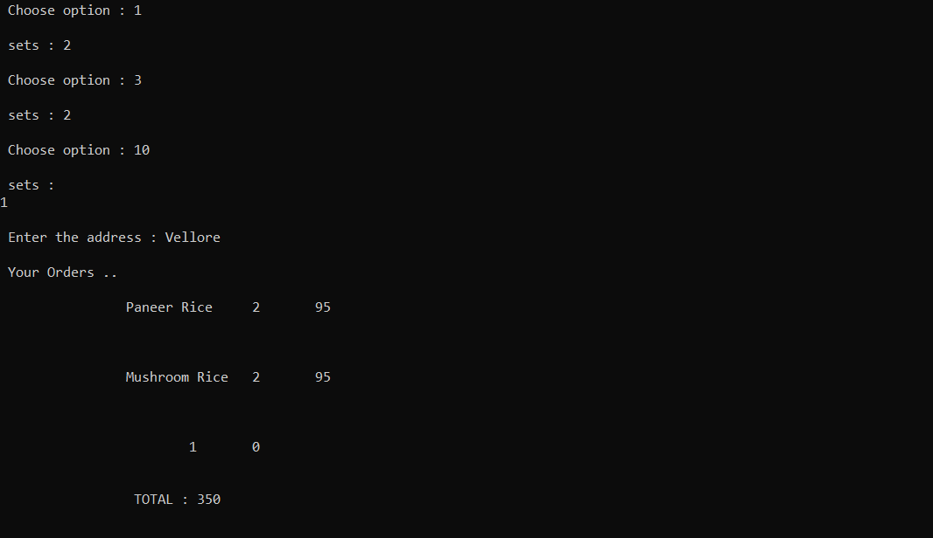

**Login into their account**

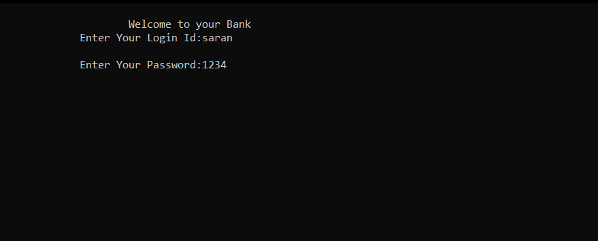

**Confirm the Payment**

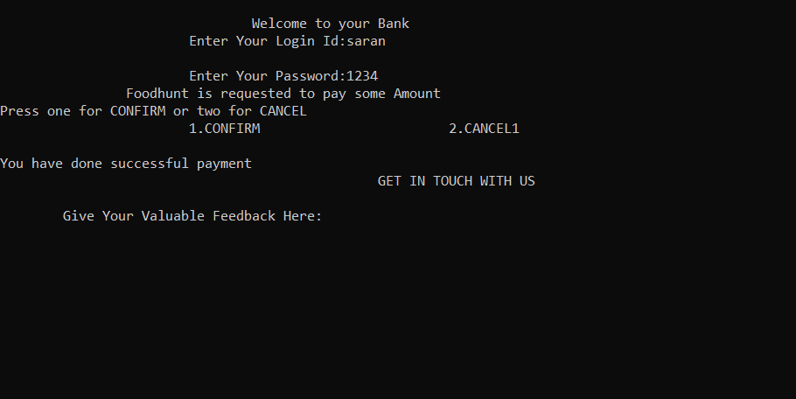

**Feedback**

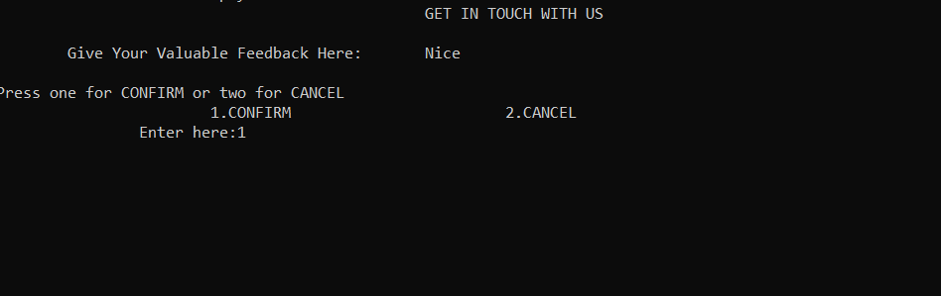

**CONCLUSION**

Along these lines, Food Hunt gives a total requesting process by picking their preferred eatery Among the decisions we show, the café is arranged by the world class cooking styles. The framework shows the eatery's best nourishment, the client is coordinated to tending to mode to convey the nourishment. The end procedure is to perform installment, framework furnish secure mode entrance with different alternatives such has Google Pay, Paytm and so forth.

This procedure is successful because of the focal database that is utilized to match up User's profile and nourishment request receipt.