Project Title :

E-Commerce Application On IBM Cloud Foundry

Phase 5 :

Project Documentation And Submission



Project Objectives :

The objectives of an e-Commerce application typically include:

1. \*\*Increase Sales\*\*:

To provide a platform for businesses to sell their products or services online, expanding their customer base and increasing sales.

1. \*\*Improve Customer Experience\*\*:

Enhance the overall shopping experience by providing a user-friendly interface, secure payment options, and personalized recommendations.

1. \*\*Expand Market Reach\*\*:

Reach a global audience and tap into new markets that might not be accessible through traditional brick-and-mortar stores.

1. \*\*Reduce Operating Costs\*\*:

Streamline operations, reduce overhead costs, and optimize inventory management.

1. \*\*Enhance Marketing and Promotion\*\*:

Use digital marketing tools to reach target audiences, promote products, and run effective advertising campaigns.

1. \*\*Collect Customer Data\*\*:

Gather valuable customer data for market analysis, trend identification, and personalized marketing strategies.

1. \*\*Increase Customer Loyalty\*\*:

Develop loyalty programs, provide exceptional customer service, and encourage repeat business.

1. \*\*Enable Mobile Commerce\*\*:

Ensure compatibility with mobile devices to accommodate the growing trend of mobile shopping.

1. \*\*Ensure Security\*\*:

Implement robust security measures to protect customer data and financial transactions.

1. \*\*Track and Analyze Performance\*\*:

Use analytics to measure the success of the e-Commerce platform, identify areas for improvement, and make data-driven decisions.

1. \*\*Streamline Supply Chain\*\*:

Optimize inventory management, order fulfillment, and shipping processes to ensure timely delivery.

1. \*\*Compliance and Legal Requirements\*\*:

Ensure adherence to regulatory and legal requirements, such as data protection and tax regulations.



Design Thinking :

Design thinking for an e-commerce application involves a user-centered approach to creating a platform that meets the needs and expectations of both customers and businesses.

The design thinking process for an e-commerce app:

1. Empathize:

- Understand the users:

Begin by researching and understanding your target audience. Create user personas to represent the various types of customers who might use your app.

- User interviews:

Conduct interviews and surveys to gather insights into their preferences, pain points, and behaviors.

- Competitive analysis:

Study existing e-commerce platforms to identify what works and what doesn’t in the market.

2. Define:

- Problem statement:

Clearly define the problem you aim to solve with your e-commerce app. This could be related to improving the shopping experience, increasing conversion rates, or enhancing user engagement.

- User stories:

Develop user stories and scenarios to map out typical user journeys and pain points.

3. Ideate:

- Brainstorm solutions:

Encourage a cross-functional team to generate a wide range of creative ideas for addressing the defined problem.

- Storyboarding:

Create storyboards or user flow diagrams to visualize potential solutions.

- Prioritization:

Rank and prioritize ideas based on their feasibility, impact, and alignment with user needs.

4. Prototype:

- Create prototypes:

Develop low-fidelity and high-fidelity prototypes of the app to test different design concepts and features.

- Usability testing:

Conduct usability tests with potential users to gather feedback and iterate on the prototypes.

- Iteration:

Continuously refine the prototypes based on user feedback, making adjustments to the design, layout, and functionality.

5. Test:

- Usability testing:

Perform usability testing with real users to validate the effectiveness of the app’s design, functionality, and user experience.

- A/B testing:

Test different versions of the app to see which design elements or features perform better in terms of user engagement, conversion rates, and other key metrics.

6. Implement:

- Development:

Once the design is validated, start the development phase, keeping design and development teams closely aligned for seamless execution.

- Quality assurance:

Thoroughly test the app to ensure it functions as expected and is free of bugs or usability issues.

7. Launch:

- Release the app:

Launch it to a limited audience initially to gather real-world data and feedback.

- Monitor performance:

Continuously monitor the app’s performance and user feedback, addressing any issues promptly.

8. Iterate:

- Continuous improvement:

Use user feedback, analytics, and market insights to make regular updates and improvements to the app.

- New features:

Introduce new features or enhancements based on changing user needs and market trends.

9. Scale:

- Expand the app’s reach and capabilities as it gains traction and popularity. This may involve adding more product categories, integrating with third-party services, or entering new markets.

Development phases Of This Project :

The development of an E-Commerce application involves several phases, each of which is crucial to the success of the project. The typical development phases in E-Commerce application :



1. \*\*Planning and Strategy\*\*:

- \*\*Market Research\*\*:

Begin by conducting market research to understand the target audience, competitors, and market trends.

- \*\*Business Goals\*\*:

Define clear business goals and objectives for the E-Commerce application, such as revenue targets and customer acquisition goals.

- \*\*Technology Stack\*\*:

Choose the appropriate technology stack and infrastructure for the application.

2. \*\*Conceptualization and Ideation\*\*:

- \*\*Idea Generation\*\*:

Generate ideas for the E-Commerce application’s features, design, and functionality.

- \*\*User Personas\*\*:

Create user personas to understand the customers’ needs and preferences.

- \*\*Wireframing and Prototyping\*\*: Develop wireframes and prototypes to visualize the application’s user interface and flow.

3. \*\*Design\*\*:

- \*\*User Interface (UI) Design\*\*:

Create visually appealing and user-friendly interfaces that align with the brand.

- \*\*User Experience (UX) Design\*\*:

Focus on enhancing the user experience, ensuring easy navigation and intuitive interactions.

- \*\*Responsive Design\*\*:

Ensure that the application is responsive, adapting to different devices and screen sizes.

4. \*\*Development\*\*:

- \*\*Front-End Development\*\*:

Develop the client-side components of the application, including web pages and mobile app interfaces.

- \*\*Back-End Development\*\*:

Build the server-side components responsible for managing data, user accounts, and business logic.

- \*\*Database Design\*\*:

Design and implement the database structure to store product information, user data, and transaction records.

- \*\*Payment Gateway Integration\*\*: Integrate secure payment gateways for processing transactions.

- \*\*Security Measures\*\*:

Implement robust security measures to protect customer data and ensure data privacy.

5. \*\*Testing\*\*:

- \*\*Quality Assurance (QA)\*\*:

Perform thorough testing to identify and resolve bugs, usability issues, and security vulnerabilities.

- \*\*Load Testing\*\*:

Test the application’s performance under heavy traffic to ensure it can handle peak loads.

- \*\*Security Testing\*\*:

Conduct security assessments to safeguard against data breaches and other security threats.

6. \*\*Deployment\*\*:

- \*\*Staging Environment\*\*:

Deploy the application to a staging environment for final testing and validation.

- \*\*Production Deployment\*\*:

Launch the application in a production environment, making it accessible to the public.

7. \*\*Marketing and Promotion\*\*:

- \*\*SEO Optimization\*\*:

Implement search engine optimization strategies to improve the application’s visibility in search engine results.

- \*\*Marketing Campaigns\*\*:

Develop marketing campaigns to attract and retain customers.

- \*\*Social Media Integration\*\*:

Leverage social media platforms for marketing and customer engagement.

8. \*\*Maintenance and Updates\*\*:

- \*\*Regular Updates\*\*:

Continuously update and improve the application by adding new features and fixing issues.

- \*\*Customer Support\*\*:

Provide excellent customer support to address user inquiries and concerns.

- \*\*Monitoring and Analytics\*\*:

Monitor application performance and gather analytics to make data-driven decisions.

9. \*\*Scaling\*\*:

- As your E-Commerce business grows, be prepared to scale the application to handle increased traffic, transactions, and data.

10. \*\*Feedback and Iteration\*\*:

- Gather feedback from users and use it to make iterative improvements to the application.

Platform layout Of This Project :

The platform layout of an e-commerce application typically consists :

1. \*\*Homepage\*\*:

This is the first page users see when they visit the website or open the app. It usually includes featured products, promotions, and navigation options.

1. \*\*Product Pages\*\*:

Each product has its own page displaying details, images, pricing, and customer reviews. Users can add items to their cart from here.

1. \*\*Shopping Cart\*\*:

Users can review the items they’ve added to their cart, update quantities, and proceed to checkout.

1. \*\*Checkout\*\*:

This is where users enter shipping and payment information. It includes options for applying discounts or promo codes.

1. \*\*User Accounts\*\*:

Customers can create accounts, log in, and manage their personal information, order history, and saved addresses.

1. \*\*Search and Navigation\*\*:

Users can search for products and filter results by category, price, brand, and other criteria.

1. \*\*Payment Gateway\*\*:

Integration with payment processors for secure online payments.

1. \*\*Order Processing\*\*:

Back-end systems for order fulfillment, including inventory management and order status updates.

1. \*\*Reviews and Ratings\*\*:

Customers can leave reviews and ratings for products, helping others make informed decisions.

1. \*\*Customer Support\*\*:

Contact options such as chat, email, or phone for assistance.

1. \*\*Wish List\*\*:

Users can save products for later purchase.

1. \*\*Recommendation Engine\*\*: Suggests products based on user behavior and preferences.
2. \*\*Admin Dashboard\*\*: For managing products, orders, customer data, and site content.
3. \*\*Analytics and Reporting\*\*: Tools for monitoring website traffic, sales data, and customer behavior.
4. \*\*Security Measures\*\*: SSL encryption, user authentication, and other security features to protect user data.
5. \*\*Responsive Design\*\*: Ensures the platform works well on various devices and screen sizes.
6. \*\*Terms and Policies\*\*: Information about returns, privacy, and terms of service.

Features Of E-Commerce Application :

E-commerce applications are software platforms that facilitate online buying and selling of products and services. They typically offer a wide range of features to enhance the user experience, streamline business operations, and ensure security and reliability.

Features of e-commerce applications:

1. User Registration and Authentication:

- User registration allows customers to create accounts and save their personal information.

- Authentication ensures secure access to user accounts and protects customer data.

2. Product Catalog:

- A product catalog displays a comprehensive list of products with details like name, price, images, and descriptions.

- Filters and search functionalities help users find products quickly.

3. Shopping Cart:

- A shopping cart enables users to add and manage items they wish to purchase.

- It calculates the total order value and allows users to modify their selections.

4. Secure Payment Processing:

- E-commerce applications integrate with various payment gateways to accept payments through credit cards, digital wallets, and other methods.

- Security measures, such as SSL encryption, protect sensitive payment data.

5. Order Management:

- Users can track their orders, view order history, and receive order status updates.

- Admins can manage and process orders efficiently.

6. Inventory Management:

- Real-time inventory tracking helps businesses monitor stock levels and prevent overselling.

- Automatic notifications for low-stock items assist in reordering.

7. Product Reviews and Ratings:

- User-generated reviews and ratings provide valuable insights for other customers.

- They help build trust and influence purchasing decisions.

8. Wishlists and Favorites:

- Users can create wishlists or mark products as favorites for future reference.

- This feature encourages return visits and repeat purchases.

9. Recommendations and Personalization:

- AI algorithms can suggest products based on user preferences and browsing history.

- Personalization enhances the shopping experience.

10. Mobile Responsiveness:

- E-commerce apps should be optimized for mobile devices to accommodate the growing number of mobile shoppers.

11. Multi-language and Multi-currency Support:

- Catering to a global audience requires support for multiple languages and currencies.

12. Order Tracking and Shipping:

- Real-time order tracking keeps customers informed about the status of their deliveries.

- Integration with shipping carriers provides accurate shipping rates and delivery estimates.

13. Sales and Discounts:

- The ability to apply discounts, promo codes, and run sales campaigns helps attract and retain customers.

14. Analytics and Reporting:

- E-commerce platforms often include tools for tracking sales, customer behavior, and other metrics.

- Insights from analytics data can inform marketing and business strategies.

15. SEO and Marketing Tools:

- Search engine optimization features help improve the visibility of the online store in search engine results.

- Marketing tools may include email marketing, social media integration, and affiliate programs.

16. Customer Support:

- Live chat, FAQs, and contact forms provide options for customer support.

- Efficient customer service is crucial for resolving issues and answering questions.

17. Security and Compliance:

- E-commerce apps must adhere to security standards and comply with regulations like PCI DSS for handling payment information.

18. Scalability:

- The ability to handle increasing traffic and transactions is essential for growing businesses.

19. Content Management:

- E-commerce platforms may include content management systems for creating and updating product descriptions, blog posts, and other content.

20. Integration with Third-party Services:

- Integration with CRM, accounting, and other third-party systems streamlines business operations.



Implementation Techniques Of This Project :

Implementing an e-commerce application involves several critical components and considerations.

The implementation techniques for an e-commerce application:

1. \*\*Platform Selection:\*\*

- Custom vs. Off-the-Shelf:

Decide whether to build a custom e-commerce solution or leverage an existing platform. Custom solutions provide more flexibility but require more development effort and maintenance.

2. \*\*Backend Development:\*\*

- Database Design:

Design a database to store product information, customer data, orders, and other relevant data.

- Server Setup:

Choose a reliable hosting solution, set up servers, and configure security measures to protect customer data.

- Frameworks and Technologies:

Utilize appropriate programming languages and frameworks like PHP, Python, Ruby on Rails, Node.js, or .NET for backend development.

- Payment Integration:

Implement secure payment gateways for processing transactions. Common options include PayPal, Stripe, and Authorize.Net.

- Inventory Management:

Develop features to track and manage inventory levels, restocking, and product availability.

3. \*\*Frontend Development:\*\*

- Responsive Design:

Create a responsive, mobile-friendly, and user-friendly interface for customers using HTML, CSS, and JavaScript.

- User Experience:

Implement an intuitive and smooth user interface with features like product search, filters, and a shopping cart.

- Security:

Ensure secure user authentication, data encryption, and protection against common web vulnerabilities like cross-site scripting (XSS) and SQL injection.

4. \*\*Product Catalog:\*\*

- Product Information:

Develop a system for adding, editing, and displaying product details, including images, descriptions, prices, and specifications.

- Categories and Filters:

Organize products into categories and provide filtering options to enhance the shopping experience.

5. \*\*Shopping Cart and Checkout:\*\*

- Shopping Cart:

Allow customers to add, remove, and manage items in their shopping cart.

- Checkout Process:

Implement a multi-step checkout process with options for guest checkout, shipping and payment methods, and order review.

6. \*\*User Accounts:\*\*

- User Registration and Login:

Develop user registration and authentication systems.

- User Profiles:

Allow users to manage their profiles, addresses, and payment methods.

- Order History:

Enable users to view their order history and track the status of their orders.

7. \*\*Security and Compliance:\*\*

- SSL Certificate:

Implement SSL (Secure Sockets Layer) to encrypt data transmission.

- PCI DSS Compliance:

Comply with Payment Card Industry Data Security Standard (PCI DSS) for handling credit card information.

- GDPR Compliance:

Ensure compliance with data protection regulations like the General Data Protection Regulation (GDPR).

8. \*\*Search and Recommendations:\*\*

- Implement search functionality with features like auto-suggestions and filters.

- Utilize recommendation algorithms to suggest products to users based on their browsing and purchase history.

9. \*\*Performance Optimization:\*\*

- Optimize website speed and performance to reduce load times and improve user experience.

- Implement caching mechanisms and content delivery networks (CDNs).

10. \*\*Testing and Quality Assurance:\*\*

- Perform rigorous testing, including functional, security, and performance testing.

- Ensure cross-browser and cross-device compatibility.

11. \*\*Deployment:\*\*

- Deploy the e-commerce application to a production server and monitor its performance.

- Set up backup and recovery procedures to safeguard against data loss.

12. \*\*Maintenance and Updates:\*\*

- Regularly update and maintain the application to fix bugs, add new features, and enhance security.

- Provide customer support and respond to feedback and issues.

13. \*\*Marketing and SEO:\*\*

- Implement SEO best practices to improve the website’s visibility in search engines.

- Use digital marketing techniques to promote products and drive traffic to the site.

14. \*\*Analytics and Reporting:\*\*

- Implement analytics tools to monitor website traffic, user behavior, and sales performance.

- Use data-driven insights to make informed business decisions.

15. \*\*Scale and Growth:\*\*

- Plan for scalability as your business grows. Consider load balancing and server scaling techniques.

- Continuously innovate and expand the product offerings.

Images Of The Platform User’s Interface :

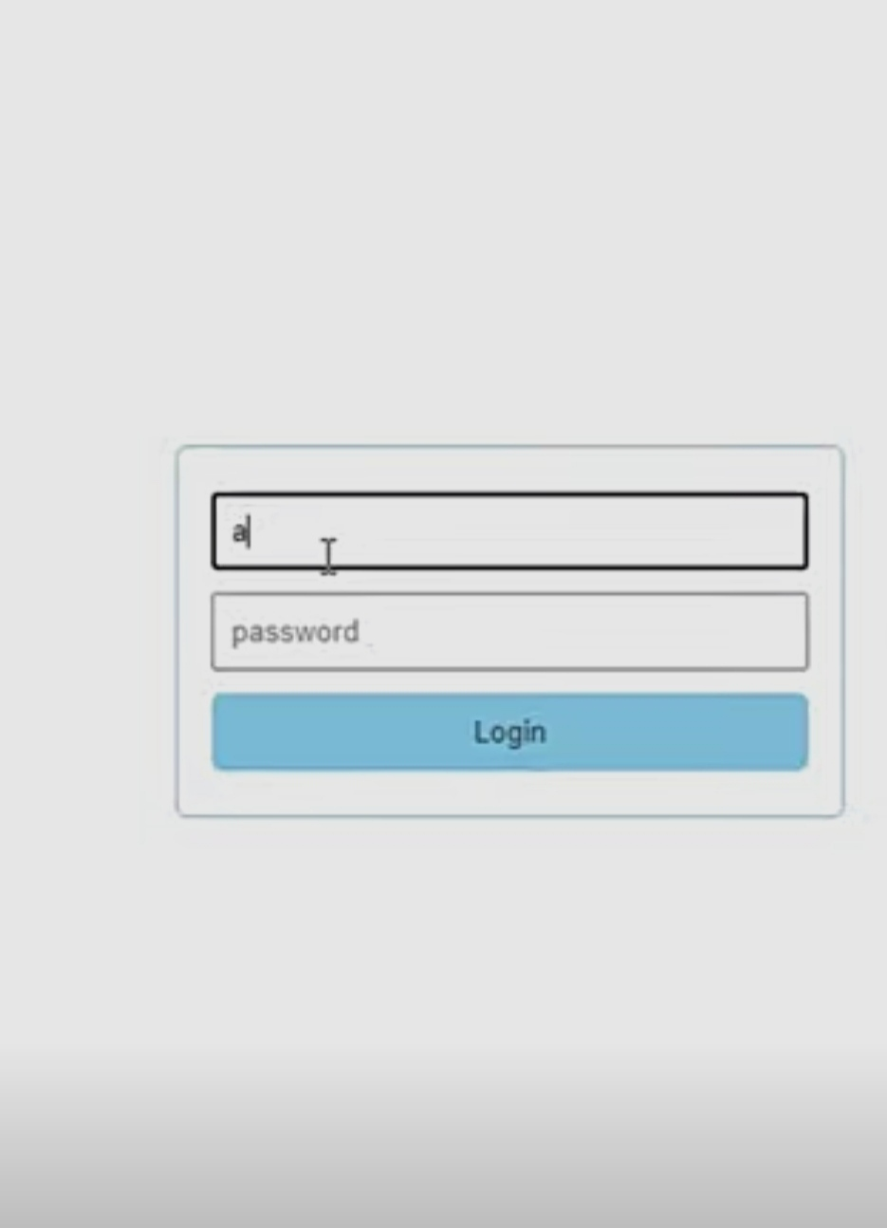

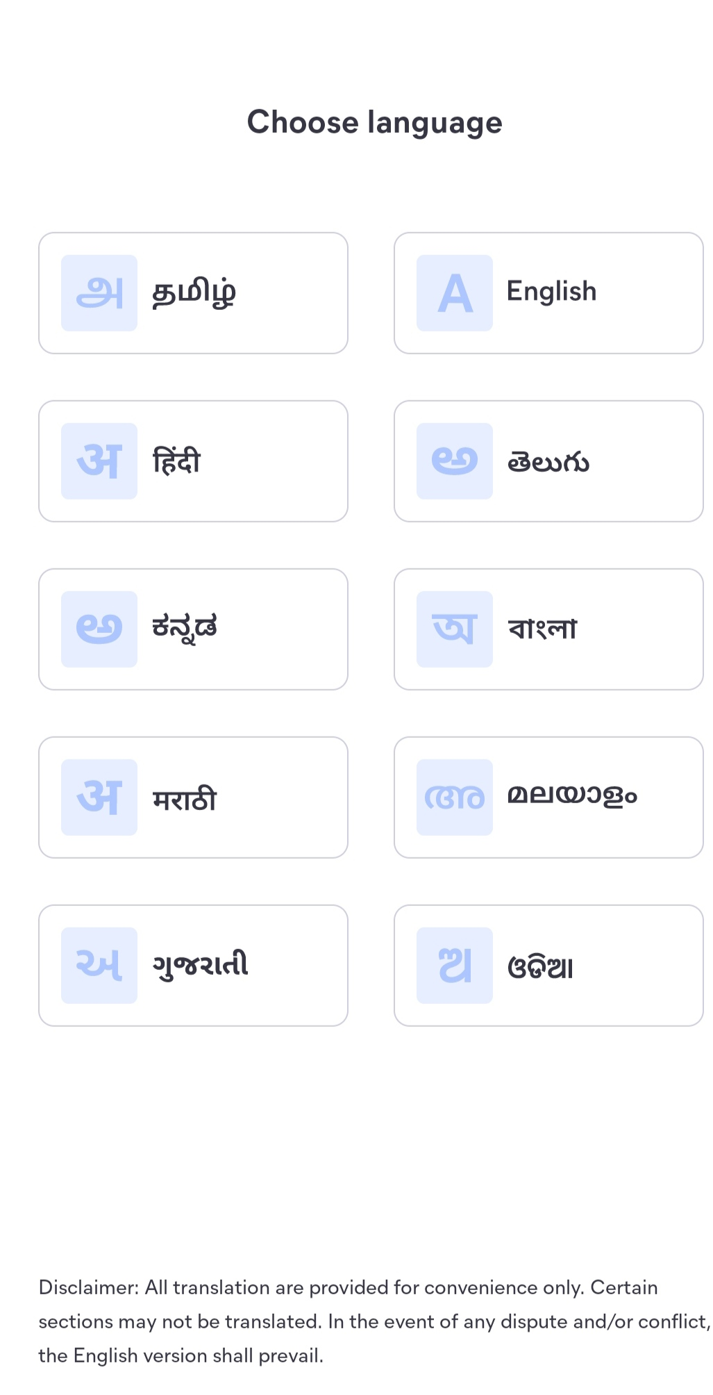



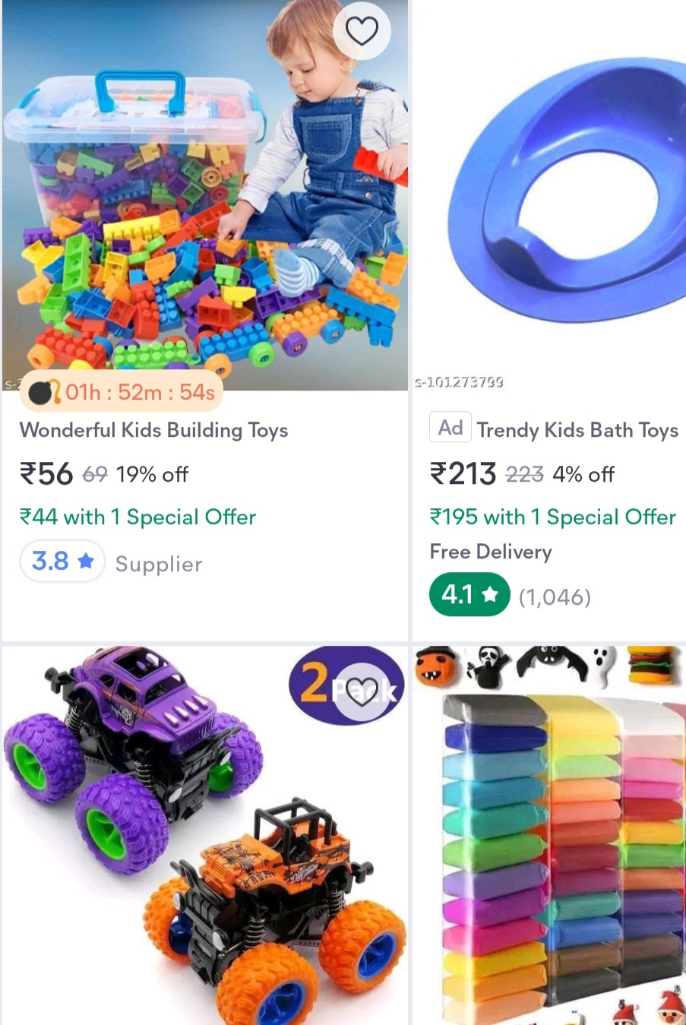

Summary Of E-Commerce Application :

\*\*E-commerce, short for electronic commerce, refers to the buying and selling of goods and services online. E-commerce applications are software platforms that facilitate these online transactions.

\*\*In summary, e-commerce applications are versatile tools that empower businesses to establish an online presence, reach a broader audience, and streamline the process of buying and selling products and services over the internet.