**PROJECT**

**Student Name: Saransh Arora UID: 24MCI100041**  **Branch: MCA AIML Section/Group: I-A**  **Semester: 1 Date of Performance: 27 – 10 - 24**   **Subject Name: DAA Subject Code: 24CAP-612**  **Here's**

# 1. Aim

To develop a To-Do List application using a queue data structure that efficiently manages tasks and their execution order**.**

# 2. Objective/Problem Definition

The primary objective is to create a program that allows users to add, remove, and view tasks in a queue format, ensuring that tasks are processed in the order they were added. The problem addressed is the need for an organized system to manage tasks effectively.

# 3. Programming Languages Used

* Python: For implementation of the queue and the application logic.
* JavaScript: If a web-based interface is created.
* HTML/CSS: For user interface design in web applications.

# 4. Block Diagram/Design Flow/Flow Chart

-Block Diagram

* Input (Add Task)
* Process (Queue Operations: Enqueue, Dequeue)
* Output (Display Task List)
* Flow Chart
* Start
* Initialize Queue
* Display Menu (Add, Remove, View, Exit)
* Perform Selected Operation
* Loop until Exit

**5. Algorithm or Pseudo Code** pseudo Initialize Queue While True:

Display Menu User

Input = Get Choice If User Input == 'Add':

Task = Get Task Details

Enqueue(Task)

Else If User Input == 'Remove':

Task = Dequeue()

Print(Task)

Else If User Input == 'View':

Print Queue

Else If User Input == 'Exit':

Break

End While

# 6. Implementation

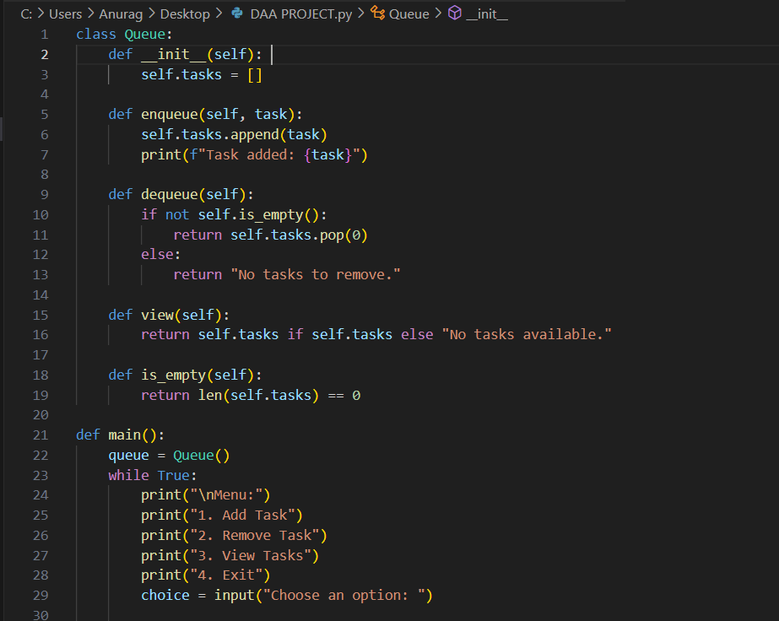

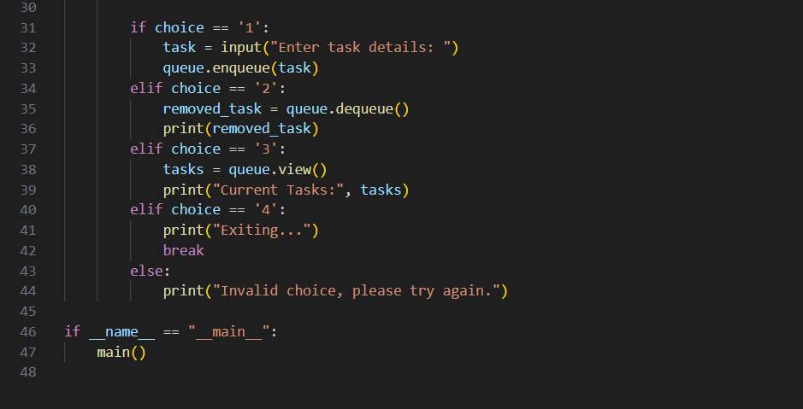

# 7. Output

# 

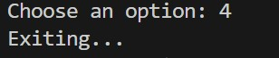

# 8. Conclusion

The To-Do List application successfully utilizes a queue data structure to manage tasks. It allows for efficient task management, ensuring tasks are processed in the order they are added.

# 9. Future Framework

* Enhance the application with priority queues for task urgency.
* Implement a persistent storage option (e.g., database) to save tasks.
* Develop a mobile application version for better accessibility**.**

# 10. Learning Outcomes

* Understanding of queue data structure and its operations.
* Experience in programming for task management applications.
* Skills in user interface design and usability considerations.