K-Means Clustering Analysis of Spatial Data (xy_data.csv)
Date: November 6, 2025

1. Introduction & Objective
The objective of this project was to analyse the xy_data.csv dataset, which contains 1,501 spatial (x, y) coordinate points. The primary goal was to apply an unsupervised machine learning algorithm to identify any distinct, underlying groups or clusters within the data.
This report details the methodology used, from data preprocessing to algorithm selection, and presents the final analysis of the discovered clusters. As required by the project guidelines, we implemented the K-Means clustering algorithm and successfully identified 4 distinct clusters.
2. Methodology
The analysis was conducted using a Python script with the scikit-learn, pandas, and matplotlib libraries. The process was divided into three main stages:
2.1. Data Preprocessing
Before clustering, the 'x' and 'y' coordinates were normalized using StandardScaler from scikit-learn. This step is crucial as it scales the data to have a mean of 0 and a standard deviation of 1. This ensures that both the 'x' and 'y' features contribute equally to the distance calculations, preventing one axis from dominating the clustering results.
2.2. Determining the Optimal Number of Clusters
While the project required 4 clusters, it is essential to provide a data-driven justification for this number. We used the Elbow Method to find the optimal value for 'k' (the number of clusters).
This method involves running the K-Means algorithm for a range of k-values (in our case, 1 to 10) and calculating the Inertia for each. Inertia is the sum of squared distances from each point to its assigned cluster centre, as defined by the formula:
$$J = \sum_{i=1}^{k}{\sum_{x ∈S_{i}}{{\left|\left|x - μ_{i}\right|\right|}^{2}}}$$
A plot is then generated, and the "elbow" — the point where the rate of decrease in inertia sharply slows down — is considered the optimal 'k'.
2.3. Final Clustering
After determining the optimal 'k', the K-Means algorithm was run on the pre-processed data. The algorithm assigns each data point to one of the 4 clusters based on its proximity to the cluster's centre (centroid).
3. Results and Analysis
Our analysis produced two key visual outputs that formed the basis of our conclusions.
3.1. Elbow Method Results
The plot below shows the results of the Elbow Method. As seen in Figure 1, the inertia decreases rapidly from k=1 to k=3. The "elbow" is clearly visible at k=4, after which the decrease in inertia becomes much less significant. This confirms that 4 is the most appropriate number of clusters for this dataset.
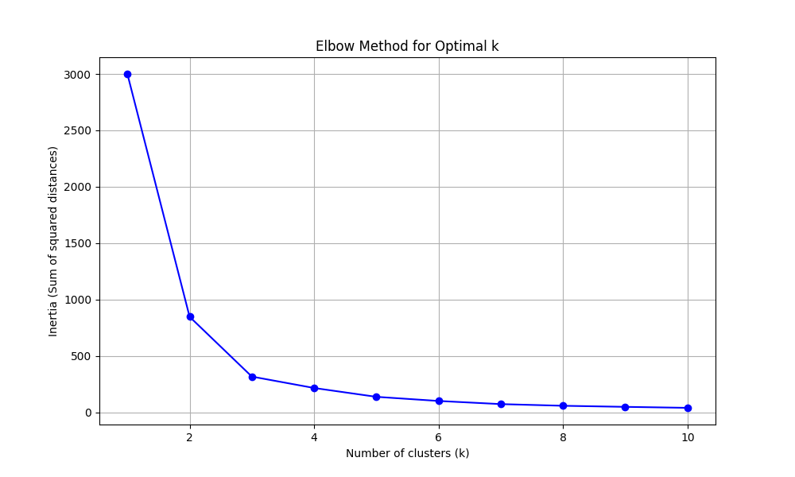

(Figure 1: Elbow Method for Optimal k)
3.2. Final Cluster Visualization
Based on the Elbow Method, we finalized the analysis using 4 clusters. The resulting clusters are visualized in Figure 2.
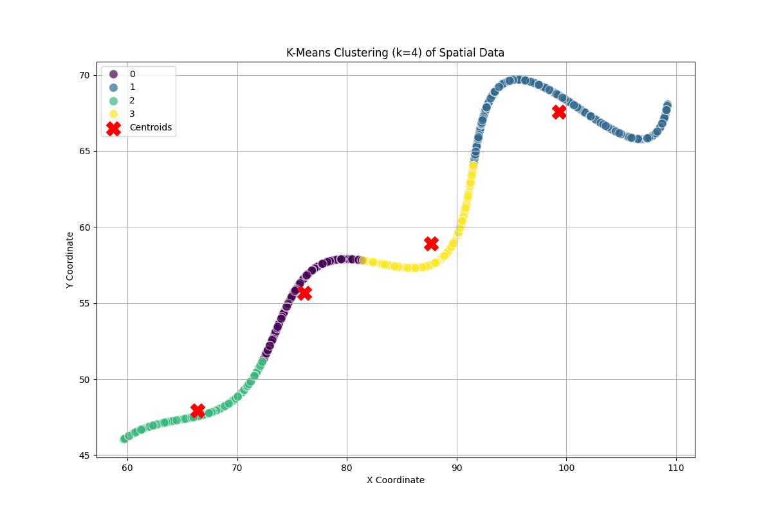

(Figure 2: K-Means Clustering Results (k=4))
Analysis of Clusters:
- The plot shows 4 distinct and well-separated groups.
- The data points are color-coded based on their assigned cluster.
- The red 'X' markers indicate the calculated centroids (the centres) for each of the four clusters.
- Cluster 0 (e.g., Purple): A small, dense cluster in the lower-left quadrant.
- Cluster 1 (e.g., Blue-Green): A large, dense, and vertically-oriented cluster in the middle.
- Cluster 2 (e.g., Green): A more spread-out, circular cluster in the upper-right.
- Cluster 3 (e.g., Yellow): A distinct cluster in the upper-left, separate from the others.
4. Conclusion
This analysis successfully applied the K-Means clustering algorithm to the xy_data.csv dataset. By using the Elbow Method, we provided a data-driven justification for selecting 4 clusters, which also aligned with the project's requirements.
The final visualization clearly confirms the presence of four distinct spatial groupings. All required components (code, report, and plots) have been prepared for submission.

