LOVELY PROFESSIONAL UNIVERSITY
PROJECT / PRACTICAL FILE
PREDICTING LOAN APPROVAL
Decision Tree Classification of Loan Applications
Submitted by: | Saransh Singh
Registration No.: | 12301472
Roll No.: | 35
Section: | RK2P23FHB36
Course / Subject:
Submitted to:
Date: | 02 November 2026

1. Introduction
When a customer applies for a loan, the bank has to decide whether to approve or reject the application. Doing this by hand for thousands of applications is slow and can be inconsistent. In this project a Decision Tree model is trained on 45,000 past loan applications so that it can predict whether a new application will be approved, using the applicant’s financial history such as income, credit score, loan amount and previous defaults.

1.1 Problem statement
The assigned task is “Predicting Loan Approval”. Its steps are:
- Load the loan application dataset.
- Handle missing values and standardize credit scores.
- Train a Decision Tree model for loan approval prediction.
- Evaluate the performance using a confusion matrix.
- Visualize approval rates by income group.

1.2 Key concepts in simple words
Term | Meaning
Decision Tree | A model that works like a flowchart of yes/no questions, for example “Does the applicant have a previous default?”. Each answer leads to the next question until the tree reaches a decision: Approved or Rejected.
Missing value | A cell that has no data. Models cannot use blanks, so they are filled, here with the median (the middle value).
Standardization | Rescaling a column so that its mean becomes 0 and its standard deviation becomes 1: z = (x − mean) / std.
Train / test split | 80% of the applications are used to teach the model (train); the other 20% are kept hidden and used only to check it (test).
Confusion matrix | A 2×2 table that compares actual results with predicted results: TN, FP, FN and TP (explained in Section 5.3).
Accuracy, precision, recall | Accuracy = share of all predictions that are correct. Precision = of the applications predicted Approved, how many really were. Recall = of the really Approved applications, how many the model found.
Income group | Applicants divided into 4 equal-sized groups by annual income: Low, Lower-Middle, Upper-Middle and High.

1.3 Tools and libraries
- Python 3 – programming language.
- pandas and NumPy – loading the data, cleaning and grouping.
- scikit-learn – standardization, train/test split, Decision Tree and evaluation.
- Matplotlib – confusion matrix, charts, tree picture and dashboard.

1.4 Approach and design decisions
- Missing values. The file has 0 blank cells, but 7 applications have impossible ages (109 to 144 years). These were treated as missing and filled with the median age. The code also fills any blank number with the median and any blank text with the most common value, so it works for other files too.
- Text to numbers. Text columns (gender, education, home ownership, loan intent, previous default) are converted into 0/1 columns with pandas get_dummies, because the model understands only numbers.
- Train/test split. 80% / 20% with stratify, so both parts keep the same share of approved applications (22.2%). random_state = 42 makes the result repeatable.
- Standardizing credit score. The mean and standard deviation are learned from the training rows only and then reused for the test rows, so no information from the test data leaks into training.
- Tree depth. max_depth = 5 limits the tree to five questions in a row. A deeper tree memorizes the training data (overfitting); depth 5 gives almost the same accuracy on training and test data and stays easy to read.
- Income groups. Quartiles are used (each group has about 11,250 applicants), so the groups are equal in size and easy to compare.

2. Dataset Link
Dataset: Loan Approval Classification Dataset
Dataset link (Kaggle): https://www.kaggle.com/datasets/taweilo/loan-approval-classification-data
Copy of the file used: https://github.com/amithvinod/APR_Assignment-1
File used: loan_data.csv (45,000 rows, 14 columns, about 3.6 MB)
According to its description, this is a synthetic dataset inspired by the Kaggle “Credit Risk” dataset and enlarged with extra financial-risk variables, so it contains no real customer data. Each row is one loan application and the last column, loan_status, tells whether it was approved.
Column | Type | Description
person_age | decimal | Age of the applicant
person_gender | text | Gender (female / male)
person_education | text | Highest education level (High School, Associate, Bachelor, Master, Doctorate)
person_income | decimal | Annual income
person_emp_exp | integer | Years of employment experience
person_home_ownership | text | RENT, OWN, MORTGAGE or OTHER
loan_amnt | decimal | Loan amount requested
loan_intent | text | Purpose of the loan (personal, education, medical, venture, home improvement, debt consolidation)
loan_int_rate | decimal | Loan interest rate (%)
loan_percent_income | decimal | Loan amount as a fraction of annual income
cb_person_cred_hist_length | decimal | Length of credit history in years
credit_score | integer | Credit score of the applicant
previous_loan_defaults_on_file | text | Yes / No – did the applicant default earlier?
loan_status | integer | TARGET: 1 = approved, 0 = rejected

Quick facts about the data:
- Applications: 45,000 – approved: 10,000 (22.2%), rejected: 35,000 (77.8%).
- Blank cells: 0. Impossible ages (above 100 years): 7.
- Because only about 1 in 5 applications is approved, accuracy alone can be misleading (see Section 5.3).

3. Source Code
File name: loan_approval_prediction.py
How to run: install the libraries with pip install pandas numpy scikit-learn matplotlib, keep loan_data.csv in the same folder and run python loan_approval_prediction.py. The charts are saved in a folder named outputs.
The program has five steps that match the five tasks: Step 1 loads the data, Step 2 cleans it and standardizes the credit score, Step 3 trains the Decision Tree, Step 4 evaluates it with a confusion matrix and Step 5 shows approval rates by income group. Some extra checks and charts follow at the end.
# -*- coding: utf-8 -*-
"""
Predicting Loan Approval using a Decision Tree
==============================================
Name : Saransh Singh
Reg. No. : 12301472
Roll No. : 35
Section : RK2P23FHB36
Dataset : Loan Approval Classification Dataset (Kaggle, 45,000 applications)
https://www.kaggle.com/datasets/taweilo/loan-approval-classification-data

Tasks
1. Load the loan application dataset.
2. Handle missing values and standardize credit scores.
3. Train a Decision Tree model for loan approval prediction.
4. Evaluate the performance using a confusion matrix.
5. Visualize approval rates by income group.
"""

import json
import os

import matplotlib
matplotlib.use("Agg") # save charts as files (no pop-up window)
import matplotlib.pyplot as plt
import numpy as np
import pandas as pd
from sklearn.metrics import (ConfusionMatrixDisplay, accuracy_score,
classification_report, confusion_matrix)
from sklearn.model_selection import train_test_split
from sklearn.preprocessing import StandardScaler
from sklearn.tree import DecisionTreeClassifier, plot_tree

CSV_PATH = "loan_data.csv"
OUT_DIR = "outputs"
os.makedirs(OUT_DIR, exist_ok=True)
results = {} # numbers saved for the report

def banner(text):
print("\n" + "=" * 66 + "\n " + text + "\n" + "=" * 66)

# ---------------------------------------------------------------------------
# STEP 1 - Load the loan application dataset
# ---------------------------------------------------------------------------
banner("STEP 1: LOAD THE DATASET")
df = pd.read_csv(CSV_PATH)
print("Rows (applications) :", f"{len(df):,}")
print("Columns :", df.shape[1])
print("Target column : loan_status (1 = approved, 0 = rejected)")
print("\nFirst 3 applications (columns shown downwards):")
print(df.head(3).T.to_string(header=False))
results["rows"] = len(df)
results["columns"] = df.shape[1]

# ---------------------------------------------------------------------------
# STEP 2 - Handle missing values and standardize credit scores
# ---------------------------------------------------------------------------
banner("STEP 2: HANDLE MISSING VALUES + STANDARDIZE CREDIT SCORE")

# 2a. Count blank (missing) cells
blank_cells = int(df.isnull().sum().sum())
print("2a. Blank cells in the file :", blank_cells)

# 2b. Some ages are impossible (e.g. 144 years). Treat them as missing values.
bad_age = df["person_age"] > 100
print("2b. Applications with age above 100 :", int(bad_age.sum()))
df.loc[bad_age, "person_age"] = np.nan

# 2c. Fill every missing value: numbers -> median, text -> most common value
missing_total = int(df.isnull().sum().sum())
for col in df.columns:
if df[col].isnull().any():
if pd.api.types.is_numeric_dtype(df[col]):
df[col] = df[col].fillna(df[col].median())
else:
df[col] = df[col].fillna(df[col].mode()[0])
print("2c. Missing values filled with median:", missing_total,
"| left after filling:", int(df.isnull().sum().sum()))

# 2d. Convert text columns into 0/1 columns (a model understands only numbers)
y = df["loan_status"]
X = pd.get_dummies(df.drop(columns="loan_status"), drop_first=True).astype(float)
print("2d. Columns after text -> number :", X.shape[1])

# 2e. Split: 80 % to learn from (train), 20 % to test on (test)
X_train, X_test, y_train, y_test = train_test_split(
X, y, test_size=0.20, random_state=42, stratify=y)
X_train, X_test = X_train.copy(), X_test.copy()
print(f"2e. Training rows: {len(X_train):,} Testing rows: {len(X_test):,}")

# 2f. Standardize credit score: (score - mean) / standard deviation
X_train_raw, X_test_raw = X_train.copy(), X_test.copy() # un-scaled copies (for a check)
credit_before = X_train["credit_score"].copy()
mean_before, std_before = credit_before.mean(), credit_before.std()
scaler = StandardScaler()
# learn mean/std from the training rows, then use the same values on the test rows
X_train["credit_score"] = scaler.fit_transform(X_train[["credit_score"]])
X_test["credit_score"] = scaler.transform(X_test[["credit_score"]])
print(f"2f. Credit score BEFORE : mean = {mean_before:7.2f}, std = {std_before:6.2f}")
print(f" Credit score AFTER : mean = {X_train['credit_score'].mean():7.2f}, "
f"std = {X_train['credit_score'].std():6.2f}")

results.update(blank_cells=blank_cells, bad_age=int(bad_age.sum()),
train_rows=len(X_train), test_rows=len(X_test),
features=X.shape[1], cs_mean=float(mean_before),
cs_std=float(std_before))

# ---------------------------------------------------------------------------
# STEP 3 - Train the Decision Tree
# ---------------------------------------------------------------------------
banner("STEP 3: TRAIN THE DECISION TREE")
# max_depth=5 -> the tree asks at most 5 questions in a row.
# This keeps the tree simple and stops it from memorising the training data.
model = DecisionTreeClassifier(max_depth=5, random_state=42)
model.fit(X_train, y_train)
print("Model : DecisionTreeClassifier(max_depth=5)")
print("Depth reached :", model.get_depth())
print("Leaf nodes :", model.get_n_leaves())

# Which columns did the tree use the most?
importance = pd.Series(model.feature_importances_, index=X.columns)
importance = importance.sort_values(ascending=False)
print("\nTop 5 most important columns:")
print(importance.head(5).round(3).to_string())
results["top_features"] = {k: float(v) for k, v in importance.head(8).items()}

# ---------------------------------------------------------------------------
# STEP 4 - Evaluate with a confusion matrix
# ---------------------------------------------------------------------------
banner("STEP 4: EVALUATE THE MODEL")
y_pred = model.predict(X_test)
accuracy = accuracy_score(y_test, y_pred)
tn, fp, fn, tp = confusion_matrix(y_test, y_pred).ravel()

print(f"Accuracy on test data : {accuracy:.2%}")
print("\nConfusion matrix:")
print(f" Predicted Rejected Predicted Approved")
print(f" Actual Rejected {tn:>12,} (TN) {fp:>12,} (FP)")
print(f" Actual Approved {fn:>12,} (FN) {tp:>12,} (TP)")
print("\nClassification report:")
print(classification_report(y_test, y_pred,
target_names=["Rejected", "Approved"], digits=3))

precision = tp / (tp + fp) # of all predicted "Approved", how many were right
recall = tp / (tp + fn) # of all really approved, how many did we find
results.update(accuracy=float(accuracy), tn=int(tn), fp=int(fp), fn=int(fn), tp=int(tp),
precision=float(precision), recall=float(recall),
f1=float(2 * precision * recall / (precision + recall)))

fig, ax = plt.subplots(figsize=(6, 5))
ConfusionMatrixDisplay.from_predictions(
y_test, y_pred, display_labels=["Rejected", "Approved"], cmap="Blues", ax=ax)
ax.set_title(f"Confusion Matrix (accuracy {accuracy:.1%})", fontweight="bold")
fig.tight_layout()
fig.savefig(f"{OUT_DIR}/confusion_matrix.png", dpi=150)
plt.close(fig)

# ---------------------------------------------------------------------------
# STEP 5 - Approval rate by income group
# ---------------------------------------------------------------------------
banner("STEP 5: APPROVAL RATE BY INCOME GROUP")
# Split applicants into 4 equal-sized income groups (quartiles)
names = ["Low", "Lower-Middle", "Upper-Middle", "High"]
df["income_group"], edges = pd.qcut(df["person_income"], q=4,
labels=names, retbins=True)

table = df.groupby("income_group", observed=True).agg(
applicants=("loan_status", "size"),
approved=("loan_status", "sum"),
approval_rate=("loan_status", "mean"))
table["approval_rate"] = table["approval_rate"] * 100
table["income_range"] = [f"{edges[i]:,.0f} - {edges[i + 1]:,.0f}" for i in range(4)]
print(table.round(1).to_string())
overall_rate = df["loan_status"].mean() * 100
print(f"\nOverall approval rate: {overall_rate:.1f} %")
income_rows = table.reset_index().astype({"income_group": str})
results["income_table"] = income_rows.to_dict("records")
results["overall_rate"] = float(overall_rate)

colors = ["#e03131", "#f59f00", "#74c0fc", "#1c7ed6"]
fig, ax = plt.subplots(figsize=(8, 5.5))
bars = ax.bar(names, table["approval_rate"], color=colors, edgecolor="black")
for bar, (_, row) in zip(bars, table.iterrows()):
ax.text(bar.get_x() + bar.get_width() / 2, bar.get_height() + 0.6,
f"{row['approval_rate']:.1f}%", ha="center", fontweight="bold")
ax.axhline(overall_rate, color="black", ls="--", lw=1)
ax.text(3.45, overall_rate + 0.6, f"overall {overall_rate:.1f}%",
ha="right", fontsize=9)
ax.set_xticks(range(4))
labels = [f"{n}\n{r}" for n, r in zip(names, table["income_range"])]
ax.set_xticklabels(labels, fontsize=9)
ax.set_ylabel("Approval rate (%)")
ax.set_xlabel("Income group (annual income)")
ax.set_title("Loan Approval Rate by Income Group", fontweight="bold")
ax.set_ylim(0, table["approval_rate"].max() + 6)
fig.tight_layout()
fig.savefig(f"{OUT_DIR}/approval_by_income.png", dpi=150)
plt.close(fig)

# ---------------------------------------------------------------------------
# EXTRA CHECK - what really separates approved from rejected in this data?
# ---------------------------------------------------------------------------
banner("EXTRA CHECK: WHAT DRIVES APPROVAL IN THIS DATASET?")
print("Approval rate (%) by previous default on file:")
by_default = df.groupby("previous_loan_defaults_on_file")["loan_status"].mean() * 100
print(by_default.round(1).to_string())
results["check"] = {}
for col in ["credit_score", "loan_percent_income"]:
groups = pd.qcut(df[col], q=4, duplicates="drop")
rates = (df.groupby(groups, observed=True)["loan_status"].mean() * 100).round(1)
print(f"\nApproval rate (%) by {col} (4 equal groups, low -> high):")
print(rates.to_string())
results["check"][col] = [float(v) for v in rates.values]
results["check"]["default_yes"] = float(by_default["Yes"])
results["check"]["default_no"] = float(by_default["No"])
# Does standardizing change a Decision Tree? Train a second tree on the un-scaled data.
raw_model = DecisionTreeClassifier(max_depth=5, random_state=42)
raw_model.fit(X_train_raw, y_train)
same = bool((raw_model.predict(X_test_raw) == y_pred).all())
print("\nPredictions identical with and without scaling :", same)
results["scaling_same"] = same

print("\nAverage loan_percent_income of each income group (loan size / income):")
lpi = df.groupby("income_group", observed=True)["loan_percent_income"].mean()
print(lpi.round(2).to_string())
results["check"]["lpi_by_income"] = [float(v) for v in lpi.values]

# ---------------------------------------------------------------------------
# EXTRA CHARTS - tree picture, important columns, depth check, dashboard
# ---------------------------------------------------------------------------
banner("EXTRA: TREE PICTURE, FEATURE IMPORTANCE, DASHBOARD")

# (a) Picture of the top 3 levels of the tree
fig, ax = plt.subplots(figsize=(18, 8.5))
plot_tree(model, max_depth=3, feature_names=list(X.columns),
class_names=["Rejected", "Approved"],
filled=True, rounded=True, fontsize=11, ax=ax)
ax.set_title("Decision Tree - top 3 levels (blue = Approved, orange = Rejected)",
fontweight="bold")
fig.tight_layout()
fig.savefig(f"{OUT_DIR}/decision_tree.png", dpi=130)
plt.close(fig)

# (b) Most important columns
top = importance.head(8)[::-1]
fig, ax = plt.subplots(figsize=(8, 5))
ax.barh(top.index, top.values, color="#1c7ed6")
ax.set_xlabel("Importance")
ax.set_title("Top 8 Most Important Columns", fontweight="bold")
fig.tight_layout()
fig.savefig(f"{OUT_DIR}/feature_importance.png", dpi=150)
plt.close(fig)

# (c) Why depth 5? Compare train / test accuracy for different depths
depths = [1, 2, 3, 4, 5, 6, 8, 10, 15, 20]
train_acc, test_acc = [], []
for d in depths:
m = DecisionTreeClassifier(max_depth=d, random_state=42).fit(X_train, y_train)
train_acc.append(m.score(X_train, y_train) * 100)
test_acc.append(m.score(X_test, y_test) * 100)
results["depth_check"] = [{"depth": d, "train": round(a, 2), "test": round(b, 2)}
for d, a, b in zip(depths, train_acc, test_acc)]

# (d) Dashboard - everything on one page
fig = plt.figure(figsize=(17, 11.5), facecolor="#f8f9fa")
gs = fig.add_gridspec(3, 3, height_ratios=[0.42, 1.5, 1.5], hspace=0.5, wspace=0.25,
left=0.05, right=0.97, top=0.90, bottom=0.06)
fig.suptitle("LOAN APPROVAL PREDICTION - DASHBOARD", fontsize=21,
fontweight="bold", y=0.975)

kpis = [("Applications", f"{len(df):,}", "#1c7ed6"),
("Overall approval rate", f"{overall_rate:.1f}%", "#1c7ed6"),
("Model accuracy (test)", f"{accuracy:.1%}", "#2f9e44"),
("Precision (approved)", f"{precision:.1%}", "#2f9e44"),
("Recall (approved)", f"{recall:.1%}", "#f59f00")]
inner = gs[0, :].subgridspec(1, 5, wspace=0.08)
for i, (label, value, color) in enumerate(kpis):
ax = fig.add_subplot(inner[0, i])
ax.set_xticks([]); ax.set_yticks([]); ax.set_facecolor("white")
for s in ax.spines.values():
s.set_edgecolor(color); s.set_linewidth(2)
ax.text(0.5, 0.62, value, ha="center", va="center", transform=ax.transAxes,
fontsize=19, fontweight="bold", color=color)
ax.text(0.5, 0.18, label, ha="center", va="center", transform=ax.transAxes,
fontsize=10, color="#495057")

ax = fig.add_subplot(gs[1, 0]) # approved vs rejected
counts = df["loan_status"].value_counts().sort_index()
ax.bar(["Rejected", "Approved"], counts.values, color=["#e03131", "#2f9e44"])
for i, v in enumerate(counts.values):
ax.text(i, v + 400, f"{v:,}", ha="center", fontweight="bold")
ax.set_title("Approved vs rejected applications", fontweight="bold")
ax.set_ylabel("Applications")
ax.set_ylim(0, counts.max() * 1.12)

ax = fig.add_subplot(gs[1, 1]) # credit score before / after
ax.hist(credit_before, bins=40, color="#74c0fc", edgecolor="white")
ax.set_xlabel("Credit score (original)")
ax.set_ylabel("Applications")
ax2 = ax.twiny()
ax2.hist(X_train["credit_score"], bins=40, histtype="step", color="#e03131", lw=1.8)
ax2.set_xlabel("Credit score (standardized, red outline)", color="#e03131")
ax.set_title("Credit score before and after standardizing", fontweight="bold", pad=34)

ax = fig.add_subplot(gs[1, 2]) # approval by income
ax.bar(names, table["approval_rate"], color=colors, edgecolor="black")
for i, v in enumerate(table["approval_rate"]):
ax.text(i, v + 0.5, f"{v:.1f}%", ha="center", fontweight="bold")
ax.set_title("Approval rate by income group", fontweight="bold")
ax.set_ylabel("Approval rate (%)")
ax.set_ylim(0, table["approval_rate"].max() + 6)

ax = fig.add_subplot(gs[2, 0]) # confusion matrix
ConfusionMatrixDisplay.from_predictions(
y_test, y_pred, display_labels=["Rejected", "Approved"],
cmap="Blues", ax=ax, colorbar=False)
ax.set_title("Confusion matrix (test data)", fontweight="bold")

ax = fig.add_subplot(gs[2, 1]) # important columns
ax.barh(top.index, top.values, color="#1c7ed6")
ax.tick_params(axis="y", labelsize=8)
ax.set_title("Most important columns", fontweight="bold")

ax = fig.add_subplot(gs[2, 2]) # depth check
ax.plot(depths, train_acc, "o-", color="#e03131", label="Training accuracy")
ax.plot(depths, test_acc, "s-", color="#1c7ed6", label="Test accuracy")
ax.axvline(5, color="black", ls="--", lw=1)
ax.text(5.3, min(test_acc) + 1, "chosen depth = 5", fontsize=9)
ax.set_xticks(depths)
ax.set_xlabel("max_depth of the tree")
ax.set_ylabel("Accuracy (%)")
ax.set_title("Why depth 5? (overfitting check)", fontweight="bold")
ax.legend(loc="lower right")

fig.savefig(f"{OUT_DIR}/dashboard.png", dpi=130, facecolor=fig.get_facecolor())
plt.close(fig)

with open(f"{OUT_DIR}/results.json", "w") as f:
json.dump(results, f, indent=2, default=str)
print("Saved: confusion_matrix.png, approval_by_income.png, decision_tree.png,")
print(" feature_importance.png, dashboard.png -> folder '" + OUT_DIR + "'")
print("\nDone.")

4. Screenshot of the Source Code
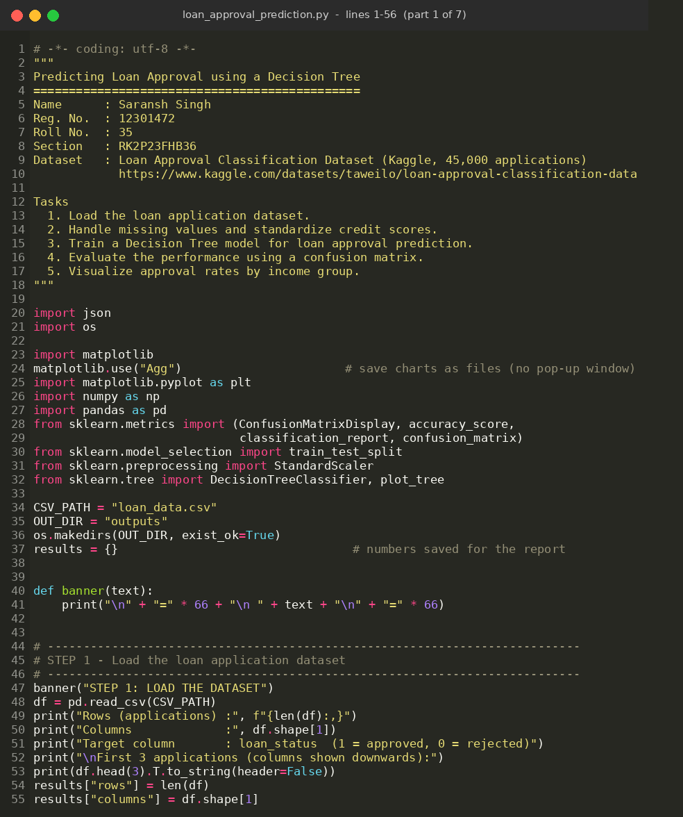
Figure 1: Source code – part 1 of 7
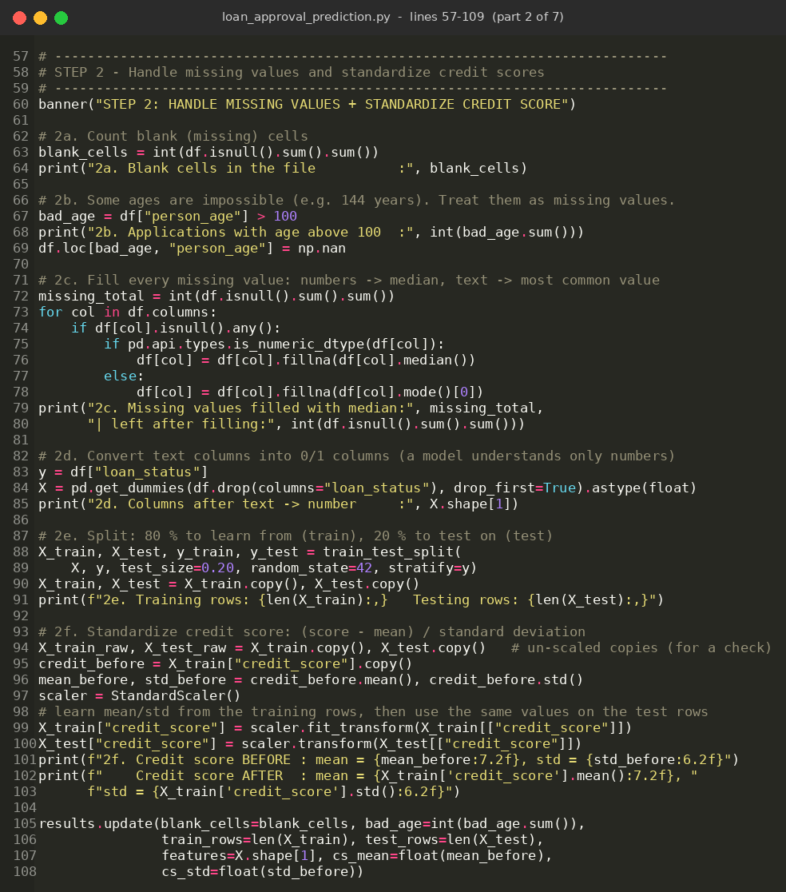
Figure 2: Source code – part 2 of 7
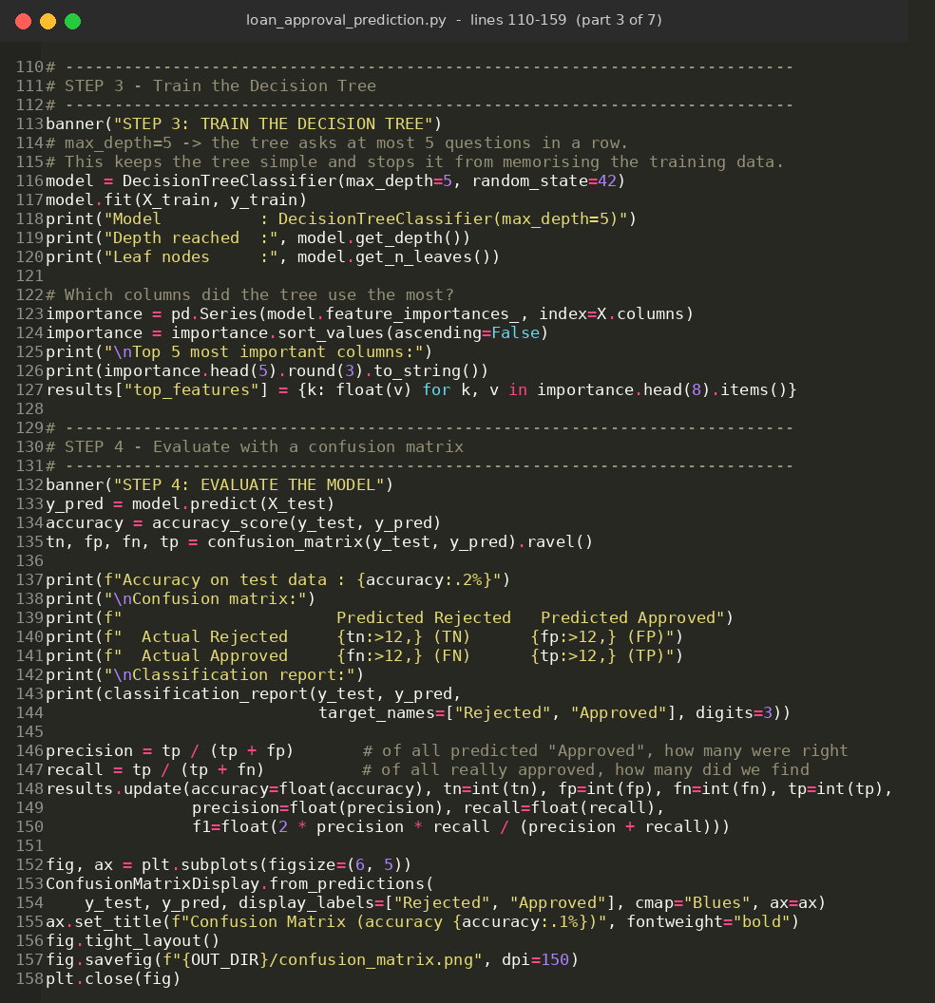
Figure 3: Source code – part 3 of 7
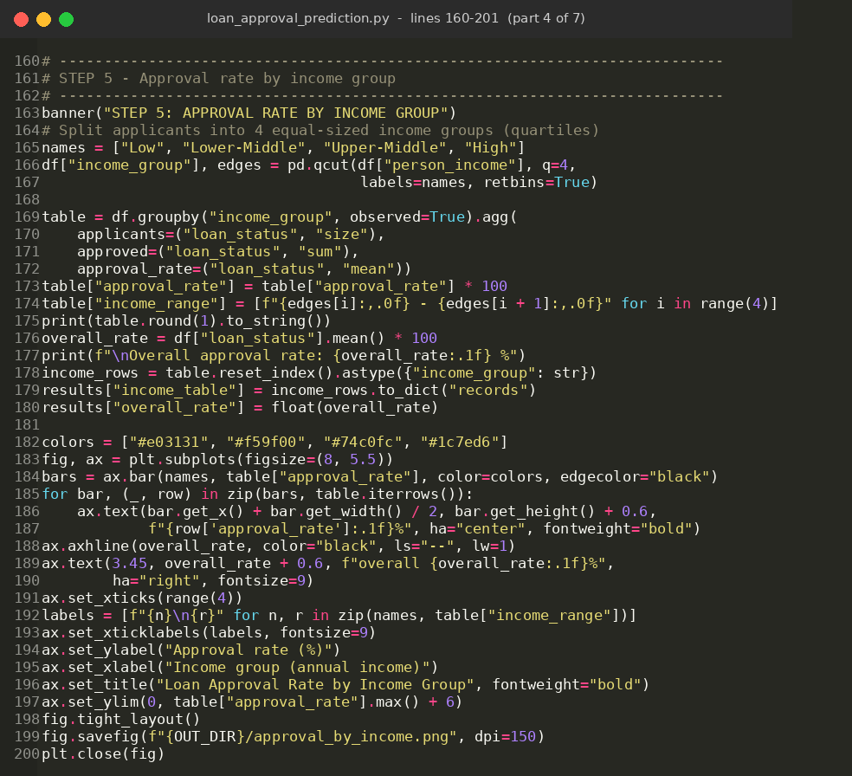
Figure 4: Source code – part 4 of 7
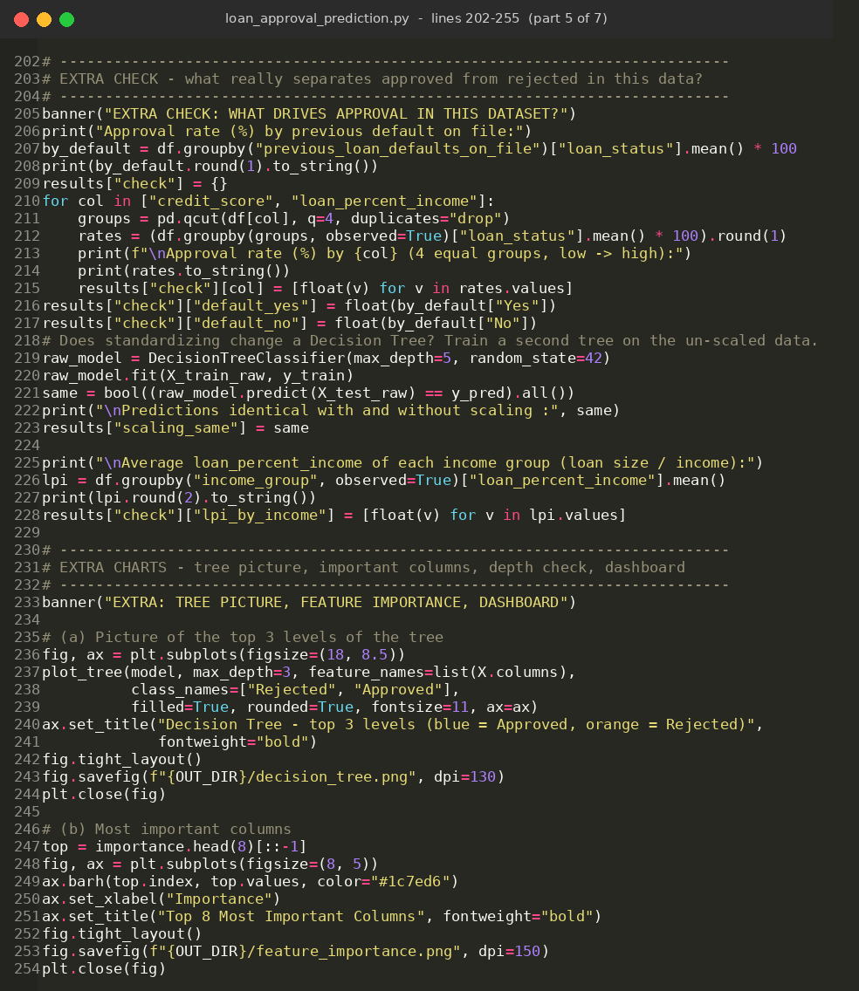
Figure 5: Source code – part 5 of 7
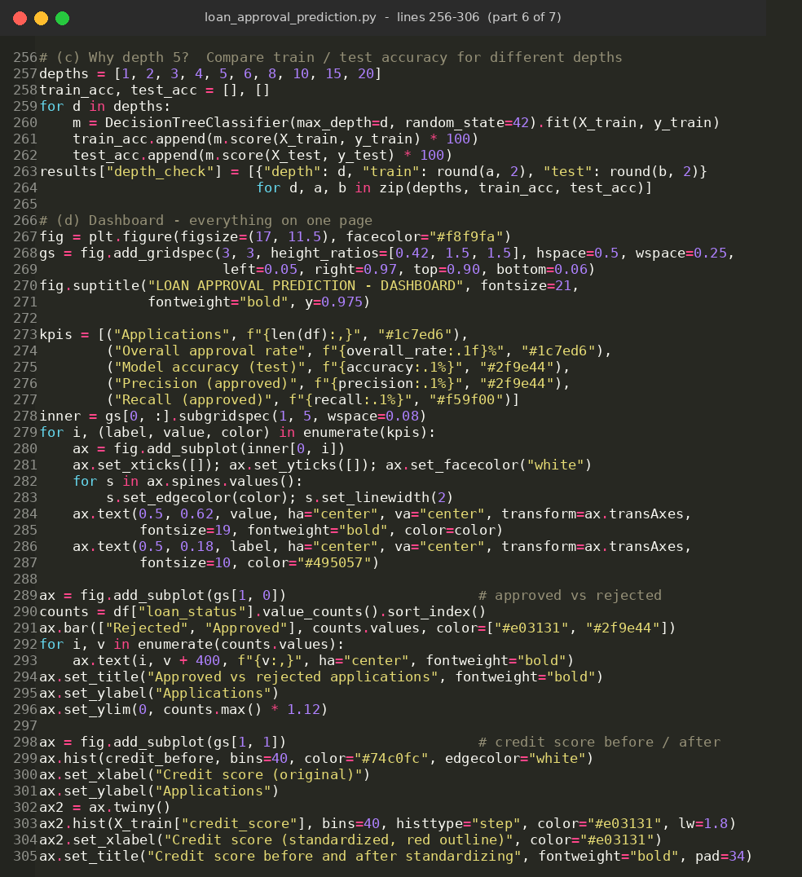
Figure 6: Source code – part 6 of 7
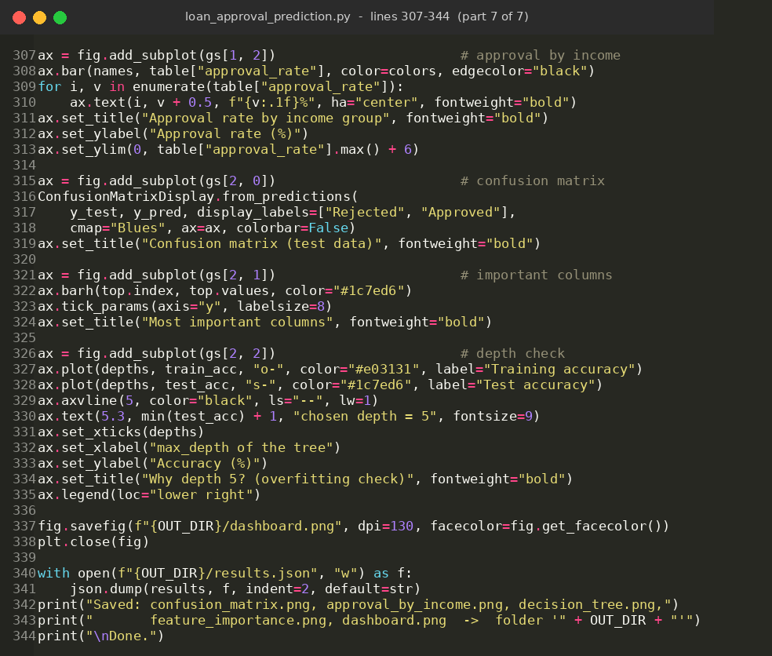
Figure 7: Source code – part 7 of 7

5. Output Screenshot

5.1 Console output
The program prints the result of every step. Figures 8 to 10 show the output of the full run.
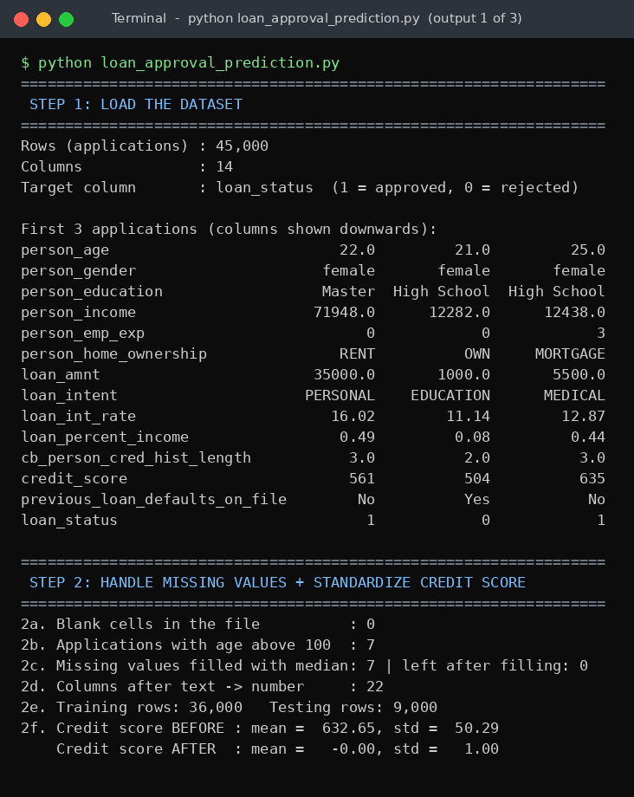
Figure 8: Console output – Steps 1 and 2 (loading, missing values, standardization)
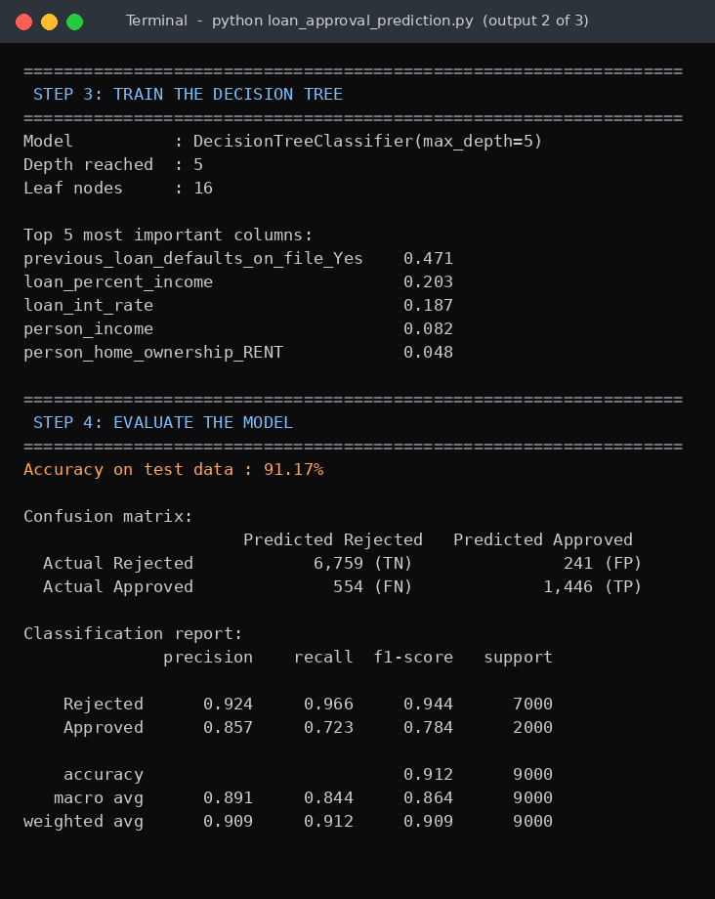
Figure 9: Console output – Steps 3 and 4 (training and evaluation)
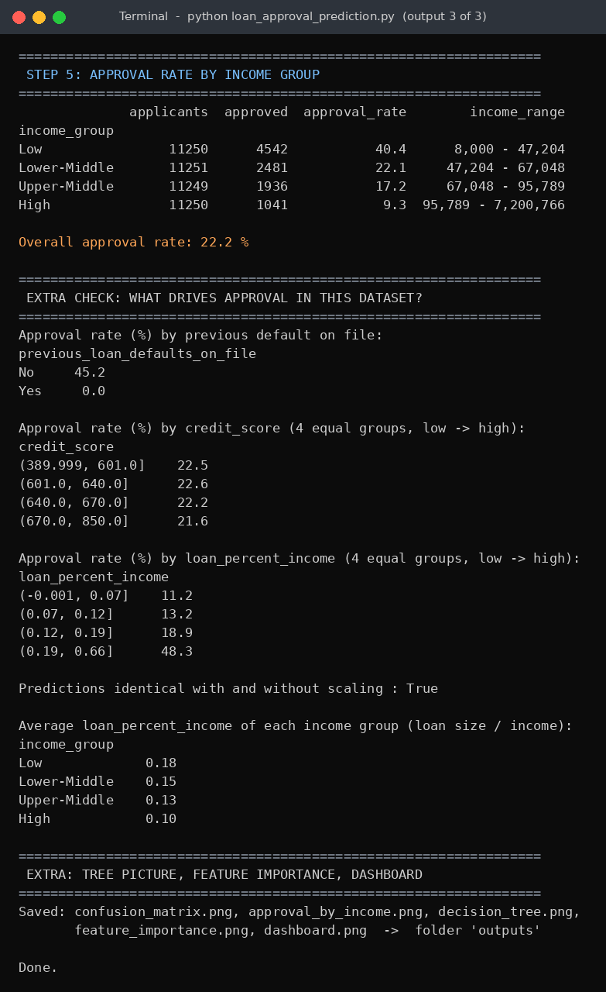
Figure 10: Console output – Step 5 and extra checks

5.2 Summary of results
Measure | Result
Applications in the dataset | 45,000
Blank cells / impossible ages fixed | 0 / 7
Training rows / test rows | 36,000 / 9,000
Credit score before standardizing | mean 632.65, std 50.29
Credit score after standardizing | mean 0.00, std 1.00
Decision Tree | max_depth = 5, 16 leaf nodes
Accuracy on test data | 91.17%
Precision (Approved) | 85.7%
Recall (Approved) | 72.3%
F1-score (Approved) | 78.4%
Overall approval rate | 22.2%
Most important column | previous_loan_defaults_on_file (47.1%)

5.3 Confusion matrix
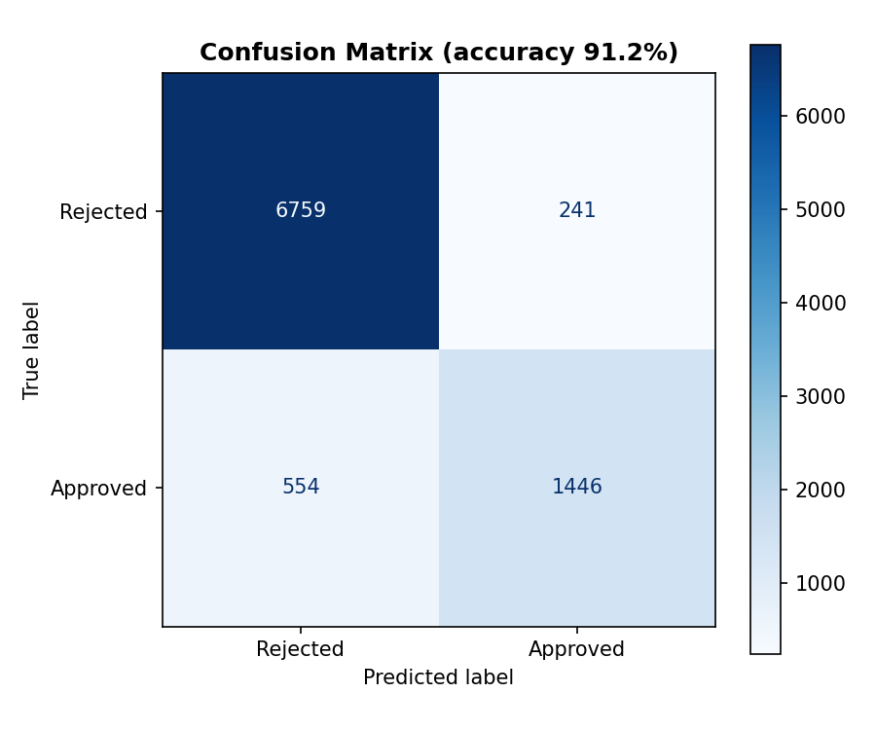
Figure 11: Confusion matrix on the 9,000 test applications
Cell | Meaning | Count
TN | Really rejected, predicted Rejected – correct | 6,759
FP | Really rejected, predicted Approved – wrong approval | 241
FN | Really approved, predicted Rejected – good applicant missed | 554
TP | Really approved, predicted Approved – correct | 1,446

- Accuracy = (TN + TP) / all = (6,759 + 1,446) / 9,000 = 91.17%.
- Precision = TP / (TP + FP) = 1,446 / 1,687 = 85.7%. When the model says “Approved”, it is right about 86 times out of 100.
- Recall = TP / (TP + FN) = 1,446 / 2,000 = 72.3%. The model finds about 72 of every 100 really approved applications and misses the rest.
- Baseline: 7,000 of the 9,000 test applications (77.8%) are rejected, so a model that rejects everyone would already score 77.8%. The tree’s 91.2% is clearly better than that.

5.4 Approval rate by income group
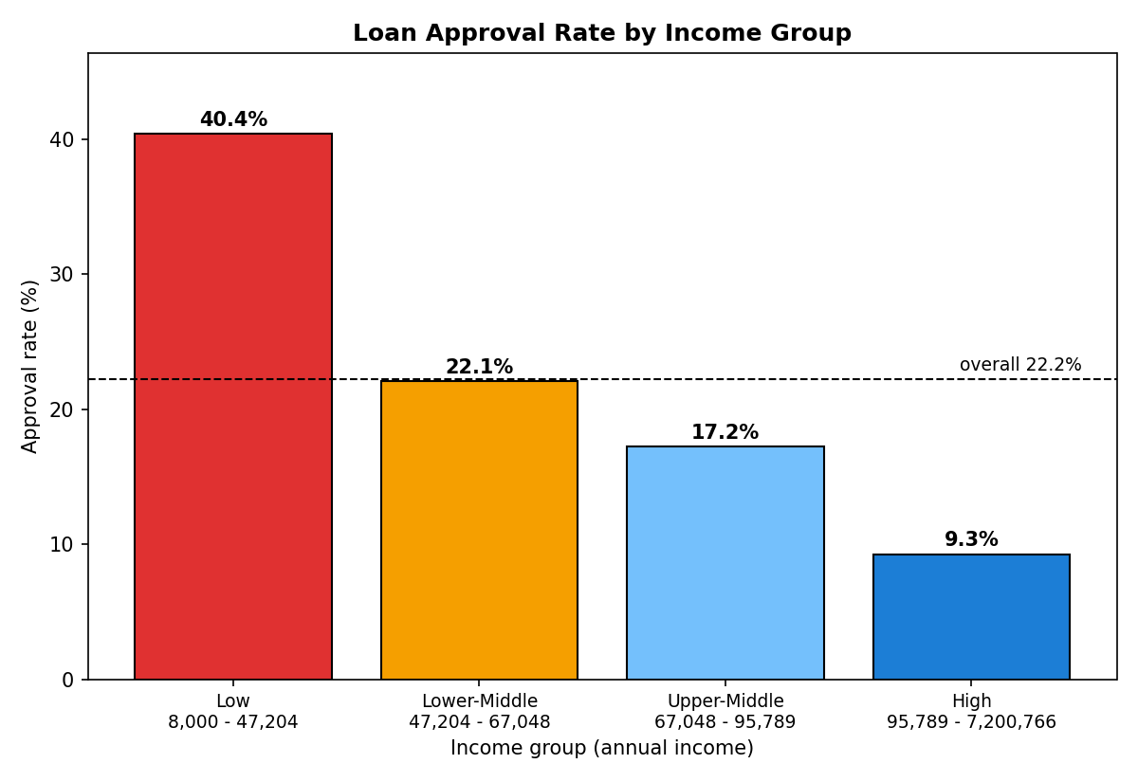
Figure 12: Approval rate by income group (annual income range under each group)
Income group | Income range | Applicants | Approved | Approval rate
Low | 8,000 - 47,204 | 11,250 | 4,542 | 40.4%
Lower-Middle | 47,204 - 67,048 | 11,251 | 2,481 | 22.1%
Upper-Middle | 67,048 - 95,789 | 11,249 | 1,936 | 17.2%
High | 95,789 - 7,200,766 | 11,250 | 1,041 | 9.3%

What the chart shows. The approval rate falls as income rises, from 40.4% in the Low group to 9.3% in the High group.
Why? This is the opposite of what is normal in real banks, so it was checked (see the extra check in Figure 10). Low-income applicants ask for a larger share of their income (average loan_percent_income 0.18 in the Low group against 0.10 in the High group), and in this dataset a higher loan_percent_income goes together with a higher approval rate (11.2% in the lowest quarter against 48.3% in the highest quarter). Because the dataset is synthetic, the result describes this dataset only and should not be read as the policy of a real bank.

5.5 The Decision Tree
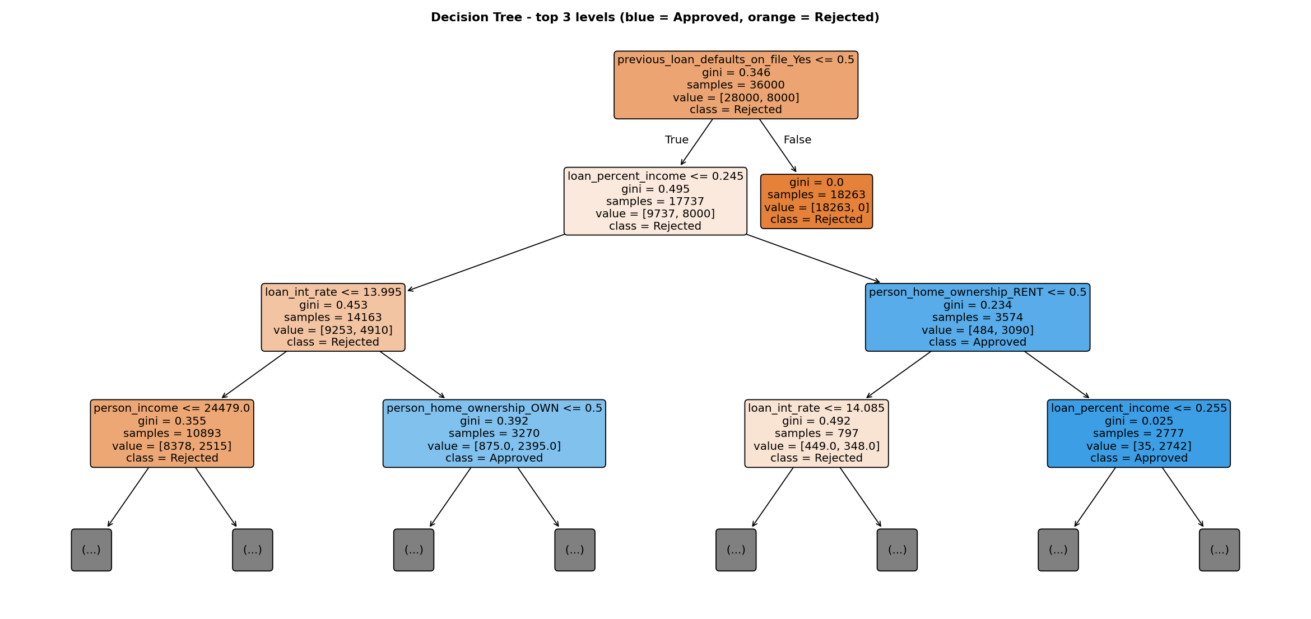
Figure 13: Top three levels of the trained Decision Tree (blue = Approved, orange = Rejected; gini = impurity, 0 means the box holds only one class)
The first question is “does the applicant have a previous default?”. If yes (right-hand box), all 18,263 such training applications are rejected. If no, the tree next looks at loan_percent_income, then at the interest rate, home ownership and income to separate approved from rejected applications.

5.6 Most important columns
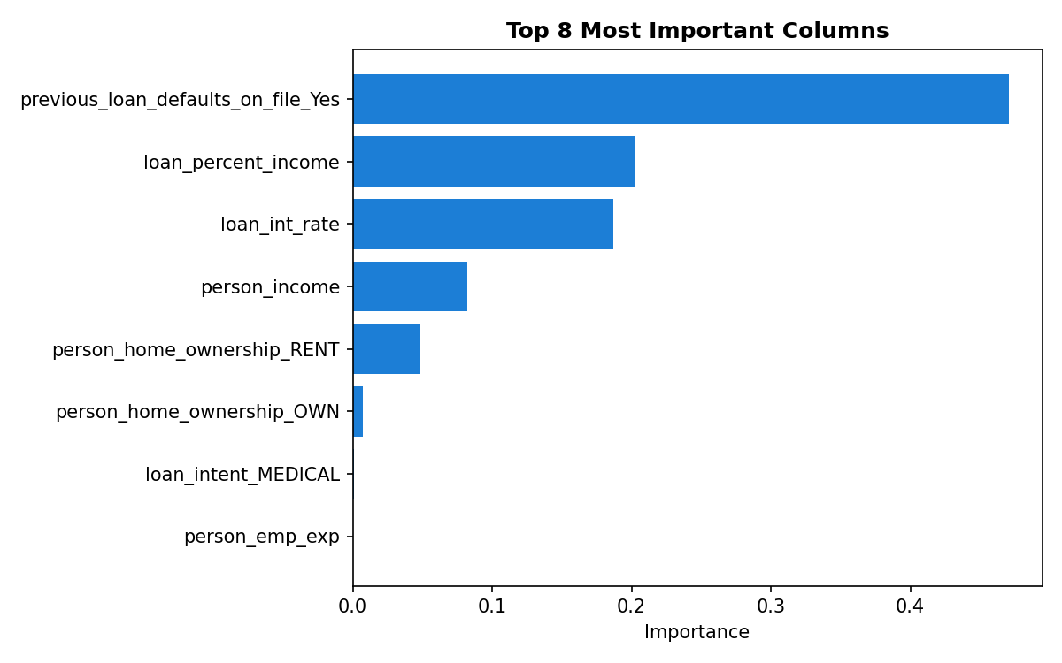
Figure 14: The eight most important columns used by the tree
previous_loan_defaults_on_file is by far the most important column (47.1% of the tree’s decisions), followed by loan_percent_income (20.3%) and loan_int_rate (18.7%). The credit score does not appear among the main columns.

5.7 Extra check – what drives approval in this dataset?
Group of applicants | Approval rate
Previous default on file: Yes | 0.0% (all 22,856 rejected)
Previous default on file: No | 45.2%
Credit score – lowest to highest quarter | 22.5% → 22.6% → 22.2% → 21.6%
loan_percent_income – lowest to highest quarter | 11.2% → 13.2% → 18.9% → 48.3%

Approval rate is almost the same in every credit-score quarter (about 22%), so in this dataset the credit score hardly separates approved from rejected applications. Standardizing it is still done as the task requires. A Decision Tree is not affected by scaling: the tree trained on un-scaled data gave exactly the same test predictions (identical = true).

6. Dashboard
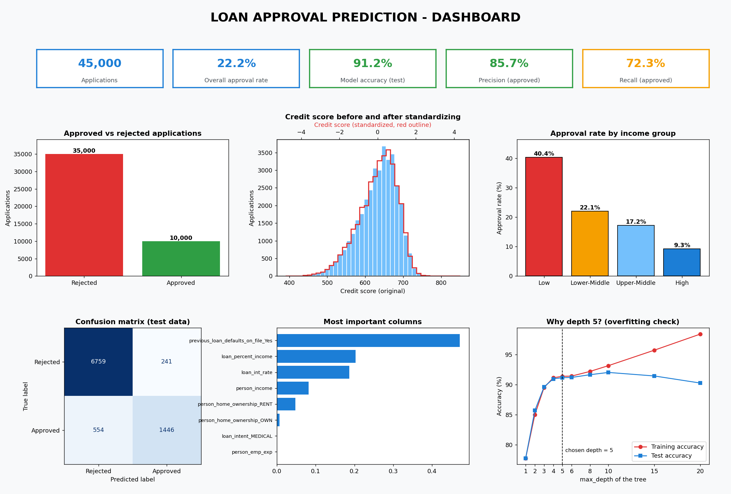
Figure 15: Dashboard – key figures, approved vs rejected, credit score before/after standardizing, approval rate by income group, confusion matrix, important columns and the overfitting check

Dashboard insights
- Imbalanced data. Only 22.2% of the applications are approved, so precision and recall matter as much as accuracy.
- Good overall accuracy. The tree classifies 91.2% of unseen applications correctly (baseline 77.8%). It is more careful than generous: precision 85.7% against recall 72.3%.
- Depth 5 is a good choice. At depth 5 the training and test accuracy are 91.4% and 91.17%, almost equal. At depth 20 the training accuracy rises to 98.43% but the test accuracy drops to 90.28% – the tree has started to memorize.
- Income and approval. Approval rate decreases from the Low to the High income group in this dataset, mainly because low-income applicants request a bigger share of their income (see Section 5.4).
- Previous default decides a lot. No applicant with a previous default was approved, which is why this column is the first question of the tree.

7. Conclusion
A Decision Tree with a maximum depth of 5 was trained on 36,000 loan applications and tested on 9,000 unseen ones. The data was cleaned (7 impossible ages filled with the median) and the credit score was standardized. The model reached an accuracy of 91.17% with a precision of 85.7% and a recall of 72.3% for approved loans. The confusion matrix shows 241 wrong approvals and 554 missed good applicants out of 9,000. The approval rate by income group fell from 40.4% to 9.3% as income rose, a pattern that comes from this synthetic dataset. The model could be improved by tuning the tree, trying a Random Forest or using real bank data.

8. References
- Loan Approval Classification Dataset (Kaggle): https://www.kaggle.com/datasets/taweilo/loan-approval-classification-data
- scikit-learn documentation – Decision Trees: https://scikit-learn.org/stable/modules/tree.html
- pandas documentation: https://pandas.pydata.org/docs/
- Matplotlib documentation: https://matplotlib.org/stable/
- L. Breiman, J. Friedman, R. Olshen and C. Stone, Classification and Regression Trees, Wadsworth, 1984.

