Project Report Template

1 Introduction

* 1. Overview

Administrator should be able to create all base data including1 Introduction

* 1. Overview

Administrator should be able to create all base data including Semester, Candidate, Course and Lecturer, Lecturer should have the ability to create Internal Results, Dean, who is One of the Lecturer, should be the only one with ability to update Internal Results, Re-evaluation Can be initialized by Candidate for all Internal Results. Now only dean can update The marks after re-evaluation.

* 1. Purpose

CRM can improve customer retention by 27%, and companies that use CRM systems to The full extent can increase sales by 29%, based on Salesforce studies.

2. Problem Definition & Design

Thinking

1.3 Empathy map

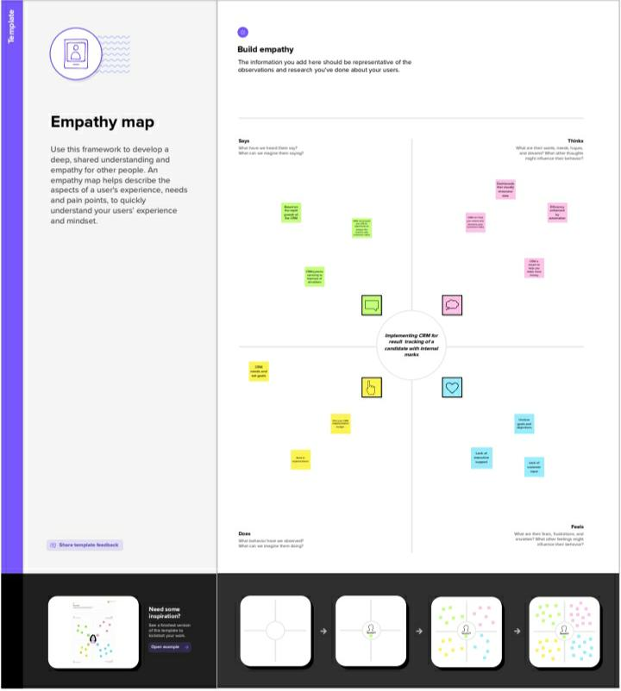

2.2 Ideation & brainstorming map

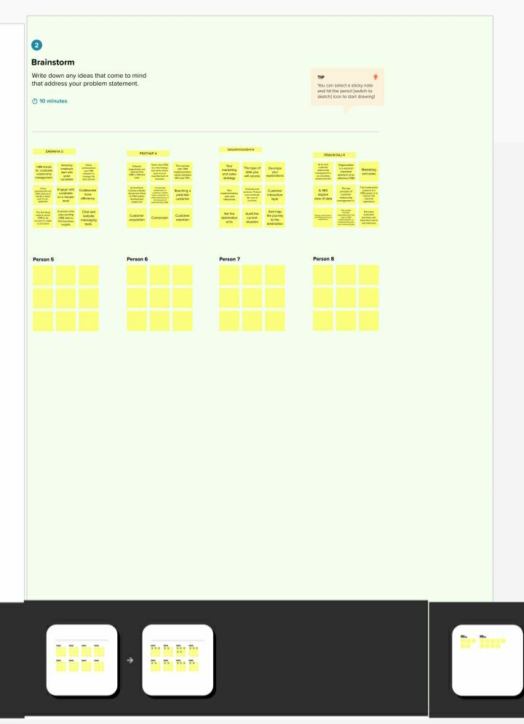

3.1 Data Model

Object name. Fields in the object

Obj1. Field label. Data type

Semester text

Candidate text

Obj2. Field label. Data type

Course details text

Lecturer details text

3.2

Activity & Screenshot

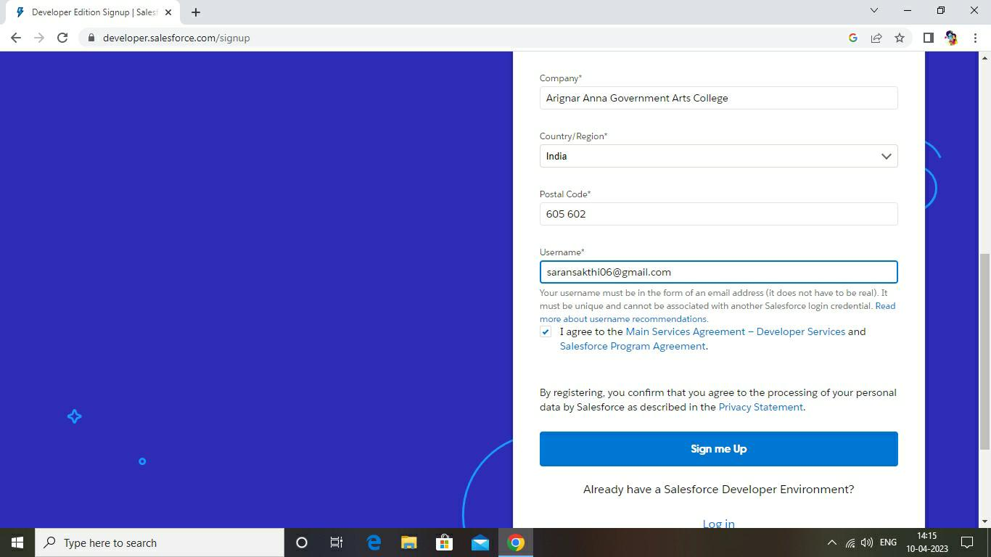

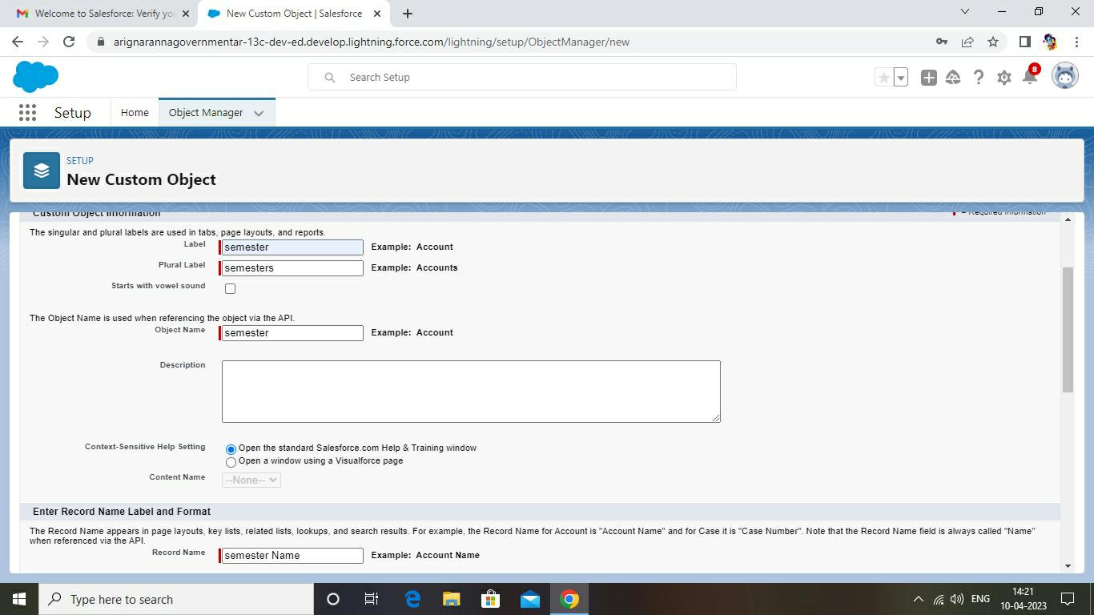

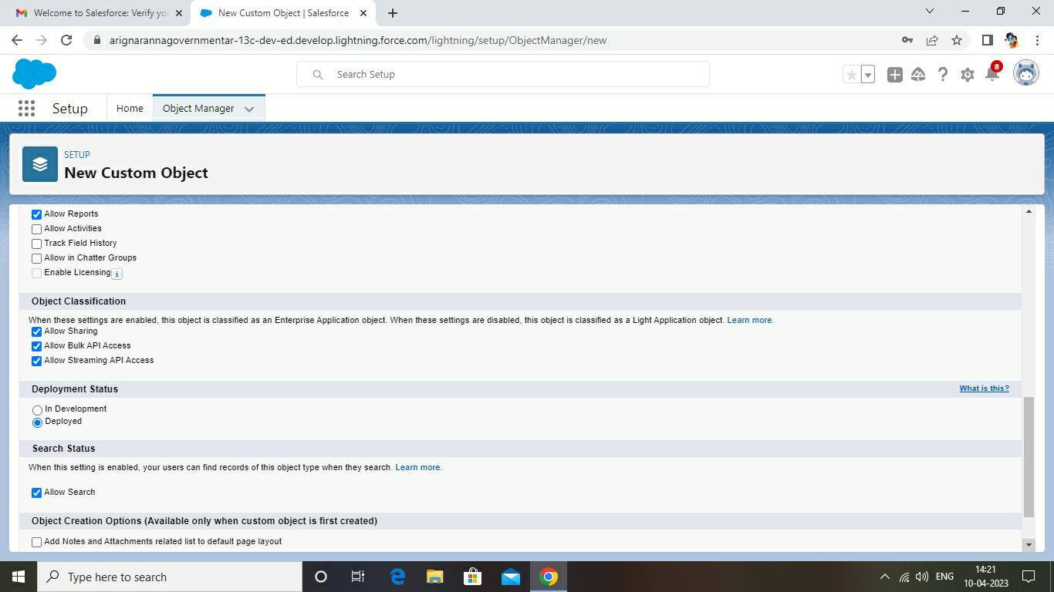

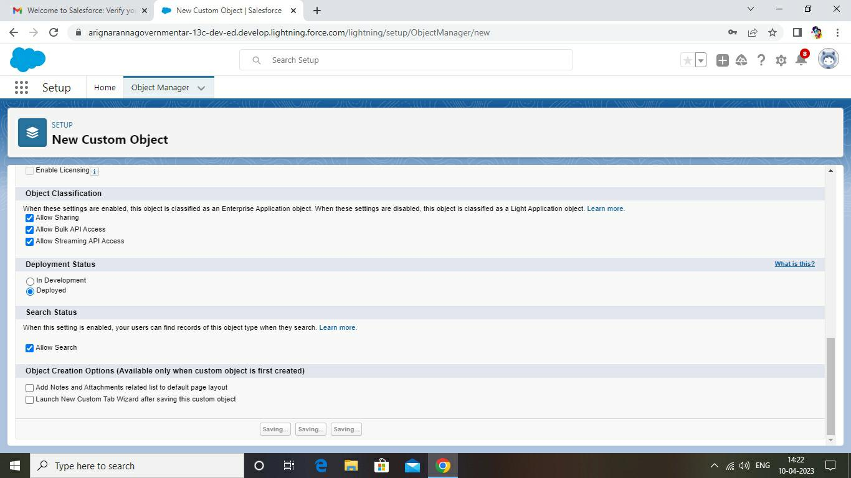

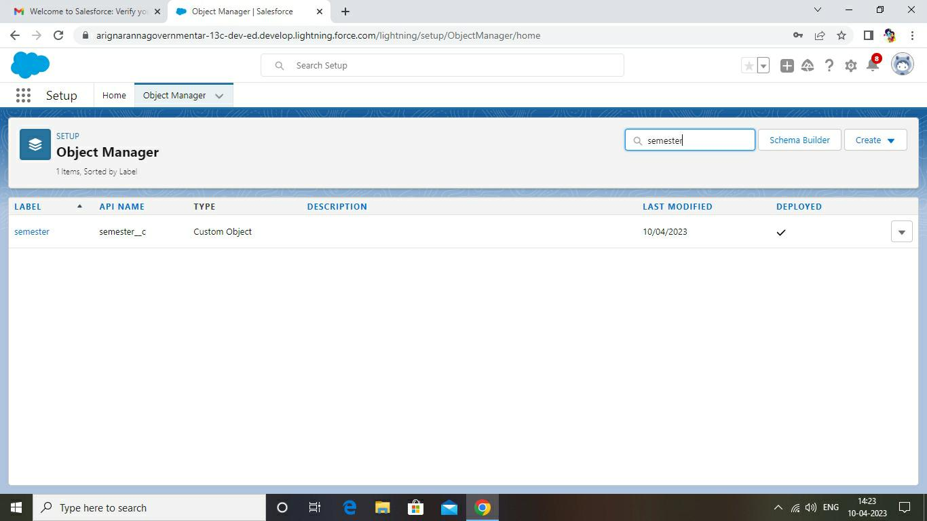

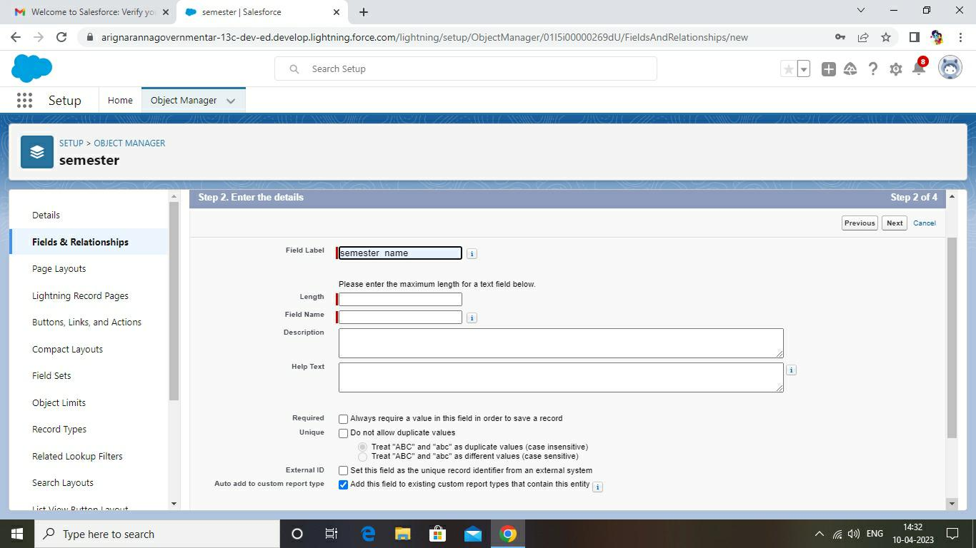

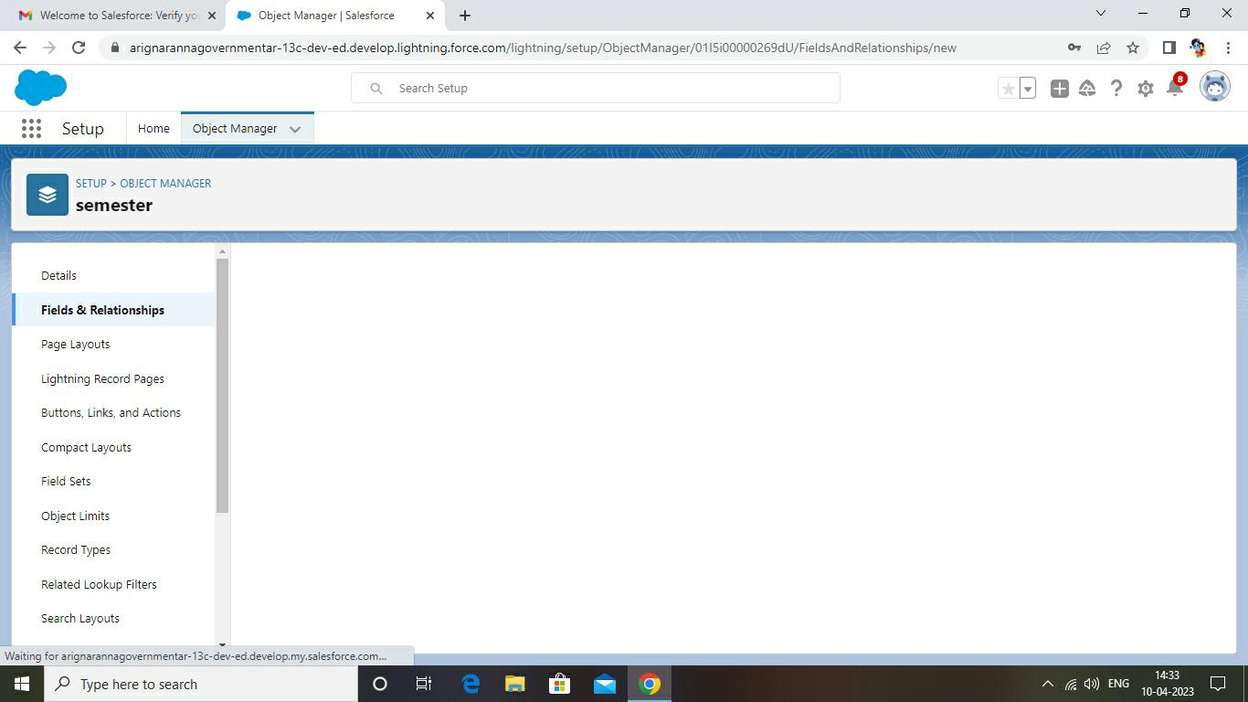

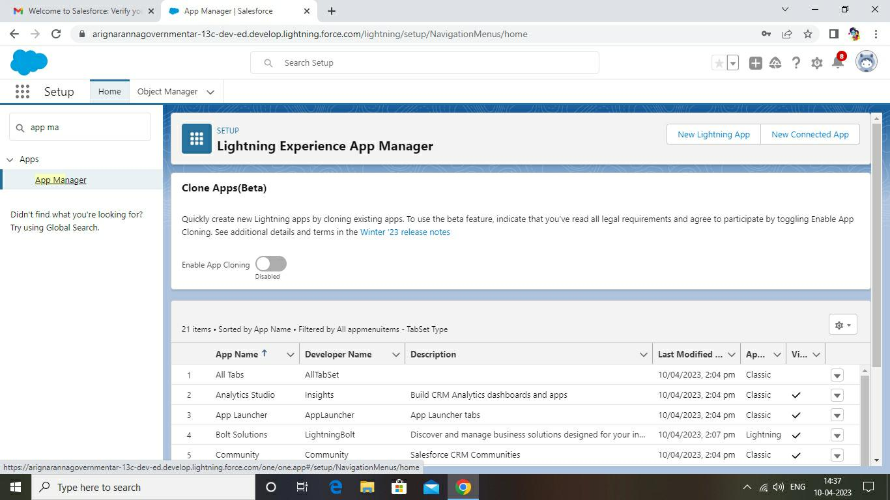

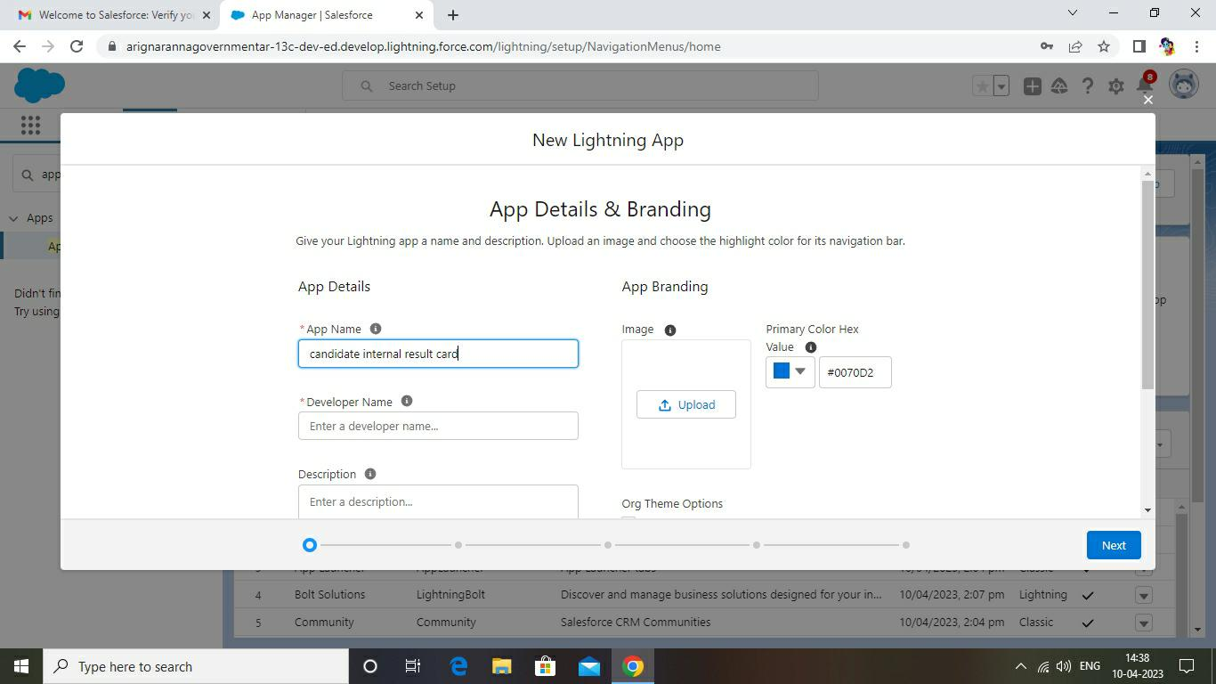

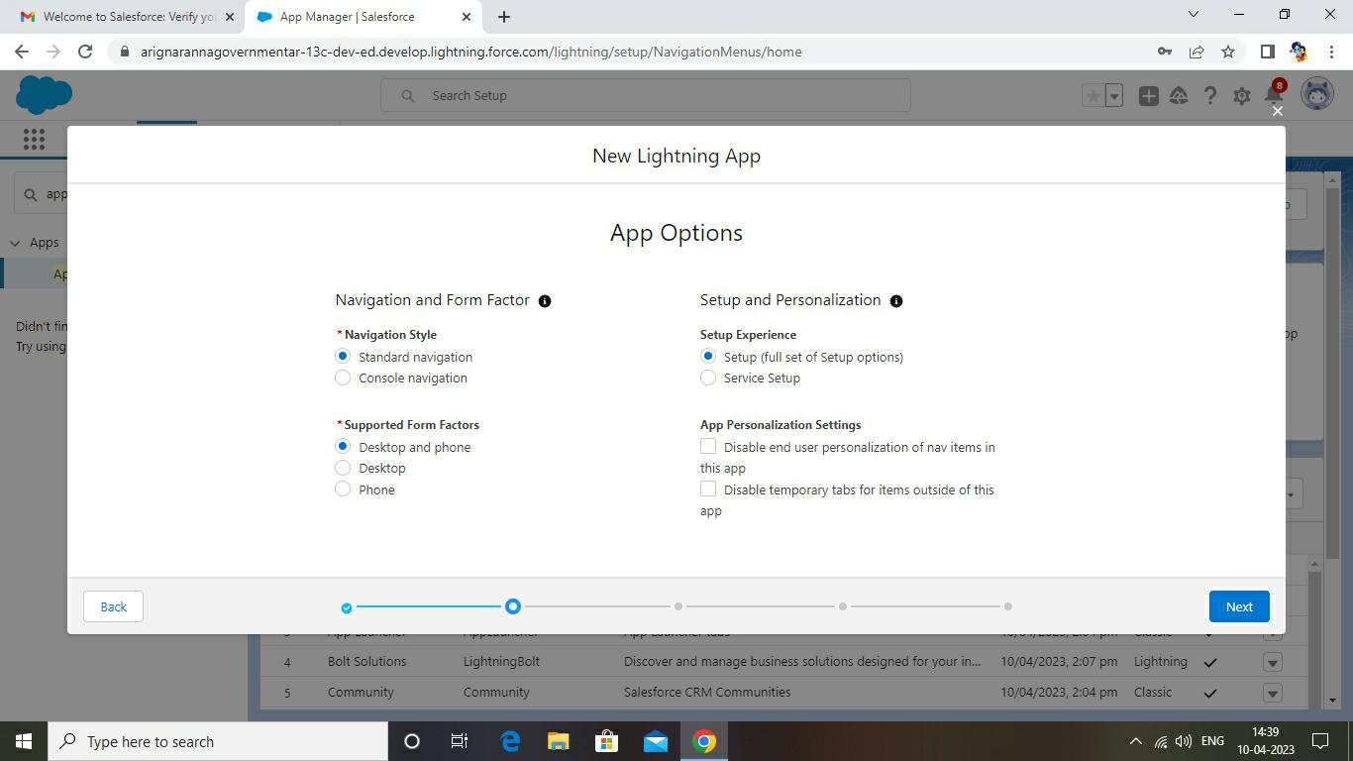

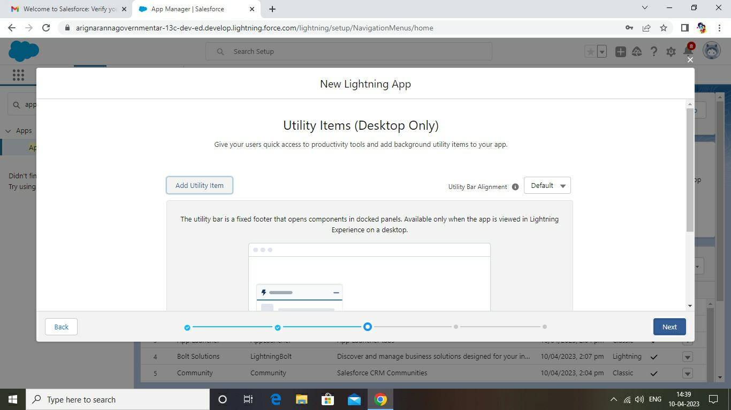

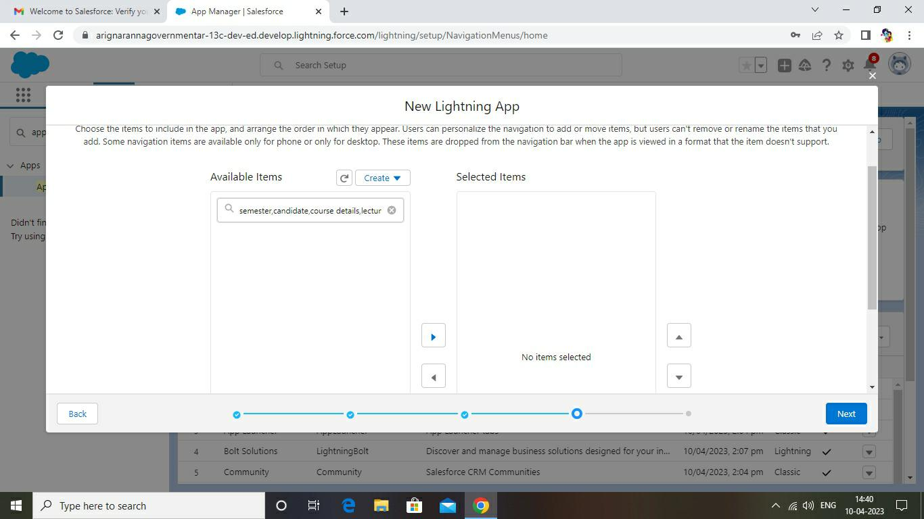

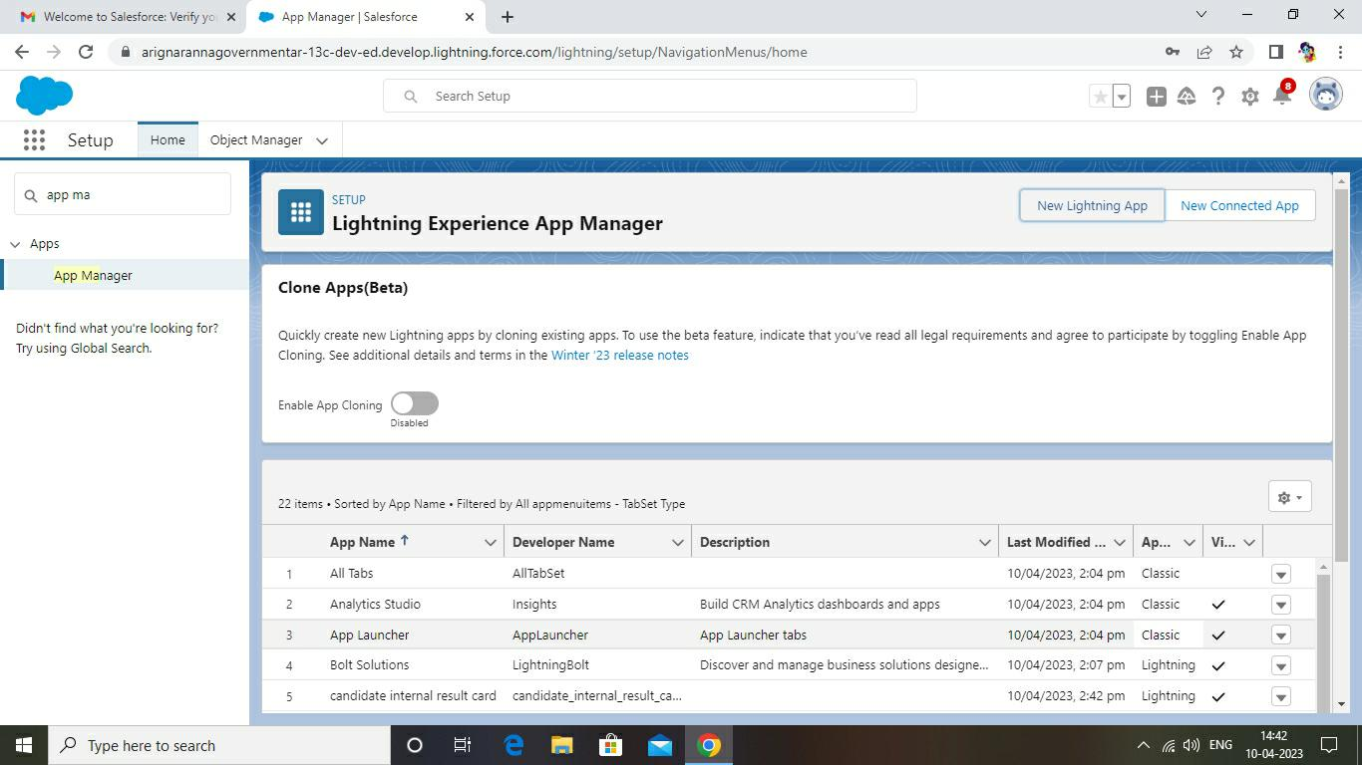

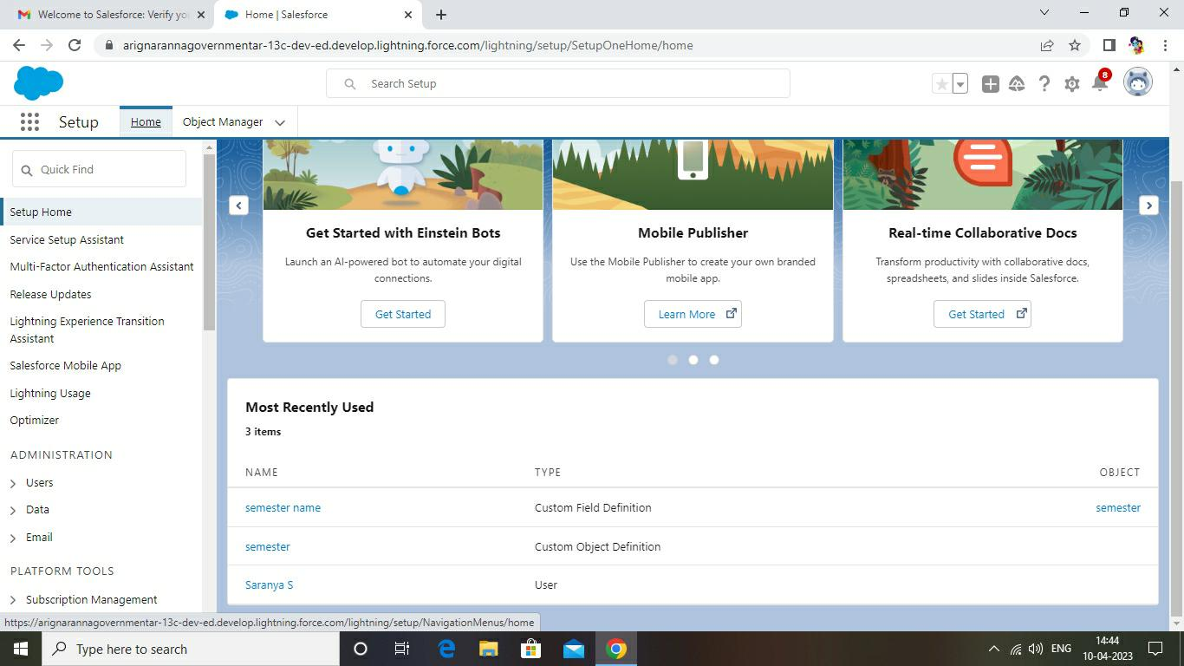

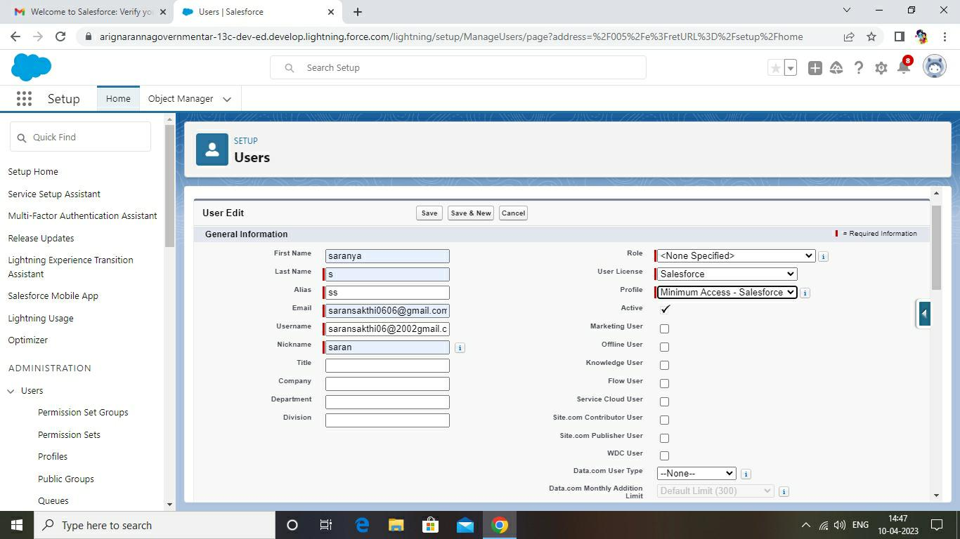

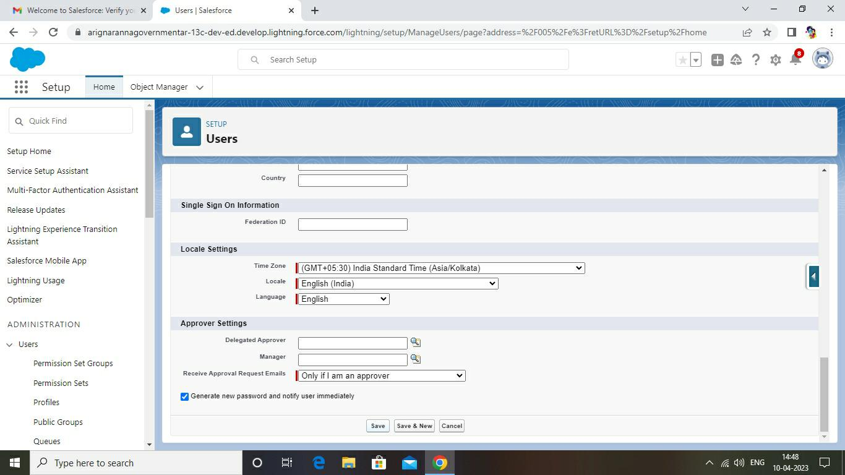

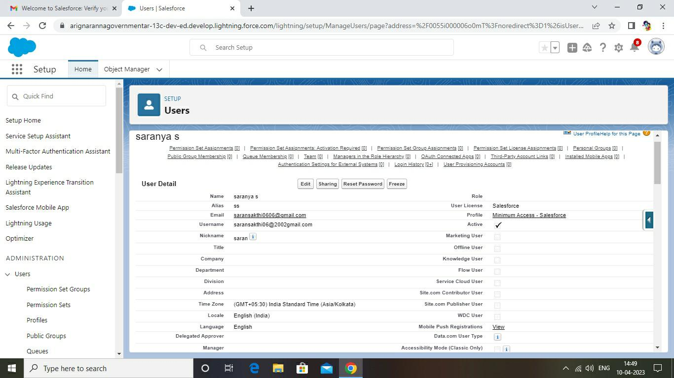

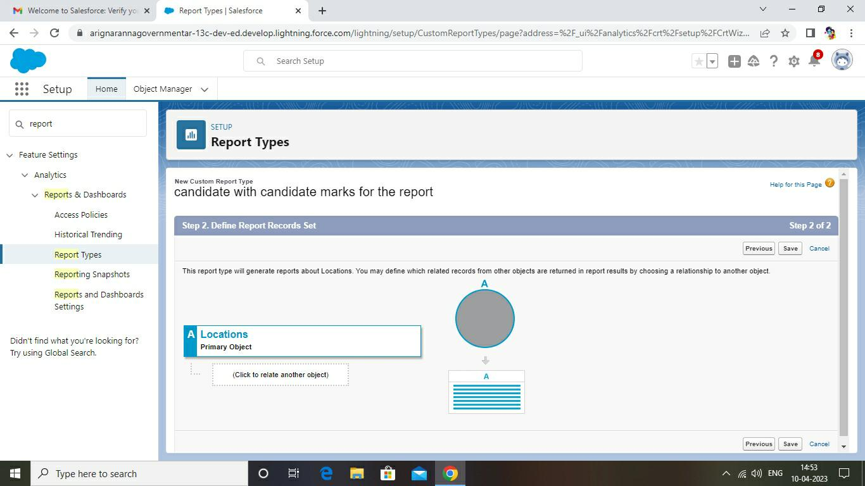

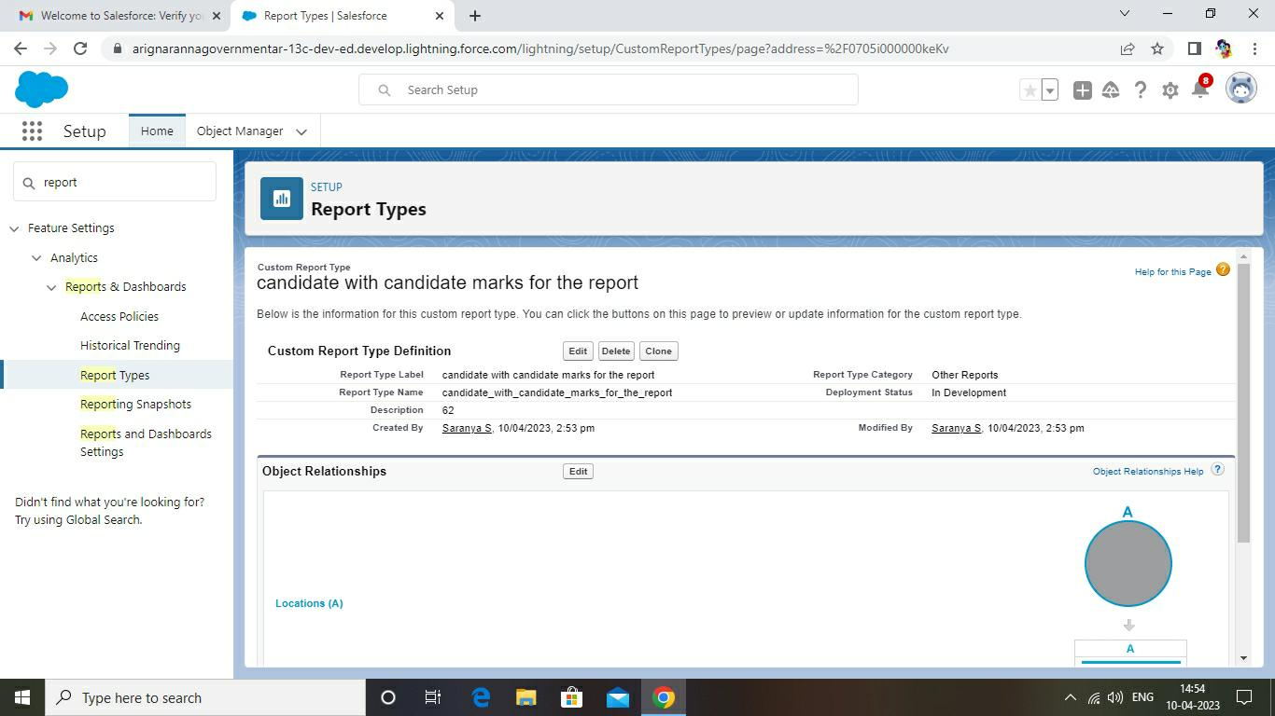

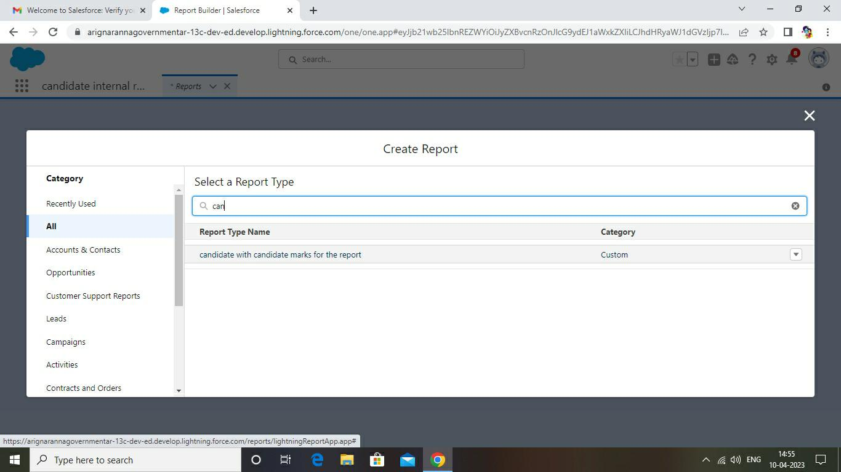

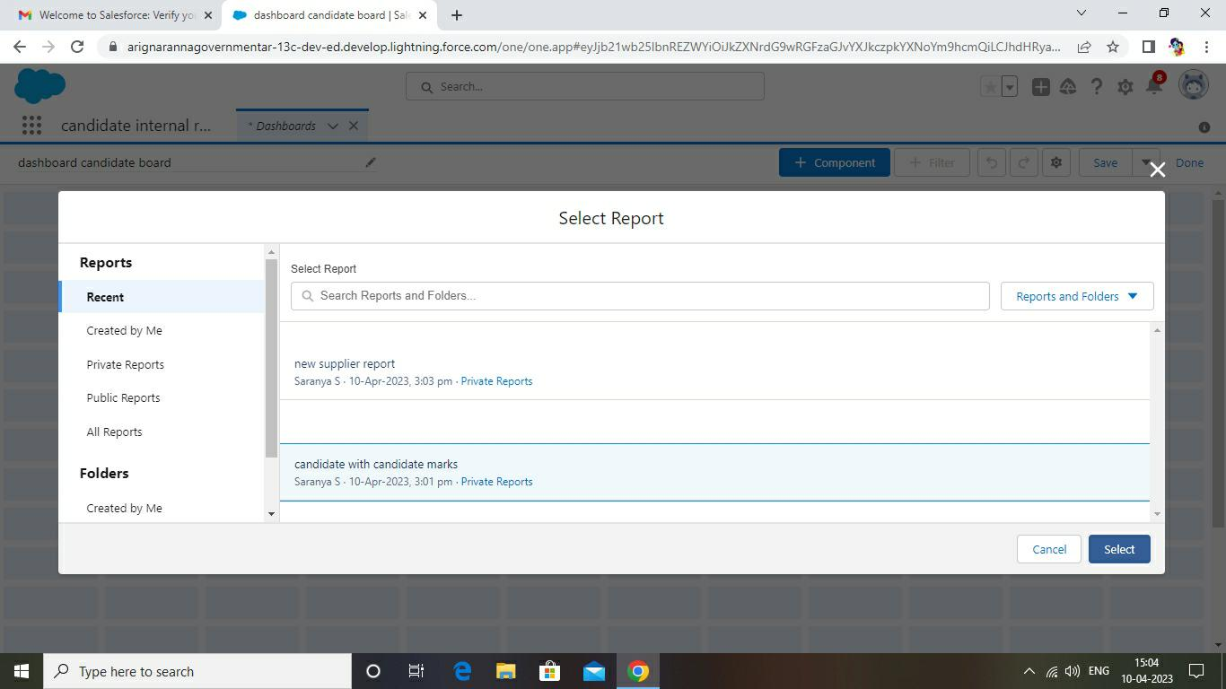

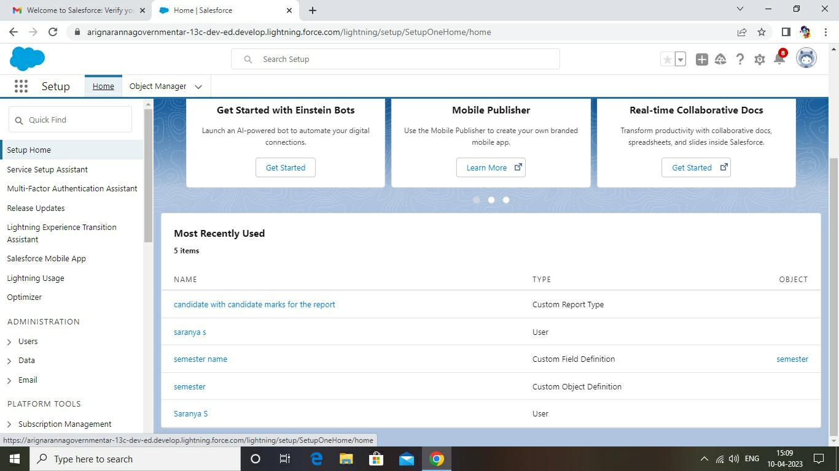

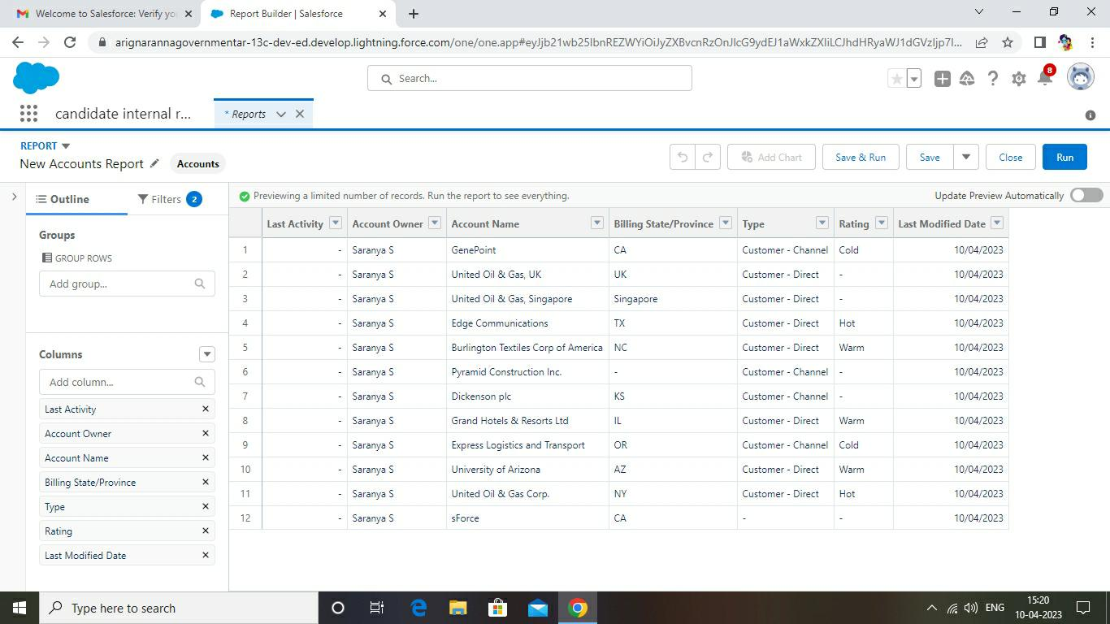

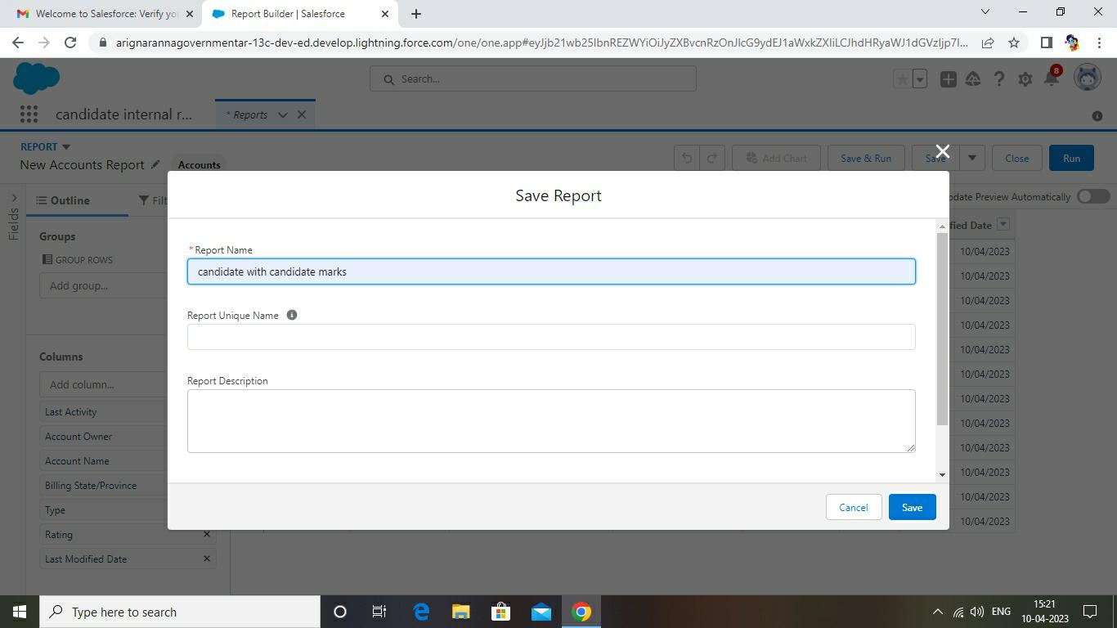

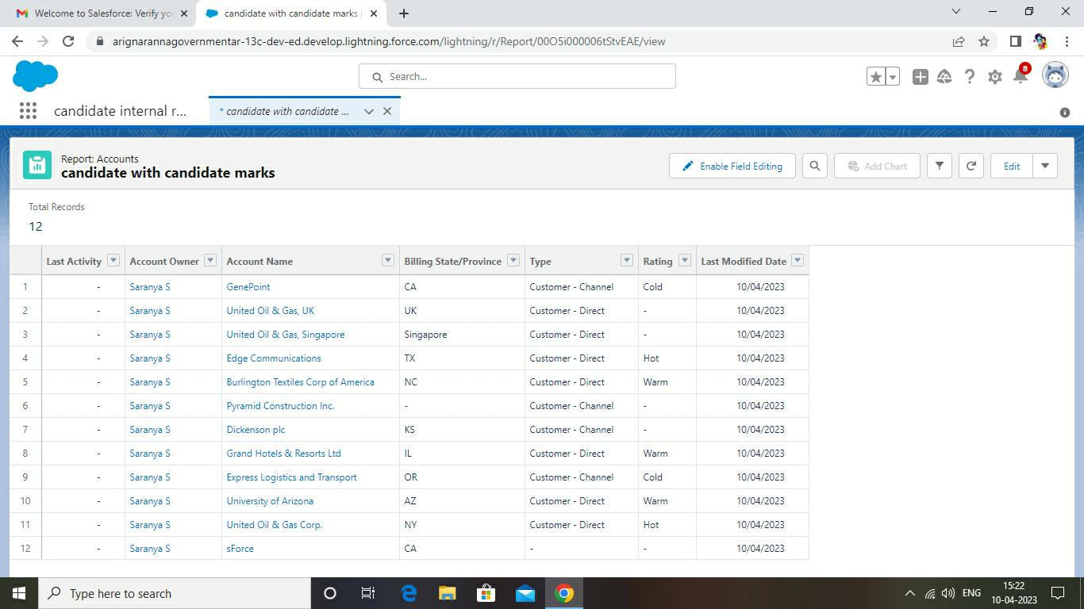

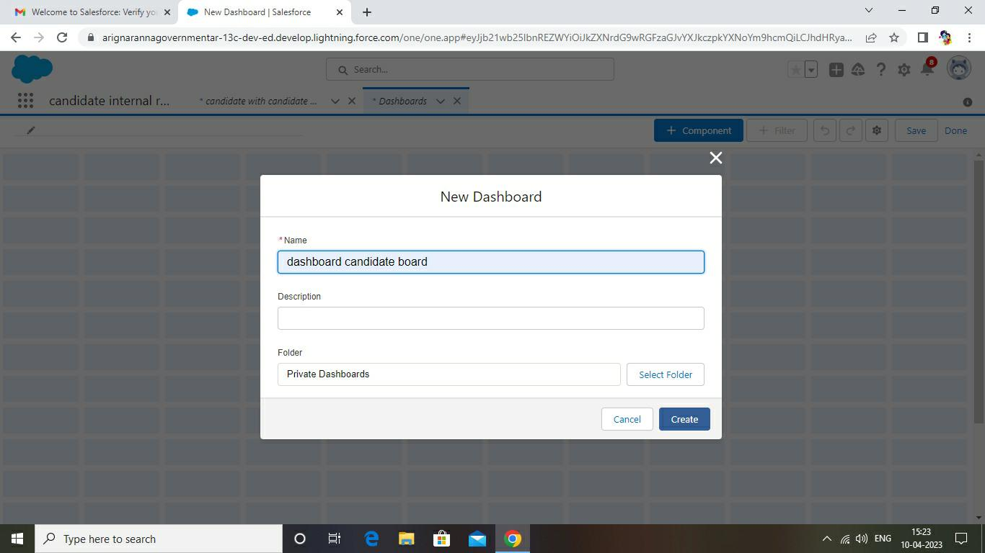

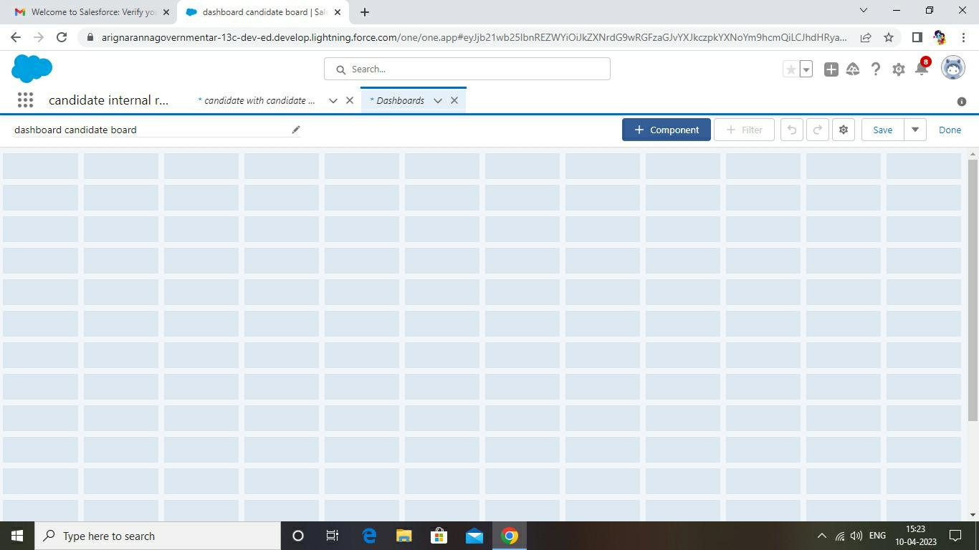

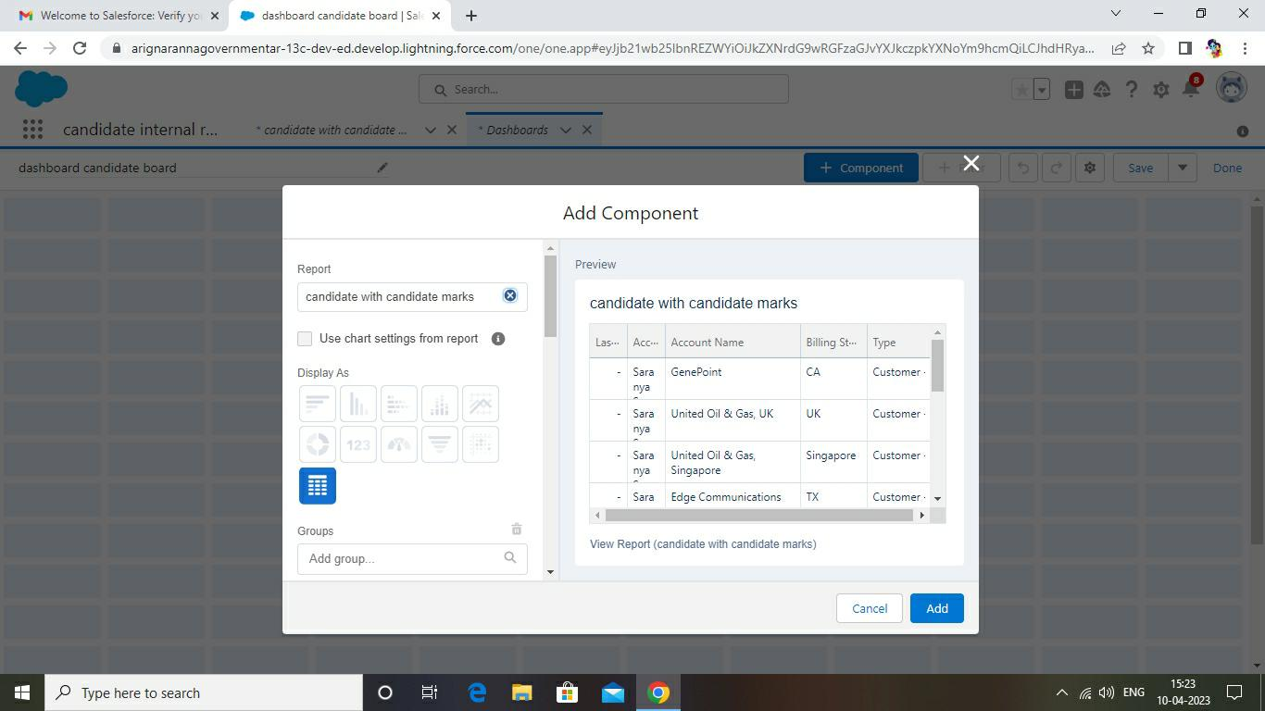

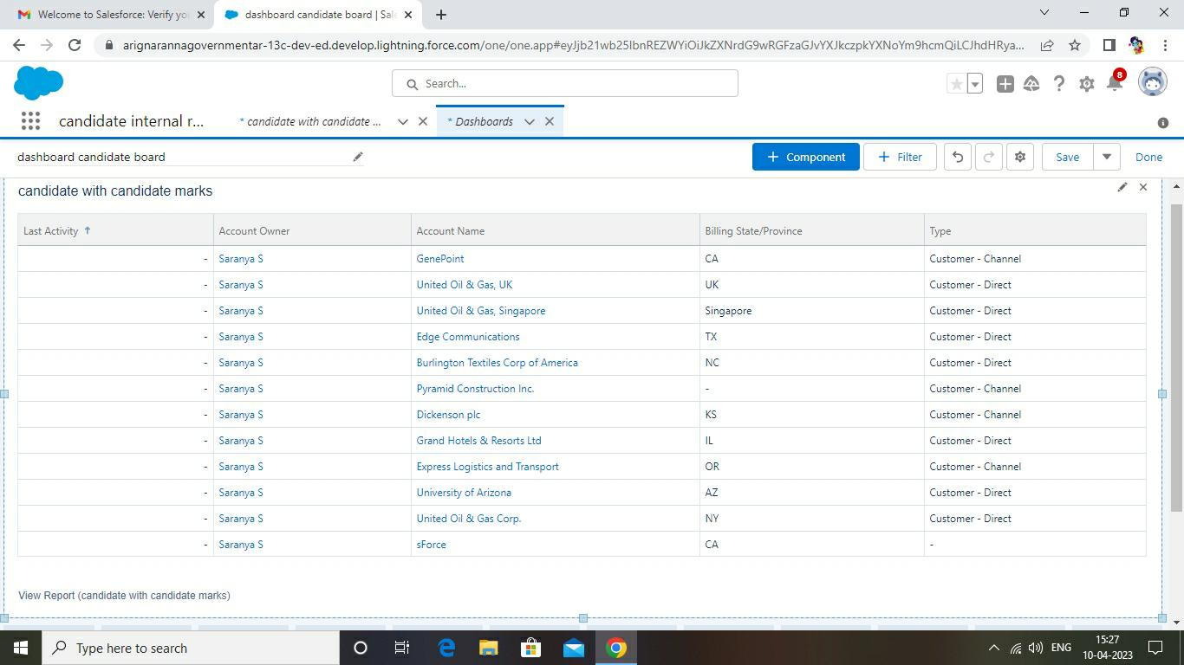

4. Trailhead profile public URL

Team leader : Saranya S https://trailblazer.me/id/saras337

Team member 1 :Praveen Raj https://trailblazer.me/id/pravr35

Team member 2 : Sanjeevgandhi

Team member 3 : prathap http://trailblazer.me/id/av287

5.Adavantages and disadvantages

Advantages,

Better knowledge of your customers. …Better segmentation. …Better customer retention. …

Better anticipation of needs. …Better and speedier communication

Disadvantages,

CRM costs. One of the greatest challenges to CRM implementation is cost.

Business culture. A lack of commitment or resistance to cultural change from people within the

Company can cause major difficulties with CRM implementation.

6. Application

Customer relationship management (CRM) is a technology for managing all your company’s

Relationships and interactions with customers and potential customers. The goal is simple:

Improve business relationships. A CRM system helps companies stay connected to

Customers, streamline processes, and improve profitability.

7. Conclusion

Customer Relationship Management enables a company to align its strategy with the needs

Of the customer in order to best meet those needs and thus ensure long-term customer

Loyalty.

8.Future scope

CRM systems might imply automation, but many only offer baseline automation options. The future Of CRM will include users who demand more functionality. They’ll be looking for providers that cover Typical CRM essentials as well as more sophisticated automation.

