Scalar fuction and its query?

The Scalar Functions in SQL are used to return a single value from the given input value. Following are a few of the most commonly used Aggregate Functions:

LCASE()

Used to convert string column values to lowercase

UCASE()

This function is used to convert a string column values to Uppercase.

LEN()

Returns the length of the text values in the column.

MID()

Extracts substrings in SQL from column values having String data type.

ROUND()

Rounds off a numeric value to the nearest integer.

NOW()

This function is used to return the current system date and time.

FORMAT()

Used to format how a field must be displayed.

Syntax:

1

2

SELECT LCASE(ColumnName)

FROM TableName;

Syntax:

1

2

SELECT UCASE(ColumnName)

FROM TableName;

Syntax:

1

SELECT LENGTH(String) AS SampleColumn;

Syntax:

1

2

SELECT MID(ColumnName, Start, Length)

FROM TableName;

Syntax:

1

2

SELECT ROUND(ColumnName, Decimals)

FROM TableName;

Syntax:

FORMAT(InputValue, Format)

2.Explain joins with eg and output:

SQL | Join (Inner, Left, Right and Full Joins)

SQL Join statement is used to combine data or rows from two or more tables based on a common field between them. Different types of Joins are as follows:

INNER JOIN

LEFT JOIN

RIGHT JOIN

FULL JOIN

Student

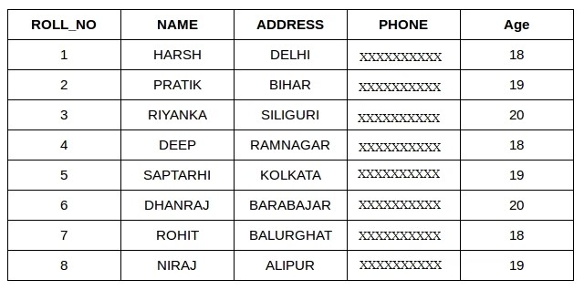

Student courses

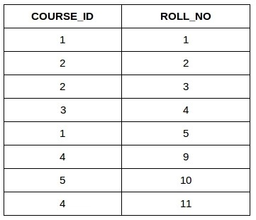

INNER JOIN

The INNER JOIN keyword selects all rows from both the tables as long as the condition is satisfied. This keyword will create the result-set by combining all rows from both the tables where the condition satisfies i.e value of the common field will be the same.

Syntax:

SELECT table1.column1,table1.column2,table2.column1,....

FROM table1

INNER JOIN table2

ON table1.matching_column = table2.matching_column;

table1: First table.

table2: Second table

matching_column: Column common to both the tables.

Note: We can also write JOIN instead of INNER JOIN. JOIN is same as INNER JOIN.

Example Queries(INNER JOIN)

This query will show the names and age of students enrolled in different courses.

SELECT StudentCourse.COURSE_ID, Student.NAME, Student.AGE FROM Student

INNER JOIN StudentCourse

ON Student.ROLL_NO = StudentCourse.ROLL_NO;

Output:

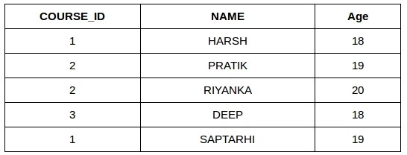

table2

B. LEFT JOIN

This join returns all the rows of the table on the left side of the join and matches rows for the table on the right side of the join. For the rows for which there is no matching row on the right side, the result-set will contain null. LEFT JOIN is also known as LEFT OUTER JOIN.

Syntax:

SELECT table1.column1,table1.column2,table2.column1,....

FROM table1

LEFT JOIN table2

ON table1.matching_column = table2.matching_column;

table1: First table.

table2: Second table

matching_column: Column common to both the tables.

Note: We can also use LEFT OUTER JOIN instead of LEFT JOIN, both are the same.

Example Queries(LEFT JOIN):

SELECT Student.NAME,StudentCourse.COURSE_ID

FROM Student

LEFT JOIN StudentCourse

ON StudentCourse.ROLL_NO = Student.ROLL_NO;

Output:

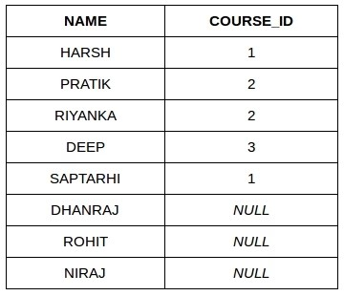

table3

C. RIGHT JOIN

RIGHT JOIN is similar to LEFT JOIN. This join returns all the rows of the table on the right side of the join and matching rows for the table on the left side of the join. For the rows for which there is no matching row on the left side, the result-set will contain null. RIGHT JOIN is also known as RIGHT OUTER JOIN.

Syntax:

SELECT table1.column1,table1.column2,table2.column1,....

FROM table1

RIGHT JOIN table2

ON table1.matching_column = table2.matching_column;

table1: First table.

table2: Second table

matching_column: Column common to both the tables.

Note: We can also use RIGHT OUTER JOIN instead of RIGHT JOIN, both are the same.

Example Queries(RIGHT JOIN):

SELECT Student.NAME,StudentCourse.COURSE_ID

FROM Student

RIGHT JOIN StudentCourse

ON StudentCourse.ROLL_NO = Student.ROLL_NO;

Output:

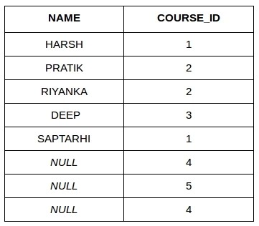:

3.sql query to rename the column name:

Methods to Rename a Column in SQL

ALTER TABLE table_name RENAME COLUMN oldcolumn_name to newcolumn_name;

ALTER TABLE table_name CHANGE COLUMN oldcolumn_name to newcolumn_name;

sp_rename 'TableName.oldcolumn_name', 'newcolumn_name', 'COLUMN';