4.sql query to find duplicate records :

One way to find duplicate records from the table is the GROUP BY statement. The GROUP BY statement in SQL is used to arrange identical data into groups with the help of some functions. i.e if a particular column has the same values in different rows then it will arrange these rows in a group.

Query to find the duplicate records in greek:

SELECT GeekRank, COUNT(GeekID) AS DuplicateRanks

FROM Geeks

GROUP BY GeekRank

HAVING COUNT(GeekRank)>1;

5.Distinct statement and its uses:

DISTINCT clause is used to remove the duplicates columns from the result set.The distinct keyword is used with select keyword in conjunction. It is helpful when we avoid duplicate values present in the specific columns/tables. The unique values are fetched when we use the distinct keyword.

SELECT DISTINCT returns only distinct (different) values.

DISTINCT eliminates duplicate records from the table.

DISTINCT can be used with aggregates: COUNT, AVG, MAX, etc.

DISTINCT operates on a single column.

Multiple columns are not supported for DISTINCT

6.Remove duplicates from the table.

To delete the duplicate rows from the table in SQL Server, you follow these steps:

Find duplicate rows using GROUP BY clause or ROW_NUMBER() function.

Use DELETE statement to remove the duplicate rows.

7.Print max salary for particular department:

Here we are going to see how to get the highest salary of each department. Here, we will first create a database named “geeks” then we will create a table “department” in that database. After, that we will execute our query on that table.

Creating Database:

CREATE geeks;

To use this database: USE geeks;

This is our table in the geeks database:

CREATE TABLE department(

ID int,

SALARY int,

NAME Varchar(20),

DEPT_ID Varchar(255));

To see the description of the table:

EXEC sp_columns department;

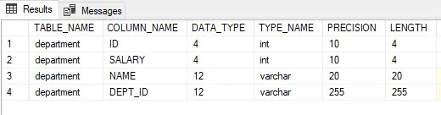

Add value into the table:

INSERT INTO department VALUES (1, 34000, 'ANURAG', 'UI DEVELOPERS');

INSERT INTO department VALUES (2, 33000, 'harsh', 'BACKEND DEVELOPERS');

INSERT INTO department VALUES (3, 36000, 'SUMIT', 'BACKEND DEVELOPERS');

INSERT INTO department VALUES (4, 36000, 'RUHI', 'UI DEVELOPERS');

INSERT INTO department VALUES (5, 37000, 'KAE', 'UI DEVELOPERS');



This is our data inside the table:

SELECT * FROM department;

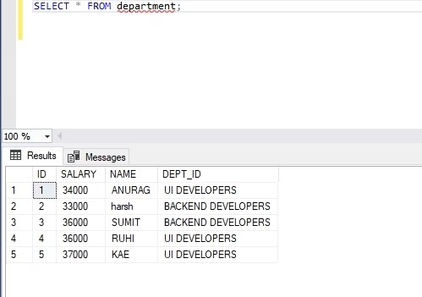

[9:54 PM, 3/23/2023] Saranya: Get the highest salary of each department on the table. Here our table contains a DEPT_ID and it has two different categories UI DEVELOPERS and BACKEND DEVELOPERS, and we will find out the highest salary of the column.

SELECT colunm_name, MAX(column_name) FROM table_name GROUP BY column_name;

Example:

SELECT DEPT_ID, MAX(SALARY) FROM department GROUP BY DEPT_ID;

Output:

