10.query to display last 5 records in a table:

Creating an Employee table :

CREATE TABLE (

ID INT PRIMARY KEY AUTO_INCREMENT,

NAME VARCHAR(30) NOT NULL,

PHONE INT(10) NOT NULL UNIQUE,

EMAIL VARCHAR(30) NOT NULL UNIQUE,DATE_OF_JOINING DATE);

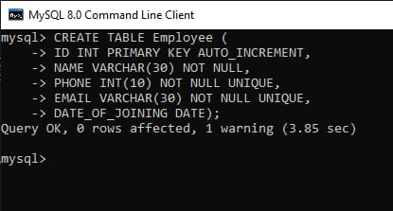

Adding values into the Employee table :

INSERT INTO Employee (NAME, PHONE, EMAIL, DATE_OF_JOINING)

VALUES

('Yogesh Vaishnav', 0000000001, 'yogesh@mail.com', '2019-10-03'),

('Vishal Vishwakarma', 0000000002, 'chicha@mail.com', '2019-11-07'),

('Ajit Yadav', 0000000003, 'ppa@mail.com', '2019-12-12'),

('Ashish Yadav', 0000000004, 'baba@mail.com', '2019-12-25'),

('Tanvi Thakur', 0000000005, 'tanvi@mail.com', '2020-01-20'),

('Sam', 0000000006, 'sam@mail.com', '2020-03-03'),

('Ron', 0000000007, 'ron@mail.com', '2020-05-16'),

('Sara', 0000000008, 'sara@mail.com', '2020-07-01'),

('Zara', 0000000009, 'zara@mail.com', '2020-08-20'),

('Yoji', 0000000010, 'yoji@mail.com', '2020-03-10),

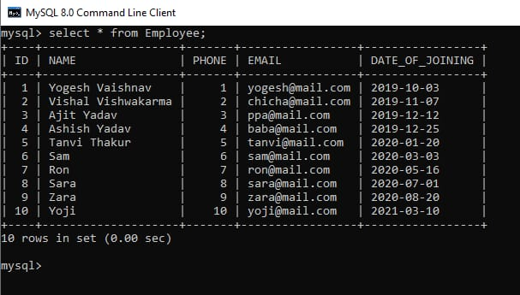

Retrieving all data from the Employee table :

SELECT * FROM Employee;



Now let’s retrieve the last 5 rows from the Employee table.

METHOD 1 : Using LIMIT clause in descending order

As we know that LIMIT clause gives the no. of specified rows from specifies row. We will retrieve last 5 rows in descending order using LIMIT and ORDER BY clauses and finally make the resultant rows ascending.

Since Employee table has IDs, we will perform ORDER BY ID in our query.

SYNTAX :(SELECT * FROM <table_name> ORDER BY <id_column> DESC LIMIT <no. of rows to retrieve>)

ORDER BY <id_column> ASC;

Example :

(SELECT * FROM Employee ORDER BY ID DESC LIMIT 5)

ORDER BY ID ASC;

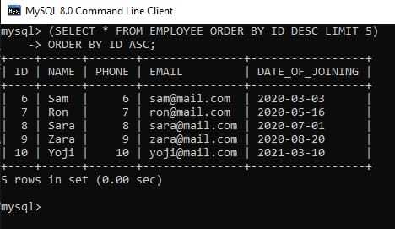

Find query to get information of employee where employee is not assigned to the department:

Step-1: Creating a database –

Creating a database company by using the following SQL query as follows.

CREATE DATABASE company;

Output:

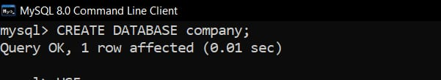

Step-2: Using the database –

Using the database company using the following SQL query as follows.

USE company;

Output:

C:\Users\acer\Downloads\WhatsApp Image 2023-03-23 at 10.48.38 PM.jpeg

Step-3: Creating a table –

Creating a table employee with 5 columns using the following SQL query as follows.

CREATE TABLE employee

(

emp_id varchar(20),

emp_name varchar(20),

emp_dept varchar(20),

emp_age INT,

emp_sex varchar(8)

)

Output:

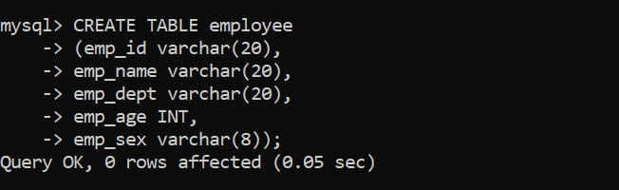

Step-4: Verifying the database –

To view the description of the database using the following SQL query as follows.

DESCRIBE employee;

Output:



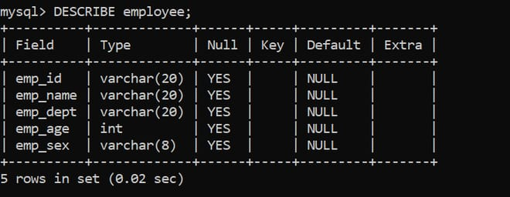

Step-5: Inserting data into the table –

Inserting rows into employee table using the following SQL query as follows.

INSERT INTO employee VALUES('E00001','JHONNY','BACKEND DEVELOPER',26,'male');

INSERT INTO employee VALUES('E00002','DARSHI',NULL,27,'male');

INSERT INTO employee VALUES('E00003','JASMINE',NULL,37,'female');

INSERT INTO employee VALUES('E00004','LILLY',NULL,47,'female');

INSERT INTO employee VALUES('E00005','RONALD','UI DEVELOPER',26,),

Output:

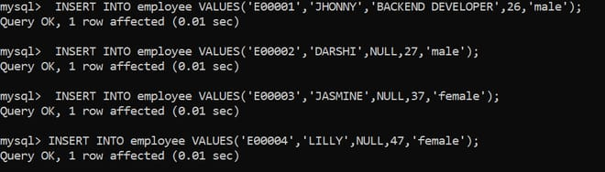

C:\Users\acer\Downloads\WhatsApp Image 2023-03-23 at 10.51.21 PM.jpeg

Step-6: Verifying the inserted data –

Viewing the table employee after inserting rows by using the following SQL query as follows.

SELECT* FROM employee;

Output:

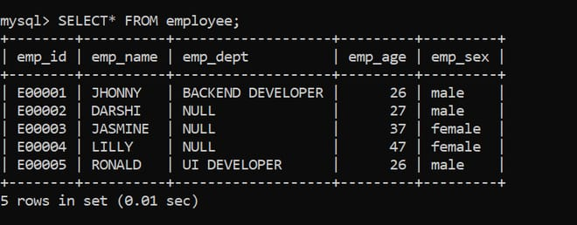

Query to find the employees whose departments are not assigned :

Here, we will see how to query to find the employees whose departments are not assigned by using the following SQL query as follows.

Syntax :

SELECT*

FROM table_name

WHERE column_name IS NULL;

Selecting Data Query –

SELECT*

FROM employee

WHERE emp_dept IS NULL;

Output :

In this table, all the employee records whose department is NULL value are obtained.

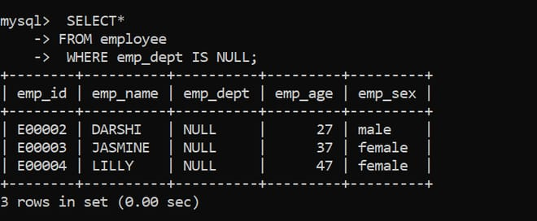

Query to find the employees whose departments are assigned :

Here, we will see how to query to find the employees whose departments are assigned using the following SQL as follows.

Syntax :

SELECT *

FROM table_name

WHERE column_name IS NOT NULL;

Selecting Query –

SELECT *

FROM employee

WHERE emp_dept IS NOT NULL;

Output :

All the records of an employee whose department is assigned are obtained.

