

AGRICONNECT
A PROJECT REPORT
Submitted by

RANJITH S 721224CSBD18
SARANYA P 721224CSBD25
SWETHA N 721224CSBD41
VADAPATHIRASAI R 721224CSBD47

in partial fulfilment of the requirements for the degree
of
BACHELOR OF ENGINEERING
IN
COMPUTER SCIENCE AND ENGINEERING

KARPAGAM INSTITUTE OF TECHNOLOGY
ANNA UNIVERSITY: CHENNAI 600 025
OCTOBER 2026

BONAFIED CERTIFICATE
Certified that this project report “AGRICONNECT” is a Bonafide work of “RANJITH S MM (721224CSBD18), SARANYA P (721224CSBD25),SWETHA N (721224CSBD41), VADAPATHIRASAI R (721224CSBD47)” who carriedout the project work under my supervision.

SIGNATURE SIGNATURE
Mr. N. SENTHIL PRABHU, M.E., Dr. SATHIYA ,M.E.,Ph.D.,
SUPERVISOR HEAD OF THE DEPARTMENT
ASSISTANT PROFESSOR

Department of Computer Science and Department of Computer Science and
Engineering Engineering
Karpagam Institue of Technology Karpagam Institute of Technology
Coimbatore – 641105 Coimbatore – 641105

Submitted for Anna University Project Viva-Voce Examination held on …………………

Internal Examiner External Examiner

ACKNOWLEDGEMENT

We express our profound gratitude to our respected Chairman,
DR.R.VASANTHAKUMAR, for giving this opportunity to pursue this course. At this
pleasing moment of having successfully completed the project works.
We wish to acknowledge sincere gratitude and heartfelt thanks to our respected
Principal Dr. P. MANIMARAN, M.E., Ph.D., for having us given the adequate
support and opportunity for completing the project work successfully.
We express our deep sense of gratitude and sincere thanks to our beloved Head
of the Department Dr. SATHYA, M.E., Ph.D., who has been a spark for
enlightening our knowledge.
Our profound gratitude goes to our project guide Mr. N. SENTHIL PRABHU,
M.E., review members and all the faculty members of Department of Computer
Science and Engineering for the invaluable knowledge they have imparted on us.
Our humble gratitude and heartiest thanks go to our family members and friends
to their encouragement and support throughout the course of this project.

ABSTRACT
AgriConnect is an AI-powered digital agricultural value-chain and marketplace platform designed to connect farmers and other agricultural stakeholders through a unified digital ecosystem. The platform brings together seed producers, farmers, by-product sellers, buyers, service providers, and processors, enabling them to discover agricultural products, exchange by-products, access agricultural services, manage procurement requirements, and communicate with one another. AgriConnect uses modern cloud technologies such as React, Python, AWS Lambda, Amazon API Gateway, Amazon Cognito, Amazon DynamoDB, and Amazon S3 to provide a scalable and secure platform. Artificial Intelligence is incorporated to support natural-language agricultural search, assisted listing creation, marketplace matching, recommendations, procurement assistance, and agricultural knowledge support. A Retrieval-Augmented Generation (RAG) approach is proposed to provide users with relevant agricultural information from verified knowledge sources while reducing the risk of unsupported responses. The platform aims to reduce information gaps, improve market access, support direct connections between agricultural stakeholders, promote the effective utilization of agricultural by-products, and improve the efficiency of agricultural procurement and service discovery. By integrating marketplace functionality, cloud computing, artificial intelligence, and agricultural knowledge assistance, AgriConnect provides a unified digital approach for improving connectivity and collaboration across the agricultural value chain.

CHAPTER 1
INTRODUCTION
  - OVERVIEW
AgriConnect is an AI-powered digital agricultural value-chain and marketplace platform developed to address the communication, market-access, procurement, and service-discovery challenges faced by farmers and other stakeholders in the agricultural sector. The platform provides a unified digital environment that connects seed producers, farmers, by-product sellers, buyers, service providers, and processors. Through AgriConnect, users can list agricultural products, discover seeds and crops, exchange agricultural by-products, find relevant agricultural services, publish procurement requirements, and communicate with potential buyers or sellers. The system combines modern web technologies, cloud computing, and artificial intelligence to improve the efficiency and accessibility of agricultural transactions. AI-based features are incorporated to support natural-language search, assisted agricultural listing creation, intelligent marketplace matching, recommendations, procurement assistance, and agricultural knowledge support. The system aims to reduce information gaps between agricultural stakeholders, improve market connectivity, promote better utilization of agricultural resources and by-products, and provide a more organized digital platform for agricultural value-chain activities.
  - ARTIFICIAL INTELLIGENCE IN AGRICULTURE
Artificial Intelligence has become an important technology for improving decision-making and automation in the agricultural sector. AI techniques can be used to understand user requirements, analyze agricultural information, recommend relevant products or services, and assist users in performing complex marketplace operations. In AgriConnect, artificial intelligence is used not only as a conversational interface but also as an intelligence layer within the agricultural marketplace. Natural Language Processing allows users to express their requirements using ordinary language instead of depending entirely on traditional search filters. For example, a buyer can provide a requirement such as “I need 5 tonnes of coconut husk near Pollachi”, and the system can identify important entities such as the required material, quantity, unit, and location before searching the available marketplace listings. AI can therefore simplify agricultural product discovery, support procurement activities, assist sellers in creating listings, and provide relevant recommendations based on user requirements.

1.3 DIGITAL AGRICULTURAL MARKETPLACE AND VALUE-CHAIN CONNECTIVITY
Agricultural activities involve multiple stakeholders, including producers, farmers, buyers, processors, service providers, and other participants who depend on one another throughout the agricultural value chain. Conventional methods of connecting these stakeholders may involve intermediaries, separate communication channels, manual enquiries, and limited access to information about available products and services. A digital agricultural marketplace can provide a centralized environment where agricultural resources and requirements can be made visible to relevant participants. AgriConnect enables users to create and discover agricultural listings, communicate with other stakeholders, submit procurement requirements, and identify services such as equipment, labour, transportation, storage, and processing. By bringing these activities into a single platform, the system is designed to improve connectivity between participants and support more efficient agricultural value-chain operations.

1.4 AGRICULTURAL BY-PRODUCT EXCHANGE AND RESOURCE UTILIZATION
Agricultural activities generate a wide range of by-products that may have economic or industrial value. However, the absence of an organized platform for identifying potential buyers and sellers can result in the underutilization or wastage of these resources. AgriConnect introduces an agricultural by-product exchange mechanism through which users can list available by-products and buyers or processors can search for materials according to their requirements. The platform can support the discovery of materials based on characteristics such as product type, quantity, location, and other listing information. This approach encourages the conversion of agricultural by-products into useful resources and creates additional opportunities for farmers, sellers, and processing industries to participate in the agricultural value chain.

1.5 ARTIFICIAL INTELLIGENCE AND AGRICULTURAL KNOWLEDGE ASSISTANCE
Agricultural stakeholders require access to reliable information related to farming practices, agricultural products, government support, and other domain-specific topics. However, agricultural information may be distributed across different sources, making it difficult for users to locate relevant information quickly. AgriConnect proposes a Retrieval-Augmented Generation (RAG)-based agricultural knowledge system to provide responses based on relevant information retrieved from a prepared knowledge base. Instead of depending only on the general knowledge of a language model, the RAG approach retrieves relevant agricultural information and uses it as context for generating responses. This can improve the relevance and reliability of agricultural knowledge assistance while reducing the possibility of unsupported information. The AI knowledge component is intended to complement the marketplace by providing users with an intelligent mechanism for obtaining agricultural information within the same platform.

1.6 CLOUD COMPUTING AND SECURE AGRICULTURAL INFORMATION SYSTEM
A digital agricultural marketplace must be capable of handling users, product listings, procurement requirements, files, transactions, and AI-related services while maintaining security and scalability. Cloud computing provides the infrastructure required to deploy and operate such a system without depending entirely on local computing resources. AgriConnect is designed using Amazon Web Services (AWS), with services such as Amazon Cognito for user authentication, Amazon API Gateway for API communication, AWS Lambda for serverless backend processing, Amazon DynamoDB for application data, and Amazon S3 for object storage. AWS Secrets Manager is used for securely managing sensitive credentials, while Amazon CloudWatch can support application monitoring and logging. The use of cloud-based services allows the system architecture to scale according to application requirements while providing mechanisms for controlled access, secure data handling, and centralized management of application resources.

1.7 PROBLEM STATEMENT
Agricultural stakeholders often face difficulties in accessing reliable market information, finding suitable buyers or sellers, locating agricultural services, and communicating their requirements efficiently. The major challenges addressed by the AgriConnect project are:
- Lack of a unified digital platform connecting different agricultural stakeholders.
- Difficulty faced by farmers and producers in discovering suitable buyers and markets.
- Limited visibility of agricultural products, seeds, crops, and by-products.
- Difficulty in finding agricultural services such as equipment, labour, transportation, storage, and processing.
- Inefficient communication between buyers, sellers, farmers, and processors.
- Difficulty in expressing complex agricultural procurement requirements through conventional search interfaces.
- Underutilization of agricultural by-products due to limited connectivity between sellers and potential users.
- Fragmented agricultural information and difficulty in obtaining relevant knowledge.
- Limited use of AI-based intelligent matching and recommendation mechanisms in agricultural marketplaces.
The AgriConnect project aims to address these challenges by developing an AI-powered digital agricultural value-chain platform that connects agricultural stakeholders, improves product and service discovery, supports procurement activities, facilitates by-product exchange, and provides intelligent agricultural assistance through AI and RAG-based technologies.

1.8 OBJECTIVES OF THE PROJECT
The major objectives of the AgriConnect project are:
- To develop a unified digital platform connecting major agricultural stakeholders.
- To provide a marketplace for agricultural products, seeds, crops, and by-products.
- To enable buyers to publish procurement requirements and discover suitable sellers.
- To provide discovery of agricultural services such as equipment, labour, transportation, storage, and processing.
- To implement AI-powered natural-language search for agricultural marketplace requirements.
- To provide AI-assisted agricultural listing creation and recommendations.
- To develop an AI-based marketplace matching mechanism for connecting relevant buyers and sellers.
- To provide agricultural knowledge assistance using a Retrieval-Augmented Generation approach.
- To provide secure authentication and role-based access for different categories of users.
- To build the platform using scalable cloud-based infrastructure.

1.9 SCOPE OF THE PROJECT
The scope of AgriConnect covers the development of a digital agricultural ecosystem in which different stakeholders can participate according to their roles and requirements. The system includes user authentication and role management, agricultural product and seed listings, crop marketplace functionality, agricultural by-product exchange, buyer procurement requirements, search and filtering, service discovery, communication, notifications, and order-related activities. The platform also incorporates artificial intelligence for natural-language search, listing assistance, marketplace matching, recommendations, and procurement support. A RAG-based knowledge system is included within the proposed architecture to provide agricultural information using relevant knowledge sources. The cloud-based architecture using AWS services provides the foundation for scalable deployment and secure management of application data. The project focuses on improving connectivity and information accessibility across the agricultural value chain while providing a foundation that can be extended in the future with advanced agricultural intelligence and additional digital services.

CHAPTER 2
LITERATURE SURVEY
2.1 INTRODUCTION
The application of digital technologies in agriculture has been extensively studied as a means of improving agricultural productivity, market access, supply-chain coordination, and communication between agricultural stakeholders. With the increasing availability of smartphones, internet connectivity, cloud computing, and artificial intelligence, agricultural applications have evolved beyond basic information-sharing platforms into intelligent digital systems capable of supporting marketplace activities, recommendations, decision-making, and knowledge assistance. Existing research covers areas such as digital agricultural marketplaces, AI-based agricultural applications, recommendation systems, supply-chain management, and knowledge-based agricultural assistance. This chapter reviews the major areas of research related to the proposed AgriConnect platform and identifies the limitations and research gaps that motivate the development of an integrated AI-powered agricultural value-chain system.

2.2 STUDIES ON EXISTING DIGITAL AGRICULTURAL PLATFORMS
Existing digital agricultural platforms can generally be categorized into agricultural information systems, farmer-to-market platforms, e-commerce-based agricultural marketplaces, and agricultural service platforms. Agricultural information systems primarily provide information related to farming practices, crops, weather, and agricultural schemes, but they may not provide direct marketplace connectivity. Farmer-to-market platforms focus mainly on connecting producers with buyers and improving access to agricultural markets. E-commerce-based platforms provide mechanisms for listing and purchasing agricultural products, but their functionality may be limited to specific product categories or transaction types. Agricultural service platforms, on the other hand, focus on providing access to equipment, labour, transportation, or other agricultural services. Although these systems address individual requirements, many existing platforms do not provide a unified environment connecting producers, buyers, processors, service providers, and by-product sellers along with intelligent AI-based assistance.

2.3 STUDIES ON AI-BASED AGRICULTURAL SYSTEMS
Recent research in artificial intelligence has demonstrated its potential to support various agricultural activities. Machine learning and natural language processing techniques have been applied to agricultural recommendation, crop-related decision support, disease identification, yield prediction, and agricultural information retrieval. Natural language processing allows users to interact with agricultural applications using natural language rather than depending entirely on predefined forms or search filters. AI-based systems can also analyze user requirements and generate recommendations based on available information. However, many agricultural AI applications are designed to solve a specific agricultural problem, such as crop disease detection or yield prediction, rather than supporting the complete agricultural value chain. This creates an opportunity for an integrated platform in which AI is used for marketplace search, listing assistance, procurement, matching, recommendations, and agricultural knowledge support.

2.4 STUDIES ON AGRICULTURAL MARKETPLACES AND SUPPLY CHAINS
Digital agricultural marketplaces have been investigated as a method of reducing information gaps between farmers, buyers, and other participants in the agricultural supply chain. Such platforms can improve product visibility and provide buyers with access to information about available agricultural commodities. Digital systems can also support procurement activities by allowing buyers to specify product requirements and enabling producers or suppliers to respond to those requirements. However, agricultural supply chains involve more than the exchange of primary agricultural products. They also include seeds, agricultural by-products, transportation, storage, processing, labour, and equipment. Existing marketplace solutions may address only selected portions of this chain. AgriConnect therefore focuses on providing a broader digital ecosystem that connects multiple stakeholders and supports different stages of the agricultural value chain through a single platform.

2.5 STUDIES ON AI-BASED RECOMMENDATION AND MATCHING SYSTEMS
Recommendation and matching systems are widely used in digital marketplaces to connect users with relevant products, services, or suppliers. Such systems generally analyze user requirements, product attributes, location, availability, and other relevant parameters to identify suitable matches. In an agricultural context, intelligent matching can help buyers identify suitable farmers or suppliers based on requirements such as product type, quantity, location, and availability. Natural-language processing can further simplify this process by converting a user's natural-language requirement into structured search parameters. For example, a requirement for a specific quantity of an agricultural by-product in a particular location can be interpreted by an AI component and converted into structured criteria before querying the marketplace database. Such an approach can improve the usability of agricultural procurement systems while ensuring that marketplace responses are based on actual available listings rather than information generated by the AI model.

2.6 STUDIES ON RAG-BASED AGRICULTURAL KNOWLEDGE SYSTEMS
Retrieval-Augmented Generation has emerged as an approach for improving the usefulness of large language model applications when domain-specific and source-based information is required. In a RAG-based system, relevant information is retrieved from a prepared knowledge base and supplied to the language model as contextual information before generating a response. This approach is particularly useful in agriculture because users may require information related to cultivation practices, agricultural schemes, farming guidance, and other domain-specific topics. A knowledge-assisted agricultural platform can therefore combine information retrieval with natural-language interaction to make relevant agricultural information easier to access. However, knowledge assistance alone does not provide marketplace functionality or direct connectivity between agricultural stakeholders. AgriConnect proposes combining a RAG-based knowledge component with marketplace and value-chain capabilities within the same platform.

2.7 RESEARCH GAP
From the analysis of existing agricultural platforms and research areas, it can be observed that many existing systems focus on individual aspects of agriculture, such as information delivery, crop recommendations, agricultural product sales, or specific farming services. These solutions may not integrate multiple agricultural stakeholders and value-chain activities into a single platform. In addition, conventional marketplace systems generally depend on structured search forms and predefined filters, which may make it difficult for users to express complex procurement requirements. There is also a gap in combining AI-based natural-language marketplace search, intelligent buyer-seller matching, agricultural by-product exchange, service discovery, and RAG-based agricultural knowledge assistance within one unified system. AgriConnect is proposed to address this gap by integrating these capabilities into a common AI-powered agricultural value-chain platform.

2.8 OBSERVATION
The literature review indicates that digital technologies can significantly improve communication, information accessibility, marketplace connectivity, and decision support within agriculture. Existing systems provide useful solutions for individual agricultural activities, but there is a need for greater integration between marketplace operations, agricultural services, procurement, and intelligent knowledge assistance. AI can provide an additional layer of intelligence by understanding natural-language requirements and assisting users in discovering relevant products and services. At the same time, a RAG-based knowledge system can provide domain-specific information using retrieved knowledge sources. Therefore, an integrated platform combining agricultural marketplace functionality, AI-based matching and recommendations, and knowledge assistance can provide a more comprehensive solution for agricultural stakeholders.

2.9 CONCLUSION
From the review of existing digital agricultural systems and research, it is evident that artificial intelligence, cloud computing, digital marketplaces, and information retrieval technologies can contribute significantly to improving agricultural value-chain connectivity. However, existing solutions often address only specific agricultural activities rather than providing a unified ecosystem for multiple stakeholders. The literature review therefore establishes the need for a platform that combines agricultural product discovery, procurement, by-product exchange, service discovery, AI-powered search and matching, and agricultural knowledge assistance. AgriConnect is designed based on this identified requirement, with the objective of providing an integrated and scalable digital platform for connecting agricultural stakeholders and improving the efficiency of agricultural value-chain activities.

CHAPTER 3
SYSTEM ANALYSIS

3.1 INTRODUCTION
System analysis is the process of examining the limitations of existing agricultural systems and identifying the requirements for developing a more effective digital solution. The agricultural sector involves multiple stakeholders such as farmers, seed producers, buyers, processors, by-product sellers, and service providers, who often depend on separate platforms and traditional communication methods to exchange information and conduct business activities. This chapter analyzes the limitations of existing agricultural marketplace and information systems and compares them with the proposed AgriConnect platform. The analysis focuses on the need for a unified system that can improve agricultural product discovery, procurement, service access, stakeholder communication, and intelligent decision support through artificial intelligence and cloud technologies.

3.2 EXISTING SYSTEMS
In existing agricultural systems, farmers and agricultural producers often depend on local markets, intermediaries, personal networks, and separate digital platforms to sell their products and find buyers. Information about available agricultural products, seeds, by-products, services, and processing facilities may be distributed across different sources, making it difficult for users to identify suitable opportunities efficiently. Buyers who require specific agricultural materials may also need to contact multiple suppliers manually to determine availability, quantity, location, and other requirements.
Existing agricultural marketplace platforms generally focus on specific categories of products or services rather than covering the complete agricultural value chain. Conventional search mechanisms often require users to enter predefined product names, categories, locations, or filters, which may not be suitable for complex procurement requirements. Agricultural by-products may also remain underutilized because sellers have limited visibility among potential buyers and processors. In addition, agricultural knowledge and marketplace activities are frequently handled through separate systems, requiring users to switch between different applications or information sources.

3.3 PROPOSED SOLUTION
The proposed AgriConnect system addresses the limitations of existing agricultural systems by providing a unified AI-powered digital agricultural value-chain and marketplace platform. The major features of the proposed system include:
- Connecting seed producers, farmers, by-product sellers, buyers, service providers, and processors through a common digital platform.
- Providing agricultural product listings for seeds, crops, and other agricultural products.
- Providing a dedicated mechanism for listing and discovering agricultural by-products.
- Enabling buyers to publish procurement or purchase requirements based on their specific needs.
- Providing search and filtering mechanisms for discovering relevant agricultural products and services.
- Supporting the discovery of agricultural services such as equipment, labour, transportation, storage, and processing.
- Using AI-powered natural-language processing to understand complex agricultural marketplace requirements.
- Converting natural-language requirements into structured parameters such as product, quantity, unit, and location for marketplace search.
- Providing AI-assisted agricultural listing creation to help users prepare relevant product information.
- Providing AI-based matching and recommendation mechanisms to connect suitable buyers and sellers.
- Providing agricultural knowledge assistance through a Retrieval-Augmented Generation (RAG) approach using relevant knowledge sources.
- Supporting communication between agricultural stakeholders through messaging and notifications.
- Providing role-based access so that different stakeholders can access functionalities relevant to their roles.
- Using cloud-based AWS services to provide scalable application infrastructure and secure management of application data.
For example, when a buyer enters a requirement such as “I need 5 tonnes of coconut husk near Pollachi”, the AI component can identify the intent, product, quantity, unit, and location. These structured requirements can then be used to search actual marketplace listings stored in the application database. The AI component is therefore designed to assist the marketplace rather than inventing unavailable products or suppliers.

3.4 FEASIBILITY

3.4.1 TECHNICAL FEASIBILITY
The proposed AgriConnect system uses widely adopted web, cloud, database, and artificial intelligence technologies. The frontend is designed using React and Vite with Tailwind CSS, while the backend uses Python and AWS Lambda for serverless application processing. Amazon API Gateway provides API communication, Amazon Cognito provides authentication, Amazon DynamoDB manages application data, and Amazon S3 provides object storage. OpenAI API is used for the proposed AI functionality, while a Retrieval-Augmented Generation architecture is planned for agricultural knowledge assistance. AWS Secrets Manager can be used to securely manage sensitive credentials, and Amazon CloudWatch provides monitoring and logging capabilities.
The modular architecture of the system allows individual components such as authentication, marketplace listings, procurement, AI services, and knowledge assistance to be developed and maintained independently. The use of serverless AWS services also provides the possibility of scaling the application according to usage requirements. Therefore, the proposed technology stack is technically suitable for developing the AgriConnect platform.

3.4.2 ECONOMIC FEASIBILITY
The proposed system uses a combination of open-source development technologies and cloud-based services. Technologies such as React, Vite, Tailwind CSS, and Python can be used without proprietary software licensing costs. Cloud services such as AWS Lambda, DynamoDB, S3, API Gateway, and Cognito support usage-based deployment, allowing infrastructure requirements to grow according to application demand.
The serverless architecture can reduce the need for maintaining dedicated backend servers and can therefore help reduce infrastructure and maintenance requirements during the initial stages of the project. The use of managed cloud services also reduces the operational effort required for maintaining databases, storage, authentication, and application infrastructure. However, actual operating costs will depend on application usage, cloud resource consumption, and AI API usage. Therefore, the proposed system is economically feasible for prototype and scalable deployment when cloud resources are appropriately managed.

3.4.3 OPERATIONAL FEASIBILITY
AgriConnect is designed to provide a user-friendly digital environment for different categories of agricultural stakeholders. The platform separates functionality according to user roles, allowing farmers, seed producers, buyers, by-product sellers, service providers, and processors to interact with the system according to their respective requirements.
The natural-language AI search functionality is intended to reduce the complexity of conventional search interfaces by allowing users to express requirements in ordinary language. For example, instead of manually selecting multiple filters, a buyer can describe the required product, quantity, and location in a single query. The marketplace can then process the requirement and identify relevant listings from the available database.
The unified nature of the platform also reduces the need for users to depend on multiple separate systems for product discovery, procurement, service discovery, and agricultural knowledge. Therefore, the proposed system is operationally feasible and can provide a more convenient digital environment for agricultural stakeholders.

CHAPTER 4
PROPOSED FRAMEWORK
4.1 WORKFLOW
The AgriConnect platform follows a systematic nine-step workflow that connects agricultural stakeholders from registration and role selection to marketplace discovery, procurement, service fulfillment, and AI-based agricultural assistance. First, the user registers or logs into the AgriConnect platform and completes the profile setup according to their role, such as farmer, buyer, seed producer, by-product seller, service provider, or processor. The user can then enter a product requirement, service requirement, or procurement request using natural language, which is analyzed by the AI component to identify important details such as product type, category, quantity, unit, and location. Based on the analyzed requirement, the system searches the available marketplace listings and presents relevant seeds, crops, agricultural by-products, products, or services. The user can communicate with the corresponding seller, buyer, or service provider through the platform to discuss availability, quantity, pricing, and other requirements. Once the requirement is confirmed, an order or procurement request can be placed and its details and status can be managed through the system. Depending on the requirement, related services such as transportation, storage, processing, equipment, or labour can support the fulfillment process. In addition to marketplace functionality, the AI-powered agricultural knowledge assistant can provide relevant agricultural guidance, recommendations, and answers using a RAG-based knowledge system. Finally, notifications and follow-up updates can keep users informed about order status, relevant matches, messages, and other activities within the platform.
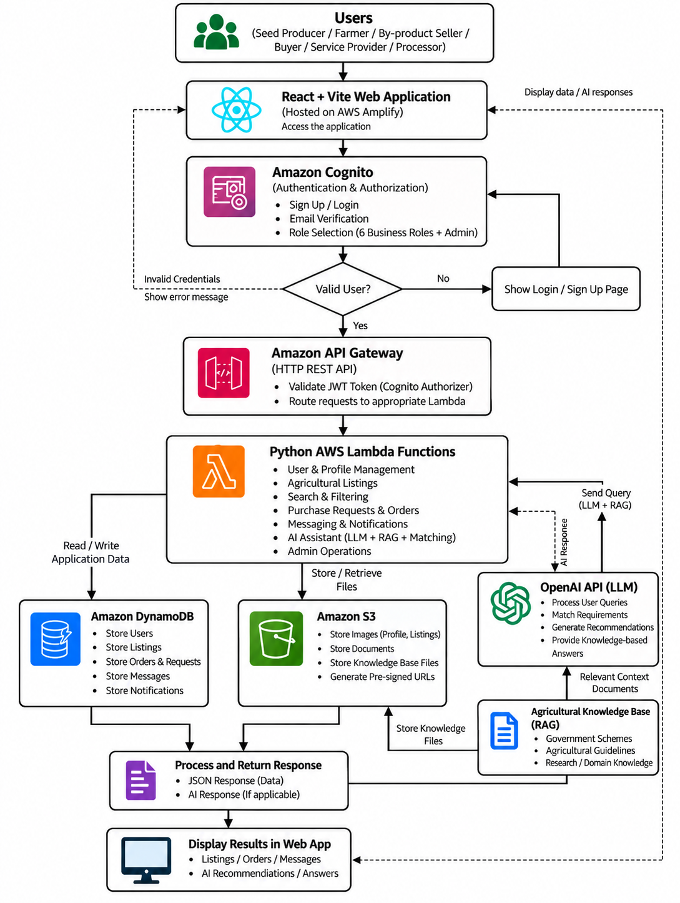

4.2 PROPOSED ARCHITECTURE
The AgriConnect architecture is organized into six logical layers, with each layer responsible for a specific set of functions within the agricultural value-chain platform, as in below diagram,
- User Layer: Consists of the different stakeholders accessing the AgriConnect platform, including farmers, seed producers, buyers, by-product sellers, service providers, processors, and administrators. Each user accesses features according to their assigned role.
- Application Layer: Handles the core functionality of the platform, including user profile management, agricultural product listings, seed and crop marketplace, by-product exchange, service discovery, procurement requirements, search and filtering, orders, messaging, notifications, and administrative management.
- AI & Services Layer: Provides the intelligence capabilities of AgriConnect. This layer includes AI-powered natural-language search, requirement analysis, listing assistance, marketplace matching, recommendations, procurement assistance, and the agricultural knowledge assistant. The RAG-based knowledge component retrieves relevant agricultural information and provides contextual responses to users.
- Data Layer: Maintains the application's core data, including user profiles, role information, agricultural listings, seeds, crops, by-products, service information, procurement requirements, orders, messages, notifications, and other marketplace-related information. Amazon DynamoDB is used as the primary database, while Amazon S3 is used for storing required files and objects.
- Cloud & Security Layer: Provides the cloud infrastructure and security mechanisms required to operate the platform. AWS Lambda handles serverless backend processing, Amazon API Gateway provides API access, Amazon Cognito manages user authentication, and AWS Secrets Manager securely manages sensitive credentials. Amazon CloudWatch provides application monitoring and logging.
- External Systems & AI Services: This layer represents external services required to extend the capabilities of AgriConnect. The OpenAI API provides the language-model capabilities required for natural-language understanding and AI-assisted functionality. Other external agricultural information sources can support the RAG-based knowledge system where applicable. The architecture allows these services to interact with the core platform through controlled APIs without directly exposing the internal application data.
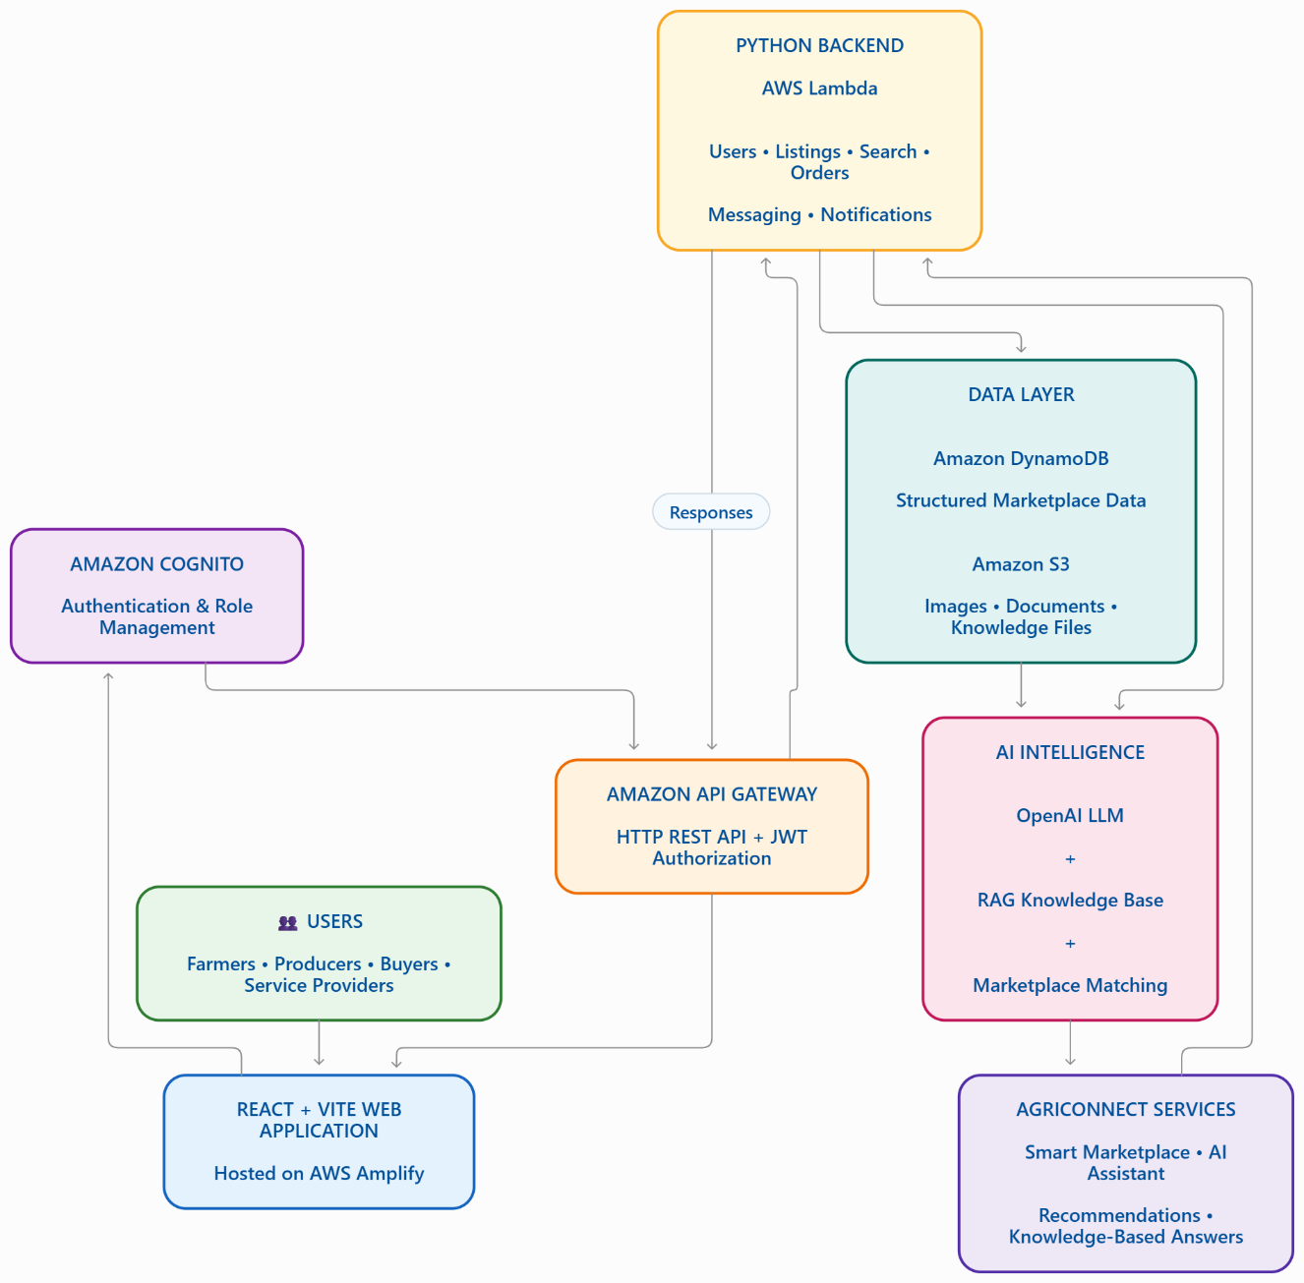

4.3 MODULE DESCRIPTION
The AgriConnect platform consists of a set of core modules that support different activities across the agricultural value chain:
- User Registration and Role Management: Allows users to register and access the platform according to their roles, such as farmer, seed producer, buyer, by-product seller, service provider, processor, or administrator.
- Agricultural Marketplace: Enables users to create, manage, search, and discover agricultural listings, including seeds, crops, agricultural products, and by-products.
- Procurement and Purchase Requirements: Allows buyers to specify their agricultural requirements, including product type, quantity, location, and other relevant details, so that suitable sellers can be identified.
- AI-Powered Search and Requirement Analysis: Uses natural language processing to understand user queries and extract important information such as product, category, quantity, unit, and location before performing marketplace searches.
- AI-Based Marketplace Matching and Recommendations: Matches buyer requirements with relevant marketplace listings and provides recommendations based on available products, services, and requirements.
- Agricultural Service Discovery: Helps users discover services related to agricultural equipment, labour, transportation, storage, and processing according to their requirements.
- Agricultural By-Product Exchange: Provides a dedicated mechanism for sellers to list agricultural by-products and enables buyers or processors to discover and utilize these resources.
- Messaging and Communication: Allows buyers, sellers, farmers, processors, and service providers to communicate through the platform for discussing product availability, quantity, pricing, and service requirements.
- Order and Transaction Management: Supports the management of orders or procurement requests, including relevant order details and status updates throughout the transaction process.
- AI-Assisted Listing Creation: Helps users create or improve agricultural product listings by using AI to generate structured and relevant listing information.
- Agricultural Knowledge Assistant: Provides agricultural guidance and answers to farming-related queries using an AI-powered Retrieval-Augmented Generation (RAG) approach based on relevant knowledge sources.
- Notifications and Follow-up: Provides notifications related to orders, procurement requests, messages, relevant marketplace matches, and other important activities.
- Admin Management: Provides administrators with centralized management capabilities for users, listings, platform activities, and other administrative operations.

4.4 TECHNOLOGY STACK
Layer | Technology | Purpose
Frontend | React.js + Vite | Development of a responsive web interface for farmers, buyers, seed producers, service providers, processors, and administrators.
UI Framework | Tailwind CSS | Provides responsive styling and reusable user-interface components.
Frontend Routing | React Router | Handles navigation between different modules and pages of the AgriConnect application.
From Validation | React Hook  From + Zod | Manages user forms and validates user-entered agricultural and marketplace information.
Backend | Python + AWS Lambda | Implements serverless backend logic, API processing, business rules, and communication with AWS services.
API | Amazon API Gateway | Provides secure HTTP API endpoints for communication between the frontend and backend services.
Authentication | Amazon Cognito | Provides user registration, authentication, authorization, and role-based access control.
Database | Amazon DynamoDB | Stores user profiles, agricultural listings, procurement requirements, orders, messages, notifications, and other application data.
File Storage | Amazon S3 | Stores agricultural images, documents, and other uploaded files using secure object storage.
AI | OpenAI API | Provides natural-language understanding, requirement analysis, AI-assisted listing creation, recommendations, and procurement assistance.
Knowledge System | RAG | Retrieves relevant agricultural information from a knowledge base and provides contextual AI-generated responses.
Secrets Management | AWS Secrets Manager | Securely stores sensitive credentials such as API keys without exposing them in application source code.
Cloud Infrastructure | Amazon Web Services (AWS) | Provides scalable cloud infrastructure for authentication, APIs, backend processing, databases, storage, and monitoring.
Monitoring | Amazon CloudWatch | Provides application logging, monitoring, and operational visibility for AWS resources.
HTTP Communication | Axioz / Fetch API | Provides application logging, monitoring, and operational visibility for AWS resources.

4.5 CONCLUSION
The layered architecture and modular design of the AgriConnect platform provide a structured approach for integrating agricultural marketplace functionality, artificial intelligence, cloud services, and agricultural knowledge assistance into a unified system. Each module, from user and role management to marketplace operations, AI-powered search, procurement, service discovery, and RAG-based knowledge assistance, can be developed, tested, maintained, and scaled independently while working together as a cohesive platform. The use of AWS cloud services provides the flexibility and scalability required to support different numbers of users and agricultural activities. The modular architecture also allows AgriConnect to be extended in the future with additional capabilities such as IoT-based agricultural monitoring, weather intelligence, digital payments, crop disease detection, price prediction, mobile applications, and advanced AI-based procurement services.

CHAPTER 5
IMPLETENTATION ROADMAP
5.1 INTRODUCTION
The AgriConnect platform is planned to be implemented in a systematic phase-wise manner, beginning with requirement analysis and system architecture and progressing through development, AI integration, cloud deployment, testing, and final deployment. This approach helps ensure that the individual components are designed, developed, tested, and integrated in an organized manner. The initial phase focuses on identifying the requirements of farmers, seed producers, buyers, by-product sellers, service providers, processors, and administrators. The major requirements include agricultural marketplace management, procurement requirements, product and by-product discovery, agricultural service discovery, communication, AI-powered search, recommendations, and agricultural knowledge assistance. The next phase focuses on designing the system architecture, database model, API structure, user interfaces, authentication mechanisms, and cloud infrastructure. React and Vite are used for the frontend, while Python and AWS Lambda are used for backend processing. Amazon Cognito is used for authentication, Amazon DynamoDB for application data, and Amazon S3 for file storage. During the AI Integration phase, the OpenAI API is incorporated to provide natural-language requirement analysis, AI-assisted listing creation, marketplace matching, recommendations, and procurement assistance, while the RAG-based knowledge system is designed to provide relevant agricultural information. The final phases involve integrating the modules, performing functional, security, usability, and performance testing, deploying the system using AWS cloud infrastructure, and monitoring the deployed application.

5.2 PHASE-WISE IMPLEMENTATION PLAN

Phase 1 – Requirement Analysis and Project Foundation
The first phase focuses on identifying and documenting the functional and non-functional requirements of the AgriConnect platform. The requirements of farmers, seed producers, buyers, by-product sellers, service providers, processors, and administrators are considered. The major requirements include user management, agricultural listings, marketplace search, procurement, service discovery, communication, AI assistance, agricultural knowledge support, security, and scalability. The basic project structure and overall system architecture are also established during this phase.

Phase 2 – Authentication and User Management
The second phase focuses on implementing secure user registration, login, authentication, and role management. Amazon Cognito is used to manage user authentication and authorization. Different roles such as farmer, buyer, seed producer, by-product seller, service provider, processor, and administrator are defined so that users can access functionality appropriate to their roles. User profile management and role-specific onboarding are also developed as part of this phase.

Phase 3 – Marketplace and Listing Development
The third phase focuses on developing the core agricultural marketplace. Users can create, update, manage, and discover agricultural listings such as seeds, crops, agricultural products, and by-products. The system also provides mechanisms for organizing listing information and supporting product discovery. Amazon DynamoDB is used to store marketplace-related data, while Amazon S3 is used for storing uploaded images and other required files.

Phase 4 – Search, Procurement and Service Discovery
This phase focuses on developing search and filtering functionality along with buyer procurement requirements. Buyers can specify the products, quantities, locations, and other requirements they need. The platform also supports discovery of agricultural services such as equipment, labour, transportation, storage, and processing. The system is designed to connect relevant requirements with available marketplace listings and services.

Phase 5 – AI Integration
The fifth phase focuses on integrating artificial intelligence into the AgriConnect platform. The OpenAI API is used to support natural-language understanding and AI-assisted functionality. The AI component analyzes user queries and extracts important information such as product type, quantity, unit, category, and location. AI-assisted listing creation, natural-language marketplace search, procurement assistance, and recommendation functionality are also integrated during this phase. The AI component is designed to work with actual marketplace data rather than generating unsupported marketplace availability.

Phase 6 – RAG-Based Agricultural Knowledge System
This phase focuses on developing the agricultural knowledge assistance component using Retrieval-Augmented Generation. Relevant agricultural information is organized into a knowledge base, and the system retrieves suitable information based on the user's query before generating a response. The objective is to provide users with contextual agricultural guidance while maintaining a clear separation between retrieved knowledge and marketplace data.

Phase 7 – Orders, Communication and Notifications
The seventh phase focuses on implementing order and procurement management, messaging, and notifications. Users can communicate with relevant buyers, sellers, processors, and service providers to discuss requirements and transaction details. Order or procurement status can be managed through the platform, while notifications provide users with updates related to orders, messages, and relevant marketplace activities.

Phase 8 – Cloud Deployment and Integration
The developed components are integrated with the AWS cloud infrastructure during this phase. Amazon API Gateway is used to provide HTTP API access, AWS Lambda handles backend processing, Amazon DynamoDB manages application data, and Amazon S3 provides file storage. AWS Secrets Manager is used for securely managing sensitive credentials, while Amazon CloudWatch supports monitoring and logging. The different cloud components are configured to communicate securely with one another.

Phase 9 – Testing and Final Deployment
The final phase focuses on testing the complete AgriConnect platform. Functional testing is performed to verify individual modules, while integration testing verifies communication between frontend, backend, database, AI, and cloud components. Security testing is performed for authentication, authorization, API access, and data handling. Usability and performance testing are also conducted to identify issues and improve the overall user experience. After successful validation, the system can be deployed and monitored for further improvements.

5.3 CONCLUSION
A phase-wise implementation roadmap provides an organized approach for developing the AgriConnect platform, allowing each major component to be designed, implemented, integrated, and validated systematically. The methodology ensures that the frontend, backend, authentication, database, marketplace, AI services, RAG knowledge system, and AWS cloud infrastructure work together as a unified platform. Testing at different stages helps identify functional, security, performance, and integration issues before final deployment. The modular implementation approach also provides flexibility for extending AgriConnect with additional agricultural intelligence, services, and advanced AI capabilities in future versions.

CHAPTER 6
MODULE IMPLEMENTATION DETAILS

6.1 USER REGISTRATION AND AUTHENTICATION
The User Registration and Authentication module provides a secure entry point to the AgriConnect platform for all agricultural stakeholders. Users can create accounts by providing the required profile information and selecting an appropriate role, such as farmer, buyer, seed producer, by-product seller, service provider, processor, or administrator. Amazon Cognito is used to manage user authentication and authorization. Role-based access control ensures that users can access only the features and operations relevant to their assigned role. This provides a secure foundation for protecting user information and marketplace activities.

6.2 ROLE-BASED USER PROFILE MANAGEMENT
The Role-Based User Profile Management module allows users to create and maintain profiles according to their activities within the agricultural value chain. A farmer can provide farming and product-related information, while a buyer can specify procurement-related requirements. Similarly, seed producers, by-product sellers, service providers, and processors can maintain information relevant to their respective activities. The role-based structure allows the platform to provide appropriate functionality to each category of user and improves the organization of marketplace interactions.

6.3 AGRICULTURAL PRODUCT LISTING AND MARKETPLACE
The Agricultural Marketplace module provides a digital environment for users to list and discover agricultural products. Farmers, producers, and other authorized users can create listings containing information such as product name, category, quantity, location, description, and other relevant details. Buyers can browse available listings and identify products according to their requirements. The module supports different categories such as seeds, crops, and other agricultural products. Amazon DynamoDB is used to store marketplace information, while Amazon S3 can be used to store associated images and files.

6.4 AGRICULTURAL BY-PRODUCT EXCHANGE
The Agricultural By-Product Exchange module is designed to improve the utilization of agricultural by-products by connecting sellers with potential buyers and processors. Users can create listings for available by-products and provide relevant details such as material type, quantity, location, and description. Buyers or processors can search for suitable materials according to their requirements. This module provides a structured digital mechanism for discovering agricultural by-products that might otherwise have limited visibility in conventional markets.

6.5 BUYER PROCUREMENT AND PURCHASE REQUIREMENTS
The Buyer Procurement module enables buyers to publish specific requirements for agricultural products or materials. A buyer can provide details such as the required product, quantity, unit, location, and other relevant conditions. These requirements can be used by the system to identify suitable marketplace listings and potential suppliers. The module is intended to simplify procurement activities by reducing the need for buyers to manually contact multiple suppliers to identify suitable products and availability.

6.6 AI-POWERED AGRICULTURAL SEARCH AND REQUIREMENT ANALYSIS
The AI-Powered Agricultural Search module allows users to express their marketplace requirements using natural language instead of depending entirely on predefined search filters. The AI component analyzes the user's query using natural-language processing techniques and identifies important entities such as product type, category, quantity, unit, and location.
For example, a buyer may enter a requirement such as “I need 5 tonnes of coconut husk near Pollachi.” The system can interpret the requirement and convert it into structured search parameters. These parameters are then used to search the actual marketplace database for matching listings. This approach improves the usability of the marketplace while ensuring that the AI does not generate imaginary products or suppliers that are not present in the available marketplace data.

6.7 AGRICULTURAL SERVICE DISCOVERY
The Agricultural Service Discovery module enables users to find services required for agricultural activities. The platform can support service categories such as agricultural equipment, labour, transportation, storage, and processing. Service providers can publish their available services, while farmers, buyers, and other stakeholders can search for services according to their requirements. This module extends the platform beyond product trading and provides additional connectivity across the agricultural value chain.

6.8 AI-ASSISTED LISTING CREATION AND RECOMMENDATION
The AI-Assisted Listing module helps users create or improve agricultural marketplace listings. Users can provide basic information about a product or service, and the AI component can assist in organizing the information into a more structured listing format. The AI-based recommendation component can also identify potentially relevant products, services, or marketplace opportunities based on user requirements. These features are intended to reduce the effort required to create listings and improve the discoverability of relevant marketplace resources.

6.9 AI-BASED MARKETPLACE MATCHING AND PROCUREMENT ASSISTANCE
The AI-Based Marketplace Matching module is designed to connect buyers with suitable sellers and service providers based on their requirements. The system analyzes structured requirements and compares them with available marketplace information such as product type, quantity, location, and other relevant attributes. Suitable candidates can then be ranked and presented to the user.
The procurement assistance component further uses AI to help users understand and manage their requirements. The AI acts as an intelligent interface to the marketplace while relying on actual database records for product and supplier availability. This separation between AI-generated understanding and database-based marketplace retrieval helps improve the reliability of procurement-related responses.

6.10 AGRICULTURAL KNOWLEDGE ASSISTANT USING RAG
The Agricultural Knowledge Assistant provides users with AI-based assistance for agriculture-related questions. The module uses a Retrieval-Augmented Generation (RAG) approach, in which relevant information is retrieved from a prepared agricultural knowledge base before generating a response. This allows the system to provide contextual information based on the available knowledge sources rather than depending entirely on the general knowledge of the language model.
The module can support users in obtaining relevant agricultural information and guidance within the same platform. The knowledge assistant is separate from the marketplace search mechanism, ensuring that marketplace availability is retrieved from actual application data rather than generated by the language model.

6.11 ORDER AND TRANSACTION MANAGEMENT
The Order and Transaction Management module manages the activities associated with confirmed marketplace requirements. It maintains relevant order or procurement information and provides status updates throughout the transaction process. The module can be used to track the progress of interactions between buyers and sellers and organize transaction-related information within the platform. The design also provides a foundation for future integration with digital payment and transaction services.

6.12 MESSAGING AND COMMUNICATION
The Messaging and Communication module enables agricultural stakeholders to communicate directly through the platform. Buyers can communicate with sellers, farmers, processors, and service providers to discuss product availability, quantity, pricing, service requirements, and other transaction-related information. Centralizing communication within the platform can reduce the dependence on separate communication channels and provide better continuity throughout the marketplace interaction.

6.13 NOTIFICATIONS AND FOLLOW-UP
The Notifications module provides users with important updates related to their activities on the platform. Notifications can be associated with procurement requirements, orders, messages, relevant marketplace matches, and other system activities. Follow-up notifications help users remain informed about changes in the status of their requirements and interactions. This module supports better communication and continuity between different stakeholders.

6.14 ADMIN DASHBOARD AND MANAGEMENT
The Admin Management module provides administrators with centralized control over important platform activities. Administrators can manage and monitor users, marketplace listings, categories, and other relevant platform information according to the permissions provided by the system. The module also provides a foundation for monitoring marketplace activity and maintaining the overall quality and organization of the platform.

6.15 CONCLUSION
The proposed AgriConnect platform is designed as a collection of interconnected modules that together support the major activities of the agricultural value chain. The system begins with secure user registration and role management and extends through agricultural marketplace operations, by-product exchange, procurement, service discovery, communication, and order management. Artificial intelligence adds an intelligent layer through natural-language search, requirement analysis, listing assistance, marketplace matching, recommendations, and procurement support. The RAG-based agricultural knowledge assistant further provides users with contextual agricultural information. The combination of AI, cloud computing, secure authentication, database-driven marketplace operations, and agricultural knowledge retrieval provides the foundation for an integrated digital agricultural ecosystem designed to improve connectivity and efficiency among agricultural stakeholders.

CHAPTER 7
IMPLEMENTATION AND REQUIREMENTS

7.1 React.js and Vite – Frontend
The frontend of the AgriConnect platform is developed using React.js with Vite as the development and build tool. React.js provides a component-based architecture that enables the development of a modular, responsive, and user-friendly web interface. The platform provides different interfaces according to the role of the user, such as farmers, seed producers, by-product sellers, buyers, service providers, processors, and administrators.
Vite is used to provide a fast development environment and efficient production builds. The frontend communicates with the backend through REST-based HTTP APIs exposed using Amazon API Gateway.

The frontend includes interfaces for:
- User registration and login
- Role-based user profiles
- Agricultural product listings
- Seed listings
- Crop listings
- Agricultural by-product listings
- Buyer procurement requirements
- Search and filtering
- Service discovery
- AI-assisted search
- Recommendations
- Orders and marketplace activities
- Messaging
- Notifications
- Administrative management
React Router is used for navigation between different application pages. Tailwind CSS is used for responsive and consistent user-interface design. React Hook Form and Zod are used for form handling and validation.
The frontend is intended to provide a simple marketplace experience where users can list agricultural resources, search for requirements, compare available options, and receive AI-assisted recommendations.

7.2 Python and AWS Lambda – Backend
The backend of AgriConnect is implemented using Python 3.12 and AWS Lambda. Python is responsible for implementing the business logic and processing requests received from the frontend.
AWS Lambda provides a serverless execution environment in which backend functions can be executed without maintaining dedicated servers. Different Lambda functions can be developed for different functional modules of the platform.
The backend is responsible for:
- Processing user requests
- Managing user profiles
- Creating and updating marketplace listings
- Retrieving agricultural products
- Managing buyer requirements
- Searching marketplace data
- Processing orders
- Managing service information
- Handling messages and notifications
- Performing AI-based requirement analysis
- Generating recommendation results
- Communicating with DynamoDB and S3
- Calling the OpenAI API when AI processing is required
The Lambda-based architecture allows individual backend functions to be developed, tested, and deployed independently. It also allows the application to scale according to the number of incoming requests.
The backend does not directly generate agricultural inventory or market information. Recommendations are generated based on the actual data available in the marketplace database.

7.3 Amazon DynamoDB – Database
Amazon DynamoDB is used as the primary database for the AgriConnect platform. DynamoDB is a fully managed NoSQL database service provided by AWS and is suitable for applications that require scalable and low-latency data access.
The database stores the major entities required by the marketplace system, including:
- User profiles
- User roles
- Agricultural product listings
- Seed listings
- Crop listings
- By-product listings
- Buyer procurement requirements
- Service provider information
- Orders
- Messages
- Notifications
- Reviews and related marketplace information, where implemented
The database design is based on the access patterns of the application. Appropriate partition keys and secondary indexes can be used to retrieve listings efficiently according to attributes such as product type, location, category, price, availability, and user.
For example, when a factory searches for a particular agricultural by-product, the backend can retrieve relevant marketplace records from DynamoDB and provide them to the recommendation logic for comparison.
DynamoDB therefore acts as the source of marketplace data for the recommendation system.

7.4 Amazon S3 – File Storage
Amazon Simple Storage Service (Amazon S3) is used for storing files and documents associated with the AgriConnect platform.
Marketplace users may need to upload supporting files such as:
- Product images
- Seed images
- Crop images
- Agricultural product documents
- Business-related documents
- Other marketplace-related attachments
Instead of storing large files directly in DynamoDB, S3 is used as the object storage layer.
The application can use presigned URLs to allow authorized users to upload or access objects without exposing the storage bucket publicly. This improves security while allowing the frontend to interact with files efficiently.
S3 can also be extended in the future to store agricultural knowledge documents used by the RAG-based knowledge system.

7.5 Amazon Cognito – Authentication
Amazon Cognito is used to provide authentication and identity management for AgriConnect.
Users are required to authenticate before accessing protected marketplace functionality. Cognito manages user identities and provides authentication tokens that can be used to authorize requests to the backend.
The platform supports different user roles, including:
- Farmer / Crop Producer
- Seed Producer
- By-Product Seller
- Buyer / Procurement User
- Service Provider
- Processor / Industry
- Administrator
Role-based authorization ensures that users can access functionality appropriate to their role.
For example, a farmer can create and manage agricultural product listings, while a factory or buyer can create procurement requirements and search for suitable suppliers.
Authentication is separated from the application business logic, allowing the backend to focus on marketplace operations while Cognito handles identity management.

7.6 Amazon API Gateway – API Management
Amazon API Gateway is used as the communication layer between the React frontend and the Python AWS Lambda backend.
The frontend sends HTTP requests to API Gateway, which routes each request to the appropriate Lambda function.
The general communication flow is:
React Frontend → API Gateway → AWS Lambda → DynamoDB / S3 / OpenAI API
API Gateway can expose endpoints for operations such as:
- User profile management
- Marketplace listing management
- Product search
- Procurement requirements
- Service discovery
- Recommendations
- Orders
- Messaging
- Notifications
Authentication can be integrated with Amazon Cognito through JWT-based authorization. This ensures that protected API endpoints can only be accessed by authenticated users with valid tokens.
API Gateway therefore provides a controlled and secure interface between the frontend and serverless backend.

7.7 OpenAI API – AI-Based Requirement Analysis and Recommendations
The OpenAI API is integrated into AgriConnect to provide natural-language understanding and AI-assisted marketplace functionality.
The purpose of the AI component is not to provide medical-style or professional agricultural consultation. Instead, it helps users understand marketplace requirements and identify suitable opportunities from available data.
For example, a factory owner may enter:
“I need 5 tonnes of coconut husk near Pollachi at a reasonable price.”
The AI component can identify important requirements such as:
- Intent: Find a product / by-product
- Product: Coconut husk
- Quantity: 5 tonnes
- Location: Pollachi
- Price preference: Reasonable / lower price
These structured requirements are then passed to the backend search system.
The backend retrieves relevant listings from DynamoDB. The AI component can then help compare and explain the available options.
For example:
Recommended Supplier: Seller A
Product: Coconut Husk
Quantity: 6 tonnes
Price: ₹X per tonne
Location: Pollachi
Reason: Suitable quantity and location with a competitive price.
Similarly, a farmer may provide:
“I have 2 tonnes of coconut. Where can I sell it?”
The system can search available buyer requirements and recommend relevant buyers based on product, quantity, location, and other marketplace attributes.
The important principle is:
AI does not invent marketplace availability.
Instead:
User Query → AI Requirement Extraction → Database Search → Candidate Listings → Matching/Ranking → AI Explanation
This makes the recommendation system dependent on actual marketplace data.

7.8 Retrieval-Augmented Generation (RAG)
A Retrieval-Augmented Generation (RAG) approach is proposed for providing agricultural knowledge and supporting information within AgriConnect.
RAG allows the system to retrieve relevant information from a curated knowledge base before generating an answer using the language model.
The basic workflow is:
User Query → Query Processing → Knowledge Retrieval → Relevant Documents → AI Response
The knowledge base may contain verified agricultural information such as:
- Government agricultural schemes
- Official agricultural guidelines
- Crop-related information
- Agricultural practices
- Government programs
- Market-related reference information
- Other verified agricultural documents
The RAG system helps reduce the possibility of generating unsupported information by grounding responses in retrieved source material.
However, the RAG component is different from the marketplace recommendation component.

Marketplace Recommendation
Uses:
DynamoDB marketplace data → Matching → Recommendation

Agricultural Knowledge Assistance
Uses:
Knowledge Base → Retrieval → RAG → Generated Response
This separation is important because marketplace recommendations must be based on actual listings and procurement requirements, whereas RAG is used for informational knowledge assistance.

7.9 AWS Cloud Infrastructure
AgriConnect uses Amazon Web Services (AWS) as the primary cloud infrastructure for hosting and operating the application.
The major AWS services used in the proposed architecture are:
AWS Service | Purpose
Amazon Cognito | User authentication and identity management
Amazon API Gateway | API exposure and request routing
AWS Lambda | Serverless backend execution
Amazon DynamoDB | Marketplace and application data
Amazon S3 | File and document storage
AWS Secrets Manager | Secure storage of API credentials and secrets
Amazon CloudWatch | Monitoring and logging
AWS Amplify | Frontend hosting and deployment

AWS Secrets Manager is used to protect sensitive credentials such as the OpenAI API key rather than storing them directly inside the source code.
Amazon CloudWatch can be used to monitor Lambda execution, API requests, errors, and other operational events.
AWS Amplify can be used to deploy and host the React frontend.
The cloud-based architecture eliminates the need for maintaining a dedicated application server and provides scalability as the number of users and marketplace operations increases.

7.10 Software Requirements
Since AgriConnect is a software-based web application, the project does not require dedicated agricultural hardware, IoT sensors, cameras, drones, or specialized physical equipment.
The major software requirements are as follows.
7.10.1 Operating System
The development environment can use:
- Windows
- Linux
- macOS
The application itself is accessed through a modern web browser.

7.10.2 Web Browser
Users can access the AgriConnect platform using modern browsers such as:
- Google Chrome
- Microsoft Edge
- Mozilla Firefox
- Safari
The browser must support modern JavaScript and web standards.

7.10.3 Python
Python 3.12 is required for backend development and AWS Lambda functions.
Python is used to implement:
- API logic
- Marketplace operations
- Database operations
- AI integration
- Recommendation processing
- RAG-related backend operations

7.10.4 Node.js and npm
Node.js and npm are required primarily for frontend development and build tooling.
They are used for:
- Installing React dependencies
- Running the Vite development server
- Managing frontend packages
- Building the production frontend
Node.js is not used as the backend technology of AgriConnect. The backend is implemented using Python and AWS Lambda.

7.10.5 React.js and Vite
React.js and Vite are required for developing the frontend interface.
React provides the component-based UI architecture, while Vite provides the development server and production build system.

7.10.6 Development and API Testing Tools
Development and testing may use tools such as:
- Visual Studio Code
- Git and GitHub
- Postman
- Browser Developer Tools
- AWS Management Console
These tools support coding, version control, API testing, debugging, and AWS resource management.

7.11 Security and Performance Requirements
Security and performance are important because AgriConnect handles user accounts, marketplace information, procurement requirements, uploaded files, and AI-related requests.

7.11.1 Authentication and Authorization
Amazon Cognito is used to authenticate users. Protected API endpoints require valid authentication tokens.
Role-based authorization is used to restrict access to functions according to the user's role.

7.11.2 API Security
API Gateway provides a controlled entry point to backend services. Cognito JWT authorization can be used to protect private endpoints.
All communication between the frontend and backend should use HTTPS.

7.11.3 Data Security
Sensitive application information must not be exposed through source code or publicly accessible storage.
AWS IAM policies are used to control access between AWS services.
Sensitive credentials such as the OpenAI API key are stored using AWS Secrets Manager.

7.11.4 S3 Security
S3 buckets should remain private by default. Presigned URLs can be used when users need temporary authorized access to uploaded files.
This prevents unrestricted public access to marketplace documents and images.

7.11.5 Database Security
DynamoDB access is performed through authorized backend services rather than exposing database credentials to the frontend.
The frontend communicates with DynamoDB indirectly through API Gateway and Lambda.

7.11.6 Performance
The application should provide efficient marketplace search and recommendation responses.
Performance can be improved through:
- Proper DynamoDB key design
- Efficient query patterns
- Appropriate secondary indexes
- Minimal API payloads
- Efficient Lambda functions
- Reduced unnecessary AI requests
- Appropriate caching where required
- Optimized frontend rendering
AI requests should be sent to the OpenAI API only when AI processing is actually required. Normal database operations should not unnecessarily invoke the language model.

7.11.7 Reliability and Monitoring
Amazon CloudWatch can be used to monitor:
- Lambda execution
- API errors
- Application logs
- Request failures
- Performance issues
Monitoring helps identify problems during development and after deployment.

7.12 Conclusion

The AgriConnect platform is implemented as a software-based, cloud-enabled agricultural marketplace and recommendation system. The architecture combines React.js and Vite for the frontend, Python and AWS Lambda for backend processing, Amazon DynamoDB for application data, Amazon S3 for file storage, Amazon Cognito for authentication, and Amazon API Gateway for secure API communication.
The OpenAI API provides natural-language understanding and AI-assisted requirement analysis, marketplace matching, and recommendation capabilities. The RAG approach provides a separate mechanism for retrieving relevant agricultural knowledge and generating grounded informational responses.
Unlike systems that depend on IoT devices, sensors, cameras, drones, or specialized agricultural hardware, AgriConnect operates primarily through web-based software and cloud services. Its main intelligence comes from processing marketplace data, understanding user requirements, comparing available opportunities, and recommending suitable options.
Therefore, the proposed implementation provides a scalable, secure, AI-assisted digital marketplace that connects different participants across the agricultural value chain and supports better buying, selling, and procurement decisions.
CHAPTER 8
FUTURE SCOPE AND CONCLUSION
AgriConnect is an AI-powered digital agricultural value-chain and marketplace platform that connects farmers, seed producers, by-product sellers, buyers, service providers, and processors through a unified digital environment. The system helps users list agricultural products, discover buyers and suppliers, create procurement requirements, and receive AI-assisted recommendations. The platform mainly focuses on marketplace intelligence and decision support, rather than professional agricultural consultation.

8.1 IMPACT

8.1.1 Improved Agricultural Market Accessibility
AgriConnect provides a common digital platform where farmers, buyers, processors, and other agricultural stakeholders can discover relevant products, suppliers, and marketplace opportunities. This can reduce dependence on fragmented communication channels.

8.1.2 Improved Connection Between Farmers and Buyers
Farmers can list their products with details such as quantity, price, location, and availability. Buyers can search these listings according to their requirements, while buyers can also publish procurement requirements that can be matched with suitable sellers. Pasted markdown

8.1.3 AI-Assisted Marketplace Recommendations
The AI component understands natural-language requirements and extracts details such as product, quantity, location, and price. The system then searches actual marketplace data and recommends suitable options. Pasted markdown

8.1.4 Better Procurement Decisions
Buyers and factories can compare available suppliers based on factors such as price, quantity, and location. The system provides recommendations to support the user's decision rather than making the final purchasing decision. Pasted markdown

8.1.5 Improved Utilization of Agricultural By-Products
The platform allows agricultural by-products such as husks, shells, stalks, and crop residues to be listed and discovered by potential buyers and industries. This can create additional opportunities for underutilized agricultural resources. Pasted markdown

8.1.6 Improved Agricultural Service Discovery
Users can discover services such as equipment, labour, transportation, storage, and processing through a common platform, improving visibility for both service providers and users.

8.1.7 Digital Value-Chain Connectivity
AgriConnect connects seed producers, farmers, by-product sellers, buyers, service providers, and processors within a common digital ecosystem, improving information flow across the agricultural value chain.

8.2 BENEFITS

8.2.1 Natural-Language Marketplace Search
Users can describe their requirements in simple language instead of manually applying multiple filters. The AI converts the requirement into structured search parameters. Pasted markdown
8.2.2 Faster Supplier and Buyer Discovery
The recommendation system reduces the effort required to search through multiple listings by considering product, quantity, location, price, and availability.

8.2.3 Better Price-Based Comparison
Users can compare available products and suppliers based on listed prices. The recommendation is based on marketplace data and does not represent a guaranteed market price. Pasted markdown

8.2.4 Improved By-Product Opportunities
The by-product marketplace helps farmers and sellers find potential buyers for agricultural materials that may otherwise remain unused.

8.2.5 Centralized Marketplace Information
Products, procurement requirements, services, and related marketplace information can be accessed through a single platform, reducing the need to depend on multiple disconnected sources.

8.2.6 AI-Assisted Listing Creation
AI can assist users in organizing basic product information into clearer and more structured marketplace listings. Pasted markdown

8.2.7 Agricultural Knowledge Assistance
The RAG-based component can retrieve relevant information from a curated agricultural knowledge base and provide it through an AI-assisted interface. Pasted markdown

8.2.8 Improved Stakeholder Communication
The platform can support communication between farmers, buyers, service providers, and other participants regarding products, prices, requirements, services, and orders.

8.2.9 Scalable Cloud-Based Platform
The use of AWS services such as Lambda, API Gateway, DynamoDB, S3, and Cognito provides a scalable foundation for increasing users, listings, and marketplace interactions. Pasted markdown

8.3 FUTURE SCOPE

8.3.1 Real-Time Agricultural Price Intelligence
Future versions can integrate verified agricultural market-price sources to compare listed prices with current and historical market information.

8.3.2 Advanced Buyer-Supplier Matching
The recommendation system can be enhanced to consider product, quantity, price, location, availability, delivery requirements, and user preferences to generate more accurate supplier and buyer rankings. Pasted markdown

8.3.3 Demand Forecasting
Historical marketplace and procurement data can be analyzed to identify demand patterns and provide farmers and producers with potential demand insights.

8.3.4 Intelligent Procurement Assistance
Factories and large buyers could specify product, quantity, budget, location, and delivery requirements. The system could then identify and rank suitable suppliers. Pasted markdown

8.3.5 By-Product Recommendation
AI-based matching can connect agricultural by-products with industries that require those materials, creating a waste-to-resource marketplace mechanism. Pasted markdown

8.3.6 Transportation and Logistics Matching
Future versions can recommend suitable transportation providers based on pickup location, delivery location, product type, quantity, and vehicle capacity.

8.3.7 Storage and Processing Integration
The platform can be extended to recommend suitable warehouses, cold storage facilities, processing units, and packaging services based on user requirements.
8.3.8 Multilingual and Voice InteractionFuture versions can support regional languages such as Tamil, Hindi, Telugu, Kannada, and Malayalam. Voice-based marketplace search can also help users who are less comfortable with typing. Pasted markdown

8.3.9 Mobile Application
Dedicated Android and iOS applications can provide convenient access to listings, recommendations, notifications, messaging, orders, and service discovery. Pasted markdown

8.3.10 Digital Payments and Analytics
Future versions can integrate secure digital payment services and provide analytics such as demand trends, price trends, procurement patterns, and marketplace activity. Pasted markdown

8.3.11 Advanced RAG and Government Data Integration
The knowledge system can be expanded using verified government schemes, agricultural guidelines, research publications, and other reliable agricultural datasets. Pasted markdown

8.3.12 Personalized Recommendations
The system can use user preferences, previous searches, preferred locations, and product categories to provide more personalized recommendations while maintaining appropriate privacy controls.

8.4 CONCLUSION

AgriConnect provides a software-based solution for improving connectivity across the agricultural value chain. It brings farmers, seed producers, by-product sellers, buyers, service providers, and processors into a unified digital marketplace.
The integration of AI enables the system to understand natural-language requirements, retrieve relevant marketplace information, compare available options, and recommend suitable buyers or suppliers. For example, a factory can specify its required product, quantity, location, and price preference, and the system can identify suitable farmer or seller listings. Similarly, farmers can discover potential buyers for their products.
The platform also provides opportunities for agricultural by-products and supports agricultural knowledge through RAG. Its cloud-based architecture provides a scalable foundation for future development.
Overall, AgriConnect aims to transform fragmented agricultural marketplace interactions into a connected, intelligent, and data-driven digital value-chain platform, helping stakeholders make better buying, selling, and procurement decisions. Pasted markdown

APPENDIX A

ILLUSTRATIVE SOURCE CODE
The following code excerpts are representative samples illustrating how the core backend, marketplace, authentication, and AI recommendation components of the AgriConnect platform can be implemented using the proposed technology stack. The examples demonstrate the basic structure of serverless API handling, DynamoDB operations, AI-based requirement analysis, and marketplace recommendations. These snippets are simplified for demonstration purposes and would require additional validation, error handling, authorization, and security measures for production deployment.

A.1 AWS Lambda – Marketplace Listing API
The following Python example demonstrates a basic AWS Lambda function for creating an agricultural marketplace listing.
import json
import boto3
import uuid
from datetime import datetime
dynamodb = boto3.resource("dynamodb")
table = dynamodb.Table("AgriConnect-Main")
def lambda_handler(event, context):
body = json.loads(event.get("body", "{}"))
listing = {
"listing_id": str(uuid.uuid4()),
"seller_id": event["requestContext"]["authorizer"]["jwt"]["claims"]["sub"],
"product_name": body["product_name"],
"category": body["category"],
"quantity": body["quantity"],
"unit": body["unit"],
"price": body["price"],
"location": body["location"],
"available": True,
"created_at": datetime.utcnow().isoformat()
}
table.put_item(Item=listing)
return {
"statusCode": 201,
"headers": {
"Content-Type": "application/json"
},
"body": json.dumps({
"message": "Listing created successfully",
"listing_id": listing["listing_id"]
})
}
This function receives product information from the frontend, creates a unique listing identifier, and stores the listing in Amazon DynamoDB.

A.2 DynamoDB – Marketplace Search
The following example demonstrates how marketplace listings can be retrieved based on a product requirement.
import boto3
dynamodb = boto3.resource("dynamodb")
table = dynamodb.Table("AgriConnect-Main")
def search_listings(product_name, location=None):
response = table.query(
IndexName="ProductIndex",
KeyConditionExpression=
boto3.dynamodb.conditions.Key("product_name")
.eq(product_name)
)
listings = response.get("Items", [])
if location:
listings = [
item for item in listings
if item.get("location", "").lower()
== location.lower()
]
return listings
The search function retrieves marketplace listings from DynamoDB and can filter the results according to requirements such as product and location.

A.3 AI Requirement Analysis – Python / OpenAI API
The following simplified example demonstrates how the OpenAI API can be used to extract structured requirements from a user's natural-language query.
from openai import OpenAI
import json
client = OpenAI()
def analyze_requirement(user_query):
prompt = f"""
Extract the marketplace requirements from the following query.
Return JSON with:
product,
quantity,
unit,
location,
price_preference.
Query:
{user_query}
"""
response = client.responses.create(
model="gpt-4.1-mini",
input=prompt
)
return json.loads(response.output_text)

For example, a user query such as:
I need 5 tonnes of coconut husk near Pollachi at a suitable price.
an be converted into structured information such as:
{
"product": "coconut husk",
"quantity": 5,
"unit": "tonnes",
"location": "Pollachi",
"price_preference": "suitable"
}
The structured requirements can then be passed to the marketplace search and recommendation logic.

A.4 AI-Based Marketplace Recommendation
The following example illustrates a simplified recommendation process that combines user requirements with actual marketplace listings.
def recommend_listings(requirement, listings):
product = requirement.get("product", "").lower()
location = requirement.get("location", "").lower()
candidates = []
for listing in listings:
if listing.get("product_name", "").lower() != product:
continue
score = 0
if listing.get("location", "").lower() == location:
score += 40
if listing.get("available", False):
score += 30
if listing.get("quantity", 0) >= requirement.get("quantity", 0):
score += 30
candidates.append({
"listing": listing,
"score": score
})
return sorted(
candidates,
key=lambda x: x["score"],
reverse=True
)

This approach demonstrates the basic principle of AgriConnect:
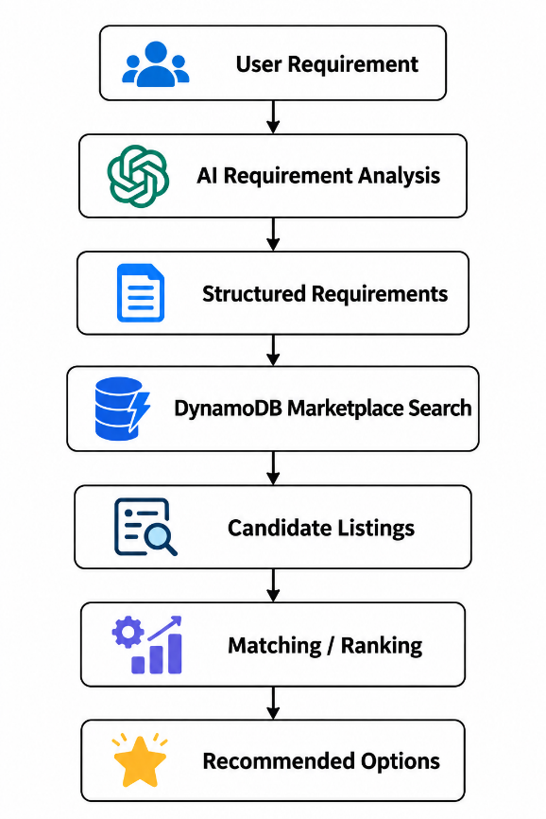
The recommendation system uses actual marketplace listings and does not generate fictional suppliers or inventory.

A.5 Amazon Cognito – Authentication Verification
The following simplified Python example demonstrates how an authenticated user's identity can be obtained from an Amazon API Gateway request.
def get_authenticated_user(event):
claims = (
event
.get("requestContext", {})
.get("authorizer", {})
.get("jwt", {})
.get("claims", {})
)
user_id = claims.get("sub")
if not user_id:
raise PermissionError("Authentication required")
return user_id

Gateway validates the JWT token before the request reaches the Lambda function.
This allows the backend to identify the authenticated user and apply appropriate role-based access rules.

A.6 Agricultural Knowledge Retrieval – RAG
The following simplified example illustrates the basic structure of a retrieval-augmented generation workflow.
def generate_knowledge_response(user_query, documents):
relevant_docs = [
doc for doc in documents
if any(
word.lower() in doc["content"].lower()
for word in user_query.split()
)
]
context = "\n".join(
doc["content"] for doc in relevant_docs[:3]
)
prompt = f"""
Answer the user's question using only the
information provided in the context.
Context:
{context}
Question:
{user_query}
"""
response = client.responses.create(
model="gpt-4.1-mini",
input=prompt
)
return response.output_text
The actual production implementation can use a proper vector database and embedding-based similarity search rather than the simplified keyword matching shown above.
The RAG workflow is:
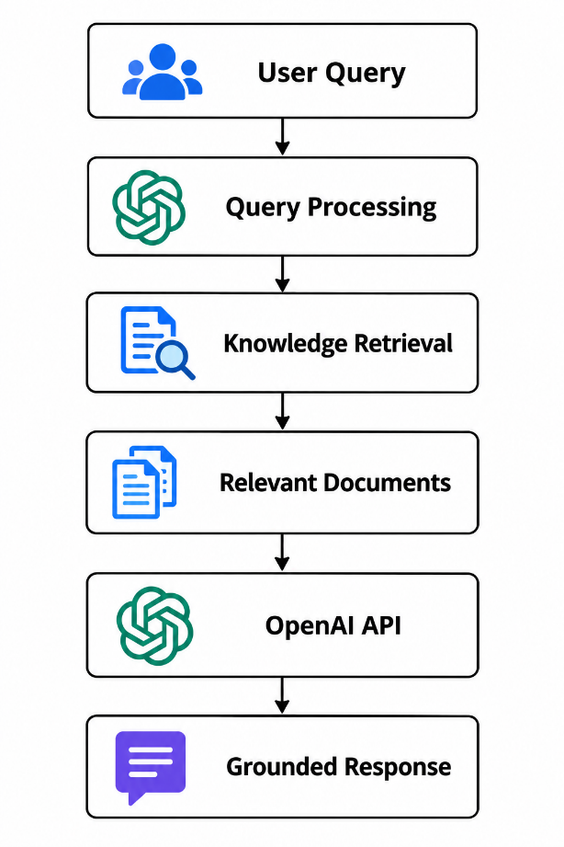

A.7 Conclusion
The above code excerpts demonstrate the major technical concepts used in the AgriConnect platform, including serverless backend processing, DynamoDB marketplace operations, Cognito-based authentication, AI requirement analysis, marketplace matching, and RAG-based knowledge assistance.
These examples are simplified representations of the proposed implementation. The complete application would include additional validation, exception handling, authorization, logging, database access controls, secure secret management, and production-level testing.

REFERENCE
- Food and Agriculture Organization of the United Nations (FAO), The State of Food and Agriculture 2022: Leveraging Automation in Agriculture for Transforming Agrifood Systems, FAO, Rome, 2022. Available at:
https://www.fao.org/publications/sofa/2022/en/
- Food and Agriculture Organization of the United Nations (FAO), Digital Agriculture, Food and Agriculture Organization of the United Nations. Available at:
https://www.fao.org/digital-agriculture/en/
- World Bank, ICT in Agriculture: Connecting Smallholders to Markets, World Bank, Washington, D.C. Available at:
https://www.worldbank.org/en/topic/agriculture
- Food and Agriculture Organization of the United Nations (FAO), The State of Agricultural Commodity Markets, FAO, Rome. Available at:
https://www.fao.org/publications/
- T. Klerkx, E. Jakku and P. Labarthe, “A Review of Social Science on Digital Agriculture, Smart Farming and Agriculture 4.0,” NJAS – Wageningen Journal of Life Sciences, Volume 90–91, 2019.
- T. Brown, B. Mann, N. Ryder, M. Subbiah, J. D. Kaplan, P. Dhariwal, A. Neelakantan, P. Shyam, G. Sastry, A. Askell, S. Agarwal, A. Herbert-Voss, G. Krueger, T. Henighan, R. Child, A. Ramesh, D. Ziegler, J. Wu, C. Winter, C. Hesse, M. Chen, E. Sigler, M. Litwin, S. Gray, B. Chess, J. Clark, C. Berner, S. McCandlish, A. Radford, I. Sutskever and D. Amodei, “Language Models are Few-Shot Learners,” Advances in Neural Information Processing Systems, Volume 33, 2020.
- P. Lewis, E. Perez, A. Piktus, F. Petroni, V. Karpukhin, N. Goyal, H. Küttler, M. Lewis, W.-t. Yih, T. Rocktäschel, S. Riedel and D. Kiela, “Retrieval-Augmented Generation for Knowledge-Intensive NLP Tasks,” Advances in Neural Information Processing Systems, Volume 33, Pages 9459–9474, 2020.
- OpenAI, OpenAI API Documentation, OpenAI. Available at:
https://platform.openai.com/docs/

