**Q1. you are tasked to create a product catalog system where user can add a product and display a product catalog Design a Spning Data JPA entity for a product catalog Include attributes for product name, price, and category .**

**Steps: • The first restful URI should display the html page where Two option should be there ie l. Add product 2.Display product . where user can choose.**

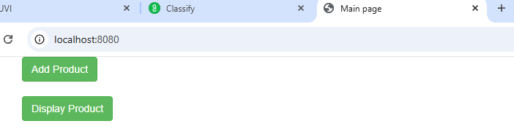

**• If auser clicks on Add product then should display the html page (product Info form )where user can enter name price and category and users can click one submit button .If a user clicks on Display product All product information should Display On webpage in tabular format**

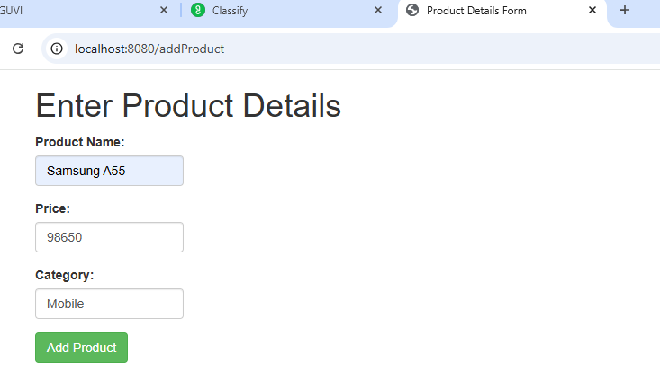

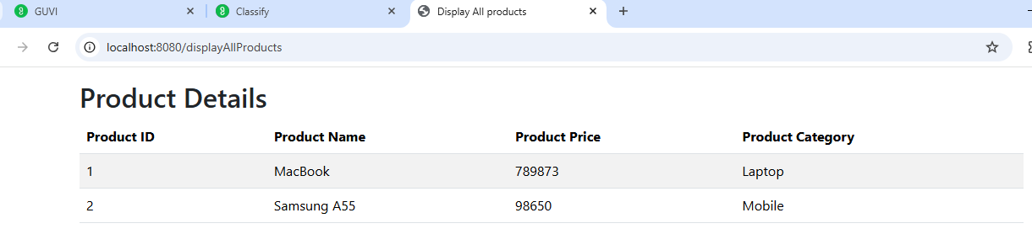

**Implement a repository method to fetch all products of a specific category**

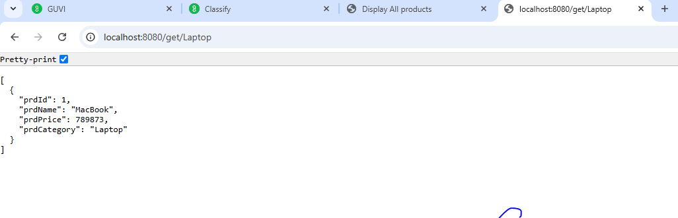

**MYSQL Screenshot:**

