**Assignment 2 [VBA]**

**Saranya P**

<<Data Analytics >>

**The VBA Of Wall Street**

**Table of Contents**

**Background** 2

**Resources Used** 2

**Objective** 2

**Instructions** 3

**Easy Level** 3

**Moderate Level** 3

**Hard Level** 4

**Script Explanation** 5

**Easy Level:** 6

**Moderate Level:** 7

**Hard Level:** 8

**Challenge** 10

**Other Considerations** 11

**Submission** 11

**# Unit 2 | Assignment - The VBA of Wall Street**

# **Background**

You are well on your way to becoming a programmer and Excel master! In this homework assignment you will use VBA scripting to analyse real stock market data. Depending on your comfort level with VBA, choose your assignment from Easy, Moderate, or Hard below.

# **Resources Used**

* [Test Data](Resources/alphabetical_testing.xlsx) - Use this while developing your scripts.

* [Stock Data](Resources/Multiple_year_stock_data.xlsx) - Run your scripts on this data to generate the final homework report.

# **Objective**

Using VBA Scripting, we need to generate a code/script to analyse the real world stock market data for the year 2014, 2015 & 2016.

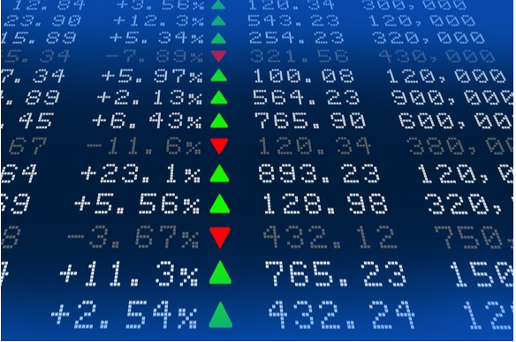

# **Instructions**

The Assignment is divided into 3 modules of difficulty levels.

## **Easy Level**

* Create a script that will loop through one year of stock data for each run and return the total volume each stock had over that year.

* You will also need to display the ticker symbol to coincide with the total stock volume.

* Your result should look as follows (note: all solution images are for 2015 data).

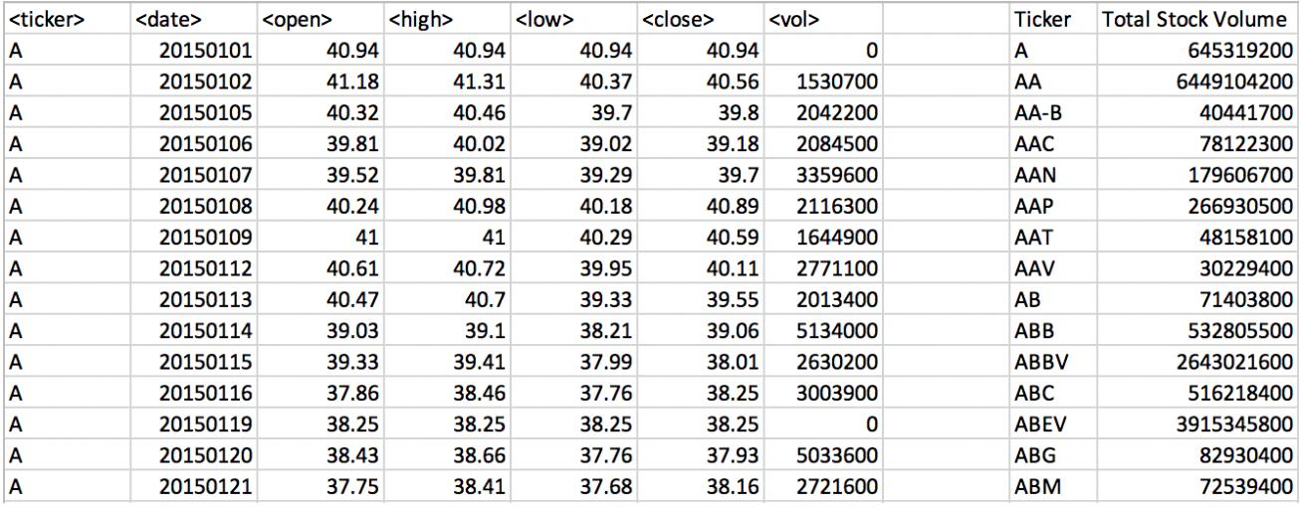

## **Moderate Level**

* Create a script that will loop through all the stocks for one year for each run and take the following information.

* The ticker symbol.

* Yearly change from opening price at the beginning of a given year to the closing price at the end of that year.

* The percent change from opening price at the beginning of a given year to the closing price at the end of that year.

* The total stock volume of the stock.

* You should also have conditional formatting that will highlight positive change in green and negative change in red.

* The result should look as follows.

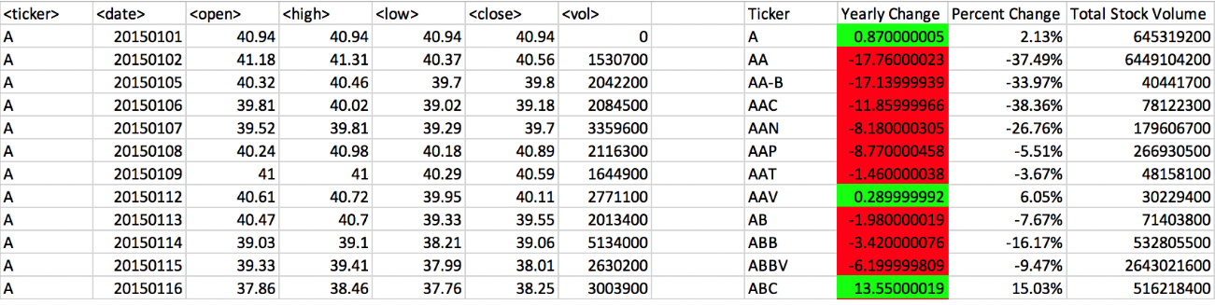

## **Hard Level**

* Your solution will include everything from the moderate challenge.

* Your solution will also be able to return the stock with the "Greatest % increase", "Greatest % Decrease" and "Greatest total volume".

* Solution will look as follows.

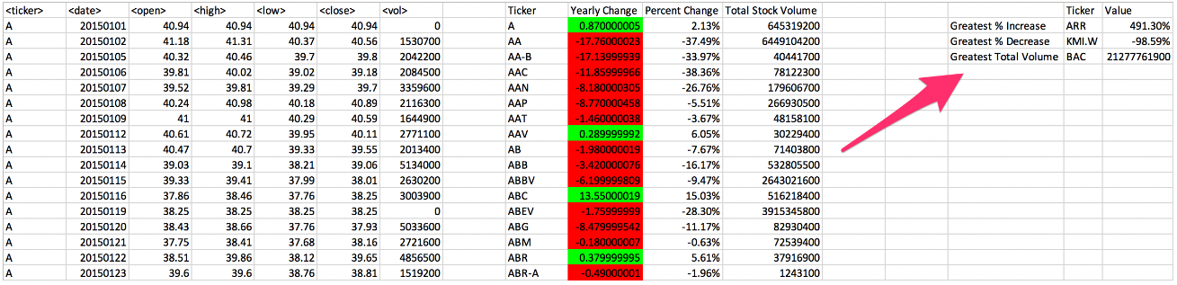

# **Script Explanation**

The Script has the below three Modules.

* **Module 1 🡪 Stock_Market_Easy**
* **Module 2 🡪 Stock_Market_Moderate**
* **Module 3 🡪 Stock_Market_Hard**

When you click on the below 3 buttons, it will call the corresponding modules to show the expected Real Stock Data.

* Easy Level Button 🡪 **Stock_Market_Easy (Module 1)**
* Medium Level Button 🡪 **Stock_Market_Moderate (Module 2)**
* Hard Level Button 🡪 **Stock_Market_Hard (Module 3)**

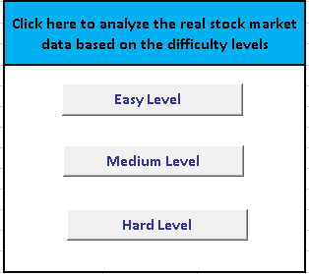

Script comments are provided in the respective scripts.

Initially we clear the target contents using the below code in all the code.

**For i = 9 To 12**

**ws.Columns(i).Clear**

**Next i**

**ws.Range("O1:Q4").Clear**

## **Easy Level:**

The Easy Module displays the below Output which contains the following fields:

* Ticker Symbol
* Total Stock Volume

For each Ticker Symbol, the Total Stock Volume has been Calculated and displayed as below.

Total Stock Volume is calculated by summing up the Volume Value for each Ticker Symbol.

**Easy Level Snapshot:**

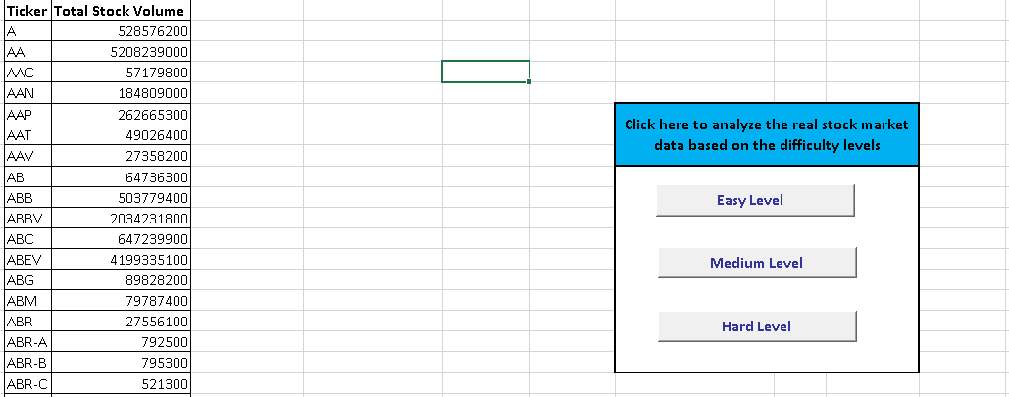

The Borders has been applied for the Target Cells using the below code.

**For i = 1 To Cells(Rows.Count, "I").End(xlUp).Row**

**ws.Range("I" & i).BorderAround ColorIndex:=1, Weight:=xlThin**

**ws.Range("J" & i).BorderAround ColorIndex:=1, Weight:=xlThin**

**Next i**

## **Moderate Level:**

The Moderate Module displays the below Output which contains the following fields:

* Ticker Symbol
* Yearly Change
* Percent Change
* Total Stock Volume

For each Ticker Symbol, the Yearly Change, Percent Change and the Total Stock Volume has been Calculated and displayed as below.

Total Stock Volume is calculated by summing up the Volume Value for each Ticker Symbol.

Yearly Change is calculated using the below formula:

**YearlyChange = CloseValue – OpenValue**

Percent Change is calculated using the below formula:

**PercentChange = YearlyChange / OpenValue**

**Moderate Level Snapshot:**

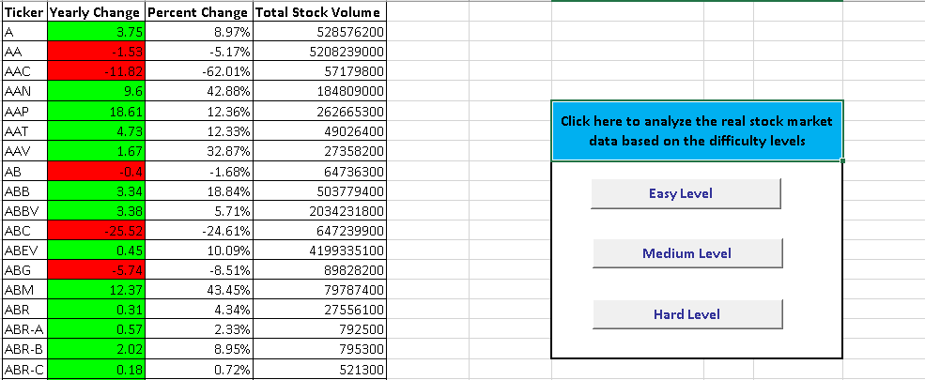

In this Module, we have done conditional formatting for the ***Yearly Change Column*** having the Positive Values in Green and Negative Values in Red using the below code.

**If ws.Range("J" & RowNum).Value >= 0 Then**

**ws.Range("J" & RowNum).Interior.ColorIndex = 4**

**Else**

**ws.Range("J" & RowNum).Interior.ColorIndex = 3**

**End If**

And also the ***Percent Change Column*** has been formatted to Percentage Style using the below condition.

**ws.Range("K" & RowNum).NumberFormat = "0.00%"**

The Borders has been applied for the Target Cells using the below code.

**For i = 1 To Cells(Rows.Count, "I").End(xlUp).Row**

**ws.Range("I" & i).BorderAround ColorIndex:=1, Weight:=xlThin**

**ws.Range("J" & i).BorderAround ColorIndex:=1, Weight:=xlThin**

**ws.Range("K" & i).BorderAround ColorIndex:=1, Weight:=xlThin**

**ws.Range("L" & i).BorderAround ColorIndex:=1, Weight:=xlThin**

**Next i**

## **Hard Level:**

The Hard Module displays the below Output which contains the following fields:

* Ticker Symbol
* Yearly Change
* Percent Change
* Total Stock Volume
* Greatest % Increase Value along with its corresponding Ticker Symbol
* Greatest % Decrease Value along with its corresponding Ticker Symbol
* Greatest Total Volume along with its corresponding Ticker Symbol

For each Ticker Symbol, the Yearly Change, Percent Change and the Total Stock Volume has been Calculated. And also the Greatest % Increase, Decrease & Total Volume Value is obtained along with its corresponding Ticker Symbol and displayed as below.

Yearly Change is calculated using the below formula:

**YearlyChange = CloseValue – OpenValue**

Percent Change is calculated using the below formula:

**PercentChange = YearlyChange / OpenValue**

Greatest % Increase, Decrease & Total Volume Value is calculated using the below condition:

**If ws.Range("K" & i).Value > GreatestPercentIncreaseValue Then**

**GreatestPercentIncreaseValue = ws.Range("K" & i).Value**

**GreatestPercentIncreaseTickerSymbol = ws.Range("I" & i).Value**

**End If**

**If ws.Range("K" & i).Value < GreatestPercentDecreaseValue Then**

**GreatestPercentDecreaseValue = ws.Range("K" & i).Value**

**GreatestPercentDecreaseTickerSymbol = ws.Range("I" & i).Value**

**End If**

**If ws.Range("L" & i).Value > GreatestTotalVolume Then**

**GreatestTotalVolume = ws.Range("L" & i).Value**

**GreatestTotalVolumeTickerSymbol = ws.Range("I" & i).Value**

**End If**

**Hard Level Snapshot:**

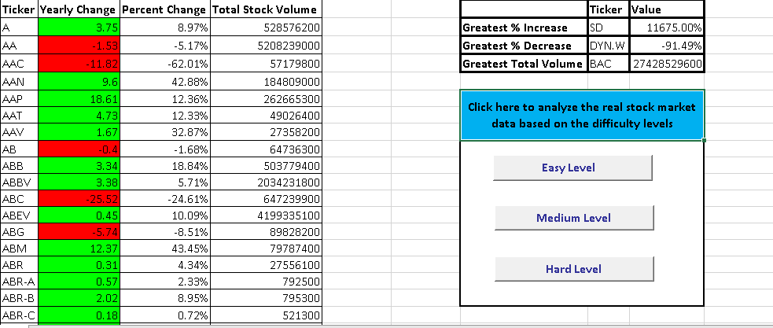

In this Module, we have done conditional formatting for the ***Yearly Change Column*** having the Positive Values in Green and Negative Values in Red using the below code.

**If ws.Range("J" & RowNum).Value >= 0 Then**

**ws.Range("J" & RowNum).Interior.ColorIndex = 4**

**Else**

**ws.Range("J" & RowNum).Interior.ColorIndex = 3**

**End If**

And also the ***Percent Change, Greatest % Increase, Decrease Value Column*** has been formatted to Percentage Style using the below condition.

**ws.Range("K" & RowNum).NumberFormat = "0.00%"**

**ws.Range("Q2").NumberFormat = "0.00%"**

**ws.Range("Q3").NumberFormat = "0.00%"**

The Borders has been applied for the Target Cells using the below code.

**For i = 1 To 4**

**ws.Range("O" & i).BorderAround ColorIndex:=1, Weight:=xlThick**

**ws.Range("P" & i).BorderAround ColorIndex:=1, Weight:=xlThick**

**ws.Range("Q" & i).BorderAround ColorIndex:=1, Weight:=xlThick**

**Next i**

**For i = 1 To Cells(Rows.Count, "I").End(xlUp).Row**

**ws.Range("I" & i).BorderAround ColorIndex:=1, Weight:=xlThin**

**ws.Range("J" & i).BorderAround ColorIndex:=1, Weight:=xlThin**

**ws.Range("K" & i).BorderAround ColorIndex:=1, Weight:=xlThin**

**ws.Range("L" & i).BorderAround ColorIndex:=1, Weight:=xlThin**

**Next i**

# **Challenge**

* Make the appropriate adjustments to your script that will allow it to run on every worksheet, i.e., every year, just by running it once.

**<Sara Comment> :**

***In the first sheet (2016), I have created 3 buttons based on difficulty levels. If we click on button (any level) once, the appropriate adjustments will be done on every worksheet.***

* This can be applied to any of the difficulties.

# **Other Considerations**

* Use the sheet `alphabetical_testing.xlsx` while developing your code. This data set is smaller and will allow you to test faster. Your code should run on this file in less than 3-5 minutes.

* Make sure that the script acts the same on each sheet. The joy of VBA is to take the tediousness out of repetitive task and run over and over again with a click of the button.

**<Sara Comment> :**

***The above considerations have been taken care in the script and also while developing the code.***

# **Submission**

* To submit please upload the following to Github:

* A screen shot for each year of your results on the Multi Year Stock Data.

**<Sara Comment> :**

***The Snapshots for Each difficulty levels are placed under snapshot folder.***

* VBA Scripts as separate files.

**<Sara Comment> :**

***The Scripts for Each difficulty levels are placed under Script folder.***

* After everything has been saved, create a sharable link and submit that to <https://bootcampspot-v2.com/>.

**<Sara Comment> :**

The link to the VBA Assignment is in the below link.

<<https://github.com/SaranyaPandiaraj/VBA-HomeWork>>