Oracle SQL Guide

Oracle SQL Guide - Employee Database Management
Table of Contents
I. CREATE TABLE 3
II. ALTER TABLE 5
I) Alter Table for adding column 5
II) ALTER table for rename column 5
III) Alter Table for updating Data Types, nullability 5
IV) Alter Table for dropping a column 5
V) Alter Table for adding constraint 6
III. RENAME Table 6
IV. DROP Table 6
V. Truncate Table 7
Difference between Drop and Truncate 8
VI. INSERT INTO 8
VII. SELECT 9
a. Select all columns from a table 10
b. Select specific columns 10
c. Filter rows using WHERE 10
d. Sort results using ORDER BY 11
e. Remove duplicates using DISTINCT 11
f. Using arithmetic expressions 12
g. Using functions (example: COUNT, AVG) 12
VIII. SQL WHERE with AND condition 13
IX. SQL WHERE with OR condition 13
X. SQL WHERE with NOT Condition 13
XI. SQL NULL VALUES 14
XII. UPDATE 14
XIII. DELETE 15
XIV SELECT TOP 16
XV AGGREGATE 17
I) MIN() 17
II) MAX() 17
III) Count() 18
IV) SUM() 18
V) AVG() 19
XVI LIKE OPERATOR 19
XVIII NOT IN OPERATOR 21
XIX ALIASES 21
XX JOIN 22
I) INNER JOIN 22
II) LEFT (OUTER) JOIN 23
III) RIGHT (OUTER) JOIN 23
IV) FULL (OUTER) JOIN 24
V) CROSS JOIN 24
VI) SELF JOIN 25
XXI UNION 26
XII UNION ALL 28

EMPLOYEE DATABASE MANAGEMENT SYSTEM

CREATE TABLE
The CREATE TABLE statement is used to create a new table in a database. It begins with the keyword CREATE TABLE followed by the table name. Inside parentheses, you define the columns (fields) of the table along with:
- Data Types – specify the type of data each column can hold (e.g., INT, VARCHAR, DATE).
- Constraints – enforce rules on the data (e.g., NOT NULL, UNIQUE, CHECK).
- Primary/Foreign Key References – define relationships between tables to maintain data integrity.
CREATE TABLE Department ( DepartmentID NUMBER GENERATED BY DEFAULT AS IDENTITY PRIMARY KEY, DeptName VARCHAR2(100) NOT NULL, Location VARCHAR2(100) );

Output:

SQL> CREATE TABLE Department ( DepartmentID NUMBER GENERATED BY DEFAULT AS IDENTITY PRIMARY KEY, DeptName VARCHAR2(100) NOT NULL, Location VARCHAR2(100) )
Table DEPARTMENT created.
Table DEPARTMENT created.

CREATE TABLE Employee (
EmpID NUMBER GENERATED BY DEFAULT AS IDENTITY PRIMARY KEY, FirstName VARCHAR2(50) NOT NULL,
LastName VARCHAR2(50) NOT NULL,
BirthDate DATE, Gender CHAR(1), HireDate DATE, DepartmentID NUMBER, Salary NUMBER(12,2),
CONSTRAINT fk_dept FOREIGN KEY (DepartmentID) REFERENCES Department(DepartmentID)
);

Output: QL> CREATE TABLE Employee (
EmpID NUMBER GENERATED BY DEFAULT AS IDENTITY PRIMARY KEY, FirstName VARCHAR2(50) NOT NULL,
LastName VARCHAR2(50) NOT NULL,
BirthDate DATE, Gender CHAR(1), HireDate DATE, DepartmentID NUMBER, Salary NUMBER(12,2),...show more...Table EMPLOYEE created.
Table DEPARTMENT created.

CREATE TABLE Project (
ProjectID NUMBER GENERATED BY DEFAULT AS IDENTITY PRIMARY KEY, ProjectName VARCHAR2(100) NOT NULL,
StartDate DATE, EndDate DATE
);

Output:
SQL> CREATE TABLE Project (
ProjectID NUMBER GENERATED BY DEFAULT AS IDENTITY PRIMARY KEY, ProjectName VARCHAR2(100) NOT NULL,
StartDate DATE, EndDate DATE
Table PROJECT created.
Table DEPARTMENT created.

CREATE TABLE EmployeeProject (EmpID NUMBER,
ProjectID NUMBER, AssignmentDate DATE,
PRIMARY KEY (EmpID, ProjectID),
FOREIGN KEY (EmpID) REFERENCES Employee(EmpID),
FOREIGN KEY (ProjectID) REFERENCES Project(ProjectID)
);

Output: SQL> CREATE TABLE EmployeeProject (EmpID NUMBER,
ProjectID NUMBER, AssignmentDate DATE,
PRIMARY KEY (EmpID, ProjectID),
FOREIGN KEY (EmpID) REFERENCES Employee(EmpID),...
Show more...
Table EMPLOYEEPROJECT created.
Table DEPARTMENT created.

SQL> RENAME EMPLOYEE TO STAFF
Table renamed.
RENAME EMPLOYEE TO STAFF;

ALTER TABLE

Definition:
The ALTER TABLE statement is used to modify the structure of an existing table in a database. It allows changes without dropping and recreating the table. Key functionalities include:
- Add Columns: Introduce new columns to an existing table.
- Modify Columns: Change the data type, size, or constraints of existing columns.
- Drop Columns: Remove columns from a table.
- Add Constraints: Apply new rules to enforce data integrity (e.g., PRIMARY KEY, FOREIGN KEY, UNIQUE, CHECK).
- Drop Constraints: Remove existing constraints from a table.
Note: Using ALTER TABLE preserves the existing data in the table while modifying its structure.

Alter Table for adding column
ALTER table PROJECT add PROJECTSUMMARY varchar2(1000);

Output:SQL> ALTER table PROJECT add PROJECTSUMMARY varchar2(1000)
Table PROJECT altered.

ALTER table for rename column
ALTER table PROJECT RENAME COLUMN PROJECTSUMMARY TO PROJECTDESC;

Output:
SQL> ALTER table PROJECT RENAME COLUMN PROJECTSUMMARY TO PROJECTDESC
Table PROJECT altered.

Alter Table for updating Data Types, nullability
ALTER table PROJECT modify PROJECTDESC number(10,2) NOT NULL;

Output:
SQL> ALTER table PROJECT modify PROJECTDESC number(10,2) NOT NULL
Table PROJECT altered.

Alter Table for dropping a column
ALTER table PROJECT drop COLUMN PROJECTDESC;

Output:
SQL> ALTER table PROJECT drop COLUMN PROJECTDESC
Table PROJECT altered.

  - Alter Table for adding constraint
ALTER TABLE STAFF
ADD CONSTRAINT chk_salary_positive CHECK (salary > 0);

Output:
SQL> ALTER TABLE STAFF
ADD CONSTRAINT chk_salary_positive CHECK (salary > 0)
Table STAFF altered.

RENAME Table
Definition: The RENAME statement is used to change the name of an existing database object, such as a table. This command allows you to update the table name without affecting its data or structure. Rename <oldtablename> TO <newtablename>

RENAME STAFF TO EMPLOYEE;

Output:
SQL> RENAME STAFF TO EMPLOYEE
Table renamed.

DROP Table
Definition:
The DROP TABLE statement is used to permanently remove an existing table from the database, along with all the data, indexes, and associated constraints stored in that table.
Key Points:
- The operation cannot be undone; all data in the table will be lost.
- Removes the table structure, its data, and any associated indexes or constraints.
- Use with caution, especially in production environments.

DROP TABLE EMPLOYEE;

Output:
SQL> DROP TABLE EMPLOYEE ORA-02449: unique/primary keys in table referenced by foreign keys
https://docs.oracle.com/error-help/db/ora-02449/
Error at Line: 4 Column:

Above error means fields from Employee are used as a reference key in some other. So, we need to remove link or delete the child element before deleting parent reference Employee table

DROP TABLE EMPLOYEEPROJECT;

Output:
SQL> DROP TABLE EMPLOYEEPROJECT
Table EMPLOYEEPROJECT dropped.
Elapsed: 00:00:00.041

Create Table:

CREATE TABLE EmployeeProject (EmpID NUMBER,
ProjectID NUMBER, AssignmentDate DATE,
PRIMARY KEY (EmpID, ProjectID),
FOREIGN KEY (EmpID) REFERENCES Employee(EmpID),
FOREIGN KEY (ProjectID) REFERENCES Project(ProjectID)
);

Output: SQL> CREATE TABLE EmployeeProject (EmpID NUMBER,
ProjectID NUMBER, AssignmentDate DATE,
PRIMARY KEY (EmpID, ProjectID),
FOREIGN KEY (EmpID) REFERENCES Employee(EmpID),...
Show more...
Table EMPLOYEEPROJECT created.
Table DEPARTMENT created.

Truncate Table
Definition:
The TRUNCATE TABLE statement is used to remove all rows from a table quickly, while keeping the table structure, columns, and constraints intact.
Key Points:
- Deletes all data in the table without logging individual row deletions, making it faster than DELETE.
- Cannot be rolled back once executed (unless used within a flashback-enabled environment).
- Resets any auto-incrementing sequences or storage associated with the table (depending on Oracle settings).
- Table structure, indexes, and constraints remain unaffected, allowing new data to be inserted immediately.
Truncate table EMPLOYEEPROJECT;

Output: SQL> Truncate table EMPLOYEEPROJECT
Table EMPLOYEEPROJECT truncated.

Table DEPARTMENT created.

Difference between Drop and Truncate

Feature | DROP TABLE | TRUNCATE TABLE
Purpose | Permanently removes the table and its structure from the database | Deletes all rows from the table but keeps the table structure intact
Data Recovery | Cannot recover data unless a backup exists | Cannot recover data through rollback (not logged row by row), but structure remains
Constraints & Indexes | All constraints, indexes, and triggers associated with the table are removed | Constraints, indexes, and triggers remain intact
Speed | Slower if there are dependencies because it removes the entire structure | Faster because it only deletes data and does not log individual row deletions
Usage | Used when the table is no longer needed | Used when the table structure is needed but all data needs to be cleared

INSERT INTO
Definition:
The INSERT INTO statement is used to add new rows of data into a table in a database. It allows specifying values for one or more columns in the table.

Basic Syntax (Oracle / MS SQL) – for Single Data Insertion:
INSERT INTO table_name (column1, column2, column3, ...)
VALUES (value1, value2, value3, ...);

Basic Syntax for multi data insertion (Oracle1 11g or earlier)
INSERT ALL
INTO DEPARTMENT (DEPARTMENTID, DEPTNAME, LOCATION) VALUES (2, 'ECE', 'Mumbai')
INTO DEPARTMENT (DEPARTMENTID, DEPTNAME, LOCATION) VALUES (3, 'MECH', 'Delhi')
SELECT * FROM dual;

Basic Syntax for multi data insertion (Oracl 19c or latest)
INSERT INTO table_name (column1, column2, column3, ...)
VALUES
(value1, value2, value3),
(value4, value5, value6),
(value7, value8, value9);

Key Points:
Column names are optional if values are provided for all columns in the correct order.
String and date values must be enclosed in single quotes ' '.
Numeric values are entered without quotes.
Can insert one row at a time or multiple rows in a single statement (syntax differs slightly between Oracle and MS SQL).

Insert new rows to department table

INSERT INTO DEPARTMENT(DEPARTMENTID,DEPTNAME, LOCATION) values(1, 'CSE', 'Chennai');

SQL> INSERT INTO DEPARTMENT(DEPARTMENTID,DEPTNAME, LOCATION) values(1, 'CSE', 'Chennai')
1 row inserted.

Table DEPARTMENT created.

Insert new rows to Employee
INSERT INTO Employee (FirstName, LastName, BirthDate, Gender, HireDate, DepartmentID, Salary) VALUES ('Alice', 'Smith', DATE '1990-05-20', 'F', DATE '2023-08-01', 1, 60000);

SQL> INSERT INTO Employee (FirstName, LastName, BirthDate, Gender, HireDate, DepartmentID, Salary) VALUES ('Alice', 'Smith', DATE '1990-05-20', 'F', DATE '2023-08-01', 1, 60000)
1 row inserted.
1 row inserted.

Table DEPARTMENT created.

Insert only specified columns
INSERT INTO Employee (FirstName, LastName, DepartmentID) VALUES ('Alice', 'Smith',1);

1 row inserted.
1 row inserted.

Table DEPARTMENT created.

Let’s do multiple data insertion in to employee Table

Insert multiple records at a time

INSERT INTO Employee (FirstName, LastName, BirthDate, Gender, HireDate, DepartmentID, Salary, managerID) VALUES ('John', 'Smith', DATE '1990-05-20', 'F', DATE '2023-08-01', 2, 60000), ('Reshmika', 'Saswath', DATE '1990-05-20', 'F', DATE '2023-08-01', 1, 40000), ('John', 'Cena', DATE '1990-05-20', 'F', DATE '2023-08-01', 3, 100000);

3 rows inserted. row inserted.

SELECT

The SELECT statement is used to retrieve data from one or more tables in a database. It is the most commonly used SQL command.

Components of SELECT
Component | Description
SELECT | Specifies the columns you want to retrieve. Use * to select all columns.
FROM | Specifies the table(s) from which to retrieve data.
WHERE | Filters rows based on a condition (optional).
ORDER BY | Sorts the result set by specified column(s) in ascending (ASC) or descending (DESC) order (optional).
DISTINCT | Removes duplicate rows from the result set (optional).
JOIN | Combines rows from multiple tables based on a related column (optional).

Examples

Select all columns from a table
[Displays all the column available in the table]

Select * from EMPLOYEE;

Output:
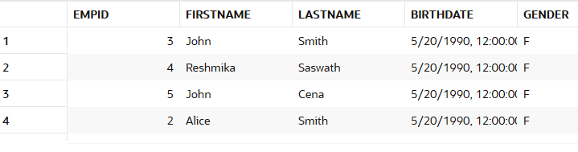

Select specific columns
[Displays only those columns specified in the Select clause.
SELECT EMPID, FIRSTNAME, LASTNAME FROM EMPLOYEE;

Output:
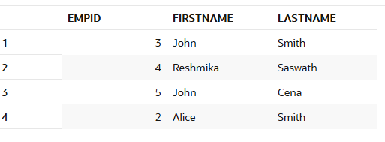

Filter rows using WHERE
Where is a conditional clause using which restrict and retrieve records based on certain criteria applied as filter. Where can be used in Select, Update and Delete as well.
SELECT empID, salary FROM employee WHERE salary > 50000;

Output:
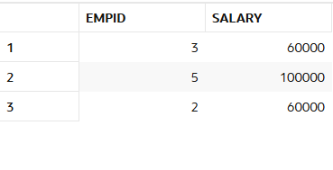

Sort results using ORDER BY
SELECT empID,firstName, salary
FROM employee
ORDER BY salary DESC;

Output:
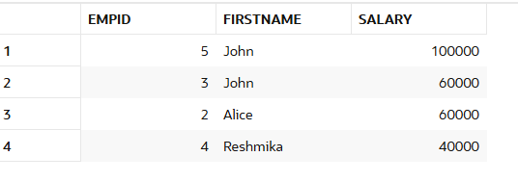

Remove duplicates using DISTINCT

SELECT DISTINCT DEPARTMENTID
From Employee;

Output:
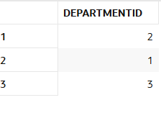

SELECT DISTINCT DEPARTMENTID, FIRSTNAME
From Employee;

Output:

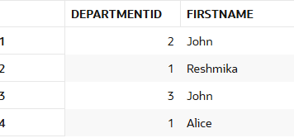

Using arithmetic expressions

Output:

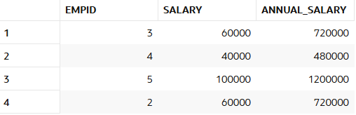

Using functions (example: COUNT, AVG)

SELECT COUNT(DISTINCT DEPARTMENTID)as TotalDepartment from EMPLOYEE;

Output:
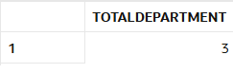

SELECT COUNT(*) AS total_employees, AVG(salary) AS avg_salary
FROM employee;

Output:
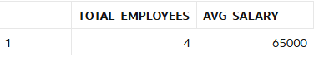

SQL WHERE with AND condition
The WHERE clause can contain one or many AND operators.
The AND operator is used to filter records based on more than one condition.
SELECT EMPID, FIRSTNAME,SALARY from Employee where departmentID=1 and salary<60000;

Output:

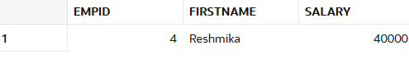

SQL WHERE with OR condition
The WHERE clause can contain one or many AND operators.
The OR operator is used to filter records based on more than one condition.
SELECT EMPID, FIRSTNAME,departmentID, SALARY from Employee where departmentID=1 or departmentID = 2;

Output:
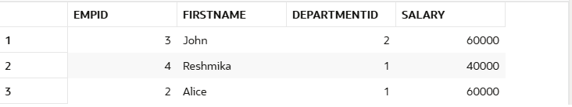

SQL WHERE with NOT Condition
The NOT operator is used in combination with other operators to give the opposite result, also called the negative result.
SELECT EMPID, FIRSTNAME,departmentID, SALARY from Employee where NOT departmentID=1;

Output:
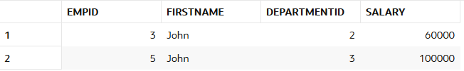

SQL NULL VALUES
Null values are not equal to blank space. It cannot validated using comparison operators, such as =, <, or <>. We have to use IS NULL or IS NOT NULL to check the null able condition of field.
EMPID, FIRSTNAME,departmentID,Gender from Employee where gender is null;

Output:
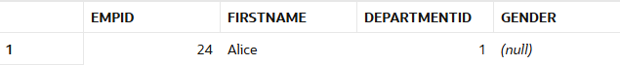

EMPID, FIRSTNAME,departmentID,Gender from Employee where gender is not null;

Output:
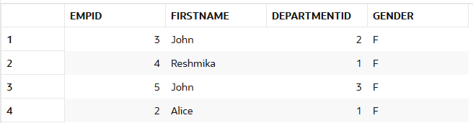

UPDATE

The UPDATE statement is used to modify the existing records in a table. Update with where conditions will make modifications only to those records that matches with where criteria. Update without where conditions will tend to update all record. Be careful in performing updates.

Update with where Condition
Update EMPLOYEE SET GENDER='M' where EMPID=24;

SQL> Update EMPLOYEE SET GENDER='M' where EMPID=24
1 row updated.

ROLLBACK;
This will undo all uncommitted changes in the current transaction, including the wrong update.

Once you issue a COMMIT, the changes become permanent and cannot be rolled back. In that case, you’d need to issue another UPDATE to fix the values manually.

Update ALL:
SQL> Update EMPLOYEE SET SALARY = '100000'
5 rows updated.
Update EMPLOYEE SET SALARY = '100000';

After update try to access the record using select and verify the modified data.

DELETE
Remove rows. You can remove all the records at a time. Also have the option to delete specific records using where condition.
DELETE FROM Employee WHERE DEPARTMENTID < 2;
SQL> DELETE FROM Employee WHERE DEPARTMENTID < 2
3 rows deleted.

DELETE ALL
DELETE FROM EMPLOYEE;
SQL> DELETE FROM EMPLOYEE
2 rows deleted.

Since we deleted all the records from employee table, let’s do a bulk insert again
INSERT INTO Employee (FirstName, LastName, BirthDate, Gender, HireDate, DepartmentID, Salary) VALUES ('John', 'Smith', DATE '1990-05-20', 'F', DATE '2023-08-01', 2, 60000), ('Reshmika', 'Saswath', DATE '1990-05-20', 'F', DATE '2023-08-01', 1, 40000), ('John', 'Cena', DATE '1990-05-20', 'F', DATE '2023-08-01', 3, 100000), ('Arun', 'Vijay', DATE '1990-11-20', 'M', DATE '2023-08-01', 3, 100000);

c4 rows inserted.

XIV SELECT TOP
It is used to limit the number of records fetched. MSSQL supports LIMIT Clause while Oracle supports FETCH FIRST n rows only and ROWNUM.

SELECT EMPID,FIRSTNAME, SALARY FROM Employee WHERE ROWNUM <= 5 ORDER BY Salary DESC;

Output:
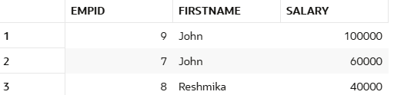

SELECT EMPID,FIRSTNAME, SALARY FROM Employee ORDER BY Salary DESC FETCH FIRST 2 ROWS ONLY;

Output:
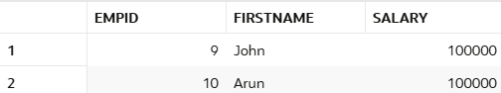

XV AGGREGATE
An aggregate function is a function that performs a calculation on a set of values, and returns a single value.

Aggregate functions are often used with the GROUP BY clause of the SELECT statement. The GROUP BY clause splits the result-set into groups of values and the aggregate function can be used to return a single value for each group.
The most commonly used SQL aggregate functions are:
- MIN() - returns the smallest value within the selected column
- MAX() - returns the largest value within the selected column
- COUNT() - returns the number of rows in a set
- SUM() - returns the total sum of a numerical column
- AVG() - returns the average value of a numerical column

Key Points
- Works only on numeric columns (e.g., INT, DECIMAL, FLOAT).
- Often used with GROUP BY to find averages per group.
- Aggregate functions ignore null values (except for COUNT(*)).

- MIN() – Fetches the minimum value from the given column.

SELECT min(SALARY) from EMPLOYEE;

Output:
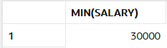

SELECT min(SALARY) as MiniumSalary, DEPARTMENTID from EMPLOYEE group by departmentID order by departmentID;

Output:
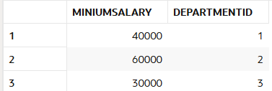

- MAX() Returns the maximum value from the given column

SELECT max(SALARY) from EMPLOYEE;

Output:
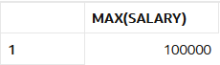

SELECT max(SALARY) as MaxSalary, DEPARTMENTID from EMPLOYEE group by departmentID order by departmentID;

Output:
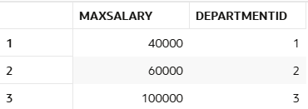

- Count() – returns the total number of rows in a given set.

Select count(*) from EMPLOYEE;

Output:
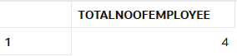

Select count(EMPID) as TotalNoOfEmployee from EMPLOYEE where DEPARTMENTID<=2;;

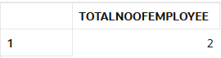

- SUM() can be applied only over a numeric column. Sum() adds all the value and returns the total result.

Select SUM(SALARY) from EMPLOYEE;

Output:
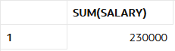

Select SUM(SALARY), DEPARTMENTID from EMPLOYEE group by DEPARTMENTID;

Output:
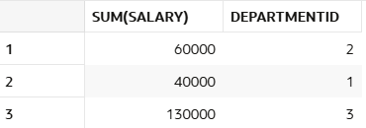

- AVG() function is an aggregate function that is used to calculate the average (arithmetic mean) of numeric values in a column.

Select AVG(SALARY) from EMPLOYEE;

Output:
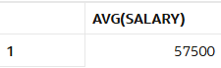

Output:
Select AVG(SALARY), DEPARTMENTID from EMPLOYEE group by DEPARTMENTID;
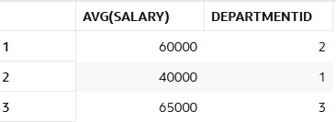

XVI LIKE OPERATOR

The LIKE operator in SQL is used within a WHERE clause to filter rows by matching a specified pattern in a column.

Two common wildcard characters are used with LIKE:
Percent sign (%) → Matches zero, one, or multiple characters.
Underscore (_) → Matches exactly one single character.

Select * from EMPLOYEE where firstname like '%a%';

Output:
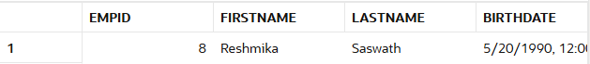

Select * from EMPLOYEE where firstname like 'J_hn';

Output:
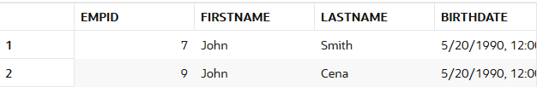

Select * from EMPLOYEE where firstname like 'R%' or firstname like 'J%';

The IN operator is used in a WHERE clause to filter rows based on whether a column’s value matches any value in a given list or subquery.
It is essentially a shorthand for multiple OR conditions.

Select EMPID, FIRSTNAME, DEPARTMENTID from EMPLOYEE where DEPARTMENTID in (1,2);

Output:
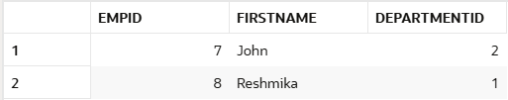

In order to see nested select queries, lets firs insert data to PROJECT & EMPLOYEE PROJECT Table.
INSERT INTO EMPLOYEEPROJECT VALUES(7,123,DATE '2026-08-01');
INSERT INTO EMPLOYEEPROJECT VALUES(7,123,DATE '2026-08-01');

1 row inserted.

INSERT INTO PROJECT VALUES(123,'Automation',DATE '2026-08-11',DATE '2027-08-01');
INSERT INTO PROJECT VALUES(123,'Data Science',DATE '2026-08-11',DATE '2027-08-01');

2 rows inserted.

Select * from EMPLOYEE where EMPID in (select EMPID from EMPLOYEEPROJECT);

Output:
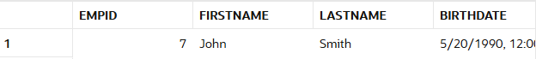

XVIII NOT IN OPERATOR

Select EMPID, FIRSTNAME, DEPARTMENTID from EMPLOYEE where DEPARTMENTID not in (1,2);

Output:
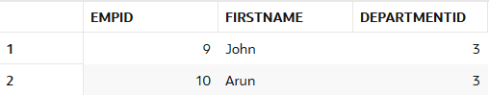

Select * from EMPLOYEE where EMPID not in (select EMPID from EMPLOYEEPROJECT);

Output: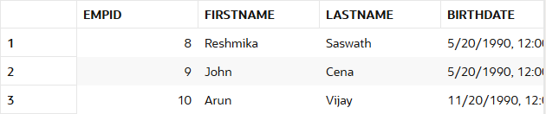

XIX ALIASES

Select EMPID as EmploymentID,FIRSTNAME "First Name" , LastName LTName ,DEPARTMENTID + EMPID AS DEPTEMPID from EMPLOYEE;

Output:
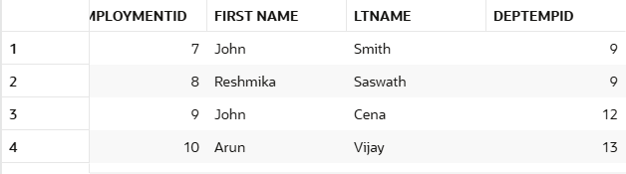

Select EMPID as EmploymentID,FIRSTNAME "First Name" , LastName LTName ,DEPARTMENTID || ',' || EMPID AS DEPTEMPID from EMPLOYEE;

Output:
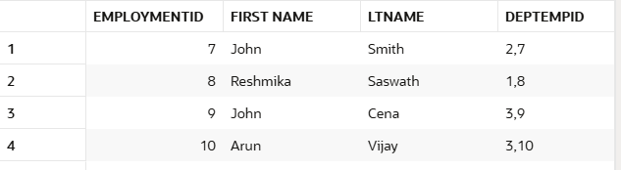

XX JOIN
In SQL, a join is used to combine rows from two or more tables based on a related column between them. Joins help you retrieve related data from multiple tables in a single query.

INNER JOIN

Returns rows that have matching values in both tables.

Select a.empid, a.firstname, b.projectid, b.assignmentdate from employee a inner join employeeproject b on a.empid = b.empid;

Output:
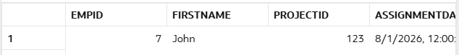

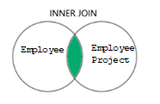

LEFT (OUTER) JOIN

Returns all rows from the left table and the matching rows from the right table. If there’s no match in the right table, columns from the right table are NULL.

Select a.empid, a.firstname, b.projectid, b.assignmentdate from employee a left join employeeproject b on a.empid = b.empid;

Output:
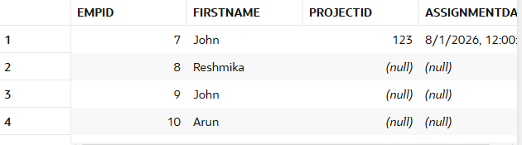

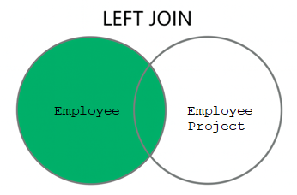

RIGHT (OUTER) JOIN
Returns all rows from the right table and the matching rows from the left table. If no match in the left table, columns from the left table are NULL

Select a.empid, a.projectid, b.projectName,b.startdate from employeeproject a right join project b on a.projectid = b.projectid;

Output:
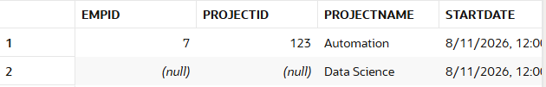

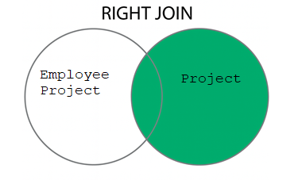

FULL (OUTER) JOIN

Returns all rows from both tables.Non-matching rows from either table will have NULL for the missing side.
Select a.empid, a.projectid, b.projectName,b.startdate from employeeproject a full outer join project b on a.projectid = b.projectid;

Output:
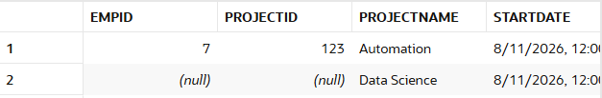

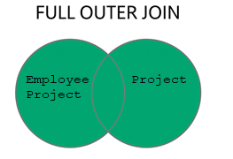

CROSS JOIN
Returns the Cartesian product of two tables (every row from the first table combined with every row from the second).

Select a.empid, a.firstname, b.departmentid,b.deptname from employee a cross join department b;

Output:
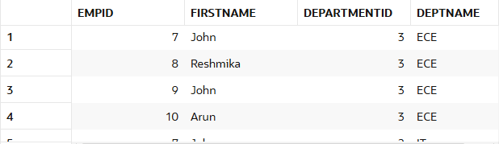

SELF JOIN

Before starting with Self Join, lets alter the employee table to include managerID column.

SQL> alter table employee add managerID number
Table EMPLOYEE altered.
alter table employee add managerID number;

Try to truncate table employee. It will through error saying dependency table has data. So, we need to first truncate employeeproject and then truncate employee table.

Truncate table employeeproject;
Output:
SQL> Truncate table employeeproject
Table EMPLOYEEPROJECT truncated.

Truncate table employee;
Output:
SQL> Truncate table employee
Table EMPLOYEE truncated.

INSERT INTO Employee (FirstName, LastName, BirthDate, Gender, HireDate, DepartmentID, Salary,MANAGERID) VALUES ('John', 'Smith', DATE '1990-05-20', 'F', DATE '2023-08-01', 2, 60000,12), ('Reshmika', 'Saswath', DATE '1990-05-20', 'F', DATE '2023-08-01', 1, 40000,1), ('John', 'Cena', DATE '1990-05-20', 'F', DATE '2023-08-01', 3, 100000,2), ('Arun', 'Vijay', DATE '1990-11-20', 'M', DATE '2023-08-01', 3, 100000,9);

4 rows inserted.

Update employee set managerid=53 where empID in (51,53,54);

3 rows inserted.

Now let’s try Self join to fetch the manager name for all those employees having manager ID assigned to it.

SELECT e1.empid AS Employee, e1.firstname as employeeName,e1.LASTNAME as lastname, e2.empid AS Manager, e2.firstname as "Manager name"
FROM employee e1
JOIN employee e2
ON e1.managerID = e2.empid;

Output:
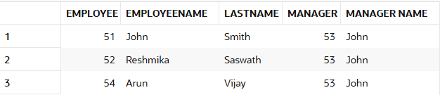

XXI UNION
The UNION operator in SQL is used to combine the result sets of two or more SELECT statements into a single result set. By default, UNION removes duplicate rows from the combined result set.

Requirements for Using UNION

- Each SELECT statement must return the same number of columns.
- The corresponding columns in each SELECT statement must have compatible data types.
- The order of the columns in all SELECT statements must be the same.
Before starting with Union, Let’s create another table Contractor

CREATE TABLE Contractor (
CONTRACTORID NUMBER GENERATED BY DEFAULT AS IDENTITY PRIMARY KEY, FirstName VARCHAR2(50) NOT NULL,
LastName VARCHAR2(50) NOT NULL,
BirthDate DATE, Gender CHAR(1), HireDate DATE, DepartmentID NUMBER, Salary NUMBER(12,2), managerID number);

Table CONTRACTOR created.

Insert data records into contractor table
INSERT INTO CONTRACTOR(FirstName, LastName, BirthDate, Gender, HireDate, DepartmentID, Salary,MANAGERID) VALUES ('Noah', 'Kelly', DATE '1990-05-20', 'F', DATE '2023-08-01', 2, 60000,12), ('Sinamika', 'Deshmukh', DATE '1990-05-20', 'F', DATE '2023-08-01', 1, 40000,1), ('Randy', 'Orton', DATE '1990-05-20', 'F', DATE '2023-08-01', 3, 100000,2), ('Arun', 'Vijay', DATE '1990-11-20', 'M', DATE '2023-08-01', 3, 100000,9);

4 rows inserted.

Now let’s try UNION on Employee and Contractor table
SELECT FirstName, LastName, BirthDate, EMPID as UNIQUEID from employee UNION
SELECT FirstName, LastName, BirthDate, CONTRACTORID as UNIQUEID from Contractor;

Output:
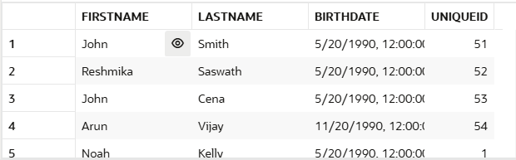

XII UNION ALL
The UNION ALL operator is used to combine the result-set of two or more SELECT statements.
The UNION ALL operator includes all rows from each statement, including any duplicates.
Requirements for UNION ALL:
- Every SELECT statement within UNION ALL must have the same number of columns
- The columns must also have similar data types
- The columns in every SELECT statement must also be in the same order
UNION ALL Syntax
While the UNION operator removes duplicate values by default, the UNION ALL includes duplicate values:

SELECT FirstName, LastName, BirthDate, EMPID as UNIQUEID from employee UNION ALL
SELECT FirstName, LastName, BirthDate, CONTRACTORID as UNIQUEID from Contractor;

Output:

SQL Server vs Oracle Data Types
Category | MS SQL Server | Oracle | Notes
Integer Numbers | INT (4 bytes), BIGINT, SMALLINT, TINYINT | NUMBER(p,0) (precision p) | Oracle uses NUMBER for all integers (with precision).
Decimal / Numeric | DECIMAL(p,s), NUMERIC(p,s) | NUMBER(p,s) | Both allow precision (p) and scale (s).
Floating Point | FLOAT(n), REAL | BINARY_FLOAT, BINARY_DOUBLE | Oracle’s binary types are IEEE floating point.
Money Types | MONEY, SMALLMONEY | (No direct equivalent) → use NUMBER(p,s) | Oracle doesn’t have MONEY type.
Character (Fixed) | CHAR(n) | CHAR(n) | Both pad with spaces to fixed length.
Character (Var.) | VARCHAR(n), VARCHAR(MAX) | VARCHAR2(n), NVARCHAR2(n) | Oracle recommends VARCHAR2.
Unicode Strings | NCHAR(n), NVARCHAR(n) | NCHAR(n), NVARCHAR2(n) | NVARCHAR is Unicode storage.
Large Text | TEXT, NTEXT (deprecated) | CLOB, NCLOB | Oracle uses LOB types for large text.
Binary (Fixed) | BINARY(n) | RAW(n) | For small binary data.
Binary (Var.) | VARBINARY(n), VARBINARY(MAX) | RAW(n) or BLOB | Use BLOB for large binary objects in Oracle.
Large Binary | IMAGE (deprecated) | BLOB | Oracle supports up to 4 GB+ with BLOB.
Date / Time | DATE, DATETIME, SMALLDATETIME, DATETIME2, DATETIMEOFFSET, TIME | DATE, TIMESTAMP, TIMESTAMP WITH TIME ZONE, TIMESTAMP WITH LOCAL TIME ZONE | Oracle DATE includes time; SQL Server separates them.
Boolean | BIT (0,1, NULL) | (No direct Boolean) use NUMBER(1) or CHAR(1) | Oracle 12c+ has BOOLEAN only in PL/SQL, not in tables.
Unique Identifier | UNIQUEIDENTIFIER (GUID) | RAW(16) | Oracle stores GUIDs in RAW(16).
XML | XML | XMLTYPE | For structured XML data.
JSON | (No JSON type, stored as NVARCHAR) | JSON (from Oracle 21c) | Older Oracle versions store JSON as CLOB.
Special Types | SQL_VARIANT, HIERARCHYID, GEOGRAPHY, GEOMETRY | ROWID, UROWID, LONG RAW | Database-spec

