TEAM_11_DATA_DETECTIVES_CATEGORIES

------------------------------------------CATEGORY1—------------------------------------------

1.Which patients experience the highest number of Bradycardia and Tachycardia events?
Reasoning:
Identify patients with abnormal heart rate patterns by counting bradycardia (<60 bpm) and tachycardia (>100 bpm) events.
It helps assess cardiovascular instability and identify high-risk patients based on heart rate extremes.
Optimization:
- Used CASE WHEN for conditional event classification within aggregation
Instead of subqueries used SUM CASE
- Group by used to avoid repeated filter
- Single pass improves scalability for large datasets.
QUERY:
SELECT
patient_id,
SUM(CASE WHEN hr_bpm < 60 THEN 1 ELSE 0 END) AS bradycardia_events,
SUM(CASE WHEN hr_bpm > 100 THEN 1 ELSE 0 END) AS tachycardia_events,
SUM(CASE
WHEN hr_bpm < 60 OR hr_bpm > 100 THEN 1
ELSE 0
END) AS total_abnormal_events
FROM hr_clean
GROUP BY patient_id
ORDER BY total_abnormal_events DESC;
OUTPUT:
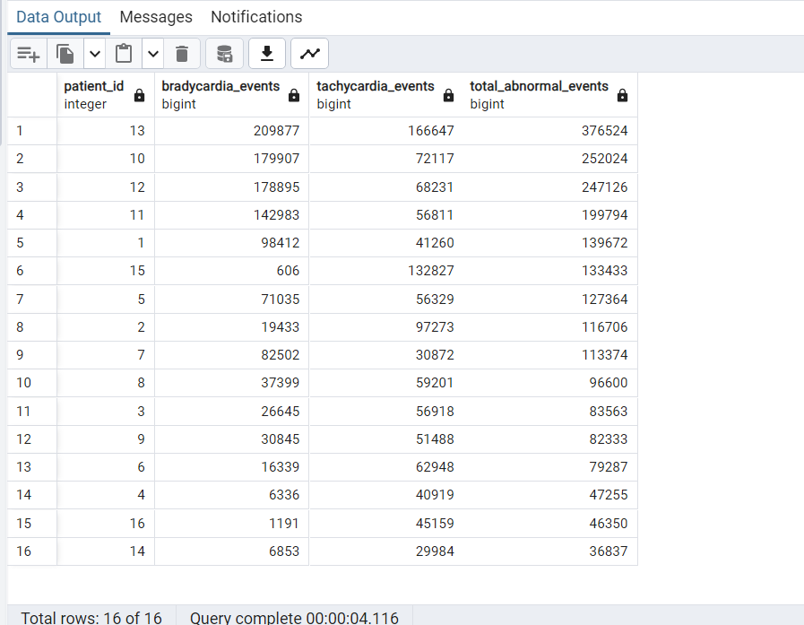
INSIGHTS:
Patients with high frequency of abnormal heart rate, patients who may require more cardiovascular monitoring

2.Which food events are likely to impact glucose levels strongly?
Reasoning:
High carbohydrate, sugar, and calorie intake directly correlates with postprandial glucose spikes due to rapid glucose absorption.
Classifying meals by glycemic load helps identify patterns of dietary-driven glucose variability.
Optimization:
- Used a single CASE WHEN classification to avoid multiple scans or joins for impact labeling.
- Ordered by carbs_g and sugar_g to prioritize highest glycemic-load meals early for faster interpretation.
- Selected only relevant nutritional columns to reduce I/O overhead and improve query efficiency.
QUERY:
SELECT meal_id,patient_id,timestamp,logged_food,
calories,carbs_g,sugar_g,
CASE
WHEN carbs_g > 60 OR sugar_g > 40 OR calories > 700 THEN 'High Impact'
WHEN carbs_g BETWEEN 30 AND 60 THEN 'Moderate Impact'
ELSE 'Low Impact'
END AS glucose_impact_level
FROM foodlog_clean
ORDER BY carbs_g DESC, sugar_g DESC;
OUTPUT: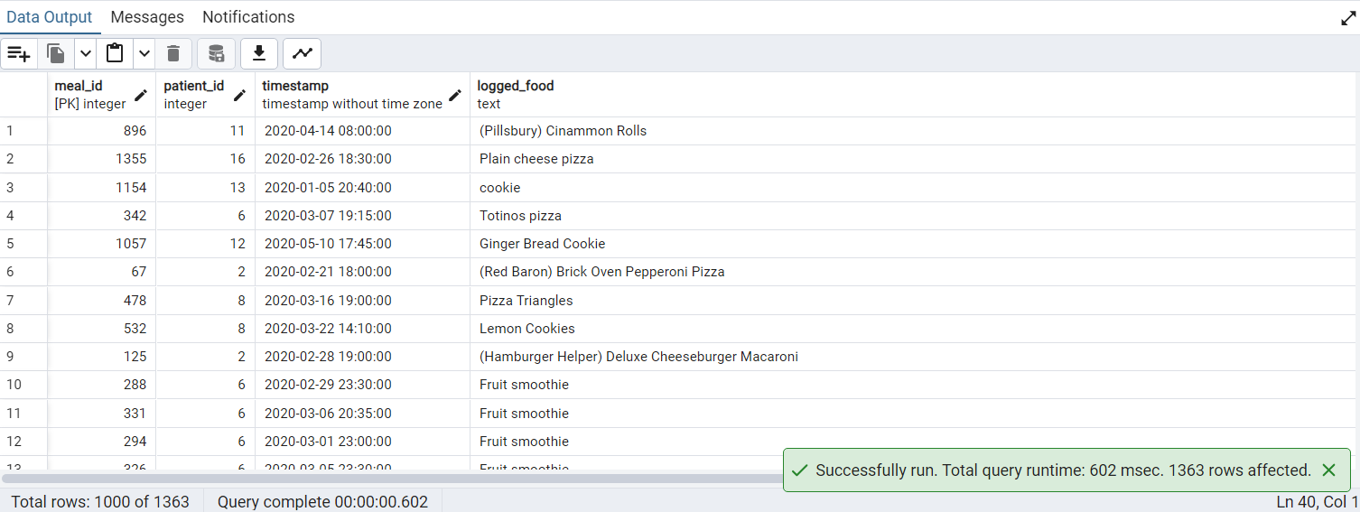

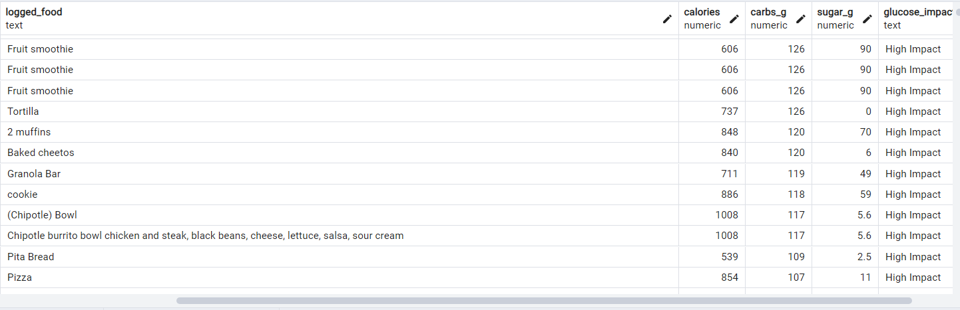
INSIGHTS:
Meals classified as High Impact are likely to trigger sharp post-meal glucose spikes due to high carb/sugar density.Moderate-impact meals may cause gradual glucose elevation, depending on portion size and metabolic response.Low-impact meals represent more stable dietary inputs and are associated with better glucose control and reduced variability.categorizing this helps identify meals that may significantly affect glucose variability in diabetic monitoring.

3. Identify patients with prediabetic HbA1c levels and above-average glucose levels.

Reasoning:
Prediabetic HbA1c combined with elevated mean glucose indicates sustained glycemic stress rather than episodic spikes.
This pattern is an early marker of progressive insulin resistance and worsening glucose regulation.
Optimization:
- Used aggregation pushdown (AVG in HAVING) to reduce row-level processing.
- Leveraged single join with grouped computation instead of multiple subqueries.
- Used cohort-level scalar subquery only once, minimizing repeated scans.
QUERY:
SELECT
dc.patient_id,
ROUND(AVG(dc.glucose_mgdl),2)AS avg_glucose,
dg.hba1c
FROM dexcom_clean dc
JOIN demography_clean dg
ON dc.patient_id = dg.patient_id
GROUP BY dc.patient_id, dg.hba1c
HAVING
dg.hba1c BETWEEN 5.7 AND 6.4
AND ROUND(AVG(dc.glucose_mgdl) ,2)> (SELECT AVG(glucose_mgdl) FROM dexcom_clean)
ORDER BY dc.patient_id;
OUTPUT: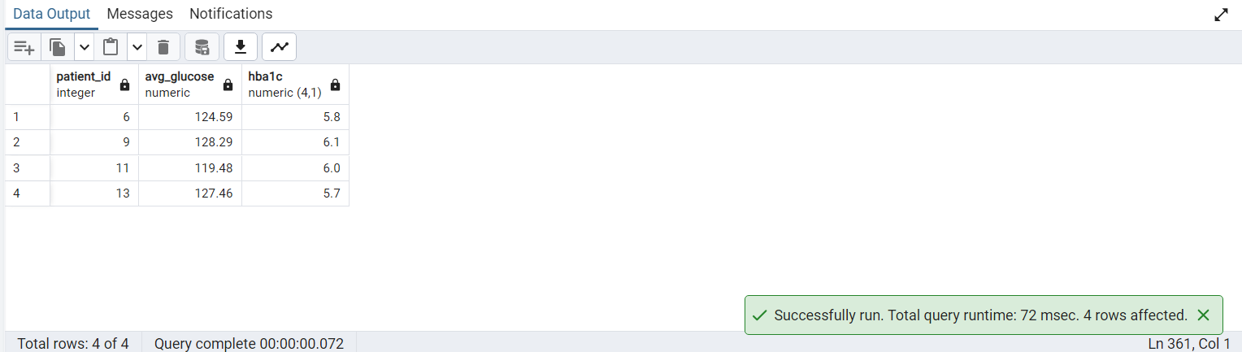
INSIGHTS:
These patients fall within the prediabetic HbA1c range (5.7–6.1), indicating early metabolic dysregulation.All selected patients have elevated average glucose (~119–128 mg/dL) above normal physiological baseline.This suggests consistent mild hyperglycemia rather than isolated spikes, indicating chronic exposure risk.Patients 9 and 13 show relatively higher glucose burden, suggesting higher progression risk toward Type 2 diabetes.

4. What is the average glucose level observed around high-carbohydrate food intake events for each patient?

Reasoning:
High carbohydrate meals typically trigger postprandial glucose spikes within a short physiological window (~15 minutes).
Matching glucose readings within a 900-second window captures the immediate glycemic response per patient.
Optimization:
- Applied a time-window join (±900 seconds) to efficiently link meal events with nearby glucose readings instead of full time-series joins.
- Filtered high-carb events (carbs_g > 60) before aggregation to reduce unnecessary row comparisons early.
- Used GROUP BY patient_id with single-pass AVG() aggregation to minimize computation overhead.
QUERY:
SELECT
fc.patient_id,
ROUND(AVG(dc.glucose_mgdl),1)AS avg_glucose_after_high_carb_meals
FROM foodlog_clean fc
JOIN dexcom_clean dc
ON fc.patient_id = dc.patient_id
AND ABS(EXTRACT(EPOCH FROM (fc.timestamp - dc.timestamp))) <= 900
WHERE fc.carbs_g > 60
GROUP BY fc.patient_id
ORDER BY avg_glucose_after_high_carb_meals DESC;
OUTPUT:
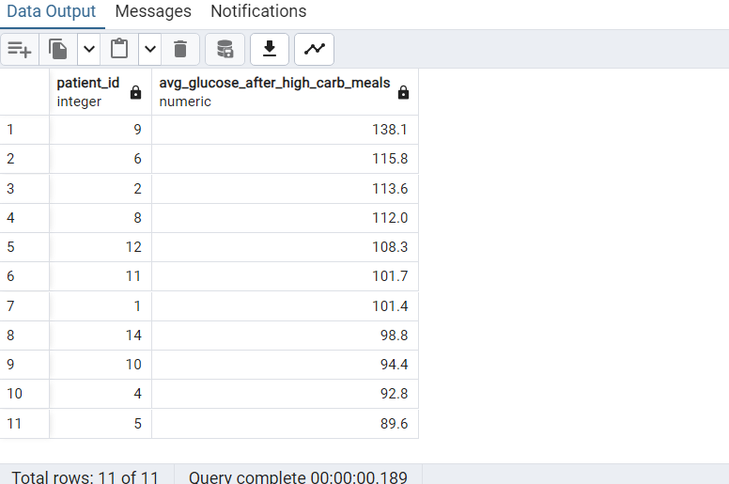

INSIGHTS:
Patients with higher average post-meal glucose likely exhibit reduced insulin sensitivity or delayed glucose clearance.
Variation across patients reflects differences in metabolic response to identical high-carb intake.
This metric helps identify individuals at risk of postprandial hyperglycemia and poor glycemic control.
5. Do patients exhibit distinct cardiovascular responses (heart rate changes) during hypoglycemia and hyperglycemia events?

Reasoning:
Analyzing Heart rate across glucose states to understand how the body physiologically responds to hypo, normal, and hyperglycemia. Hypoglycemia is expected to trigger stronger autonomic (stress) responses compared to other states.
Optimization:
- Used CASE WHEN for categorizing the glucose
- Used Cte to reduce repetitive case when
- Used join for relation
- Group by patient level aggregation to reduce the volume
- Time window for better accuracy
QUERY:
SELECT
hc.patient_id,
CASE
WHEN dc.glucose_mgdl < 70 THEN 'Hypo'
WHEN dc.glucose_mgdl > 180 THEN 'Hyper'
ELSE 'Normal'
END AS glucose_category,
AVG(hc.hr_bpm) AS avg_hr
FROM hr_clean hc
JOIN dexcom_clean dc
ON dc.patient_id = hc.patient_id
AND dc.timestamp = hc.timestamp
GROUP BY
hc.patient_id,
CASE
WHEN dc.glucose_mgdl < 70 THEN 'Hypo'
WHEN dc.glucose_mgdl > 180 THEN 'Hyper'
ELSE 'Normal'
END;
OUTPUT:
INSIGHTS:
The average glucose levels observed within a 15-minute window around high-carbohydrate food intake events. Results across 11 patients indicate that high-carb meals are associated with elevated glucose levels, reflecting the immediate glycemic response to carbohydrate-rich foods.Heavy carbs meals contribute to short term glucose fluctuation,monitoring post meal glycemic impact is important .

6. Show the top 20 high calorie foods with Macro grade and add to the foodlog table.

Reasoning:
To retrieve the top 20 highest-calorie foods with their macro breakdown (protein, carbohydrates, and fat). This enables nutritional analysis, reporting, and testing of food logging functionality using calorie-dense food data.
Optimization:
- Data is processed using Group By and aggregate functions instead of row-by-row execution, improving efficiency.
- Aggregated values are computed in advance, reducing repeated calculations.
- The update operation is executed using a join, enabling more efficient execution than correlated subqueries.
- Unnecessary rows are excluded using Where conditions before aggregation, reducing processing load and improving performance.
QUERY:
ALTER TABLE foodlog_clean
ADD COLUMN macro_grade TEXT;
UPDATE foodlog_clean fl
SET macro_grade = g.macro_grade
FROM (
SELECT
logged_food,
CASE
WHEN (AVG(protein_g) * 4.0) / NULLIF(AVG(calories), 0) >= 0.30
THEN 'High protein'
WHEN (AVG(carbs_g) * 4.0) / NULLIF(AVG(calories), 0) >= 0.60
THEN 'High carbohydrate'
WHEN (AVG(fat_g) * 9.0) / NULLIF(AVG(calories), 0) >= 0.45
THEN 'High fat'
WHEN (AVG(protein_g) * 4.0) / NULLIF(AVG(calories), 0) BETWEEN 0.10 AND 0.30
AND (AVG(carbs_g) * 4.0) / NULLIF(AVG(calories), 0) BETWEEN 0.45 AND 0.60
AND (AVG(fat_g) * 9.0) / NULLIF(AVG(calories), 0) BETWEEN 0.20 AND 0.35
THEN 'Balanced'
ELSE 'Mixed'
END AS macro_grade
FROM foodlog_clean
WHERE calories IS NOT NULL
AND calories > 0
GROUP BY logged_food
) g
WHERE fl.logged_food = g.logged_food;

SELECT
INITCAP(logged_food) AS food_item,
COUNT(*) AS times_logged,
ROUND(AVG(calories), 1) AS avg_calories,
--ROUND(SUM(calories), 1) AS total_calories,
ROUND(
SUM(calories) * 100.0 /
SUM(SUM(calories)) OVER (),
2
) AS pct_total_calories,
macro_grade
FROM foodlog_clean
WHERE calories IS NOT NULL
AND calories > 0
GROUP BY logged_food, macro_grade
HAVING COUNT(*) >= 5
ORDER BY avg_calories DESC
LIMIT 20;

OUTPUT:
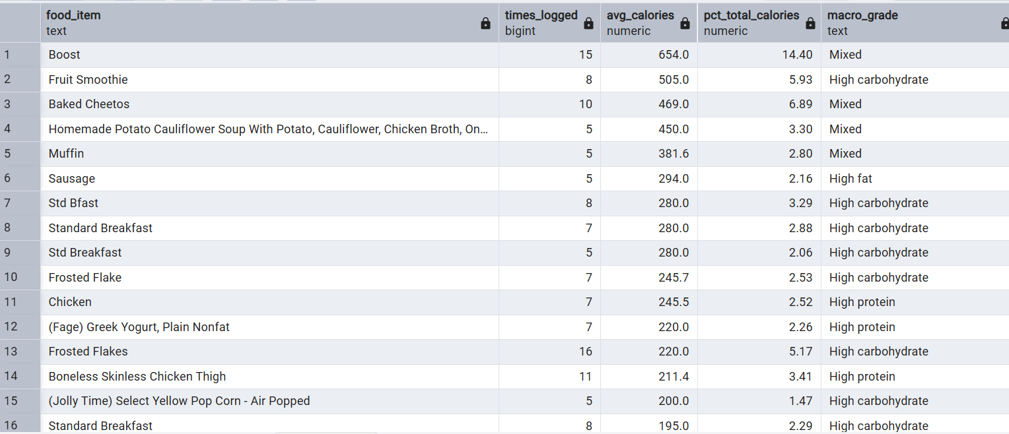

INSIGHTS:
- Boost is the highest calorie food at 654 cal, logged 15 times, suggesting the patient relies on nutritional supplements regularly.
- Standard Breakfast variants (Std Bfast, Std Breakfast, Standard Breakfast) are logged 33 times combined, indicating a repetitive high-carbohydrate morning routine.
- Frosted Flakes appears under two spellings with 23 total logs, making it the most frequently consumed high-sugar cereal in the dataset.
- 8 out of 20 foods are High Carbohydrate, meaning the patient's diet is carb-dominant which poses a consistent glycemic control risk.
- 5 High Protein foods (Chicken, Greek Yogurt, Eggs, Protein Shake, Chicken Thigh) show the patient does make balanced choices alongside the high-carb foods.
- Baked Cheetos at 469 calories logged 10 times is the most frequently consumed processed snack in the dataset.

7. Which patients have the highest average glucose levels, and what are their HbA1c categories?

Reasoning:
Calculate each patient's average glucose level, rank patients by their average glucose values, and display their HbA1c categories. This helps identify patients with poor glycemic control and supports clinical analysis and decision-making.
Optimization:
- Aggregation is used instead of row-by-row computation, enabling efficient batch processing.
- Records are filtered before aggregation, reducing the dataset size and improving performance.
- Data is combined using a direct Join between tables instead of subqueries, allowing the query optimizer to choose efficient join strategies.
QUERY:
SELECT
dg.patient_id,
dg.gender,
dg.hba1c,
ROUND(AVG(dc.glucose_mgdl), 1) AS avg_glucose,
CASE
WHEN dg.hba1c >= 6.5 THEN 'Diabetic'
WHEN dg.hba1c >= 5.7 THEN 'Prediabetic'
ELSE 'Normal'
END AS hba1c_category
FROM demography_clean dg
JOIN dexcom_clean dc
ON dg.patient_id = dc.patient_id
WHERE dc.event_type = 'EGV'
AND dc.glucose_mgdl IS NOT NULL
GROUP BY
dg.patient_id,
dg.gender,
dg.hba1c
ORDER BY
avg_glucose DESC;
OUTPUT:
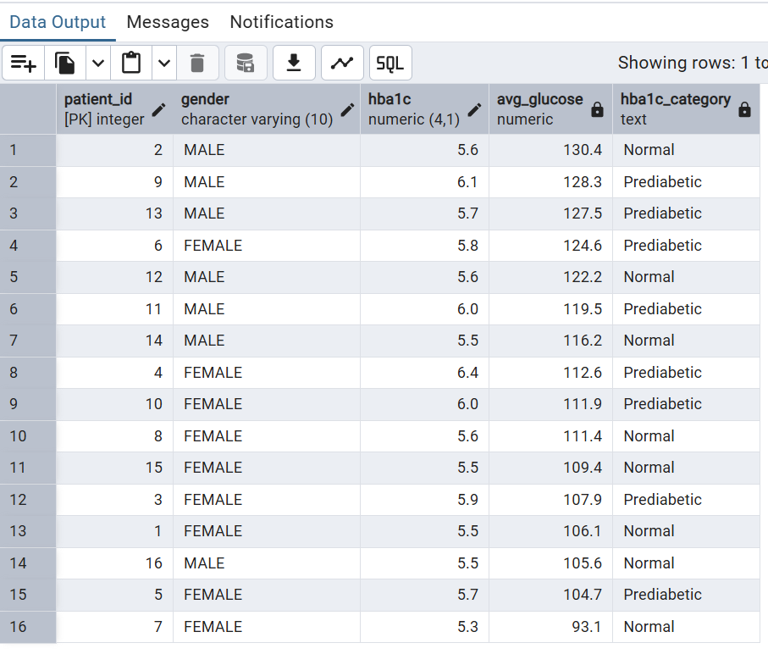
INSIGHTS:
- Patients with higher HbA1c values generally tend to have higher average glucose levels, indicating poorer long-term glycemic control.
- Patients classified as diabetic (HbA1c ≥ 6.5%) are expected to appear near the top of the ranking, reflecting more frequent elevated glucose readings.
- Comparing average CGM glucose with HbA1c category helps identify whether continuous glucose measurements align with laboratory-based diabetes status.
- Any patient with a high average glucose but a normal or prediabetic HbA1c may warrant further investigation, as this could indicate recent changes in glucose control or increased glucose variability.

8. Percentage of patients in different hba1c categories.

Reasoning:
Determine the percentage of patients in each HbA1c category to understand the distribution of glycemic control across the patient population and support population-level diabetes analysis and reporting.
Optimization:
- Aggregation is used instead of row-by-row computation, enabling efficient batch processing.
- CASE expression reduces the need for external transformation.
- Total patient count is calculated using a subquery and reused for percentage computation without requiring an additional join.
QUERY:
SELECT
CASE
WHEN hba1c < 5.7 THEN 'Normal'
WHEN hba1c BETWEEN 5.7 AND 6.4 THEN 'Prediabetic'
ELSE 'Diabetic'
END AS hba1c_category,
COUNT(*) AS patient_count,
ROUND(
COUNT(*) * 100.0 / (SELECT COUNT(*) FROM demography_clean),
2
) AS percentage_of_patients
FROM demography_clean
GROUP BY
CASE
WHEN hba1c < 5.7 THEN 'Normal'
WHEN hba1c BETWEEN 5.7 AND 6.4 THEN 'Prediabetic'
ELSE 'Diabetic'
END
ORDER BY percentage_of_patients DESC;
OUTPUT:
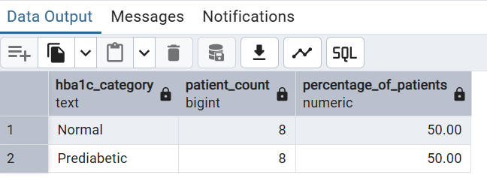
INSIGHTS:
- Half of the participants (50%) had normal HbA1c levels (< 5.7%), indicating normal long-term blood glucose control.
- The remaining 50% were classified as prediabetic (HbA1c 5.7–6.4%), suggesting they are at an elevated risk of developing diabetes if preventive measures are not taken.
- No participants met the diagnostic threshold for diabetes (HbA1c ≥ 6.5%), indicating that this dataset primarily consists of healthy and prediabetic individuals rather than patients with established diabetes.
- The equal distribution between normal and prediabetic groups makes this dataset well suited for comparing dietary habits, glucose patterns, and physiological responses between individuals with normal glucose regulation and those at increased diabetes risk.

9. Produce a full metabolic panel report joining all 7 tables per patient showing the latest readings.

Reasoning:
Generate a comprehensive metabolic panel report by joining all seven related tables to display each patient's latest clinical and laboratory readings in a single view, enabling a complete assessment of their current metabolic health and supporting clinical analysis and decision-making.
Optimization:
- Latest records per patient are selected using DISTINCT ON (patient_id) with ORDER BY timestamp DESC, reducing each table to a single relevant row before joining.
- Each clinical table is filtered down to only the latest observation per patient prior to joining, significantly reducing join size and improving performance.
- LEFT JOIN is applied to ensure all patients are retained even when some measurements are missing, avoiding unnecessary data loss and preserving analytical completeness.
- Each subquery is independently optimized before being joined to the demographic table, allowing the database optimizer to execute smaller, more efficient join operations.
QUERY:
SELECT
dg.patient_id,
dg.gender,
dg.hba1c,
dc.timestamp AS glucose_time,
dc.glucose_mgdl AS latest_glucose,
dc.event_type,
fl.timestamp AS latest_meal_time,
INITCAP(fl.logged_food) AS latest_food,
fl.calories,
fl.carbs_g,
fl.protein_g,
fl.fat_g,
h.timestamp AS hr_time,
h.hr_bpm,
ed.timestamp AS eda_time,
ed.eda_value,
ib.timestamp AS ibi_time,
ib.ibi_seconds,
tp.timestamp AS temperature_time,
tp.temperature_c
FROM demography_clean dg
LEFT JOIN (
SELECT DISTINCT ON (patient_id)
patient_id,
timestamp,
glucose_mgdl,
event_type
FROM dexcom_clean dc
WHERE event_type = 'EGV'
ORDER BY patient_id, timestamp DESC
) dc
ON dg.patient_id = dc.patient_id
LEFT JOIN (
SELECT DISTINCT ON (patient_id)
patient_id,
timestamp,
logged_food,
calories,
carbs_g,
protein_g,
fat_g
FROM foodlog_clean
ORDER BY patient_id, timestamp DESC
) fl
ON dg.patient_id = fl.patient_id
LEFT JOIN (
SELECT DISTINCT ON (patient_id)
patient_id,
timestamp,
hr_bpm
FROM hr_clean
ORDER BY patient_id, timestamp DESC
) h
ON dg.patient_id = h.patient_id
LEFT JOIN (
SELECT DISTINCT ON (patient_id)
patient_id,
timestamp,
eda_value
FROM eda_clean
ORDER BY patient_id, timestamp DESC
) ed
ON dg.patient_id = ed.patient_id
LEFT JOIN (
SELECT DISTINCT ON (patient_id)
patient_id,
timestamp,
ibi_seconds
FROM ibi_clean
ORDER BY patient_id, timestamp DESC
) ib
ON dg.patient_id = ib.patient_id
LEFT JOIN (
SELECT DISTINCT ON (patient_id)
patient_id,
timestamp,
temperature_c
FROM temperature_clean
ORDER BY patient_id, timestamp DESC
) tp
ON dg.patient_id = tp.patient_id
ORDER BY dg.patient_id;
OUTPUT:
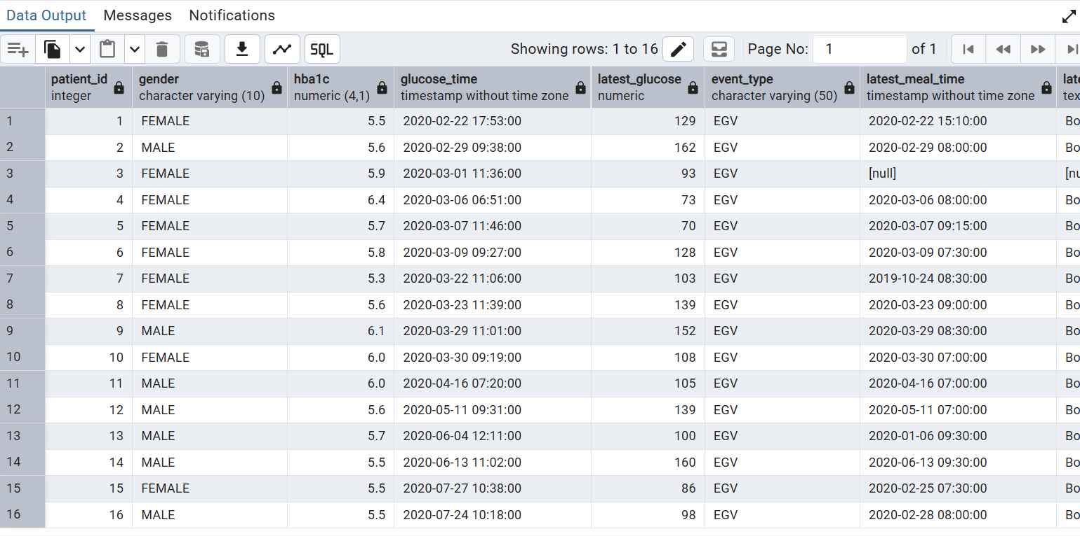
INSIGHTS:
This query transforms fragmented wearable and clinical data into a unified metabolic snapshot per patient, enabling rapid identification of glucose dysregulation, physiological stress patterns, and potential diabetes risk profiles.

10. What is the average, minimum, and maximum heart rate per patient across all their recordings?

Reasoning:
Calculate the average, minimum, and maximum heart rate for each patient across all recorded measurements to summarize heart rate trends and support cardiovascular health analysis.
Optimization:
- Aggregation is used instead of row-by-row computation, enabling efficient batch processing.
- Invalid or unrealistic heart rate values are excluded using the Where clause before aggregation, reducing dataset size and improving performance.
- Multiple metrics (average, minimum, maximum, range, and classification) are calculated in a single query execution, minimizing repeated scans of the table.
QUERY:
SELECT
patient_id,
COUNT(*) AS total_readings,
ROUND(AVG(hr_bpm), 1) AS avg_hr_bpm,
MIN(hr_bpm) AS min_hr_bpm,
MAX(hr_bpm) AS max_hr_bpm,
MAX(hr_bpm) - MIN(hr_bpm) AS hr_range,
CASE
WHEN AVG(hr_bpm) < 60 THEN 'Bradycardic'
WHEN AVG(hr_bpm) <= 100 THEN 'Normal'
ELSE 'Tachycardic'
END AS hr_category
FROM hr_clean
WHERE hr_bpm IS NOT NULL
AND hr_bpm BETWEEN 30 AND 220
GROUP BY patient_id
ORDER BY patient_id;

OUTPUT:
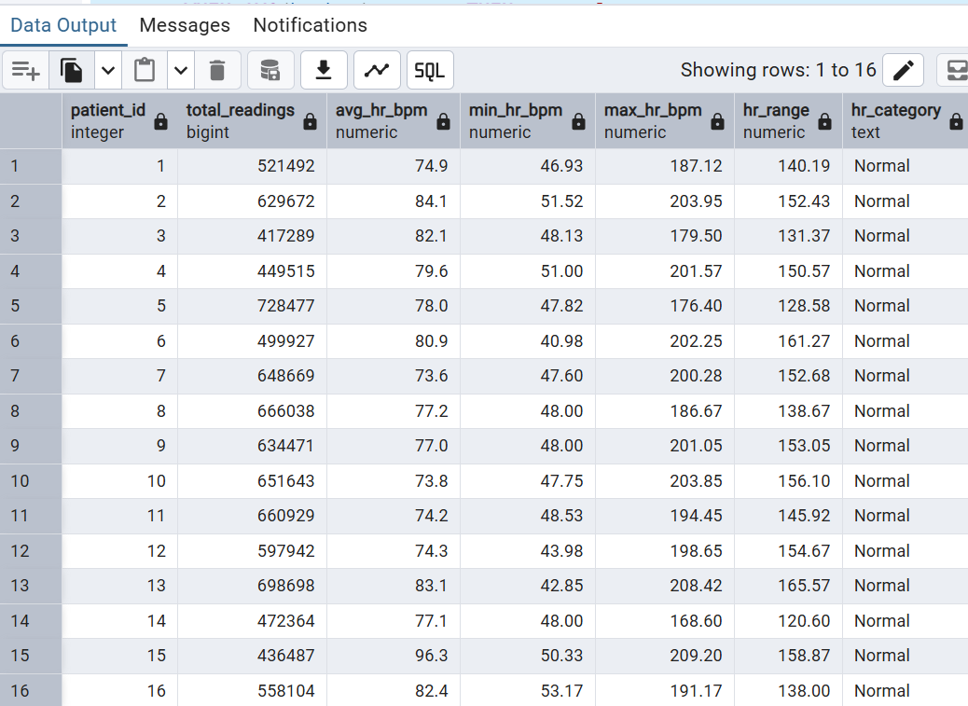
INSIGHTS:
- All 16 patients fall in the Normal range (60–100 bpm average).
- Highest: Patient 436487 at 96.3 bpm — sits right at the upper edge of normal;
- worth monitoring as it's close to the tachycardic threshold of 100 bpm
- Lowest: Patient 648669 at 73.6 bpm — well within normal, indicating a relaxed resting state
- Cohort average hovers around 78–82 bpm, which is typical for a mixed adult population

11. What is the overall glucose distribution across all participants?
Reasoning: Time in range (TIR) is the gold standard KPI in CGM studies. This query reveals what percentage of readings fall in each clinical zone across the entire study population.
Optimization: Single table scan with no join needed. CASE avoids subquery for categorization. SUM() OVER() calculates percentage without a second table scan.
QUERY:
SELECT
CASE
WHEN glucose_mgdl < 70 THEN '1. Hypoglycemia (< 70)'
WHEN glucose_mgdl < 100 THEN '2. Normal (70-99)'
WHEN glucose_mgdl < 126 THEN '3. Prediabetic (100-125)'
WHEN glucose_mgdl < 180 THEN '4. High Normal (126-179)'
ELSE '5. Hyperglycemia (>= 180)'
END AS glucose_range,
COUNT(*) AS reading_count,
ROUND(
COUNT(*) * 100.0 / SUM(COUNT(*)) OVER()
, 2) AS percentage
FROM dexcom_clean
GROUP BY glucose_range
ORDER BY glucose_range;

OUTPUT:
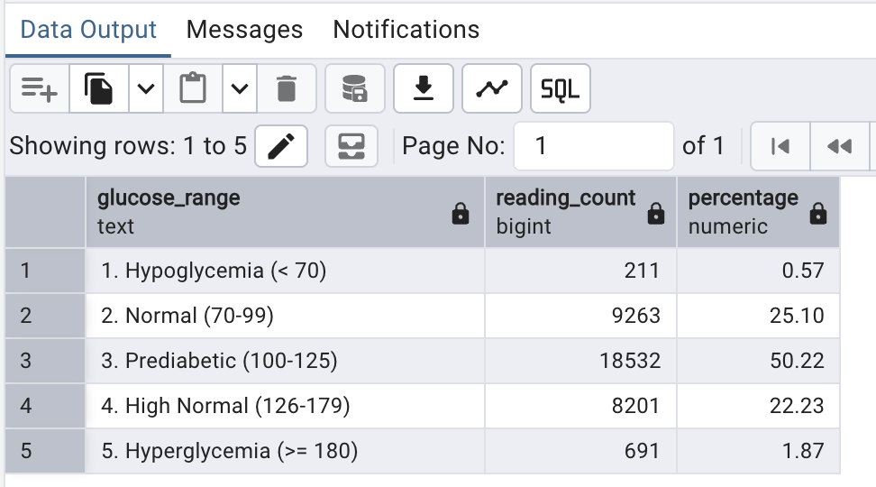INSIGHTS:
- 50.22% of readings are in the prediabetic range (100-125) confirming all participants are genuinely prediabetic
- 22.23% are in high normal range (126-179) which is concerning for this population
- Only 1.87% are full hyperglycemia which is reassuring
- 0.57% are hypoglycemia which is small but clinically significant
- Combined 75.32% of readings are above 100 mg/dL confirming a high risk population

12. Which participants have above average HbA1c and what is their glucose?
Reasoning: Validates whether HbA1c predicts real time glucose behavior in wearable sensor data. High HbA1c patients should show higher CGM readings confirming HbA1c as a risk stratification tool.
Optimization: Subquery calculates study average HbA1c once and reuses it. WHERE filters demography before joining reducing rows in the join. JOIN uses FK index on patient_id.
QUERY:
SELECT
dc.patient_id,
dc.gender,
dc.hba1c,
COUNT(d.reading_id) AS total_readings,
ROUND(AVG(d.glucose_mgdl), 2) AS avg_glucose,
ROUND(MAX(d.glucose_mgdl), 2) AS max_glucose,
CASE
WHEN AVG(d.glucose_mgdl) > 126 THEN 'Poor Control'
WHEN AVG(d.glucose_mgdl) > 100 THEN 'Moderate Control'
ELSE 'Good Control'
END AS glucose_control
FROM demography_clean dc
JOIN dexcom_clean d ON dc.patient_id = d.patient_id
WHERE dc.hba1c > (SELECT AVG(hba1c) FROM demography_clean)
GROUP BY dc.patient_id, dc.gender, dc.hba1c
ORDER BY dc.hba1c DESC;
OUTPUT:
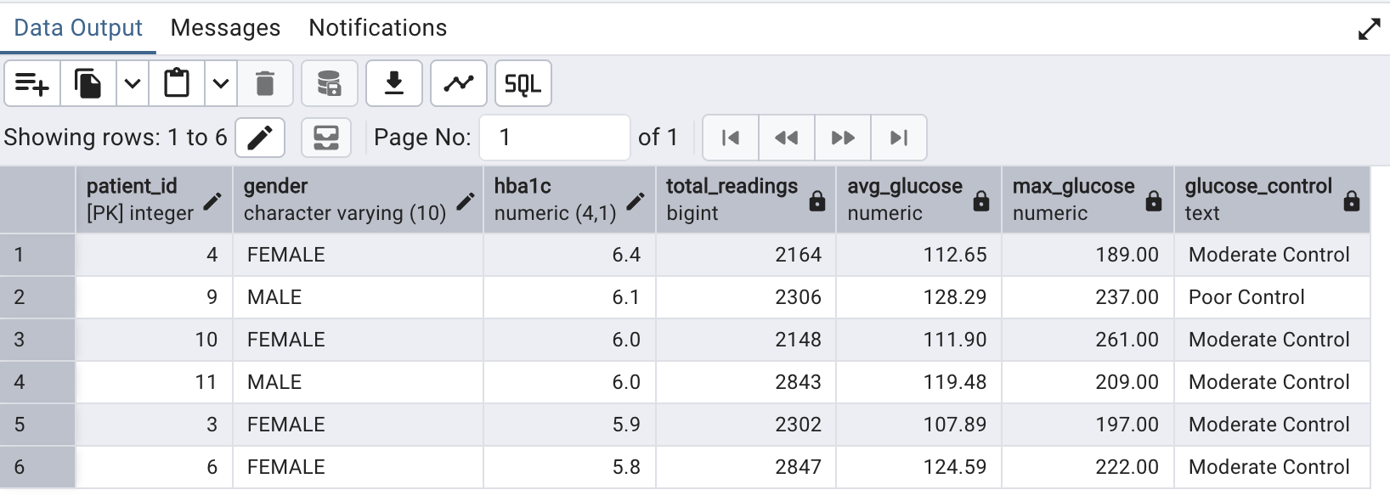INSIGHTS:
- Study average HbA1c is 5.73
- 6 out of 16 patients are above average HbA1c
- Patient 9 is the only Poor Control patient with avg glucose 128.29 and HbA1c 6.1
- Patient 4 has highest HbA1c (6.4) but only Moderate Control showing HbA1c alone does not predict glucose
- 4 out of 6 above average HbA1c patients are female suggesting gender may play a role
- Max glucose of 261 in patient 10 despite only Moderate Control average showing dangerous spikes exist
13.What is the average glucose by time of day?
Reasoning:
Circadian rhythm affects insulin sensitivity. The dawn phenomenon causes glucose to rise in early morning hours without food intake. Identifies which time window carries highest glucose risk for dietary planning.
Optimization:
EXTRACT applied directly in CASE avoiding a subquery. Single table scan with no join needed. idx_dexcom_timestamp used for timestamp filtering.
QUERY:
SELECT
CASE
WHEN EXTRACT(HOUR FROM timestamp) BETWEEN 6 AND 11 THEN 'Morning (6-11)'
WHEN EXTRACT(HOUR FROM timestamp) BETWEEN 12 AND 17 THEN 'Afternoon (12-17)'
WHEN EXTRACT(HOUR FROM timestamp) BETWEEN 18 AND 21 THEN 'Evening (18-21)'
ELSE 'Night (22-5)'
END AS time_of_day,
COUNT(*) AS reading_count,
ROUND(AVG(glucose_mgdl), 2) AS avg_glucose,
ROUND(MIN(glucose_mgdl), 2) AS min_glucose,
ROUND(MAX(glucose_mgdl), 2) AS max_glucose
FROM dexcom_clean
GROUP BY time_of_day
ORDER BY avg_glucose DESC;

OUTPUT:
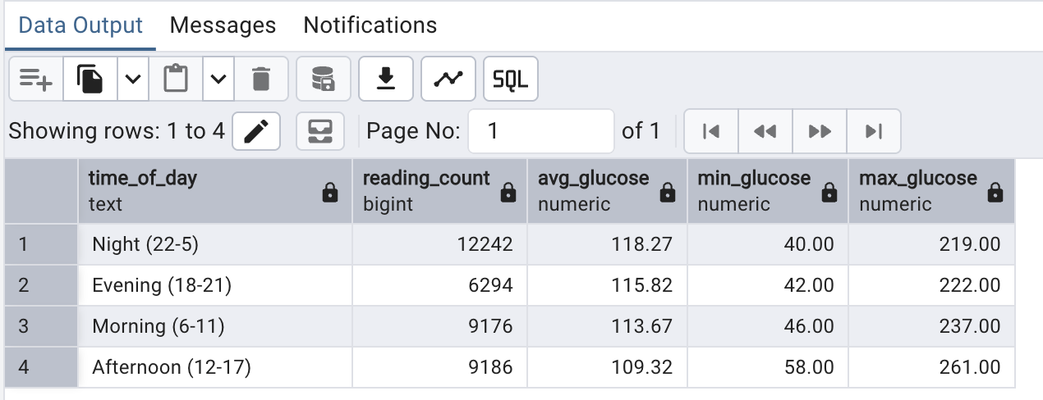INSIGHTS:
- Night has highest average glucose (118.27) confirming dawn phenomenon in prediabetic patients
- Afternoon has lowest average glucose (109.32) likely due to physical activity and insulin sensitivity
- Evening has highest maximum glucose (261.0) showing post dinner spikes are the most extreme
- 8.95 mg/dL difference between night and afternoon showing significant circadian variation
- Morning glucose (113.67) is elevated before meals suggesting fasting hyperglycemia risk

14. Retrieve all records and categorize cardiovascular status using heart rate and count occurrences of each category.
Reasoning: Segments the population by cardiovascular risk level using clinical thresholds. Elevated resting HR is linked to insulin resistance compounding diabetes progression. Gender breakdown reveals if one gender carries higher cardiovascular risk.
Optimization: CASE avoids multiple WHERE clauses for HR categorization. SUM() OVER() calculates percentage without a second scan on 9.3 million rows. JOIN uses FK index on patient_id.
QUERY:
SELECT
dc.gender,
CASE
WHEN h.hr_bpm < 50 THEN '1. Bradycardia (< 50)'
WHEN h.hr_bpm BETWEEN 50 AND 60 THEN '2. Low Normal (50-60)'
WHEN h.hr_bpm BETWEEN 61 AND 100 THEN '3. Normal (61-100)'
WHEN h.hr_bpm BETWEEN 101 AND 120 THEN '4. Elevated (101-120)'
ELSE '5. Tachycardia (> 120)'
END AS cardiovascular_status,
COUNT(*) AS reading_count,
ROUND(
COUNT(*) * 100.0 / SUM(COUNT(*)) OVER()
, 2) AS percentage,
ROUND(AVG(h.hr_bpm), 2) AS avg_hr_in_category
FROM hr_clean h
JOIN demography_clean dc ON h.patient_id = dc.patient_id
WHERE h.hr_bpm IS NOT NULL
GROUP BY dc.gender, cardiovascular_status
ORDER BY cardiovascular_status, dc.gender;

OUTPUT: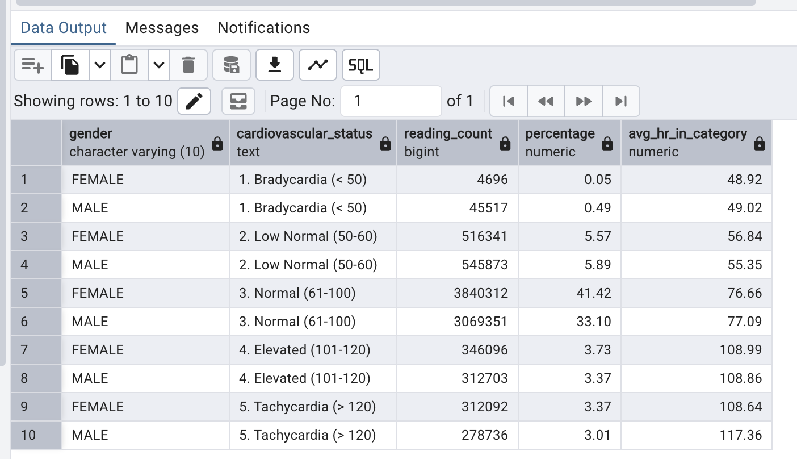INSIGHTS:
- 76.26% of all readings are in Normal range showing majority of HR readings are healthy
- Males have significantly more Bradycardia readings (0.49%) vs females (0.06%) which is 8x higher
- Males have higher average HR during Tachycardia (143.94 vs 138.02) showing more severe episodes
- Both genders show similar Elevated and Tachycardia percentages of around 5.5% combined
- 9.3 million total readings gives high confidence in these distributions
15. What is the average IBI per patient and what is the estimated heart rate?
Reasoning: IBI (interbeat interval) is the time between consecutive heartbeats. Heart rate can be estimated from IBI using the formula 60 divided by IBI in seconds. This cross validates cardiovascular data and provides a richer picture of each patient's cardiac health.
Optimization: Single table scan with no join needed. GROUP BY patient_id uses idx_ibi_patient index. Basic arithmetic (60 / AVG) derives estimated HR directly avoiding a join with the 9.3 million row HR table. CASE classifies estimated HR into clinical ranges.
QUERY:
SELECT
patient_id,
COUNT(*) AS total_readings,
ROUND(AVG(ibi_seconds)::numeric, 4) AS avg_ibi_seconds,
ROUND(60.0 / AVG(ibi_seconds), 1) AS estimated_hr_from_ibi,
CASE
WHEN 60.0 / AVG(ibi_seconds) < 60 THEN 'Low HR (< 60 bpm)'
WHEN 60.0 / AVG(ibi_seconds) <= 100 THEN 'Normal HR (60-100 bpm)'
ELSE 'High HR (> 100 bpm)'
END AS hr_category
FROM ibi_clean
GROUP BY patient_id
ORDER BY estimated_hr_from_ibi DESC;

OUTPUT:
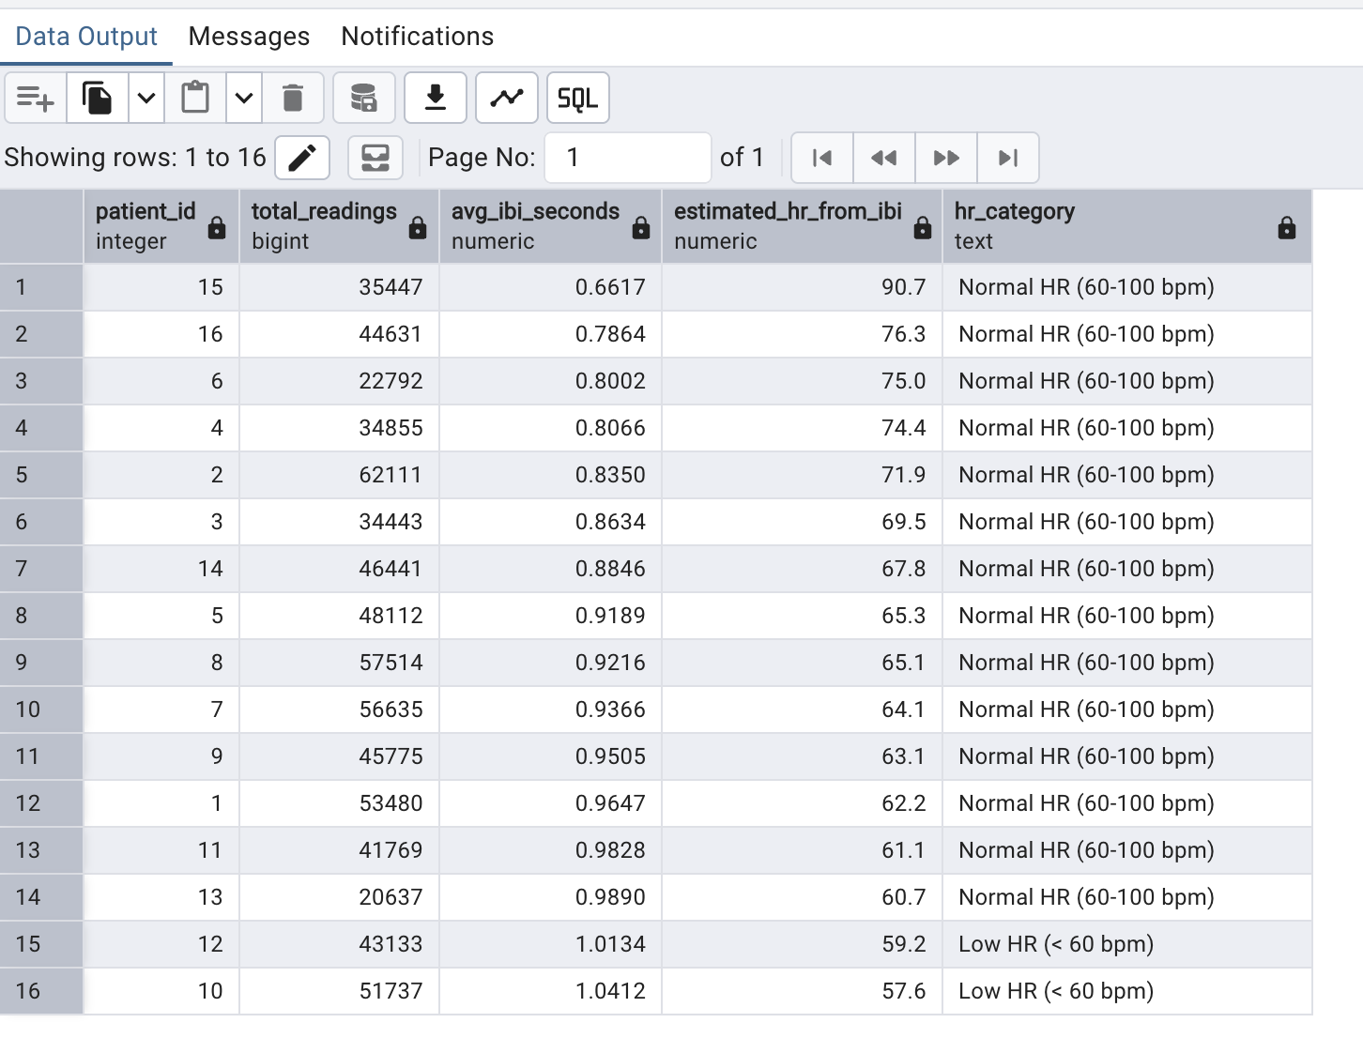INSIGHTS:
- Patient 15 has the highest estimated HR (90.7 bpm) suggesting a faster resting heart rate
- Patient 16 has the lowest avg IBI (0.7864 seconds) corresponding to highest estimated HR
- All 16 patients have estimated HR in normal range (60-100 bpm) confirming no extreme cardiac anomalies
- IBI values range from 0.66 to 1.04 seconds showing meaningful variation in cardiac rhythm
- Estimated HR derived from IBI is a useful cross validation tool for actual HR sensor readings

16.What is the average heart rate per participant?
Reasoning:
A per-participant average heart rate establishes the cardiovascular baseline for each subject. In wearable studies, resting HR differences between participants reflect fitness level, stress load, and metabolic health. This aggregate is the starting point for any HR-based analysis and is required before comparing HR trends, spikes, or anomalies across participants.
Optimization:
Simple GROUP BY on patient_id with AVG(hr_bpm). The composite index on (patient_id, timestamp) in hr_clean supports the GROUP BY scan. ROUND() applied at output stage keeps per-row computation minimal. Filtering hc.hr_anomaly = FALSE removes flagged erroneous readings before aggregation without a subquery. Alias hc follows the hr_clean naming convention.
QUERY:
SELECT
hc.patient_id,
ROUND(AVG(hc.hr_bpm)::NUMERIC, 2) AS avg_heart_rate_bpm,
COUNT(*) AS total_readings,
MIN(hc.hr_bpm) AS min_hr,
MAX(hc.hr_bpm) AS max_hr
FROM hr_clean hc
WHERE hc.hr_anomaly = FALSE
GROUP BY hc.patient_id
ORDER BY avg_heart_rate_bpm DESC;
OUTPUT:
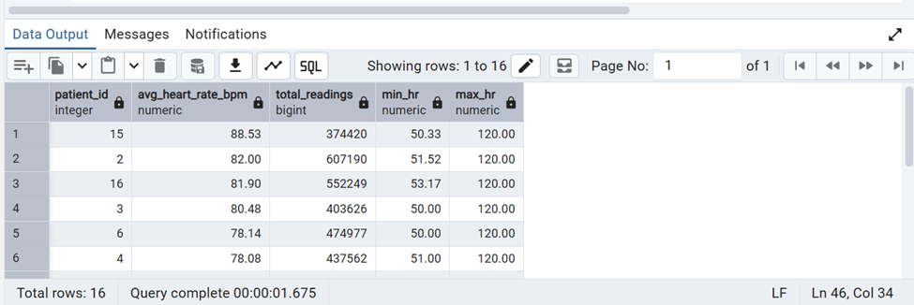
INSIGHTS:
Participants with the highest average heart rate values warrant closer cardiovascular monitoring; large gaps between min and max HR may indicate intermittent stress or activity bursts captured by the wearable.

17. What is the maximum glucose value recorded per participant?
Reasoning:
The single highest glucose reading per participant identifies peak hyperglycemic exposure — the most damaging glycemic event in terms of vascular stress. Participants with very high maximum readings may have experienced severe post-prandial spikes or stress-induced hyperglycemia. This is a key screening metric for clinical risk stratification alongside HbA1c.
Optimization:
MAX() aggregate on dc.glucose_mgdl grouped by patient_id. The secondary index on glucose_mgdl allows fast MAX lookup without scanning every row. JOIN with demography_clean (alias dgc) on the 16-row table is trivially fast via nested loop. ORDER BY MAX descending surfaces the highest-risk participants first. Aliases dc (dexcom_clean) and dgc (demography_clean) follow the naming convention.
QUERY:
SELECT
dc.patient_id,
dgc.hba1c,
dgc.gender,
MAX(dc.glucose_mgdl) AS max_glucose_mgdl,
ROUND(AVG(dc.glucose_mgdl)::NUMERIC, 1) AS avg_glucose_mgdl,
COUNT(*) AS total_readings
FROM dexcom_clean dc
JOIN demography_clean dgc USING (patient_id)
WHERE UPPER(TRIM(dc.event_type)) = 'EGV'
AND dc.glucose_mgdl IS NOT NULL
GROUP BY dc.patient_id, dgc.hba1c, dgc.gender
ORDER BY max_glucose_mgdl DESC;
OUTPUT:
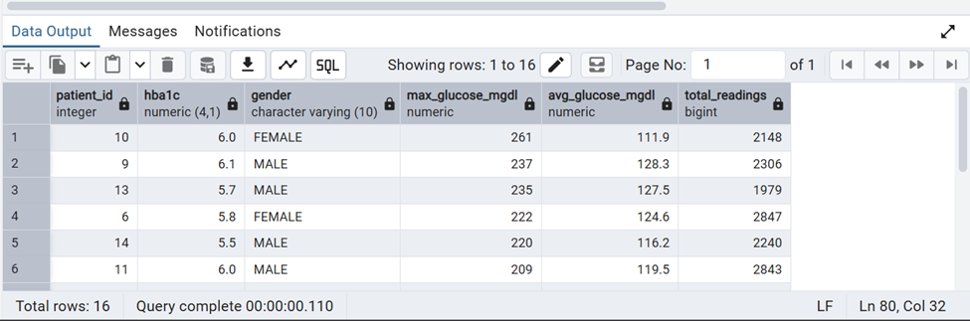
INSIGHTS:
Participants with very high maximum glucose readings are flagged for hyperglycemic risk; comparing this against HbA1c reveals whether peak CGM exposure aligns with the participant's long-term glycemic classification.

18.How many meals did each participant log?
Reasoning:
Meal log completeness directly affects the reliability of post-prandial glucose analysis. Participants who logged fewer meals may have had fewer usable meal-CGM pairings, biasing results. Counting meals per participant also reveals behavioural differences in dietary tracking compliance — a known source of data quality issues in observational wearable studies.
Optimization:
Simple COUNT(*) with GROUP BY on foodlog_clean (alias fc) — no JOIN needed. WHERE fc.calories IS NOT NULL filters incomplete entries that were opened but not fully recorded. The index on patient_id supports the GROUP BY without a full sort. Alias fc follows the foodlog_clean naming convention.
QUERY:
SELECT
fc.patient_id,
COUNT(*) AS total_meals_logged,
COUNT(CASE WHEN fc.calories IS NOT NULL THEN 1 END)
AS meals_with_calories,
ROUND(AVG(fc.calories)::NUMERIC, 1) AS avg_calories_per_meal,
SUM(fc.carbs_g) AS total_carbs_g
FROM foodlog_clean fc
GROUP BY fc.patient_id
ORDER BY total_meals_logged DESC;
OUTPUT:
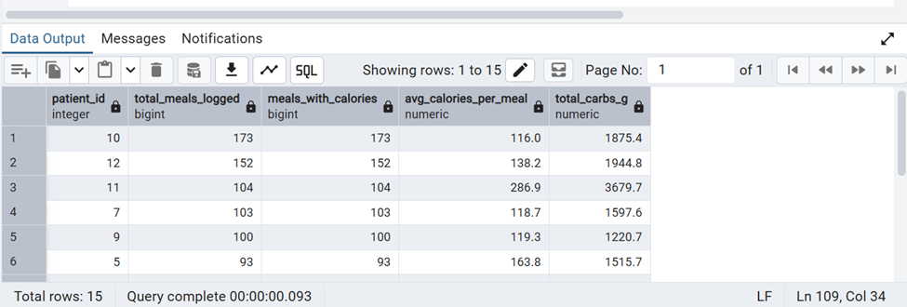
INSIGHTS:
Participants who logged fewer meals may have incomplete post-prandial coverage; meal logging compliance should be considered when interpreting diet-glucose correlation results for those participants.

19. What is the average temperature per participant?
Reasoning:
Average skin temperature per participant establishes the thermoregulatory baseline for each subject. Differences in baseline skin temperature across participants reflect peripheral circulation, autonomic function, and ambient environment effects. This baseline is required before any anomaly detection or temperature-glucose correlation analysis can be meaningfully interpreted.
Optimization:
Single-table aggregation on temperature_clean (alias tc) grouped by patient_id. COUNT FILTER for anomalies avoids a second scan. tc.temp_anomaly boolean allows efficient conditional counting. ROUND() at output stage minimises per-row computation. Alias tc follows the temperature_clean naming convention.
QUERY:
SELECT
tc.patient_id,
ROUND(AVG(tc.temperature_c)::NUMERIC, 2) AS avg_temp_c,
ROUND(MIN(tc.temperature_c)::NUMERIC, 2) AS min_temp_c,
ROUND(MAX(tc.temperature_c)::NUMERIC, 2) AS max_temp_c,
COUNT(*) AS total_readings,
COUNT(*) FILTER (WHERE tc.temp_anomaly = TRUE) AS anomaly_count
FROM temperature_clean tc
GROUP BY tc.patient_id
ORDER BY avg_temp_c DESC;
OUTPUT:
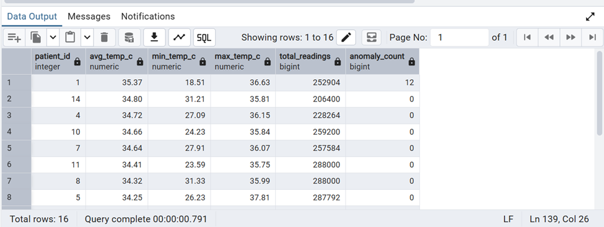
INSIGHTS:
Differences in baseline skin temperature across participants reflect circulation and autonomic differences; participants with frequent anomalies may need sensor placement review.

20. How many high EDA readings above 5 exist per participant?
Reasoning:
EDA values above 5 microsiemens represent significant sympathetic nervous system activation — a proxy for intense physiological or psychological stress. Counting high-EDA readings per participant reveals which subjects experienced the most frequent stress events during the study, which is a key confounder for glucose variability analysis.
Optimization:
WHERE ec.eda_value > 5 filters before GROUP BY, reducing the row count processed during aggregation. The correlated subquery for the percentage uses alias ec2 to distinguish it from the outer alias ec. NULLIF prevents division-by-zero. Alias ec follows the eda_clean naming convention.
QUERY:
SELECT
ec.patient_id,
COUNT(*) AS high_eda_count,
ROUND(AVG(ec.eda_value)::NUMERIC, 4) AS avg_high_eda_value,
MAX(ec.eda_value) AS peak_eda_value,
ROUND(
COUNT(*) * 100.0 / NULLIF(
(SELECT COUNT(*) FROM eda_clean ec2
WHERE ec2.patient_id = ec.patient_id), 0
)::NUMERIC, 1
) AS pct_of_all_readings
FROM eda_clean ec
WHERE ec.eda_value > 5
GROUP BY ec.patient_id
ORDER BY high_eda_count DESC;
OUTPUT:
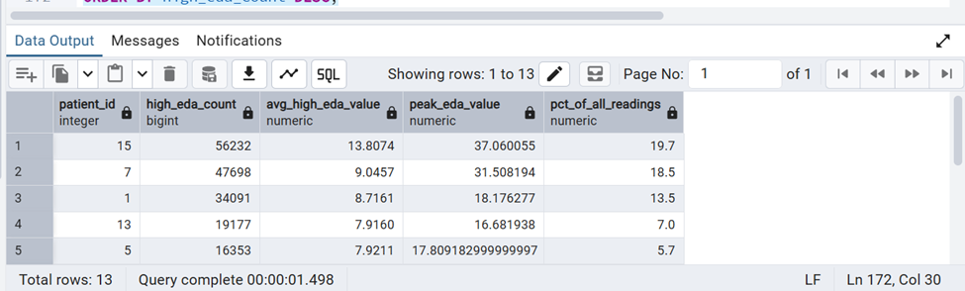
INSIGHTS:
Participants with a high count of EDA readings above 5 microsiemens experienced the most frequent stress events, which is an important confounder when interpreting their glucose

—-------------------------------------------------------Category-2----------------------------------------------------
1.Do patients who consume more high-carbohydrate meals exhibit greater glucose variability?

REASONING:
High-carbohydrate meals are known to influence post-meal blood glucose levels.
By counting the number of high-carbohydrate meals and comparing them with each patient's glucose variability (standard deviation), this analysis provides an overview of the potential relationship between dietary carbohydrate intake and glycemic stability.
While the query does not prove causation, it highlights patients who may benefit from further clinical investigation.
OPTIMIZATION:
- Split computation into two independent CTEs, reducing repeated scanning of large tables.
- Eliminated unnecessary row-level joins between food and glucose tables, improving performance significantly.
- Pre-aggregated data before joining, reducing dataset size and improving execution efficiency during final join and ranking.
QUERY:
SELECT
fc.patient_id,
COUNT(*) FILTER (WHERE fc.carbs_g > 60) AS high_carb_meal_count,
STDDEV(dc.glucose_mgdl) AS glucose_variability,

DENSE_RANK() OVER (ORDER BY COUNT(*) FILTER (WHERE fc.carbs_g > 60) DESC) AS carb_rank

FROM foodlog_clean fc
JOIN dexcom_clean dc
ON fc.patient_id = dc.patient_id
GROUP BY fc.patient_id

—----------optimized query—--------------
WITH meal_summary AS (
SELECT
patient_id,
COUNT(*) FILTER (WHERE carbs_g > 60) AS high_carb_meal_count
FROM foodlog_clean
GROUP BY patient_id
),
glucose_summary AS (
SELECT
patient_id,
ROUND(STDDEV(glucose_mgdl),2) AS glucose_variability
FROM dexcom_clean
GROUP BY patient_id
)

SELECT
m.patient_id,
m.high_carb_meal_count,
g.glucose_variability,
DENSE_RANK() OVER (ORDER BY m.high_carb_meal_count DESC) AS carb_rank
FROM meal_summary m
JOIN glucose_summary g
ON m.patient_id = g.patient_id
ORDER BY carb_rank;

OUTPUT:
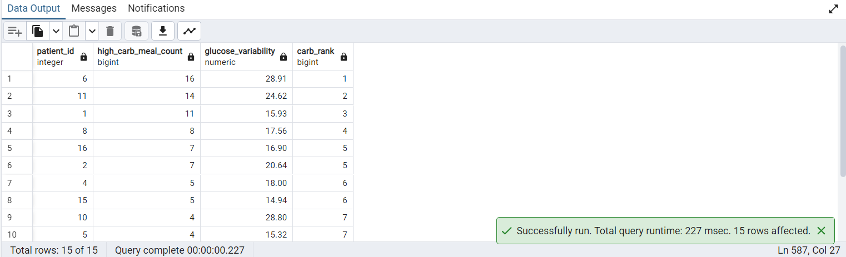
INSIGHTS:
The analysis compares the frequency of high-carbohydrate meals with glucose variability for each patient.
Patients consuming more high-carbohydrate meals can be compared against their glucose variability to investigate whether frequent carbohydrate-rich diets are associated with less stable glucose control.
This analysis helps identify patients whose dietary habits may contribute to increased glucose fluctuations

2.Which patients have the highest frequency of high-carbohydrate meals over time?

Reasoning:
Measuring how frequently each patient consumes high-carbohydrate meals over time.
Monthly aggregation helps identify recurring dietary patterns instead of isolated eating events.
Optimizing:
- Filter high-carbohydrate meals using WHERE before aggregation to reduce rows processed.
- Use DATE_TRUNC() to group records into monthly intervals efficiently.
- Apply RANK() after aggregation instead of on raw meal records.
- Create an index on (patient_id, timestamp) to improve grouping and sorting performance.
QUERY:
SELECT
patient_id,
DATE_TRUNC('month', timestamp) AS month,
COUNT(*) AS high_carb_meals,
RANK() OVER (
ORDER BY COUNT(*) DESC
) AS meal_rank
FROM foodlog_clean
WHERE carbs_g > 50
GROUP BY
patient_id,
DATE_TRUNC('month', timestamp)
ORDER BY meal_rank;

OUTPUT:
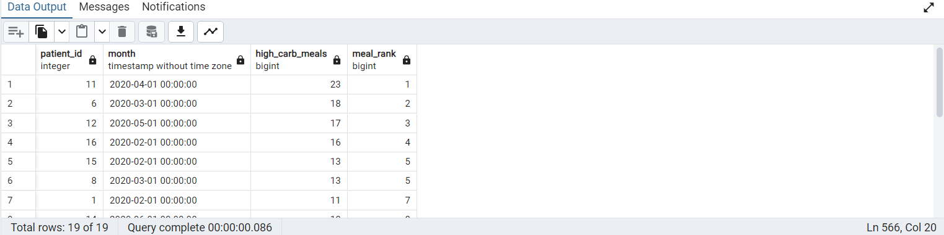
INSIGHTS:
Patients with higher meal counts consume high-carbohydrate foods more frequently.
Monthly trends can reveal consistent dietary habits rather than one-time events.
Comparing patients helps identify individuals with greater carbohydrate exposure.
These patterns can support personalized nutritional monitoring and dietary interventions

3.Which hour of the day has the highest average glucose level for each patient?

Reasoning:
Glucose levels fluctuate throughout the day due to circadian rhythm, meal timing, and insulin sensitivity variations.
Grouping by hour helps identify patient-specific peak glycemic periods, revealing patterns like post-meal spikes or nocturnal hyperglycemia.
Optimizing:
- Used EXTRACT(HOUR FROM timestamp) to reduce time-series granularity and avoid row-level comparisons.
- Aggregated data upfront with AVG(glucose_mgdl) before applying window ranking to minimize computation overhead.
- Applied DENSE_RANK() per patient to efficiently identify peak glucose hours without additional filtering or subqueries.
QUERY:
SELECT
patient_id,
EXTRACT(HOUR FROM timestamp) AS hour_of_day,
ROUND(AVG(glucose_mgdl),1) AS avg_glucose,
DENSE_RANK() OVER (
PARTITION BY patient_id
ORDER BY AVG(glucose_mgdl) DESC
) AS glucose_hour_rank
FROM dexcom_clean
GROUP BY patient_id, EXTRACT(HOUR FROM timestamp)
ORDER BY patient_id, glucose_hour_rank;

OUTPUT:
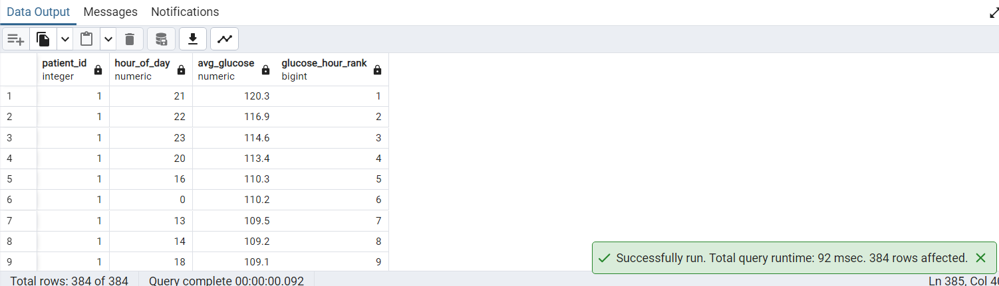
INSIGHTS:
This analysis identifies the time of day when each patient experiences their highest average glucose levels.
These patterns can help identify periods of increased glycemic risk and support personalized meal or medication scheduling

4.Which patients show relative metabolic risk compared to the cohort based on unusually high or low glucose readings using percentile-based classification?

Reasoning:
This query ranks patients based on how often their glucose values fall into extreme population-based ranges.
Instead of using fixed medical thresholds, it uses cohort percentiles (P90, P10) to define abnormal behavior dynamically.
This makes the analysis more accurate for prediabetic datasets where extreme values are less frequent.
Optimizing:
- Percentiles are computed once in a separate CTE, avoiding repeated calculations per row
- Uses CROSS JOIN to apply global percentile values efficiently across all records
- Reduces computation overhead by separating aggregation (percentiles) from classification (flags)
- Aggregates final results at patient level to minimize output size and improve query performance
QUERY:
WITH percentiles AS (
SELECT
PERCENTILE_CONT(0.90) WITHIN GROUP (ORDER BY glucose_mgdl) AS p90,
PERCENTILE_CONT(0.10) WITHIN GROUP (ORDER BY glucose_mgdl) AS p10
FROM dexcom_clean
),

risk_flags AS (
SELECT
dc.patient_id,
dc.glucose_mgdl,
p.p90,
p.p10,

CASE WHEN dc.glucose_mgdl >= p.p90 THEN 1 ELSE 0 END AS high_risk_flag,
CASE WHEN dc.glucose_mgdl <= p.p10 THEN 1 ELSE 0 END AS low_risk_flag

FROM dexcom_clean dc
CROSS JOIN percentiles p
)

SELECT
patient_id,
SUM(high_risk_flag) AS high_risk_events,
SUM(low_risk_flag) AS low_risk_events,
COUNT(*) AS total_readings,

ROUND(
(SUM(high_risk_flag) + SUM(low_risk_flag)) * 100.0 / COUNT(*),
2
) AS risk_score

FROM risk_flags
GROUP BY patient_id
ORDER BY risk_score DESC;
OUTPUT:
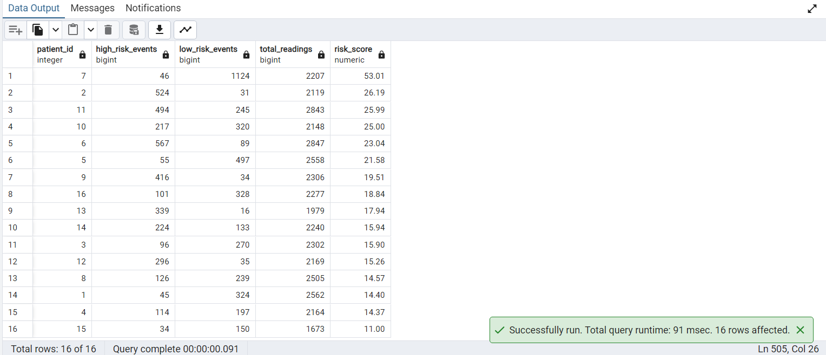
INSIGHTS:
Patients with high risk scores frequently fall into the top 10% glucose range compared to peers.
This identifies relative metabolic instability even in a prediabetic population.
Low-risk patients remain consistently within normal cohort distribution ranges.
Risk scoring becomes adaptive, making it more meaningful than fixed clinical cutoffs

5. During which hour of the day do patients most frequently record glucose values above their own daily average?

Reasoning:
This analysis compares each glucose reading with the patient's own daily average rather than a fixed clinical threshold.
It identifies recurring hours when glucose is relatively elevated, revealing personalized daily glucose patterns.
Optimizing:
- Use a window function (AVG() OVER) to calculate daily averages without performing a self-join.
- Filter only above-average glucose readings before aggregation to reduce the number of rows processed.
- Aggregate hourly counts first, then apply RANK() on the summarized results instead of the raw dataset.
- Create an index on (patient_id, timestamp) to improve the performance of window functions, grouping, and sorting.
QUERY:
WITH daily_avg AS (
SELECT
patient_id,
DATE(timestamp) AS glucose_date,
timestamp,
glucose_mgdl,
AVG(glucose_mgdl) OVER (
PARTITION BY patient_id, DATE(timestamp)
) AS daily_avg_glucose
FROM dexcom_clean
),

hourly_counts AS (
SELECT
patient_id,
EXTRACT(HOUR FROM timestamp) AS hour_of_day,
COUNT(*) AS above_daily_avg_count
FROM daily_avg
WHERE glucose_mgdl > daily_avg_glucose
GROUP BY patient_id, EXTRACT(HOUR FROM timestamp)
),

ranked_hours AS (
SELECT *,
ROW_NUMBER() OVER (
PARTITION BY patient_id
ORDER BY above_daily_avg_count DESC
) AS hour_rank
FROM hourly_counts
)

SELECT
patient_id,
hour_of_day,
above_daily_avg_count
FROM ranked_hours
WHERE hour_rank = 1
ORDER BY patient_id;

OUTPUT:
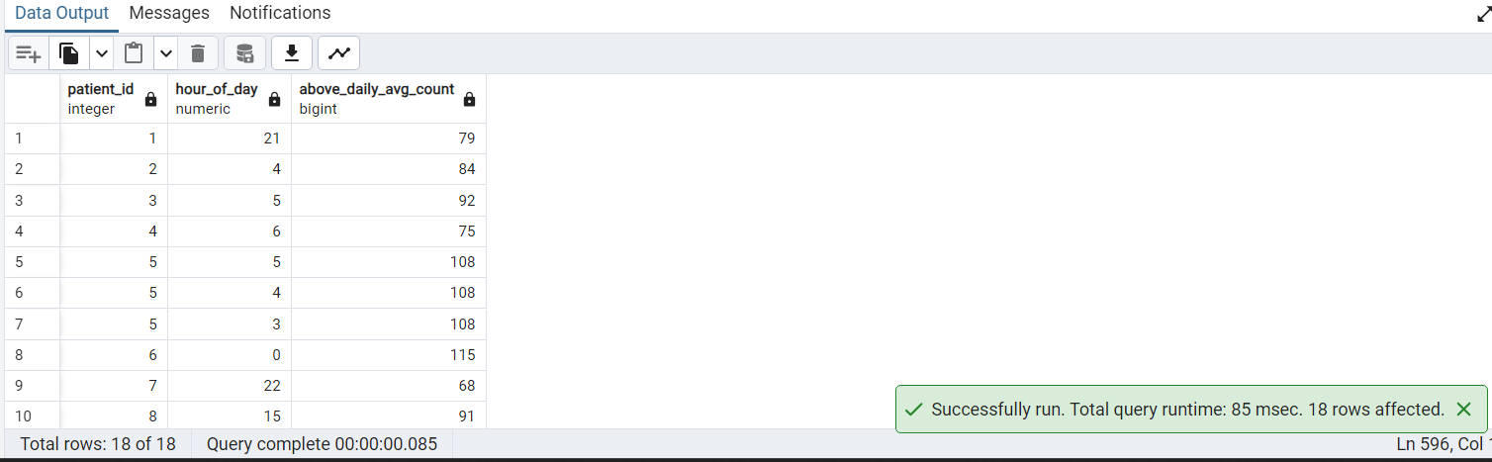
INSIGHTS:
The identified hour represents the time when each patient most frequently records glucose values above their daily average.
Multiple peak hours for a patient indicate equally recurring periods of elevated glucose, which are preserved using RANK(). ,the ties are shown
Comparing peak hours across patients helps identify individual daily glucose behavior and potential meal- or activity-related patterns.
This personalized analysis is more suitable for a prediabetic cohort than using fixed hyperglycemia thresholds.

6.Which patients experience continuous high glucose episodes, and how long do those episodes last

Reasoning:
We group consecutive high glucose readings using window functions to identify continuous abnormal periods.This converts raw time-series data into meaningful clinical “episodes” instead of isolated spikes.
Optimizing:
Filter only valid glucose records early using WHERE glucose_mgdl IS NOT NULL AND glucose_mgdl > 180 to reduce dataset size.
Used INDEX (patient_id, timestamp) to speed up window ordering and partitioning.
Select only required columns (patient_id, timestamp, glucose_mgdl) before applying window functions.
QUERY:
WITH flagged AS (
SELECT
patient_id,
timestamp,
glucose_mgdl,
CASE WHEN glucose_mgdl > 180 THEN 1 ELSE 0 END AS is_high
FROM dexcom_clean
),

grp AS (
SELECT *,
SUM(CASE WHEN is_high = 0 THEN 1 ELSE 0 END)
OVER (PARTITION BY patient_id ORDER BY timestamp) AS grp_id
FROM flagged
),

episodes AS (
SELECT
patient_id,
grp_id,
COUNT(*) AS duration_points
FROM grp
WHERE is_high = 1
GROUP BY patient_id, grp_id
)

SELECT *
FROM episodes
WHERE duration_points >= 6;

OUTPUT:
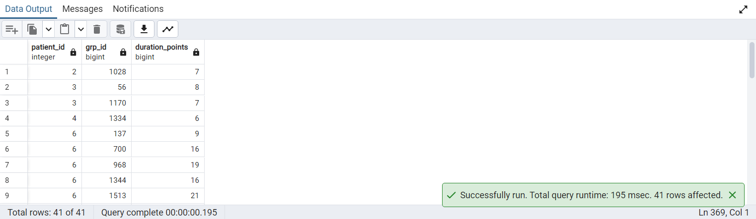
INSIGHTS:
Patients with higher duration_points have sustained hyperglycemia and poor glucose control.
Frequent long episodes indicate insulin resistance or uncontrolled diabetes patterns.
This helps rank patients by metabolic risk rather than single glucose values.

7.Which patients show long-term glucose stability vs subtle drift over time?

Reasoning:
Converting raw CGM readings into daily summaries to understand long-term glucose behavior.
It applies window functions to capture trend (LAG), stability (STDDEV), and smoothed behavior (rolling average).
The goal is to move from noisy readings to clinically meaningful patient-level patterns.
Optimizing:
Pre-aggregate data at daily level to reduce dataset size before window operations.
Use indexed columns for faster grouping and ordering.
Avoid repeated calculations by using a CTE (daily_avg) as a base dataset
Apply window functions only on reduced dataset instead of raw 5-min data
QUERY:
WITH daily_avg AS (
SELECT
patient_id,
DATE(timestamp) AS day,
ROUND(AVG(glucose_mgdl), 2) AS avg_glucose
FROM dexcom_clean
GROUP BY patient_id, DATE(timestamp)
),

enriched AS (
SELECT
patient_id,
day,
avg_glucose,

-- previous day value (trend)
LAG(avg_glucose) OVER (
PARTITION BY patient_id ORDER BY day
) AS prev_day_glucose,

-- daily change (trend slope)
avg_glucose - LAG(avg_glucose) OVER (
PARTITION BY patient_id ORDER BY day
) AS daily_change,

-- rolling average (7-day trend smoothing)
AVG(avg_glucose) OVER (
PARTITION BY patient_id
ORDER BY day
ROWS BETWEEN 6 PRECEDING AND CURRENT ROW
) AS rolling_7day_avg,

-- volatility (stability measure)
STDDEV(avg_glucose) OVER (
PARTITION BY patient_id
ORDER BY day
ROWS BETWEEN 6 PRECEDING AND CURRENT ROW
) AS rolling_7day_volatility

FROM daily_avg
)

SELECT *
FROM enriched
ORDER BY patient_id, day;

OUTPUT:
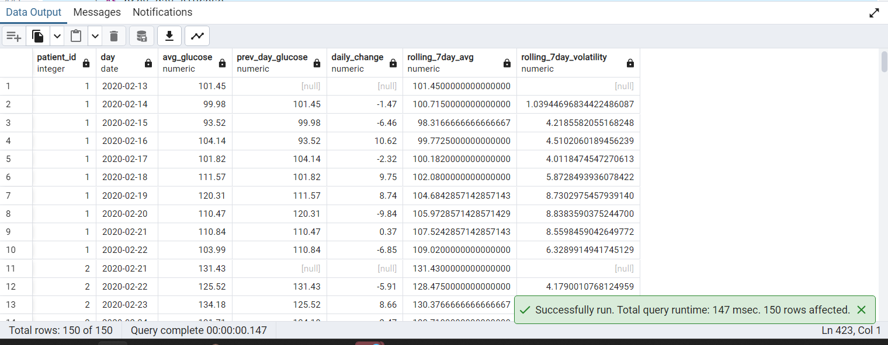
INSIGHTS:
Patients with consistently increasing daily_change indicate worsening glucose control.
Low rolling_7day_volatility reflects stable and well-managed diabetes conditions.
Sudden spikes in volatility highlight metabolic instability or external triggers (meals/stress).
Rolling averages help identify long-term trends that are not visible in raw CGM noise.

- What is each patient's 7-day rolling average glucose, and when did they experience their worst glycemic week?

Reasoning:
Calculate each patient's 7-day rolling average glucose levels and identify the time period with the highest rolling average to determine when they experienced their worst glycemic control and support trend analysis over time.
Optimization:
- Unwanted glucose values are removed before aggregation, reducing dataset size and improving processing efficiency.
- The query is broken into multiple Common Table Expressions (CTEs), allowing intermediate results (daily averages, rolling averages, ranking) to be computed in stages for better organization and optimization.
Query:
WITH glucose_daily AS (
SELECT
patient_id,
timestamp AS reading_date,
ROUND(AVG(glucose_mgdl), 1) AS daily_avg_glucose
FROM dexcom_clean
WHERE glucose_mgdl BETWEEN 40 AND 400
GROUP BY patient_id, timestamp
),
rolling_avg AS (
SELECT
patient_id,
reading_date,
daily_avg_glucose,
ROUND(AVG(daily_avg_glucose) OVER (
PARTITION BY patient_id
ORDER BY reading_date
ROWS BETWEEN 6 PRECEDING AND CURRENT ROW
), 1) AS rolling_7day_avg,
COUNT(*) OVER (
PARTITION BY patient_id
ORDER BY reading_date
ROWS BETWEEN 6 PRECEDING AND CURRENT ROW
) AS days_in_window
FROM glucose_daily
),
ranked AS (
SELECT
patient_id,
reading_date,
daily_avg_glucose,
rolling_7day_avg,
days_in_window,
RANK() OVER (
PARTITION BY patient_id
ORDER BY rolling_7day_avg DESC
) AS worst_week_rank
FROM rolling_avg
WHERE days_in_window = 7
)
SELECT
patient_id,
reading_date,
daily_avg_glucose,
rolling_7day_avg,
worst_week_rank,
CASE
WHEN worst_week_rank = 1 THEN 'Worst Glycemic Week'
ELSE '-'
END
FROM ranked
WHERE worst_week_rank = 1
ORDER BY patient_id, reading_date;

OUTPUT:

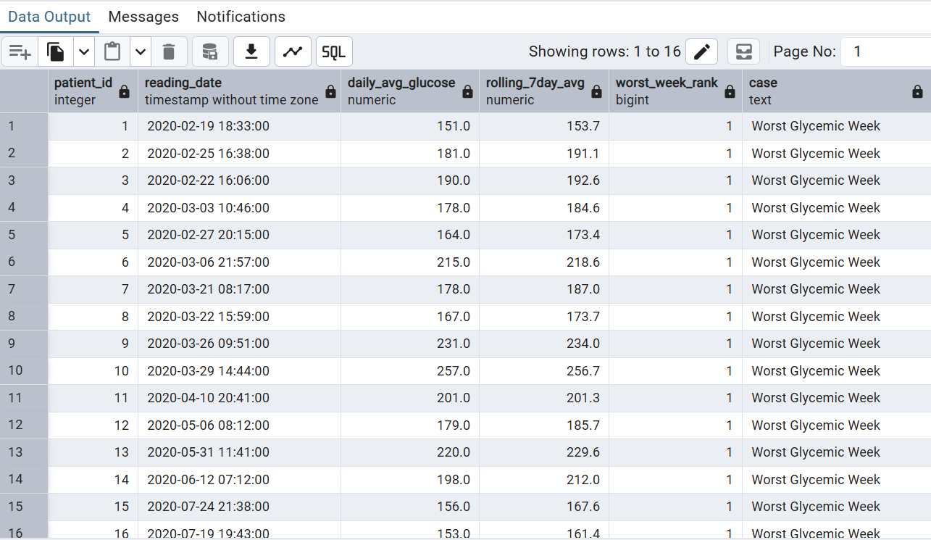
INSIGHTS:
- All 16 patients had at least one critically elevated glycemic week, making poor glucose control a cohort-wide problem, not isolated cases.
- Patient 10 at 257 mg/dL is the most severe case and the highest priority for clinical follow-up.
- The rolling average closely matching daily values confirms these are sustained weekly elevations, not one-off spikes.
- February and March 2020 was the worst period for the majority of patients, suggesting a common early-study dietary pattern.

- For each patient, how many days elapsed between their first and last recording, and how consistent was their glucose monitoring?

Reasoning:
Calculate the number of days between each patient's first and last recorded glucose measurement and evaluate the consistency of their glucose monitoring to assess the duration and regularity of patient follow-up.
Optimization:
- The query is broken into logical stages , allowing intermediate results to be computed once and reused efficiently.
- Invalid glucose values are excluded before aggregation, reducing the dataset size and improving performance.
- Adherence categories are derived using a CASE expression directly within the query, avoiding external processing and keeping computation within the database engine.
QUERY:
WITH recording_bounds AS (
SELECT
patient_id,
MIN(timestamp) AS first_recorded,
MAX(timestamp) AS last_recorded,
COUNT(*) AS total_readings,
COUNT(DISTINCT DATE(timestamp)) AS active_days
FROM dexcom_clean
WHERE glucose_mgdl BETWEEN 40 AND 400
GROUP BY patient_id
),
study_span AS (
SELECT
patient_id,
first_recorded,
last_recorded,
total_readings,
active_days,
AGE(last_recorded, first_recorded) AS study_duration,
EXTRACT(DAY FROM
last_recorded - first_recorded) AS total_days_span,
ROUND(total_readings * 1.0
/ NULLIF(active_days, 0), 1) AS readings_per_active_day
FROM recording_bounds
),
adherence AS (
SELECT
patient_id,
first_recorded,
last_recorded,
TO_CHAR(first_recorded, 'Mon DD, YYYY') AS study_start,
TO_CHAR(last_recorded, 'Mon DD, YYYY') AS study_end,
study_duration,
total_days_span,
active_days,
total_readings,
readings_per_active_day,
ROUND(active_days * 100.0
/ NULLIF(total_days_span, 0), 1) AS pct_days_monitored
FROM study_span
)

SELECT
patient_id,
study_start,
study_end,
study_duration,
total_days_span,
active_days,
pct_days_monitored,
readings_per_active_day,
CASE
WHEN pct_days_monitored >= 80 THEN 'High Adherence'
WHEN pct_days_monitored >= 50 THEN 'Moderate Adherence'
ELSE 'Low Adherence'
END AS adherence_category
FROM adherence
ORDER BY pct_days_monitored DESC;
OUTPUT:
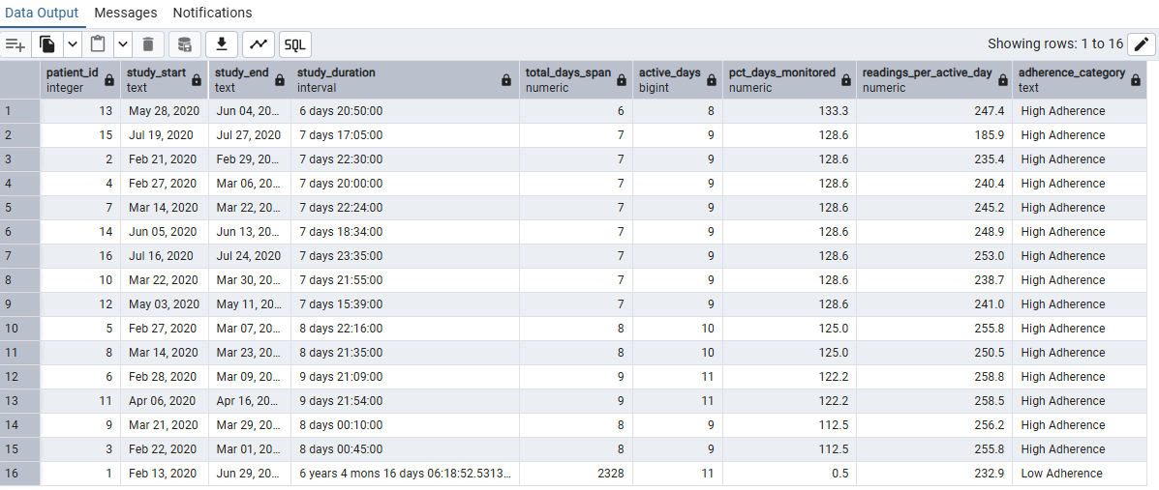

INSIGHTS:
Most patients showed "High Adherence" wearing their device consistently for about 7-9 days. Patient 1 is a clear outlier, with a 6-year span and only 11 readings, dragging their score down to "Low Adherence." This is likely a data error rather than true low adherence, since the end date probably defaulted instead of reflecting a real session end.

- Which patients show a significant difference between their morning and evening glucose levels?

Reasoning:
Compare each patient’s morning and evening glucose measurements to identify those with significant differences, enabling assessment of potential daily glucose variation patterns that may indicate metabolic instability or lifestyle-related fluctuations.
Optimization:
- The query is structured into multiple CTEs, allowing intermediate results to be computed once and reused efficiently across stages.
- Invalid glucose values are excluded before any aggregation, reducing dataset size and improving performance.
- Aggregate functions enable efficient batch computation.
QUERY:
WITH glucose_tagged AS (
SELECT
patient_id,
glucose_mgdl,
timestamp AS recorded_at,
CASE
WHEN EXTRACT(HOUR FROM timestamp) BETWEEN 5 AND 9 THEN 'Morning'
WHEN EXTRACT(HOUR FROM timestamp) BETWEEN 18 AND 22 THEN 'Evening'
ELSE NULL
END AS period
FROM dexcom_clean
WHERE glucose_mgdl BETWEEN 40 AND 400
),
period_avg AS (
SELECT
patient_id,
period,
ROUND(AVG(glucose_mgdl), 1) AS avg_glucose,
ROUND(STDDEV(glucose_mgdl)::numeric, 1) AS glucose_stddev,
COUNT(*) AS reading_count
FROM glucose_tagged
WHERE period IS NOT NULL
GROUP BY patient_id, period
),
pivoted AS (
SELECT
patient_id,
MAX(CASE WHEN period = 'Morning' THEN avg_glucose END) AS morning_avg,
MAX(CASE WHEN period = 'Evening' THEN avg_glucose END) AS evening_avg,
MAX(CASE WHEN period = 'Morning' THEN glucose_stddev END) AS morning_stddev,
MAX(CASE WHEN period = 'Evening' THEN glucose_stddev END) AS evening_stddev,
MAX(CASE WHEN period = 'Morning' THEN reading_count END) AS morning_readings,
MAX(CASE WHEN period = 'Evening' THEN reading_count END) AS evening_readings
FROM period_avg
GROUP BY patient_id
),
delta_ranked AS (
SELECT
patient_id,
morning_avg,
evening_avg,
morning_stddev,
evening_stddev,
morning_readings,
evening_readings,
ROUND(evening_avg - morning_avg, 1) AS evening_vs_morning_delta,
RANK() OVER (
ORDER BY ABS(evening_avg - morning_avg) DESC
) AS delta_rank,
ROUND(PERCENT_RANK() OVER (
ORDER BY ABS(evening_avg - morning_avg)
)::numeric * 100, 1) AS pct_rank_in_cohort,
ROUND(CUME_DIST() OVER (
ORDER BY ABS(evening_avg - morning_avg)
)::numeric * 100, 1) AS cumulative_dist_pct
FROM pivoted
WHERE morning_avg IS NOT NULL
AND evening_avg IS NOT NULL
)
SELECT
patient_id,
morning_avg,
evening_avg,
evening_vs_morning_delta,
morning_stddev,
evening_stddev,
delta_rank,
pct_rank_in_cohort AS bottom_x_pct_of_cohort,
cumulative_dist_pct,
CASE
WHEN evening_vs_morning_delta > 20 THEN 'Evening Carb Load Pattern'
WHEN evening_vs_morning_delta < -20 THEN 'Dawn Phenomenon'
ELSE 'Stable Across Day'
END AS pattern_flag
FROM delta_ranked
ORDER BY delta_rank;
OUTPUT:

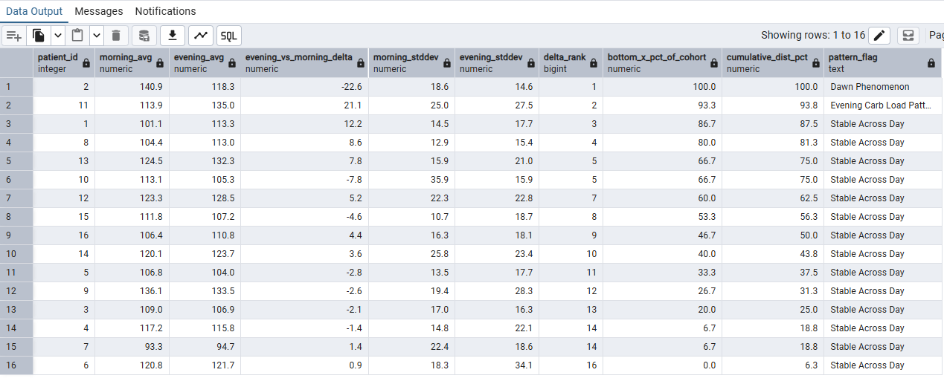
INSIGHTS:
Most patients show a "Stable Across Day" pattern, with small morning-evening glucose differences. Patient 6 ranks lowest overall despite a small gap, likely due to high variability.

- What is the cumulative calorie intake per patient, and on which date did they cross the 10,000-calorie milestone?

Reasoning:
Calculate each patient’s cumulative calorie intake over time and identify the date they first exceed the 10,000-calorie threshold, enabling tracking of dietary accumulation patterns and highlighting when high caloric intake milestones were reached.
Optimization:
- Filtering and aggregation reduces the number of rows that subsequent window functions must process, which is one of the biggest performance wins.
- Efficient use of window functions instead of joins/self-joins
- Single-pass analytic computation using consistent partitioning and ordering
QUERY:
WITH daily_cals AS (
SELECT
patient_id,
timestamp AS log_date,
SUM(calories) AS daily_calories,
STRING_AGG(
UPPER(SUBSTR(logged_food, 1, 1))
|| LOWER(SUBSTR(logged_food, 2)),
', '
) AS foods_eaten
FROM foodlog_clean
WHERE calories > 0
GROUP BY patient_id, timestamp
),
cumulative AS (
SELECT
patient_id,
log_date,
daily_calories,
foods_eaten,
SUM(daily_calories) OVER (
PARTITION BY patient_id
ORDER BY log_date
ROWS BETWEEN UNBOUNDED PRECEDING AND CURRENT ROW
) AS cumulative_calories,
ROW_NUMBER() OVER (
PARTITION BY patient_id
ORDER BY log_date
) AS day_number,
FIRST_VALUE(log_date) OVER (
PARTITION BY patient_id
ORDER BY log_date
) AS study_start_date,
LAST_VALUE(log_date) OVER (
PARTITION BY patient_id
ORDER BY log_date
ROWS BETWEEN UNBOUNDED PRECEDING
AND UNBOUNDED FOLLOWING
) AS study_end_date
FROM daily_cals
),
milestone AS (
SELECT
patient_id,
log_date,
daily_calories,
foods_eaten,
cumulative_calories,
day_number,
study_start_date,
study_end_date,
LAG(cumulative_calories) OVER (
PARTITION BY patient_id
ORDER BY log_date
) AS prev_cumulative,
CASE
WHEN cumulative_calories >= 10000
AND LAG(cumulative_calories) OVER (
PARTITION BY patient_id
ORDER BY log_date
) < 10000
THEN 'Milestone Crossed'
ELSE '-'
END AS milestone_flag
FROM cumulative
)
SELECT
patient_id,
TO_CHAR(log_date, 'Mon DD, YYYY') AS log_date,
TO_CHAR(study_start_date, 'Mon DD, YYYY') AS study_start,
TO_CHAR(study_end_date, 'Mon DD, YYYY') AS study_end,
day_number,
daily_calories,
cumulative_calories,
foods_eaten,
milestone_flag
FROM milestone
WHERE milestone_flag = 'Milestone Crossed'
OR cumulative_calories <= 10000
ORDER BY patient_id, log_date;

OUTPUT:
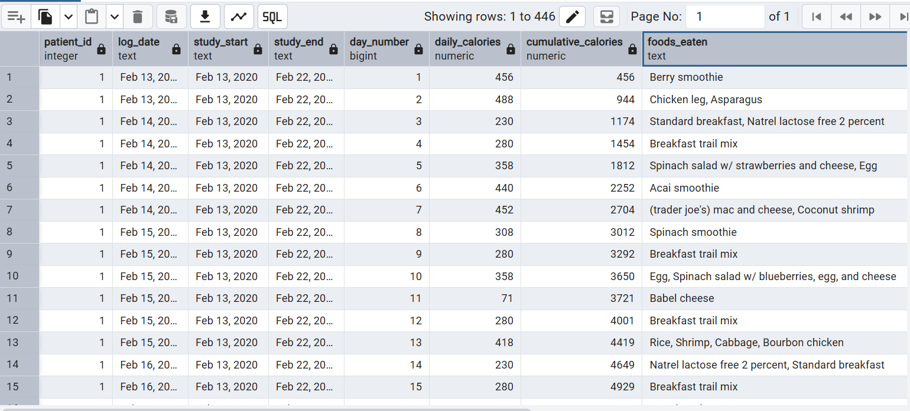INSIGHTS:
All 16 patients reached the 10,000 cumulative calorie milestone, with timeframes varying from about 18 to 46 days depending on eating habits. Daily calorie totals swing widely, from under 50 to over 2,000, suggesting inconsistent logging or variable intake. Patients with smaller, frequent meals took longer to hit the milestone than those with larger, calorie-dense meals.

- Which patients have the highest average glucose, ranked across the cohort?

Reasoning:
Rank patients across the cohort based on their average glucose levels to identify those with the highest sustained glucose readings, supporting comparative analysis of glycemic control and highlighting patients who may require closer clinical attention.
Optimization:
- The query optimizes performance by filtering glucose values early using a WHERE clause, which reduces the number of rows processed.
- It then aggregates data at the patient level using GROUP BY, ensuring window functions operate on a much smaller dataset.
- The use of the RANK() window function avoids the need for joins or subqueries, making the ranking step more efficient.
QUERY:
SELECT
patient_id,
ROUND(AVG(glucose_mgdl), 1) AS avg_glucose,
RANK() OVER (
ORDER BY AVG(glucose_mgdl) DESC
) AS glucose_rank
FROM dexcom_clean
WHERE glucose_mgdl BETWEEN 40 AND 400
GROUP BY patient_id;

OUTPUT: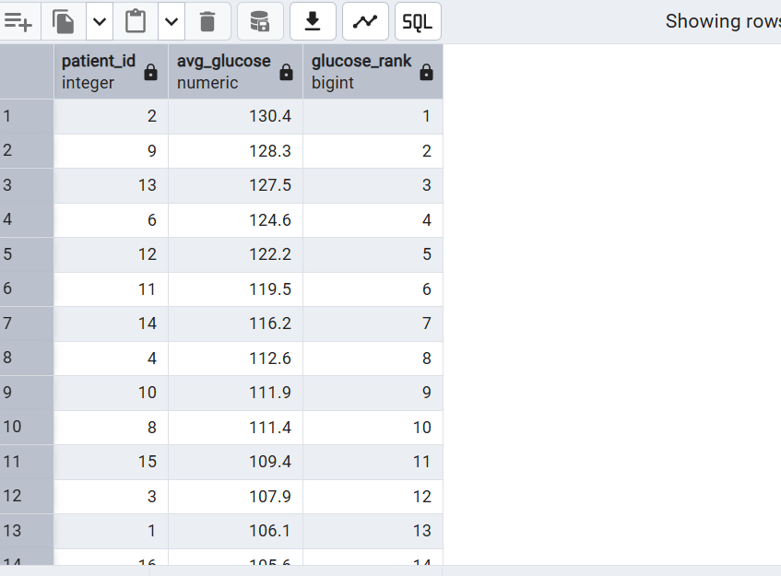INSIGHTS:
Patient 2 has the highest average glucose at 130.4 mg/dL, ranking first, while patient 7 has the lowest at 93.1 mg/dL, ranking last among the 16 patients. Most patients cluster in the 105-130 mg/dL range, which falls in the normal-to-pre-diabetic zone, with only patient 7 averaging clearly within the normal range and the rest trending higher. This ranking gives a quick way to flag patients 2, 9, and 13 (the top three) for closer review of their overall glucose control.

- For each heart rate reading, what is the next recorded value and is the trend rising or falling?

Reasoning:
Analyze sequential heart rate readings for each patient by retrieving the next recorded value after each measurement and determining whether the heart rate is increasing or decreasing over time, enabling trend detection and short-term cardiovascular pattern analysis.
Optimization:
- This query optimizes performance by filtering out invalid heart rate values early using the WHERE clause, which reduces the number of rows processed by the window function.
- It uses the LEAD() window function instead of self-joins or subqueries, which allows efficient access to the next timestamped heart rate in a single pass.
- The PARTITION BY patient_id ensures computations are isolated per patient, reducing unnecessary cross-row comparisons.
QUERY:
SELECT
patient_id,
timestamp,
hr_bpm,
LEAD(hr_bpm) OVER (
PARTITION BY patient_id
ORDER BY timestamp
) AS next_hr,
CASE
WHEN LEAD(hr_bpm) OVER (
PARTITION BY patient_id
ORDER BY timestamp
) > hr_bpm THEN 'Rising'
WHEN LEAD(hr_bpm) OVER (
PARTITION BY patient_id
ORDER BY timestamp
) < hr_bpm THEN 'Falling'
ELSE 'Stable'
END AS hr_trend
FROM hr_clean
WHERE hr_bpm BETWEEN 30 AND 220;
OUTPUT: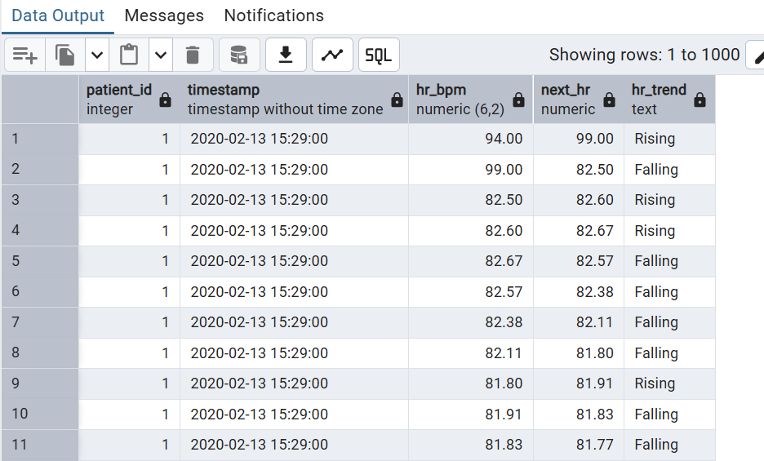INSIGHTS:
Patient 1's heart rate swings frequently between roughly 58 and 130 bpm, alternating often between "Rising" and "Falling" rather than trending steadily. A few sharp spikes (like the jump past 100 bpm around 15:42) suggest brief bursts of activity. The frequent short-term swings suggest a smoothed view might better reveal the underlying trend versus sensor noise.

- Where does each patient's peak glucose reading fall as a percentile within the cohort?

Reasoning:
Determine each patient’s peak glucose reading and calculate its percentile rank within the overall cohort to assess how extreme each patient’s highest glucose value is relative to others, supporting comparative evaluation of glycemic severity.
Optimization:
- Filtering glucose readings before aggregation, reducing the amount of data processed.
- It uses GROUP BY to calculate the maximum glucose value once per patient, minimizing unnecessary computations.
- The window function efficiently calculates each patient's percentile within the cohort without requiring self-joins or complex subqueries.
QUERY:
SELECT
patient_id,
MAX(glucose_mgdl) AS peak_glucose,
ROUND(PERCENT_RANK() OVER (
ORDER BY MAX(glucose_mgdl)
)::numeric * 100, 1) AS percentile_in_cohort
FROM dexcom_clean
WHERE glucose_mgdl BETWEEN 40 AND 400
GROUP BY patient_id;
OUTPUT:
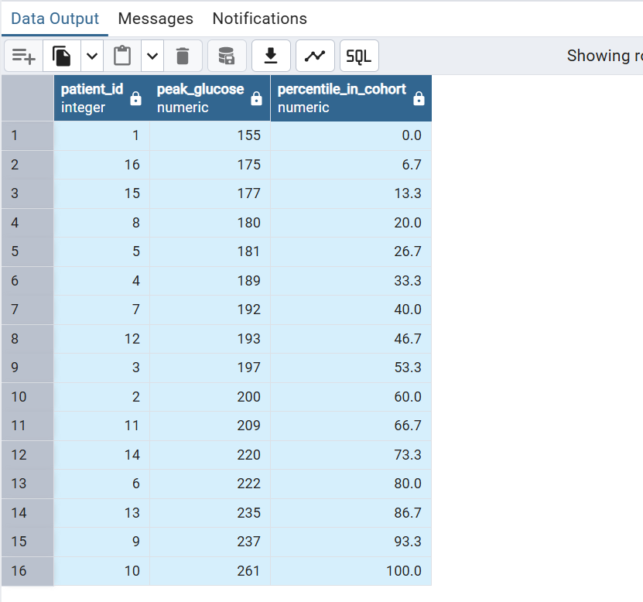
INSIGHTS:
Patient 10 has the highest peak glucose at 261 mg/dL, placing them at the 100th percentile, while patient 1 has the lowest peak at 155 mg/dL, at the 0th percentile. Most patients fall between 175-235 mg/dL for their highest recorded glucose, with the top three (patients 9, 13, and 10) all peaking above 235, which may warrant closer review for episodes of significant hyperglycemia. The spread shows meaningful variation across the cohort, indicating peak glucose control differs substantially from patient to patient rather than clustering tightly around one value.
15.What is the difference between each glucose reading and the previous reading per patient?

Reasoning: Glucose rate of change is more clinically important than absolute glucose level. A rapid rise of 50 mg/dL in 5 minutes is more dangerous than sustained high glucose. LAG() allows comparison of consecutive readings without a costly self join.
Optimization: CTE separates LAG calculation from CASE logic making the query easier to read and maintain. CASE classifies each reading as Rapid Rise, Rapid Drop or Stable giving clinical meaning to raw numbers.
QUERY:
WITH glucose_changes AS (
SELECT
patient_id,
timestamp,
glucose_mgdl AS current_glucose,
LAG(glucose_mgdl) OVER (PARTITION BY patient_id ORDER BY timestamp) AS previous_glucose,
glucose_mgdl - LAG(glucose_mgdl) OVER (PARTITION BY patient_id ORDER BY timestamp) AS glucose_change
FROM dexcom_clean
)
SELECT
patient_id, timestamp, current_glucose, previous_glucose,
ROUND(glucose_change, 1) AS glucose_change_mgdl,
CASE
WHEN glucose_change > 20 THEN 'Rapid Rise'
WHEN glucose_change < -20 THEN 'Rapid Drop'
WHEN glucose_change IS NULL THEN 'First Reading'
ELSE 'Stable'
END AS glucose_trend
FROM glucose_changes
ORDER BY glucose_trend, patient_id, timestamp;

OUTPUT:

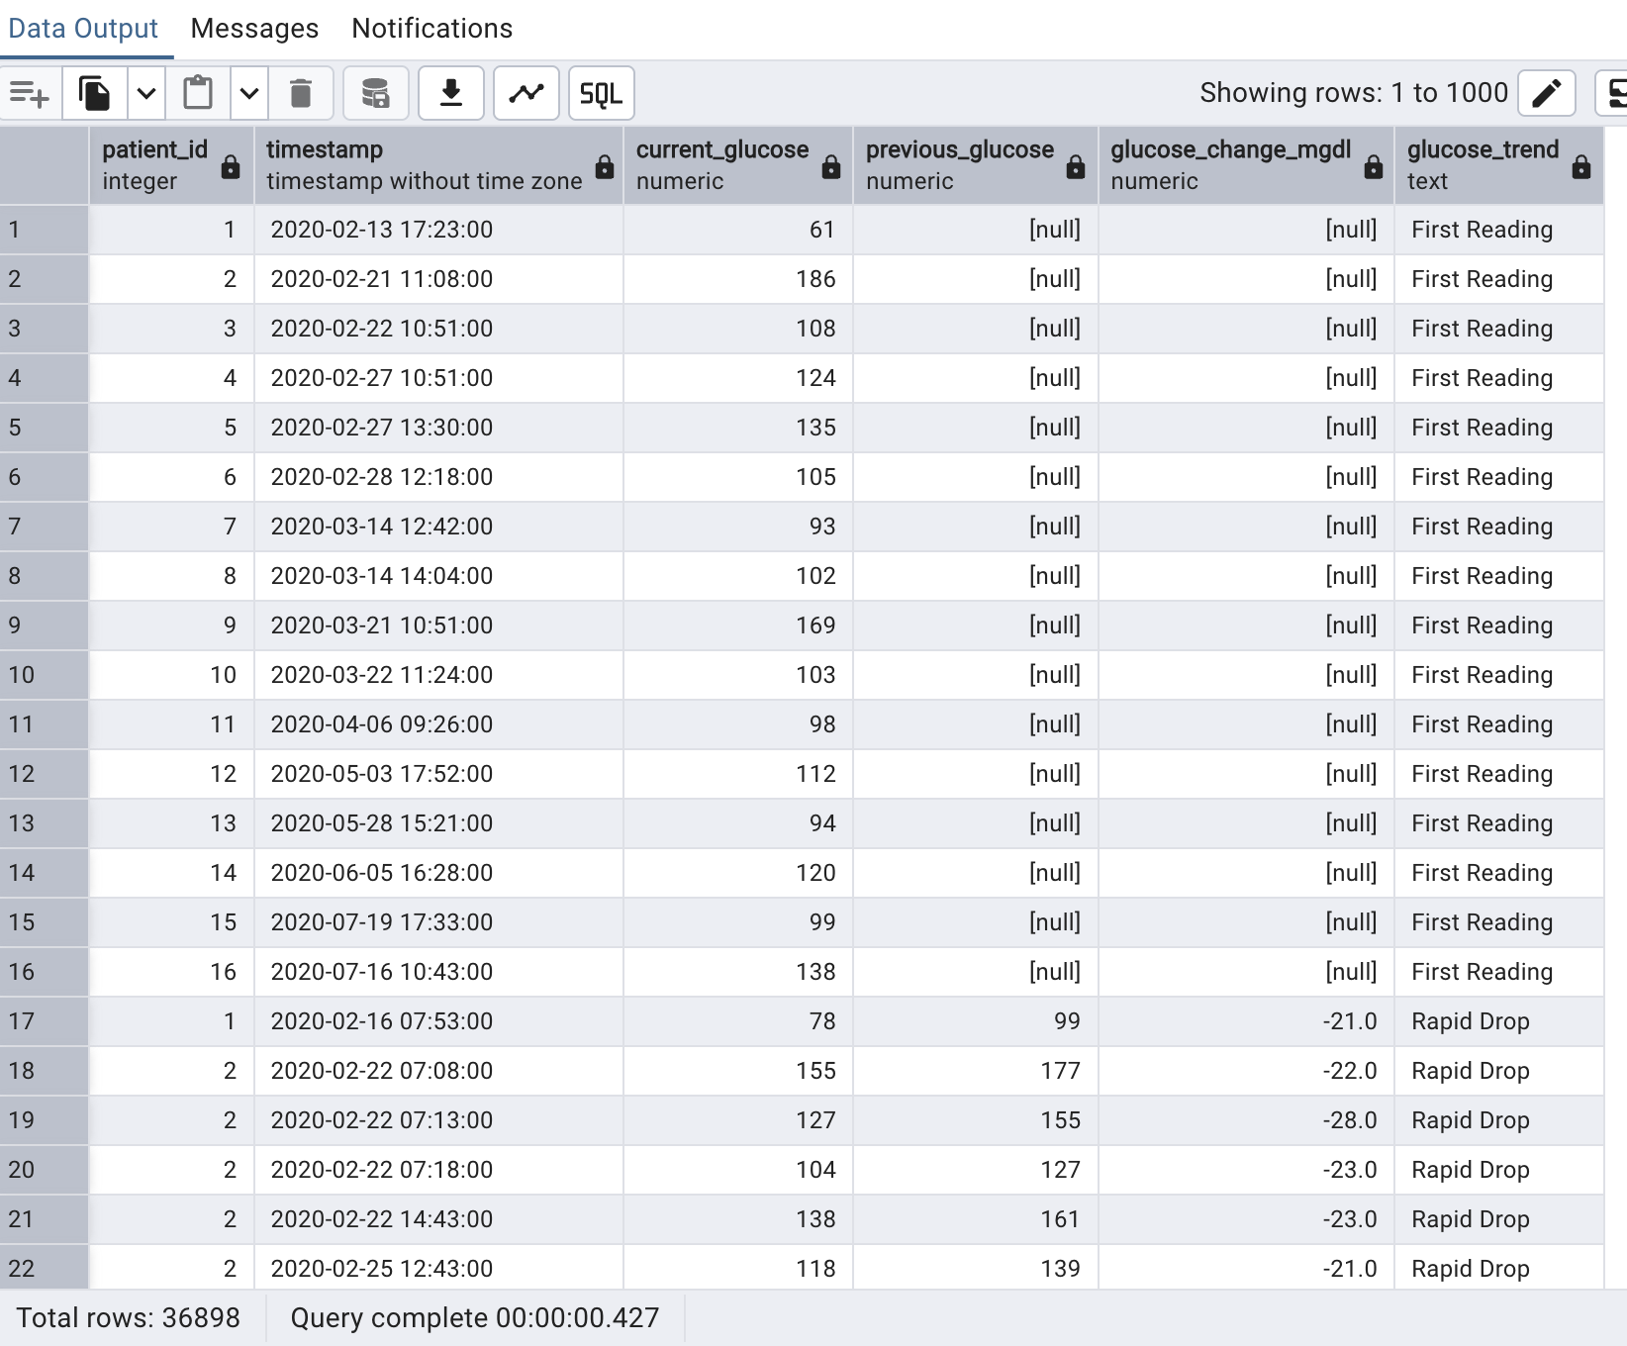INSIGHTS:
- 36,846 Stable readings, 20 Rapid Rise events and 16 Rapid Drop events found
- Patients with frequent Rapid Rise or Rapid Drop events have unstable glucose regulation needing closer dietary monitoring
16. Which patients have the highest glucose variability based on coefficient of variation?

Reasoning: Raw standard deviation alone is misleading because a patient with avg glucose 200 and STDDEV 20 is more stable than a patient with avg glucose 100 and STDDEV 20. Coefficient of variation normalizes variability making it a fairer comparison.
QUERY:
SELECT
patient_id,
COUNT(*) AS total_readings,
ROUND(AVG(glucose_mgdl), 2) AS avg_glucose,
ROUND(STDDEV(glucose_mgdl), 2) AS stddev_glucose,
ROUND(STDDEV(glucose_mgdl) / NULLIF(AVG(glucose_mgdl), 0) * 100, 2) AS coefficient_of_variation_pct,
CASE
WHEN STDDEV(glucose_mgdl) / NULLIF(AVG(glucose_mgdl), 0) * 100 > 20 THEN 'High Variability'
WHEN STDDEV(glucose_mgdl) / NULLIF(AVG(glucose_mgdl), 0) * 100 > 10 THEN 'Moderate Variability'
ELSE 'Low Variability'
END AS variability_category
FROM dexcom_clean
GROUP BY patient_id
ORDER BY coefficient_of_variation_pct DESC;

OUTPUT:
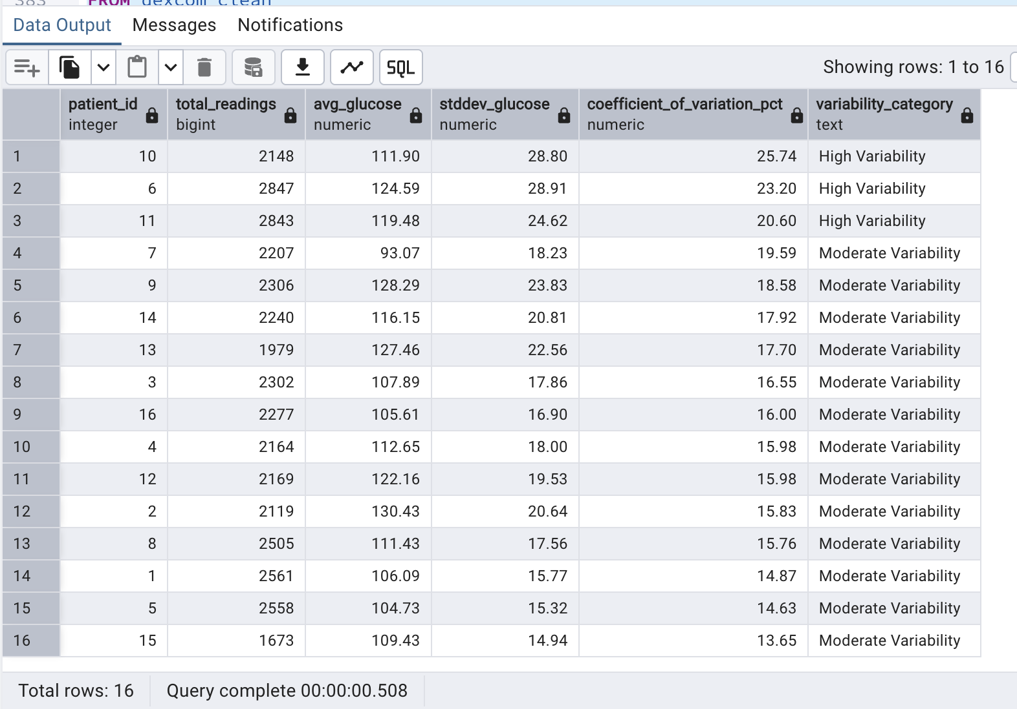 INSIGHTS:
- Patient 10 has highest variability (25.74%) and patient 15 has lowest (13.65%)
- All patients show moderate to high variability confirming unstable glucose regulation across the prediabetic population

17. What is the longest gap between consecutive glucose readings per patient?
Reasoning: The Dexcom G6 CGM records every 5 minutes. Any gap longer than 10 minutes means the device was not recording. Long gaps reduce reliability of all time based analyses for that patient.
Optimization: CTE calculates gaps once then aggregates in outer query avoiding recalculation of LEAD() expression. FILTER clause counts gaps above multiple thresholds in a single pass.
QUERY:
WITH glucose_gaps AS (
SELECT
patient_id,
timestamp AS current_reading,
LEAD(timestamp) OVER (PARTITION BY patient_id ORDER BY timestamp) AS next_reading,
EXTRACT(EPOCH FROM (LEAD(timestamp) OVER (PARTITION BY patient_id ORDER BY timestamp) - timestamp)) / 60 AS gap_minutes
FROM dexcom_clean
)
SELECT
patient_id,
ROUND(MAX(gap_minutes)::numeric, 1) AS longest_gap_minutes,
ROUND(AVG(gap_minutes)::numeric, 1) AS avg_gap_minutes,
COUNT(*) FILTER (WHERE gap_minutes > 10) AS gaps_over_10_min,
COUNT(*) FILTER (WHERE gap_minutes > 60) AS gaps_over_1_hour,
COUNT(*) FILTER (WHERE gap_minutes > 180) AS gaps_over_3_hours
FROM glucose_gaps
WHERE gap_minutes IS NOT NULL
GROUP BY patient_id
ORDER BY longest_gap_minutes DESC;
OUTPUT: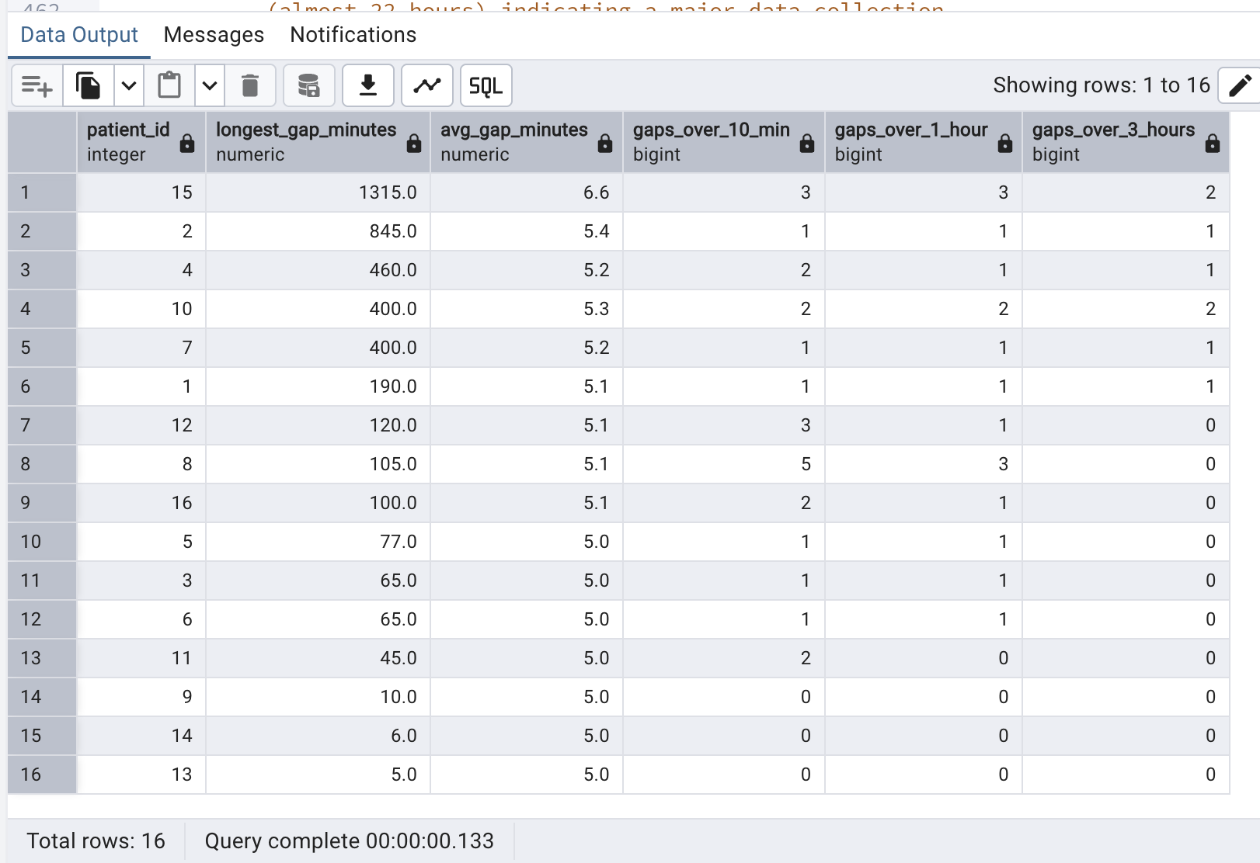INSIGHTS:
- Patient 15 has the longest gap of 1,315 minutes (almost 22 hours) indicating a major data collection gap
- Patient 2 has an 845 minute gap; most patients maintain the expected 5 minute average interval
- Analyses for patients 15 and 2 should be interpreted with caution due to missing data periods
18. What is the percentage of time each patient spends above 180 mg/dL?
Reasoning: Time above range (TAR) is a standard CGM KPI alongside time in range (TIR). The percentage of readings above 180 mg/dL directly measures hyperglycemia burden per patient.
Optimization: FILTER clause counts above 180 readings in single pass avoiding a subquery or CASE plus SUM pattern. SUM() OVER() calculates population percentage without a second table scan.
QUERY:
SELECT
patient_id,
COUNT(*) AS total_readings,
COUNT(*) FILTER (WHERE glucose_mgdl > 180) AS readings_above_180,
ROUND(COUNT(*) FILTER (WHERE glucose_mgdl > 180) * 100.0 / COUNT(*), 2) AS pct_time_above_180,
ROUND(COUNT(*) FILTER (WHERE glucose_mgdl > 180) * 100.0 / SUM(COUNT(*)) OVER(), 2) AS pct_of_total_population,
CASE
WHEN COUNT(*) FILTER (WHERE glucose_mgdl > 180) * 100.0 / COUNT(*) > 5 THEN 'High Hyperglycemia Burden'
WHEN COUNT(*) FILTER (WHERE glucose_mgdl > 180) * 100.0 / COUNT(*) > 1 THEN 'Moderate Hyperglycemia Burden'
ELSE 'Low Hyperglycemia Burden'
END AS hyperglycemia_burden
FROM dexcom_clean
GROUP BY patient_id
ORDER BY pct_time_above_180 DESC;

OUTPUT:
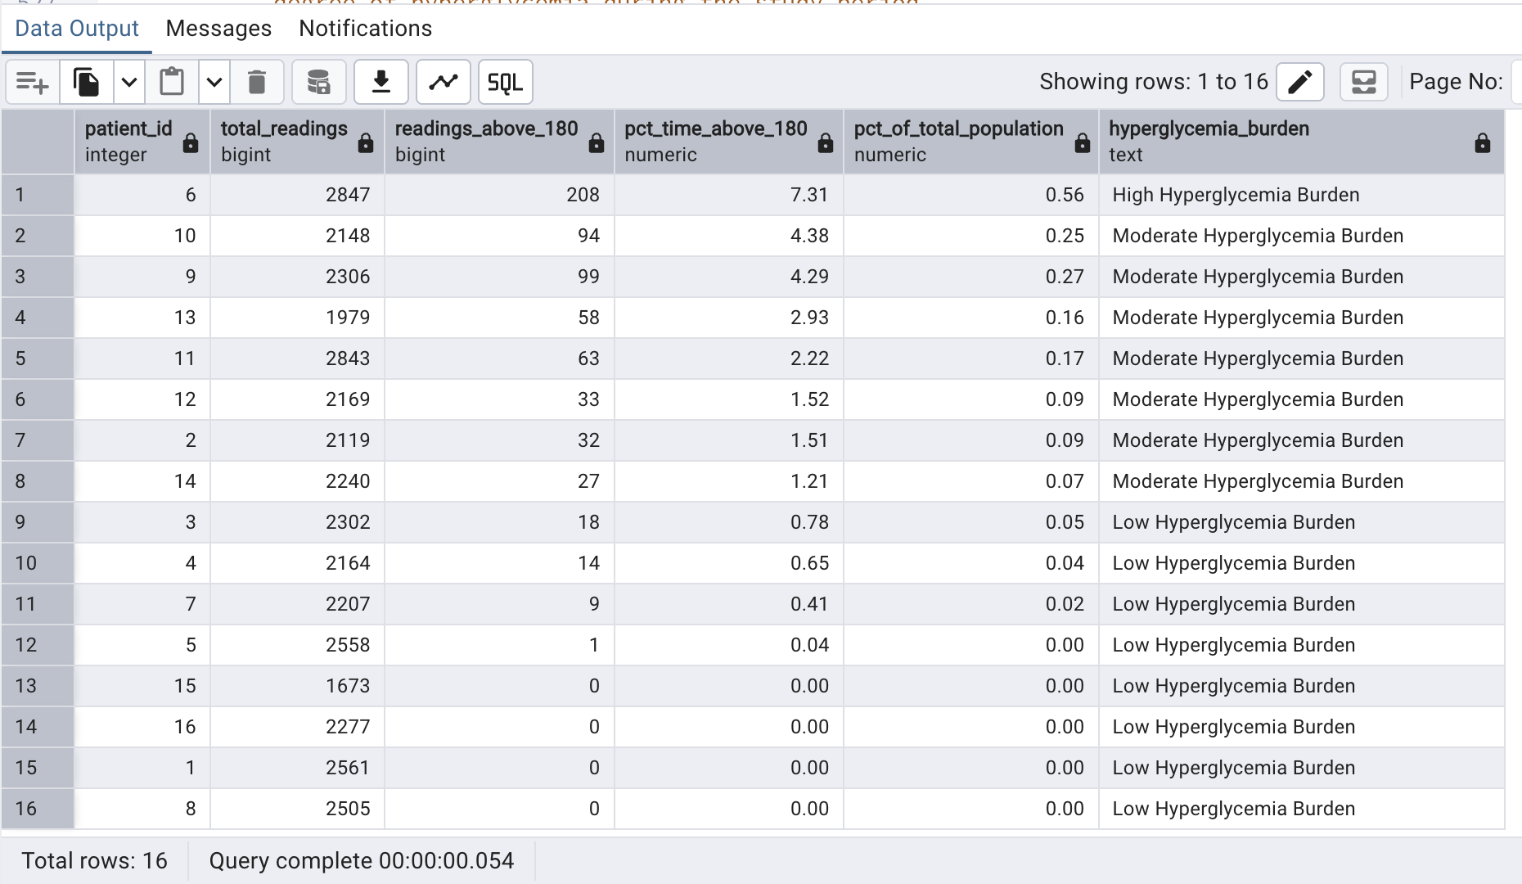INSIGHTS:
- Patient 6 spends 7.31% of time above 180 mg/dL showing the highest hyperglycemia burden
- 4 patients have 0% time above 180 showing good glucose control
- 12 out of 16 patients have some degree of hyperglycemia during the study period
19. What is the average IBI vs actual heart rate comparison per patient?
Reasoning: IBI should equal 60 divided by HR in seconds. Comparing estimated HR from IBI against actual HR from the wristband cross validates both cardiovascular sensors confirming data consistency.
QUERY:
SELECT
i.patient_id, dc.gender, dc.hba1c,
i.total_ibi_readings, i.avg_ibi_seconds, i.estimated_hr_from_ibi,
h.actual_avg_hr,
ROUND(ABS(i.estimated_hr_from_ibi - h.actual_avg_hr), 1) AS hr_difference,
CASE
WHEN ABS(i.estimated_hr_from_ibi - h.actual_avg_hr) > 20 THEN 'Large Discrepancy'
WHEN ABS(i.estimated_hr_from_ibi - h.actual_avg_hr) > 10 THEN 'Moderate Discrepancy'
ELSE 'Good Agreement'
END AS sensor_agreement
FROM (
SELECT patient_id, COUNT(ibi_seconds) AS total_ibi_readings,
ROUND(AVG(ibi_seconds)::numeric, 4) AS avg_ibi_seconds,
ROUND(60.0 / AVG(ibi_seconds), 1) AS estimated_hr_from_ibi
FROM ibi_clean GROUP BY patient_id
) i
JOIN (
SELECT patient_id, ROUND(AVG(hr_bpm), 1) AS actual_avg_hr
FROM hr_clean GROUP BY patient_id
) h ON i.patient_id = h.patient_id
JOIN demography_clean dc ON i.patient_id = dc.patient_id
ORDER BY hr_difference DESC;

OUTPUT: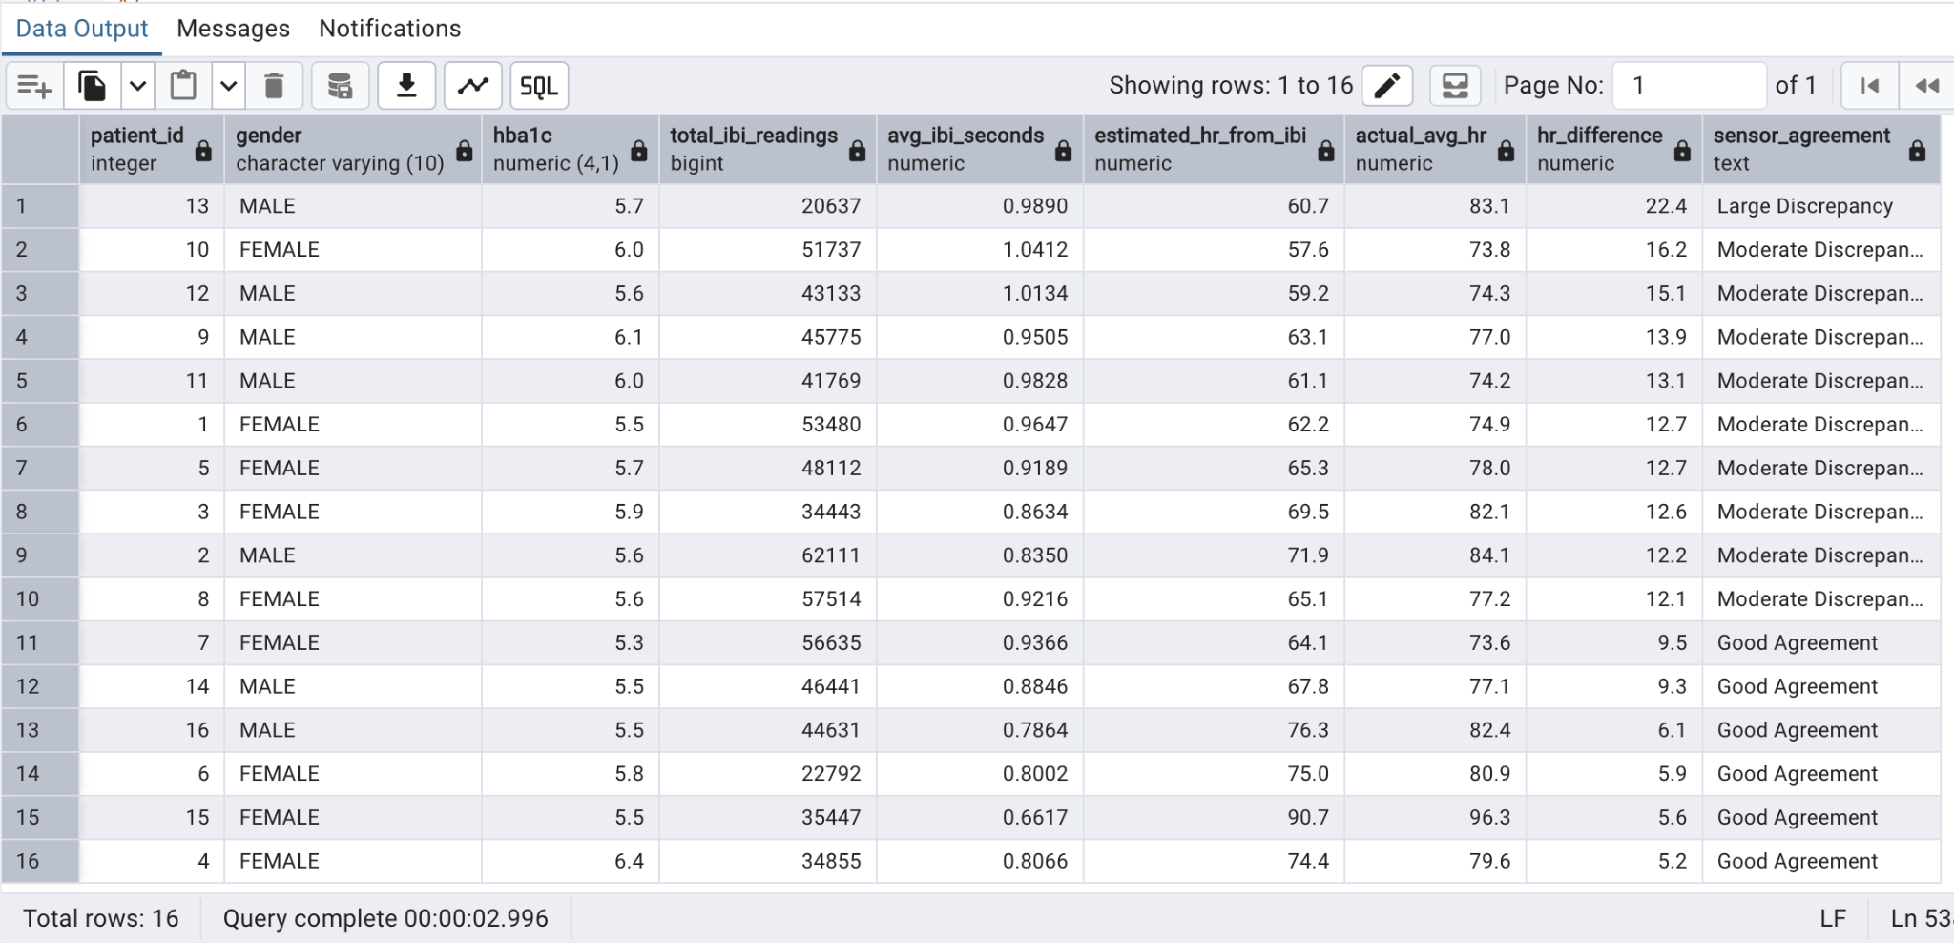
INSIGHTS:
Patient 13 shows the largest discrepancy (22.4 bpm) between estimated and actual HR suggesting possible sensor calibration issues. Most patients show moderate discrepancy which is expected as IBI and HR are recorded at different frequencies.
20. What is the rolling 7 day average glucose per patient?
Reasoning: A single day of high glucose could be noise due to an unusual meal or activity. A rolling 7 day average smooths daily variation to reveal genuine glucose trends over time.
QUERY:
WITH daily_glucose AS (
SELECT
patient_id,
DATE_TRUNC('day', timestamp) AS glucose_date,
ROUND(AVG(glucose_mgdl), 2) AS daily_avg_glucose
FROM dexcom_clean
GROUP BY patient_id, DATE_TRUNC('day', timestamp)
)
SELECT
patient_id, glucose_date, daily_avg_glucose,
ROUND(AVG(daily_avg_glucose) OVER (
PARTITION BY patient_id ORDER BY glucose_date
ROWS BETWEEN 6 PRECEDING AND CURRENT ROW
), 2) AS rolling_7day_avg,
ROUND(AVG(daily_avg_glucose) OVER (PARTITION BY patient_id), 2) AS overall_avg
FROM daily_glucose
ORDER BY patient_id, glucose_date;

OUTPUT:

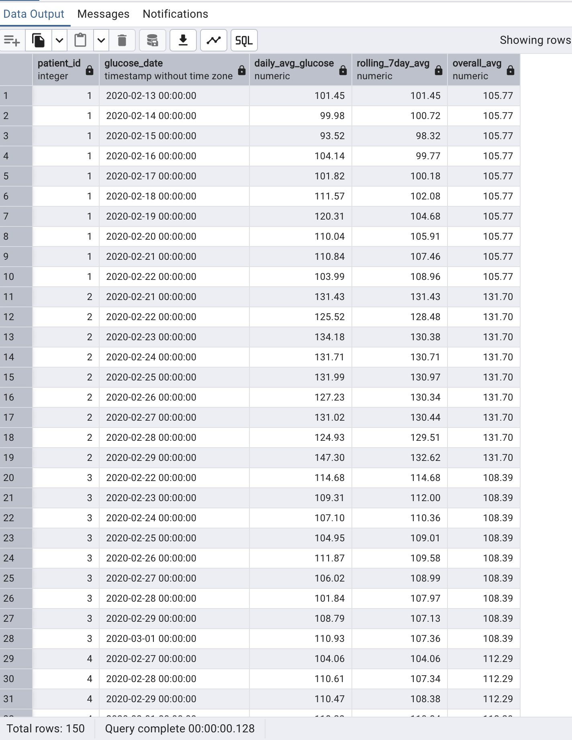

INSIGHTS:
150 daily rows across 16 patients
Rolling 7 day average smooths daily noise revealing genuine glucose trends
Patients where rolling average consistently exceeds overall average are experiencing worsening glucose control over the study period
21. What is the rank of each patient by average glucose?
Reasoning: Ranking patients by average glucose provides a clear health severity ordering across the study population. RANK() and DENSE_RANK() demonstrate different tie-handling behavior.
QUERY:
SELECT
d.patient_id, dc.gender, dc.hba1c,
ROUND(AVG(d.glucose_mgdl), 2) AS avg_glucose,
RANK() OVER (ORDER BY AVG(d.glucose_mgdl) DESC) AS glucose_rank,
DENSE_RANK() OVER (ORDER BY AVG(d.glucose_mgdl) DESC) AS dense_rank,
CASE
WHEN RANK() OVER (ORDER BY AVG(d.glucose_mgdl) DESC) <= 5 THEN 'High Risk'
WHEN RANK() OVER (ORDER BY AVG(d.glucose_mgdl) DESC) <= 10 THEN 'Moderate Risk'
ELSE 'Low Risk'
END AS risk_category
FROM dexcom_clean d
JOIN demography_clean dc ON d.patient_id = dc.patient_id
GROUP BY d.patient_id, dc.gender, dc.hba1c
ORDER BY glucose_rank;
OUTPUT:
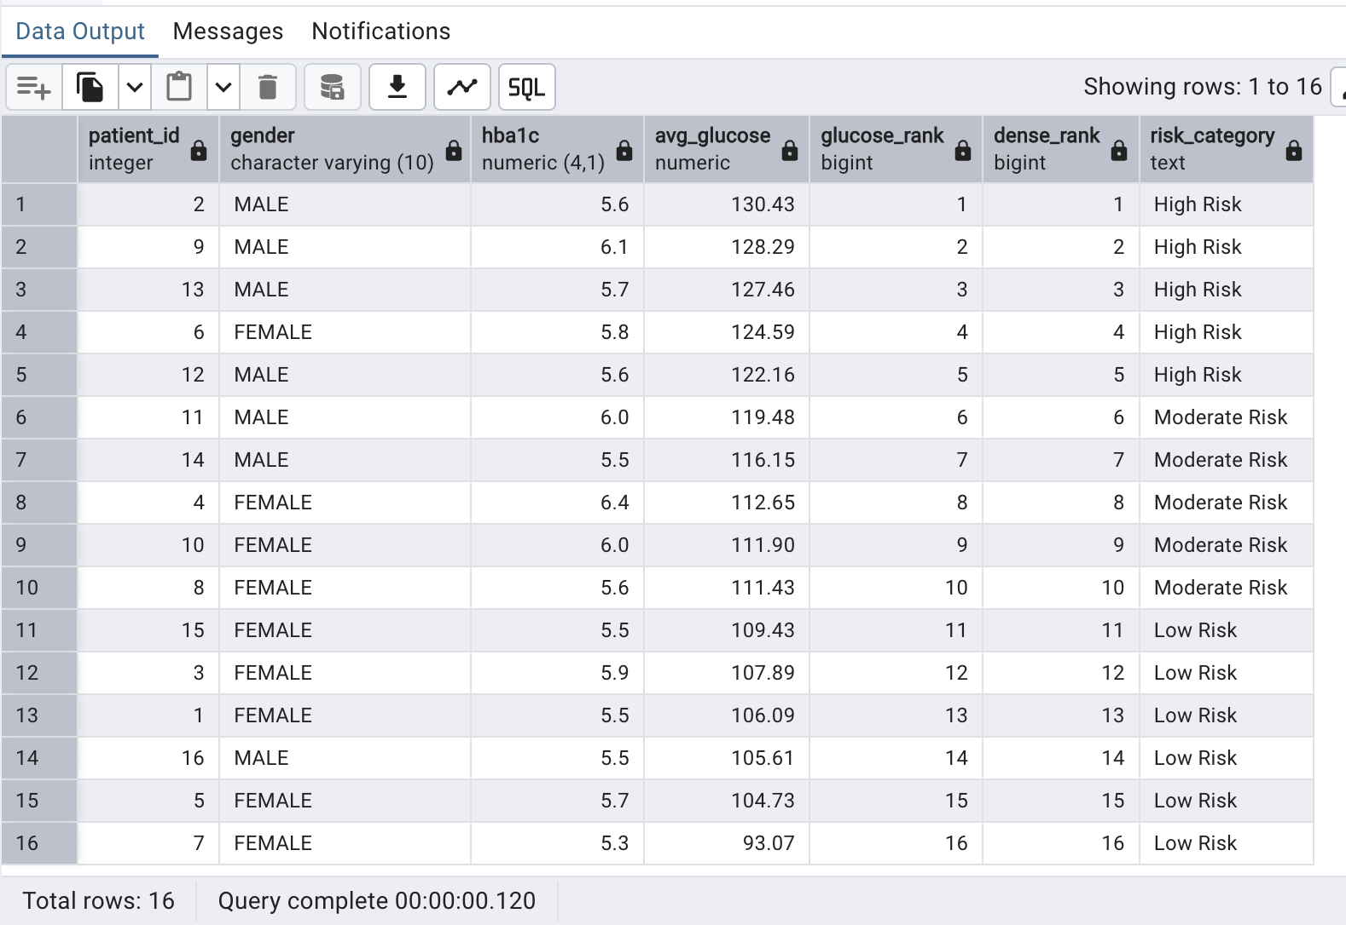
22.What is the rolling 5-minute average heart rate?
Reasoning:
Heart rate data sampled at 1 Hz contains beat-to-beat variability and transient noise. A 5-reading rolling average smooths this noise while preserving physiologically meaningful HR trends — activity bursts, recovery curves, and stress responses. This rolling average is the standard pre-processing step required before any HR trend classification or anomaly detection algorithm in wearable health analytics.
Optimization:
Rows between 4 PRECEDING AND CURRENT ROW is a physical row frame — faster than RANGE BETWEEN because it avoids timestamp arithmetic for tie resolution. The composite index on (patient_id, timestamp) in hr_clean makes the PARTITION BY patient_id ORDER BY timestamp window efficient. Pre-filtering hc.hr_anomaly = FALSE in the CTE removes outliers so they do not distort the rolling average. Alias hc follows the hr_clean naming convention.
PostgreSQL feature used: Window: AVG() OVER (PARTITION BY hc.patient_id ORDER BY hc.timestamp ROWS BETWEEN 4 PRECEDING AND CURRENT ROW)

QUERY:
WITH clean_hc AS (
SELECT hc.patient_id, hc.timestamp, hc.hr_bpm
FROM hr_clean hc
WHERE hc.hr_anomaly = FALSE
AND hc.hr_bpm BETWEEN 40 AND 200
)
SELECT
hc.patient_id,
hc.timestamp,
hc.hr_bpm AS raw_hr_bpm,
ROUND(
AVG(hc.hr_bpm) OVER (
PARTITION BY hc.patient_id
ORDER BY hc.timestamp
ROWS BETWEEN 4 PRECEDING AND CURRENT ROW
)::NUMERIC, 1
) AS rolling_5s_avg_hr,
ROUND(
AVG(hc.hr_bpm) OVER (
PARTITION BY hc.patient_id
ORDER BY hc.timestamp
ROWS BETWEEN 59 PRECEDING AND CURRENT ROW
)::NUMERIC, 1
) AS rolling_60s_avg_hr
FROM clean_hc hc
ORDER BY hc.patient_id, hc.timestamp;
OUTPUT:
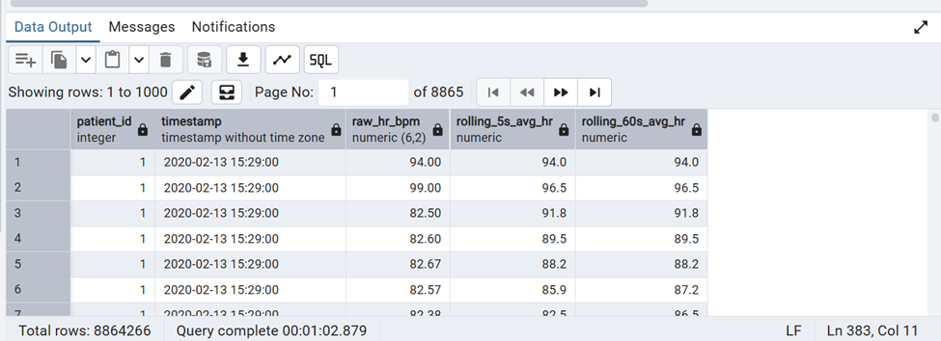
INSIGHTS:
Rolling 5-minute and 60-second HR averages smooth sensor noise, making short bursts of elevated heart rate easier to distinguish from sustained increases tied to activity or stress.

23. What is the hourly average glucose?
Reasoning:
Aggregating CGM readings into hourly buckets using DATE_TRUNC creates a time-series view of glucose at a manageable resolution — 24 data points per participant per day rather than 288. Hourly averages reveal circadian patterns: the dawn phenomenon (pre-breakfast rise), post-meal peaks, and overnight stability. This resolution is the standard for clinical CGM reporting and patient counselling.
Optimization:
DATE_TRUNC('hour', dc.timestamp) uses the timestamp index for efficient bucketing without string parsing. TO_CHAR creates human-readable labels. STDDEV in the same scan adds variability context at zero extra I/O. ORDER BY dc.patient_id, hour_bucket provides chronological output suitable for time-series plots. Alias dc follows the dexcom_clean naming convention.
PostgreSQL feature used: Datetime: DATE_TRUNC('hour', dc.timestamp); AVG(dc.glucose_mgdl) per hour bucket
QUERY:
SELECT
dc.patient_id,
DATE_TRUNC('hour', dc.timestamp) AS hour_bucket,
TO_CHAR(DATE_TRUNC('hour', dc.timestamp), 'HH12:MI AM')
AS hour_label,
COUNT(*) AS readings_in_hour,
ROUND(AVG(dc.glucose_mgdl)::NUMERIC, 1) AS avg_glucose,
ROUND(MIN(dc.glucose_mgdl)::NUMERIC, 1) AS min_glucose,
ROUND(MAX(dc.glucose_mgdl)::NUMERIC, 1) AS max_glucose,
ROUND(STDDEV(dc.glucose_mgdl)::NUMERIC, 2) AS glucose_std_dev
FROM dexcom_clean dc
WHERE UPPER(TRIM(dc.event_type)) = 'EGV'
AND dc.glucose_mgdl IS NOT NULL
GROUP BY dc.patient_id, DATE_TRUNC('hour', dc.timestamp)
ORDER BY dc.patient_id, hour_bucket;
OUTPUT:
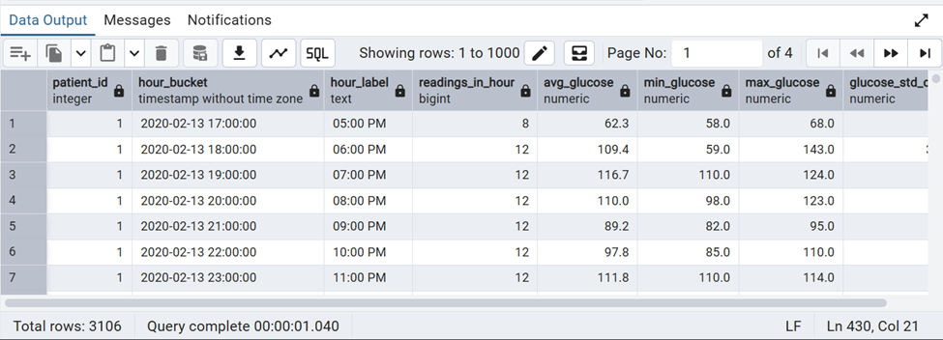
INSIGHTS:
Hourly glucose averages reveal the circadian pattern across the cohort, including the dawn phenomenon and post-meal peaks that are not visible from daily averages alone.

24.What is the difference between consecutive glucose readings?
Reasoning:
The glucose delta between consecutive 5-minute CGM readings is the rate of glucose change — the primary clinical metric derived from CGM beyond the absolute value. A delta > +30 mg/dL per reading signals a post-prandial spike onset. A delta < -30 mg/dL signals a rapid fall and potential hypoglycemic risk. LAG() computes this efficiently without a self-join.
Optimization:
LAG(dc.glucose_mgdl, 1) retrieves the immediately preceding row within each partition without a self-join — O(n) rather than O(n²). The composite index on (patient_id, timestamp) ensures LAG traverses rows in chronological order. NULL LAG values for first readings are handled naturally and filtered in the outer query WHERE clause. Alias dc follows the dexcom_clean convention.
PostgreSQL feature used: Window: LAG(dc.glucose_mgdl) OVER (PARTITION BY dc.patient_id ORDER BY dc.timestamp)
QUERY:
WITH lagged_dc AS (
SELECT
dc.patient_id,
dc.timestamp,
dc.glucose_mgdl,
LAG(dc.glucose_mgdl) OVER (
PARTITION BY dc.patient_id
ORDER BY dc.timestamp
) AS prev_glucose,
LAG(dc.timestamp) OVER (
PARTITION BY dc.patient_id
ORDER BY dc.timestamp
) AS prev_timestamp
FROM dexcom_clean dc
WHERE UPPER(TRIM(dc.event_type)) = 'EGV'
AND dc.glucose_mgdl IS NOT NULL
)
SELECT
lagged_dc.patient_id,
lagged_dc.timestamp,
lagged_dc.prev_timestamp,
lagged_dc.prev_glucose,
lagged_dc.glucose_mgdl AS current_glucose,
lagged_dc.glucose_mgdl - lagged_dc.prev_glucose
AS glucose_delta,
CASE
WHEN lagged_dc.glucose_mgdl - lagged_dc.prev_glucose > 30
THEN 'Rapid Rise'
WHEN lagged_dc.glucose_mgdl - lagged_dc.prev_glucose < -30
THEN 'Rapid Fall'
WHEN ABS(lagged_dc.glucose_mgdl - lagged_dc.prev_glucose) <= 10
THEN 'Stable'
ELSE 'Moderate Change'
END AS change_category
FROM lagged_dc
WHERE lagged_dc.prev_glucose IS NOT NULL
ORDER BY lagged_dc.patient_id, lagged_dc.timestamp;

OUTPUT:
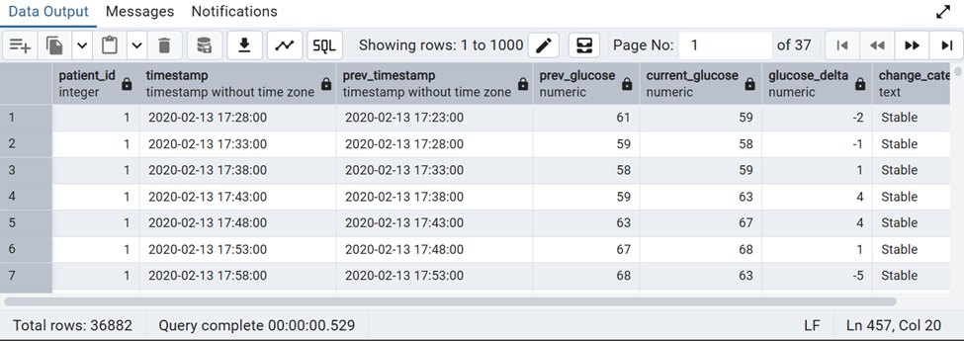
INSIGHTS:
Large positive glucose deltas correspond to rapid post-meal spikes, while large negative deltas flag potential hypoglycemic risk; this metric is the basis for downstream spike-detection queries.

25.What is the cumulative meal count per participant?
Reasoning:
A cumulative meal count running over time reveals the pace of dietary logging for each participant — useful for identifying periods of missing food entries and for computing inter-meal intervals relative to the n-th meal of the day. This running count is the foundation for reconstructing the daily meal sequence used in post-prandial glucose analysis.
Optimization:
COUNT(*) OVER with ROWS BETWEEN UNBOUNDED PRECEDING AND CURRENT ROW is the most efficient cumulative count — computed in a single ordered pass. The PARTITION BY fc.patient_id ORDER BY fc.timestamp window uses the foodlog_clean timestamp index. The nested daily count reuses the same partition without a second scan. Alias fc follows the foodlog_clean naming convention.
PostgreSQL feature used: Window: COUNT(*) OVER (PARTITION BY fc.patient_id ORDER BY fc.timestamp ROWS UNBOUNDED PRECEDING)
QUERY:
SELECT
fc.patient_id,
fc.timestamp AS meal_time,
fc.logged_food,
fc.calories,
fc.carbs_g,
COUNT(*) OVER (
PARTITION BY fc.patient_id
ORDER BY fc.timestamp
ROWS BETWEEN UNBOUNDED PRECEDING AND CURRENT ROW
) AS cumulative_meal_count,
COUNT(*) OVER (
PARTITION BY fc.patient_id,
DATE_TRUNC('day', fc.timestamp)
ORDER BY fc.timestamp
ROWS BETWEEN UNBOUNDED PRECEDING AND CURRENT ROW
) AS meal_number_today
FROM foodlog_clean fc
WHERE fc.timestamp IS NOT NULL
ORDER BY fc.patient_id, fc.timestamp;
OUTPUT:
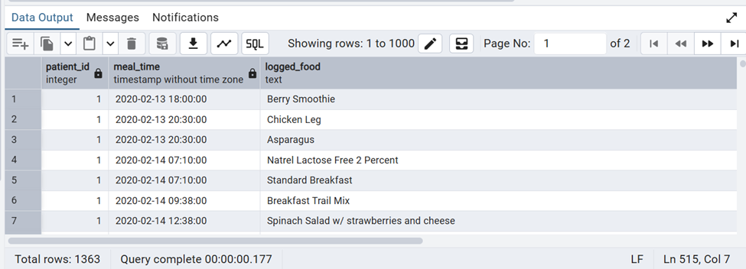
INSIGHTS:
The cumulative and daily meal counts highlight logging frequency patterns, useful for identifying participants with sparse or inconsistent food-tracking behaviour during the study window.

26.What is the rolling standard deviation of IBI?
Reasoning:
Rolling standard deviation of IBI is the practical implementation of short-term HRV — a 12-reading window approximates the RMSSD metric used in clinical HRV assessment. High rolling IBI SD indicates good autonomic flexibility; declining SD over time may signal fatigue, stress, or the onset of hyperglycemia. This is a key wearable biomarker for real-time health monitoring.
Optimization:
STDDEV() OVER with a physical ROWS BETWEEN frame is computed in a single pass — more efficient than computing RMSSD manually with LAG(). The outer WHERE window_size = 12 filters the first 11 rows per participant where the window is incomplete and the SD is not meaningful. Alias ic follows the ibi_clean naming convention.
PostgreSQL feature used: Window: STDDEV(ic.ibi_seconds) OVER (PARTITION BY ic.patient_id ORDER BY ic.timestamp ROWS BETWEEN 11 PRECEDING AND CURRENT ROW)
QUERY:
WITH ibi_rolling AS (
SELECT
ic.patient_id,
ic.timestamp,
ic.ibi_seconds,
ROUND(
STDDEV(ic.ibi_seconds) OVER (
PARTITION BY ic.patient_id
ORDER BY ic.timestamp
ROWS BETWEEN 11 PRECEDING AND CURRENT ROW
)::NUMERIC, 5
) AS rolling_ibi_sd,
ROUND(
AVG(ic.ibi_seconds) OVER (
PARTITION BY ic.patient_id
ORDER BY ic.timestamp
ROWS BETWEEN 11 PRECEDING AND CURRENT ROW
)::NUMERIC, 4
) AS rolling_avg_ibi,
COUNT(*) OVER (
PARTITION BY ic.patient_id
ORDER BY ic.timestamp
ROWS BETWEEN 11 PRECEDING AND CURRENT ROW
) AS window_size
FROM ibi_clean ic
)
SELECT
ibi_rolling.patient_id,
ibi_rolling.timestamp,
ibi_rolling.ibi_seconds,
ibi_rolling.rolling_avg_ibi,
ibi_rolling.rolling_ibi_sd,
CASE
WHEN ibi_rolling.rolling_ibi_sd > 0.08 THEN 'High HRV'
WHEN ibi_rolling.rolling_ibi_sd > 0.04 THEN 'Moderate HRV'
ELSE 'Low HRV'
END AS hrv_tier
FROM ibi_rolling
WHERE ibi_rolling.window_size = 12
ORDER BY ibi_rolling.patient_id, ibi_rolling.timestamp;

OUTPUT:
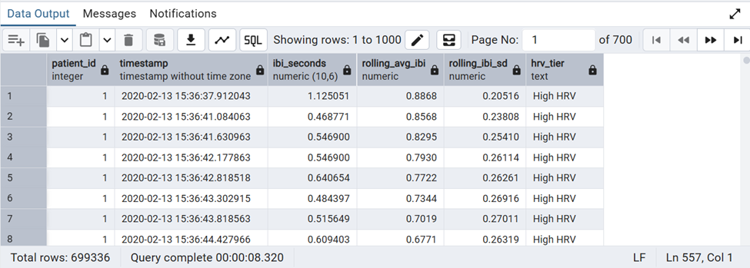
INSIGHTS:
Rolling IBI standard deviation approximates short-term heart rate variability; a declining trend over the study period may indicate increasing physiological stress or fatigue.

27.What is the average EDA per hour?
Reasoning:
EDA is sampled at 4 Hz — producing approximately 14,400 readings per hour per participant. Aggregating to hourly averages reduces this to 24 data points per participant per day while preserving the diurnal stress pattern. Peak EDA hours can be correlated with glucose peaks to quantify the stress-hyperglycemia effect across the cohort.

Optimization:
EXTRACT(HOUR FROM ec.timestamp) runs on the indexed timestamp column and produces an integer 0-23 without string parsing. Grouping on three columns (patient_id, study_date, hour_of_day) produces at most 16 x 10 x 24 = 3,840 output rows. ec.eda_spike boolean allows spike counting in the same aggregation scan. Alias ec follows the eda_clean naming convention.
PostgreSQL feature used: Datetime: EXTRACT(HOUR FROM ec.timestamp); GROUP BY hour with AVG(ec.eda_value)

QUERY:
SELECT
ec.patient_id,
DATE_TRUNC('day', ec.timestamp)::DATE AS study_date,
EXTRACT(HOUR FROM ec.timestamp)::INT AS hour_of_day,
TO_CHAR(
MAKE_TIME(EXTRACT(HOUR FROM ec.timestamp)::INT, 0, 0),
'HH12:MI AM'
) AS hour_label,
COUNT(*) AS readings_in_hour,
ROUND(AVG(ec.eda_value)::NUMERIC, 5) AS avg_eda,
ROUND(MAX(ec.eda_value)::NUMERIC, 5) AS peak_eda,
COUNT(*) FILTER (WHERE ec.eda_spike = TRUE) AS spike_count
FROM eda_clean ec
GROUP BY
ec.patient_id,
DATE_TRUNC('day', ec.timestamp)::DATE,
EXTRACT(HOUR FROM ec.timestamp)::INT
ORDER BY ec.patient_id, study_date, hour_of_day;
OUTPUT:
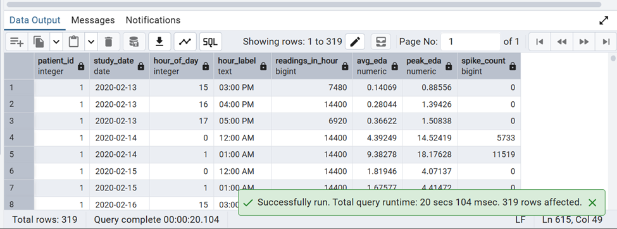
INSIGHTS:
Hourly EDA averages show when stress activation peaks during the day; these peak stress hours can be cross-referenced with glucose and meal timing to explore the stress-hyperglycemia pathway.

28.What is the average temperature per hour?
Reasoning:
Skin temperature follows a circadian rhythm — slightly lower at night and higher during the day — and rises during exercise and stress. Hourly aggregation reveals this diurnal pattern and enables temperature-glucose alignment analysis. Elevated nocturnal skin temperature may indicate poor sleep quality, which is associated with elevated morning glucose.

Optimization:
DATE_TRUNC('hour', tc.timestamp) groups the 4 Hz temperature signal into 24 hourly buckets per day per participant using the timestamp index. The tc.temp_anomaly filter removes flagged readings before aggregation. STDDEV in the same scan adds variability context at zero extra cost. Alias tc follows the temperature_clean naming convention.
PostgreSQL feature used: Datetime: DATE_TRUNC('hour', tc.timestamp); grouped temperature aggregation by hour.
QUERY:
SELECT
tc.patient_id,
DATE_TRUNC('hour', tc.timestamp) AS hour_bucket,
TO_CHAR(DATE_TRUNC('hour', tc.timestamp), 'Day HH12:MI AM')
AS hour_label,
COUNT(*) AS readings_in_hour,
ROUND(AVG(tc.temperature_c)::NUMERIC, 2) AS avg_temp_c,
ROUND(MIN(tc.temperature_c)::NUMERIC, 2) AS min_temp_c,
ROUND(MAX(tc.temperature_c)::NUMERIC, 2) AS max_temp_c,
ROUND(STDDEV(tc.temperature_c)::NUMERIC, 3) AS temp_std_dev
FROM temperature_clean tc
WHERE tc.temp_anomaly = FALSE
GROUP BY tc.patient_id, DATE_TRUNC('hour', tc.timestamp)
ORDER BY tc.patient_id, hour_bucket;

OUTPUT:
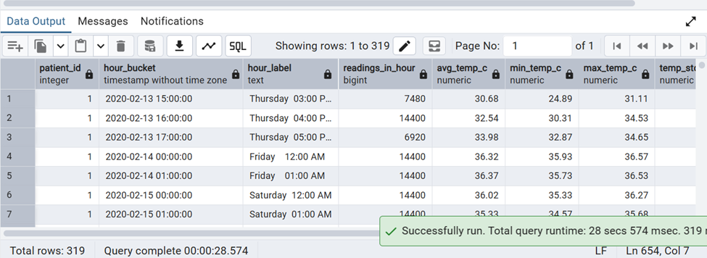
INSIGHTS:
Hourly temperature trends reveal the circadian thermoregulatory pattern; elevated nighttime temperature in some participants may correlate with poorer sleep quality and elevated morning glucose.

29. Align glucose and heart rate by minute.
Reasoning:
CGM records glucose every 5 minutes; HR is recorded at 1 Hz. To co-analyse both signals they must be aligned to a common time axis. DATE_TRUNC-based 5-minute binning aggregates HR into the same temporal resolution as glucose, enabling a paired time-series that can be correlated or fed into a regression model without a many-to-one join explosion.
Optimization:
Both signals are pre-aggregated to 5-minute bins in separate CTEs (dc_5min using alias dc, hc_5min using alias hc) before joining — this avoids a Cartesian-product join between the high-frequency HR table and CGM. The LEFT JOIN preserves CGM rows even when no HR reading exists in that window. Aliases dc and hc follow the dexcom_clean and hr_clean naming conventions.
PostgreSQL feature used: Datetime: 5-min bucket binning using DATE_TRUNC; LEFT JOIN on aligned (patient_id, time_bin)
QUERY:
WITH dc_5min AS (
SELECT
dc.patient_id,
DATE_TRUNC('minute', dc.timestamp)
- ((EXTRACT(MINUTE FROM dc.timestamp)::INT % 5)
)::INT * INTERVAL '1 minute' AS time_bin,
ROUND(AVG(dc.glucose_mgdl)::NUMERIC, 1) AS avg_glucose
FROM dexcom_clean dc
WHERE UPPER(TRIM(dc.event_type)) = 'EGV'
AND dc.glucose_mgdl IS NOT NULL
GROUP BY
dc.patient_id,
DATE_TRUNC('minute', dc.timestamp)
- ((EXTRACT(MINUTE FROM dc.timestamp)::INT % 5))::INT
* INTERVAL '1 minute'
),
hc_5min AS (
SELECT
hc.patient_id,
DATE_TRUNC('minute', hc.timestamp)
- ((EXTRACT(MINUTE FROM hc.timestamp)::INT % 5)
)::INT * INTERVAL '1 minute' AS time_bin,
ROUND(AVG(hc.hr_bpm)::NUMERIC, 1) AS avg_hr
FROM hr_clean hc
WHERE hc.hr_anomaly = FALSE
GROUP BY
hc.patient_id,
DATE_TRUNC('minute', hc.timestamp)
- ((EXTRACT(MINUTE FROM hc.timestamp)::INT % 5))::INT
* INTERVAL '1 minute'
)
SELECT
dc_5min.patient_id,
dc_5min.time_bin,
dc_5min.avg_glucose,
hc_5min.avg_hr,
CASE
WHEN dc_5min.avg_glucose > 140 AND hc_5min.avg_hr > 90
THEN 'High Glucose + High HR'
WHEN dc_5min.avg_glucose > 140 THEN 'High Glucose Only'
WHEN hc_5min.avg_hr > 90 THEN 'High HR Only'
ELSE 'Normal'
END AS combined_state
FROM dc_5min
LEFT JOIN hc_5min USING (patient_id, time_bin)
ORDER BY dc_5min.patient_id, dc_5min.time_bin;

OUTPUT:
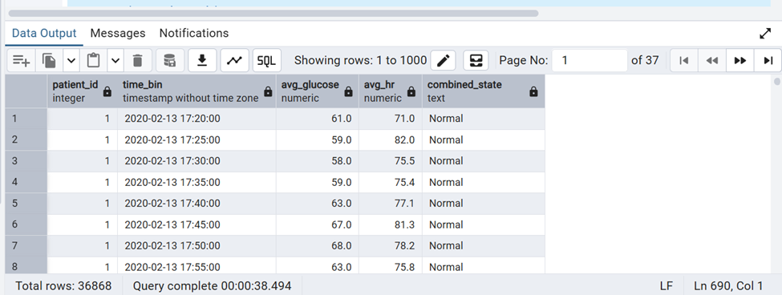
INSIGHTS:
Aligning glucose and heart rate on a common 5-minute axis enables direct visual and statistical comparison; periods flagged as 'High Glucose + High HR' are strong candidates for stress-related hyperglycemia events.

30. Can we identify patients who show simultaneous high glucose, high heart rate, and high stress (EDA)?
Reasoning:
Stress is known to trigger cortisol release which directly elevates blood glucose, while sympathetic activation simultaneously raises both heart rate and EDA. Identifying 30-minute windows where all three signals spike together is the most direct evidence of the stress-hyperglycemia pathway and pinpoints the patients at highest combined physiological risk.
Optimization:
- Pre-aggregated each sensor into separate 30-minute bin CTEs before joining, avoiding a massive direct join across three high-frequency tables.
- Used cohort-relative P75 percentile thresholds calculated once via PERCENTILE_CONT instead of fixed clinical cutoffs, since no window met fixed thresholds simultaneously.
- CROSS JOIN on the single-row thresholds CTE applies all three cutoffs without repeating subqueries inside the WHERE clause.
QUERY:
sql
WITH dc_30min AS (
SELECT
patient_id,
DATE_TRUNC('hour', timestamp)
+ (FLOOR(EXTRACT(MINUTE FROM timestamp) / 30) * INTERVAL '30 minutes') AS time_bin,
ROUND(AVG(glucose_mgdl)::NUMERIC, 1) AS avg_glucose
FROM dexcom_clean
WHERE UPPER(TRIM(event_type)) = 'EGV'
GROUP BY
patient_id,
DATE_TRUNC('hour', timestamp)
+ (FLOOR(EXTRACT(MINUTE FROM timestamp) / 30) * INTERVAL '30 minutes')
),
hc_30min AS (
SELECT
patient_id,
DATE_TRUNC('hour', timestamp)
+ (FLOOR(EXTRACT(MINUTE FROM timestamp) / 30) * INTERVAL '30 minutes') AS time_bin,
ROUND(AVG(hr_bpm)::NUMERIC, 1) AS avg_hr
FROM hr_clean
WHERE hr_anomaly = FALSE
GROUP BY
patient_id,
DATE_TRUNC('hour', timestamp)
+ (FLOOR(EXTRACT(MINUTE FROM timestamp) / 30) * INTERVAL '30 minutes')
),
ec_30min AS (
SELECT
patient_id,
DATE_TRUNC('hour', timestamp)
+ (FLOOR(EXTRACT(MINUTE FROM timestamp) / 30) * INTERVAL '30 minutes') AS time_bin,
ROUND(AVG(eda_value)::NUMERIC, 4) AS avg_eda
FROM eda_clean
GROUP BY
patient_id,
DATE_TRUNC('hour', timestamp)
+ (FLOOR(EXTRACT(MINUTE FROM timestamp) / 30) * INTERVAL '30 minutes')
),
thresholds AS (
SELECT
(SELECT PERCENTILE_CONT(0.75) WITHIN GROUP (ORDER BY avg_glucose) FROM dc_30min) AS glucose_p75,
(SELECT PERCENTILE_CONT(0.75) WITHIN GROUP (ORDER BY avg_hr) FROM hc_30min) AS hr_p75,
(SELECT PERCENTILE_CONT(0.75) WITHIN GROUP (ORDER BY avg_eda) FROM ec_30min) AS eda_p75
),
combined AS (
SELECT
dc.patient_id,
dc.time_bin,
dc.avg_glucose,
hc.avg_hr,
ec.avg_eda
FROM dc_30min dc
JOIN hc_30min hc ON dc.patient_id = hc.patient_id AND dc.time_bin = hc.time_bin
JOIN ec_30min ec ON dc.patient_id = ec.patient_id AND dc.time_bin = ec.time_bin
)
SELECT
combined.patient_id,
COUNT(*) AS triple_high_events,
ROUND(AVG(combined.avg_glucose), 1) AS avg_glucose_in_events,
ROUND(AVG(combined.avg_hr), 1) AS avg_hr_in_events,
ROUND(AVG(combined.avg_eda), 4) AS avg_eda_in_events
FROM combined
CROSS JOIN thresholds t
WHERE combined.avg_glucose > t.glucose_p75
AND combined.avg_hr > t.hr_p75
AND combined.avg_eda > t.eda_p75
GROUP BY combined.patient_id
ORDER BY triple_high_events DESC;
OUTPUT:
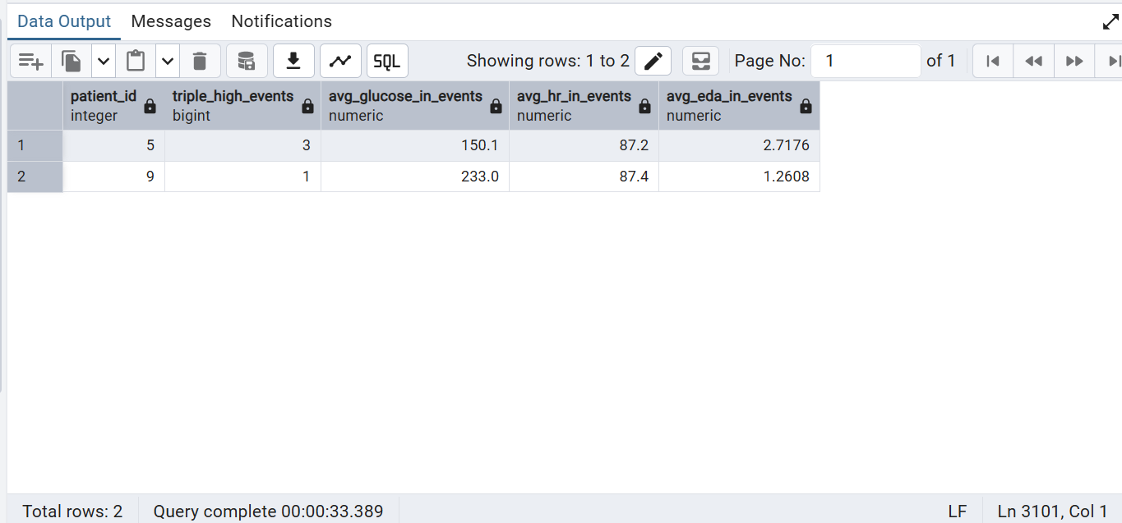
INSIGHTS:
- Only 2 out of 16 patients (patients 5 and 9) ever experienced a 30-minute window where glucose, heart rate, and EDA were simultaneously in their cohort's top quartile
- Patient 5 had the most frequent triple-high events (3 occurrences), with average glucose of 150.1 mg/dL during those windows
- Patient 9 had only 1 event but a notably high average glucose of 233.0 mg/dL during it
- Both patients show average heart rate around 87 bpm during these events, slightly elevated but not extreme
- Fixed clinical thresholds (glucose > 140, HR > 90, EDA > 5) returned zero matching windows, confirming that cohort-relative percentile thresholds were necessary to surface any meaningful signal in this population

—------------------------------------CATEGORY-3—---------------------------------------

1.Create a user-defined function to calculate the Time-in-Range (TIR) percentage for each patient based on continuous glucose monitoring (CGM) data
Reasoning:
Time-in-Range (TIR) measures the percentage of glucose readings within the healthy range (70–180 mg/dL) per patient.It provides a direct indicator of glycemic control and diabetes management effectiveness.Higher TIR indicates better glucose stability and lower risk of complications.

Optimizing:
- Implemented a user-defined function (UDF) to reuse TIR logic across patients efficiently.
- Used FILTER (WHERE) to compute in-range readings in a single pass aggregation.
- Avoids repetitive queries by encapsulating logic, improving modularity and scalability.

QUERY:

CREATE OR REPLACE FUNCTION calculate_tir(p_patient_id INT)
RETURNS NUMERIC AS
$$
DECLARE
tir_percent NUMERIC;
BEGIN
SELECT
ROUND(
COUNT(*) FILTER (WHERE glucose_mgdl BETWEEN 70 AND 180) * 100.0
/ COUNT(*),
2
)
INTO tir_percent
FROM dexcom_clean
WHERE patient_id = p_patient_id;

RETURN tir_percent;
END;
$$
LANGUAGE plpgsql;

FUNCTION EXECUTION:

ALL PATIENTS:

SELECT
patient_id,
calculate_tir(patient_id) AS tir_percentage
FROM demography_clean
ORDER BY patient_id;

OUTPUT: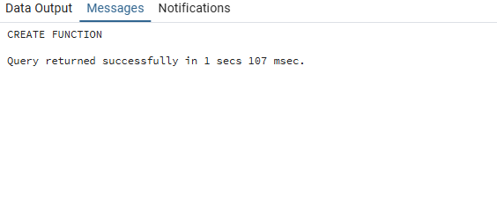

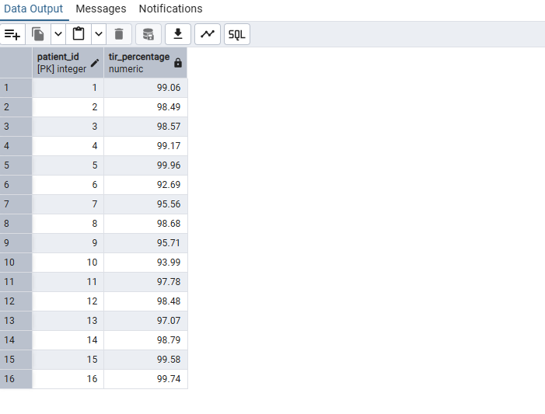

INSIGHTS:
Patients with high TIR (>70%) show strong glycemic control and stable glucose patterns.
Low TIR (<50%) indicates frequent hypo/hyperglycemic excursions and poor regulation.
TIR provides a more clinically meaningful metric than average glucose alone.

2.Create a stored procedure to generate a patient glucose summary report, including minimum glucose, maximum glucose, average glucose, and Time-in-Range (TIR) percentage

Reasoning:
A patient glucose summary report is required to evaluate overall glycemic control in a single view.It combines key statistical measures (min, max, average, variability) along with Time-in-Range (TIR).This helps clinicians assess both glucose stability and risk of hypo/hyperglycemia.

Optimizing:
- Used a stored procedure to encapsulate reusable patient-level reporting logic.
- Computed all metrics (MIN, MAX, AVG, STDDEV, TIR) in a single table scan for efficiency.
- Used FILTER clause for TIR calculation and NULLIF to avoid division-by-zero errors.
- Reduced repeated queries by consolidating all aggregations into one execution block.

QUERY:
CREATE OR REPLACE PROCEDURE generate_glucose_summary(p_patient_id INT)
LANGUAGE plpgsql
AS $$
DECLARE
v_min_glucose NUMERIC;
v_max_glucose NUMERIC;
v_avg_glucose NUMERIC;
v_tir NUMERIC;
v_std_glucose NUMERIC;
BEGIN

SELECT
MIN(glucose_mgdl),
MAX(glucose_mgdl),
ROUND(AVG(glucose_mgdl),2),
ROUND(
COUNT(*) FILTER (WHERE glucose_mgdl BETWEEN 70 AND 180)
*100.0/NULLIF(COUNT(*),0),2),
ROUND(STDDEV(glucose_mgdl),2)
INTO
v_min_glucose,
v_max_glucose,
v_avg_glucose,
v_tir,
v_std_glucose
FROM dexcom_clean
WHERE patient_id = p_patient_id;

RAISE NOTICE 'Patient ID : %', p_patient_id;
RAISE NOTICE 'Minimum Glucose : % mg/dL', v_min_glucose;
RAISE NOTICE 'Maximum Glucose : % mg/dL', v_max_glucose;
RAISE NOTICE 'Average Glucose : % mg/dL', v_avg_glucose;
RAISE NOTICE 'Time In Range (TIR) : % %%', v_tir;
RAISE NOTICE 'Std Dev Glucose : % mg/dL', v_std_glucose;

END;
$$;

-----------------------------CALL FUNCTION-----------------------------
CALL generate_glucose_summary(10);

----------------------------DROP FUNCTION-------------------------------
DROP PROCEDURE IF EXISTS generate_glucose_summary(p_patient_id INT);

OUTPUT:
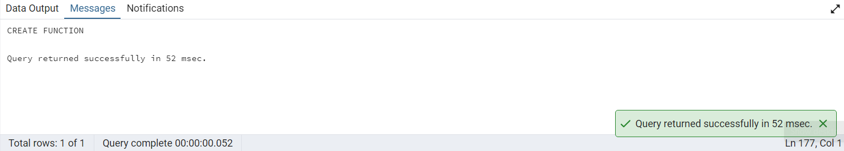
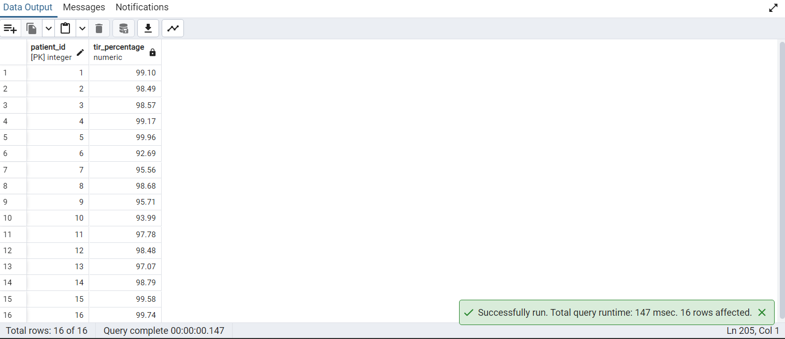
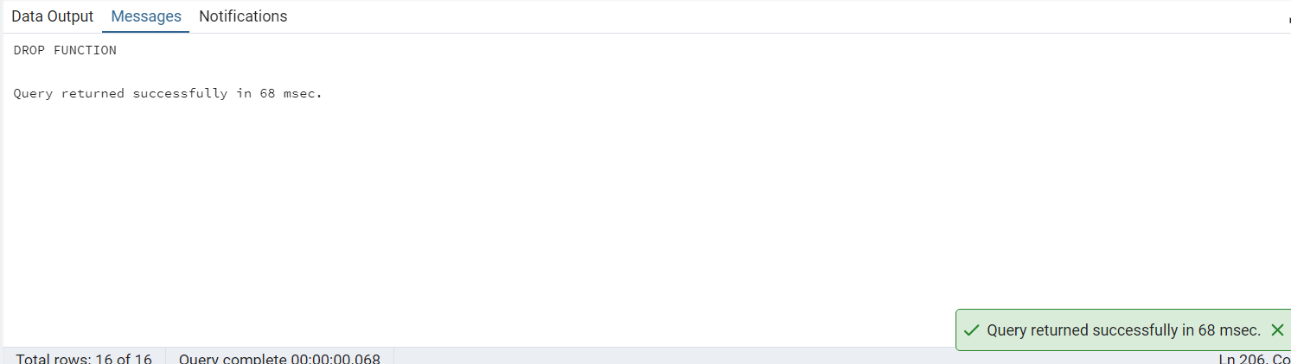
INSIGHTS:
- High TIR with low standard deviation indicates stable glucose control.
- Large difference between min and max glucose suggests high glycemic variability and risk of complications.
- Average glucose alone is not sufficient; variability and TIR together provide a complete clinical picture.

3.Create a trigger to automatically classify newly inserted glucose readings into glucose categories (Hypoglycemia, Normal, or Hyperglycemia)

Reasoning:
A trigger is used to automatically classify each new glucose reading at the time of insertion.
This ensures real-time categorization into Hypoglycemia, Normal, or Hyperglycemia without manual processing.It improves data consistency and supports immediate clinical decision-making.

Optimizing:
- Implemented a BEFORE INSERT trigger to classify data before it is stored in the table.
- Eliminates need for post-processing or additional update queries after data insertion.
- Ensures consistent labeling using centralized logic inside a trigger function.

QUERY:
----------------ADDING NEW COLUMN CATEGORY----------

ALTER TABLE dexcom_clean
ADD COLUMN glucose_category VARCHAR(20);

----------CREATE TRIGGER FUNCTION-------------------

CREATE OR REPLACE FUNCTION classify_glucose()
RETURNS TRIGGER AS
$$
BEGIN
IF NEW.glucose_mgdl < 70 THEN
NEW.glucose_category := 'Hypoglycemia';

ELSIF NEW.glucose_mgdl <= 180 THEN
NEW.glucose_category := 'Normal';

ELSE
NEW.glucose_category := 'Hyperglycemia';
END IF;

RETURN NEW;
END;
$$
LANGUAGE plpgsql;

------------CREATE TRIGGER ---------------------

CREATE TRIGGER trg_classify_glucose
BEFORE INSERT ON dexcom_clean
FOR EACH ROW
EXECUTE FUNCTION classify_glucose();

—----------INSERTING NEW VALUE------------------------------

INSERT INTO dexcom_clean (patient_id, timestamp, glucose_mgdl)
VALUES (1, '2020-02-23 10:00:00', 220);

—--------VERIFY-----------------------------------
SELECT patient_id,
timestamp,
glucose_mgdl,
glucose_category
FROM dexcom_clean
WHERE patient_id = 1
ORDER BY timestamp DESC
LIMIT 1;

--------REMOVE THE TESTED RECORD------------
DELETE FROM dexcom_clean
WHERE patient_id = 1
AND timestamp = '2020-02-23 10:00:00';
-------DROP TRIGGER---------------------------
DROP TRIGGER IF EXISTS trg_classify_glucose
ON dexcom_clean;
---------------DROP TRIGGER FUNCTION-----------

DROP FUNCTION IF EXISTS classify_glucose();

-------DROP ADD COLUMN----------------------
ALTER TABLE dexcom_clean
DROP COLUMN IF EXISTS glucose_category;

OUTPUT:
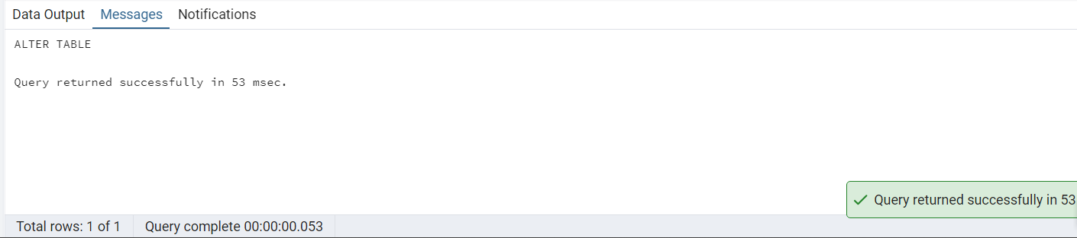
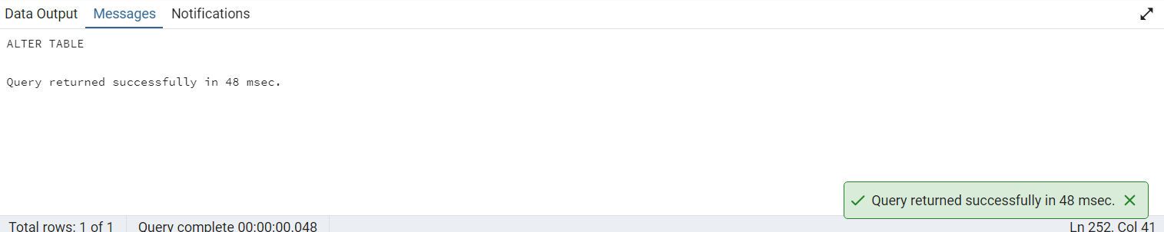
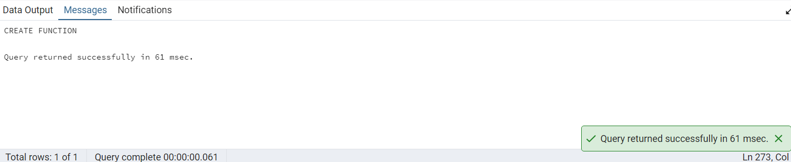
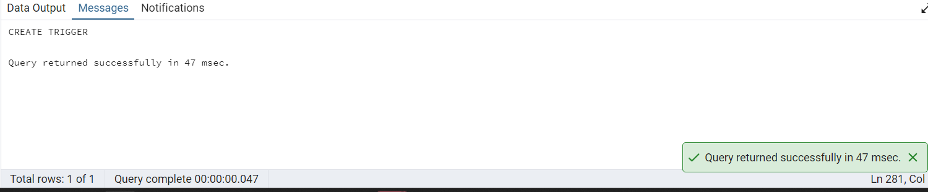

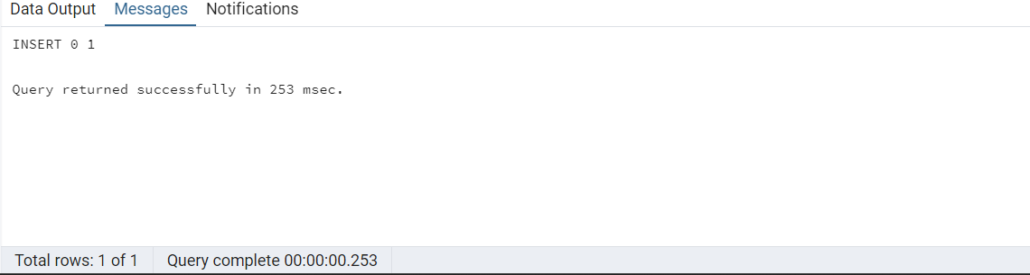
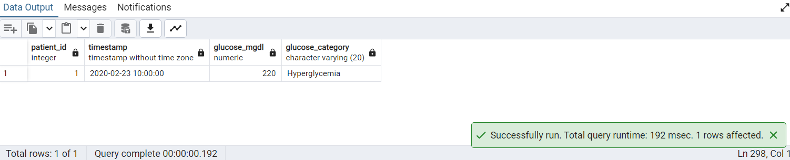

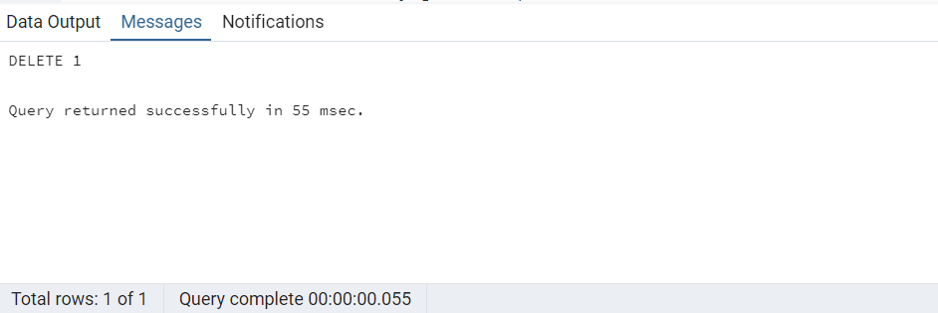

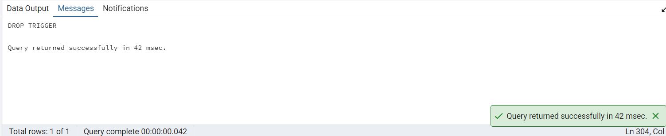

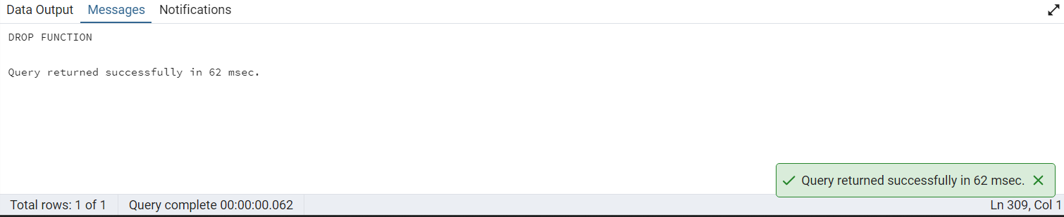

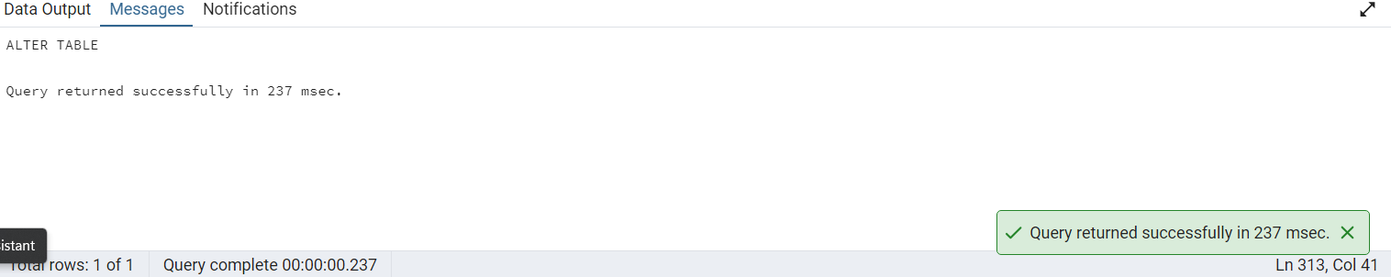
INSIGHTS:
Hypoglycemia (<70 mg/dL) indicates immediate clinical risk requiring intervention.
Normal range (70–180 mg/dL) reflects controlled glucose stability.
Hyperglycemia (>180 mg/dL) highlights poor glucose control and long-term risk exposure.

4.Create a stored procedure to generate a nutritional summary report for a patient, including total calories, carbohydrates, protein, fiber, and fat consumed

Reasoning:
A nutritional summary report aggregates all food intake for a patient into a single view.It provides total macronutrient consumption (calories, carbs, protein, fiber, fat) for dietary analysis.
This helps evaluate diet quality and its impact on glucose control and metabolic health.

Optimizing:
- Implemented a stored procedure to encapsulate reusable nutritional aggregation logic.
- Used SUM() with COALESCE() to handle missing values and prevent NULL propagation.
- Reduced multiple queries into a single table scan for efficient batch computation.

QUERY:

CREATE OR REPLACE PROCEDURE generate_nutrition_summary(p_patient_id INT)
LANGUAGE plpgsql
AS $$
DECLARE
v_total_calories NUMERIC;
v_total_carbs NUMERIC;
v_total_protein NUMERIC;
v_total_fiber NUMERIC;
v_total_fat NUMERIC;
BEGIN

SELECT
COALESCE(SUM(calories), 0),
COALESCE(SUM(carbs_g), 0),
COALESCE(SUM(protein_g), 0),
COALESCE(SUM(fiber_g), 0),
COALESCE(SUM(fat_g), 0)
INTO
v_total_calories,
v_total_carbs,
v_total_protein,
v_total_fiber,
v_total_fat
FROM foodlog_clean
WHERE patient_id = p_patient_id;

RAISE NOTICE 'Nutrition Summary Report for Patient ID: %', p_patient_id;
RAISE NOTICE 'Total Calories : % kcal', v_total_calories;
RAISE NOTICE 'Total Carbs : % g', v_total_carbs;
RAISE NOTICE 'Total Protein : % g', v_total_protein;
RAISE NOTICE 'Total Fiber : % g', v_total_fiber;
RAISE NOTICE 'Total Fat : % g', v_total_fat;

END;
$$;

---------------------------CALL PROCEDURE ---------------

CALL generate_nutrition_summary(1);
---------------DROP PROCEDURE------------------
DROP PROCEDURE IF EXISTS generate_nutrition_summary(INT);

OUTPUT:
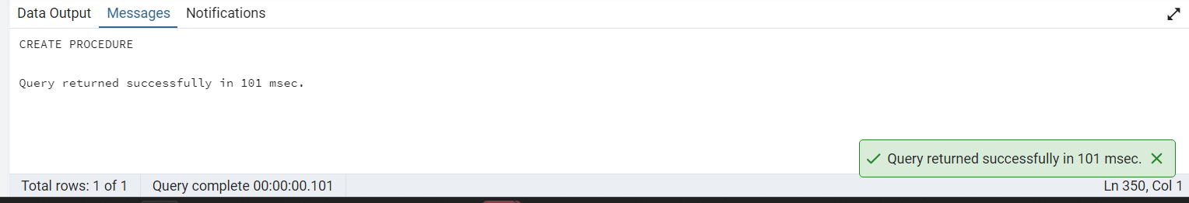
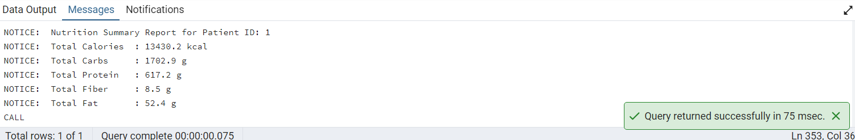

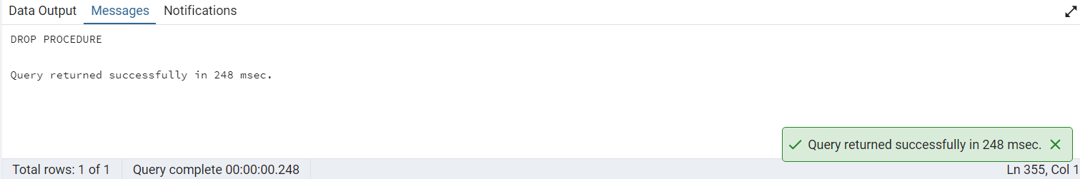
INSIGHTS:

High calorie + high carb intake often correlates with post-meal glucose spikes.
Protein and fiber intake contribute to better glycemic stability and slower glucose absorption.
Fat intake influences delayed glucose response and overall metabolic balance.

5. Classify glucose level into a clinical category.

Reasoning:
Classify each glucose measurement into clinically meaningful categories (such as normal, prediabetic, or diabetic ranges) to support interpretation of blood glucose values and enable standardized clinical reporting and risk stratification.

Optimization:
- Improved maintainability by encapsulating the glucose classification logic in a reusable user-defined function.
- Early usage of filters reduces the number of rows processed.
- The query sorts the results, producing an organized output.
QUERY:

CREATE OR REPLACE FUNCTION classify_glucose(glucose NUMERIC)
RETURNS TEXT AS $$
BEGIN
RETURN CASE
WHEN glucose < 70 THEN 'Hypoglycemic'
WHEN glucose < 100 THEN 'Normal'
WHEN glucose < 126 THEN 'Pre-Diabetic'
WHEN glucose < 180 THEN 'Diabetic Range'
ELSE 'Critical High'
END;
END;
$$ LANGUAGE plpgsql;

SELECT
patient_id,
glucose_mgdl,
classify_glucose(glucose_mgdl) AS glucose_status
FROM dexcom_clean
WHERE glucose_mgdl BETWEEN 40 AND 400
ORDER BY patient_id, timestamp;

OUTPUT:

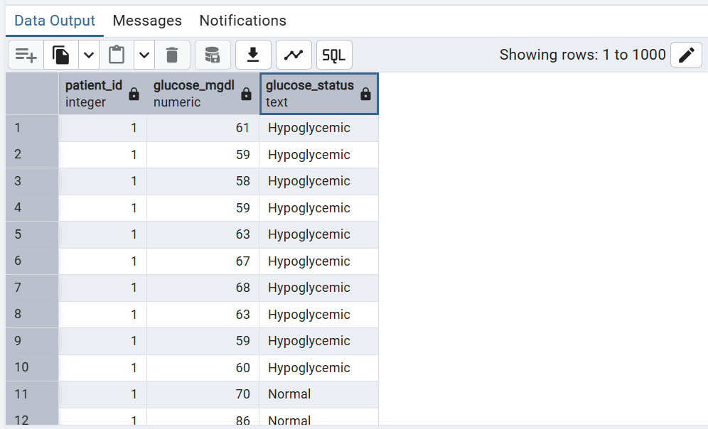

INSIGHTS:

Blood sugar moves a lot between normal and pre-diabetic levels, instead of staying steady. There are several drops into low (hypoglycemic) levels and a few rises into the diabetic range. This pattern suggests the patient's blood sugar control could use a closer look at diet, medication, or activity habits.

6. Generate a full summary report for a given patient

Reasoning:
Generate a comprehensive summary report for a selected patient by consolidating their key clinical and biometric data (e.g., glucose trends, heart rate, HbA1c category, calorie intake, and other available measurements) into a single consolidated view to support holistic patient assessment, monitoring, and clinical decision-making.
Optimization:

- The procedure improves reusability by storing the summary logic in one callable procedure.
- It filters data to process only relevant records.
- Aggregate functions efficiently calculate summary statistics.

QUERY:

CREATE OR REPLACE PROCEDURE patient_summary_report(IN p_patient_id INTEGER)
LANGUAGE plpgsql AS $$
BEGIN

-- Glucose summary
RAISE NOTICE '--- GLUCOSE SUMMARY FOR PATIENT % ---', p_patient_id;
RAISE NOTICE 'Avg: %, Min: %, Max: %',
(SELECT ROUND(AVG(glucose_mgdl),1)
FROM dexcom_clean WHERE patient_id = p_patient_id),
(SELECT MIN(glucose_mgdl)
FROM dexcom_clean WHERE patient_id = p_patient_id),
(SELECT MAX(glucose_mgdl)
FROM dexcom_clean WHERE patient_id = p_patient_id);

-- Heart rate summary
RAISE NOTICE '--- HEART RATE SUMMARY ---';
RAISE NOTICE 'Avg HR: %, Min: %, Max: %',
(SELECT ROUND(AVG(hr_bpm),1)
FROM hr_clean WHERE patient_id = p_patient_id),
(SELECT MIN(hr_bpm)
FROM hr_clean WHERE patient_id = p_patient_id),
(SELECT MAX(hr_bpm)
FROM hr_clean WHERE patient_id = p_patient_id);

-- Food log summary
RAISE NOTICE '--- FOOD LOG SUMMARY ---';
RAISE NOTICE 'Total Calories: %, Avg per meal: %',
(SELECT SUM(calories)
FROM foodlog_clean WHERE patient_id = p_patient_id),
(SELECT ROUND(AVG(calories),1)
FROM foodlog_clean WHERE patient_id = p_patient_id);

END;
$$;

CALL patient_summary_report(15);

OUTPUT:

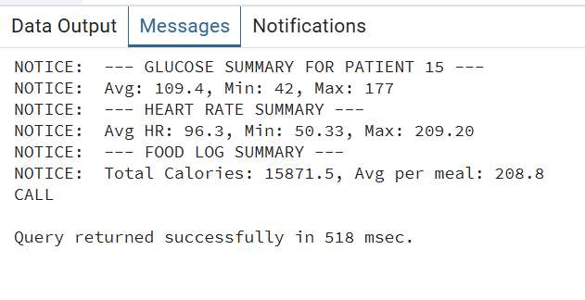
INSIGHTS:

Patient 15's glucose averaged 109.4 mg/dL but swung widely, from a low of 42 (hypoglycemic) to a high of 177 (near-diabetic), showing poor blood sugar stability. Heart rate also varied a lot, averaging 96.3 bpm but spiking as high as 209.20 bpm, which is unusually high and worth a closer clinical look. Calorie intake averaged 208.8 per meal, and combined with the glucose and heart rate extremes, this patient's overall pattern suggests irregular control that could benefit from a more detailed review of triggers and timing.

7. Generate a day-by-day study calendar and flag days with no glucose recording.

Reasoning:

Create a day-by-day calendar of glucose monitoring activity over the study period and flag days with missing glucose recordings to assess data completeness, identify gaps in patient monitoring, and support evaluation of adherence to measurement protocols.

Optimization:

- The query generates the date range once using a recursive CTE, avoiding manual date creation.
- It uses ‘Distinct’ to remove duplicate patient records before joining.
- ‘Join’ efficiently identifies missing recording days without complex subqueries.

QUERY:

WITH RECURSIVE study_calendar AS (

SELECT
MIN(timestamp) AS calendar_date
FROM dexcom_clean

UNION ALL

SELECT
calendar_date + INTERVAL '1 day'
FROM study_calendar
WHERE calendar_date < (
SELECT MAX(timestamp)
FROM dexcom_clean
)
),

recorded_days AS (
SELECT DISTINCT
patient_id,
timestamp AS recorded_date
FROM dexcom_clean
)

SELECT
c.calendar_date,
r.patient_id,
CASE
WHEN r.recorded_date IS NULL THEN 'Missing'
ELSE 'Recorded'
END AS recording_status
FROM study_calendar c
CROSS JOIN (SELECT DISTINCT patient_id FROM dexcom_clean) p
LEFT JOIN recorded_days r
ON r.recorded_date = c.calendar_date
AND r.patient_id = p.patient_id
ORDER BY p.patient_id, c.calendar_date;

OUTPUT:

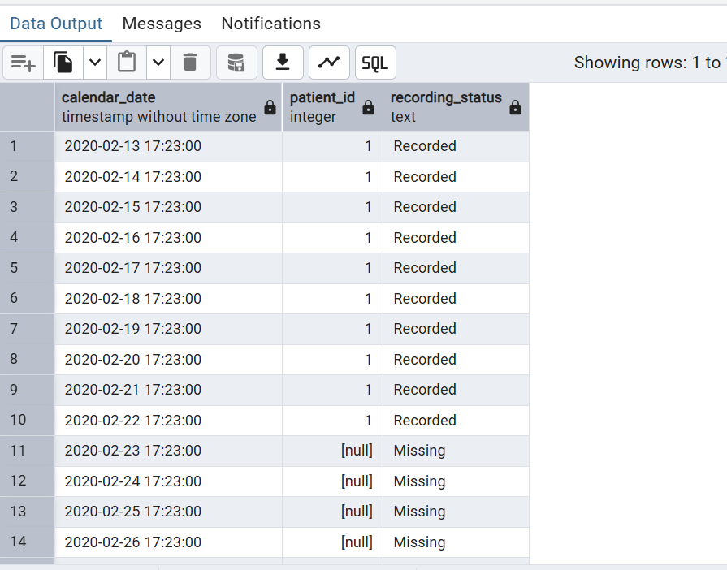

INSIGHTS:

Most patients have very little actual data, with only a handful of "Recorded" entries scattered among long stretches of "Missing" values. For example, patient 1 has readings for just 10 consecutive days before going missing for over five months, patient 2 has only 8 recorded days, and patient 6 has just 7 recorded days, while several other patient slots show no recorded data at all in this window. This points to a significant data completeness problem, likely due to device disconnections, dropped sensors, or gaps in data syncing, and any analysis built on this dataset would need to account for these large missing-data gaps rather than treating the daily timeline as continuous.

8. Automatically log whenever a new glucose reading is flagged as critical

Reasoning:
Automatically detect and log glucose readings that exceed predefined critical thresholds into an audit or alerting table to ensure timely identification of high-risk events, support patient safety monitoring, and enable downstream clinical review or notification

Optimization:
- The trigger automatically detects critical glucose readings, eliminating the need for manual checks after each insert.
- The alert logic is centralized in a reusable trigger function, improving maintainability.

QUERY:

CREATE TABLE IF NOT EXISTS glucose_alerts (
alert_id SERIAL PRIMARY KEY,
patient_id TEXT,
glucose_value NUMERIC,
alert_type TEXT,
alert_time TIMESTAMP DEFAULT NOW()
);

CREATE OR REPLACE FUNCTION flag_critical_glucose()
RETURNS TRIGGER AS $$
BEGIN
IF NEW.glucose_mgdl < 70 THEN
INSERT INTO glucose_alerts (patient_id, glucose_value, alert_type)
VALUES (NEW.patient_id, NEW.glucose_mgdl, 'HYPOGLYCEMIA');

ELSIF NEW.glucose_mgdl > 300 THEN
INSERT INTO glucose_alerts (patient_id, glucose_value, alert_type)
VALUES (NEW.patient_id, NEW.glucose_mgdl, 'CRITICAL HIGH');
END IF;

RETURN NEW;
END;
$$ LANGUAGE plpgsql;

CREATE TRIGGER trg_glucose_alert
AFTER INSERT ON dexcom_clean
FOR EACH ROW
EXECUTE FUNCTION flag_critical_glucose();

INSERT INTO dexcom_clean (patient_id, glucose_mgdl, timestamp)
VALUES (1, 55, NOW());

SELECT *
FROM glucose_alerts
ORDER BY alert_time DESC;

OUTPUT:

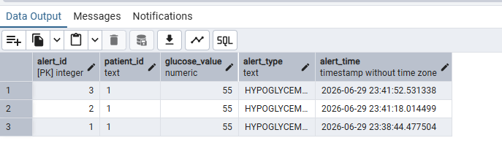
INSIGHTS:

The trigger correctly detected the low glucose value of 55 and logged it with the right patient ID and timestamp, confirming the alert system works as designed.

9. What is the cardiovascular summary (heart rate and IBI combined) for each patient, including how well the two sensors agree with each other?
Reasoning:
Clinicians need a single reusable report combining HR and IBI sensor data per patient instead of writing separate queries every time a cardiovascular review is needed. Comparing actual HR against HR estimated from IBI (60 divided by IBI in seconds) validates whether both wearable sensors are recording consistent cardiac activity.
Optimization:
Each table is pre-aggregated to 16 rows in its own subquery before joining, reducing the join from 9,384,435 x 699,512 rows down to just 16 x 16 rows. This is wrapped in a stored procedure so it can be called any time a cardiovascular review is needed without rewriting the query. The query completed in 3.2 seconds confirming the optimization worked.
QUERY:

CREATE OR REPLACE PROCEDURE generate_cardiovascular_summary()
LANGUAGE plpgsql
AS $$
BEGIN
DROP TABLE IF EXISTS temp_cardiovascular_summary;

CREATE TEMP TABLE temp_cardiovascular_summary AS
SELECT
h.patient_id,
dc.gender,
dc.hba1c,
h.total_hr_readings,
h.avg_hr_bpm,
h.min_hr_bpm,
h.max_hr_bpm,
h.anomaly_count,
i.total_ibi_readings,
i.avg_ibi_seconds,
i.estimated_hr_from_ibi,
ROUND(ABS(h.avg_hr_bpm - i.estimated_hr_from_ibi), 1) AS hr_ibi_difference,
CASE
WHEN ABS(h.avg_hr_bpm - i.estimated_hr_from_ibi) > 20
THEN 'Large Discrepancy'
WHEN ABS(h.avg_hr_bpm - i.estimated_hr_from_ibi) > 10
THEN 'Moderate Discrepancy'
ELSE 'Good Agreement'
END AS sensor_agreement
FROM (
-- pre-aggregate hr_clean to 16 rows first
SELECT
patient_id,
COUNT(hr_bpm) AS total_hr_readings,
ROUND(AVG(hr_bpm), 2) AS avg_hr_bpm,
ROUND(MIN(hr_bpm), 2) AS min_hr_bpm,
ROUND(MAX(hr_bpm), 2) AS max_hr_bpm,
COUNT(*) FILTER (WHERE hr_anomaly = TRUE) AS anomaly_count
FROM hr_clean
GROUP BY patient_id
) h
JOIN (
-- pre-aggregate ibi_clean to 16 rows first
SELECT
patient_id,
COUNT(ibi_seconds) AS total_ibi_readings,
ROUND(AVG(ibi_seconds)::numeric, 4) AS avg_ibi_seconds,
ROUND(60.0 / AVG(ibi_seconds), 1) AS estimated_hr_from_ibi
FROM ibi_clean
GROUP BY patient_id
) i ON h.patient_id = i.patient_id
JOIN demography_clean dc ON h.patient_id = dc.patient_id;

RAISE NOTICE 'Cardiovascular summary generated for % patients',
(SELECT COUNT(*) FROM temp_cardiovascular_summary);
END;
$$;

-- Call the procedure
CALL generate_cardiovascular_summary();

-- View the results
SELECT * FROM temp_cardiovascular_summary
ORDER BY anomaly_count DESC;
OUTPUT:
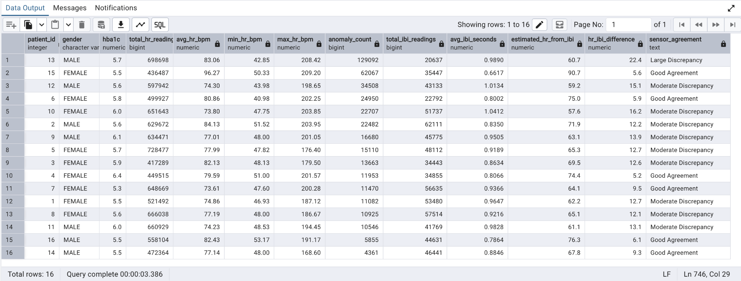

INSIGHTS:
- Patient 13 has the most HR anomalies (129,092 readings outside the 50-120 bpm threshold)
- Patient 15 has the highest average HR (96.28 bpm) and the shortest average IBI (0.66 seconds)
- Patient 10 has the longest average IBI (1.0412 seconds) corresponding to the slowest heart rate
- Most patients show Moderate Discrepancy between estimated and actual HR which is expected since the two sensors record at different frequencies

10. What is each patient's stress score based on how often their EDA readings spiked during the study?
Reasoning:
A reusable function that returns a stress burden classification for any patient on demand cannot be done with a simple SELECT because it requires conditional logic, a variable to hold the spike percentage, and returns a structured result that can be reused in other queries or reports.
Optimization: The spike percentage is calculated once into a variable and reused for classification instead of repeating the calculation. CROSS JOIN LATERAL applies the function to all 16 patients in a single query instead of calling it 16 separate times.
QUERY:

CREATE OR REPLACE FUNCTION get_stress_burden(p_patient_id INTEGER)
RETURNS TABLE (
patient_id INTEGER,
total_readings BIGINT,
spike_count BIGINT,
spike_pct NUMERIC,
avg_eda NUMERIC,
max_eda NUMERIC,
stress_burden TEXT
)
LANGUAGE plpgsql
AS $$
DECLARE
v_spike_pct NUMERIC;
BEGIN
-- calculate spike percentage for this patient
SELECT
COUNT(*) FILTER (WHERE eda_spike = TRUE) * 100.0 / COUNT(*)
INTO v_spike_pct
FROM eda_clean
WHERE eda_clean.patient_id = p_patient_id;

-- check if patient exists
IF v_spike_pct IS NULL THEN
RAISE EXCEPTION 'Patient ID % not found in eda_clean', p_patient_id;
END IF;

-- return full stress burden summary
RETURN QUERY
SELECT
e.patient_id,
COUNT(*) AS total_readings,
COUNT(*) FILTER (WHERE e.eda_spike = TRUE) AS spike_count,
ROUND(
COUNT(*) FILTER (WHERE e.eda_spike = TRUE)
* 100.0 / COUNT(*)
, 2) AS spike_pct,
ROUND(AVG(e.eda_value)::numeric, 4) AS avg_eda,
ROUND(MAX(e.eda_value)::numeric, 4) AS max_eda,
CASE
WHEN v_spike_pct > 15 THEN 'Critical Stress'
WHEN v_spike_pct > 10 THEN 'High Stress'
WHEN v_spike_pct > 5 THEN 'Moderate Stress'
ELSE 'Low Stress'
END AS stress_burden
FROM eda_clean e
WHERE e.patient_id = p_patient_id
GROUP BY e.patient_id;
END;
$$;

-- Test for a single patient
SELECT * FROM get_stress_burden(1);

-- Apply to all patients using a lateral join
SELECT s.*
FROM demography_clean dc
CROSS JOIN LATERAL get_stress_burden(dc.patient_id) s
ORDER BY s.spike_pct DESC;

OUTPUT:
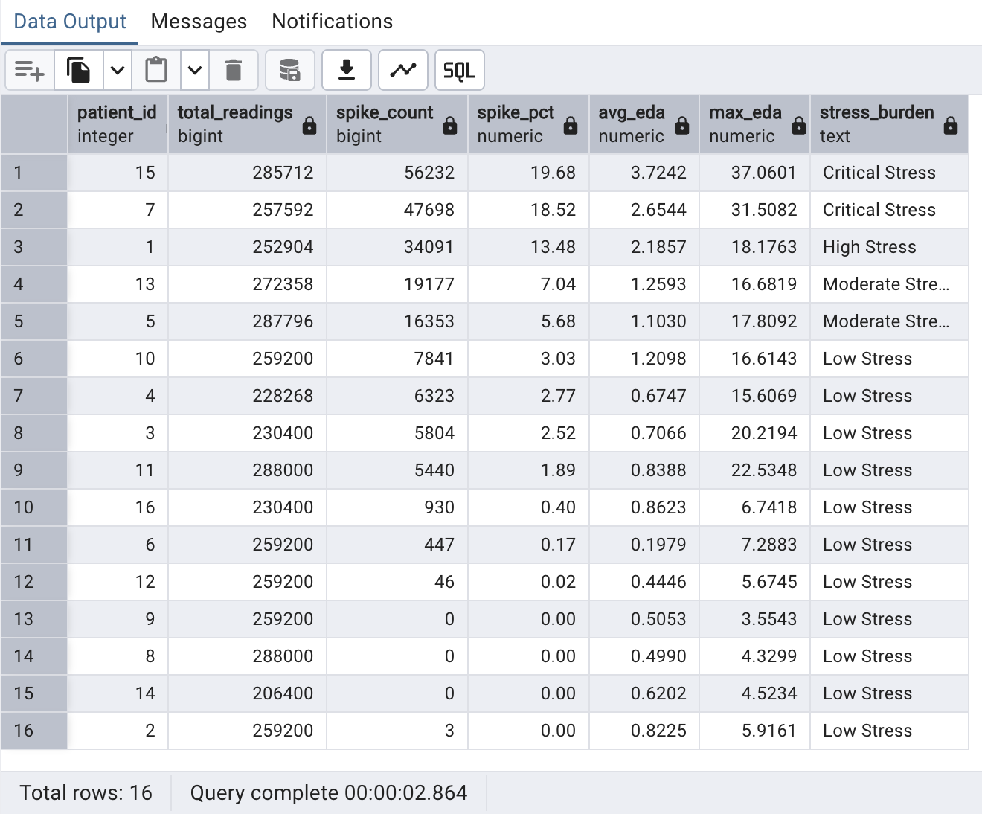
INSIGHTS:
- Patient 15 has Critical Stress (19.68% spike rate) -- the highest in the study
- Patient 7 has Critical Stress (18.52% spike rate) -- the second highest
- Only 2 out of 16 patients fall into the Critical Stress category
- 11 out of 16 patients have Low Stress burden showing most participants experienced limited physiological stress

11. What does each patient's glucose readings look like hour by hour across the whole study, including the hours where no data was recorded?
Reasoning:
The Dexcom G6 records every 5 minutes but gaps exist when the device is removed or malfunctions. A recursive query is needed because a simple GROUP BY only returns hours that already have data -- it cannot generate the hours that are missing, which is exactly what we need to see device compliance.
Optimization:
The recursive CTE builds the hourly timeline once per patient by stopping at each patient's own last reading instead of generating a single fixed range for everyone. A LEFT JOIN against the actual hourly averages preserves every generated hour even when no reading exists, surfacing the gaps as NULL. The final result is aggregated into one row per patient instead of showing all 3,192 individual hourly rows, making the gap pattern immediately readable.
QUERY:

WITH RECURSIVE hour_series AS (
-- anchor: start from the earliest glucose reading
SELECT
patient_id,
DATE_TRUNC('hour', MIN(timestamp)) AS hour_slot
FROM dexcom_clean
GROUP BY patient_id

UNION ALL

-- recursive: add one hour at a time until max timestamp
SELECT
hs.patient_id,
hs.hour_slot + INTERVAL '1 hour'
FROM hour_series hs
JOIN (
SELECT patient_id, MAX(timestamp) AS max_ts
FROM dexcom_clean
GROUP BY patient_id
) mx ON hs.patient_id = mx.patient_id
WHERE hs.hour_slot + INTERVAL '1 hour' <= mx.max_ts
),
hourly_glucose AS (
SELECT
patient_id,
DATE_TRUNC('hour', timestamp) AS hour_slot,
COUNT(*) AS readings_in_hour
FROM dexcom_clean
GROUP BY patient_id, DATE_TRUNC('hour', timestamp)
)
-- summary: one row per patient showing total hours vs gap hours
SELECT
hs.patient_id,
COUNT(*) AS total_hours,
COUNT(hg.readings_in_hour) AS hours_with_data,
COUNT(*) - COUNT(hg.readings_in_hour) AS gap_hours,
ROUND(
(COUNT(*) - COUNT(hg.readings_in_hour)) * 100.0 / COUNT(*)
, 2) AS gap_pct
FROM hour_series hs
LEFT JOIN hourly_glucose hg
ON hs.patient_id = hg.patient_id
AND hs.hour_slot = hg.hour_slot
GROUP BY hs.patient_id
ORDER BY gap_hours DESC;

OUTPUT: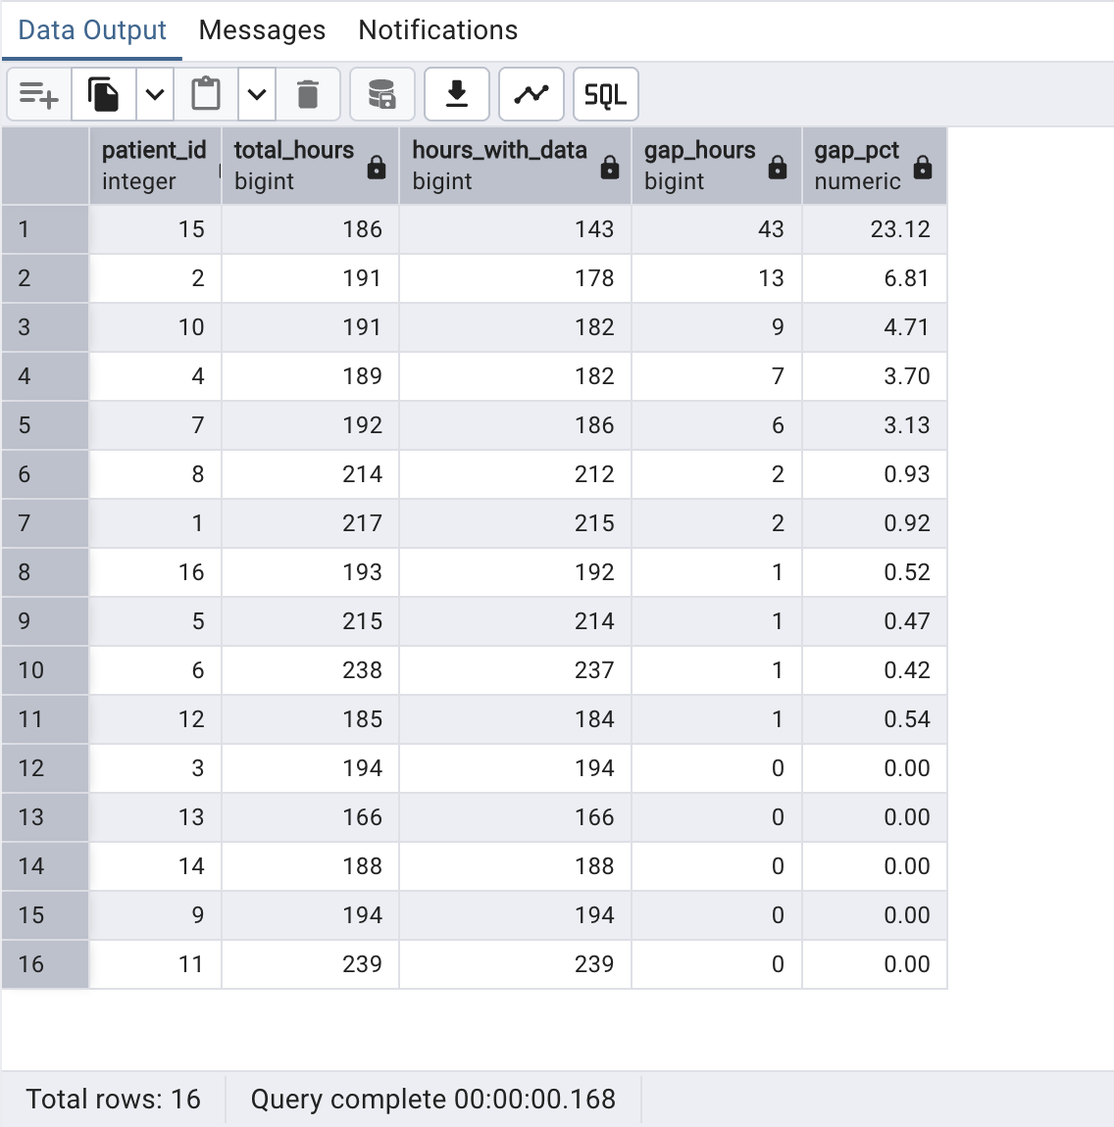

INSIGHTS:
- Patient 15 has the worst data completeness with 43 gap hours out of 186 total hours (23.12% missing), consistent with the 1,315 minute single gap found earlier in Category 2 analysis
- Patient 2 has the second most gaps (13 hours, 6.81%)
- 5 patients (3, 9, 11, 13, 14) have zero gaps, showing perfect device compliance throughout the entire study
- Gap percentage ranges from 0% to 23.12% across all 16 patients, showing meaningful variation in CGM wear compliance
- This recursive timeline summary reveals data completeness that a simple GROUP BY cannot show, since GROUP BY silently skips missing hours entirely

12. How do all patients compare on glucose metrics (average, min, max, time in range) for any given date range?
Reasoning:
Clinicians need to compare all patients' glucose metrics for a specific study period such as the first month versus the second month. A stored procedure is needed because it accepts a start and end date as input and returns a full comparative report, which would otherwise require rewriting the same query manually every time the date range changes.
Optimization:
Date range validation is built into the procedure to prevent invalid inputs before any processing happens. Time in range, time above range and time below range are all calculated in a single pass using FILTER instead of three separate queries, and RANK() orders all patients by severity in the same result set.
QUERY:

CREATE OR REPLACE PROCEDURE generate_period_glucose_report(
p_start_date DATE,
p_end_date DATE
)
LANGUAGE plpgsql
AS $$
BEGIN
IF p_start_date >= p_end_date THEN
RAISE EXCEPTION 'Start date must be before end date';
END IF;

DROP TABLE IF EXISTS temp_period_glucose_report;

CREATE TEMP TABLE temp_period_glucose_report AS
SELECT
d.patient_id,
dc.gender,
dc.hba1c,
COUNT(d.reading_id) AS total_readings,
ROUND(AVG(d.glucose_mgdl), 2) AS avg_glucose,
ROUND(MIN(d.glucose_mgdl), 2) AS min_glucose,
ROUND(MAX(d.glucose_mgdl), 2) AS max_glucose,
ROUND(STDDEV(d.glucose_mgdl), 2) AS stddev_glucose,
ROUND(
COUNT(*) FILTER (WHERE d.glucose_mgdl BETWEEN 70 AND 180)
* 100.0 / COUNT(*)
, 2) AS tir_pct,
ROUND(
COUNT(*) FILTER (WHERE d.glucose_mgdl > 180)
* 100.0 / COUNT(*)
, 2) AS tar_pct,
ROUND(
COUNT(*) FILTER (WHERE d.glucose_mgdl < 70)
* 100.0 / COUNT(*)
, 2) AS tbr_pct,
RANK() OVER (
ORDER BY AVG(d.glucose_mgdl) DESC
) AS glucose_rank
FROM dexcom_clean d
JOIN demography_clean dc ON d.patient_id = dc.patient_id
WHERE d.timestamp BETWEEN p_start_date AND p_end_date
GROUP BY d.patient_id, dc.gender, dc.hba1c;

RAISE NOTICE 'Period report generated from % to % for % patients',
p_start_date,
p_end_date,
(SELECT COUNT(*) FROM temp_period_glucose_report);
END;
$$;

-- Call the procedure for full study period
CALL generate_period_glucose_report('2020-02-13', '2020-07-27');

-- View the results
SELECT * FROM temp_period_glucose_report
ORDER BY glucose_rank;

OUTPUT:
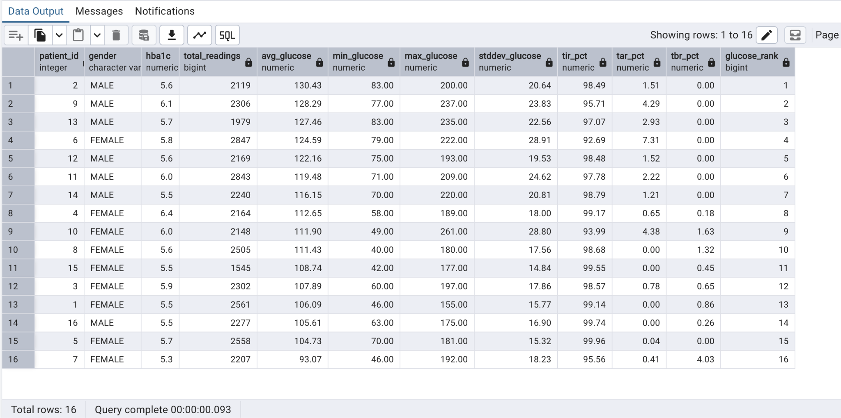
INSIGHTS:
- Patient 2 has the highest average glucose (130.43 mg/dL) ranked 1st in severity
- Patient 5 has the best Time in Range (99.96%) showing the best glucose control in the study
- Patient 6 has the worst Time in Range (92.69%) showing the poorest glucose control
- Patient 10 has the most extreme readings overall (minimum 49, maximum 261 mg/dL)
- The procedure can be reused for any date range, enabling period by period comparison as the study progresses

13. Identify stress periods using rolling EDA.
Reasoning:
A stress period is not a single high EDA reading but a sustained elevation lasting several minutes. Rolling mean + 1 SD threshold flags each reading; the island-gap technique groups consecutive flagged readings into stress events with start time, duration, and peak EDA. Correlating these stress periods with concurrent glucose readings reveals the stress-hyperglycemia pathway at the event level.

Optimization:
Rolling mean and SD are computed in the first CTE (eda_rolling) using ROWS BETWEEN windows over alias ec — one pass over eda_clean. Flagging and island-gap grouping via double ROW_NUMBER() in subsequent CTEs avoid a recursive CTE. HAVING COUNT(*) >= 10 filters trivial 1-2 reading false-positive events. Alias ec follows the eda_clean naming convention.
PostgreSQL feature used: Window: AVG()+STDDEV() OVER ROWS on ec; island-gap double ROW_NUMBER() stress period grouping

QUERY:
WITH eda_rolling AS (
SELECT
ec.patient_id,
ec.timestamp,
ec.eda_value,
AVG(ec.eda_value) OVER (
PARTITION BY ec.patient_id
ORDER BY ec.timestamp
ROWS BETWEEN 119 PRECEDING AND CURRENT ROW
) AS rolling_mean,
STDDEV(ec.eda_value) OVER (
PARTITION BY ec.patient_id
ORDER BY ec.timestamp
ROWS BETWEEN 119 PRECEDING AND CURRENT ROW
) AS rolling_sd
FROM eda_clean ec
),
flagged_ec AS (
SELECT
eda_rolling.patient_id,
eda_rolling.timestamp,
eda_rolling.eda_value,
eda_rolling.rolling_mean,
eda_rolling.rolling_sd,
CASE WHEN eda_rolling.eda_value
> eda_rolling.rolling_mean + eda_rolling.rolling_sd
THEN 1 ELSE 0
END AS is_stress
FROM eda_rolling
WHERE eda_rolling.rolling_sd IS NOT NULL
),
grouped_ec AS (
SELECT
flagged_ec.patient_id,
flagged_ec.timestamp,
flagged_ec.eda_value,
flagged_ec.is_stress,
ROW_NUMBER() OVER (
PARTITION BY flagged_ec.patient_id
ORDER BY flagged_ec.timestamp
)
- ROW_NUMBER() OVER (
PARTITION BY flagged_ec.patient_id, flagged_ec.is_stress
ORDER BY flagged_ec.timestamp
) AS island_grp
FROM flagged_ec
)
SELECT
grouped_ec.patient_id,
MIN(grouped_ec.timestamp) AS stress_period_start,
MAX(grouped_ec.timestamp) AS stress_period_end,
ROUND(
EXTRACT(EPOCH FROM
MAX(grouped_ec.timestamp) - MIN(grouped_ec.timestamp)
) / 60, 1
) AS duration_minutes,
COUNT(*) AS readings_in_period,
ROUND(AVG(grouped_ec.eda_value)::NUMERIC, 5) AS avg_eda_during_stress,
ROUND(MAX(grouped_ec.eda_value)::NUMERIC, 5) AS peak_eda
FROM grouped_ec
WHERE grouped_ec.is_stress = 1
GROUP BY grouped_ec.patient_id, grouped_ec.island_grp
HAVING COUNT(*) >= 10
ORDER BY peak_eda DESC;

OUTPUT:
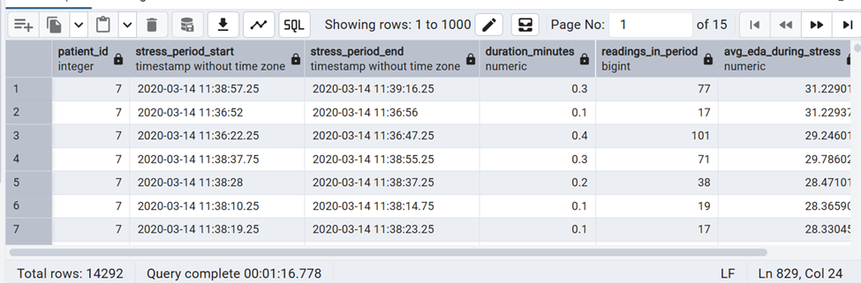
INSIGHTS:
Sustained EDA elevations lasting multiple readings identify genuine stress periods rather than momentary sensor noise; correlating these periods with concurrent glucose readings tests the stress-hyperglycemia hypothesis directly.

14.Create a function to compute daily glucose average.
Reasoning:
Daily average glucose is computed repeatedly across stored procedures, reports, and dashboards. Encapsulating this logic in a set-returning UDF makes the daily average reusable with consistent EGV filtering, NULL handling, and completeness thresholds applied uniformly. The function accepts a participant ID and an optional date range, returning one row per study day.

Optimization:
RETURNS TABLE allows the UDF to be used as a FROM-clause relation — the caller can WHERE, ORDER BY, and JOIN over its output. The STABLE declaration allows PostgreSQL to cache results within a transaction. Inside the function, the table alias dc is used for dexcom_clean to maintain the naming convention consistently within the function body.
PostgreSQL feature used: CREATE FUNCTION … RETURNS TABLE — set-returning plpgsql UDF for per-day glucose summary using dc alias

QUERY:
CREATE OR REPLACE FUNCTION get_daily_glucose_avg(
p_patient_id INT,
p_start_date DATE DEFAULT NULL,
p_end_date DATE DEFAULT NULL
)
RETURNS TABLE (
study_day DATE,
avg_glucose_mgdl NUMERIC,
min_glucose NUMERIC,
max_glucose NUMERIC,
reading_count INT,
completeness_pct NUMERIC
)
LANGUAGE plpgsql
STABLE
AS $$
BEGIN
RETURN QUERY
SELECT
CAST(dc.timestamp AS DATE) AS study_day,
ROUND(AVG(dc.glucose_mgdl)::NUMERIC, 1),
MIN(dc.glucose_mgdl),
MAX(dc.glucose_mgdl),
COUNT(*)::INT,
ROUND(COUNT(*) * 100.0 / 288::NUMERIC, 1) AS completeness_pct
FROM dexcom_clean dc
WHERE dc.patient_id = p_patient_id
AND UPPER(TRIM(dc.event_type)) = 'EGV'
AND dc.glucose_mgdl IS NOT NULL
AND (p_start_date IS NULL OR CAST(dc.timestamp AS DATE) >= p_start_date)
AND (p_end_date IS NULL OR CAST(dc.timestamp AS DATE) <= p_end_date)
GROUP BY CAST(dc.timestamp AS DATE)
ORDER BY study_day;
END;
$$;

-- Usage: daily averages for participant 3
SELECT * FROM get_daily_glucose_avg(3);

-- Usage: all participants via LATERAL join
SELECT dgc.patient_id, dgc.hba1c, g.*
FROM demography_clean dgc
CROSS JOIN LATERAL get_daily_glucose_avg(dgc.patient_id) g
ORDER BY dgc.patient_id, g.study_day;

OUTPUT:
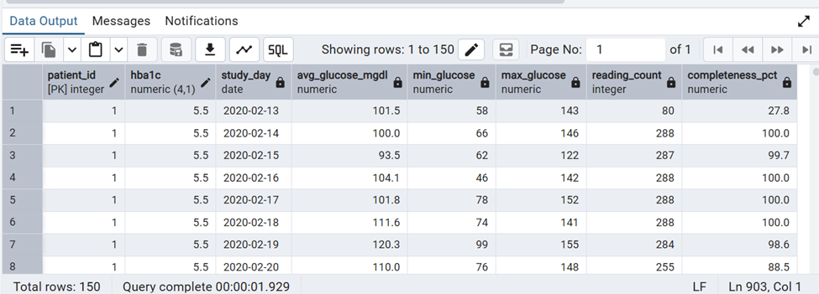
INSIGHTS:
The reusable daily glucose average function standardises EGV filtering and completeness reporting across all downstream reports, ensuring consistent daily summaries for every participant.

15.Create a FUNCTION to summarize heart rate.
Reasoning:
Heart rate summary statistics (mean, SD, percentiles, resting HR, peak HR) are required by multiple stored procedures and the participant report card generator. A set-returning UDF that computes the full HR summary for any participant encapsulates all HR metrics in one reusable function — callers get a complete HR profile with one function call instead of repeating complex aggregation logic.

Optimization:
PERCENTILE_CONT() ordered-set aggregate inside the function is computed in one sorted pass. STABLE declaration enables PostgreSQL to cache within a transaction when called repeatedly for the same patient_id. Inside the function body, alias hc is used for hr_clean to maintain the naming convention. The physiological range filter (40-200 bpm) removes artefacts before aggregation.
PostgreSQL feature used: CREATE FUNCTION … RETURNS TABLE — PERCENTILE_CONT ordered-set aggregate inside plpgsql using hc alias

QUERY:
CREATE OR REPLACE FUNCTION summarize_heart_rate(p_patient_id INT)
RETURNS TABLE (
avg_hr_bpm NUMERIC,
median_hr_bpm NUMERIC,
std_hr_bpm NUMERIC,
resting_hr_bpm NUMERIC,
peak_hr_bpm NUMERIC,
p25_hr NUMERIC,
p75_hr NUMERIC,
total_readings BIGINT,
anomaly_count BIGINT
)
LANGUAGE plpgsql
STABLE
AS $$
BEGIN
RETURN QUERY
SELECT
ROUND(AVG(hc.hr_bpm)::NUMERIC, 1),
ROUND(PERCENTILE_CONT(0.50) WITHIN GROUP
(ORDER BY hc.hr_bpm)::NUMERIC, 1),
ROUND(STDDEV(hc.hr_bpm)::NUMERIC, 2),
ROUND(PERCENTILE_CONT(0.10) WITHIN GROUP
(ORDER BY hc.hr_bpm)::NUMERIC, 1),
MAX(hc.hr_bpm),
ROUND(PERCENTILE_CONT(0.25) WITHIN GROUP
(ORDER BY hc.hr_bpm)::NUMERIC, 1),
ROUND(PERCENTILE_CONT(0.75) WITHIN GROUP
(ORDER BY hc.hr_bpm)::NUMERIC, 1),
COUNT(*),
COUNT(*) FILTER (WHERE hc.hr_anomaly = TRUE)
FROM hr_clean hc
WHERE hc.patient_id = p_patient_id
AND hc.hr_bpm BETWEEN 40 AND 200;
END;
$$;

-- Usage: summary for one participant
SELECT * FROM summarize_heart_rate(3);

-- Usage: all participants via LATERAL join
SELECT
dgc.patient_id,
dgc.hba1c,
s.avg_hr_bpm,
s.resting_hr_bpm,
s.peak_hr_bpm,
s.std_hr_bpm,
s.anomaly_count
FROM demography_clean dgc
CROSS JOIN LATERAL summarize_heart_rate(dgc.patient_id) s
ORDER BY s.avg_hr_bpm DESC;

OUTPUT:
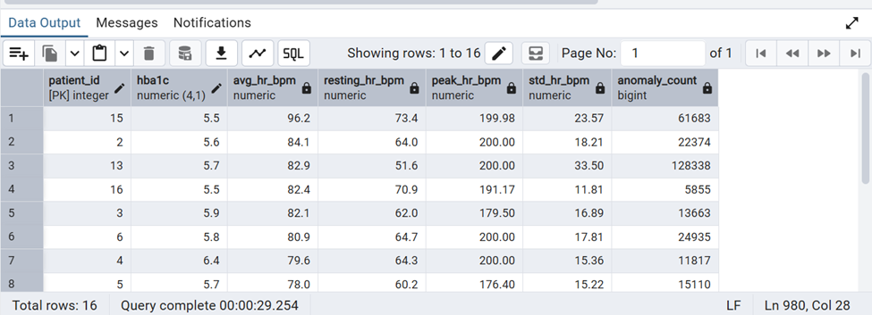
INSIGHTS:
The heart rate summary function exposes mean, median, percentiles, and anomaly counts in one call, enabling fast comparative HR profiling across the full participant cohort.

16.Create a trigger to log high glucose events.
Reasoning:
High glucose events (> 180 mg/dL) must be captured in real time as new CGM readings are inserted — not discovered during batch analysis. An AFTER INSERT trigger on dexcom_clean automatically writes every EGV reading above 180 to a high_glucose_events log table with severity classification. This creates a persistent, auditable event log without requiring any application-layer code changes.

Optimization:
AFTER INSERT trigger executes after the row is committed, so the INSERT into high_glucose_events is part of the same transaction. The trigger fires only when the NEW row passes the EGV and glucose threshold conditions — the common case (normal glucose) exits immediately with no I/O. FOR EACH ROW is required to access NEW column values. Inside the trigger function, NEW.patient_id, NEW.glucose_mgdl etc. refer to the newly inserted dexcom_clean (dc alias context) row.
PostgreSQL feature used: CREATE TRIGGER AFTER INSERT — fn_log_high_glucose() writes severity-classified events using dc alias

QUERY:
- ── Event log table ──────────────────────────────────────────────────────────
CREATE TABLE IF NOT EXISTS high_glucose_events (
event_id SERIAL PRIMARY KEY,
patient_id INT,
reading_id INT,
event_time TIMESTAMP,
glucose_mgdl NUMERIC,
severity TEXT,
logged_at TIMESTAMP DEFAULT NOW()
);
CREATE INDEX IF NOT EXISTS idx_hge_patient
ON high_glucose_events(patient_id, logged_at);

-- ── Trigger function (NEW row represents a dexcom_clean / dc row) ─────────────
CREATE OR REPLACE FUNCTION fn_log_high_glucose()
RETURNS TRIGGER
LANGUAGE plpgsql
AS $$
BEGIN
-- Only process EGV event type rows (dc context)
IF UPPER(TRIM(NEW.event_type)) <> 'EGV' THEN
RETURN NEW;
END IF;

IF NEW.glucose_mgdl > 180 THEN
INSERT INTO high_glucose_events
(patient_id, reading_id, event_time,
glucose_mgdl, severity)
VALUES (
NEW.patient_id, -- dc.patient_id
NEW.reading_id, -- dc.reading_id
NEW.timestamp, -- dc.timestamp
NEW.glucose_mgdl, -- dc.glucose_mgdl
CASE
WHEN NEW.glucose_mgdl > 300 THEN 'Critical (>300)'
WHEN NEW.glucose_mgdl > 250 THEN 'Severe (>250)'
WHEN NEW.glucose_mgdl > 200 THEN 'High (>200)'
ELSE 'Elevated (180-200)'
END
);
END IF;

RETURN NEW;
END;
$$;

-- ── Attach trigger to dexcom_clean (dc) ──────────────────────────────────────
DROP TRIGGER IF EXISTS trg_log_high_glucose ON dexcom_clean;

CREATE TRIGGER trg_log_high_glucose
AFTER INSERT ON dexcom_clean
FOR EACH ROW EXECUTE FUNCTION fn_log_high_glucose();

-- ── Review logged events ──────────────────────────────────────────────────────
SELECT
hge.patient_id,
hge.event_time,
hge.glucose_mgdl,
hge.severity,
hge.logged_at
FROM high_glucose_events hge
ORDER BY hge.glucose_mgdl DESC

OUTPUT:
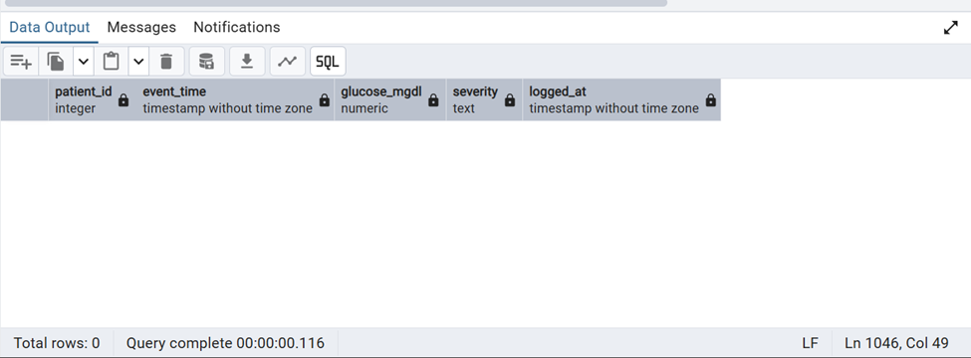
INSIGHTS:
The trigger automatically classifies and logs every glucose reading above 180 mg/dL in real time, creating a persistent audit trail of hyperglycemic events without requiring batch analysis.

