**LAPTOP REQUEST CATALOG ITEMS**



### TEAM ID - NM2025TMID17441

Group Leader: G.Rubika 030CAEE3B597D76B76F4714C315F14A4

Group Members:

T.Saranya 23DB966BF112858B87E4F3B37EED130A

K.Aswini 32623C6A91D07A29B534345BB7CA8500

A.Haripriya 2A8F0742ADC261F89C44D1A477E4E32F

Sub Titles

* Introduction
* Update set - add variables
* Service Catalog Items
* UI Policy
* UO Action
* Export Update set
* Logic to another instance
* Testing
* Conclusion

INTRODUCTION

In today’s fast-paced work environment, ensuring employees have timely access to the necessary

tools—such as laptops—is crucial for productivity and onboarding efficiency. However, the Current laptop

process in the organization is manual, inconsistent, and often leads to delays due to incomplete or inaccurate submissions. To streamline and modernize this workflow, a Service Catalog it em will be developed within

the IT Service Management (ITSM) platform.

## UPDATE SETS

1. **Open service now.**
2. **Click All and search for update sets**
3. **under system update sets Select local update sets**
4. **Click new**
5. **Fill the details to create an update set: “Laptop Request”**
6. **Click submit and make current**
7. **By clicking the submit button it activates the update set .**



Aj Favori łe• Histc›ry Work spaces .

e e « -



# SERVICE CATALOG ITEMS

1. **Open service now.**
2. **Click All and search service catalog**
3. **under catalog definitions Select maintain items**
4. **Click New.**
5. **Either following details to create an new catalog item Name: Laptop Request**

**Catalog: service gCatalog Category: Hardware**

**Short Description: Use this item to request a new l**

**aptop**

1. **Select SAVE**

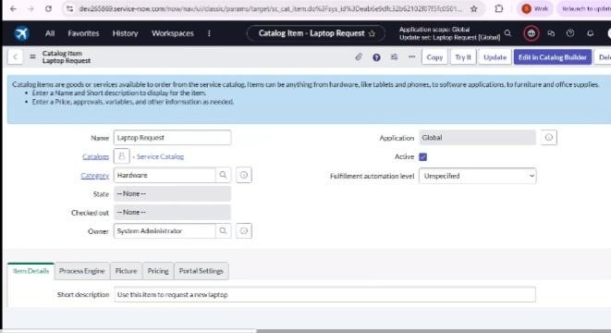

## ADD VARIABLES

**Step1:**

**\*After saving scroll down and click on variable (related list)**

* **Click new and enter the details as below**
  1. **Variable 1:Laptop Model Type: Single line text Name: laptop_model Order:100**
* **Click submit**
* **Again click new and add Remaining variables in the above process**

1. Variable :Justification Type: Multi line text Name: justification Order:200
2. Variable :Additional Accessories Type: Checkbox

Name: additional_accessories Order:300

1. Variable : Accessories Details Type: Multi line text Name:accessories_details Order:400

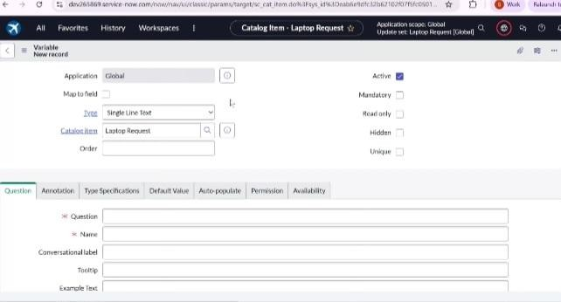Step2:

* After adding above details which will added to the. newly created catalog item

### UI POLICY

1. **Click all -> service catalog**
2. **under catalog definition**
3. **Search for ‘laptop request’ which is created before and scroll down click on “Catalog Ui policies”**
4. **In the catalog ui policies related list tab click new**
5. **Give short description as: show accessories details**
6. **Click save.(do not submit)**
7. **Scroll down and select ‘catalog ui action’.**
8. chlick new
9. Select variable name as: accessories_details Order:100

Mandatory: True Visible : True

1. Click on save and again click save button Of the catalog ui policy form

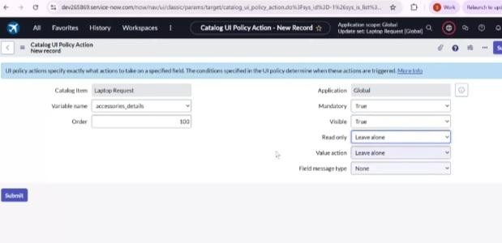

# UI ACTION

1. Open service now.
2. Click All ->ui action
3. under system definitionSelect ui actions
4. Click on new
5. Fill the following details to create an ui action Table: shopping cart(sc_cart) Order:100

Action name: Reset form Client : checked

Script:

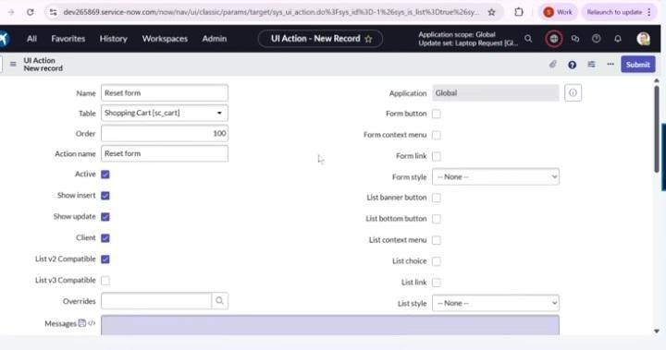function resetForm() { g_form.clearForm(); // Clears all fields in the form

alert("The form has been reset."); }

1. Click save

# EXPORT UPDATE SET

1. Click All -> update sets
2. Select local update set
3. Select created update set `Laptop Request Project’
4. Set the state to ‘Complete’
5. In the related list Update tab. updates are visible which we perform under this update set.
6. Click on export to XML ,it will download one file

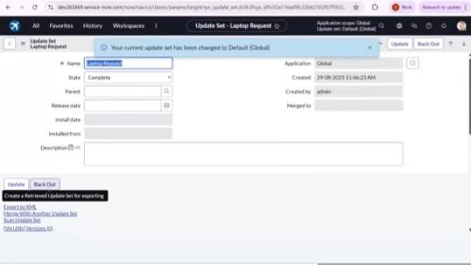

## LOGIC TO ANOTHER INSTANCE

* 1. Open another instance in incognito window
  2. Login with credentials
  3. Click all ->update sets
  4. under system update set Select “Retrieved update set”
  5. It open retrieved update set list and scroll down
  6. Click on Import update set from XML
  7. Upload the downloaded file in XML file
  8. Click on Upload and it gets uploaded.
  9. Open retrieved update set ‘laptop request project’
  10. Click on preview update set
  11. And click on commit update set
  12. And also see the related tab updates
  13. After commiting update set in this instance

we get all updates which are done in the previous instance

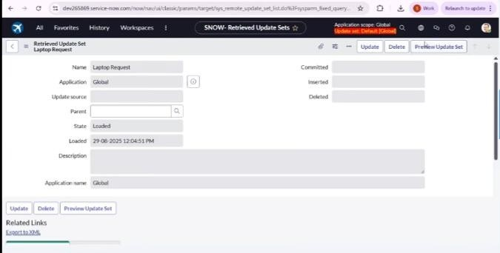

1. **TESTING**
2. **Search for service catalog in application navigator in targe instance**
3. **Select catalog under service catalog**
4. **Select hardware category and search for ‘laptop request’**
5. **Select laptop request item and open it**
6. **It shows three variables only**
7. **As per our scenario when we click on additional. accessories checkbox then accessories details fields is. visible and that should be mandatory**
8. 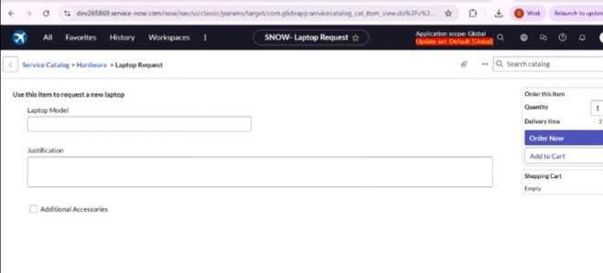Now see the results,it fulfills our requirements.

## CONCLUSION

**This project modernizes laptop requests within the organization by leveraging ServiceNow’s Service Catalog capabilities. The dynamic form interface, validations, reset functionality, and update**

**set-based deployment ensure a streamlined, audit-compliant, and user-friendly experience. This**

**leads to faster service delivery, higher accuracy, and improved employee satisfaction.**